**AP Chemistry Daily Videos**

[**9.7 Galvanic (Voltaic) and Electrolytic Cells**](https://apclassroom.collegeboard.org/7/home)

[**Video #1**](https://apclassroom.collegeboard.org/7/home?apd=2jad6wzeuy)

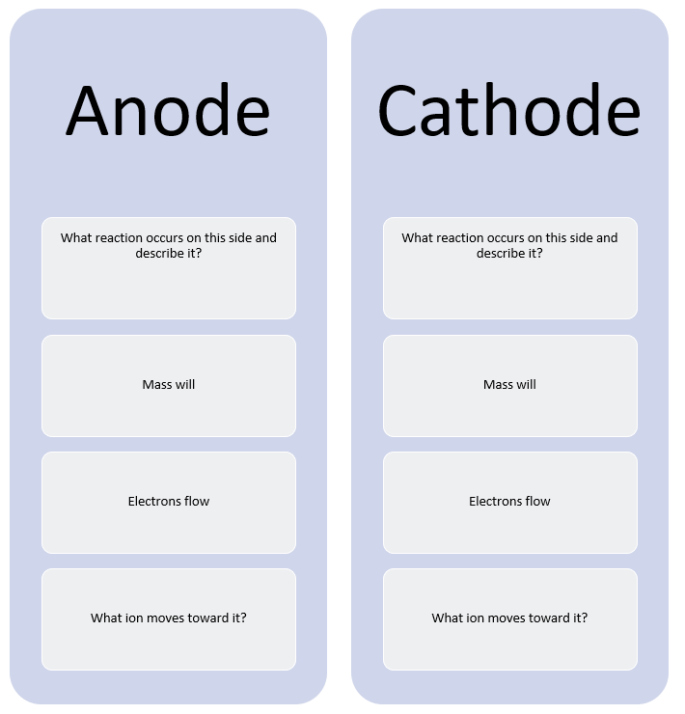



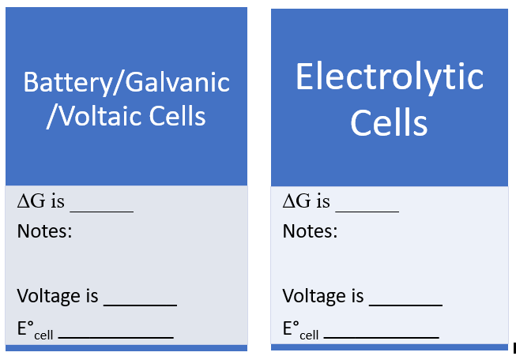

1. **What is a Volt?**
2. **Draw a picture of a battery, including the voltmeter.**

[**Video #2**](https://apclassroom.collegeboard.org/7/home?apd=2jad6wzeuy)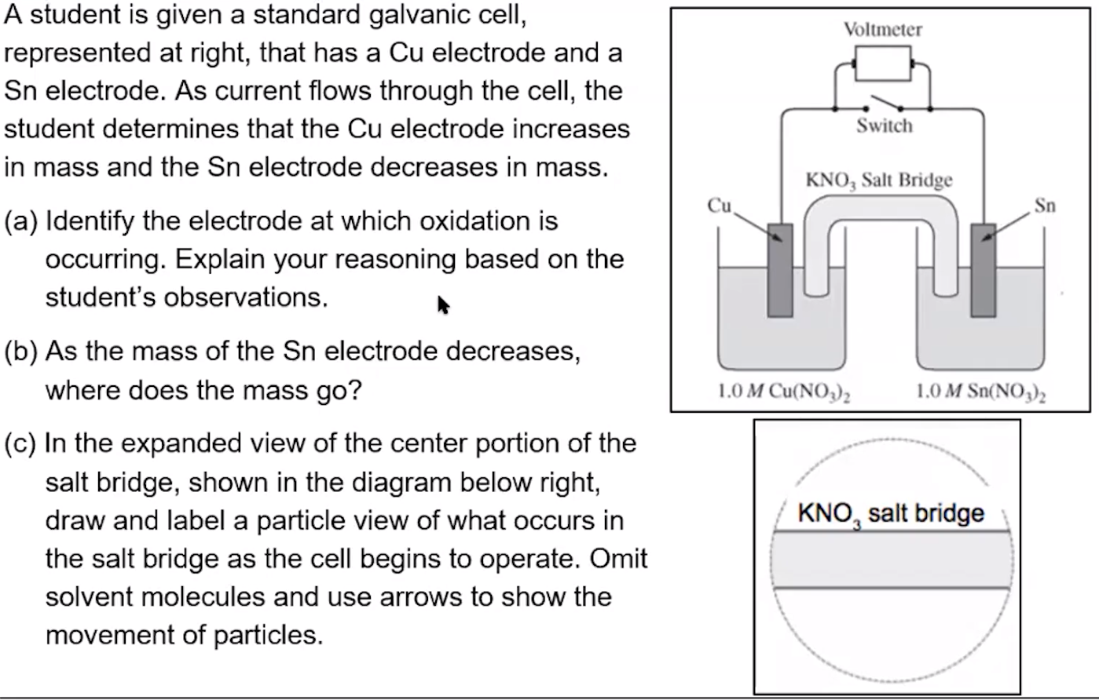

1. **Try the problem on your own. Then evaluate your work and identify any errors you may have made.**

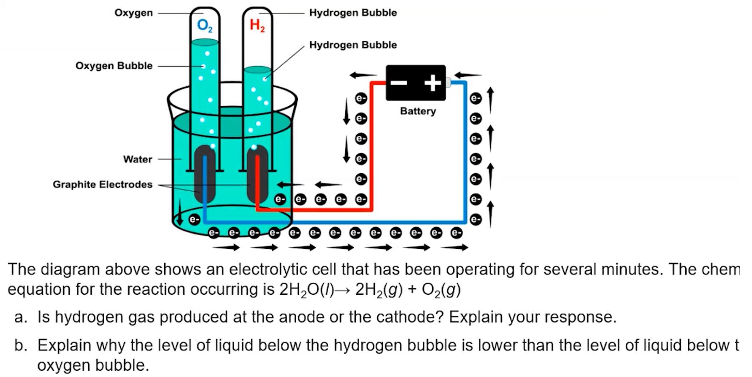

1. **Try the problem on your own. Then evaluate your work and identify any errors you may have made.**