**AP Chemistry Daily Videos**

[**9.8 Cell Potential and Free Energy**](https://apclassroom.collegeboard.org/7/home)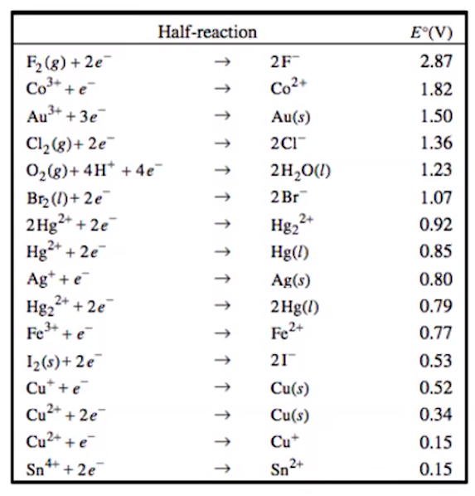

[**Video #1**](https://apclassroom.collegeboard.org/7/home?apd=56lbmkbp48)

1. **What is voltage?**
2. **What is a half cell?**

1. **Describe what information can be obtained by looking at the table of half-reactions.Make sure your answer includes standard conditions, the symbol for standard conditions, what a reduction potential is, and how you can obtain the voltage for an oxidation process.**
2. **Why are substances with the most positive values favored in reduction reactions? (Hint: What are electrons attracted to?).**
3. **Describe what is E°cell and how it can be calculated.**
4. **@ 4:24, go back to 9.7 and complete the table on page.**
5. **While balancing half reactions, what happens to E° value when you multiple a half reaction? What happens to E°when you reverse a reaction?**

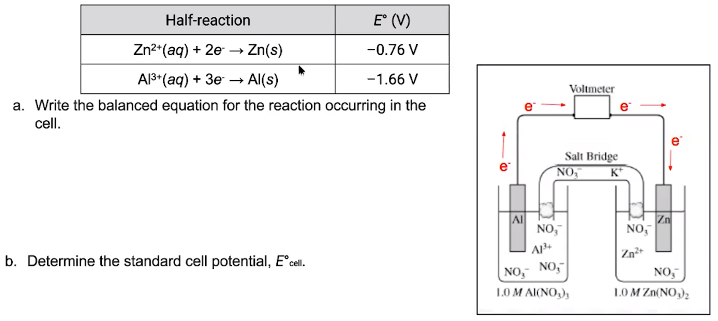

1. **Try the problem on your own. Then evaluate your work and identify any errors you may have made.**

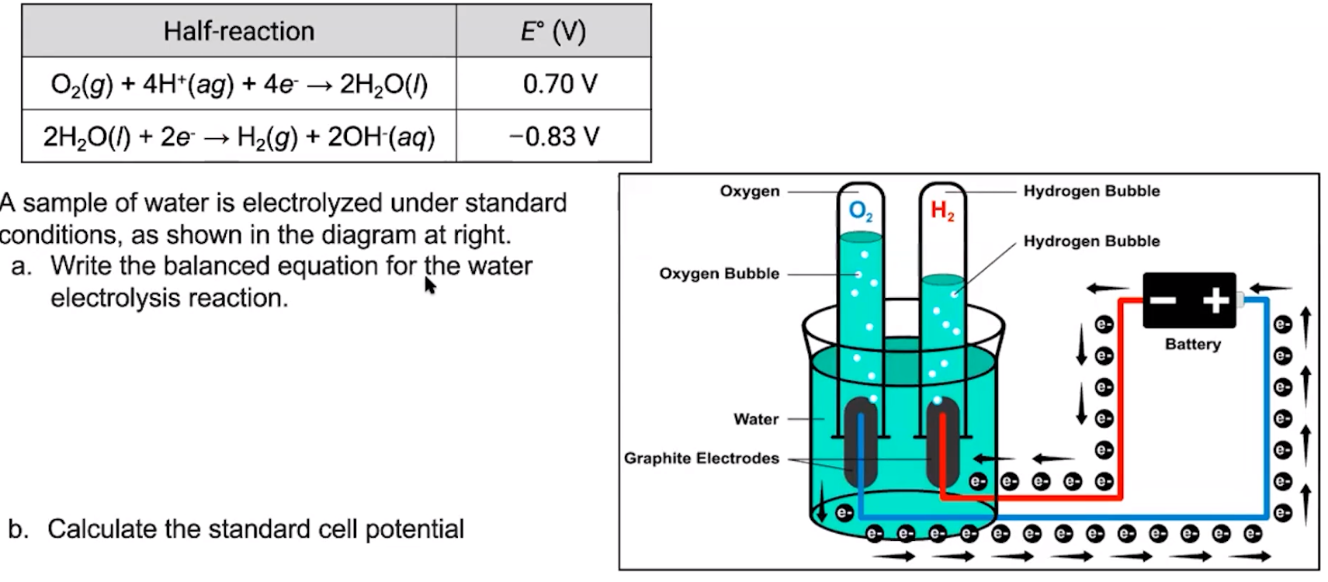

1. **Try the problem on your own. Then evaluate your work and identify any errors you may have made.**
2. **Summarize the 5 main points from this video.**

[**Video #2**](https://apclassroom.collegeboard.org/7/home?apd=60fw9npe8l)

1. **Describe each variable in this equation.**
2. **How does ΔG relate to E°cell?**



1. **Try part c from #9’s problem.**
2. **Try the problem on your own. Then evaluate your work and identify any errors you may have made.**