**AP Chemistry Daily Videos**

[**9.9 Cell Potential Under Nonstandard Conditions**](https://apclassroom.collegeboard.org/7/home)

[**Video #1**](https://apclassroom.collegeboard.org/7/home?apd=3ftm8conhb)

1. **What are standard conditions? Does ΔG=ΔG° at standard conditions?**
2. **What is the difference between E°cell and Ecell?**
3. **If you have the following redox reaction: Cu2+(aq) + Zn(s) → Cu(s) + Zn2+(aq) in a 1.0 M ZnSO4 and 1.0M CuSO4 solution (used in standard conditions). Calculate Q.**

**Answer check: You should have written Q=[Zn2+]/[Cu2+] because solids are left out. According to our concentrations Q=1. Q will always be equal to 1 in standard conditions.**

1. **There are 2 ways of knowing which way a reaction will proceed to reach equilibrium: A) compare Q to K B) the sign of ΔG. If ΔG=neg and Q<K then the reaction proceeds towards the products. What happens to Q and ΔG as the reaction proceeds and reactants turn into products? See** [**Khan Academy Link**](https://www.khanacademy.org/science/ap-chemistry/thermodynamics-ap/gibbs-free-energy-tutorial-ap/v/changes-in-free-energy-and-the-reaction-quotient) **for detailed answer.**

**Answer check: As product increases and reactant decreases Q↑. There’s a formula that relates Q to ΔG. ΔG=ΔG°+RTlnQ**

**Based on this formula, as Q↑,ΔG↑, until the reaction reaches equilibrium. At equilibrium: Q=K and ΔG gets larger until it equals 0. When ΔG=0 neither reactants or products are favored.**

1. **Note: The reaction ΔG=ΔG°+RTlnQ at equilibrium becomes 0=ΔG°+RTlnK or ΔG°= -RTlnK. Make sure you pick the correct equation depending on if you are at equilibrium or not.**

1. **@ 0:47 Does cell potential change as concentration or pressures of aq and gases change?**
2. **Complete the following table to relate these concepts to a battery.**

| **Condition of Battery** | **ΔG (-,+,0?)** | **Ecell(-,+,0?)** | **Q related to K?** | **At equilibrium?** |
| --- | --- | --- | --- | --- |
| **New** |  | **+High** | **Q<K** |  |
| **Used (Reactants have decreased concentration as they turned into product; Product concentration increased)** |  |  |  |  |
| **Dead** |  |  |  | **Yes** |

1. **Make a statement relating how Ecell changes as Q approaches K, until Q=K at equilibrium. Hint,Ecell is measured in Volts, meaning how much potential energy a reaction has.**

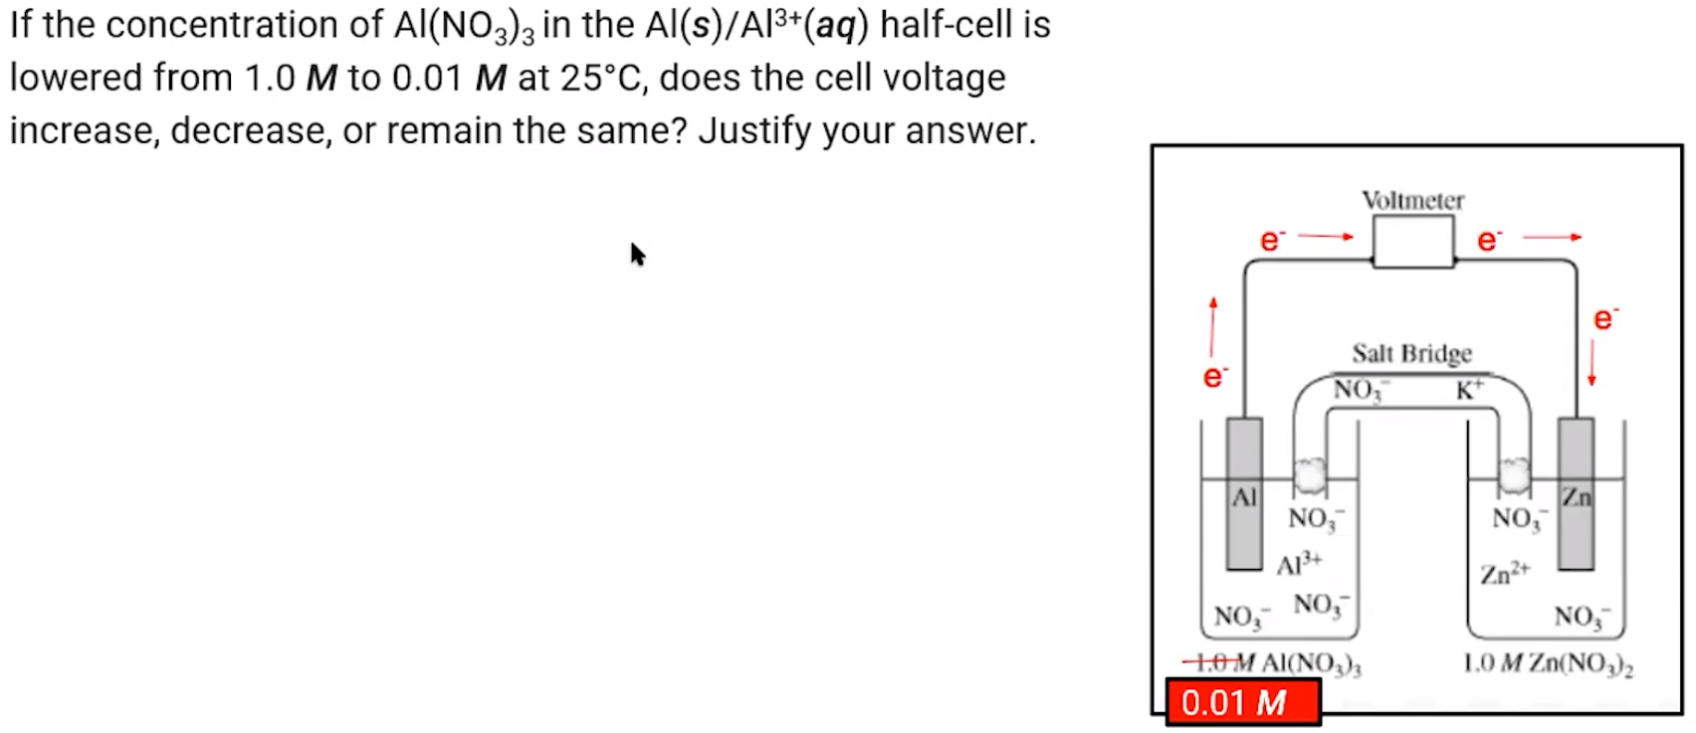

1. **Try the problem on your own. Then evaluate your work and identify any errors you may have made.**
2. **@ 4:37 What advice did your instructor give you?**
3. **How did you do on the two multiple choice questions?**

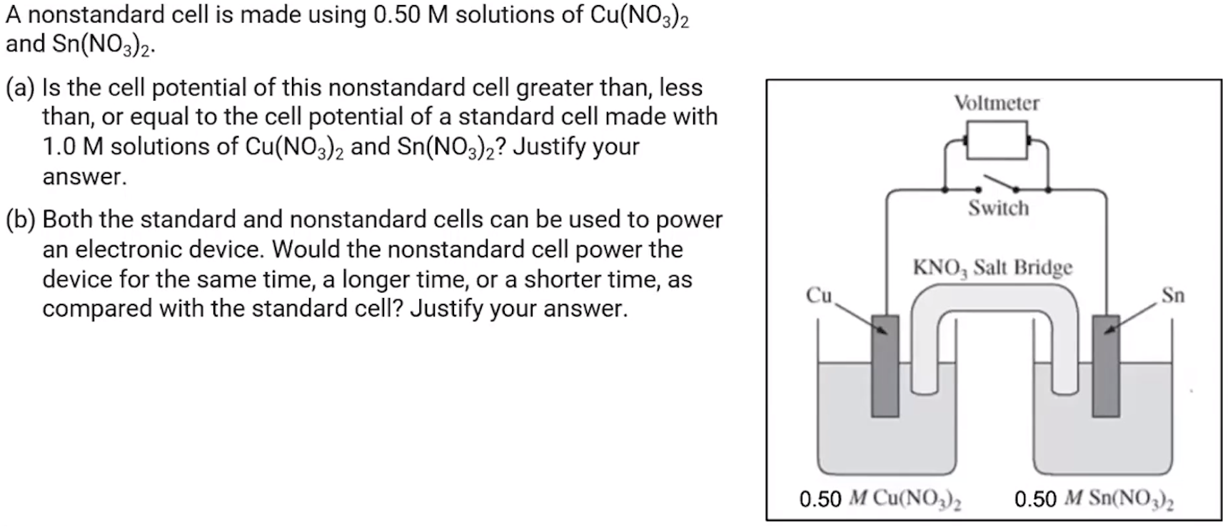

1. **Try the problem on your own. Then evaluate your work and identify any errors you may have made.**
2. **Summarize the main points of this video.**