**IN CLASS ACTIVITY**

**Mental Math – Number Sense**

**Factors of Ten**

1. 6.02 x 1000 =
2. 0.02 x 1000 =
3. 6.02 x 0.01 =
4. 0.3 x 1000 =
5. 0.1 x 1000 =
6. 602 x 0.001 =

**Fractions, Decimals, and Percents**

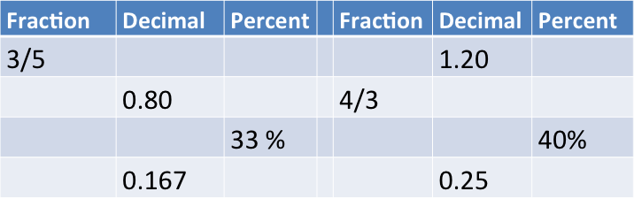



60 % of 80 =

80 % of 1200 =

33% of 360 =

125% of 1200 =

**Scientific Notation: Writing large or small numbers in scientific notation vastly simplifies operations!**

6.02 x 101 = ________

6.02 x 10-3 = ________

6.02 x 104 = ________

3.2 x 10-4  = 0.32 x 10? = 32 x 10?

1.6 x 108  = 16 x 10? = 0.16 x 10?

**Remember these exponent rules:**

*am* × *an = am+n*

*am* ÷ *an = am-n*

*(am)n = amxn*

(5 x 10-2) (5 x 10-5) = __________

(2.0 x 10-6)2(1.0 x 10-6) = _________

(0.00042)(200 000 000) = _______

(0.00042) ÷(200 000 000) =_____

(0.0050)2 =__________

(1.0 x 10-5)2 (0.5 x 10-5) = ________

**Fermi Estimation Rules**

1. Round all values to ONE significant digit.
2. Divide numerator and denominator by any obvious common number factor, especially powers of ten
3. Combine factors in the denominator and factors in the numerator, by multiplying, except for 100.

Apply Fermi estimation rules to approximate the following: **NO CALCULATOR!!!**

444 746 246 = 8.85 0.70 72.00 3.0 =

125 738 757 6.65 86.00

3.65 1000 4.15 323 = 48.0 303 1.0 =

676 1.00 706 11.0 298 1000

60.0 17.0 666 44.0 = 4.00 1.00 7.00 30.0 =

3.00 214 37.0 18.0 5.05 6.00

6.47 0.88 7.48 28.9 = 71.8 1.62 851 21.2 =

2.55 65.3 12.2 5.52 2.77 189 38.6 19.59

Solve the following problems without using a calculator.

1. When solid tin metal is heated in an atmosphere of chlorine gas, the product of the reaction is found to contain 62.2 percent Sn by mass and 37.4 percent Cl by mass. What is the empirical formula for this compound?
2. What mass of Iridium is produced when 0.0500 mol of Ir2O3 is reduced completely with excess H2?

2 H2O(l) + 4 MnO4 – (aq) + 3 ClO2 – (aq) 🡪 4 MnO2(s) + 3 ClO4 – (aq) + 4 OH – (aq)

1. According to the balanced equation above, how many moles of ClO2–(aq) are needed to react completely with 25 mL of 0.20 M KMnO4 solution