AP CHEMISTRY ONLINE REVIEW CLASSES
WORKING GOOGLE DOCUMENT
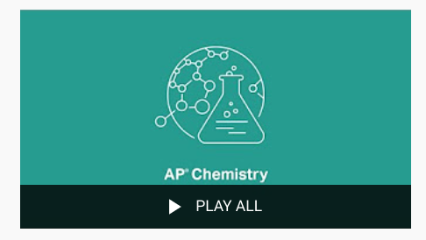

AP Chemistry online classes and review sessions taught by Mr. Byrne, Glenbard West High School (Glen Ellyn, IL), and Mr. Farabaugh, Albemarle High School (Charlottesville, VA). Topics include "Acids and Bases."

AP exams in 2020 will be at-home, online tests. Check http://apstudents.org/exams2020 for more information.

TABLE OF CONTENTS
AP CHEMISTRY PRACTICE 1.1-1.4
AP CHEMISTRY PRACTICE 1.5-1.8
AP CHEMISTRY PRACTICE 2.1 - 2.4
AP CHEMISTRY PRACTICE 2.5 - 2.7
AP CHEMISTRY PRACTICE 3.1-3.3
AP CHEMISTRY PRACTICE 3.4-3.6
AP CHEMISTRY PRACTICE 3.7-3.10
AP CHEMISTRY PRACTICE 3.11 - 3.13
AP CHEMISTRY PRACTICE 4.1-4.4
AP CHEMISTRY PRACTICE 4.-5 - 4.9
AP CHEMISTRY PRACTICE 5.1-5.3
AP CHEMISTRY PRACTICE 5.4,5.7-5.9
AP CHEMISTRY PRACTICE 5.5-5.6,5.10-5.11
AP CHEMISTRY PRACTICE 6.1 - 6.5
AP CHEMISTRY PRACTICE 6.6 - 6.9
AP CHEMISTRY PRACTICE 7.1-7.6
AP CHEMISTRY PRACTICE 7.7-7.10
AP CHEMISTRY PRACTICE 8.1
AP CHEMISTRY PRACTICE 8.2
AP EXAM FRQ PRACTICE 8.3

AP CHEMISTRY PRACTICE 1.1-1.4
AP Chemistry: 1.1-1.4 Moles, Mass Spectrometry, Elemental Composition, and Mixtures
WATCH THIS VIDEO BY SEAN BYRNE TO ASSIST IN THIS QUESTIONS

1.1 Moles and Molar Mass
- Scientists cannot count particles directly. So we find a connection between the mass of a substance and the number of particles.
- Avogadro’s number (N_{A} = 6.022 × 10²³) tells us the number of particles in one mole of a pure substance.
- The mass of an individual atom is sometimes expressed in Atomic Mass Units (amu).
  - For Oxygen
    - One atom = 16.00 amu
AND
    - One mole of atoms = 16.00 grams

1.1 Moles and Molar Mass Guided Practice

A student is given 50.0 mL of a solution of Na₂CO₃ of unknown concentration. To determine the concentration of the solution, the student mixes the solution with excess 1.0 M Ca(NO₃)₂ (aq), causing a precipitate to form. The balanced equation for the reaction is shown below

Na₂CO₃(aq) + Ca(NO₃)₂(aq) ⟶ 2 NaNO₃ (aq) + CaCO₃(s)

The student filters and dries the precipitate of CaCO₃ (molar mass 100.1 g/mol) and records the data in the table below.

Volume of Na₂CO₃ solution | 50.0 mL
Volume of 1.0 M Ca(NO₃)₂ added | 100.0 mL
Mass of CaCO₃ precipitate collected | 0.93 g

Determine the number of moles of Na₂CO₃ in the original 50.0 mL of solution.

1.1 Moles and Molar Mass Guided Practice # 2

Analyze the number of moles of Na₂CO₃ in the original 50.0 mL of solution by solving for the following quantities:

- The number of particles of Na₂CO₃ in 9.30 × 10^{－3} moles Na₂CO₃

- The number of carbon atoms in 9.30 × 10^{－3} moles Na₂CO₃

- The number of sodium atoms in 9.30 × 10^{－3} moles Na₂CO₃

1.2 Mass Spectroscopy of Elements
- The mass spectrum of a sample containing a single element can be used to determine the identity of the isotopes of that element and the relative abundance of each isotope in nature
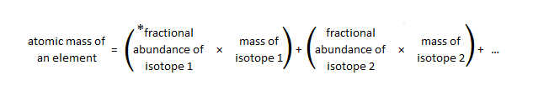
*fractional abundance is the percentage represented as a decimal. ie. 80% = 0.80

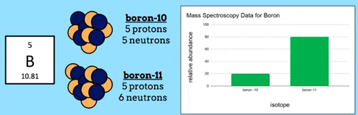

20% of Boron atoms have a mass of 10 amu
80% of Boron atoms have a mass of 11 atm
Therefore:

Average Atomic Mass of Boron = (0.20 × 10) + (0.80 × 11) = 10.8 amu
1.2 Mass Spectroscopy of Elements Guided Practice

The mass spectrum of element X is presented in the diagram below. Based on the spectrum, what is the identity of element X?
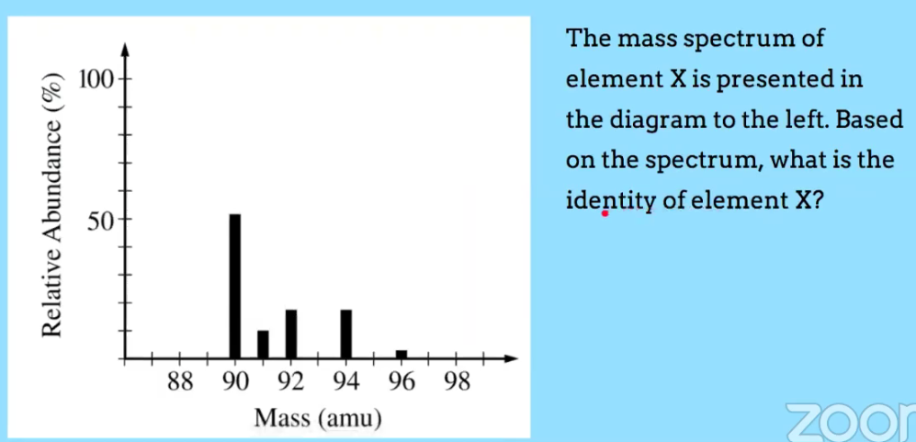
1.3 Composition of Mixtures
- Compounds ⇒ individual molecules OR formula unit
- Law of Definite Proportions = the ratio of mass of the constituent elements in any pure sample of that compound is always the same
- Empirical formula = lowest whole number ratio of atoms of the elements in a compound.

1.3 Composition of Mixtures Guided Practice # 1
A sample of a compound contains 3.21 g of sulfur and 11.4 g of fluorine. What is the empirical formula of the compound?

1.4 Composition of Mixtures
- Mixtures contain molecules or formula units of two or more types, in varying proportions
- Elemental analysis can be used to determine the relative numbers of atoms in a substance and to determine its purity
1.4 Composition of Mixtures Guided Practice
A sample of carbonate rock is a mixture of CaCO₃ and MgCO₃. The rock is analyzed in a laboratory, and the results are recorded in the table below. Calculate the mole ratio of Ca to Mg in the rock.
Total mass of sample (g) | Mass of C in sample (g) | Mass of Mg in sample (g) | Mass of Ca in sample (g) | Molar Mass of C (g/mol) | Mass Mass of Mg (g/mol) | Molar Mass of Ca (g/mol)
98.5 | 12.0 | 2.4 | 36.1 | 12.0 | 24.3 | 40.1

AP EXAM FRQ PRACTICE 1.1 - 1.4 - HOMEWORK

The average atomic mass of naturally occurring neon is 20.18 amu. There are two common isotopes of naturally occurring neon as indicated in the table below
Isotope | Mass (amu)
Ne-20 | 19.99
Ne-22 | 21.99

(i) Using the information above, calculate the percent abundance of each isotope.

A 31 g sample of a compound that contains only the elements C,H and N is completely burned in O₂ to produce 44.0 g of CO₂, 45.0 g of H₂O, and some NO₂. Determine the empirical formula of the compound.

2 NO(g) + O₂(g) ⟶ 2 NO₂(g)

A student investigates the reactions of nitrogen oxides. One of the reactions in the investigation requires an equimolar mixture of NO(g) and NO₂(g), which the student produces by using the reaction represented above.

- The particle-level representation of the equimolar mixture of NO(g) and NO₂(g) in the flask at the completion of the reaction between NO(g) and O₂(g) is shown below in the box on the right. In the box below on the left , draw the particle-level representation of the reactant mixture NO(g) and O₂(g) that would yield the product mixture shown in the box on the right. In your drawing, represent oxygen atoms and nitrogen atoms as indicated below.
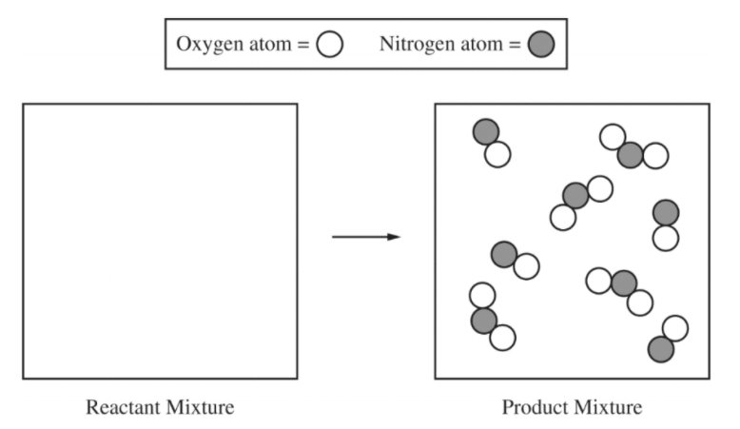

AP CHEMISTRY PRACTICE 1.5-1.8
AP Chemistry: 1.5-1.8 Atomic Structure, Electron Configuration, Spectroscopy, Periodic Trends
WATCH THIS VIDEO BY SEAN BYRNE TO ASSIST IN THESE QUESTIONS

1.5 Atomic Structure and Electron Configuration
- Atoms ⇒ negatively charged electrons + positively charged nucleus
- Coulomb's Law is used to calculate the force between charged particles.
- F_{coulombic} ∝ $\frac{q_{1}q_{2}}{r^{2}}$
- In atoms and ions, electrons can be thought of as being in “shells” (energy levels)” and “subshells (sublevels)”.
- Electron configurations describe the model
- Core electrons ⇒ inner electrons
- Valence electrons ⇒ outer electrons
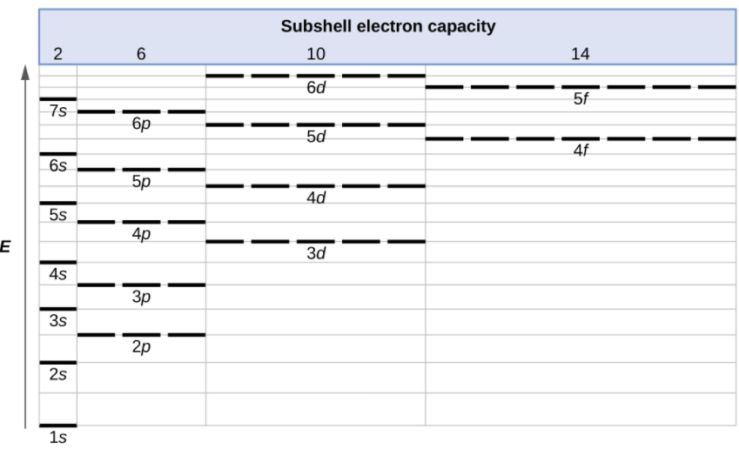

- Electron configuration order: 1s² 2s² 2p⁶ 3s² 3p⁶ 4s² 3d¹⁰ 4p⁶ 5s² ….
  - s holds 2 electrons; p holds 6 electrons; d holds 10 electrons; f holds 14 electrons
- Aufbau Principle - “to build up” electrons are added to the lowest subshells first
- Hund’s Rule - each subshell should have one electron before any are doubled up

1.5 Atomic Structure and Electron Configuration-Guided Practice

- What is the electron configuration of argon?

- What is the electron configuration of vanadium?

Electron Configuration Short-Cut
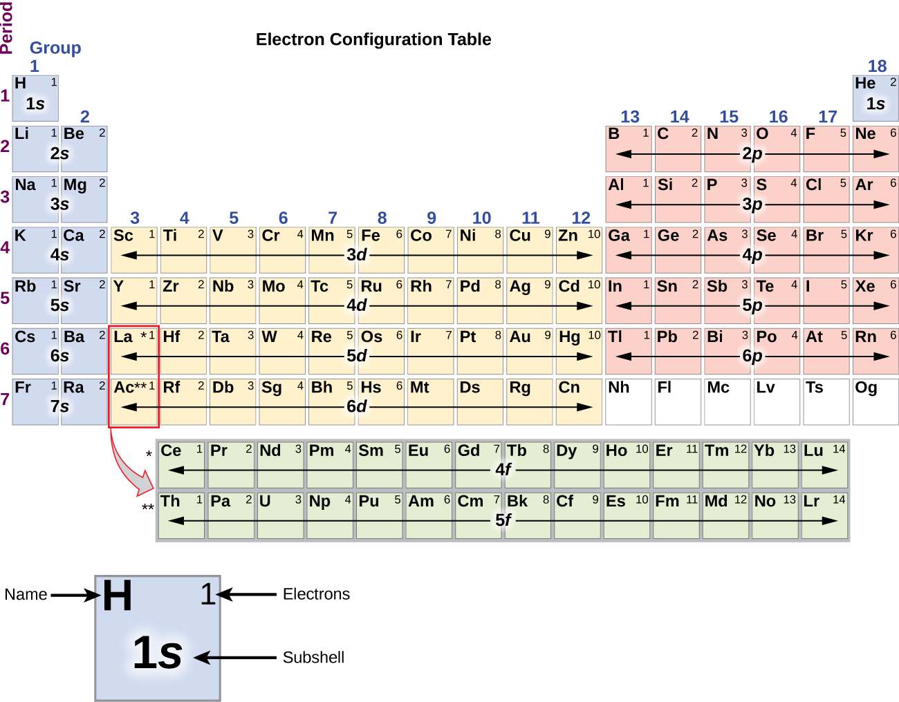

1.6 Photoelectron Spectroscopy
- The energies of electrons in a given shell can be measured experimentally with photoelectron spectroscopy (PES)
  - The position of each peak in the PES spectrum is related to the energy required to remove an electron from the corresponding subshell; and
  - The height of each peak is proportional to the number of electrons in that subshell.

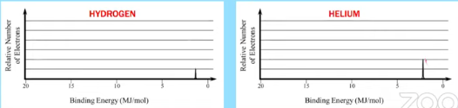

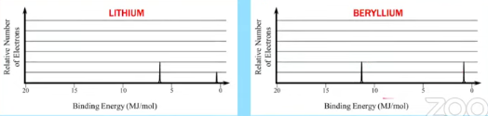
1.6 Photoelectron Spectroscopy - Guided Practice

The complete photoelectron spectrum of an element is given above. What is the electron configuration of the element with this spectrum?
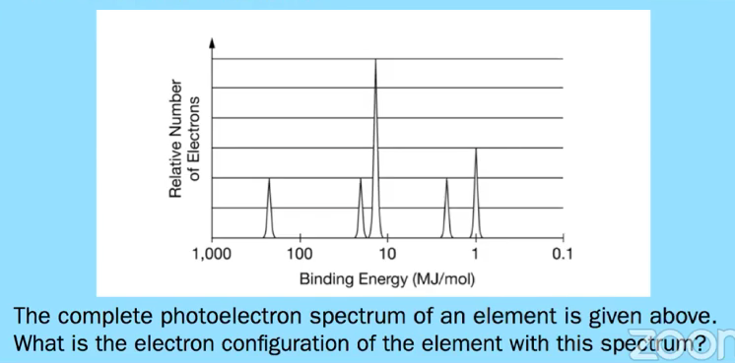

1.7 Periodic Trends
- Organization of the periodic table⇒ recurring properties; periodicity useful to make predictions.
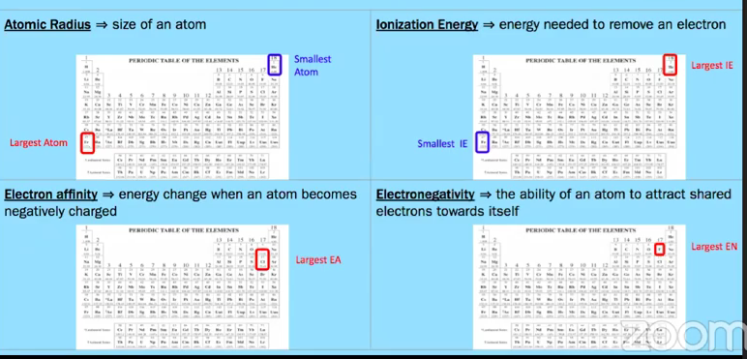
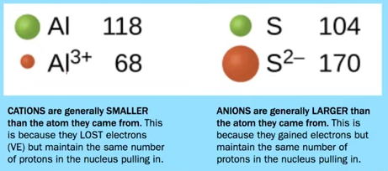
1.7 Periodic Trends Guided Practice # 1

The elements in which of the following have most nearly the same atomic radius?
- Be, B, C, N _____
- Ne, Ar, Kr, Xe _____
- Mg, Ca, Sr, Ba _____
- C, P, Se, I _____
- Cr, Mn, Fe, Co _____

1.7 Periodic Trends Guided Practice # 2

Using the following elements from the periodic table, select which one that best fits each statement:

- Se  - Br  - Ag  - Cs  - Pb | - Has the highest electronegativity _________  - Has the largest atomic radius _______  - Has the lowest first-ionization energy ________

1.8 Valence Electrons and Ionic Compounds

- The likelihood that two elements will form a chemical bond is determined by the interactions between the valence electrons and nuclei of elements.
- Elements of the same column of the periodic table tend to form similar compounds because they tend to have similar charges
- GROUP # = # OF VALENCE ELECTRONS

1.8 Valence Electrons and Ionic Compounds- Guided Practice # 1 & 2

Atoms of Mg combine with atoms of F to form a compound. Identify another element that you would expect to combine with atoms of F in the same ratio?

Based on the information below and periodic trends, what oxides would you expect to be formed by Rb?

Element | Known Oxides
H | H₂O, H₂O₂
Li | Li₂O, Li₂O₂
Na | Na₂O, Na₂O₂, NaO₂
K | K₂O, K₂O₂, KO₂

AP EXAM FRQ PRACTICE 1.5-1.8 - HOMEWORK

(e) The only common oxide of zinc has the formula ZnO

(i) Write the electron configuration for a Zn atom in the ground state.

(ii) From which sublevel are electrons removed when a Zn atom in the ground state is oxidized?

3. Answer the following questions related to Fe and its ions, Fe²⁺ and Fe³⁺.

- Write the ground-state electron configuration of the Fe²⁺ ion.

Ion | Ionic Radius (pm)
Fe²⁺ | 92
Fe³⁺ | 79

- The radii of the ions are given in the table above. Using the principles of atomic structure, explain why the radius of the Fe²⁺ ion is larger than the radius of the Fe³⁺ ion.

- Fe³⁺ ions interact more strongly with water molecules in aqueous solution than Fe²⁺ ions do. Give one reason for this stronger attraction, and justify your answer using Coulomb’s law.

AP CHEMISTRY PRACTICE 2.1 - 2.4
AP Chemistry: 2.1-2.4 Chemical Bonds, Intramolecular Force, and Structure of Solids
WATCH THIS VIDEO BY MICHAEL FARABAUGH TO ASSIST IN THIS QUESTIONS

Coulomb’s Law
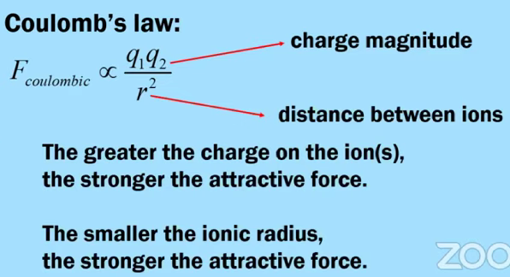
The greater the charge and smaller the ionic radius on the ion(s), the stronger the attractive force.

Ionic Bonding versus Covalent Bonding

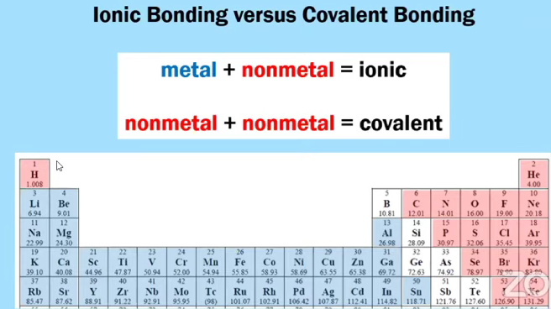

Metallic Bonding
A metal consists of a crystal lattice of positive particles that consist of a nucleus and the core electrons, with a “sea” of delocalized valence electrons that can move freely throughout the latter.
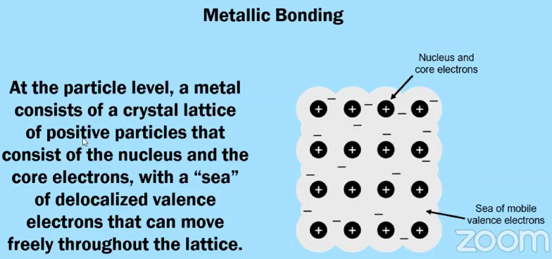
Does not conduct electricity/ heat | Conducts electricity/heat as a liquid or aqueous | Conducts electricity/heat as a solid
Molecular/Covalent | Ionic and Metallic | Metallic, only

Diagram of Potential Energy versus Internuclear Distance
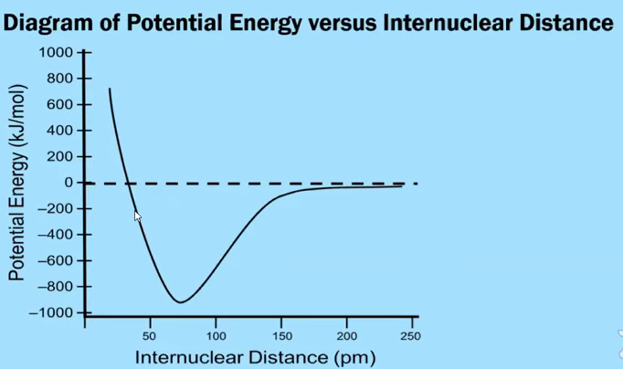
Trends in Bond Length and Bond Energy
- The smaller the bond, more energy required to break
  - Use atomic size (trends)
  - Use bond order ( single, double or triple)

Particle Diagrams of Ionic & Metallic Solids

Ionic Solids
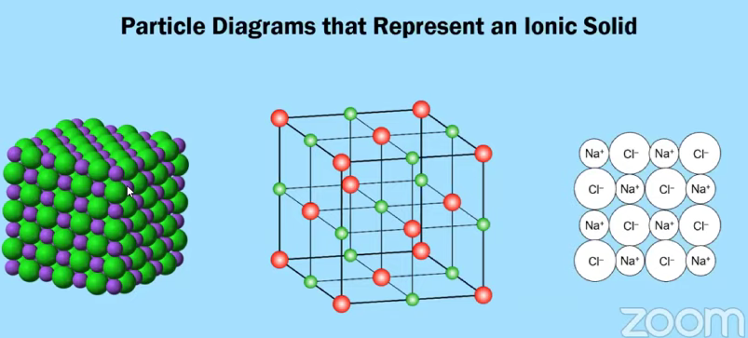

Alloys
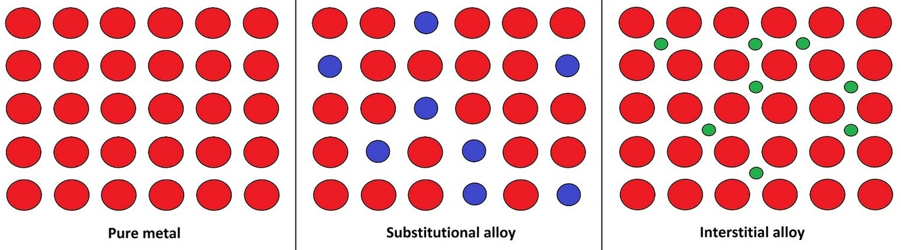
2.1 Types of Chemical Bonds

Use your knowledge of periodic trends in electronegativity to answer the following questions.

- For each of these polar covalent bonds, which atoms has a partial positive charge (δ+) and which atom has a partial negative charge (δ－)?

CーN F一Br Si一O

- Arrange these three bonds in order from least polar to most polar.

NーF PーF OーF

Diagram of Potential Energy versus Internuclear Distance

Consider the following information for the ClーCl bond:

Bond | ClーCl | BrーBr
Bond Length (pm) | 200 | ?
Bond Energy (kJ/mol) | 243 | ?

Make a prediction about the BrーBr bond, in terms of bond length and bond energy.
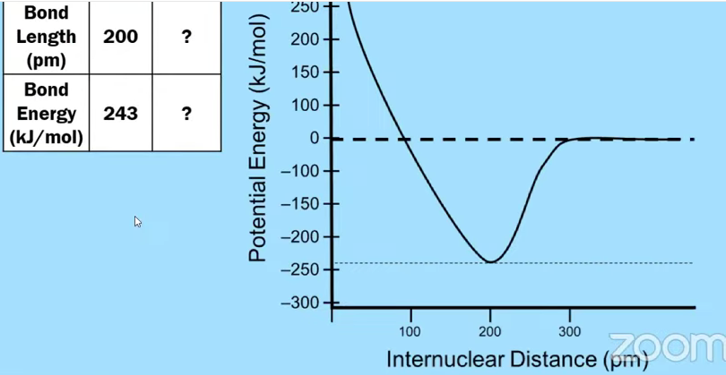
Data for the lattice energy of NaF is given in the table below. Make predictions about the lattice energy of MgO and KCl. Do you predict that the lattice energy of each compound is less than 930 kJ/mol or greater than 930 kJ/mol? Justify your answer in terms of periodic properties and Coulomb’s law.
Reaction | Lattice Energy (kJ/mol)
NaF(s) ⟶ Na⁺(g) + F－(g) | 930
MgO(s) ⟶ Mg²⁺(g) + O^{2－}(g)
KCl(s) ⟶ K⁺(g) + Cl－(g)

Solid | Does the solid conduct electricity?
Cu(s) | yes
CuCl₂(g) | no

A student checked the conductivity of two different solids, and the results are listed in the table above.
Explain why the student got these results, in terms of principles of chemical bonding. Your explanation should include a discussion of the specific particles present in each substance and how the behavior of these particles is related to the conductivity of the solid.

Element | Atomic radius (pm)
Cu | 130
Zn | 125

Brass is an alloy that contains copper and zinc. The atomic radii of the elements are given in the table above. Should brass be classified as an interstitial alloy or a substitutional alloy? Justify your answer.

Element | Atomic radius (pm)
Fe | 132
C | 76

Steel is an alloy that contains iron and carbon. The atomic radii of the elements are given in the table above. Should steel be classified as an interstitial alloy or a substitutional alloy? Justify your answer.

AP EXAM PRACTICE FRQ PRACTICE 2.1-2.4 - HOMEWORK

- Answer the following questions about nitrogen and oxygen.

- Write the Lewis electron-dot structure for the diatomic molecules N₂ and O₂.

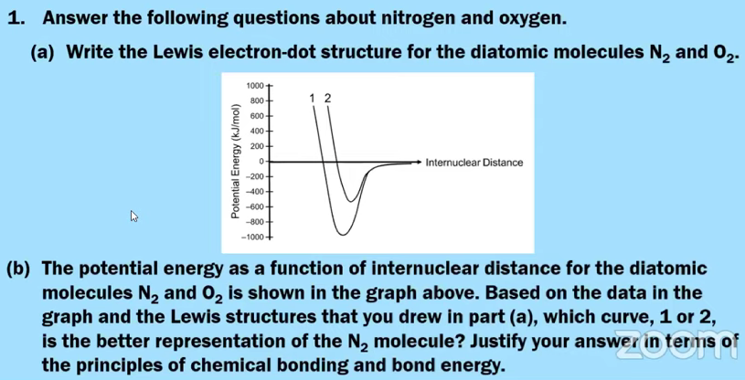
- The potential energy as a function of internuclear distance for the diatomic molecules N₂ and O₂ is shown in the graph above. Based on the data in the graph and the Lewis structures that you drew in part (a), which curve, 1 or 2, is the better representation of the N₂ molecule? Justify your answer in terms of the principles of chemical bonding and bond energy.

2. Answer the following questions related to Mg and Sr.

- Write the complete ground state electron configuration for the ions Mg²⁺ and Sr²⁺.

- Do you predict that the ionic radius of Sr²⁺ is larger or smaller in size than the ionic radius of Mg²⁺? Justify your answer in terms of atomic structure and the electron configuration of each ion.

- The lattice energy of MgCl₂(s) is equal to 2300 kJ/mol. Do you predict that the lattice energy of SrCl₂ should be less than or greater than 2300 kJ/mol? Justify your answer in terms of Coulomb’s law.

AP CHEMISTRY PRACTICE 2.5 - 2.7
AP Chemistry: 2.5-2.7 Lewis Diagrams, Formal Charge, and VSEPR
WATCH THIS VIDEO BY MICHAEL FARABAUGH TO ASSIST IN THIS QUESTIONS

Periodic Table & Valence Electrons
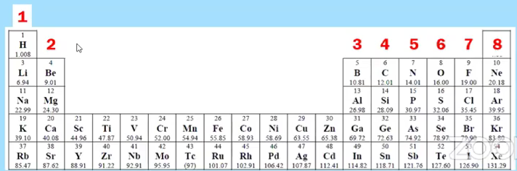
Drawing Lewis Electron Dot Diagrams (Structures)

CH₄ NH₃ H₂O CH₂Cl₂

NH₄⁺ OH－

C₂H₆ C₂H₄ C₂H₂

Deciding on “Which” Lewis Dot Structure

CCl₂O

AP Tip: The AP Exam may give you a skeleton structure an ask you to fill in the missing electrons (bonding and nonbonding)

Example AP Question
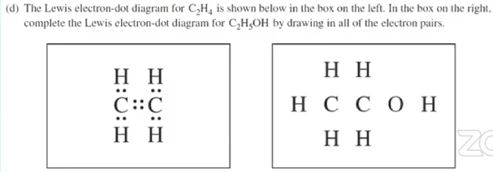

Resonance Structures - more than one equivalent Lewis structure can be drawn for a molecule or polyatomic ion

O₃

CO₃^{2－}

Formal Charge = ( valence electrons) - (bonds + nonbonding electrons)

CCl₂O

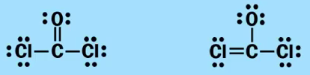

Formal Charge Guidelines
- Formal charge is not a real charge; it’s a bookkeeping system. It’s useful when comparing two Lewis structures in which each atom obeys the octet rule.
- If you have a molecule in which each atom obeys the octet rule, the most preferred structure is the one in which each atom has a formal charge of zero.
- If you have a polyatomic ion, then the sum of all the formal charges in the Lewis structure will be equal to the overall charge of the polyatomic ion.
- If it’s not possible for each of the atoms to have a formal charge of zero, the most favorable structure is the one in which the negative formal charge (if there is one) is on the atom with the highest electronegativity value.

Exceptions to the Octet Rule - Less Than An Octet
BF₃

Exceptions to the Octet Rule - More Than An Octet
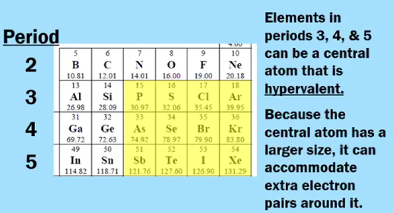
PF₅ SF₆

SO₄^{2－}

AP Tip: If you can draw a Lewis structure in which each atom obeys the octet rule, then do that! The AP Exam will never ask students to decide, on their own, when drawing a Lewis structure, whether they should obey the octet rule OR expand the octet in order to get better formal charges.
VSEPR and Molecular Geometry (Summarized from Michael’s Video)
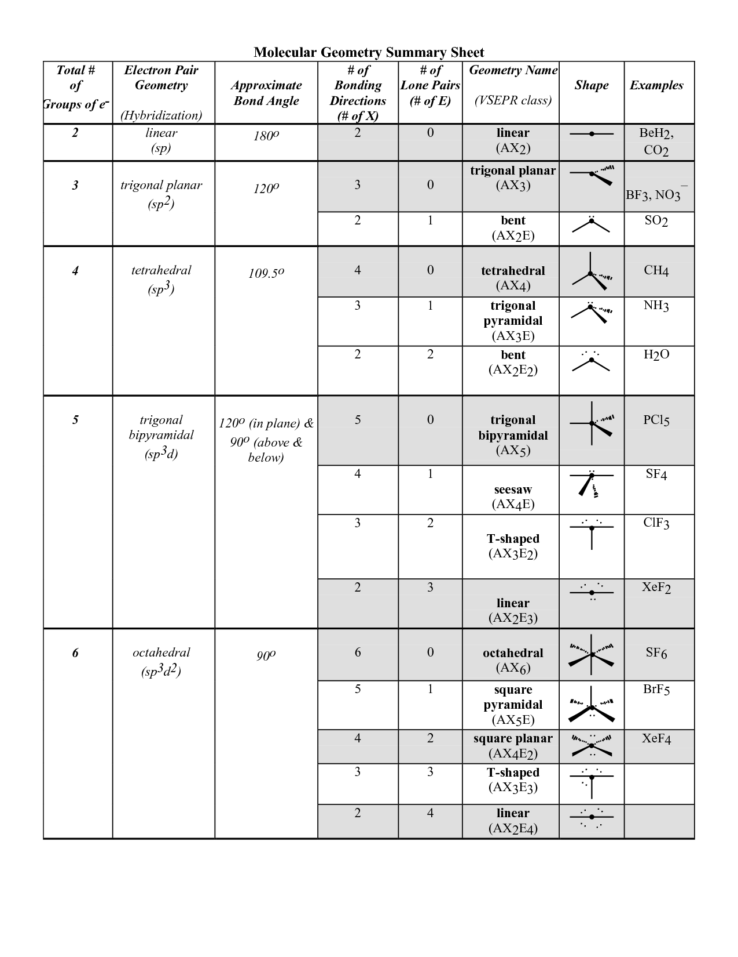

pHET Simulation on Molecular Shapes : https://phet.colorado.edu/en/simulation/molecule-shapes

Sigma and Pi Bonds

Any single bond is a sigma, 𝛔, bond

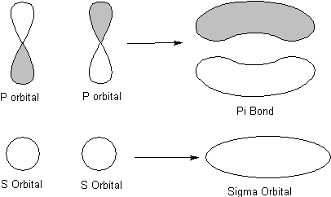

A double bond or triple bond contains 1 pi, 𝜋 or 2 pi,𝜋, bonds - respectively

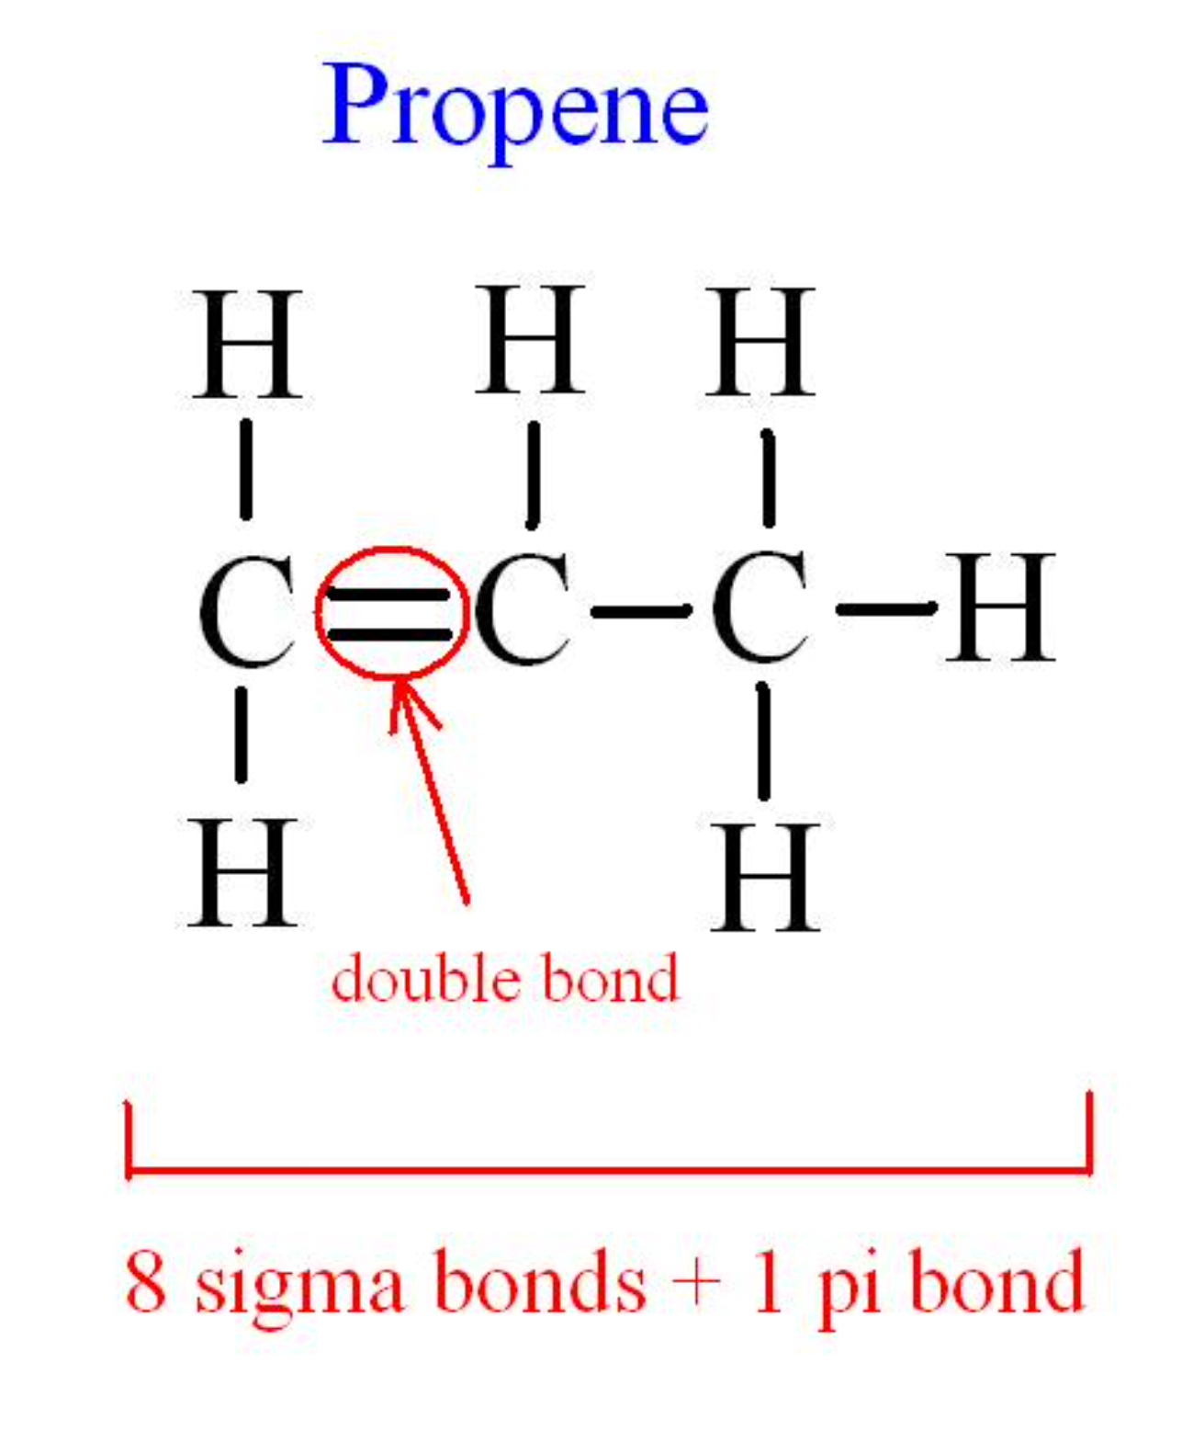

AP EXAM PRACTICE FRQ PRACTICE 2.5-2.7 - HOMEWORK

- (c) S₂Cl₂ is a product of the reaction.

(i) In the box below, complete the Lewis electron-dot diagram for the S₂Cl₂ molecule by drawing in all of the electron pairs.
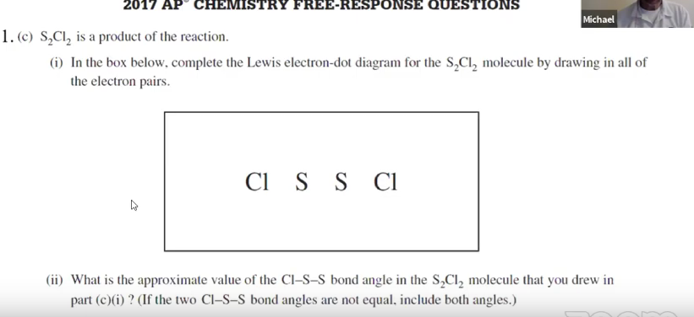
(ii) What is the approximate value of the Cl一S一S bond angle in the S₂Cl₂ molecule that you drew in part (c)(i) ? (If the two Cl一S一S bond angles are not equal, include both angles.)

2. Answer the following questions about the isomers fulminic acid and isocyanic acid.

Two possible Lewis electron-dot diagrams for fulminic, HCNO, are shown below.
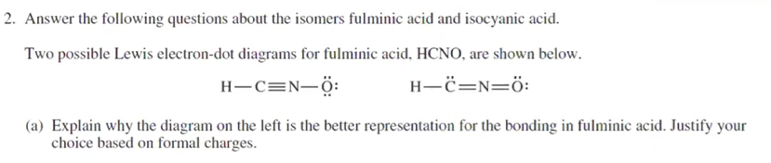
- Explain why the diagram on the left is the better representation for the bonding in fulminic acid. Justify your choice based on formal charges.

2. (d) The skeletal structure of the HNO₂ molecule is shown in the box below.

(i) Complete the Lewis electron-dot diagram of the HNO₂ molecule in the box below, including any lone pairs of electrons.
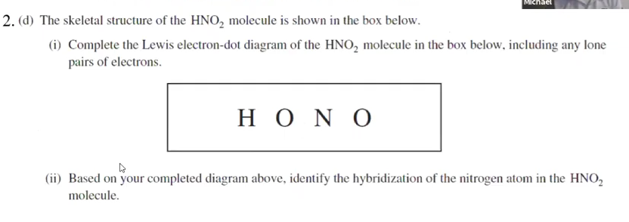

(ii) Based on your completed diagram above, identify the hybridization of the nitrogen atom in the HNO₂ molecule.

AP CHEMISTRY PRACTICE 3.1-3.3
AP Chemistry: 3.1-3.3 Intermolecular Forces, Solids, Liquids, and Gases
WATCH THIS VIDEO BY MICHAEL FARABAUGH TO ASSIST IN THESE QUESTIONS
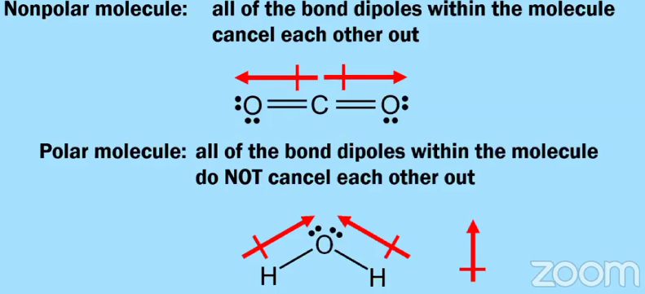
Molecular Polarity

Nonpolar molecule: all of the bond dipoles within the molecule cancel each other out

Polar molecule: all of the bond dipoles within the molecule do NOT cancel each other out.

NON-POLAR MOLECULES - symmetry causes dipoles to cancel out
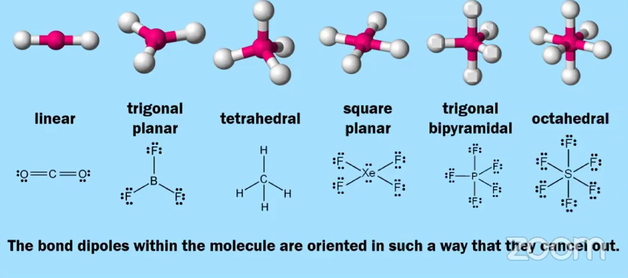

AP FRQ TIP: CANNOT JUST SAY “BECAUSE OF SYMMETRY IT IS NOT POLAR” YOU NEED TO EXPLICITLY SAY “DIPOLES CANCEL OUT DUE TO SYMMETRY”

POLAR MOLECULES - dipoles DO NOT cancel out
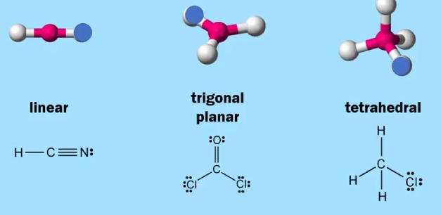
POLAR GEOMETRY - all these geometries have bond dipoles within the molecule to not cancel out
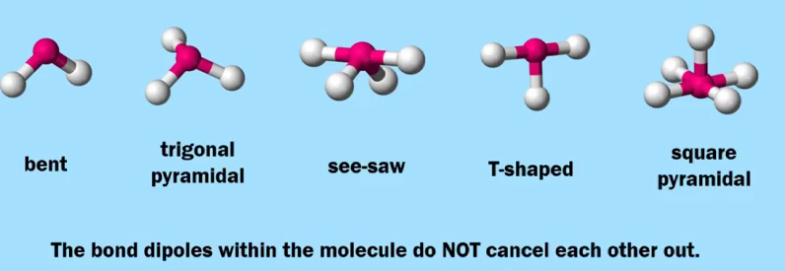

Intermolecular Forces

Question: When a (covalent) molecular substance is heated and undergoes a phase change from a liquid to a gas, what type of attractive forces are broken?

Intramolecular Forces  the attractive forces that exist WITHIN A MOLECULE  [STRONG - particles are relatively close together] | Intermolecular (or Interparticle) Forces  the attractive forces that exist BETWEEN MOLECULES (or particles)  [WEAK- particles are relatively far apart]
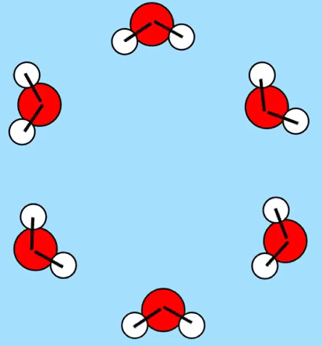 | 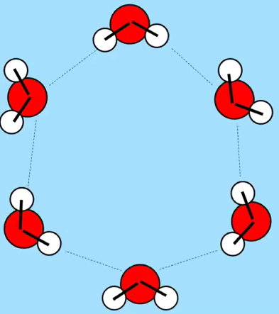

Substance | Boiling Point (K)
# 1 | 87
#2 | 165

Substances # 1 and # 2 represent two different elements located in Group 18 (noble gases).

Which substance, #1 or # 2, has stronger attractive forces between particles? How can you tell?

Types of Intermolecular Forces & AP CHEMISTRY TIPS

- London Dispersion forces - interactions between particles or molecules as a result of temporary or instantaneous dipoles. (occur continuous motion of electrons)

  - *Polarizability: the ease with which the charge distribution in an electron cloud can be distorted
    - AP Tip : When comparing, make sure you say “it is more polarizable ….”

  - Larger the atom/molecule, the larger the electron cloud, thus more polarizable and greater dispersion forces

  - ON THE AP EXAM, DO NOT WRITE THAT A MOLECULE HAS STRONGER LONDON DISPERSION FORCES BECAUSE IT HAS A LARGER MASS!

- Dipole-Dipole Forces - an attraction between polar molecules in such a way that the partial positive end (δ+) of one molecule is attracted to the partial negative end (δ－) of a nearby molecule.

  - STUDENT MISCONCEPTION: [THIS IS NOT ALWAYS TRUE] IF YOU ARE GIVEN TWO DIFFERENT CHEMICAL FORMULAS, AND ONE MOLECULE IS POLAR, AND THE OTHER MOLECULE IS NONPOLAR, THE POLAR MOLECULE WILL ALWAYS HAVE A STRONG IMF.
    - HAVE TO BE GIVEN INFORMATION….NOT JUST BY LOOKING AT FORMULA
    - IF YOU ARE GIVEN DATA….YOU HAVE TO CONSIDER THE DATA!

EXAMPLE AP QUESTION
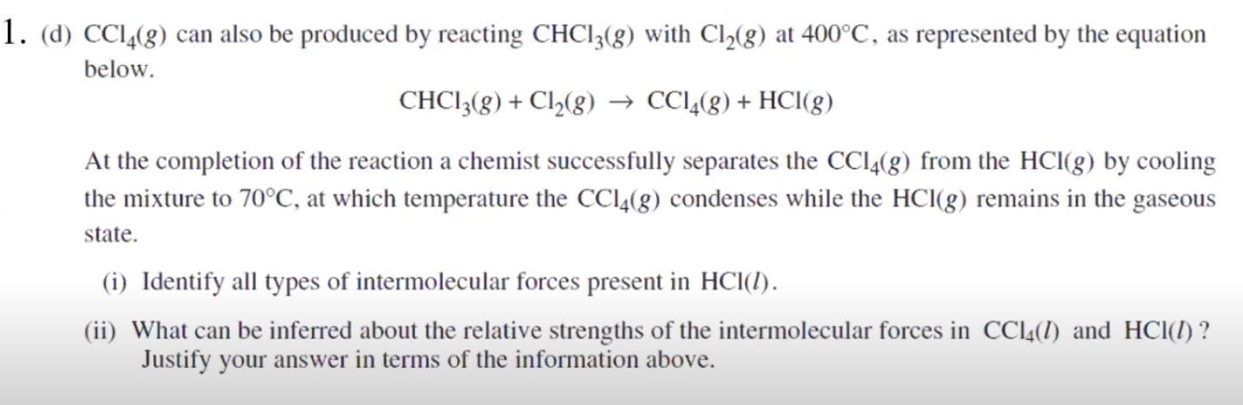

b. Hydrogen Bonding - a strong dipole-dipole interaction, which occurs between a H atom (bonded to an N, O, or F) on one molecule and an N, O, or F on another molecule (or another part of a large macromolecule)
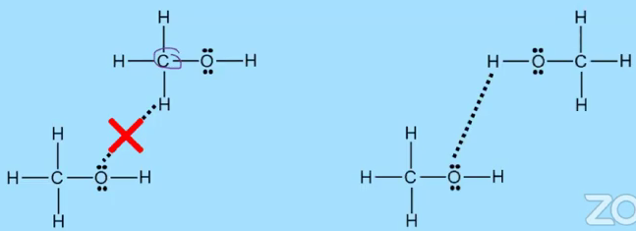

- Ion-Dipole Forces - an attractive force between an ion and a polar molecule (interparticle force)
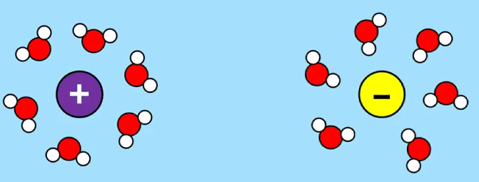

Properties of Liquids

Vapor Pressure - the pressure exerted by a gas in equilibrium with its liquid phase at a given temperature
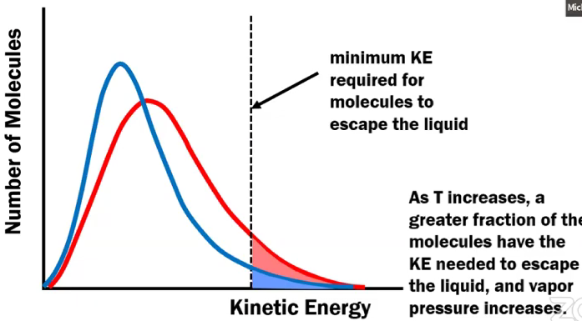

Using the diagram and information given below, which liquid, C₅H₁₂ or H₂O, has a higher vapor pressure at 300 K? Justify your answer.
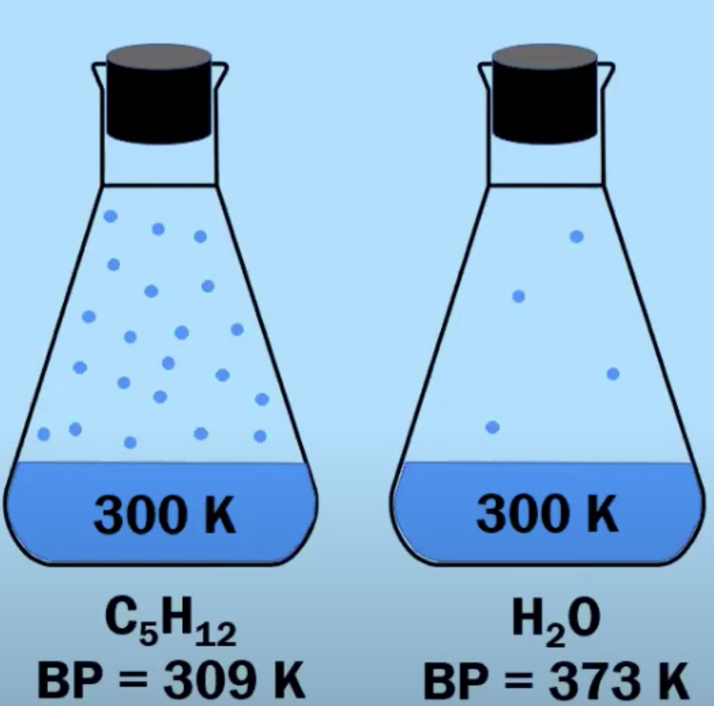

Properties of Ionic Solids
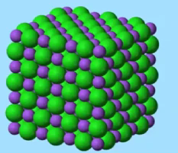 | - Relatively high melting point and boiling point  - Brittle solid because of the repulsion of like charges caused when one layer slides across another layer  - Conducts electricity when molten or aqueous because of mobile ions (NOT in the solid state)

Properties of Metallic Solids
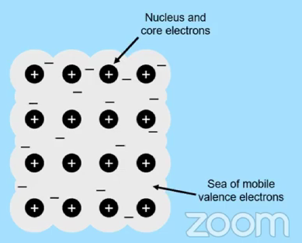 | - Good conductor of heat and electricity  - NOT brittle  - Malleable and ductile  - When stress is applied, the metal cores can easily rearrange their structure.  - Metal alloys - substitutional and interstitial

Covalent Network Solids
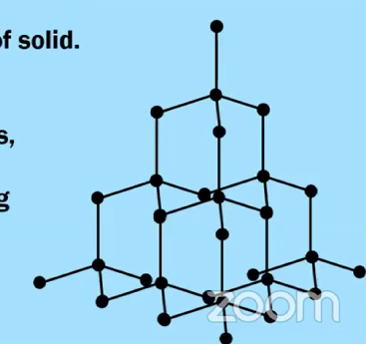 | - Atoms are covalently bonded in a 3-D network  - Diamond, quartz, SiC and SiO₂  - They have many strong covalent bonds, which is why these types of solids are very hard and have rather high melting points.

Covalent Molecular Solid
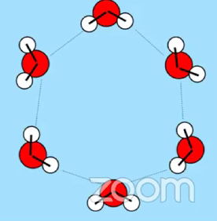 | - Composed of distinct, individual molecules.  - Sugar, water  - Molecules are attracted to each other through relatively weak intermolecular forces  - Relatively low melting points because of weak intermolecular forces  - Non-conductors of electricity because their valence electrons are held tightly within the covalent bonds of each molecule
Solids, Liquids and Gases
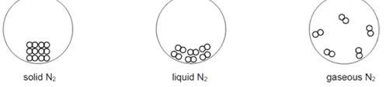
Solids  Particles are close to each other. Motion of particles is limited to vibration in crystal structure | Liquids  Particles are close to each other and constantly moving and colliding. Properties (BP,VP) are related to IMF | Gases  No definite volume or shape. Particles are very far apart from each other and constantly moving and colliding. Minimal to no IMF.s  Can be described in terms of amount of gas (moles, pressure, volume, and temperature.

ANOTHER AP FRQ EXAMPLE WITH STUDENT MISCONCEPTION
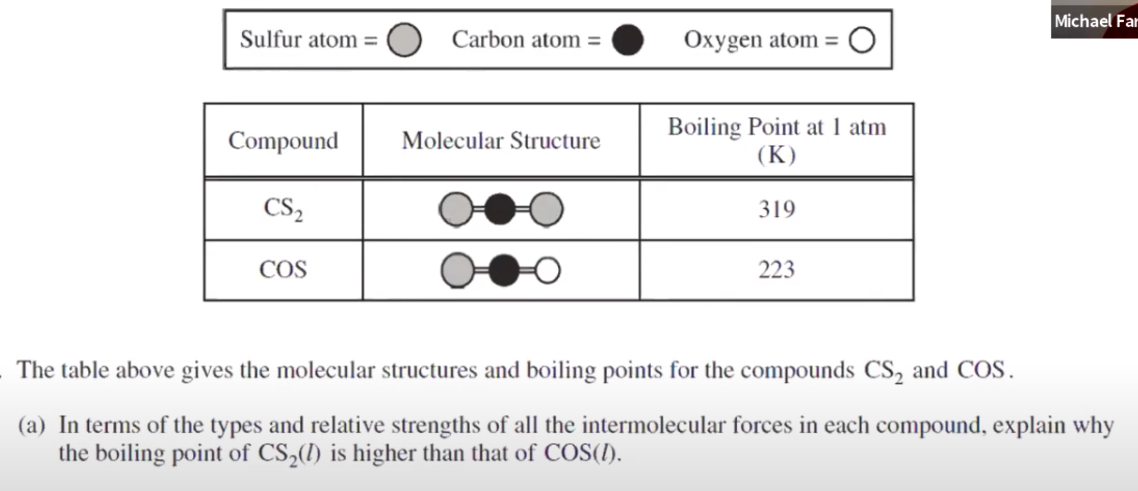

*Student Misconceptions* RECOGNIZE THESE
- Students failed to identify the IMF’s that are present in BOTH molecules
- Students said that the C－S bonds in CS₂ were polar, but did not mention that the two bond dipoles cancel each other out in the linear molecule.
- Students said that the strength of the IMF’s in CS₂ are greater than the strength of the IMF’s in COS. But they did not specifically state that the LDF’s in CS₂ are greater than the combined LDF’s and dipole-dipole forces in COS.
- Students said that CS₂ and COS only have LDF’s
- Students said that both molecules have LDF’s and dipole-dipole forces.
- Students implied or stated that boiling a liquid involves breaking covalent bonds.
- Students used the molar mass as the only reason why CS₂ has stronger IMFs
- Students said that dipole-dipole forces are always stronger than LDF’s
AP EXAM FRQ PRACTICE 3.1-3.3 - HOMEWORK

6. Answer the following questions in terms of principles of chemical bonding and intermolecular forces. In each explanation where a comparison is to be made, a complete answer must include a discussion of both substances. The following complete Lewis electron-dot diagrams may be useful in answering parts of this question.
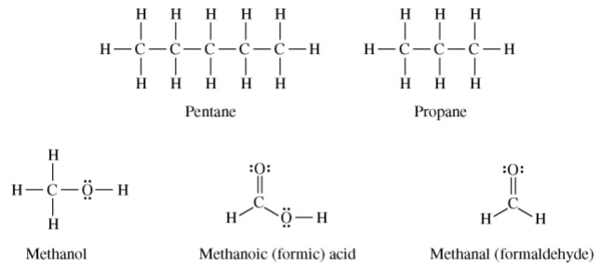
- At 1 atm and 298 K, pentane is a liquid whereas propane is a gas. Explain.

- At 1 atm and 298 K, methanol is a liquid whereas propane is a gas. Explain.

- Indicate the hybridization of the carbon atom in each of the following:

  - Methanol

  - Methanoic (formic) acid

(e) Explain the following observations about the two carbon-oxygen bonds in the methanoate (formate) anion, HCO₂－. You may draw a Lewis electron-dot diagram (or diagrams) of the methanoate ion as part of your explanations.
(i) The two carbon-oxygen bonds in the methanoate (formate) anion, HCO₂－, have the same length.

(ii) The length of the carbon-oxygen bonds in the methanoate (formate) anion, HCO₂－, is intermediate between the length of the carbon-oxygen bond in methanol and the length of the carbon-oxygen bond in methanal.

AP CHEMISTRY PRACTICE 3.4-3.6
AP Chemistry: 3.4-3.6 Ideal Gas Law and Kinetic Molecular Theory
WATCH THIS VIDEO BY SEAN BYRNE TO ASSIST IN THESE QUESTIONS

3.4 Ideal Gas Law
PV = nRT | P = pressure, atmospheres  V = volume, Liters  n = moles  R = 0.0821 L atm mol^{－1} K^{－1}  T = temperature, Kelvin

3.4 Guided Practice - Calculating the Molar Mass of a Gas from Ideal Gas Law

A 2.00 L container will hold about 4.00 g of a gas at 18.0 ºC and 1.08 atm. Calculate the molar mass for this gas.

3.4 Partial Pressures of Gases

In a sample containing a mixture of ideal gases, the pressure exerted by each component (the partial pressure) is independent of the other components. Therefore, the total pressure of the sample is the sum of the partial pressures.
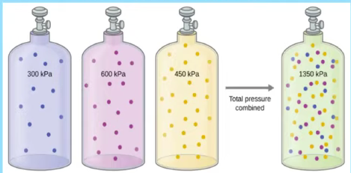 | P_{A} = P_{total} × Ꭓ_{A}, where Ꭓ_{A} = $\frac{moles A}{total moles}$  P_{total} = P_{A} + P_{B} + P_{C}

3.4 Guided Practice Partial Pressures of Gases (Typo in video, be careful)

A gas mixture at OºC and 1.15 atm contains 0.010 mol of H₂, 0.015 mol of O₂, and 0.025 mol of N₂. Assuming ideal behavior, what are the partial pressures of hydrogen gas(H₂), oxygen gas (O₂) and nitrogen gas (N₂) in the mixture?

3.4 Ideal Gas Law & KMT Summary Table
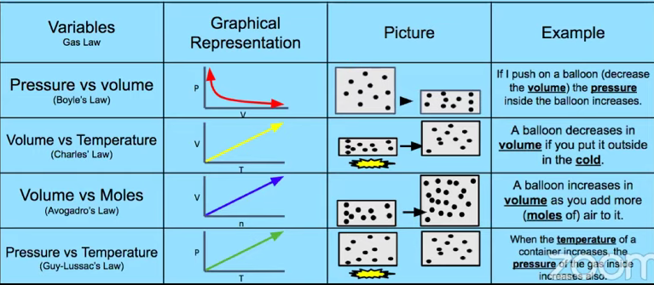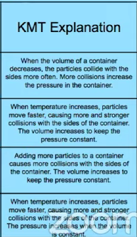

Helpful PhET simulations: bit.ly/phet-chem-simulations or bit.ly/phet-gas-laws

3.5 Kinetic Molecular Theory

The Kinetic Molecular Theory (KMT) tells us WHY ideal gases behave as they do. There are Five “Postulates”

- Gases are composed of molecules that are in continuous motion, traveling in straight lines and changing direction only when they collide with other molecules or with the walls of a container
- The pressure exerted by a gas in a container results from collisions between the gas molecules and the container walls.
- The average kinetic energy of the gas molecules is proportional to the kelvin temperature of the gas.
- The molecules composing the gas are negligibly small compared to the distances between them.
- Gas molecules exert no attractive or repulsive forces on each other or the container walls; therefore, their collisions are elastic (do not involve a loss of energy).
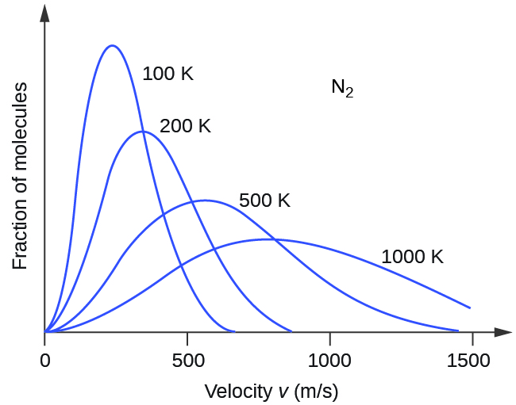 | What’s Happening?  - As the temperature of nitrogen gas increases there are more molecules moving at higher speeds.  - The average speed of the molecules is increasing.  - However, there are still some molecules with slower speeds.
3.6 Deviations from Ideal Gas Law
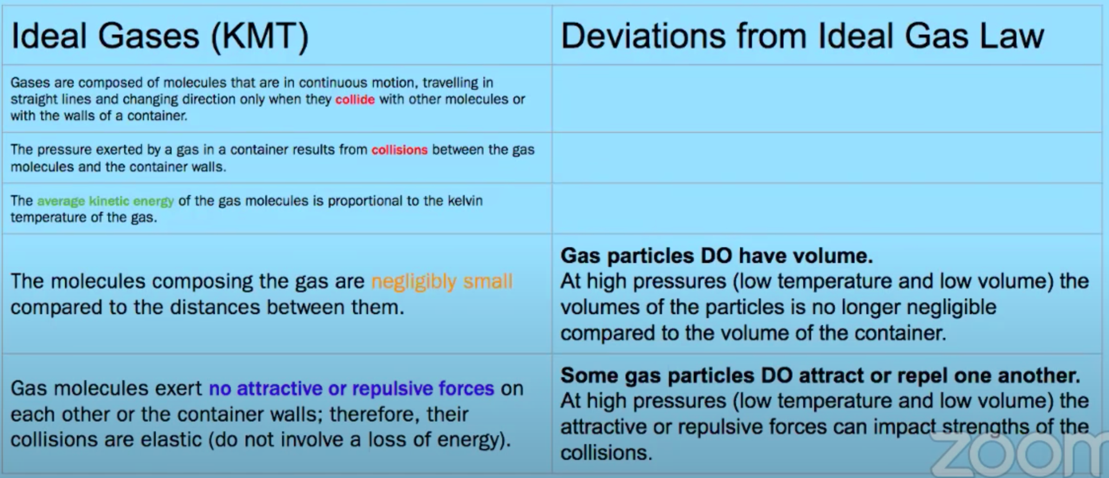
3.6 Guided Practice Deviations from Ideal Gas Law
Explain the following statements about gases. Be sure to mention specific information about both gases.
- Ar(g) deviates more from ideal behavior at extremely high pressures than Ne(g) does.

- The pressure of a sample of CH₄ (g) (molar mass = 16 g/mol) is closer to the pressure predicted by the ideal gas law than a sample of NH₃(g) (molar mass = 17 g/mol)
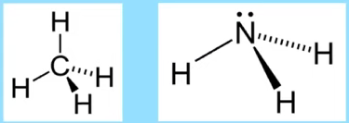
AP EXAM FRQ PRACTICE 3.4-3.6 - HOMEWORK

Mg(s) + 2 H⁺(aq) ⟶ Mg²⁺(aq) + H₂(g)
2. A student performs an experiment to determine the volume of hydrogen gas produced when a given mass of magnesium reacts with excess HCl(aq), as represented by the net ionic equation above. The student begins with a 0.0360 g sample of pure magnesium and a solution of 2.0 M HCl(aq).
- Calculate the number of moles of magnesium in the 0.0360 g sample.

- Calculate the number of molecules of HCl(aq) needed to react completely with the sample of magnesium.

As the magnesium reacts, the hydrogen gas produced is collected by water displacement at 23.0ºC. The pressure of the gas in the collection tube is measured to be 749 torr.
- Given that the equilibrium vapor pressure of water is 21 torr at 23.0ºC, calculate the pressure that the H₂(g) produced in the reaction would have if it were dry.

- Calculate the volume, in liters measured at the conditions in the laboratory, that the H₂(g) produced in the reaction would have if it were dry.

AP CHEMISTRY PRACTICE 3.7-3.10
AP Chemistry: 3.7-3.10 Solutions, Mixtures, and Solubility
WATCH THIS VIDEO BY SEAN BYRNE TO ASSIST IN THESE QUESTIONS

3.7 Solutions and Mixtures
- Solutions are also called homogeneous mixtures  - Can be solids, liquids or gases  - Macroscopic properties do not vary throughout the sample | 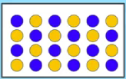
- Heterogeneous mixture, the macroscopic properties depend on location in the mixture. | 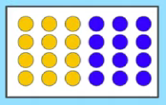
- Solution composition can be expressed in a variety of ways; molarity of the most common
Molarity = $\frac{moles of solute}{Liters of solution}$

3.7 Solutions and Mixtures Guided Practice
- What is the molarity of I－(aq) in a solution that contains 56 g of SrI₂ in 1.65 L of the solution?

- How many moles of Na⁺ ions are in 245. mL of 0.100 M Na₃PO₄(aq)?

- Approximately what mass of CuSO₄・5H₂O is required to prepare 250 mL of 0.175 M copper(II) sulfate solution?

3.8 Representations of Solutions
- Solid Al(NO₃)₃ is added to distilled water to produce a solution in which the concentration of nitrate, [NO₃－], is 0.10 M. What is the concentration of aluminum ion, [Al³⁺], in this solution?
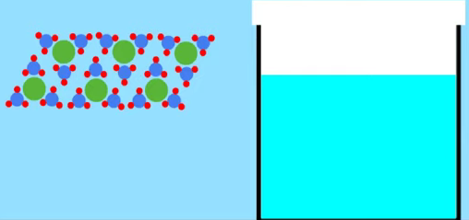 | ⟶ | 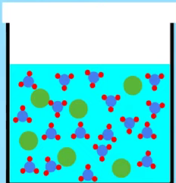

3.9 Separation of Solutions and Mixtures Chromatography
The components of a liquid solution cannot be separated by filtration. They can, however, be separated using processes that take advantage of differences in the intermolecular interactions of the components.
- Chromatography (paper, thin-layer, and column) separates chemical species by taking advantage of the differential strength of intermolecular interactions between and among the components of the solution (the mobile phase) and with the surface components of the stationary phase.
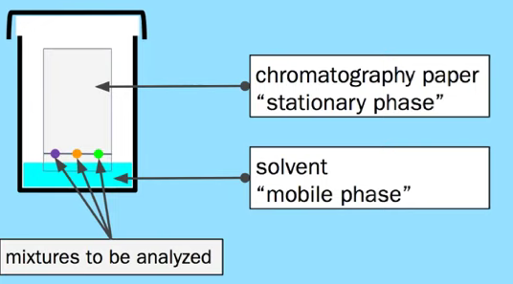 | As the mobile phase moves through the stationary phase, it picks up particles from the mixture to be analyzed.  The component parts of the mixture will travel at different rates, based on size and polarity of particle.  - Larger particles will move more slowly  - Particles with a polarity which matches the solvent will move farther.

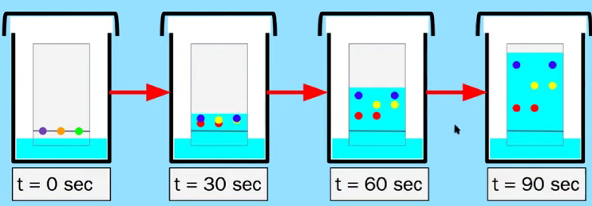
Retention Factor
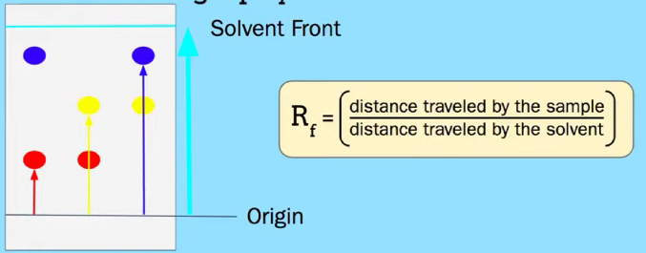
- Distillation separates chemical species by taking advantage of the differential strength of intermolecular attractions between and among the components and the effects these interactions have on the vapor pressures of the components in the mixture.
- Distillation separates parts of a mixture based on different boiling points.  - A mixture must have two liquids of different boiling points.  - The mixture is slowly heated to a temperature that is between the boiling points of the liquids.  - The gas particles rise through the still head and meet cooler air.  - The thermometer measures the temperature of the gas  - Water flows through the condenser, cooling the vapor back into liquid.  - The receiving flask collects the liquid. | 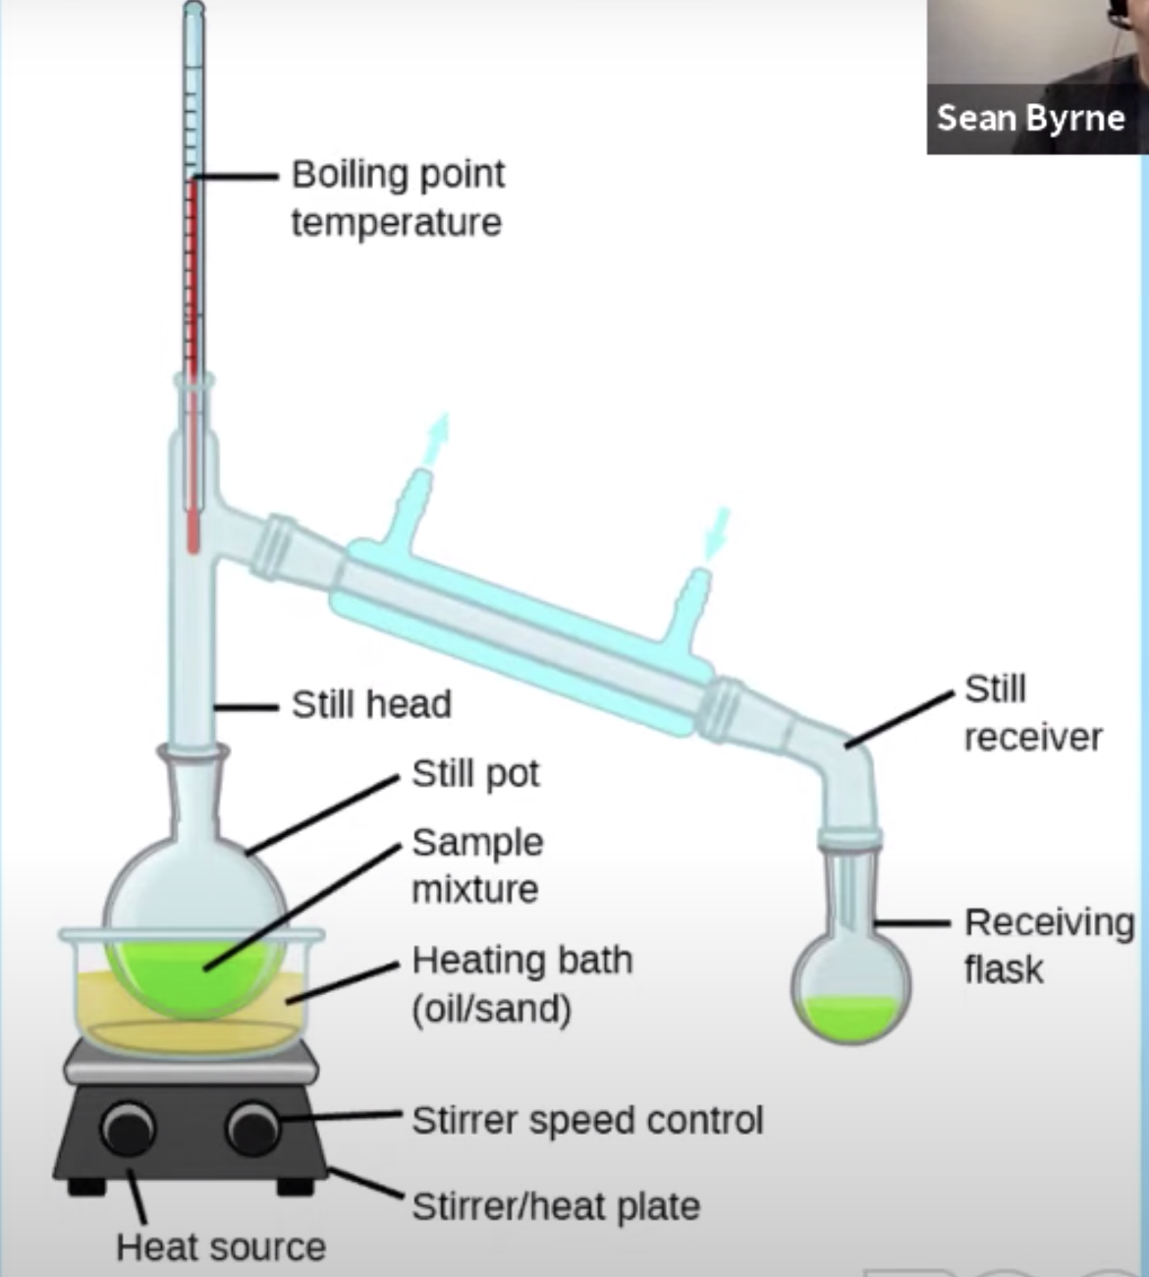

3.9 Distillation Guided Practice
A student performed a fractional distillation of a mixture of two straight-chain hydrocarbons, C₇H₁₆ and C₈H₁₈.  Using four clean, dry flasks, the student collected the distillate over the volume ranges (A, B, C, and D) shown in the graph to the right.  Over what volume range should the student collect the distillate of the compound with the stronger intermolecular forces? | 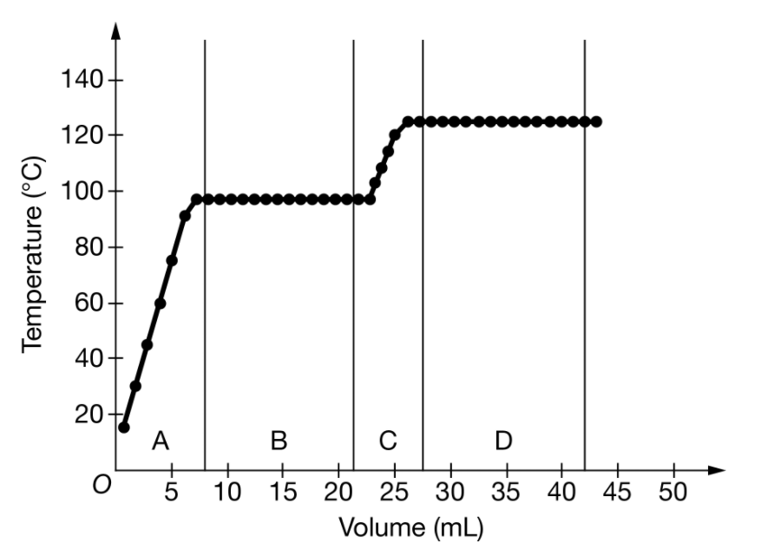
3.10 Solubility
- Substances with similar intermolecular interactions tend to be miscible (soluble) in one another.

3.10 Solubility Guided Practice

What does this image indicate about the intermolecular interactions of the substances?
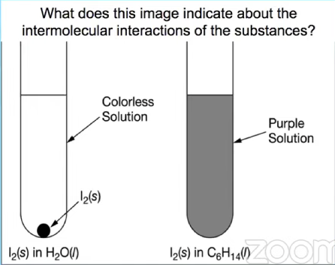

Which of these pairs of molecules would you expect to mix together?
A. | 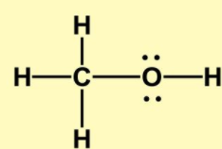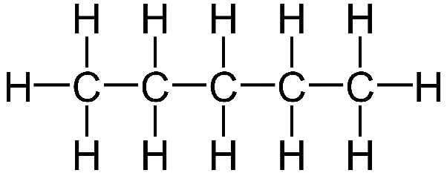
B. | 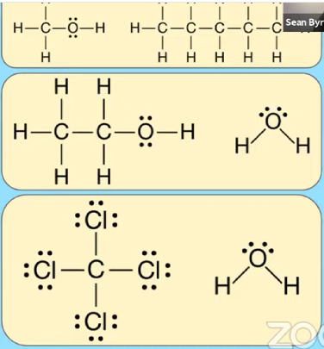
C.

AP EXAM FRQ PRACTICE 3.7-3.10 - HOMEWORK
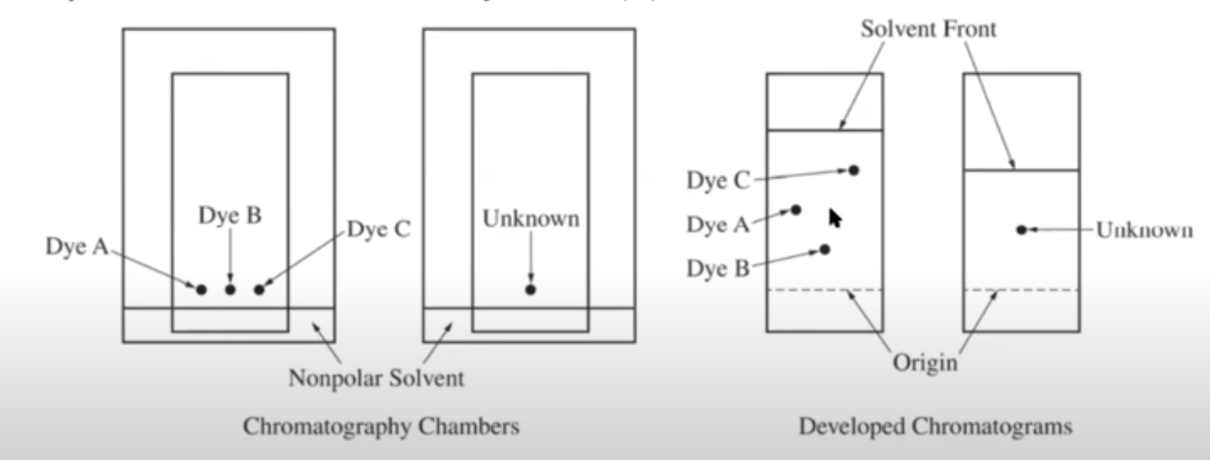
- A student Investigates various dyes using paper chromatography. The student has samples of three pure dyes, labeled A, B, and C, and an unknown sample that contains one of the three dyes. The student prepares the chromatography chambers shown above on the left by putting a drop of each dye at the indicated position on the chromatography paper ( a polar material) and standing the paper in a nonpolar solvent. The developed chromatograms are shown above on the right.

- Which dye ( A, B, or C) is the least polar? Justify your answer in terms of the interactions between the dyes and the solvent or between the dyes and the paper.

- Which dye is present in the unknown sample? Justify your answer.

Other Practice Problems:
- A 360. mg sample of aspiring, C₉H₈, (molar mass 180. g), is dissolved in enough water to produce 200. mL of solution. What is the molarity of aspiring in a 50. mL sample of this solution?

- Approximately what mass of CuSO₄・5H₂O is required to prepare 250 mL of 0.10 M copper(II) sulfate solution?

AP CHEMISTRY PRACTICE 3.11 - 3.13
AP Chemistry: 3.11-3.13 Spectroscopy, Photoelectric Effect, and Beer-Lambert Law
WATCH THIS VIDEO BY SEAN BYRNE TO ASSIST IN THESE QUESTIONS

3.11 Spectroscopy

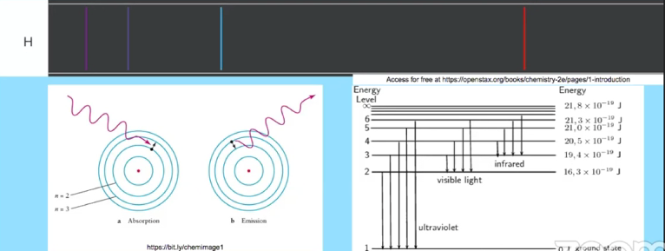

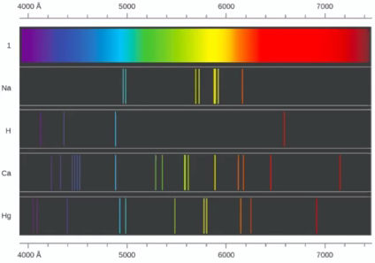

3.11 The Electromagnetic Spectrum
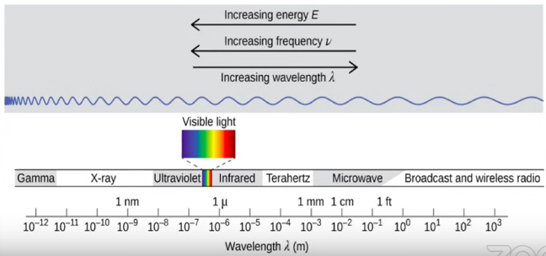

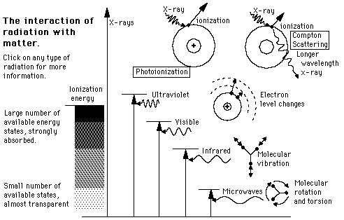 | Differences in absorption or emission of photons in different spectral regions are related to the different types of molecular motion or electronic transition:  - Microwave radiation → transitions in molecular rotational levels  - Infrared radiation → transitions in molecular vibrational levels  - Ultraviolet and visible radiation → transitions in electronic energy levels.
SAMPLE PROBLEM 3 (AP STYLE)
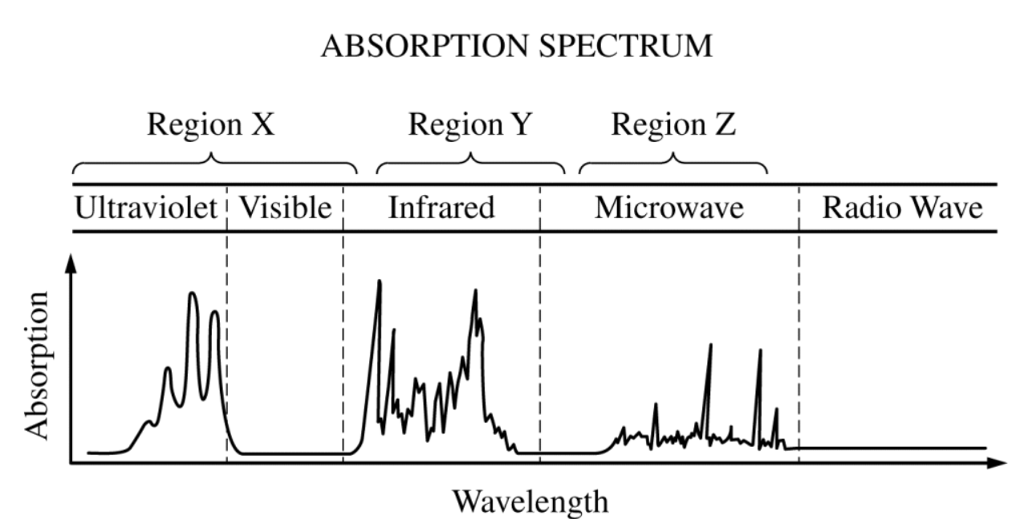
The diagram above represents the absorption spectrum for a pure molecular substance. What types of molecular motion or electronic transitions would you expect to find in each region labeled? (Region X, Region Y and Region Z)

3.12 Photoelectric Effect
- When a photon is absorbed (or emitted) by an atom or molecule, the energy of the species is increased (or decreased) by an amount equal to the energy of the photon.
- The wavelength of the electromagnetic wave is related to its frequency and the speed of light by the equation:
  - c = λν

- The energy of a photon is related to the frequency of the electromagnetic wave through Planck’s equation.
  - E_{photon} = hν

FROM AP CHEMISTRY EQUATIONS SHEET
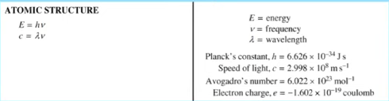
3.12 Photoelectric Effect Guided Practice
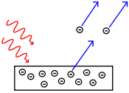  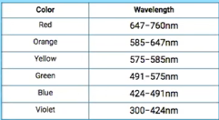 | The diagram to the left represents the photoelectric effect for a metal.  There is also a table of wavelength with their respective colors they absorb.  When the metal surface is exposed to light with increasing frequency and energy of photons, electrons first begin to be ejected from the metal when the energy of the photos is 3.3 x 10^{－19} J.  What is the frequency of light with photon energy 3.3 x 10^{－19} J?  What is the color of this light?
3.13 Beer-Lambert Law
- The Beer － Lambert law relate the absorption of light by a solution to three variables according to the equation:
  - A = ε b c
    - ε describes how intensely a sample of molecules or ions absorbs light of a specific wavelength. This is a constant unique to the molecule.
    - b = the path length
    - c = concentration of solution are proportional to the number of absorbing species.
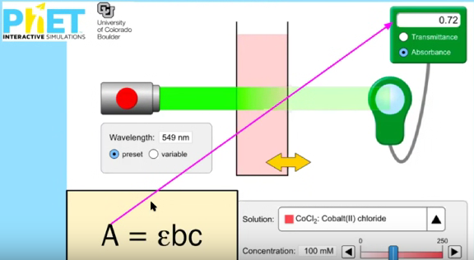
- In most experiments the path length and wavelength if light are held constant. In such cases, the absorbance is proportional only to the concentration of absorbing molecules or ions
Beer-Lambert Law PhET Simulation (Linked on Image)

3.13 Beer-Lambert Law Guided Practice
Fe³⁺(aq) + KSCN(s) → FeSCN²⁺(aq) + K⁺(aq)  To determine the moles of Fe³⁺(aq) in a 100. mL sample of an unknown solution, excess KSCN(s) is added to convert all the Fe³⁺(aq) into the dark red species FeSCN²⁺(aq), as represented by the equation above. The absorbance of FeSCN²⁺(aq) at different concentrations is shown in the graph to the right.  The absorbance of the mixture is 0.20 at 453 nm.  - What is the concentration of FeSCN²⁺(aq)?  - How many moles of Fe³⁺(aq) were present in the 125 mL sample? | 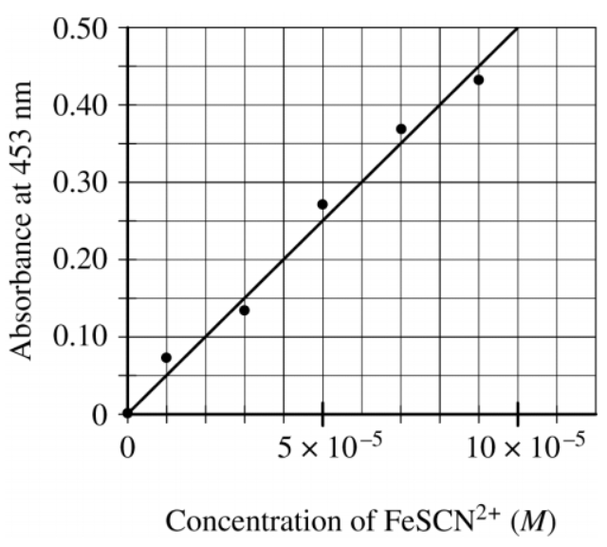
3.13 Beer-Lambert Law Guided Practice

A student uses visible spectrophotometry to determine the concentration of CoCl₂(aq) in a sample solution. First the student prepares a set of CoCl₂(aq) solutions of known concentration. Then the student uses a spectrophotometer to determine the absorbance of each of the standard solutions at a wavelength of 510 nm and constructs a standard curve. Finally, the student determines the absorbance of the sample of unknown concentration

The student made the standard curve below.

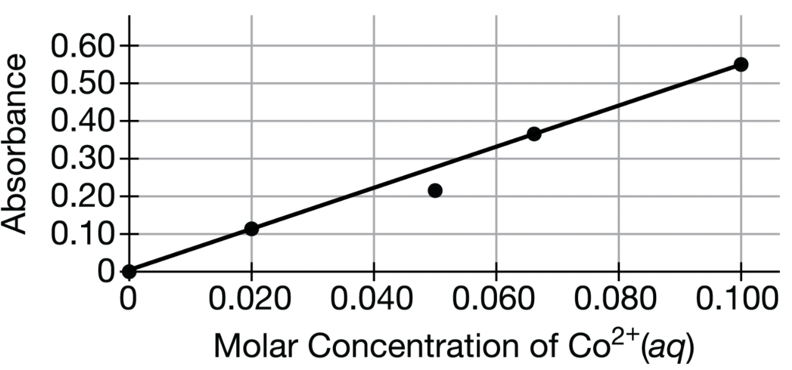

What is a possible experimental error which could have caused the error in the point the student plotted at 0.050MCo²⁺(aq) ?

AP EXAM FRQ PRACTICE 3.11-3.13 - HOMEWORK
To spectrophotometrically determine the mass percent of cobalt in an ore containing cobalt and some inert materials, solutions with known [Co²⁺] are prepared and the absorbance of each of the solutions is measured at the wavelength of optimum absorbance. The data are used to create a calibration plot, shown below.
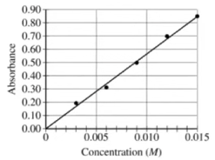
A 0.630 g sample of the ore is completely dissolved in concentrated HNO₃(aq). The mixture is diluted with water to a final volume of 50.00 mL. Assume that all the cobalt in the ore sample is converted to Co²⁺(aq).

- What is the [Co²⁺] in the solution if the absorbance of the sample of the solution is 0.74?

- Calculate the number of moles of Co²⁺(aq) in the 50.00 mL solution.

- Calculate the mass percent of Co in the 0.630 g sample of the ore.

The student in the previous problem used a spectrophotometer to determine the absorbance of each of the standard solutions at a wavelength of 510 nm. A wavelength of 510 nm corresponds to an approximate frequency of 6 x 10¹² s⁻¹.
- What is the approximate energy if one photon of this light?

- What is the color of this light?

AP CHEMISTRY PRACTICE 4.1-4.4
AP Chemistry: 4.1-4.4 Reactions, Net Ionic Equations, and Chemical Changes
WATCH THIS VIDEO BY MICHAEL FARABAUGH TO ASSIST IN THESE QUESTIONS

Physical Change versus Chemical Change

A physical change occurs when a substance undergoes a change in properties, but not a change in composition.
- If the only attractions that are broken/formed are intermolecular (or interparticle) forces, then it is likely a physical change.
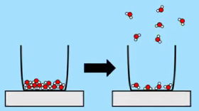
Examples of Physical Changes: Phase Changes

H₂O(s) ⟶ H₂O(l) CH₃OH(l) ⟶ CH₃OH(g) CO₂(s)⟶ CO₂(g)

C₅H₁₂(l) ⟶ C₅H₁₂(s) HCl(g) ⟶ HCl(l) I₂(g) ⟶ I₂(s)

Examples of Physical Changes: Separating a Mixture
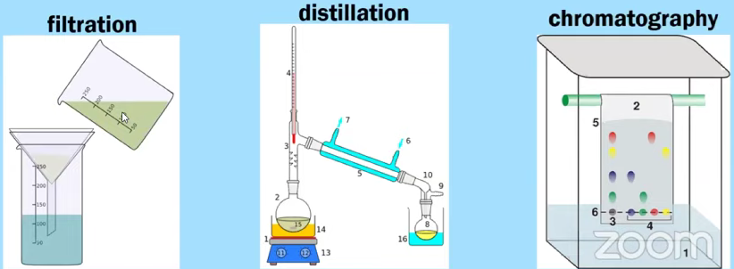
A chemical change occurs when substances are transformed into new substances, with different compositions.  - If chemical bonds are broken/formed, then it is likely a chemical change  2 H₂O(l) ⟶ 2 H₂(g) + O₂(g)  CO(g) + 2H₂(g)⟶ CH₃OH(g)  2 Na(s) + 2 H₂O⟶ 2 NaOH(aq) + H₂(g)  AgNO₃ (aq) + NaCl(aq) ⟶ NaNO₃(aq) + AgCl(s) | 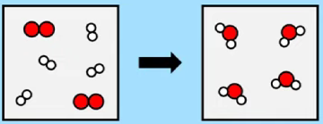
Writing a Balanced Chemical Equation

*AP EXAM TIPS*

- YOU DON’T HAVE TO MEMORIZE CHEMICAL FORMULAS. WHEN THE AP EXAM ASKS YOU A QUESTION, THEY TYPICALLY GIVE YOU BOTH THE NAME AND THE CHEMICAL FORMULA.

- ON THE AP EXAM, IF YOU ARE ASKED TO WRITE A BALANCED CHEMICAL EQUATION, YOU WILL NOT BE REQUIRED TO INCLUDE THE PHASE OF MATTER (e.g., s, l, g, aq) FOR EACH SUBSTANCE.

  - HOWEVER, YOU SHOULD DOUBLE-CHECK YOUR ANSWER TO MAKE SURE THAT EACH CHEMICAL FORMULA HAS BEEN WRITTEN CORRECTLY AND THAT YOUR EQUATION HAS BEEN BALANCED CORRECTLY.

Solid calcium hydroxide, Ca(OH)₂(s), reacts with a solution of aqueous hydrobromic acid, HBr(aq), to produce water and aqueous calcium bromide, CaBr₂(aq).

Solutions of phosphoric acid, H₃PO₄, and potassium hydroxide, KOH, are combined, and the products of the reaction are water and potassium phosphate, K₃PO₄

A sample of C₅H₁₂O undergoes combustions by reacting completely with O₂ to produce CO₂ and H₂O.

TIP FOR BALANCING COMBUSTION REACTIONS: BALANCE CARBON FIRST, THEN HYDROGEN, THEN OXYGEN

Solutions of Mg(NO₃)₂ and Na₃PO₄ are combined. The products are NaNO₃ and Mg₃(PO₄)₂

NET IONIC EQUATIONS

Guidelines for Writing Net Ionic Equations - It can be helpful to do the following:
- Stare with a molecular equation
- Make the transition to the complete ionic equation
  - Tips for when to transition to ionic equation or not
    - Strong acid/strong base or ionic compound
    - Says “aqueous,” break it up
    - Says “solid,” leave it as is, don’t split it up.
    - If it is a (covalent) molecular substance, a weak acid/base, a gas, a pure liquid, a purse solid or an insoluble (slightly soluble) ionic solid, leave it as is - don’t split up.
- Cross of the spectator ions on both sides of the equation
- Now you have the net ionic equation
AP TIP: UNLESS YOU ARE GIVEN MORE INFORMATION, ASSUME THAT WHEN AN IONIC SOLID DISSOLVES IN WATER, IT SIMPLY BREAKERS UP INTO AQUEOUS IONS. IT DOES NOT REACT WITH WATER MOLECULES.

A sample of solid calcium chloride, CaCl₂, is dissolved completely in water. When this solution is tested for conductivity, it is observed that it does conduct electricity. Write the net ionic equation for the dissolution of CaCl₂ in water.

A sample of solid magnesium nitrate, Mg(NO₃)₂, is dissolved completely in water. When this solution is tested for conductivity, it is observed that it does conduct electricity. Write the net ionic equation for the dissolution of Mg(NO₃)₂ in water.

A sample of methanol, CH₃OH, is added to water and the solution mixed completely. When this solution is tested for conductivity, it is observed that it does not conduct electricity. Write the net ionic equation for the dissolution of CH₃OH in water.

Be careful- a (covalent) molecular substance that is soluble in water will exist in solution at the particle level as molecules. It does not dissociate into ions.

NET IONIC EQUATIONS
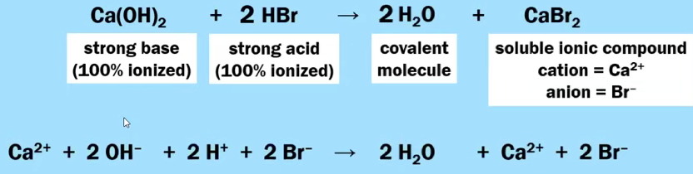

H₃PO₄ + 3 KOH ⟶ 3 H₂O + K₃PO₄

3 Mg(NO₃)₂ + 2 Na₃PO₄ ⟶ 6 NaNO₃ + Mg₃(PO₄)₂

Mistakes to Avoid When Writing Net Ionic Equations - COMMON MISTAKES

Write the Net Ionic Equation For: 2 NaOH(aq) + CuSO₄(aq) ⟶ Cu(OH)₂(s) + Na₂SO₄(aq)

Student Work | Mistake Made
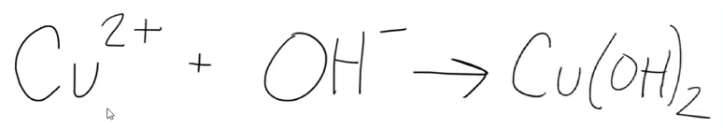
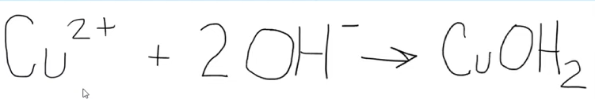
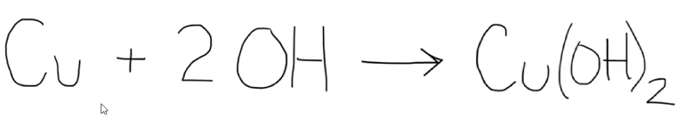
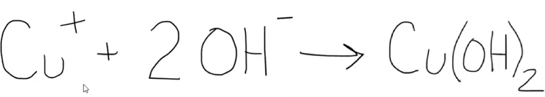
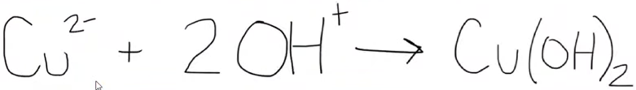
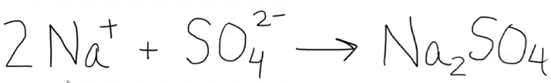
Mistakes to Avoid When Writing Net Ionic Equations - COMMON MISTAKES

A strip of solid aluminum metal is added to a solution of copper(II) chloride. The products of the reaction are solid copper and aqueous aluminum chloride.

Write the molecular equation.

2 Al(s) + 3 CuCl₂(aq) ⟶ 3 Cu(s) + 2 AlCl₃(aq)

Write the net ionic equation.

Student Work | Mistake Made
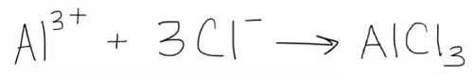
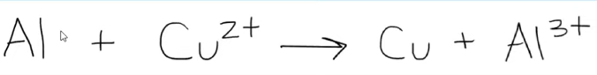
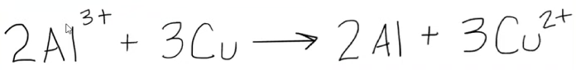

Using Particle Diagrams to Represent Reactions
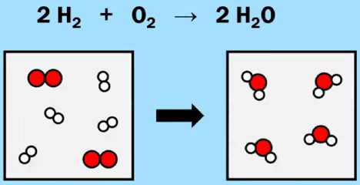

Particle Diagrams can also be used to illustrate the concept of limiting reactants and theoretical yield.
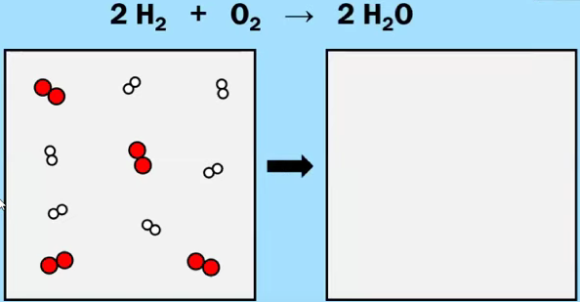
Guided Practice - Using Particle Diagrams to Represent Reactions (Continued)

AgNO₃ (aq) + NaCl(aq) ⟶ NaNO₃(aq) + AgCl(s)

A dilute solution of AgNO₃(aq) is combined with excess NaCl(aq) to form AgCl(s). Which of these diagrams best represents the ions that are present in significant concentrations in the solution? Justify your answer.

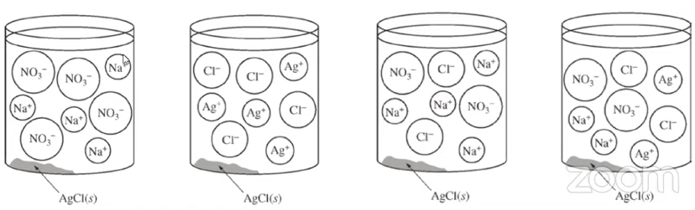

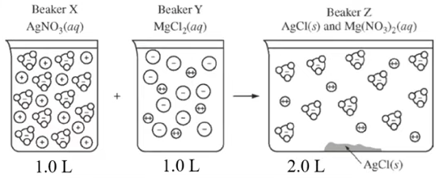

2 AgNO₃(aq) + MgCl₂(aq) ⟶ 2 AgCl(s) + Mg(NO₃)₂(aq)

- After examining the particle diagram shown above, a student made the claim that the concentration of AgNO₃(aq) is the same as the concentration of MgCl₂(aq).

Do you agree with the student’s claim? Justify your answer based on the information in the particle diagram.

- After examining the particle diagram shown above, a student made the claim that the value of [Mg²⁺] in Beaker Y is twice as much as the value of [Mg²⁺] in Beaker Z.

Do you agree with the student’s claim? Justify your answer based on the information in the particle diagram.

Guided Practice - Using Particle Diagrams to Represent Reactions (Continued)

A student is given 50.0 mL of a solution of Na₂CO₃ of unknown concentration. To determine the concentration of the solution, the student mixes the solution with excess 1.0 M Ca(NO₃)₂ (aq), causing a precipitate to form. The balanced equation for the reaction is shown below

Na₂CO₃(aq) + Ca(NO₃)₂(aq) ⟶ 2 NaNO₃ (aq) + CaCO₃(s)

- Write the net ionic equation for the reaction that occurs when the solutions of Na₂CO₃ and Ca(NO₃)₂ are mixed.

- The diagram below is incomplete. Draw in the species needed to accurately represent the major ionic species remaining in the solution after the reaction has been completed.

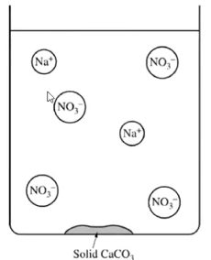

AP EXAM FRQ PRACTICE 4.1-4.4 - HOMEWORK

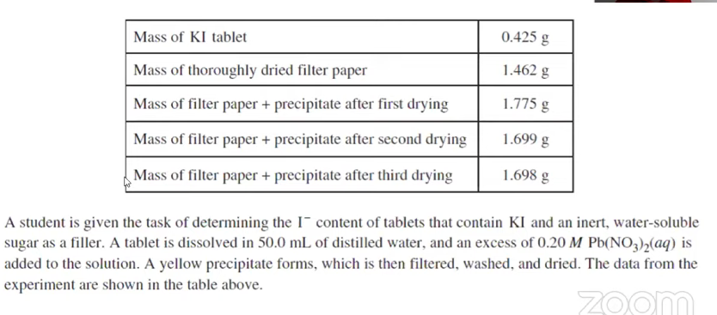
A student is given the task of determining the I－ content of tablets that contain KI and an inert, water-soluble sugar as a filler. A tablet is dissolved in 50.0 mL of distilled water, and an excess of 0.20 M Pb(NO₃)₂(aq) is added to the solution. A yellow precipitate forms, which is then filtered, washed, and dried. The data from the experiment are shown in the table above.
- For the chemical reaction that occurs when the precipitate forms,
  - Write a balanced, net-ionic equation for the reaction, and

  - Explain why the reaction is best represented by a net-ionic equation.

- Explain the purpose of drying and weighing the filter paper with the precipitate three times.

- In the filtrate solution, is [K⁺] greater than, less than, or equal to [NO₃－]? Justify your answer.

- Calculate the number of moles of precipitate that is produced in the experiment.

- Calculate the mass percent of I－ in the tablet.

- In another trial, the student dissolves a tablet in 55.0 mL of water instead of 50.0 mL of water. Predict whether the experimentally determined mass percent of I－ will be greater, less than, or equal to the amount calculated in part (e). Justify your answer.

AP CHEMISTRY PRACTICE 4.-5 - 4.9
AP Chemistry: 4.5-4.9 Stoichiometry, Titration, Acid-Base Reactions, and Redox Reactions
WATCH THIS VIDEO BY MICHAEL FARABAUGH TO ASSIST IN THESE QUESTIONS

STOICHIOMETRY - the following unbalanced chemical equation and question will hit on the following topics

Al(s) + HCl(aq) ⟶ AlCl₃ (aq) + H₂(g)

- moles to moles
Al(s) and HCl(aq) react together according to the chemical equation shown above. If 0.36 mol of AlCl₃ is produced in this reaction, how many moles of H₂ are also produced?

- grams to grams
Al(s) and HCl(aq) react together according to the chemical equation shown above. How many grams of Al are required to produce 75 grams of H₂? Assume that HCl is added in excess.

- connection to molarity
Al(s) and HCl(aq) react together according to the chemical equation shown above. How many mL of 5.0 M HCl are required to react completely with 4.25 grams of Al?

- Connection to ideal gas law (PV = nRT)
35 g Al(s) reacts with excess HCl(aq) according to the chemical equation shown above. What is the volume (in L) of H₂ gas produced at a temperature of 345 K and a pressure of 1.12 atm?

2 Al(s) + 6 HCl(aq) ⟶ 2 AlCl₃ (aq) + 3 H₂(g)

- limiting reactant and theoretical yield
125 g of Al(s) reacts with 2.50 L of 3.20 M(aq) according to the chemical equation shown above.
- Which chemical,Al or HCl, is the limiting reactant?

- What is the theoretical yield of H₂ in units of grams?

You can also convert one reactant into the other reactant (DO WE HAVE ENOUGH?)

INTRODUCTION TO TITRATION
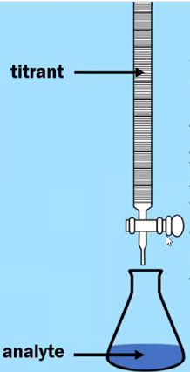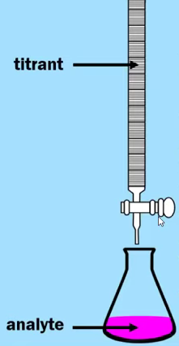 | - A titration is an experiment that can be used to calculate the amount of moles or the concentration of one chemical by reacting it with a known quantity of another chemical.  - The standard solution of known concentration is known as the titrant. The solution of unknown concentration is known as the analyte.  - The titrant is added slowly to the analyte by using a buret.  - The equivalence point in a titration is the point at which just enough titrant has been added to react with all of the analyte. This point may be indicated by a color change.  - This observable event is called the end point of the titration.
Titration - Guided Example
HC₂H₃O₂(aq) + NaOH(aq) ⟶ H₂O(l) + NaC₂H₃O₂(aq)
A solution of vinegar contains an unknown amount of acetic acid, HC₂H₃O₂. A 25.0 mL sample of vinegar is titrated with a 0.650 M NaOH according to the chemical reaction shown above. If it requires 32.04 mL of the titrant to reach the equivalence point, what is the concentration of HC₂H₃O₂ in the vinegar?

If there is a 1-to-1 mole ratio between the acid and the base, you can also use the following equation as a shortcut
M_{a}V_{a} = M_{b}V_{b}

Benzoic acid + KOH(aq) ⟶ H₂O + potassium benzoate

Benzoic acid is a monoprotic acid. A sample of solid benzoic acid with a mass of 0.180 g is dissolved into the water and titrated with 0.125 M KOH according to the chemical reaction shown above. It requires 11.79 mL of the titrant to reach the equivalence point. Calculate the molar mass of the benzoic acid.

TYPES OF CHEMICAL REACTIONS
- ACID BASE REACTIONS - SEE MORE IN THIS VIDEO “8.1 INTRODUCTION TO ACIDS AND BASES”
- By definition a Brønsted-Lowry acid is a proton (H⁺) donor, and a Brønsted-Lowry base is a proton (H+) acceptor.
Guided Practice 1- Brønsted-Lowry Conjugate Acids and Bases
Conjugate Acid | Conjugate Base
HF
H₂S
NH₄⁺
 | C₂H₃O₂－
 | HPO₄^{2－}
 | CH₃NH₂
 | SO₄^{2－}

Guided Practice 2- Identifying acid-base reactions
Each of the following reactions contains hydrochloric acid as a reactant. However, only one of these reactions is classified as an acid-base reaction. Which reaction is an acid-base reaction? Justify your answer.

- Zn(s) + 2 HCl(aq) ⟶ ZnCl₂(aq) + H₂(g)

- AgNO₃(aq) + HCl(aq) ⟶ AgCl(s) + HNO₃(aq)

- Ba(OH)₂(aq) + 2 HCl(aq) ⟶ BaCl₂(aq) + 2 H₂O(l)

A Brønsted-Lowry acid-base rxn always involves the transfer of H⁺ from an acid (H⁺ donor) to a base (H⁺ acceptor.)
A Brønsted-Lowry acid-base rxn often involves the formation of H₂O, but not always. An acid-base reaction always involves the formation of an ionic compound (salt)
Example: NH₃ + HCl ⟶ NH₄Cl
Guided Practice 3- Identifying acid-base reactions
Each of the following reactions contains sulfuric acid as a reactant. However, only one of these reactions is classified as an acid-base reaction. Which reaction is an acid-base reaction? Justify your answer.
- 2 Al(s) + 3 H₂SO₄(aq) ⟶ Al₂(SO₄)₃ (aq) + 3 H₂(g)

- 2 KOH (aq) + H₂SO₄(aq) ⟶ K₂SO₄ (aq) + 2 H₂O(l)

- Pb(NO₃)₂(aq) + H₂SO₄(aq) ⟶ PbSO₄(s) + 2 HNO₃(aq)

- REDOX REACTIONS
- Oxidation-Reduction (Redox) reactions involve the transfer of electrons from one substance to another.
  - The species that loses electrons is said to be oxidized.
  - The species that gains electrons is said to be reduced.
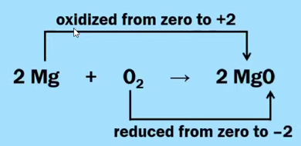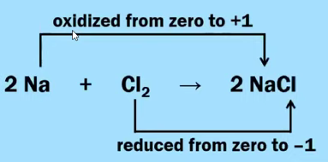
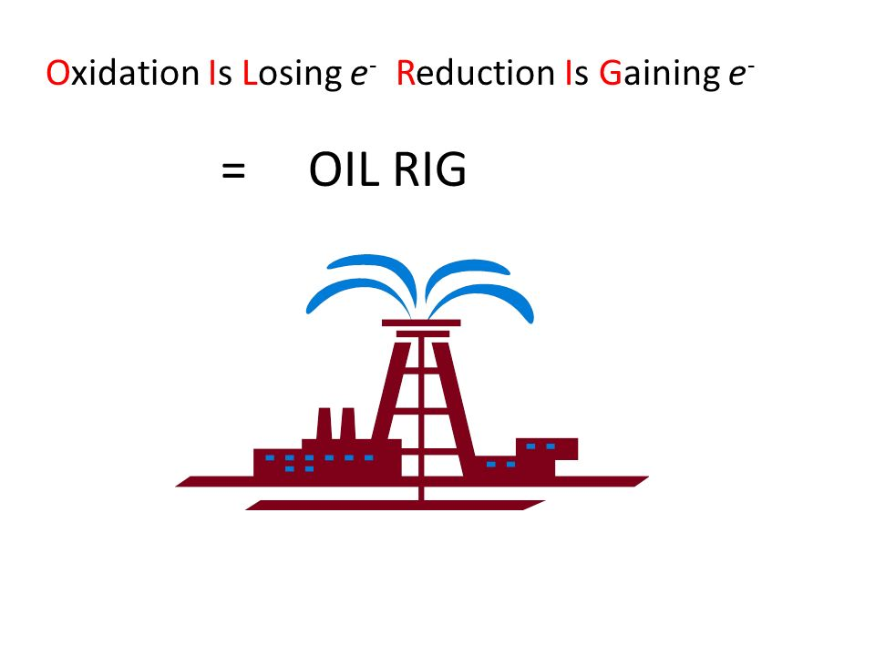
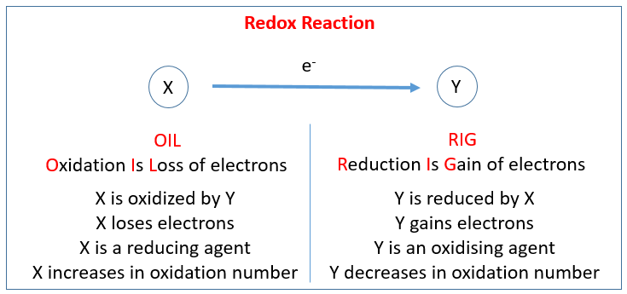
Important skill for you to have to examine a chemical formula and assign the oxidation numbers to each element within that formula.
- For an atom in its elemental form, the oxidation number is equal to zero.
  - H₂ Li C N₂ O₂ F₂ Na Mg Al etc.
- For a monatomic ion, the oxidation number is equal to the charge on the ion
  - N³⁻ O²⁻ F⁻¹ Na⁺¹ Mg²⁺ Al³⁺ etc.
- The oxidation number of fluorine (F) is always -1 in all of its compounds.
  - HF NaF CF₄ NF₃ OF₂
- The oxidation number of the other halogens (Cl, Br, or I) is usually -1. When (Cl, Br, or I) is bonded to oxygen (O) or fluorine (F), it will have a positive oxidation number.
  - HCl NaBr MgI₂ (Normal)
  - HOCl NaBrO₃ KIO₄ (Strange)
- The oxidation number of hydrogen (H) is normally +1 when it is bonded to other nonmetals.
  - CH₄ NH₃ H₂O HF
- The oxidation number of hydrogen (H) is equal to -1 when it is bonded to metals.
- NaH CaH₂
- The oxidation number of oxygen (O) is normally -2. One exception to this rule is with compounds known as peroxides that contain the O₂²⁻ ion. In peroxides, the oxidation number for oxygen is -1.
  - H₂O Al₂O₃ CO₂ H₂O₂
  - In a neutral compound, the sum of the oxidation numbers of all the atoms is equal to zero.

KMnO₄ NaOCl

  - In a polyatomic ion, the sum of the oxidation numbers of all the atoms is equal to the charge on the ion.

BrO₃⁻¹ Cr₂O₇²⁻

Guided Practice 4 - Redox Reactions
A student made the claim that the reaction shown below is a redox reaction. Do you agree with the student’s claim? Justify your answer in terms of the oxidation numbers.

FeS + HNO₃ ⟶ Fe(NO₃)₂ + H₂S

Looking at these chemical reactions again….

- Zn(s) + 2 HCl(aq) ⟶ ZnCl₂(aq) + H₂(g) REDOX REACTION

- AgNO₃(aq) + HCl(aq) ⟶ AgCl(s) + HNO₃(aq) PRECIPITATE REACTION

- Ba(OH)₂(aq) + 2 HCl(aq) ⟶ BaCl₂(aq) + 2 H₂O(l) ACID-BASE REACTIONS

- 2 Al(s) + 3 H₂SO₄(aq) ⟶ Al₂(SO₄)₃ (aq) + 3 H₂(g) REDOX REACTION

- 2 KOH (aq) + H₂SO₄(aq) ⟶ K₂SO₄ (aq) + 2 H₂O(l) ACID-BASE REACTIONS

- Pb(NO₃)₂(aq) + H₂SO₄(aq) ⟶ PbSO₄(s) + 2 HNO₃(aq) PRECIPITATE REACTION

REDOX HALF REACTIONS
2 Mg + O₂ ⟶ 2 MgO

OXIDATION HALF-REACTION: Mg ⟶ Mg²⁺ + 2e
REDUCTION HALF-REACTION: 4e- + O₂ ⟶ 2 O²⁻

- The oxidation half-reaction shows the loss of electrons
- The reduction half-reaction shows the gain of electrons.
- If you add two half-reactions together, the number of electrons lost should be equal to the number of electrons gained.

Guided Practice 5 - Redox Half Reactions

Fe³⁺ ⟶ Fe²⁺

Sn²⁺ ⟶ Sn⁴⁺

Guided Practice 6 - Redox Half Reactions (A little more complicated....)

NO₃⁻¹ + 4 H⁺ ⟶ NO + 2 H₂O

5 H₂O + As₂O₃ ⟶ 2 H₃AsO₄ + 4 H⁺

- PRECIPITATION REACTIONS
- Involve the combination of two different ionic compounds in aqueous solution.
- A compound that is insoluble (or slightly soluble) is formed.
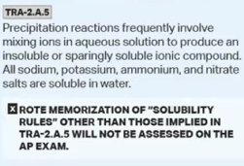
Examples of Precipitation Reactions & Net Ionic Equations (Check Out This Video)
- 2 AgNO₃ (aq) + MgCl₂(aq) ⟶ 2 AgCl(s) + Mg(NO₃)₂(aq)
  - NET IONIC EQUATION:

- Na₂CO₃(aq) + Ca(NO₃)₂(aq) ⟶ 2 NaNO₃ (aq) + CaCO₃(s)
  - NET IONIC EQUATION:

- 2 NaOH(aq) + CuSO₄(aq) ⟶ Cu(OH)₂(s) + Na₂SO₄(aq)
  - NET IONIC EQUATION:

- 3 Mg(NO₃)₂(aq) 2 Na₃PO₄(aq) ⟶ 6 NaNO₃(aq) + Mg(PO₄)₂(s)
  - NET IONIC EQUATION:

AP EXAM FRQ PRACTICE 4.5-4.9 - HOMEWORK

6H⁺(aq) + 2 MnO₄⁻(aq) + 5 H₂C₂O₄(aq)→10 CO₂(g) + 8 H₂O(l)+ 2 Mn²⁺(aq)

A student dissolved a 0.139 g sample of oxalic acid, H₂C₂O₄, in water in an Erlenmeyer flask. Then the student titrated the H₂C₂O₄ solution in the flask with a solution of KMnO₄, which has a dark purple color. The balanced chemical equation for the reaction that occurred during the titration is shown above

- Identify the species that was reduced in the titration reaction. Justify your answer in terms of oxidation numbers.

- The student used a 50.0mL buret to add the KMnO₄(aq) to the H₂C₂O₄(aq) until a faint lavender color was observed in the flask, an indication that the end point of the titration had been reached. The initial and final volume readings of the solution in the buret are shown below. Write down the initial reading and the final reading and use them to determine the volume of KMnO₄(aq) that was added during the titration.
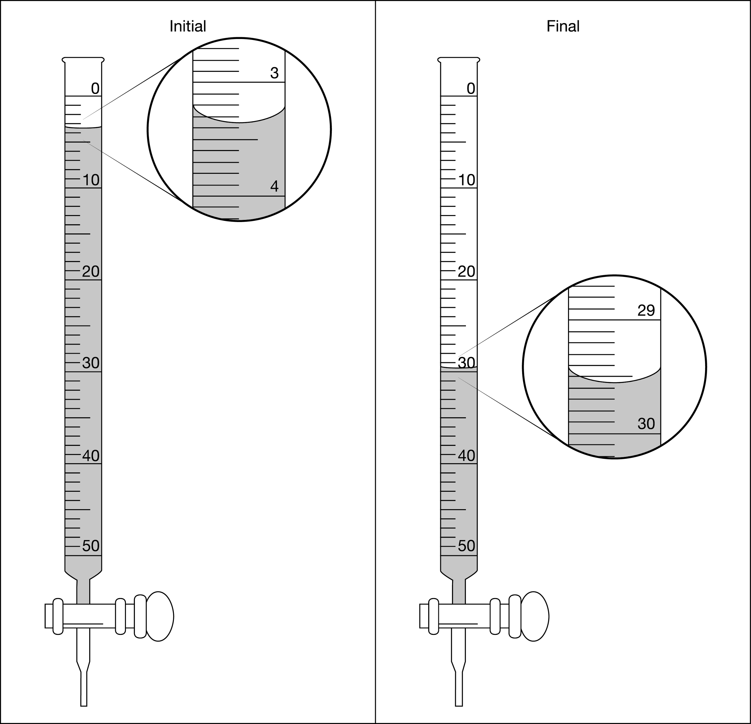
(b) Given that the concentration of KMnO₄(aq) was 0.0235M, calculate the number of moles of MnO₄⁻ ions that completely reacted with the H₂C₂O₄.

(c) The student proposes to perform another titration using a 0.139 g sample of H₂C₂O₄, but this time using 0.00143 M KMnO₄(aq)in the buret. Would this titrant concentration be a reasonable choice to use if the student followed the same procedure and used the same equipment as before? Justify your response.

AP CHEMISTRY PRACTICE 5.1-5.3
AP Chemistry: 5.1-5.3 Reaction Rates, Rate Law, and Concentration Changes
WATCH THIS VIDEO BY SEAN BYRNE TO ASSIST IN THESE QUESTIONS

5.1 Reaction Rates
2 R(aq) ⟶ 2 X (aq) + P (aq)

Rate of Decomposition = $-\left(\frac{change in concentration of reactant}{change in time}\right)=-\left(\frac{[R]_{f}-[R]_{i}}{t_{2}-t_{1}}\right)=-\left(\frac{Δ[R]}{Δt}\right)$

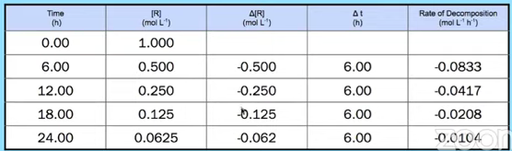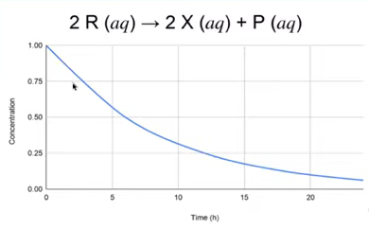

Rate of Appearance = $+\left(\frac{change in concentration of reactant}{change in time}\right)=+\left(\frac{[P]_{f}-[P]_{i}}{t_{2}-t_{1}}\right)=+\left(\frac{Δ[P]}{Δt}\right)$

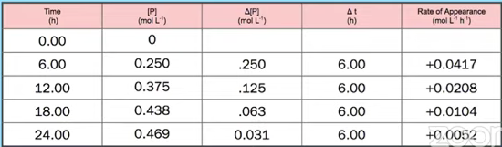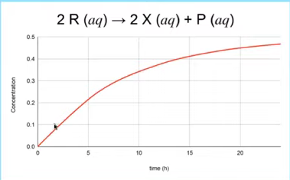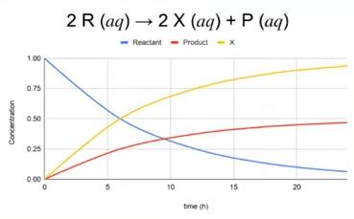
5.1 Reaction Rates - Guided Practice

5 Br－(aq) + BrO₃－(aq) + 6 H⁺(aq) ⟶ 3 Br₂(aq) + 3 H₂O(l)

The rate of disappearance of Br－(aq) at a particular moment during the reaction is 3.5 × 10^{－4} mol L^{－1}s^{－1}.

- What is the rate of appearance of Br₂(aq) at that moment?

- What is the rate of disappearance of H⁺(aq) at that moment?

- What is the rate of disappearance of BrO₃－(aq) at that moment?

Factors Affecting Rate
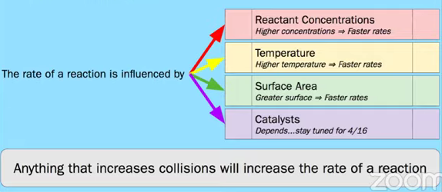

Factors Affecting Rate - Guided Practice # 1

CaCO₃(s) + 2H⁺(aq) ⟶ Ca²⁺(aq) + H₂O(l) + CO₂(g)

Experiment | Initial Mass of CaCO₃(s) (grams) | Volume of H⁺(aq) | Initial Concentration of H⁺(aq) (M) | Initial Temperature of Reactants (ºC)
1 | 5.00 (powder) | 50. mL | 1.0 | 25.0
2 | 5.00 (powder) | 50. mL | 2.0 | 25.0

The initial rate of formation of CO₂(g) from the chemical reaction represented by the equation above was studied in two separate experiments.

- Which experiment, if any, will have the faster initial rate of formation of CO₂(g)?
Factors Affecting Rate - Guided Practice # 2
CaCO₃(s) + 2H⁺(aq) ⟶ Ca²⁺(aq) + H₂O(l) + CO₂(g)

Experiment | Initial Mass of CaCO₃(s) (grams) | Volume of H⁺(aq) | Initial Concentration of H⁺(aq) (M) | Initial Temperature of Reactants (ºC)
3 | 5.00 (powder) | 50. mL | 1.0 | 25.0
4 | 5.00 (pellets) | 50. mL | 1.0 | 25.0

The initial rate of formation of CO₂(g) from the chemical reaction represented by the equation above was studied in two separate experiments.

- Which experiment, if any, will have the faster initial rate of formation of CO₂(g)?

Factors Affecting Rate - Guided Practice # 3
CaCO₃(s) + 2H⁺(aq) ⟶ Ca²⁺(aq) + H₂O(l) + CO₂(g)

Experiment | Initial Mass of CaCO₃(s) (grams) | Volume of H⁺(aq) | Initial Concentration of H⁺(aq) (M) | Initial Temperature of Reactants (ºC)
5 | 5.00 (powder) | 50. mL | 1.0 | 25.0
6 | 5.00 (powder) | 50. mL | 2.0 | 50.0

The initial rate of formation of CO₂(g) from the chemical reaction represented by the equation above was studied in two separate experiments.

- Which experiment, if any, will have the faster initial rate of formation of CO₂(g)?

5.2 Introduction to Rate Law

X + Y ⟶ Z + W

This is the Rate Law: Rate = k [X]^{m} [Y]^{n}
For Rate Laws:
- Reactants only
- m = order with respect to X
- n = order with respect to Y
- m + n = overall order of the reaction
- k = “Rate constant”
      - temperature dependent
      - units reflect overall order

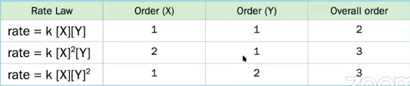

5.2 Introduction to Rate Law - Guided Practice # 1

Ozone in the upper atmosphere is depleted when it reacts with nitrogen oxides. The rates of the reactions of nitrogen oxides with ozone are important factors in deciding how significant these reactions are in the formation of the ozone hole over Antarctica. One such reaction is the combination of nitric oxide, NO, with ozone, O₃:

NO(g) + O₃(g) ⟶ NO₂(g) + O₂(g)

Use the data to determine the rate law and the rate constant for the reaction at 25ºC.

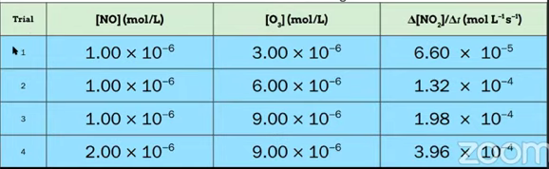

5.2 Introduction to Rate Law - Guided Practice # 2 (More Challenging)

Acetaldehyde decomposes when heated to yield methane and carbon monoxide according to the equation:

CH₃OH(g) ⟶ CH₄(g) + CO(g)

Determine the rate law and the rate constant for the reaction from the following experimental data:

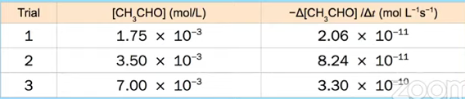

5.3 Concentration Changes Over Time

- Rate Law ⇒ Rate = k[A]
  - Relates rate of a reaction to the concentration of the reaction

- Integrated rate law
  - Relates concentration of a reaction to time.
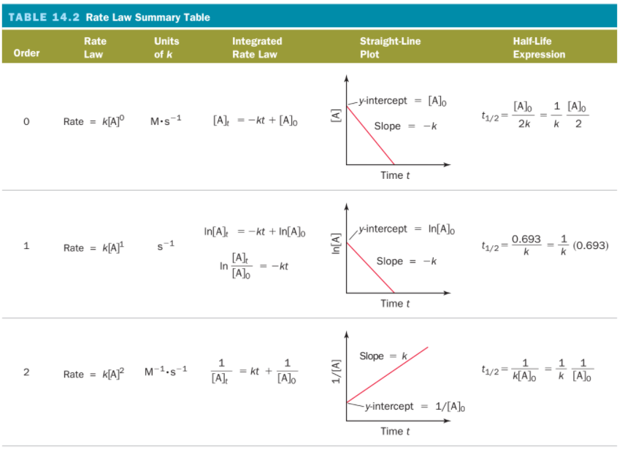
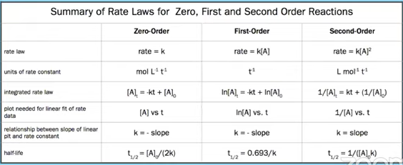

5.3 Concentration Changes Over Time - Guided Practice
The radioactive decay of A is a first order reaction, with the half-life equal to 8.50 min.
- What is the value of k for this reaction?

- If the initial concentration of A is 0.150 M, how long will it take for the concentration to drop to 0.0300 M?

AP EXAM FRQ PRACTICE 5.1 - 5.3 - HOMEWORK
Hydrogen reacts with nitrogen monoxide to form dinitrogen monoxide (laughing gas) according to the equation:
H₂(g) + 2 NO(g) ⟶ N₂O(g) + H₂O(g)
Determine the rate law, the rate constant, and the orders with respect to each reactant from the following data:
[NO] (mol L⁻¹) | [H₂] (mol L⁻¹) | Rate (mol L⁻¹s⁻¹)
0.30 | 0.35 | 2.835 × 10^{－3}
0.60 | 0.35 | 1.134 × 10^{－2}
0.60 | 0.70 | 2.268 × 10^{－2}

AP EXAM FRQ PRACTICE 5.1 - 5.3 - HOMEWORK (CONTINUED)
Na₂C₃₇H₃₄N₂S₃O₉ + OCl－ ⟶ products
blue colorless

Blue food coloring can be oxidized by household bleach (which contains OCl－) to form colorless products, as represented by the equation above. A student used a spectrophotometer set at a wavelength of 635 nm to study the absorbance of the food coloring over time during the bleaching process. In the study, bleach is present in large excess so that the concentration of OCl－ is essentially constant throughout the reaction. The student use data from the study to generate the graphs below.
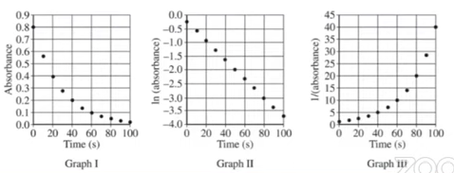
- Based on the graphs above, what is the order of the reaction with respect to the blue food coloring?

- The reaction is known to be first order with respect to bleach. In a second experiment, the student prepares solutions of food coloring and bleach with concentrations that differ from those used in the first experiment. When the solutions are combined, the student observes that the reaction mixture reaches an absorbance near zero to rapidly. In order to correct the problem, the sooner proposed of the following three possible modifications to the experiment.
  - Increasing the temperature
  - Increasing the concentration of the food coloring
  - Increasing the concentration of the bleach
Circle the one proposed modification above that could correct the problem, and explain how that modification increases the time for the reaction mixture to reach an absorbance near zero.

- In another experiment, a student wishes to study the oxidation of red food coloring with bleach. How would the student need to modify the original experimental procedure to determine the order of the reaction with respect to the red food coloring?

AP CHEMISTRY PRACTICE 5.4,5.7-5.9
AP Chemistry: 5.4, 5.7-5.9 Reaction Mechanisms, Rate Law, and Steady-State Approximation
WATCH THIS VIDEO BY SEAN BYRNE TO ASSIST IN THESE QUESTIONS

5.4 Elementary Reactions

- The rate law of an elementary reaction can be inferred from stoichiometry of the molecules participating in a collision.

Overall: H₂(g) + 2 ICl(g) ⟶ 2 HCl(g) + I₂(g)
Step 1: H₂(g) + ICl(g) ⟶ HI(g) + HCl(g) rate = k[H₂][ICl]
Step 2: HI(g) + ICl(g) ⟶ HCl(g) + I₂(g) rate = k[HI][ICl]

5.4 Elementary Reactions - Guided Practice

Use the reaction stoichiometry to PREDICT the expected rate law.

Elementary Reaction | Rate Law
A + 2B ⟶ products
3A ⟶ products
O₃ + Cl ⟶ O₂ + ClO
2 NO + H₂ ⟶ N₂ + H₂O

5.8 Reaction Mechanism and Rate Law - Guided Practice HINT: LOOK FOR THE SLOW STEP

- Which of the following represents a rate law for the overall reaction that is consistent with the proposed mechanism?

Overall: H₂(g) + 2 ICl(g) ⟶ 2 HCl(g) + I₂(g)
Step 1: H₂(g) + ICl(g) ⟶ HI(g) + HCl(g) rate = k[H₂][ICl] (SLOW)
Step 2: HI(g) + ICl(g) ⟶ HCl(g) + I₂(g) rate = k[HI][ICl] (FAST)

- What is the rate law for the overall reaction that is consistent with the proposed mechanism?

Step 1: HBr(g) + O₂(g) ⟶ HOBr₂(g) (SLOW)
Step 2: HOBr₂(g) + HBr(g) ⟶ 2 HOBr(g) (FAST)
Step 3: 2 HOBr(g) ⟶ H₂O₂(g) + Br₂(g) (FAST)

5.8 Reaction Mechanism and Rate Law - Guided Practice HINT: LOOK FOR THE SLOW STEP

2 NO₂(g) + F₂(g) ⟶ NO₂F(g)

- NO₂ and F₂ can react to produce NO₂F as represented above. A proposed mechanism for this reaction has two elementary steps, as shown below.

Step 1: NO₂ + F₂ ⟶ NO₂F + F (slow)
Step 2: NO₂ + F ⟶ NO₂F (fast)

Write a rate law for the overall reaction that is consistent with the proposed mechanism.

5.7 Introduction to Reaction Mechanisms
The particle models shown represent a proposed two-step mechanism for the destruction of ozone (O₃) in the upper atmosphere. Notice the labels.
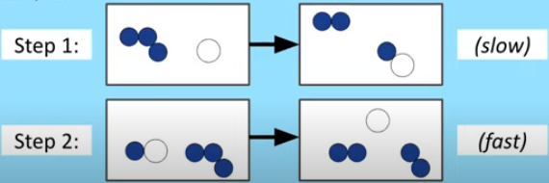
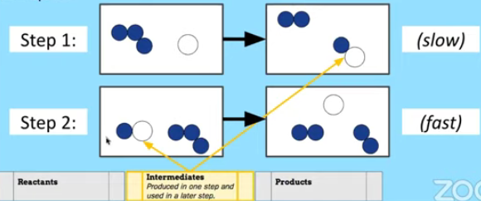
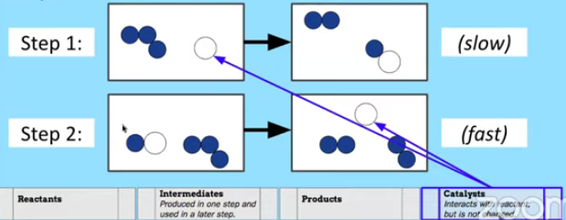

5.7 Introduction to Reaction Mechanisms- Guided Practice 1
The particle models shown represent a proposed three-step mechanism reaction. Identify each of the species below. Use arrows between each identity in the boxes below to the particle diagram in the image
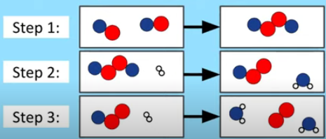
 | Reactants |  |  | Intermediates  Produced in one step and used in a later step |  |  | Products |  |  | Catalysts  Interacts with reactant, but is not changed.

5.7 Introduction to Reaction Mechanisms- Guided Practice 2
Identify the Reactants, Products, Intermediates and Catalysts in the following mechanism.
Use arrows between each identity in the boxes below to the particle diagram in the image
Step 1: 2 NO + H₂ ⟶ N₂ + H₂O₂ (slow)
Step 2: H₂O₂ + H₂ ⟶ 2 H₂O (fast)

 | Reactants |  |  | Intermediates  Produced in one step and used in a later step |  |  | Products |  |  | Catalysts  Interacts with reactant, but is not changed.

5.7 Introduction to Reaction Mechanisms- Guided Practice 2
Identify the Reactants, Products, Intermediates and Catalysts in the following mechanism.
Use arrows between each identity in the boxes below to the particle diagram in the image

Step 1: NO(g) + O₃(g) ⟶ NO₂(g) + O₂(g)
Step 2: NO₂(g) + O(g) ⟶ NO(g) + O₂(g)

 | Reactants |  |  | Intermediates  Produced in one step and used in a later step |  |  | Products |  |  | Catalysts  Interacts with reactant, but is not changed.

5.9 Steady-State Approximation
- If the first elementary reaction is not rate limiting, approximations (such as steady state) must be made to determine a rate law expression
- We cannot express a rate law with an intermediate concentration- the intermediate is not a species in the overall reaction.
What is the expected rate law for the overall reaction shown below?
Step 1: NO₂(g) + F₂(g) ⇄ NO₂F₂(g) (fast)
Step 2: NO₂F₂(g) ⟶ NO₂F(g) + F(g) (slow)
Step 3: F(g) +NO₂ (g) ⟶ NO₂F(g) (fast)
Solution:
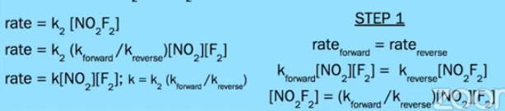
Answer: Rate = k [NO₂][F₂] ; k = k₂(k_{forward} /k_{reverse})

5.9 Steady-State Approximation-Guided Practice
What is the expected rate law for the overall reaction shown below?
Step 1: NO(g) + Br₂(g) ⇄ NOBr₂(g) (fast)
Step 2: NOBr₂(g) + NO ⟶ 2 NO(g) + 2 Br(g) (slow)

AP EXAM FRQ PRACTICE 5.4, 5.7-5.9 - HOMEWORK
Identify the elementary step which would complete the mechanism for the overall reaction listed.
Overall: NO₂(g) + CO(g) ⟶ NO(g) + CO₂(g)
Step 1: ? ?
Step 2: NO₃(g) + CO(g) ⟶ NO₂(g) + CO₂(g)

AP EXAM FRQ PRACTICE 5.4, 5.7-5.9 - HOMEWORK - CONTINUED
Nitrogen dioxide, NO₂(g), is produced as a by-product of the combustion of fossil fuels in internal combustion
engines. At elevated temperatures NO₂(g) decomposes according to the equation below.

2 NO₂(g) ⟶ 2 NO(g) + O₂(g)

The concentration of a sample of NO₂(g) is monitored as it decomposes and is recorded on the graph directly
below. The two graphs that follow it are derived from the original data.
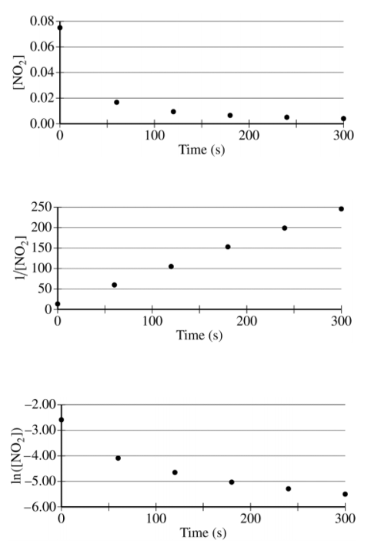
(a) Explain how the graphs indicate that the reaction is second order.
(b) Write the rate law for the decomposition of NO₂(g).
(c) Consider two possible mechanisms for the decomposition reaction.
(i) Is the rate law described by Mechanism I shown below consistent with the rate law you wrote in part (b) ?
Justify your answer.
Mechanism I

Step 1: NO₂(g) + NO₂(g) ⟶ NO(g) + NO₃(g) slow
Step 2: NO₃(g) ⟶ NO(g) + O₂(g) fast

(ii) Is the rate law described by mechanism II shown below consistent with the rate law you wrote in
part (b) ? Justify your answer.

Mechanism II

Step 1: NO₂(g) + NO₂(g) ⇄ N₂O₄(g) fast equilibrium
Step 2: N₂O₄(g) ⟶ 2 NO(g) + O₂(g) slow

AP CHEMISTRY PRACTICE 5.5-5.6,5.10-5.11
AP Chemistry: 5.5-5.6, 5.10-5.11 Collision Model, Reaction Energy Profiles, and Catalysis
WATCH THIS VIDEO BY SEAN BYRNE TO ASSIST IN THESE QUESTIONS

5.5 Collision Model
- For an elementary reaction to successfully produce products, reactants must successfully collide to initiate bond-breaking and bond-making events.
- Successful collisions have both sufficient energy to overcome energy barriers and orientations that allow the bonds to rearrange in the required manner.
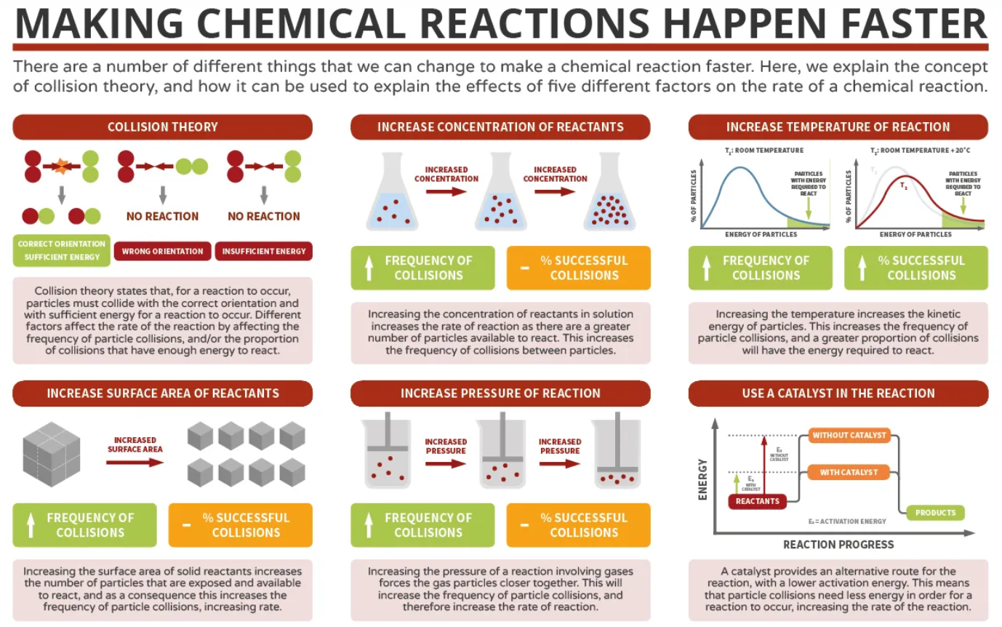
5.6 Reaction Energy Profiles

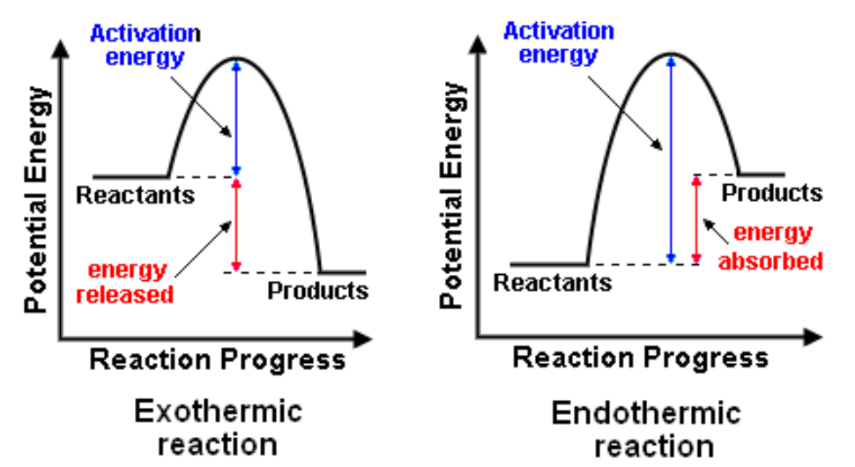

5.6 Reaction Energy Profiles - Guided Practice

Shown below is a potential energy diagram for the uncatalyzed decomposition of H₂O₂(aq). According to the diagram, is the decomposition reaction exothermic or endothermic? Justify your answer. (In the video, Sean says this is endothermic...he is WRONG)
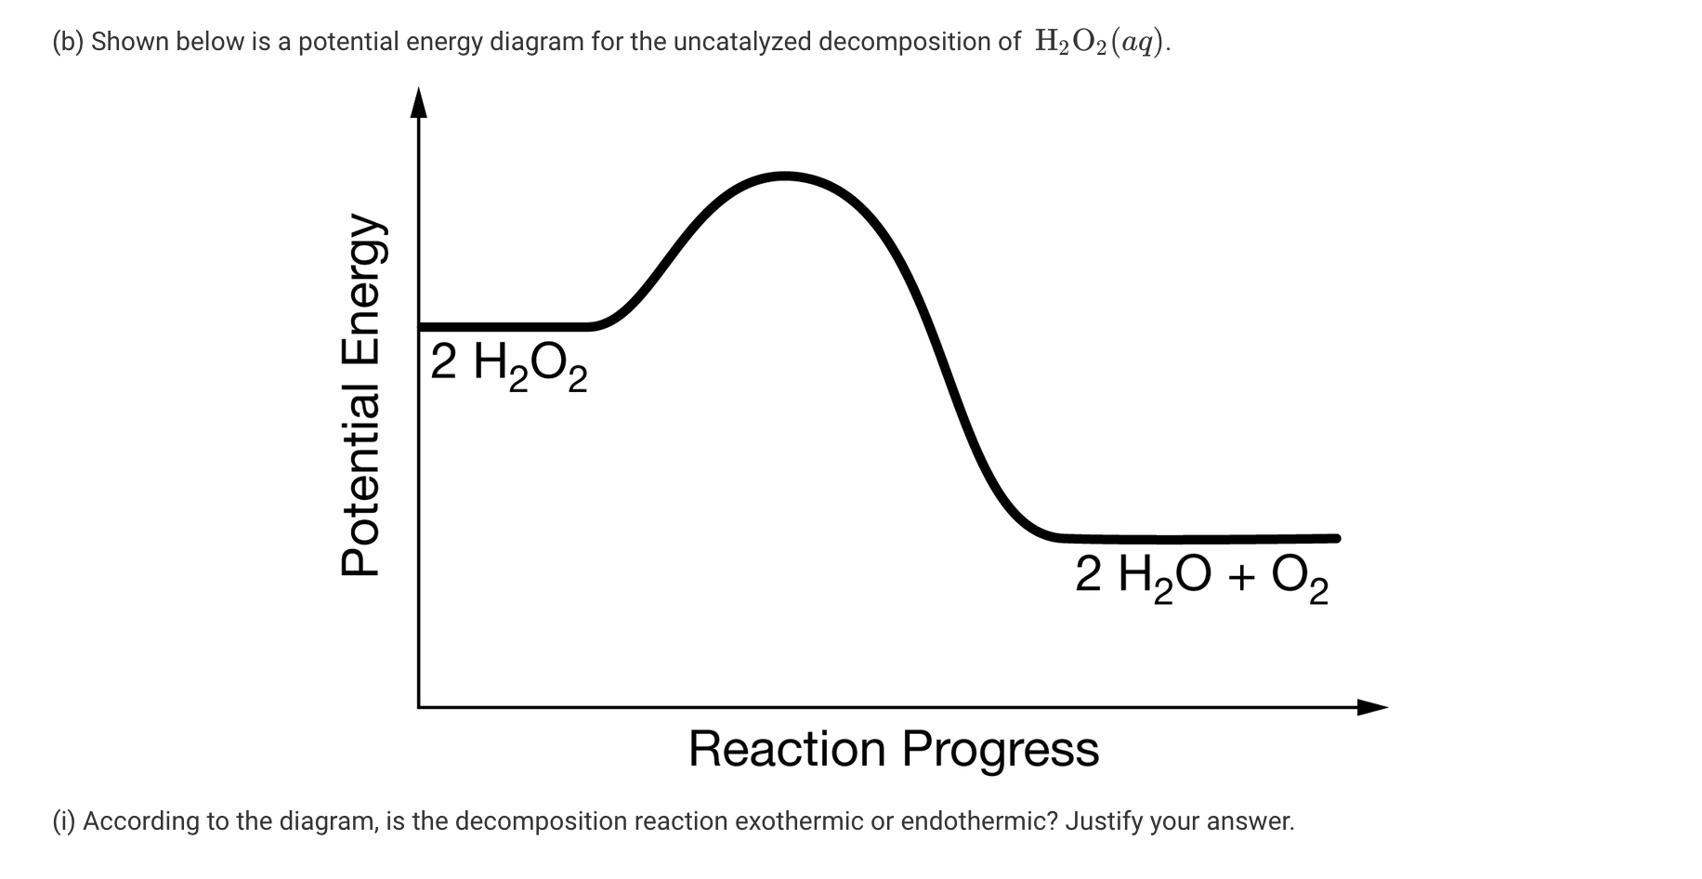

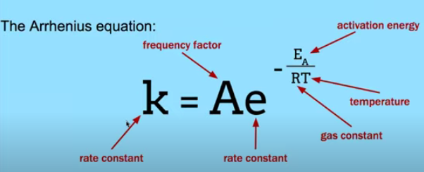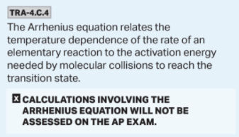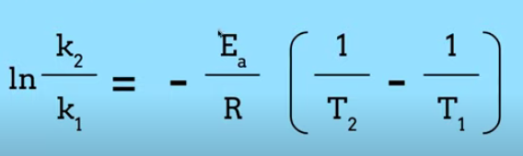

5.10 Multiple Step Reaction Energy Profile
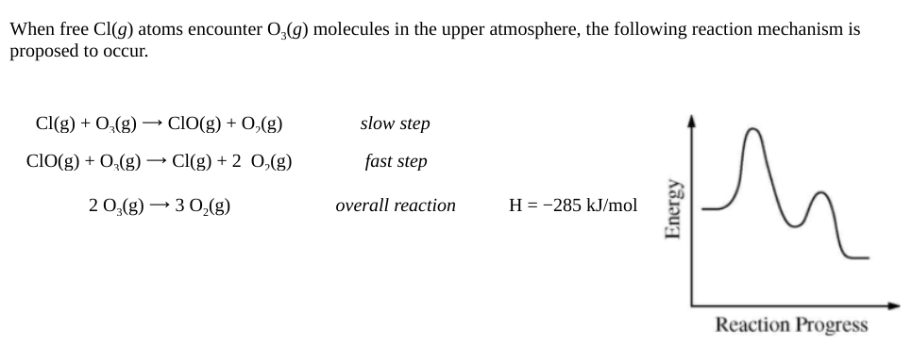
5.11 Catalysis

- Explain the relationships between the effect of a catalyst on a reaction and changes in the reaction mechanism.
  - Catalyst must
    - Increase the number of effective collisions
    - Or provide a reaction path with a lower activation energy
  - In a reaction mechanism containing a catalyst, the net concentration of the catalyst is constant.
    - The catalyst will frequently be consumed in the rate-determining step of the reaction, only to be regenerated in a subsequent step in the mechanism.
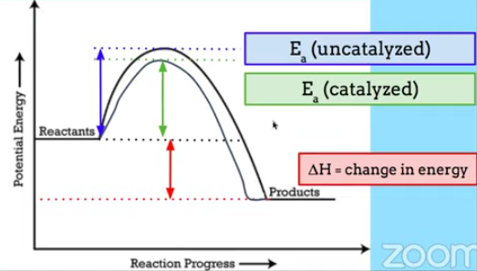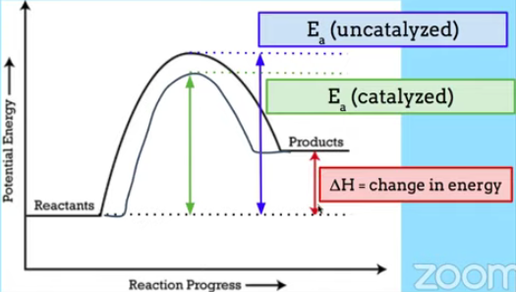

5.11 Catalysis - Guided Practice # 1

Consider the four reaction-energy diagrams below:

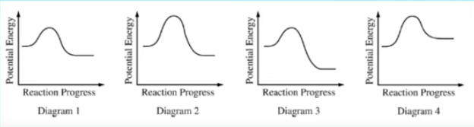

Identify the two diagrams that could represent a catalyzed and an uncatalyzed reaction pathway for the same reaction. Indicate which of the two diagrams represents the catalyzed reaction pathway for the reaction.

- Catalysts provide a reaction path with a lower activation energy
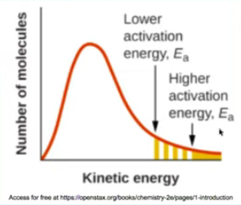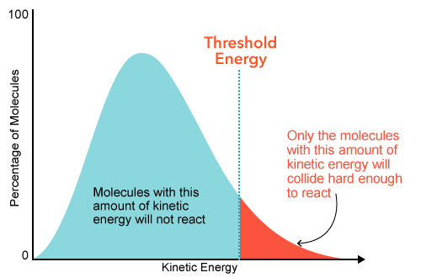

5.11 Catalysis - Guided Practice # 2

X + Y₂ ⟶ XY₂

The energy distribution profile for the X and the Y₂ molecules is shown in the graph below.

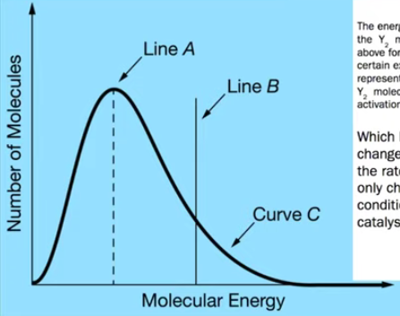

Line A represents the mist probable energy if the Y₂ molecules, and Line B represents the activation energy.

Which line on this graph would change to explain the increase in the rate of the reaction if the only change in experimental conditions is the addition of a catalyst?

5.11 Catalysis - Guided Practice # 3

The two reaction diagrams here represent the same reaction: one without a catalyst and one with a catalyst. Estimate the activation energy for each process, and identify which one involves a catalyst.

ALSO: ΔH_{RXN} = ENERGY_{PRODUCTS} - ENERGY_{REACTANTS} (DOES NOT CHANGE)

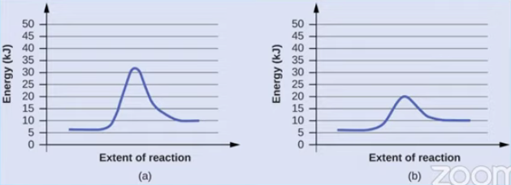

5.10 & 5.11 Multiple Step Reaction Energy Profile & Catalysis - Guided Practice # 4

Reaction diagrams for a chemical process with and without a catalyst are shown below. Both reactions involve a two-step mechanism with a rate-determining first step.
- Compute activation energies for the first step of each mechanism
- Identify which corresponds to the catalyzed reaction
- Compare the second steps of these two mechanisms.

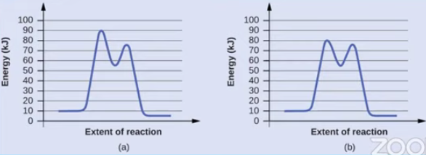

5.11 Catalysis
- Explain the relationships between the effect of a catalyst on a reaction and changes in the reaction mechanism.
  - Binding catalysis
    - The reactants are either oriented more favorably or react with lower activation energy.
    - There is often a new reaction intermediate in which the catalyst is bound to the reactant (s).
    - Many enzymes function in this manner.
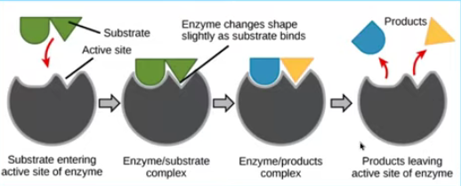
  - Acid-base catalysis
    - A reactant or intermediate either gains or loses a proton
    - This introduces a new reaction intermediate and new elementary reactions involving that intermediate.
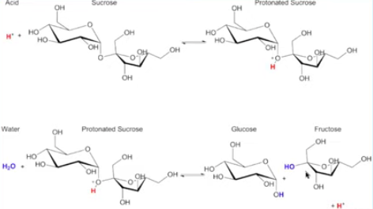

  - Surface catalysis
    - A reactant or intermediate binds to, or forms a covalent bond with, the surface.
    - This introduces elementary reactions involving this new bound reaction intermediate(s).
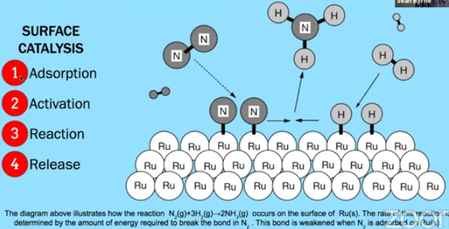

SAMPLE AP FRQ STYLE FOR 2020

Indicate whether you agree or disagree with the statement below. Support your answer with a short explanation.

“Adding a catalyst to a reaction mixture adds energy that causes the reaction to proceed more quickly.”

AP EXAM FRQ PRACTICE 5.5 -5.6, 5.10-5.11 - HOMEWORK

CS₂(g) + 3 Cl₂(g) ⟶ CCl₄(g) + S₂Cl₂(g)

- Carbon tetrachloride, CCl₄(g), can be synthesized according to the reaction represented above. A chemist runs the reaction at a constant temperature of 120°C in a rigid 25.0 L container.

- Chlorine gas, Cl₂(g), is initially present in the container at a pressure of 0.40 atm.

  - How many moles of Cl₂(g) are in the container?

  - How many grams of carbon disulfide, CS₂(g), are needed to react completely with the Cl₂(g) ?

- At 30°C the reaction is thermodynamically favorable, but no reaction is observed to occur. However, at 120°C, the reaction occurs at an observable rate.

  - Explain how the higher temperature affects the collisions between the reactant molecules so that the reaction occurs at an observable rate at 120°C.

  - The graph below shows a distribution for the collision energies of reactant molecules at 120°C. Draw a second curve on the graph that shows the distribution for the collision energies of reactant molecules at 30°C.

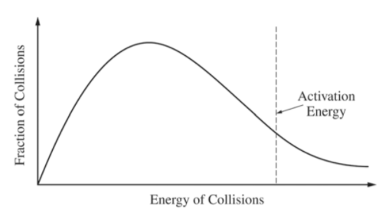

AP EXAM FRQ PRACTICE 5.5 -5.6, 5.10-5.11 - HOMEWORK (CONTINUED)
The formation of C₂H₅Cl(g) is an exothermic reaction (ΔHº = －72.6 kJ/mol_{rxn}). The following two step reaction mechanism is proposed:
Step 1: C₂H₄(g) + HCl(g) ⟶ C₂H₅⁺(g) + Cl－(g) Slow step
Step 2: C₂H₅⁺(g) + Cl－(g) ⟶ C₂H₅Cl(g) Fast step
(c) Write the rate law for the reaction that is consistent with the reaction mechanism above.

(d) Identify an intermediate in the reaction mechanism above.

(e) Using the axes provided, draw a curve that shows energy changes that occur during the progress of the reaction.
The curve should illustrate both proposed two-step mechanisms and the enthalpy change of the reaction.

Potential Energy
Progress of Reaction

(f) On the diagram, clearly indicate the activation energy, E_{a}, for the rate determining step in the reaction.

AP CHEMISTRY PRACTICE 6.1 - 6.5
AP Chemistry: 6.1-6.5 Energy Diagrams, Thermal Equilibrium, and Heat Capacity
WATCH THIS VIDEO BY MICHAEL FARABAUGH TO ASSIST IN THIS QUESTION
6.1 ENDOTHERMIC & EXOTHERMIC PROCESSES
EXOTHERMIC PROCESSES | ENDOTHERMIC PROCESSES
If energy is released during a chemical or physical change, the reaction is called exothermic. | If energy is absorbed during a chemical or physical change, the reaction is called endothermic.
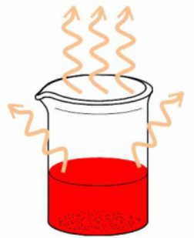 | 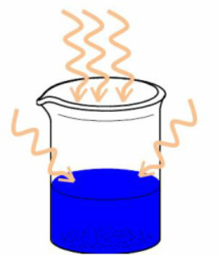
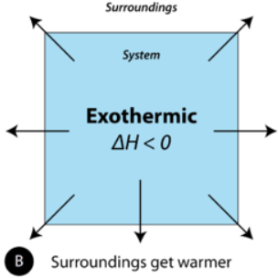 | 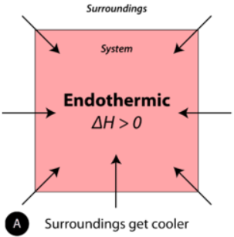
- In an exothermic reaction, energy is released INTO the surroundings as heat.  - As a result, the temperature of the surroundings increases. | - In an endothermic reaction, energy is absorbed FROM the surroundings.  - As a result, the temperature of the surroundings decreases.
EXAMPLES OF EXOTHERMIC PROCESSES:   | EXAMPLES OF ENDOTHERMIC PROCESSES  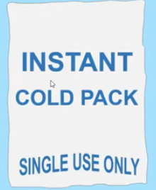
EXOTHERMIC AND ENDOTHERMIC PROCESSES

- System = the portion of the experiment on which we choose to focus our attention. The system normally consists of the reactants and products.
- Surroundings = everything else. The surroundings normally consists of the container, and everything outside the container.
**NOTE: When a solid is dissolved in water to form a solution, the thermometer that is used to record the temperature is considered to be part of the surroundings.**

The first law of thermodynamics states that energy cannot be created or destroyed. It can change from one form to another.
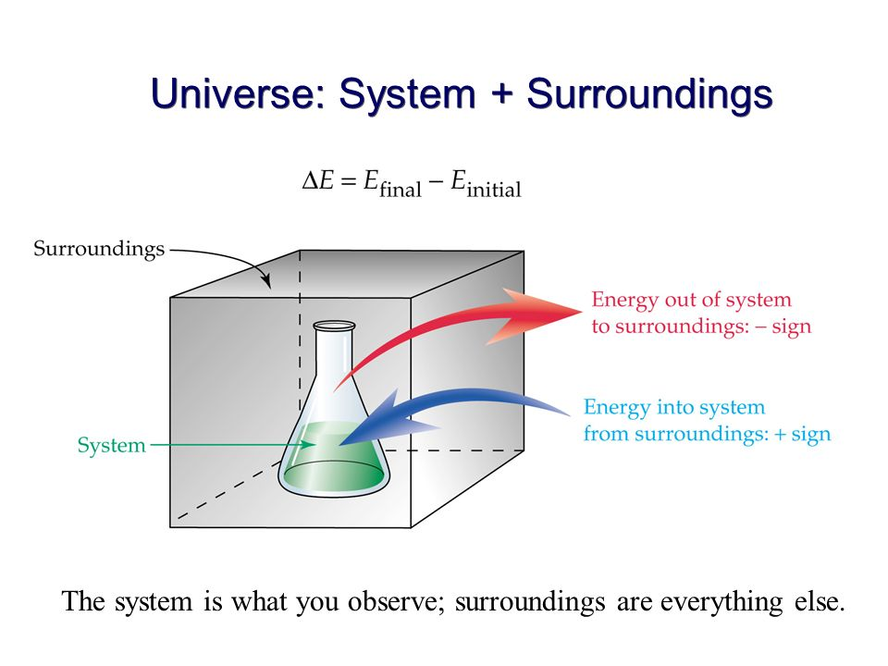

Exothermic & Endothermic Processes - Guided Example

This is the chemical equation for the process of evaporation

H₂O(l) ⟶ H₂O(g)

For each sentence, circle the phrase that factually completes the statement about the process of evaporation.

- Evaporation is an (exothermic / endothermic) process.
- The water is part of the (system / surroundings)
- Heat flows from the (surroundings to the system / system to the surrounding)

6.2 Energy Diagrams

Energy, Enthalpy and Heat
- In chemistry, we tend to use the words energy, enthalpy, and heat interchangeably.
  - Energy = the capacity to do work or transfer heat
  - ΔE = q + w; some textbooks define the change in internal energy of the system ΔE as the sum of the heat (q) and the work (w).
- Heat = the transfer of energy that takes place because of a difference in temperature.
  - Heat spontaneously transfers from the warmer object to the colder object.
- Enthalpy (H) = used to measure changes in energy for a constant-pressure system.
  - In chemistry, many phase changes and chemical reactions occur at constant pressure.
  - ΔH = q_{p}
    - If ΔH > 0, it’s an endothermic process
    - If ΔH < 0, it’s an exothermic process

TIPS FOR AP CHEMISTRY - q vs ΔH

- If the question asks you to calculate the value of q, they are referring to the MAGNITUDE of the heat that is absorbed or released in a certain process. They don’t normally ask for the SIGN of q. The units of q are joules (J) or kilojoules (kJ)

- If the question asks you to calculate the value of ΔH, they are referring to the CHANGE in enthalpy for a certain process. You should include the SIGN of ΔH in your final answer. The units of ΔH are typically kJ/mol or kJ/mol_{rxn}.

6.3 Heat Transfer and Thermal Equilibrium
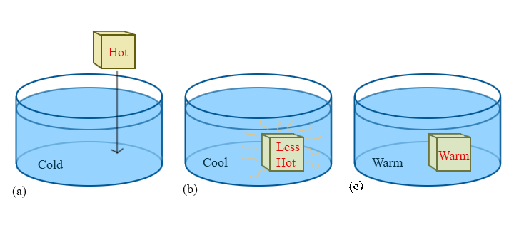
When two substances at different temperatures come into contact:
- The higher temperature substance will lose energy (via collision) to the lower temperature substance
- The lower temperature substance will gain energy (via collision) from the higher temperature substance
- The amount of energy lost will equal to the amount of energy gained
  - qloss = －qgained
- Eventually both objects will reach the same temperature and be said to be at thermal equilibrium

6.4 Heat Capacity and Calorimetry - Guided AP Style Practice Questions

Mass of Copper | 50.00 g
Initial Temperature of Copper | 100.0 ºC
Mass of Water | 100.0 ºC
Initial Temperature of Water | 20.0 ºC
Final Temperature of System (Copper + Water) | 23.6ºC
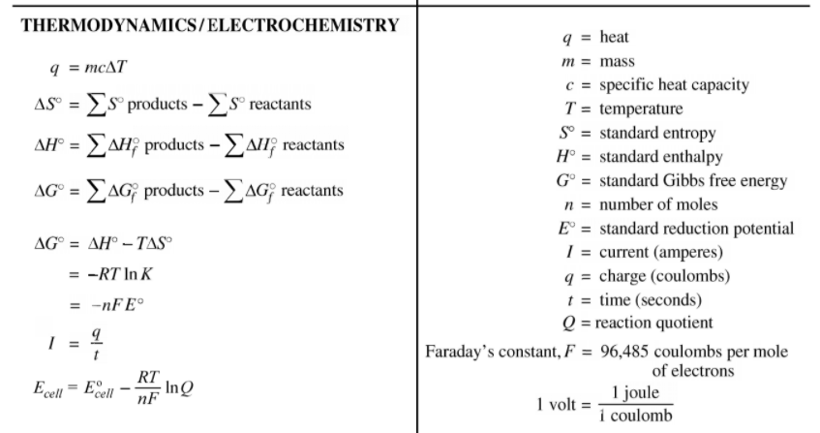
  - The specific heat capacity of water is equal to 4.182 J/gºC. That means that it requires 4.18 J of heat in order to raise the temperature of 1 gram of H₂O by 1 ºC.

- We can use the equation q = mcΔT to solve for the specific heat capacity of copper because…

  - mcΔT (for the copper) = mcΔT (for the water)

Using this information, answer the following questions…

- What is the |ΔT| for the copper?

- What is the |ΔT| for the water?

- A student claims that, since the magnitude of ΔT for the copper is greater than that of water, it means that the magnitude of heat (q) lost by the copper is greater than the magnitude of (q) gained by the water. Do you agree with this claim? Is the magnitude of heat (q) lost by the copper less than, more than, or equal to the magnitude of heat (q) gained by the water?

- Using the information given and the heat capacity equation, solve for the specific heat capacity of copper.

Heat Capacity and Calorimetry - Guided AP Style Practice Questions (Continued)
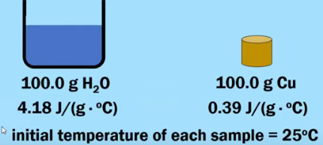

- Suppose that each of these samples absorbs 500 J of heat. Which sample, H₂O or Cu, will reach a higher final temperature? Justify your answer.

- The specific heat capacity of Cu is equal to 0.39 J/gºC. Calculate the molar heat capacity of Cu, in units of J/mol ºC.

6.5 Energy of Phase Changes
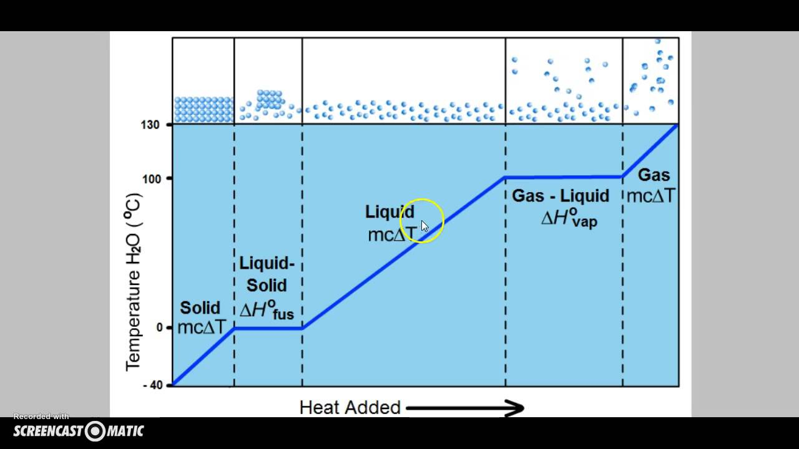
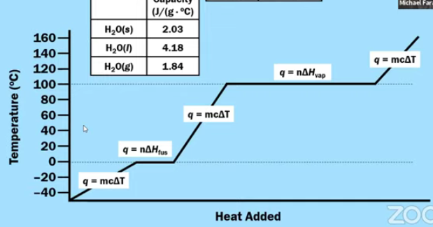

6.5 Energy of Phase Changes - Guided Practice # 1

The following question refers to the graph below, which shows the heating curve for methane, CH₄.
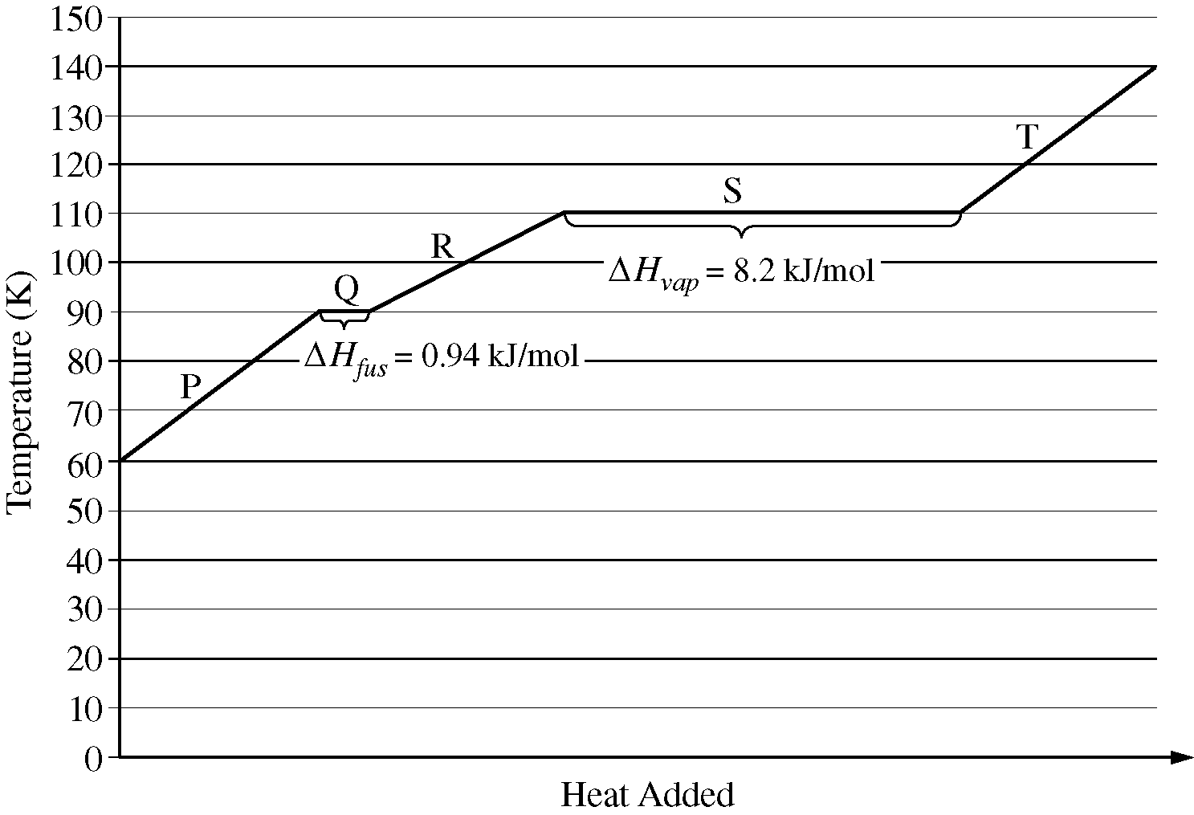 | In terms of intermolecular attractive forces, explain why line segment S is much longer than line segment Q.

6.5 Energy of Phase Changes - Guided Practice # 2

Substance | ΔH_{vap} (kJ/mol) | In terms of intermolecular attractive forces, explain why the value of ΔH_{vap} for H₂O is much greater than the value of ΔH_{vap} for CH₄.
CH₄ | 8.2
H₂O | 40.7

6.5 Energy of Phase Changes - AP STYLE QUESTION # 1*

Some building materials contain small capsules filled with paraffin wax to improve the insulating properties of the materials. The melting and freezing of paraffin inside the capsules in the material helps to regulate temperature. Paraffin wax begins to melt at 37ºC.

- While the wax is melting, is the net flow of thermal energy from the wax to the surroundings or from the surroundings to the wax? Justify your answer.

- Calculate the amount of thermal energy, in kJ, that is required to melt 15.2 grams of solid paraffin wax when the temperature of the surroundings is above the melting point of paraffin. (The molar mass of paraffin is 282.62 g/mol, and its molar heat of fusion is 48.78 kJ/mol)

- When paraffin wax melts, its density decreases. Provide a particle level explanation of this observation.

6.5 Energy of Phase Changes - AP STYLE QUESTION # 2*

A student investigates the enthalpy of solutions, ΔH_{soln}, for two alkali metal halides, LiCl and NaCl. In addition to the salts, the student has access to a calorimeter, a balance with a precision of ±0.1 g, and a thermometer with a precision of ±0.1 ºC.

- To measure ΔH_{soln} for LiCl, the student adds 100.0 g of water initially at 15.0 ºC to a calorimeter and adds 10.0 g of LiCl(s), stirring to dissolve. After the LiCl dissolves completely, the maximum temperature reached by the solution is 35.6 ºC.

  - Calculate the magnitude of the heat absorbed by the solution during the dissolution process, assuming that the specific heat capacity of the solution is 4.18 J/g ºC. Include units with your answer.

  - Determine the value of ΔH_{soln} for LiCl in kJ/mol_{rxn}

- The lattice enthalpy of LiCl is positive, indicating that it takes energy to break the ions apart in LiCl. However, the dissolution of LiCl in water is an exothermic process. Identify all particle-particle interactions that contribute significantly to the dissolution process being exothermic. For each interaction, inclue the particles that interact and the specific type of intermolecular force between those particles.

6.5 Energy of Phase Changes - AP STYLE QUESTION # 2*

Aluminum metal can be recycled from scrap metal by melting the metal to evaporate impurities.

- Calculate the amount of heat needed to purify 1.00 mole of Al originally at 298 K by melting it. The melting point of Al is 933 K. The molar heat capacity of Al is 24 J/(mol⋅K), and the heat of fusion of Al is 10.7 kJ/mol.

- The equation for the overall process of extracting Al from Al₂O₃ is shown below. Which requires less energy, recycling existing Al or extracting Al from Al₂O₃? Justify your answer with a calculation.

Al₂O₃(s) → 2 Al(s) + $\frac{3}{2}$O₂(g) ∆H° = 1675 kJ/mol_{rxn}

AP EXAM FRQ PRACTICE - 6.1-6.5 - HOMEWORK

MgO(s) + 2 H⁺(aq) ⟶ Mg²⁺(aq) + H₂O(l)

A student was assigned the task of determining the enthalpy change for the reaction between solid MgO and aqueous HCl represented by the net-ionic equation above. The student uses a polystyrene cup calorimeter and performs four trials. Data for each trial are shown in the table below.
Trial | Volume of 1.0 M HCl (mL) | Mass of MgO(s) Added (g) | Initial Temperature of Solution  (ºC) | Final Temperature of Solution  (ºC)
1 | 100.0 | 0.25 | 25.5 | 26.5
2 | 100.0 | 0.50 | 25.0 | 29.1
3 | 100.0 | 0.25 | 26.0 | 28.1
4 | 100.0 | 0.50 | 24.1 | 28.1

- Which is the limiting reactant in all four trials, HCl or MgO? Justify your answer.

- The data in one of the trials is inconsistent with the data in the other three trials. Identify the trial with inconsistent data and draw a line through the data from that trial in the table above. Explain how you identified the inconsistent data.

For parts (c) and (d), use the data from one of the other three trials (i.e., not from the trial you identified in part (b) above). Assume the calorimeter has a negligible heat capacity and that the specific heat of the contents of the calorimeter is 4.18 J/gºC. Assume that the density of the HCl(aq) is 1.0 g/mL.

- Calculate the magnitude of q, the thermal energy change, when the MgO was added to the 1.0 M HCl(aq). Include units with your answer.

- Determine the student's experimental value of ΔHº for the reaction between MgO and HCl in units of kJ/mol_{rxn}.

- Enthalpies of formation for substances involved in the reaction are shown in the table below. Using the information in the table, determine the accepted value of ΔHº for the reaction between MgO(s) and HCl(aq).

Substance | ΔH_{f}º (kJ/mol)
MgO(s) | －602
H₂O(l) | －286
H⁺(aq) | 0
Mg²⁺(aq) | －467

- The accepted value and the experimental value do not agree. If the calorimeter leaked heat energy to the environment, would it help account for the discrepancy between the values? Explain.

AP CHEMISTRY PRACTICE 6.6 - 6.9
AP Chemistry: 6.6-6.9 Enthalpy of Reaction/Formation and Hess's Law
WATCH THIS VIDEO BY MICHAEL FARABAUGH TO ASSIST IN THIS QUESTION

6.6 Introduction to Enthalpy of Reaction

ΔH > 0 ΔH <0
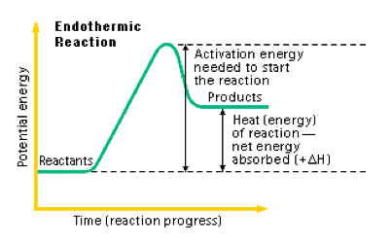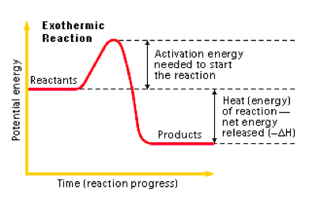

6.6 Introduction to Enthalpy of Reaction - Guided Practice # 1

The combustion of methane gas is represented by the equation shown below.

CH₄(g) + 2 O₂(g) ⟶ CO₂(g) + 2 H₂O(g) ΔHº = －802 kJ/mol_{rxn}

When this reaction occurs, is energy absorbed or released by the system?

6.6 Introduction to Enthalpy of Reaction - Guided Practice # 2

CH₄(g) + 2 O₂(g) ⟶ CO₂(g) + 2 H₂O(g) ΔHº = －802 kJ/mol_{rxn}

CH₄(g) + 2 O₂(g) ⟶ CO₂(g) + 2 H₂O(l) ΔHº = ???

If this reaction had been written with 2 moles of liquid water on the right instead of 2 moles of vapor, would the magnitude of ΔHº be less than or greater than 802 kJ? (Remember that evaporation is an endothermic process and condensation is an exothermic process)

Stoichiometry & Enthalpy Change for a Reaction - Guided Practice

The combustion of methane gas is represented by the equation shown below.

CH₄(g) + 2 O₂(g) ⟶ CO₂(g) + 2 H₂O(g) ΔHº = －802 kJ/mol_{rxn}

The following stoichiometric quantities are derived from this reaction

$\frac{802 kJ}{1 mol {CH}_{4}}$ $\frac{802 kJ}{2 mol O_{2}}$ $\frac{802 kJ}{1 mol CO_{2}}$ $\frac{802 kJ}{2 mol H_{2}O}$

- Suppose that 7.50 g of CH₄(g) reacts completely with excess O₂(g) according to the equation shown above. How many kJ of thermal energy would be released?

- Suppose that 45.0 g of O₂(g) reacts completely with excess CH₄(g) according to the equation shown above. How many kJ of thermal energy would be released?

- The combustion of propane gas is represented by the equation shown below.

C₃H₈(g) + 5 O₂(g) ⟶ 3 CO₂(g) + 4 H₂O(g) ΔHº = ???

Suppose that 1.00 gram of C₃H₈(g) reacts completely with O₂(g) according to the equation shown above. The heat that is released from this reaction is completely transferred to a container with 250.0 g of water inside. The temperature of the water increases from 20.0ºC to 68.2 ºC. (The specific heat capacity of water is 4.18 J/gºC).

- Calculate the amount of heat (q) released from the combustion of 1.00 g of C₃H_{8.}

- Calculate the value of ΔHº, in units of kJ/mol_{rxn} for the reaction shown above.

6.7 Bond Enthalpies
- Bond enthalpy represents the energy required to break a bond. (endothermic to break a bond)
- It can also represent the amount of energy released when a bond is formed. (exothermic to make a bond)

Table of Bond Enthalpies
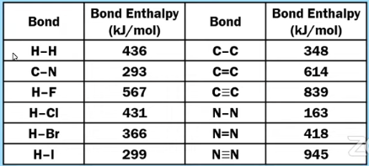

Let’s see how we can get the value of ΔHº

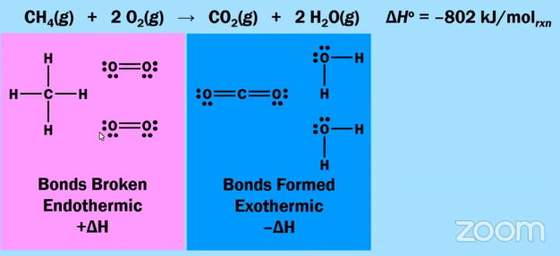
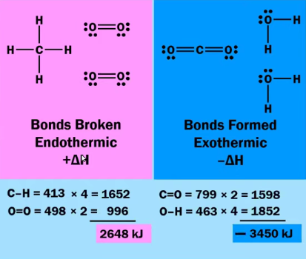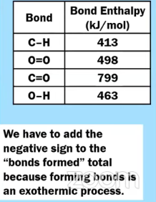
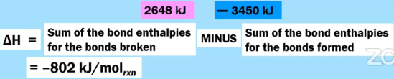

6.7 Bond Enthalpies - Sample AP Style Question # 1

Fulminic acid can convert to isocyanic acid according to the equation below.

HCNO(g) ⇄ HNCO(g)
Fulminic acid isocyanic acid
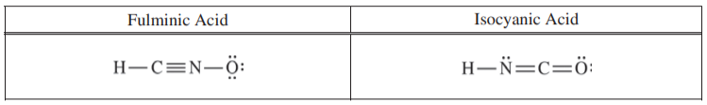

(b) Using the Lewis electron-dot diagrams of fulminic acid and isocyanic acid shown in the boxes above and the table of average bond enthalpies below, determine the value of ΔHº for the reaction of HCNO(g) to form HNCO(g) .

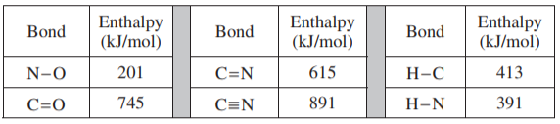

6.7 Bond Enthalpies - Sample AP Style Question # 2

The compound BrCl can decompose into Br₂ and Cl₂, as represented by the balanced chemical equation below.

2 BrCl(g) ⇄ Br₂(g) + Cl₂(g) ΔHº = 1.6 kJ/mol_{rxn}

Calculate the bond energy of the Br-Cl bond, in kJ/mol, using ΔHº for the reaction (1.6 kJ/mol_{rxn}) and the information in the following table.
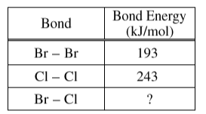

6.8 Enthalpy of Formation
- The standard enthalpy of formation, ΔH_{f}º, represents the change in enthalpy associated with the formation (synthesis) of one mole of a compound from its elements under standard conditions (1 atm and 25ºC).
- By definition, the standard enthalpy of formation, ΔH_{f}º, for a pure element in its standard state is equal to ZERO.

Examples of standard enthalpy of formation, ΔH_{f}º,:

C(s) + ½ O₂(g) ⟶ CO(g) ΔH_{f}º = －110.5 kJ/mol_{rxn}

C(s) + O₂(g) ⟶ CO₂(g) ΔH_{f}º = －393.5 kJ/mol_{rxn}

H₂(g) + ½ O₂(g) ⟶ H₂O(g) ΔH_{f}º = －241.8 kJ/mol_{rxn}

C(s) + H₂(g) ⟶ CH₄(g) ΔH_{f}º = －74.8 kJ/mol_{rxn}
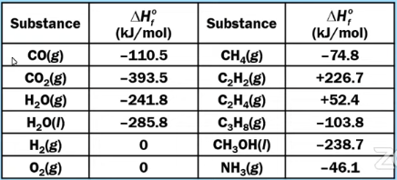
6.8 Enthalpy of Formation - Guided Practice # 1

- Calculate the ΔH_{rxn} for the following chemical equation. Use the ΔH_{f}º given above. (Pay attention to phases!)

CH₄(g) + 2 O₂(g) ⟶ CO₂(g) + 2 H₂O(g)

- Calculate the ΔH_{rxn} for the following chemical equation. Use the ΔH_{f}º given on the previous page. (Pay attention to phases!)
CH₄(g) + 2 O₂(g) ⟶ CO₂(g) + 2 H₂O(l)

NOTE: DO NOT CONFUSED BOND ENTHALPY WITH ENTHALPY OF FORMATION!

6.8 Enthalpy of Formation - AP Style Question

In a separate experiment, the student measures the enthalpies of combustion of propene and vinyl chloride. The student determines that the combustion of 2.00 mol of vinyl chloride releases 2300 kJ of energy, according to the equation below.
2 C₂H₃Cl(g) + 5 O₂(g) ⟶ 4 CO₂(g) + 2 H₂O(g) + 2 HCl(g) ∆H° = -2300 kJ/mol_{rxn}

(c) Using the table of standard enthalpies of formation below, determine whether the combustion of 2.00 mol of propene releases more, less, or the same amount of energy that 2.00 mol of vinyl chloride releases. Justify your answer with a calculation. The balanced equation for the combustion of 2.00 mol of propene is 2 C₃H₆(g) + 9 O₂(g) ⟶ 6 CO₂(g) + 6 H₂O(g).

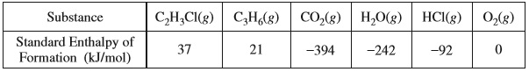

6.9 Hess’s Law
- If you add two or more reactions together, the value of ΔH for the overall reaction is equal to the SUM of the ΔH values of the individual reactions.
- Rules Associated with Changing Thermochemical Equations
  - If an equation is reversed, change the sign of ΔH
  - If an equation is multiplied by N, multiply the value of ΔH by N
  - If equations are added together, add up the total of the ΔH values
6.9 Hess’s Law - Guided Practice

Show how Equations 1, 2 and 3 can be manipulated and combined together in a certain way so that they will equal Equation 4. As you are manipulating the equations, manipulate the ΔH’s and then calculate the ΔH_{rxn} for Equation 4.

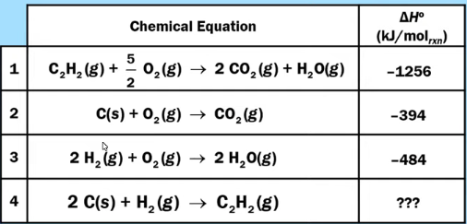

AP EXAM FRQ PRACTICE - 6.6-6.9 - HOMEWORK

Na₂S₂O₃(aq) + 4 NaOCl(aq) + 2 NaOH(aq) ⟶ 2 Na₂SO₄(aq) + 4 NaCl(aq) + H₂O(l)

A student performs an experiment to determine the value of the enthalpy change, ΔHº_{rxn}, for the oxidation-reduction reaction represented by the balanced equation above.

In the experiment, the student uses the solutions shown in the table below.

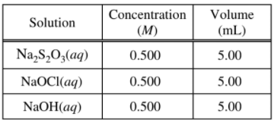

(c) Using the balanced equation for the oxidation-reduction reaction and the information in the table above, determine which reactant is the limiting reactant. Justify your answer.

The solutions, all originally at 20.0°C, are combined in an insulated calorimeter. The temperature of the reaction mixture is monitored, as shown in the graph below.
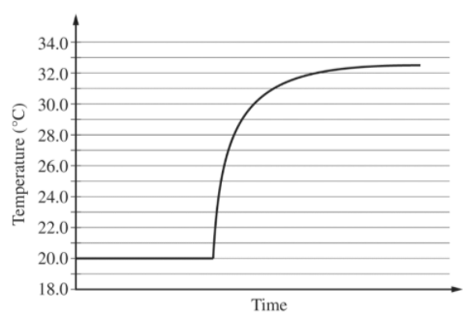
(d) According to the graph, what is the temperature change of the reaction mixture?

AP EXAM FRQ PRACTICE - 6.6-6.9 - HOMEWORK (CONTINUED)

(e) The mass of the reaction mixture inside the calorimeter is 15.21 g.

(i) Calculate the magnitude of the heat energy, in joules, that is released during the reaction. Assume that the specific heat of the reaction mixture is 3.94 J/(g·°C) and that the heat absorbed by the calorimeter is negligible.

(ii)Using the balanced equation for the oxidation-reduction reaction and your answer to part (c), calculate the value of the enthalpy change of the reaction, ΔHº_{rxn} , in kJ/mol_{rxn} . Include the appropriate algebraic sign with your answer.

The student repeats the experiment, but this time doubling the volume of each of the reactants, as shown in the
table below.

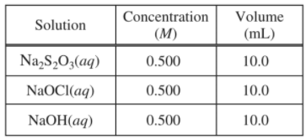

(f) The magnitude of the enthalpy change, ΔHº_{rxn} , in kJ/mol_{rxn} , calculated from the results of the second experiment is the same as the result calculated in part (e)(ii). Explain this result.

AP CHEMISTRY PRACTICE 7.1-7.6
AP Chemistry: 7.1-7.6 Equilibrium, Reversible Reactions, and the Equilibrium Constant
WATCH THIS VIDEO BY SEAN BYRNE TO ASSIST IN THIS QUESTION

7.1 Introduction to Equilibrium & 7.2 Direction of Reversible Reactions

Evaporation & Condensation of Water Reaches Equilibrium in a Closed Container
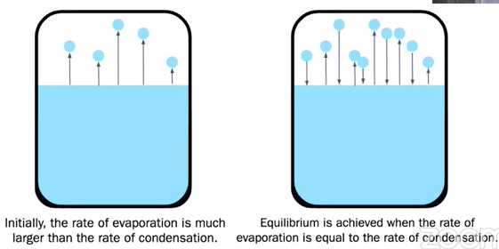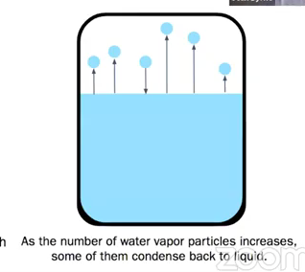

Dissolution of a solid reaches equilibrium in a closed container
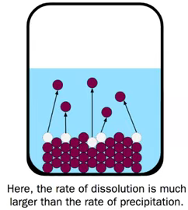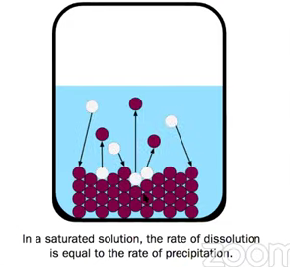

Consider the following reaction as it approaches equilibrium in a closed container
N₂O₄(g) ⇄ 2 NO₂(g)
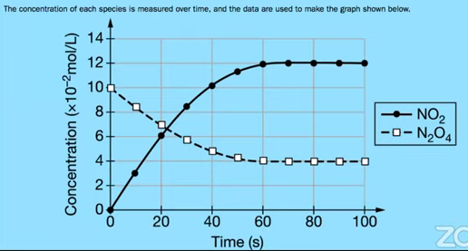 | - AP Chemistry Misconception:  - Students think that when we say “Equilibrium” that we have equal amounts of reactants and products. (FALSE)  - Equilibrium, for this reaction, starts at about 60 minutes- the concentrations of the reactants and products DO NOT CHANGE (CONSTANT)  - Reactants decrease in concentration and Products increase in concentration
2 SO₂(g) + O₂(g) ⇄ 2 SO₃(g)
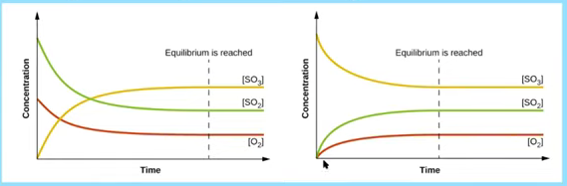
Start with all reactants, no products and still end up achieving equilibrium. | Start with all products, no reactants and still end up achieving

Equilibrium

- When equilibrium is reached:
  - Reactants and products are simultaneously present
  - The concentrations or partial pressures of all species remain constant
  - No observable changes occur in the system
  - The equilibrium state is dynamic; the forward and reverse processes continue to occur at equal rates, resulting in no net observable change.

7.3 Reaction Quotient and Equilibrium Constants & 7.4 Calculating the Equilibrium Constant

aA + bB ⇄ cC + dD

$Q = \frac{[C]^{c}[D]^{d}}{[A]^{a}[B]^{b}}$ $K_{eq} = \frac{[C]^{c}[D]^{d}}{[A]^{a}[B]^{b}}$
AT ANY TIME AT EQUILIBRIUM
${ K}_{P} = \frac{(P_{C})^{c}(P_{D})^{d}}{(P_{A})^{a}(P_{B})^{b}}$
7.3 Reaction Quotient and Equilibrium Constants & 7.4 Calculating the Equilibrium Constant (Continued)
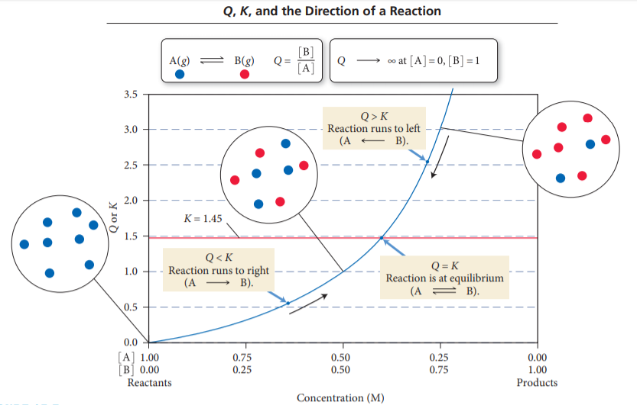
7.3 Reaction Quotient and Equilibrium Constants & 7.4 Calculating the Equilibrium Constant - Guided Practice # 1

The initial concentrations or pressures of reactants and products are given for each of the following systems. Calculate the reaction quotient and determine the direction in which each system will proceed to reach equilibrium.

- 2 | 2 NH₃(g) ⇄ N₂(g) + 3 H₂(g) | K_{c} = 17 | [NH₃] = 0.20 M | [N₂] = 1.00 M | [H₂] = 1.00 M

- 2 | 2 NH₃(g) ⇄ N₂(g) + 3 H₂(g) | K_{P} = 6.8 × 10⁴ | NH₃= 3.0 atm | N₂ = 2.0 atm | H₂ = 1.0 atm

- 2 | 2 SO₃(g) ⇄ 2 SO₂(g) + O₂(g) | K_{c} = 0.230 | [SO₃] = 0.00 M | [SO₂] = 1.00 M | [O₂] = 1.00 M
Hint: Zero on Top = 0. Zero on Bottom = ∞

- 2 | 2 SO₃(g) ⇄ 2 SO₂(g) + O₂(g) | K_{P} = 16.5 | SO₃= 1.00 atm | SO₂ = 1.00 atm | O₂ = 1.00 atm

7.3 Reaction Quotient and Equilibrium Constants 7.4 Calculating the Equilibrium Constant- Guided Practice # 2

2 A(g) + B(g) ⇄ 2 C (g)

A(g) and B(g) react to form C(g), according to the balanced equation above. In an experiment, a previously evacuated rigid vessel is charged with A(g), B(g), and C(g), each with a concentration of 0.0100 M. The following table shows the concentrations of the gases at equilibrium at a particular temperature.

[A]_{eq} | [B]_{eq} | [C]_{eq}
0.018 | 0.014 | 0.0020

- Calculate the value of K_{c}.

- If the experiment is repeated at a higher temperature, K_{c}, is found to have a larger value. Describe the effect of the temperature change on the concentrations of the gases at equilibrium.

7.3 Reaction Quotient and Equilibrium Constants & 7.4 Calculating the Equilibrium Constant - Guided Practice # 3

- NOTE: SOLIDS & LIQUIDS ARE NOT WRITTEN IN EQUILIBRIUM EXPRESSIONS*
  - The reaction quotient does NOT include substances whose concentrations (or partial pressures) are independent of the amount, such as for solids and pure liquids.

Write equilibrium expressions for the following reactions. (Remember, we do not include solids or liquids)

- CH₄(g) + 2 O₂(g) ⇄ CO₂(g) + 2 H₂O(l) K =

- 2 Pb(NO₃)₂(s) ⇄ 2 PbO(s) + 4 NO₂(g) + O₂(g) K =

- C₈H₁₀N₄O₂(aq) + H₂O(l) ⇄ C₈H₁₀N₄O₂H⁺(aq) + OH－(aq) K_{b} =

- Al(NO₃)₃(s) ⇄ Al³⁺(aq) + 3 NO₃－(aq) K_{sp} =

7.5 Magnitude of Equilibrium Constant

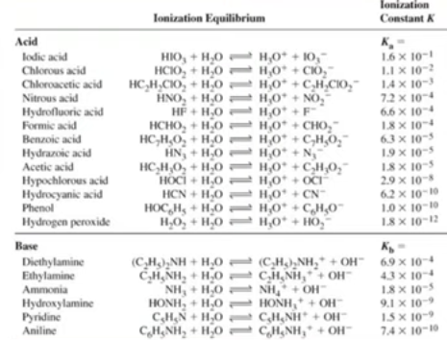 | - Small K values are reactant favored  - Large K values are product favored.  - The larger the K value, the more products that will be present at equilibrium  - The smaller the K value, the less products (and thus more reactants) present at equilibrium

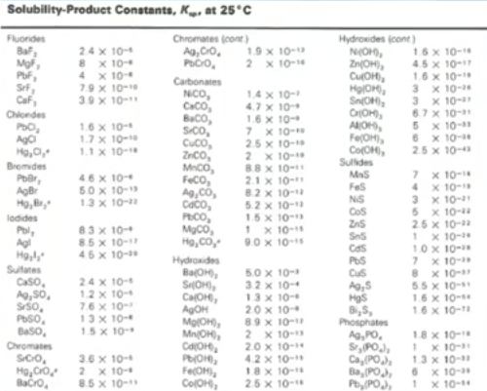

7.5 Magnitude of Equilibrium Constant - Guided Practice

Reaction | Equilibrium Reactions at 298 K | K_{eq}
1 | Br₂(g) + Cl₂(g) ⇄ 2 BrCl(g) | 10.
2 | N₂(g) + O₂(g) ⇄ 2 NO(g) | 4.2 × 10^{－31}

The table above shows data for two reactions carried out in two separate experiments. The students started with 2 evacuated 1.0-Liter rigid containers at a constant temperature of 298 K. To each container 0.50 mol of the appropriate reactants was added, and the reaction was allowed to reach equilibrium.

Based on this information, how do the relative concentrations of BrCl and NO present inside their respective containers at equilibrium compare to one another?

7.6 Properties of the Equilibrium Constant
- If a chemical equation is modified in some way, then the equilibrium constant for the equation changes because of the modification. There are three common modifications:
- If you reverse the equation, invert the equilibrium constant.
- If you multiply the coefficients in the equations by a factor, raise the equilibrium constant to the same factor.
- If you add two or more individual chemical equations to obtain an overall equation, multiply the corresponding equilibrium constants by each other to obtain the overall equilibrium constant.

7.6 Properties of the Equilibrium Constant - Guided Practice # 1

Reaction 1: CO(g) + 3 H₂(g) ⇄ CH₄(g) + H₂O(g) $K_{1}= \frac{[CH_{4}][H_{2}O]}{[CO][H_{2}]^{3}}$

Reaction 2: CO₂(g) + H₂(g) ⇄ CO(g) + H₂O(g) $K_{2}= \frac{[CO][H_{2}O]}{[CO_{2}][H_{2}]}$

Reaction 3: CH₄(g) + 2 H₂O(g) ⇄ CO₂(g) + 4 H₂(g) $K_{3}=$

The chemical equations and equilibrium expressions for two reactions at the same temperature are given above. Based on the information, how can they be used to calculate the value of K₃ for Reaction 3 at the same temperature?

7.6 Properties of the Equilibrium Constant - Guided Practice # 2

Reaction 1: CO(g) + 3 H₂(g) ⇄ CH₄(g) + H₂O(g) $K_{1}= \frac{[CH_{4}][H_{2}O]}{[CO][H_{2}]^{3}}$

Reaction 2: 2 CO₂(g) + 6 H₂(g) ⇄ 2 CH₄(g) + 2 H₂O(g) $K_{2}= \frac{[CH_{4}]^{2}[H_{2}O]^{2}}{[CO_{2}]^{2}[H_{2}]^{6}}$

The chemical equations and equilibrium expressions for two reactions at the same temperature are given above. Based on the information, how can you manipulate the K₁ to get the K₂ value for Reaction 2 at the same temperature?

7.6 Properties of the Equilibrium Constant - Guided Practice # 3

Reaction 1: HOCl(aq) + H₂O(l) ⇄ H₃O⁺(aq) + OCl－(aq) $K_{1}= \frac{[H_{3}O^{+}] [OCl^{-}]}{[HOCl]}$

Reaction 2: 2 H₂O(l) ⇄ H₃O⁺(aq) + OH－(aq) K₂ = [H₃O⁺] [OH－]

Reaction 3: OCl－(aq) + H₂O(l) ⇄ HOCl(aq) + OH－(aq) K₃ = ?

Based on the equilibrium constants given above, what is the correct expression for the equilibrium constant for Reaction 3?

AP EXAM FRQ PRACTICE - 7.1-7.6 - HOMEWORK

In an experiment, X(g) and Y(g) were combined in a rigid container at constant temperature and allowed to react as shown in the equation below. The graph provides the data collected during the experiment.

X(g) + Y(g) ⇄ XY(g)

Indicate whether you agree or disagree with the statement below. Support your answer with a short explanation.

“The reaction was about to reach equilibrium at time =A because the concentrations of X and XY were almost the same.”

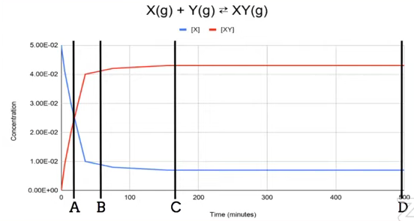

AP EXAM FRQ PRACTICE - 7.1-7.6 - HOMEWORK (CONTINUED)

An equimolar mixture of X(g) and Y(g) is placed inside a rigid container at constant temperature. Each particle diagram below represents the changes that occur over time.
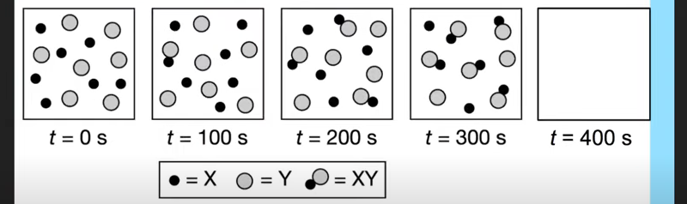
Draw a particle diagram in the box for t = 400 s that is consistent with the conclusion that equilibrium was reached for this reaction after 300 seconds, but before 400 seconds.

N₂(g) + O₂(g) ⇄ 2 NO(g)

- At high temperatures, N₂(g) and O₂(g) can react to produce nitrogen monoxide, NO(g), as represented by the equation above.

- Write the expression for the equilibrium constant, K_{P}, for the forward reaction.

- A student injects N₂(g) and O₂(g) into a previously evacuated, rigid vessel and raises the temperature of the vessel to 2000ºC. At this temperature the initial partial pressures of N₂(g) and O₂(g) are 6.01 atm and 1.61 atm, respectively. The system is allowed to reach equilibrium. The partial pressure of NO(g) at equilibrium is 0.122 atm. Calculate the value of K_{P}.

AP CHEMISTRY PRACTICE 7.7-7.10
AP Chemistry: 7.7-7.10 Calculating Equilibrium Concentrations and Le Châtelier's Principle
WATCH THIS VIDEO BY SEAN BYRNE TO ASSIST IN THIS QUESTION
7.7 Calculating Equilibrium Concentrations - Guided Practice # 1

H₂(g) + I₂(g) ⇄ 2 HI(g)

At Equilibrium, [H₂] = 0.100 M , [I₂] = 0.100 M and [HI] = 0.714 M. Calculate the value of K_{c}.

7.7 Calculating Equilibrium Concentrations - Guided Practice # 2
H₂(g) + I₂(g) ⇄ 2 HI(g) K_{c} = 51.0
A sample of H₂(g) and I₂(g) is added to a previously evacuated reaction vessel. The initial concentrations are the following.
[H₂] = [I₂] = 2.0 M
Calculate the concentrations of all three gases in the reaction at equilibrium. Use the ICE Table to help you compute your answer.
H₂(g) + I₂(g) 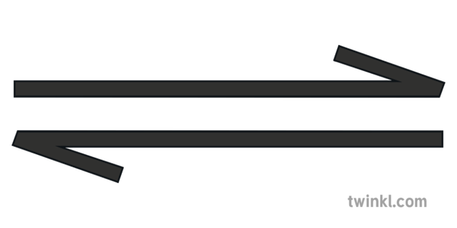 2 HI(g)

Initial | 2.0 M | 2.0 M | 0
Change | － x | － x | + 2 x
Equilibrium | 2 － x | 2 － x | 2 x
(NOTE: YOU WILL NOT HAVE TO USE QUADRATICS ON THE AP EXAM!)

Graphical representation of the answer to Guided Practice # 2
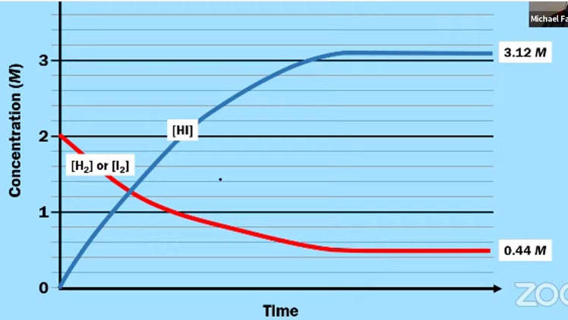

7.7 Calculating Equilibrium Concentrations - Guided Practice # 3
H₂(g) + I₂(g) ⇄ 2 HI(g) K_{c} = 51.0
A sample of HI(g) is added to a previously evacuated reaction vessel. The initial concentration is the following.
[HI] = 3.0 M
Calculate the concentrations of all three gases in the reaction at equilibrium. Use the ICE Table to help you compute your answer.
(NOTE: in order to reach equilibrium, the reaction must proceed from right to left ∴ + reactants, － products)

H₂(g) + I₂(g) 2 HI(g)

Initial
Change
Equilibrium

Graphical representation of the answer to Guided Practice # 3
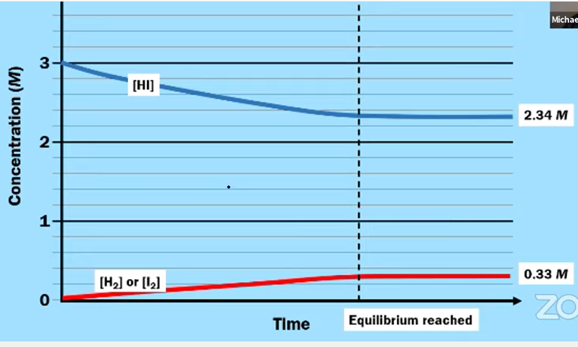

7.7 CALCULATING EQUILIBRIUM CONCENTRATIONS *IMPORTANT NOTES*
- FOR ANY REACTION, THE EQUILIBRIUM CONCENTRATIONS OF THE REACTANTS AND PRODUCTS DEPEND ON THE INITIAL CONCENTRATIONS
- HOWEVER, THE EQUILIBRIUM CONSTANT IS ALWAYS THE SAME AT A GIVEN TEMPERATURE, REGARDLESS OF THE INITIAL CONCENTRATIONS.

- THERE IS NO SUCH THING AS THE LAW OF CONSERVATION OF MOLES. (MOLES CAN CHANGE….GRAMS CANNOT)
7.7 Calculating Equilibrium Concentrations - Guided Practice # 4
H₂(g) + I₂(g) ⇄ 2 HI(g) K_{c} = 51.0
A sample of H₂(g) and I₂(g) and HI(g) is added to a previously evacuated reaction vessel. The initial concentration are the following.
[H₂] = [I₂] = 1.0 M
[HI] = 3.0 M
Calculate the concentrations of all three gases in the reaction at equilibrium. Use the ICE Table to help you compute your answer.
PROBLEM: WHICH DIRECTION WILL YOU GO? TOWARDS REACTANTS OR PRODUCTS?
NEED TO CALCULATE Q FIRST!
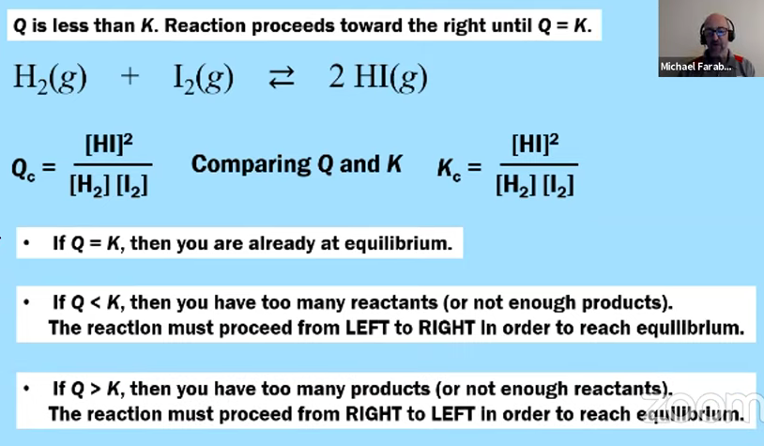

- What is the reaction quotient for the given initial conditions? Which direction will the reaction move towards?
- If the reaction proceeds towards products, － reactants, + products
- If the reaction proceeds towards reactants, + reactants, － products

- Now that you know which direction, complete the ICE table to identify the equilibrium concentrations of all species.
H₂(g) + I₂(g) 2 HI(g)

Initial
Change
Equilibrium

Graphical representation of the answer to Guided Practice # 4
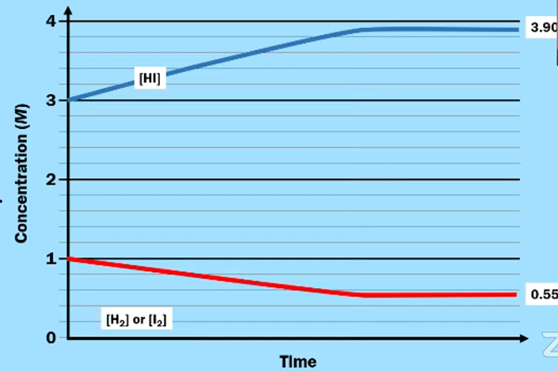
An easier way to remember which direction for K and Q
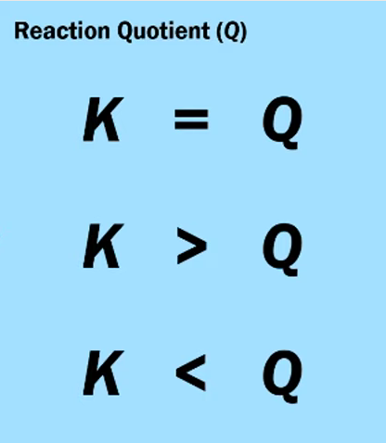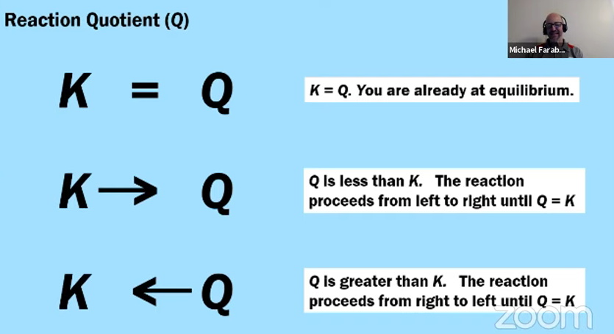

7.8 Representations of Equilibrium : SUMMARY OF GUIDED PRACTICE 2, 3 & 4
For H₂(g) + I₂(g) ⇄ 2 HI(g)
All have the SAME K_{c}
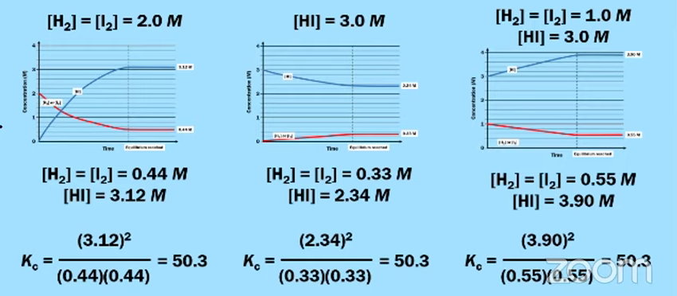

7.9 Introduction to Le Châtelier’s Principle & 7.10 Reaction Quotient and Le Châtelier’s Principle

Supposed that a chemical reaction has already reached equilibrium.
- The rate of the forward reaction = the rate of the reverse reaction.
- The concentration (or partial pressures) of each reactant and product are no longer changing over time
What would happen if a system at equilibrium experiences some sort of external stress?
- Le Châtelier’s Principle - if a system at equilibrium is perturbed (or experiences an external stress), the position of the equilibrium shifts in the direction that relieves the stress.
- What is a stress?
Change in Concentration | Change in Pressure/Volume | Change in Temperature

Recall that when Q = K, the system is at equilibrium.
- If a change occurs that causes Q to become less than K, the equilibrium position will shift from left to right until Q = K.
- If a change occurs that causes Q to become greater than K, the equilibrium position will shift from right to left until Q = K.
Stresses on Equilibrium # 1 - Change in Concentration
2 NO₂(g) ⇄ N₂O₄(g)
brown colorless
- Adding More Reactants
  - Suppose that the system shown above is at equilibrium and additional NO₂(g) is added to the reaction vessel (at constant temperature). (Concentration of NO₂ increases - denoted by larger brackets)
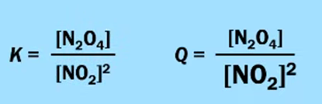 | Q is now LESS than K.  The equilibrium position shifts to the right until Q = K.

- Adding More Products
  - Suppose that the system shown above is at equilibrium and additional N₂O₄(g) is added to the reaction vessel (at constant temperature). (Concentration of N₂O₄ increases - denoted by larger brackets)
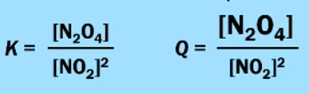 | Q is now GREATER than K.  The equilibrium position shifts to the left until Q = K.

2 NO₂(g) ⇄ N₂O₄(g)
brown colorless
- Removing Some Reactants
  - Suppose that the system shown above is at equilibrium and somel NO₂(g) is removed from the reaction vessel (at constant temperature). (Concentration of NO₂ decreases - denoted by larger brackets)
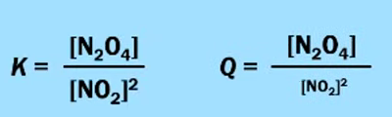 | Q is now GREATER than K.  The equilibrium position shifts to the left until Q = K.

- Removing Some Products
  - Suppose that the system shown above is at equilibrium and some N₂O₄(g) is removed from the reaction vessel (at constant temperature). (Concentration of N₂O₄ decreases - denoted by larger brackets)
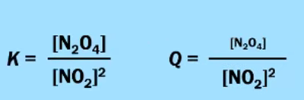 | Q is now LESS than K.  The equilibrium position shifts to the right until Q = K.

AP CHEMISTRY EXAM TIP:
- DO NOT SAY “BECAUSE OF LE CHÂTELIER’S PRINCIPLE”.
- INSTEAD SAY “AS A RESULT OF THIS CHANGE, Q WILL BE < OR > K, AND THE EQUILIBRIUM WILL SHIFT TOWARD RIGHT/LEFT.

Stresses on Equilibrium # 2 - Change in Pressure/Volume
2 NO₂(g) ⇄ N₂O₄(g)
brown colorless

- Adding an Inert Gas
  - Suppose that the system shown above is at equilibrium and a sample of He(g) (or Ne or Ar) is added to the reaction vessel (at constant temperature).
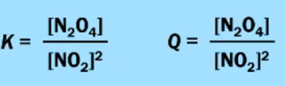 | Q = K.  There is no shift in the equilibrium position.

2 NO₂(g) ⇄ N₂O₄(g)
brown colorless

- Decreasing the Volume of the Reaction Vessel
  - Suppose that the system shown above is at equilibrium and the volume of the reaction vessel is reduced by half(at constant temperature).
Let’s say [NO₂]_{eq} = 1.0 M and [N₂O₄]_{eq} = 5.0 M. If I halve the volume, I double the concentration.
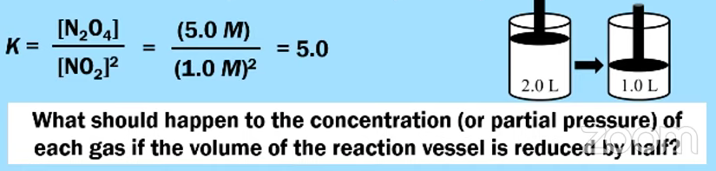
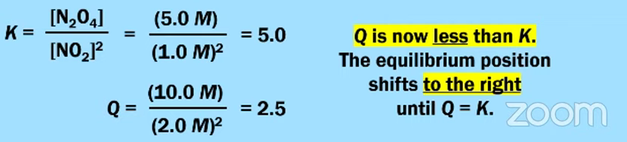

2 NO₂(g) ⇄ N₂O₄(g)
brown colorless

- Increasing the Volume of the Reaction Vessel
  - Suppose that the system shown above is at equilibrium and the volume of the reaction vessel is doubled(at constant temperature).

Let’s say [NO₂]_{eq} = 1.0 M and [N₂O₄]_{eq} = 5.0 M … if I Double the Volume, I Halve the Concentration.
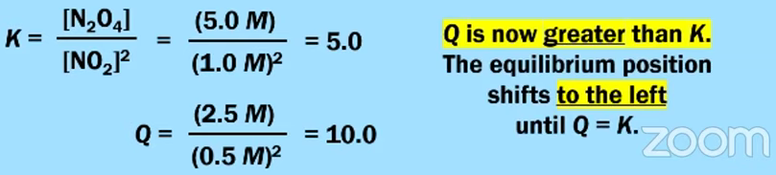

EQUILIBRIUM PARTICLE DIAGRAMS

2 NO₂(g) ⇄ N₂O₄(g)
brown colorless

Decreasing the Volume of the Reaction Vessel (Increasing the Pressure)
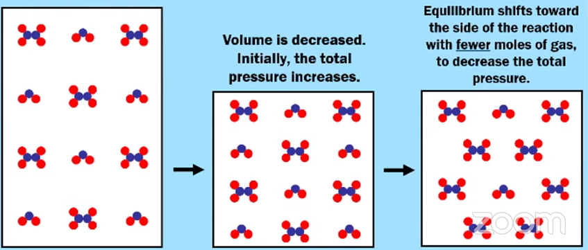

Increasing the Volume of the Reaction Vessel (Decreasing the Pressure)
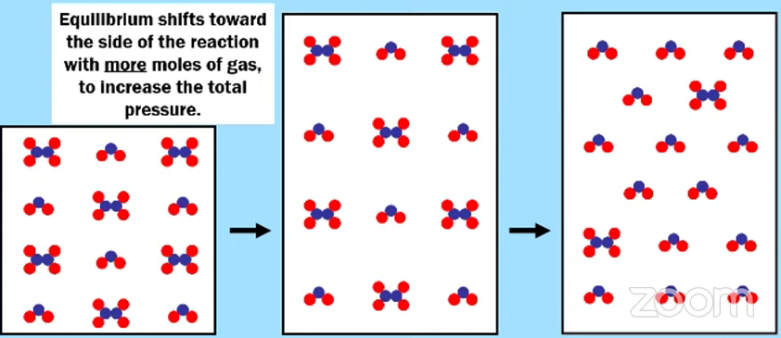
SUMMARY OF PRESSURE/VOLUME CHANGES:
- DECREASING THE VOLUME OF THE REACTION VESSEL CAUSES A SHIFT TOWARD THE SIDE OF THE EQUATION WITH FEWER MOLES OF GAS
- INCREASING THE VOLUME OF THE REACTION VESSEL CAUSES A SHIFT TOWARD THE SIDE WITH MORE MOLES OF GAS
- IF BOTH SIDES OF THE EQUATION HAVE EQUAL MOLES, THERE WILL BE NO SHIFT (Q WILL ALWAYS EQUAL K)
- THIS ALSO WORKS FOR AQUEOUS EQUILIBRIA AS WELL WITH DISSOLVING IONS
Stresses on Equilibrium # 3 - Change in Temperature
2 NO₂(g) ⇄ N₂O₄(g)
brown colorless
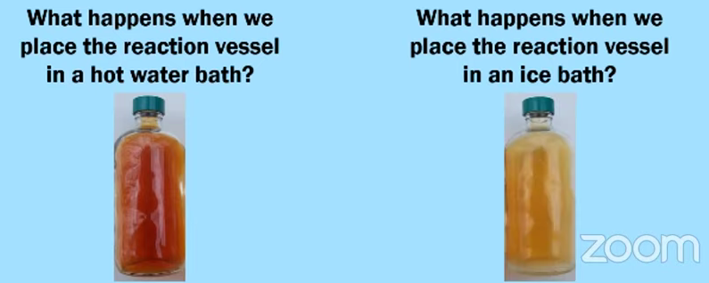
DARKER BROWN LIGHTER BROWN

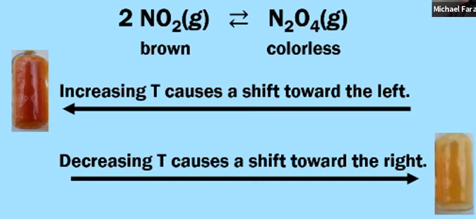

These observations can tell us information about this reaction. Is this reaction, as written, endothermic or exothermic?

Changing the temperature will also change the value of K. The information in the data table above can tell us about this reaction. Is this reaction, as written, endothermic or exothermic?

2 NO₂(g) ⇄ N₂O₄(g)

Temperature | K_{c}
15ºC | 160
100ºC | 5.0

ANSWER: When you increase temperature, it is like adding heat. When you did this, your value of K_{c} decreased. (When you remove heat, your value of K_{c} increases) THIS MEANS HEAT IS A PRODUCT.

2 NO₂(g) ⇄ N₂O₄(g) + HEAT

THEREFORE IT IS AN EXOTHERMIC REACTION.
SUMMARY OF TEMPERATURE CHANGES
HEAT + A ⇄ B
- For an ENDOTHERMIC reaction…
  - Increasing temperature (T) causes a shift toward the right, and K increases.
  - Decreasing temperature (T) causes a shift toward the left, and K decreases.

A ⇄ B + HEAT
- For an EXOTHERMIC reaction…
  - Increasing temperature (T) causes a shift toward the left, and K decreases
  - Decreasing temperature (T) causes a shift toward the right, and K increases.

7.10 Reaction Quotient and Le Châtelier’s Principle - Guided Practice

PCl₃(g) + Cl₂(g) ⇄ PCl₅(g)

Using the chemical equilibrium shown above, convey how the equilibrium will shift by completing the particle diagram drawn in the box labeled “New Equilibrium.”

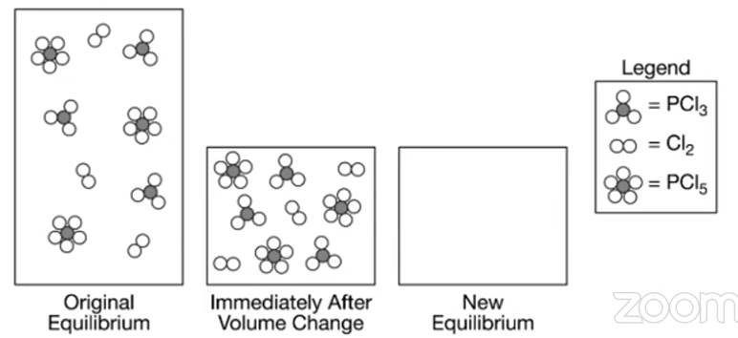

AP EXAM FRQ PRACTICE 7.7 - 7.10 - HOMEWORK

CaCO₃(s) ⇄ CaO(s) + CO₂(g)

When heated, calcium carbonate decomposes according to the equation above. In a study of the decomposition of calcium carbonate, a student added a 50.0 g sample of powdered CaCO₃(s) to a 1.00 L rigid container. The student sealed the container, pumped out all of the gases, then heated the container in an oven at 1100 K. As the container was heated, the total pressure of the CO₂(g) in the container was measured over time. The data are graphed and plotted in the graph below.
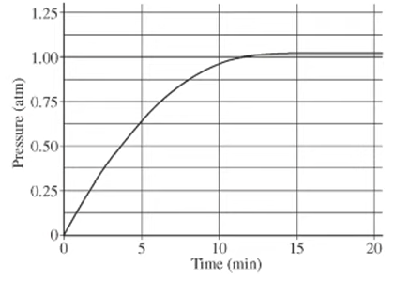
The student repeated the experiment, but this time the student uses a 100.0 g sample of powdered CaCO₃(s). In this experiment, the final pressure in the container was 1.04 atm, which was the same final pressure as in the first experiment.

- Calculate the number of moles of CO₂(g) present in the container after 20 minutes of heating.

- The student claimed that the final pressure in the container in each experiment became constant because all of the CaCO₃(s) had decomposed. Based on the data in the experiments, do you agree with this claim? Explain.

- After 20 minutes some CO₂(g) was injected into the container, initially raising the pressure to 1.5 atm. Would the final pressure inside the container be less than, greater than, or equal to 1.04 atm. Explain your reasoning.

- Are there sufficient data obtained in the experiments to determine the value of the equilibrium constant, K_{P}, for the decomposition of CaCO₃(s) at 1100 K? Justify your answer.

AP EXAM FRQ PRACTICE 7.7 - 7.10 - HOMEWORK (CONTINUED)

Ba²⁺(aq) + EDTA^{4－} (aq) ⇄ Ba(EDTA)^{2－} (aq) K = 7.7 × 10⁷
The polyatomic ion C₁₀H₁₂N₂O₈^{4－} is commonly abbreviated as EDTA^{4－}. The ion can form complexes with metal ions in aqueous solutions. A complex of EDTA^{4－} with Ba²⁺ ion forms according to the equation above. A 50.0 mL volume of a solution that has an EDTA^{4－}(aq) concentration of 0.30 M is mixed with 50.0 mL of 0.20 M Ba(NO₃)₂ to produce 100.0 mL of solution.
- Considering the value of K for the reaction, determine the concentration of Ba(EDTA)^{2－} (aq) in the 100.0 mL of solution. Justify your answer.

- The solution is diluted with distilled water to a total volume of 1.00 L. After equilibrium has been reestablished, is the number of moles Ba²⁺(aq) of present in the solution greater than, less than, or equal to the number of moles of Ba²⁺(aq) present in the original solution before it was diluted? Justify your answer.

AP CHEMISTRY PRACTICE 7.11-7.13
AP Chemistry: 7.11-7.13 Solubility Equilibria, Common-Ion Effect, and pH
WATCH THIS VIDEO (OR THIS VIDEO) BY MICHAEL FARABAUGH TO ASSIST IN THIS QUESTION

7.11 Introduction to Solubility Equilibria
- Suppose we have a beaker of pure water and a sample of solid is added to the beaker.  - The solution is stirred for several minutes. Then the solution is left undisturbed for several minutes.  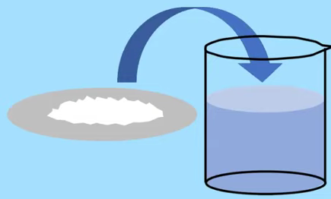 | Now the solution looks like this:  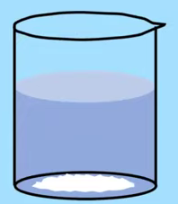  Some might classify this solid solute as INSOLUBLE
If we take a closer look…
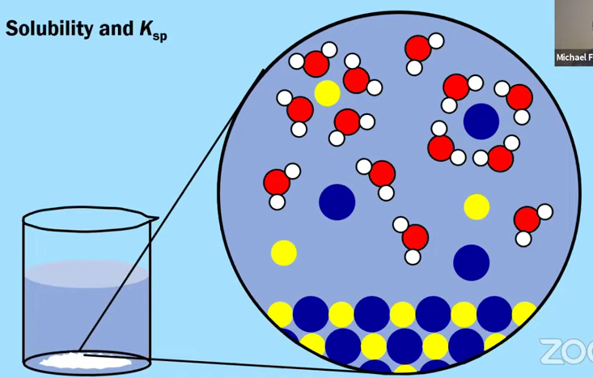 | - We have undissolved solid (precipitation)  AND  - We have some aqueous ions (dissolution)  So at the same time we are getting dissolution AND precipitation, at the SAME RATE.  SOLUBILITY EQUILIBRIUM

Solubility and Solubility Equilibria Expressions, K_{sp}

BaSO₄(s) ⇄ Ba²⁺(aq) + SO₄²⁻(aq) K_{sp} = [Ba²⁺] [SO₄²⁻]

Mg(OH)₂(s) ⇄ Mg²⁺(aq) + 2 OH－(aq) K_{sp} = [Mg²⁺][OH－]²

CaF₂(s) ⇄ Ca²⁺(aq) + 2 F－(aq) K_{sp} = [Ca²⁺][ F－]²

Ag₂CO₃(s) ⇄ 2 Ag⁺(aq) + CO₃^{2－}(aq) K_{sp} = [Ag⁺]² [CO₃^{2－}]

Solubility and K_{sp} (The Solubility Product) - Guided Practice # 1
Compound | K_{sp} | Which substance, AgCl(s), AgBr(s) orAgI(s) has the greatest solubility?
AgCl(s) | 1.8 × 10^{－10}
AgBr(s) | 5.4 × 10^{－13}
AgI(s) | 8.5 × 10^{－17}

Solubility and K_{sp} are related to each other, but they are NOT the same thing.
The K_{sp} is CONSTANT ...BUT ...The Molar Solubility can have different values in different solutions
Solubility is the moles of ions that dissolve per Liter of solution, M.

Calculating Solubility with Simple and Similar Stoichiometry- Guided Practice # 2
Compound | K_{sp} | Solubility (M) | After reviewing below how to calculate the solubility for AgCl(s), calculate the molar solubilities of AgBr(s) and AgI(s) and place that in the table at left.
AgCl(s) | 1.8 × 10^{－10} | 1.3 × 10^{－5} M
AgBr(s) | 5.4 × 10^{－13}
AgI(s) | 8.5 × 10^{－17}

AgCl(s) ⇄ Ag⁺(aq) + Cl－(aq) K_{sp} = [Ag⁺] [Cl－]

- The concentration of Ag⁺(aq) has the same value as the solubility of AgCl(s) because of stoichiometry (there is a one to one mole ratio of solid and ion)

K_{sp} = [Ag⁺] [Cl－] = 1.8 × 10^{－10}

= (×) (×) = 1.8 × 10^{－10} and “×” is the solubility. Solve for “×”

= ×² = 1.8 × 10^{－10} and × = $\sqrt{1.8 × 10^{-8}}$ = 1.3 × 10^{－5} M (solubility in moles/L)

Calculating Solubility with Complex and Dissimilar Stoichiometry

PbCl₂(s) ⇄ Pb²⁺(aq) + 2 Cl－(aq) K_{sp} = [Pb²⁺][ Cl－]²

- Which ion, Pb²⁺(aq) or Cl－(aq), has the same value as the solubility of PbCl₂(s)?
  - The Pb²⁺(aq) , since it is a one to one mole ratio with solid ; calculation will be a little different though...

[Pb²⁺] = × [ Cl－] = 2×

K_{sp} = [Pb²⁺][ Cl－]² = 1.7 × 10^{－5}
= (×) (2×)² = 1.7 × 10^{－5}
= 4×³ = 1.7 × 10^{－5} $=\sqrt[3]{\frac{1.7 x 10^{-5}}{4}}$ = 0.016 M ∴ [Pb²⁺] = 0.016 M [ Cl－] = 0.032 M

Calculating Solubility with Complex and Dissimilar Stoichiometry - Guided Practice # 3

Using the information in the table below, calculate the molar solubility of both salts and then identify which compound has the greater solubility.

Compound | K_{sp} | Solubility (M)
MnCO₃(s) | 2.3 × 10^{－11}
Mn(OH)₂(s) | 1.9 × 10^{－13}

Calculating Solubility with Complex and Dissimilar Stoichiometry - Guided Practice # 4

Compound | Molar Mass (g/mol) | K_{sp} | Solubility (mol/L) | Solubility  (g/L)
BaSO₄(s) | 233.39 | 1.1 × 10^{－10}
Mg(OH)₂(s) | 58.316 | 5.6 × 10^{－12}

Based on the information in the table above, calculate the solubility of BaSO₄(s) and Mg(OH)₂(s) in units of mol/L and g/L.

Calculating K_{sp} FROM Solubility -Guided Practice # 5

Compound | Molar Mass (g/mol) | K_{sp} | Solubility (g/L)
CaF₂(s) | 78.08 |  | 0.086
Ag₂CO₃(s) | 275.75 |  | 0.035

Based on the information in the table above, calculate the value of K_{sp} for CaF₂(s) and Ag₂CO₃(s).

7.12 Common-Ion Effect

Compound | K_{sp} | Solubility (M)
BaSO₄(s) | 1.1 × 10^{－10} | 1.0 × 10^{－5}

BaSO₄(s) ⇄ Ba²⁺(aq) + SO₄²⁻(aq)

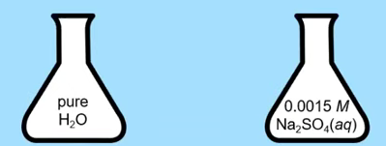

A sample of BaSO₄(s) is dissolved completely in a solution of 0.0015 M Na₂SO₄(aq). Do you predict that the solubility of BaSO₄ in this solution will be less than, greater than, or equal to 1.0 × 10^{－5} M ? Justify your answer.

- Recall Le Châtelier’s Principle. How will the position of the equilibrium be affected if additional SO₄^{2－} ions are added to the solution?
  - Adding More Products, Q is now GREATER than K. The equilibrium position shifts to the left until Q = K.
THEREFORE:
    - If we add more SO₄^{2－} ions, the equilibrium will shift LEFT (towards the undissolved solid). This will DECREASE the solubility of BaSO₄(s)

This is an example of the Common Ion Effect
- The Common Ion Effect says that the solubility of an ionic solid is reduced when it is dissolved into a solution that already contains one of the ions present in the ionic solid.

We can also CALCULATE this new solubility.

Calculate the solubility of BaSO₄ in a solution of 0.0015 M Na₂SO₄(aq)

K_{sp} = [Ba²⁺] [SO₄²⁻] = 1.1 × 10^{－10} BUT, [SO₄²⁻] = 0.0015 M (from Na₂SO₄(aq) solution)

[Ba²⁺] (0.0015 M) = 1.1 × 10^{－10} [Ba²⁺] = 7.3 × 10^{－8} M
This is the solubility of BaSO₄ in 0.0015 M Na₂SO₄

7.13 pH and Solubility

Compound | K_{sp} | Solubility (M)
Mg(OH)₂(s) | 5.6 × 10^{－12} | 1.1 × 10^{－4}

Mg(OH)₂(s) ⇄ Mg²⁺(aq) + 2 OH－(aq)

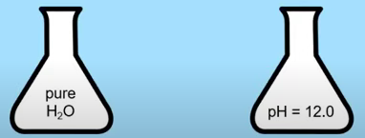

A sample of Mg(OH)₂(s) is dissolved completely in a solution that has a pH of 12.0. Do you predict that the solubility of Mg(OH)₂(s) in this solution will be less than, greater than, or equal to 1.1 × 10^{－4} M ? Justify your answer.

- Recall Le Châtelier’s Principle. How will the position of the equilibrium be affected if additional OH－ ions (from a higher pH) are added to the solution?
  - Adding More Products, Q is now GREATER than K. The equilibrium position shifts to the left until Q = K.
THEREFORE:
    - If we have a high/basic pH, that means we have added more OH－ ions, the equilibrium will shift LEFT (towards the undissolved solid). This will DECREASE the solubility of Mg(OH)₂(s)
We can calculate this solubility as well….but be careful.

But first, let’s identify [OH－]

pH + pOH = 14.00 and 10^{－pOH} = [OH－]

12 + pOH = 14.00

pOH = 2.00 10^{－2.00} = [OH－] = 1.0 × 10^{－2} M

Now we can CALCULATE the new molar solubility

K_{sp} = [Mg²⁺][OH－]² = 5.6 × 10^{－12}

=[Mg²⁺] (1.0 × 10^{－2} M ) = 5.6 × 10^{－12} [Mg²⁺] = 5.6 × 10^{－8} M
This is the solubility of Mg(OH₂) in a solution with pH = 12.0

7.13 pH and Solubility (continued)

Remember acids:
- HCl is a strong acid (1 of 7 to remember)
- Other acids with HX formula, like HF , is a weak acid
  - A Weak acid is only partially ionized in solution. The majority of HF(aq) exists in the form of HF molecules, and not in the form H⁺ and F－
Compound | K_{sp} | Solubility (M)
CaF₂(s) | 1.5 × 10^{－10} | 1.3 × 10^{－4}

CaF₂(s) ⇄ Ca²⁺(aq) + 2 F－(aq)
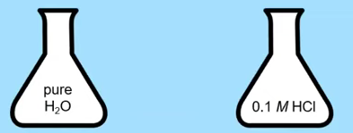
It is observed that CaF₂ is more soluble in a solution of 0.1 M HCl than it is in pure water. Explain this result.
Hint: The negative ion will react with H⁺
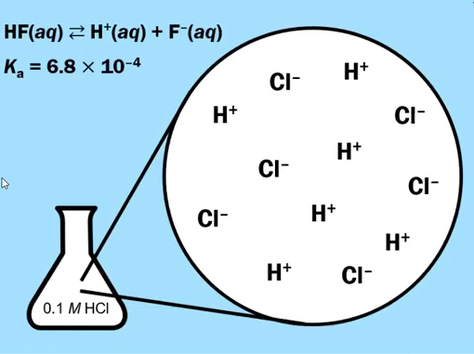 | 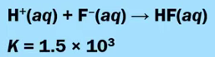  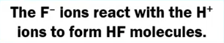  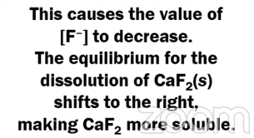
TO SUMMARIZE:
- For a the solubility of CaF₂ in HCl….the HCl will react with F－ to form HF….removing it from solution
- [F－] decreases, and thus we are removing a product from solution. Q < K, shifts towards right.
- Solubility of CaF₂ increases as the equilibrium shifts toward the right (the soluble ions)

7.13 pH and Solubility (continued)

Ag₂CO₃(s) ⇄ 2 Ag⁺(aq) + CO₃^{2－}(aq)
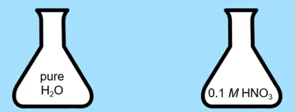
It is observed that Ag₂CO₃ is more soluble in a solution of 0.1 M HNO₃ than it is in pure water. Explain this result.

Hint: The negative ion will react with H⁺

This time the carbonate ion, CO₃^{2－}, will react with H⁺.

2 H⁺(aq) + CO₃^{2－}(aq) ⟶ H₂CO₃ ⟶ H₂O(l) + CO₂(g)

- This removes CO₃^{2－}(aq) from solution, lowers the value of Q, which will need to shift right

- Therefore the solubility of Ag₂CO₃ increases as the equilibrium shifts toward the right.

What about this one?
Mg(OH)₂(s) ⇄ Mg²⁺(aq) + 2 OH－(aq)
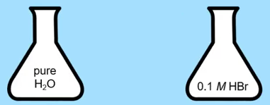

It is observed that Mg(OH₂) is more soluble in a solution of 0.1 M HBr than it is in pure water. Explain this result.

Hint: The negative ion will react with H⁺

The OH－(aq) will react with H⁺(aq)

H+(aq) + OH－(aq) ⟶ H₂O(l)

- This removes OH－(aq) from solution, lowers the value of Q, which will need to shift right

- Therefore the solubility of Mg(OH₂) increases as the equilibrium shifts toward the right.
SUMMARY OF SOLUBILITY AND pH

- FOCUS ON THE ANION: IF AN IONIC SOLID IS MORE SOLUBLE IN AN ACIDIC SOLUTION THAT IT IS IN PURE WATER, THAN IT IS LIKELY THAT THE ANION UNDERGOES A CHEMICAL REACTION WITH H+ IONS.
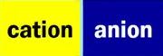
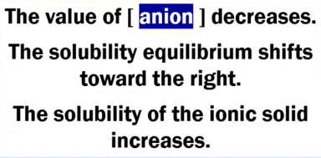 | OH－ + H⁺ ⟶ H₂O  F－+ H⁺ ⟶ HF  S^{2－} + 2 H⁺ ⟶ H₂S  CO₃^{2－} + 2 H⁺ ⟶ H₂O + CO₂  PO₄^{3－} + 3 H⁺ ⟶ H₃PO₄

Reaction Quotient, Q, versus K_{sp} －Predicting if a Precipitate Will Form

CaF₂(s) ⇄ Ca²⁺(aq) + 2 F－(aq) K_{sp} = 1.8 × 10^{－7}

100.0 mL of a 1.2 × 10^{－3} M Ba(NO₃)₂(aq) is combined with 100.0 mL of a 3.2 × 10^{－3} M NaF(aq).  Will a precipitate form? Justify your answer. | 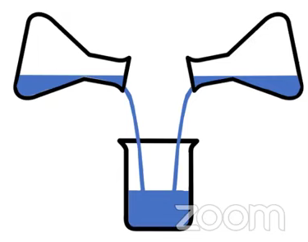
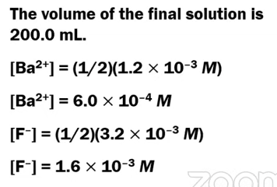 | 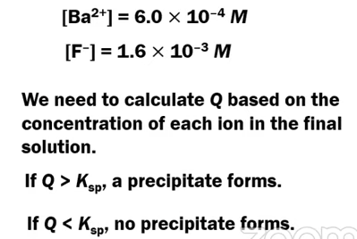
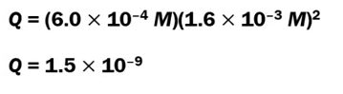
THIS IS LESS THAN THE K_{sp} … NO PRECIPITATE WILL FORM
Reaction Quotient, Q, versus K_{sp} - Guided Practice # 1

PbI₂(s) ⇄ Pb²⁺(aq) + 2 I－(aq) K_{sp} = 9.8 × 10^{－9}

100.0 mL of 4.8 × 10^{－3} M Pb(NO₃)₂ (aq) is combined with 100.0 mL of 6.4 × 10^{－2} M KI(aq). Will a precipitate form? Justify your answer.

Reaction Quotient, Q, versus K_{sp} - Guided Practice # 2 * (Tougher - Watch at 53:52 in video)

Compound | K_{sp} | 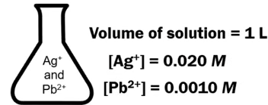
Ag₂SO₄(s) | 1 × 10^{－5}
PbSO₄(s) | 1 × 10^{－8}

A 0.0010 mol sample of K₂SO₄(s) is added to the solution in the flask. Will a precipitate occur?

AP EXAM FRQ PRACTICE 7.11 - 7.13 - HOMEWORK
- Answer the following questions about the solubility of some fluoride salts of alkaline earth metals.

- A student prepares 100. mL of a saturated solution of MgF₂ by adding 0.50 g of solid MgF₂ to 100. mL of distilled water at 25ºC and stirring until no more solid dissolves. (Assume that the volume of the undissolved MgF₂ is negligibly small.) The saturated solution is analyzed, and it is determined that [F－] in the solution is 2.4 × 10^{－3} M.

  - Write the chemical equation for the dissolving of solid MgF₂ in water.

  - Calculate the number of moles of MgF₂ that dissolved.

  - Determine the value of the solubility-product constant, K_{sp}, for MgF₂ at 25ºC.

- A beaker contains 500. mL of a solution in which both Ca²⁺(aq) and Ba²⁺(aq) are present at a concentration of 0.10 M at 25ºC. A student intends to separate the ions by adding 0.20 M NaF solution one drop at a time from a buret. At 25^{c}C the value of K_{sp} for CaF₂ is 3.5 × 10^{－11}; the value of K_{sp} for BaF₂ is 1.8 × 10^{－6}.

  - Which salt will precipitate first, CaF₂ or BaF₂? Justify your answer.

For parts (b)(ii) and (b)(iii) below, assume that the addition of the NaF solution does not significantly affect the total volume of the liquid in the beaker.

  - Calculate the minimum concentration of F－(aq) necessary to initiate precipitation of the salt selected in part (b)(i).

  - Calculate the minimum volume of 0.20 M NaF that must be added to the beaker to initiate precipitation of the salt selected in part (b)(i).

- There are several ways to dissolve salts that have limited solubility. Describe one procedure to redissolve the precipitate formed in part (b).

AP CHEMISTRY PRACTICE 8.1
AP Chemistry: 8.1 Introduction to Acids and Bases
WATCH THIS VIDEO BY MICHAEL FARABAUGH TO ASSIST IN THIS QUESTION

WARM UP - AP CHEMISTRY FRQ

CH₃CH₂COOH(aq) + H₂O (l) ⇄ CH₃CH₂COO－(aq) + H₃O⁺(aq)

2. Propanoic acid, CH₃CH₂COOH, is a carboxylic acid that reacts with water according to the equation above. At 25ºC the pH of a 50.0 mL sample of 0.20 M CH₃CH₂COOH is 2.79.
- Identify a Brønsted-Lowry conjugate acid-base pair in the reaction. Clearly label which is the acid and which is the base.

FROM UNIT 4 - DEFINITION OF BRØNSTED ACID/BASE
By definition a Brønsted-Lowry acid is a proton (H⁺) donor, and a Brønsted-Lowry base is a proton (H+) acceptor.
WARM-UP PROBLEM # 1
Four different examples of acid-base reactions are shown below. In each of these reactions, focus on the H₂O. Decide if H₂Ois acting as a Brønsted-Lowry acid or as a Brønsted-Lowry base.

- H₂O + HCl ⟶ H₃O⁺ + Cl⁻¹
- H₂O + HCO₃⁻¹ ⟶ H₂CO₃ + OH⁻¹
- H₂O + NH₃ ⟶ NH₄⁺ + OH⁻¹
- H₂O + HCO₃⁻¹ ⟶ H₃O⁺ + CO₃²⁻

WARM - UP PROBLEM # 2
N₂O₄(g) ⇄ 2 NO₂ (g) ΔHº = +58 kJ/mol_{rxn}

The chemical equation shown above represents the reversible reaction in which N₂O₄(g) is converted into NO₂(g). The value of the equilibrium constant,K, for this reaction is equal to 0.005 at 25ºC.
If the temperature of the reaction vessel is increased from 25ºC to 100ºC, do you predict that the value of K will decrease, increase, or remain the same? Justify your answer.

WARM-UP PROBLEM # 3
A chemist has three different samples of pure water. Each sample is at a different temperature as shown below.

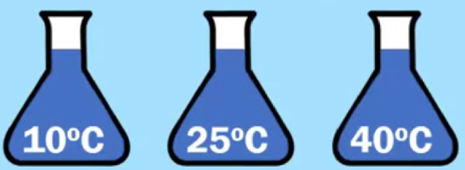

Does each sample have the same pH value? If yes, explain why. If no, explain why not.

If these samples do not have the same pH value, arrange them in order from lowest pH to highest pH.

Definition of pH and pOH
The concentrations of hydronium ion and hydroxide ion are often reported as pH and pOH, respectively.

pH = －log [H₃O⁺] pOH = －log[OH－]

pH = －log [H⁺] 10^{-pH} = [H⁺]

H⁺ versus H₃O⁺
The terms “hydrogen ion” and “hydronium ion” and the symbols H⁺(aq) and H₃O⁺(aq) are often used interchangeably for aqueous ions of hydrogen.
H₂O + HCl ⟶ H₃O⁺ + Cl⁻¹

HCl ⟶ H⁺ + Cl⁻¹
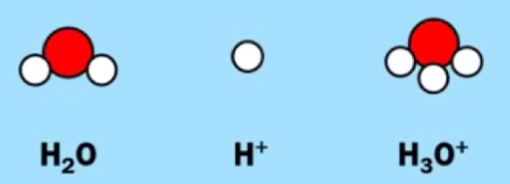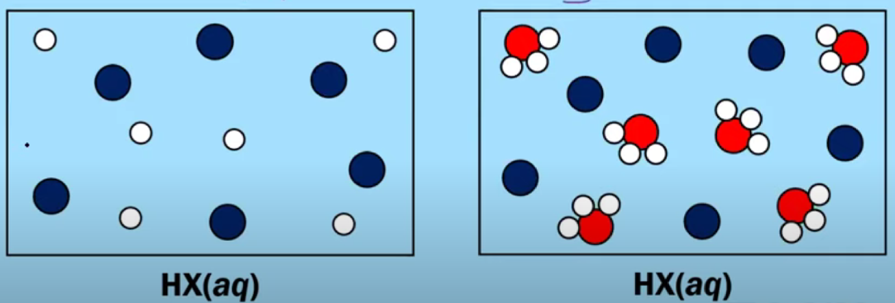

Autoionization of Water
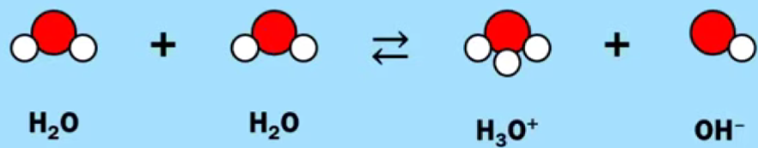

The equilibrium constant, K, for this reaction is very small!

K_{W} = [H⁺][OH⁻¹] = 1.0 × 10⁻¹⁴ at 25ºC

WARM-UP PROBLEM # 4
Which of these particle diagrams represents a sample of pure water? How can you tell?
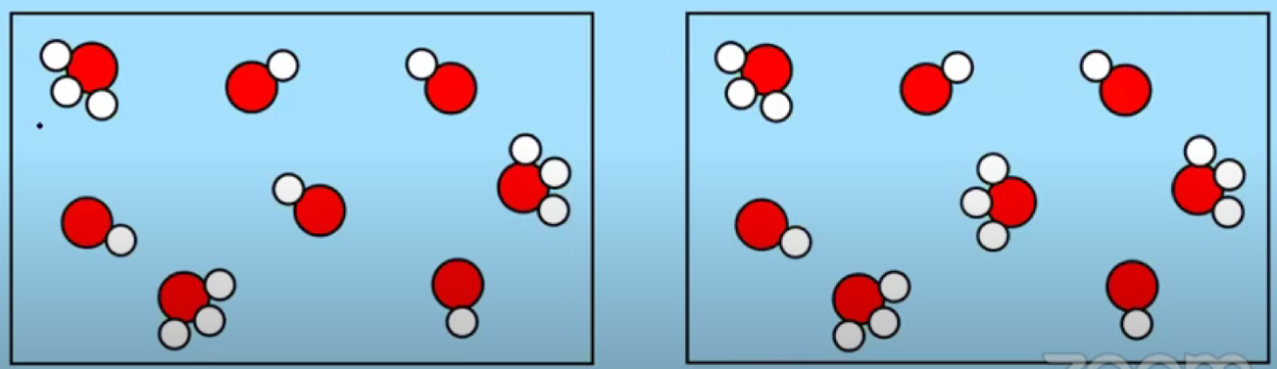

Relationship between pH and pOH in pure water.
In pure water, [H₃O⁺] = [OH⁻¹] and pH = pOH. Pure water is called a neutral solution.

At 25ºC, pK_{W} = 14.0

pH = pOH = 7

pK_{W} = 14.0 = pH + pOH at 25º

Effect of changes in temperature on the value of K_{W} and the pH of pure water
Energy + H₂O + H₂O ⇄ H₃O⁺ + OH⁻¹
The value of K_{W} is temperature dependent. pK_{W} will deviate from 14.0 at temperatures other than 25ºC. The pH (and the pOH) of pure, neutral water will deviate from 7.0 at temperatures other than 25ºC.

Guided Practice # 1
Fill in the missing information in the table below. Assume that each solution is at 25ºC.

[H₃O⁺] | pH | [OH⁻¹] | pOH
1.0 × 10⁻⁹ M
 | 4.0
 |  | 1.0 × 10⁻¹² M
 |  |  | 8.0

Guided Practice # 2
Temperature (ºC) pK_{W}  10 14.5  20 14.2  25 14.0  30 13.8  40 13.5 | Look closely at these pK_{W} values.  What happens to the value of pK_{W}as the temperature increases?  What happens to the value of K_{W} as the temperature increases?  H₂O + H₂O ⇄ H₃O⁺ + OH⁻¹ K_{W} = 1.0 × 10⁻¹⁴
Based on the information in the table shown above, is the autoionization of water an endothermic process or exothermic process? Justify your answer.

Guided Practice # 3
A student heats a sample of pure water to a temperature of 50ºC and records the pH as 6.6. What is the value of pOH at 50ºC? Justify your answer.

Guided Practice # 4
A sample of pure water at a certain temperature has a pH of 7.39.
- What is the value of pOH at this temperature?

- What is the value of [H₃O⁺] in this sample at this temperature?

- Calculate the value of K_{W} at this temperature.

- The reaction 2 H₂O ⇄ H₃O⁺ + OH⁻¹ is endothermic in the forward direction. K_{W} = 1.0 × 10⁻¹⁴ . Is the temperature of this sample of water less than 25ºC or more than 25ºC? Justify your answer.

AP EXAM PRACTICE FRQ 8.1 - HOMEWORK

A solution of HI(aq) is added to a solution of methylamine, CH₃NH₂(aq). An acid-base reaction takes place. All of the water is removed by evaporation, producing crystals of the ionic compound methylammonium iodide.

- In the reaction described above, methylamine and the methylammonium ion represent a conjugate acid-base pair.
  - Does the methylamine behave as an acid or as a base in this reaction? Justify your answer.

  - Write the chemical formula (including the correct charge) for the methylammonium ion.

H₂(g) + I₂(g) ⇄ 2 HI(g)

Temperature (K) | Equilibrium Constant, K
298 | 790
700 | 55

The reaction represented by the balanced equation shown above is an equilibrium system. The value of the equilibrium constant, K, is determined at two different temperatures. The results are shown in the data table above.

- Based on the information shown above, is the forward reaction classified as an endothermic process or as an exothermic process? Justify your answer.

AP CHEMISTRY PRACTICE 8.2
AP Chemistry: 8.2 pH and pOH of Strong Acids and Bases
WATCH THIS VIDEO BY SEAN BYRNE TO ASSIST IN THIS QUESTION

8.2 pH and pOH of Strong Acids and Bases
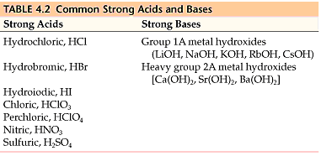
Review of pH, pOH and K_{w}

H₂O(l) + H₂O (l) ⇄ H₃O⁺(aq) + OH－(aq)

K_{W} = [H₃O⁺][OH－] = 1.0 × 10^{－14} at 25ºC

$[H_{3}O^{+}]=\frac{1.0 × {10}^{-14}}{[OH^{-}]}$ $[OH]=\frac{1.0 × {10}^{-14}}{[H_{3}O^{+}]}$

pH = －log [H₃O⁺] pOH = －log[OH－]

pH = －log [H⁺] 10^{-pH} = [H⁺]
8.2 pH and pOH of Strong Acids and Bases-Guided Practice # 1

- If you are given a 0.0025 M HCl solution, what is the pH and pOH?

- If you are given a 0.0015 M NaOH solution, what is the pH and pOH?

8.2 pH and pOH of Strong Acids and Bases-Guided Practice # 2

- Calculate the pH, [H₃O⁺], pOH, and [OH－] of a 1.25 × 10^{－5} M solution of HBr.

- Calculate the pH, [H₃O⁺], pOH, and [OH－] of a 3.85 × 10^{－4} M solution of KOH.

- Calculate the pH, [H₃O⁺], pOH, and [OH－] of a 2.90 × 10^{－6} M solution of HNO₃.

- Calculate the pH, [H₃O⁺], pOH, and [OH－] of a 8.75 × 10^{－3} M solution of LiOH.

8.2 pH and pOH of Strong Acids and Bases-Sample AP Style Question
Solution X | 100 mL of 0.10 M HCl
Solution Y | 200 mL of 0.50 M NaOH
Solution Z | 300 mL of distilled water

A student prepares three solutions, X, Y, and Z, as described in the table above. All solutions are measured at 25ºC.

- Using the information above, rank the solutions in order of increasing pH.


- Which of the 3 solutions would have the greatest change in pH by the addition of 100 mL of distilled water? Justify your answer?
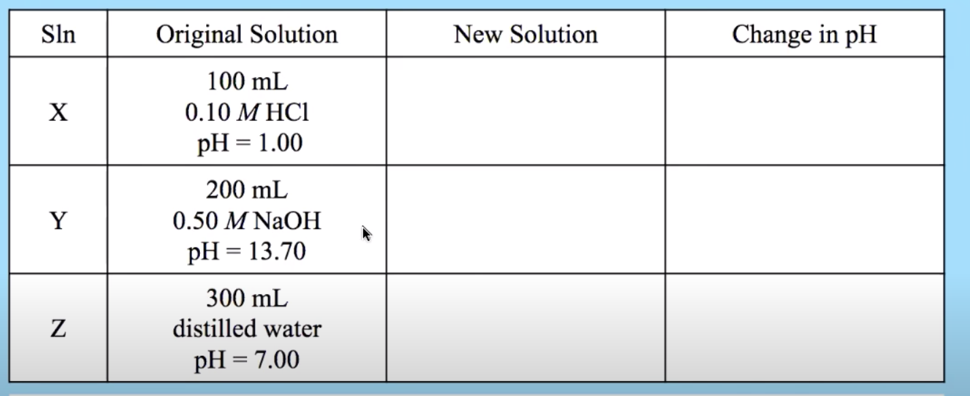

AP EXAM PRACTICE FRQ 8.2 - HOMEWORK

CH₃CH₂COOH(aq) + H₂O (l) ⇄ CH₃CH₂COO－(aq) + H₃O⁺(aq)

Propanoic acid, CH₃CH₂COOH, is a carboxylic acid that reacts with water according to the equation above. At 25ºC the pH of a 50.0 mL sample of 0.20 M CH₃CH₂COOH is 2.79.

- For each of the following statements,determine whether the statement is true or false. In each case, explain the reasoning that supports your answer.
  - If the pH of a hydrochloric acid solution is the same as the pH of a propanoic acid solution, then the molar concentration of the hydrochloric acid solution must be less than the molar concentration of the propanoic acid solution..

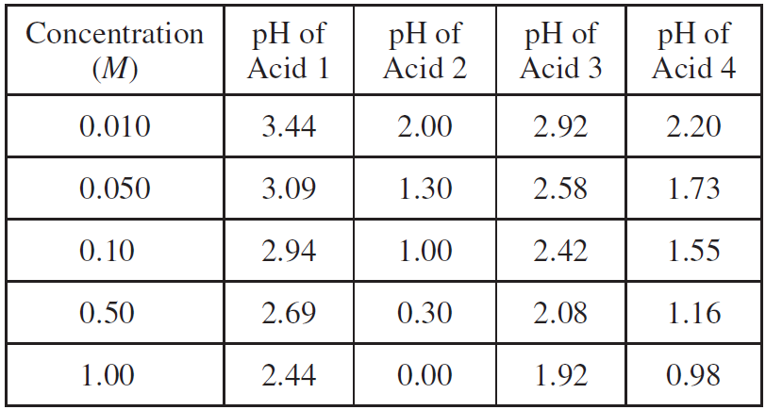
The pH of solutions of four acids prepared at various concentrations were measured and recorded in the table above. The four acids are, in no particular order, chlorous, hydrochloric, lactic, and propanoic.
Which of the four acids listed in the table is hydrochloric acid? Justify your answer.

AP EXAM FRQ PRACTICE 8.3
AP Chemistry: 8.3 Weak Acid and Base Equilibria
WATCH THIS VIDEO BY MICHAEL FARABAUGH TO ASSIST IN THIS QUESTION
8.3 Weak Acid Base Equilibria

Weak Acid Versus Strong Acid
- Weak acids react with water to produce hydronium ions.
- However, molecules of a weak acid will only partially ionize in this way.
  - Only a small percentage of the molecules of a weak acid are ionized in a solution.
  - Thus, the concentration of H₃O⁺ is much less than the initial concentration of the molecular acid, and most of the acid molecules remain un-ionized.

8.3 Weak Acid Base Equilibria -Guided Practice # 1

Which of the diagrams represents a strong acid, which one represents a weak acid?
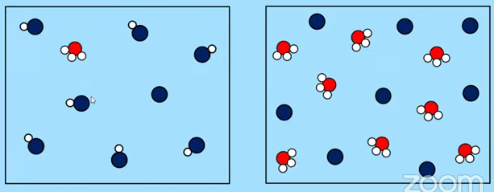

The K_{a} Expression
- A solution of a weak acid involves equilibrium between an un-ionized acid and its conjugate base.
- The equilibrium constant for this reaction is K_{a}, often reported as pK_{a}.
- The pH of a weak acid solution can be determined from the initial acid concentration and the pK_{a}.
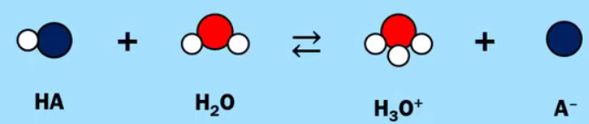
$K_{a}=\frac{[H_{3}O^{+}][A^{-}]}{[HA]}$
Relationship between K_{a} (or pK_{a}) and Acid Strength
- When comparing two different weak acids,
  - The larger the magnitude of K_{a}, the stronger the acid
  - The smaller the value of of pK_{a}, the stronger the acid
    - pK_{a} = －log (K_{a})

Relationship between K_{a} (or pK_{a}) and Acid Strength- Guided Practice # 2

CH₃COOH + H₂O ⇆ H₃O⁺ + CH₃COO－ K_{a} = 1.8 × 10^{－5}

HF + H₂O ⇆ H₃O⁺ + F－ K_{a} = 6.8 × 10^{－4}

Two examples of weak monoprotic acids are acetic acid, CH₃COOH, and hydrofluoric acid, HF. There equilibrium dissociations and K_{a}’s are given above. Which of these two weak acids is the stronger acid? How can you tell?

Weak Bases and the K_{b} Expression
- A solution of a weak base involves equilibrium between an un-ionized base and its conjugate acid.
- The equilibrium constant for this reaction is K_{b}, often reported as pK_{b}.
- The pH of a weak base solution can be determined from the initial base concentration and the pK_{b}.

The K_{b} Expression
$K_{b}=\frac{[HB^{+}][{OH}^{-}]}{[B]}$

Percent Ionization
- The percent ionization of a weak acid can be calculated from its K_{a} (or pK_{a}) and the initial concentration of the acid.
$K_{a}=\frac{[H_{3}O^{+}][A^{-}]}{[HA]_{original}}$

$percent ionization=\frac{[H_{3}O^{+}]}{[HA]_{original}} × 100\%$

- The percent ionization of a weak base can be calculated from its K_{b} (or pK_{b}) and the initial concentration of the base.
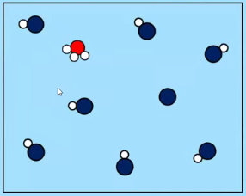
$K_{b}=\frac{[HB^{+}][{OH}^{-}]}{[B]_{original}}$

$percent ionization=\frac{[OH^{-}]}{[B]_{original}} × 100\%$

Percent Ionization -Guided Practice # 3
Based on this particle diagram, what is the percent ionization of this acid?

8.3 Weak Acid Base Equilibria -Guided Practice # 4

CH₃CH₂COOH + KOH ⟶ H₂O + CH₃CH₂COOK

2 HNO₃ + Ca(OH)₂ ⟶ 2 H₂O + Ca(NO₃)₂

(CH₃)₂NH + HBr ⟶ (CH₃)₂NH₂Br

Three different acid-base reactions are shown above.
For each reaction, write the net-ionic equation.
Represent substances as ions if the substances are extensively ionized in solution. Omit formulas for any ions or molecules that are unchanged by the reaction.
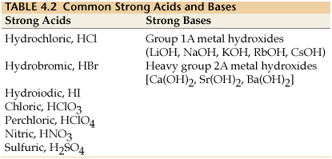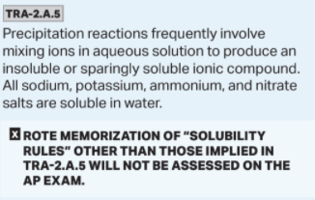

8.3 Weak Acid Base Equilibria -Guided Practice # 5

CH₃COOH + H₂O ⇆ H₃O⁺ + CH₃COO－

Acetic acid, CH₃COOH, is a weak monoprotic acid that reacts with water according to the equation shown above.
A solution of 0.10 M CH₃COOH has a pH of 2.87.

- Calculate the value of K_{a} for CH₃COOH.
- Calculate the percent ionization for 0.10 M CH₃COOH.

8.3 Weak Acid Base Equilibria -Guided Practice # 5
HOCl + H₂O ⇆ H₃O⁺ + ClO－

Hypochlorous acid, HClO, is a weak monoprotic acid that reacts with water according to the equation shown above.
The K_{a} for HOCl is 3.0 × 10^{－8}.

- Calculate the pH of a 0.10 M HOCl.
- Calculate the percent ionization for 0.10 M HOCl.

8.3 Weak Acid Base Equilibria -Guided Practice # 6
Examine the data in the table below. Can you tell which acid is the stronger acid?

Acid | K_{a} | pH of a 0.10 M solution | % ionization
CH₃COOH | 1.7 × 10^{－5} | 2.87 | 1.3%
HOCl | 3.0 × 10^{－8} | 4.26 | 0.055%

8.3 Weak Acid Base Equilibria -Guided Practice # 6
(CH₃)₃N + H₂O ⇆ (CH₃)₃NH⁺ + OH－

Trimethylamine, (CH₃)₃N, is a weak base that reacts with water according to the equation shown above.
The K_{b} for (CH₃)₃N is 6.4 × 10^{－5}.

- Calculate the pH of 0.10 M (CH₃)₃N.
- Calculate the percent ionization of 0.10 M (CH₃)₃N.

8.3 Weak Acid Base Equilibria -Guided Practice # 6
Suppose you have a 100 mL sample of 0.10 M CH₃COOH, at an initial pH of 2.87, and you add 900 mL of H₂O.
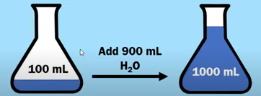

- What is the new concentration of CH₃COOH?
- What happens to the concentration of H₃O⁺, [H₃O⁺] ?
- What happens to the pH?
- What happens to the percent ionization?

Concentration of CH₃COOH | [H₃O⁺] | pH | % ionization
0.10 M | 0.0013 | 2.87 | 1.3%
 | 2. | 3. | 4.

8.3 Weak Acid Base Equilibria -Guided Practice # 7 - Answered
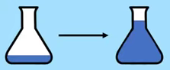
Diluting a weak acid with water causes the percent ionization to increase. How can we explain why this happens?

LeChâtelier’s Principle, Q < K, equilibrium is shifted towards the product side.
Dilution with water causes a stress on the equilibrium system. It causes the concentration of all three aqueous particles :HA, H₃O⁺, and A－, to decrease. The position of the equilibrium shifts toward the side of the reaction with a greater number of moles of aqueous particles. (Like a decrease in pressure/increase in volume with gases). In this example, that means the system shifts toward the products. As a result of this shift, the % ionization of HA increases.

A student is given a 25.0 mL sample of a solution of an unknown monoprotic acid and asked to determine the concentration of the acid by titration. The student uses a standardized solution of 0.110 M NaOH(aq), a buret, a flask, an appropriate indicator, and other laboratory equipment necessary for the titration.

- The images below show the buret before the titration begins (below left) and at the end point (below right). What should the student record as the volume of NaOH(aq) delivered to the flask?

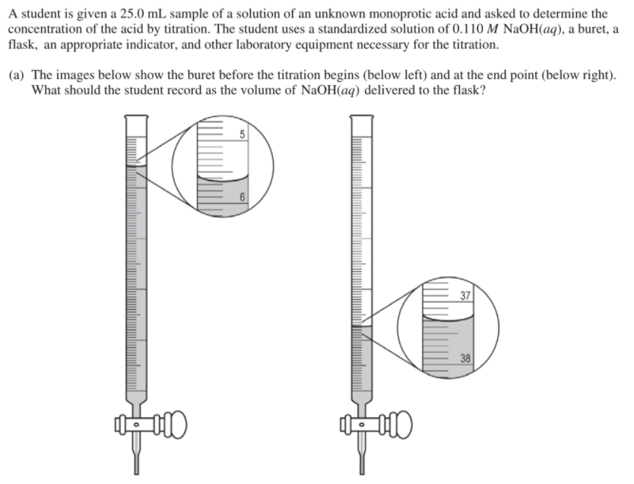
- Based on the given information and your answer to part (a), determine the value of the concentration of the acid that should be recorded in the student’s lab report.

- In a second trial, the student accidentally added more NaOH(aq) to the flask than was needed to reach the end point, and then recorded the final volume. Would this error increase, decrease, or have no effect on the calculated acid concentration for the second trial? Justify your answer.

AP EXAM PRACTICE FRQ 8.3 - HOMEWORK

HF(aq) + H₂O(l) ⇄ F－(aq) + H₃O⁺(aq)

The ionization of HF(aq) in water is represented by the equation above. In a 0.0350 M HF(aq) solution, the percent ionization of HF is 13.0 percent.

- Two particulate representations of the ionization of HF molecules in the 0.0350 M HF(aq) solution are shown below in Figure 1 and Figure 2. Water molecules are not shown. Explain why the representation of the ionization of HF molecules in water in Figure 1 is more accurate than the representation in Figure 2. (The key below identifies the particles in the representations.)
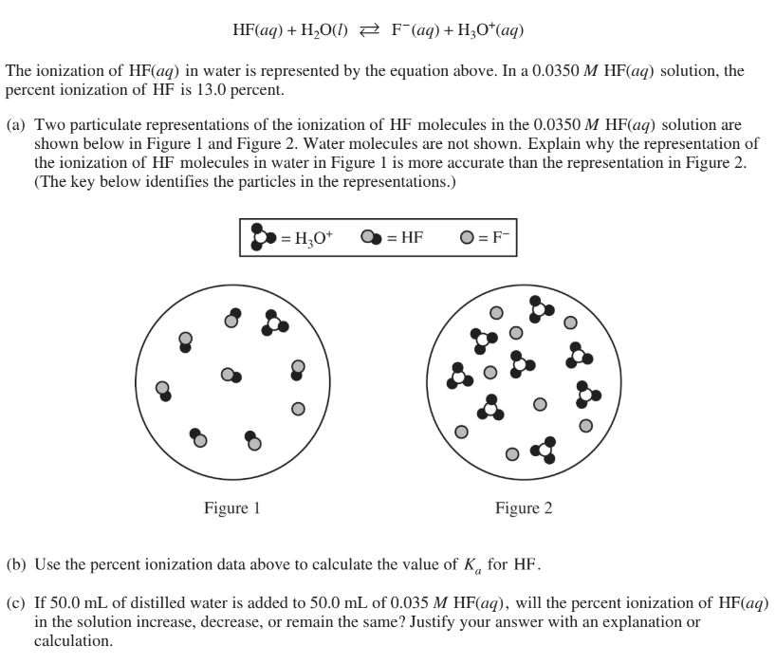
- Use the percent ionization data above to calculate the value of K_{a} for HF.

- If 50.0 mL of distilled water is added to 50.0 mL of 0.035 M HF(aq), will the percent ionization of HF(aq) in the solution increase, decrease, or remain the same? Justify your answer with an explanation or calculation.

AP CHEMISTRY PRACTICE 8.4, 8.7-8.9
AP Chemistry: 8.4, 8.7-8.9 Acid-Base Reactions, Buffers, pH, pKa, and Henderson-Hasselbalch
WATCH THIS VIDEO (OR THIS VIDEO) BY MICHAEL FARABAUGH TO ASSIST IN THIS QUESTION

8.4 Acid-Base Reactions and Buffers
Definition of a Buffer and Examples of Buffer Solutions
- A buffer is a solution that resists changes in pH when a small amount of a strong acid or a strong base is added to the solution.
- Typically, a buffer contains a weak acid and its conjugate base.
Guided Practice 1 - Identifying Strong versus Weak Acids
Which of the following are strong acids? Which of the following are weak acids? Label each as such.

- HCl, hydrochloric acid ______________________________
- HBr, hydrobromic acid ______________________________
- HOCl, hypochlorous acid ______________________________
- HCN, hydrocyanic acid ______________________________
- HF, hydrofluoric acid ______________________________
- HC₂H₃O₂, acetic acid ______________________________
- HNO₂, nitrous acid ______________________________
- HNO₃, nitric acid ______________________________
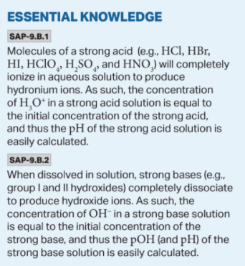 | - Strong acids are 100% ionized.  - HCl, HBr, HI, HClO₄ , H₂SO₄, and HNO₃  - Strong bases are soluble hydroxides with cations from Group 1 and Group 2  - LiOH, NaOH, KOH, RbOH, CsOH, Ca(OH)₂, Sr(OH)₂, Ba(OH)₂
Definition of a Buffer and Examples of Buffer Solutions-Guided Practice # 2
Write in all the conjugate bases of all the conjugate acids in the table below.
Conjugate Acid | Conjugate Base | For a buffer, you want a WEAK ACID and its conjugate base.  Cannot use these three. (Strong Acids)  Not make a good buffer.  Since these five are weak acids, they WOULD make a good buffer solution.
HCl
HBr
HNO₃
HNO₂
HOCl
HCN
HF
HC₂H₃O₂
We could find the conjugate bases as sodium salts of the conjugate acids:
1.0 M HNO₂ and 1.0 M NaNO₂  1.0 M HOCl and 1.0 M NaOCl  1.0 M HCN and 1.0 M NaCN  1.0 M HF and 1.0 M NaF  1.0 M HC₂H₃O₂ and 1.0 M NaC₂H₃O₂ | Guiding Questions  - What is the pH of each of these buffer solutions?  - Why do they behave as a good pH buffer solution? How exactly does a buffer work?

Guided Example: Calculating the pH of the buffer solution of 1.0 M HNO₂ and 1.0 M NaNO₂
Note: HNO₂ is a weak acid (because K_{a} <<< 1)
- We can write the acid dissociation expression:
HNO₂ + H₂O ⇆ H₃O⁺ + NO₂－ K_{a} = 4.0 × 10^{－4}

- Can plug this expression into the K_{a} with the concentrations of HNO₂ and NO₂－
$K_{a}=\frac{[H_{3}O^{+}][{{NO}_{2}^{-}}^{}]}{[HNO_{2}]}=4.0 x 10^{-4}$

- Both [HNO₂] and [NO₂－] are 1.0 M and thus equal….and can cancel out, giving us the [H₃O⁺]
$\frac{[H_{3}O^{+}][{1.0M}^{}]}{[1.0 M]}=4.0 x 10^{-4}$
${[H}_{3}O^{+}] = 4.0 x 10^{-4} = K_{a}$
- To calculate pH, we need to use the equation pH = － log( [H₃O⁺] )

${[H}_{3}O^{+}] = 4.0 x 10^{-4}$
$pH = -log({[H}_{3}O^{+}]) = -log(4.0 x 10^{-4}) = 3.40$

- Since our [H₃O⁺] = K_{a} , then the pH = pK_{a}. This is only true when you have equal concentrations of a weak acid and its conjugate base.

Guided Practice # 3: Complete the table by calculating the pK_{a} and pH of buffer solutions: pK_{a} = － log( K_{a} )
Buffer Components | K_{a} of the Weak Acid | pK_{a} of the Weak Acid | pH of the Buffer Solution
1.0 M HNO₂ and 1.0 M NaNO₂ | 4.0 × 10^{－4}
1.0 M HOCl and 1.0 M NaOCl | 2.9 × 10^{－8}
1.0 M HCN and 1.0 M NaCN | 6.2 × 10^{－10}
1.0 M HF and 1.0 M NaF | 6.8 × 10^{－4}
1.0 M HC₂H₃O₂ and 1.0 M NaC₂H₃O₂ | 1.8 × 10^{－5}

Relationship between pH and pK_{a}
$K_{a}=\frac{[H_{3}O^{+}][A^{-}]}{[HA]}$ pK_{a} = －log(K_{a})

- When [HA] = [A－], the pH = pK_{a} .
- When [HA] > [A－], the pH < pK_{a} .
- When [HA] < [A－], the pH > pK_{a} .

Example of HNO₂ and NO₂－
$K_{a}=\frac{[H_{3}O^{+}][{{NO}_{2}^{-}}^{}]}{[HNO_{2}]}=4.0 x 10^{-4}$ pK_{a} = 3.40

When [HNO₂] = [NO₂－], pH = pK_{a} = 3.40
Guided Practice # 4: Relationship between pH and pK_{a}
In the table make a prediction for the other two buffer solutions. Will the pH be less than or greater than the pK_{a}?
Buffer Components | pH of the Buffer Solution | Prediction | Calculation
1.0 M HNO₂ and 1.0 M NaNO₂ | 3.40
1.2 M HNO₂ and 0.80 M NaNO₂ | ???
0.8 M HNO₂ and 1.2 M NaNO₂ | ???

Guided Practice # 5: Relationship between pH and pK_{a}.
After making your predictions from Guided Practice # 4 , perform the calculations to determine the pH and place the value in the table. (Use the Guided Example to help with the calculations.)

How to Prepare a Buffer Solution
- There are two common methods to prepare a buffer solution:
  - Method # 1
    - Mix two solutions together
    - One solution that contains the weak acid (HA)
    - Another solution that contains the conjugate base (A－ )
      - Examples:
        - Combine 500 mL of 2 M HC₂H₃O₂ and 500 mL of 2 M NaC₂H₃O₂ and you get 1000 mL of 1 M HC₂H₃O₂ and 1 M NaC₂H₃O₂
        - Combine 500 mL of 2.4 M HC₂H₃O₂ and 500 mL of 1.6 M NaC₂H₃O₂ and you get 1000 mL of 1.2 M HC₂H₃O₂ and 0.8 M NaC₂H₃O₂
- Method # 2
  - Start with a solution that contains a weak acid (HA)
  - Then add a strong base to this solution until HALF of the weak acid (HA) has been neutralized.
  - HA + OH－ ⟶ A－ + H₂O
  - Example:
    - Combine 100 mL of 2 M HC₂H₃O₂ and 100 mL of 1 M NaOH and you get 200 mL of 0.5 M HC₂H₃O₂ and 0.5 M NaC₂H₃O₂. Calculations?
HC₂H₃O₂ : 100 mL of 2 M = 0.1 L x 2 M = 0.2 mol
NaOH or OH－ : 100 mL of 1M = 0.1 L x 1M = 0.1 mol
R | HC₂H₃O₂ | + | OH－ | ⇄ | H₂O | + | C₂H₃O₂－
I | 0.2 mol |  | 0.1 mol |  |  |  | 0
C | -0.1 mol |  | -0.1 mol |  |  |  | +0.1 mol
E | 0.1 mol |  | 0 |  |  |  | 0.1 mol
Where is 0.5 M from: Well, 0.1 mol in 200 mL (or 0.2 L) total.
So: 0.1 M / 0.2 L = 0.5 M
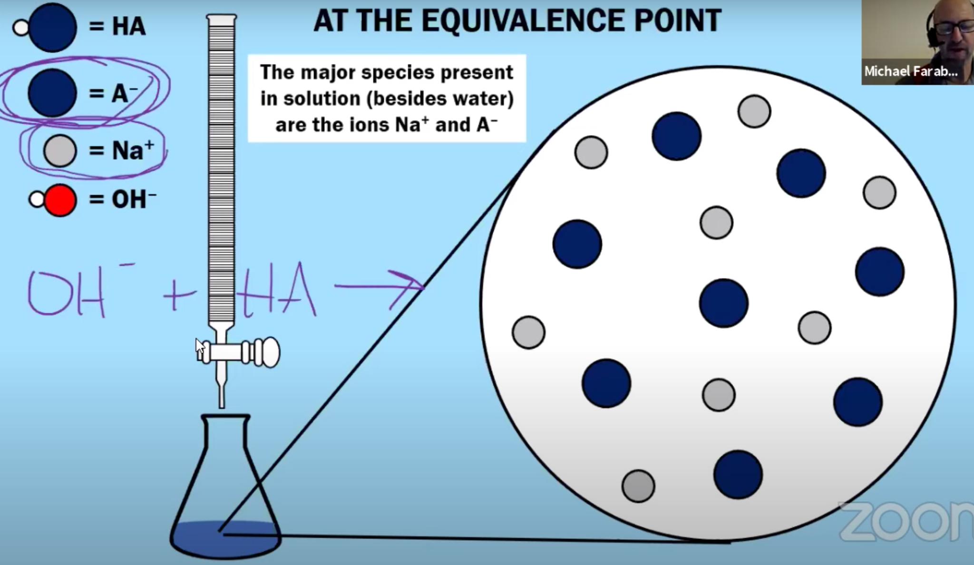
Remember for Acid/Base Titrations
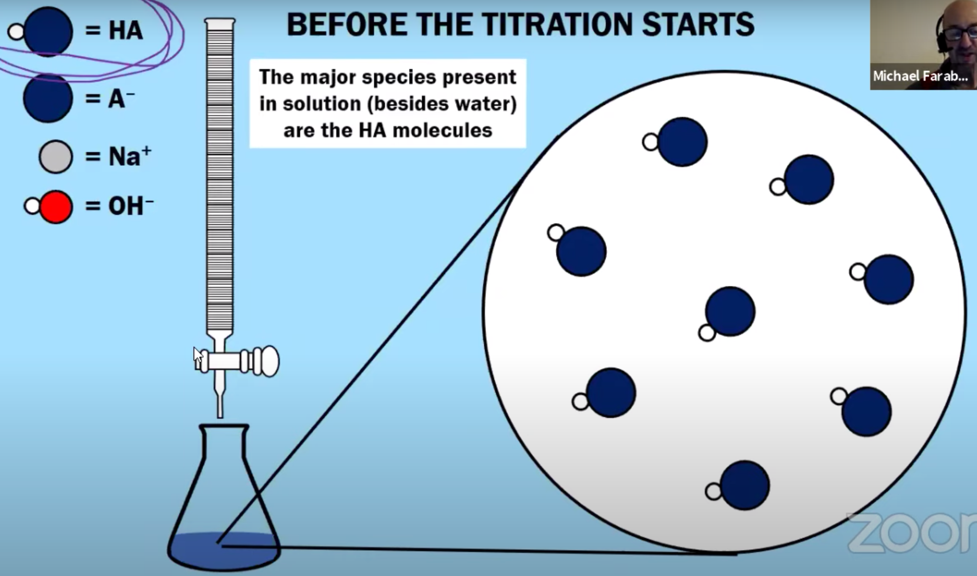

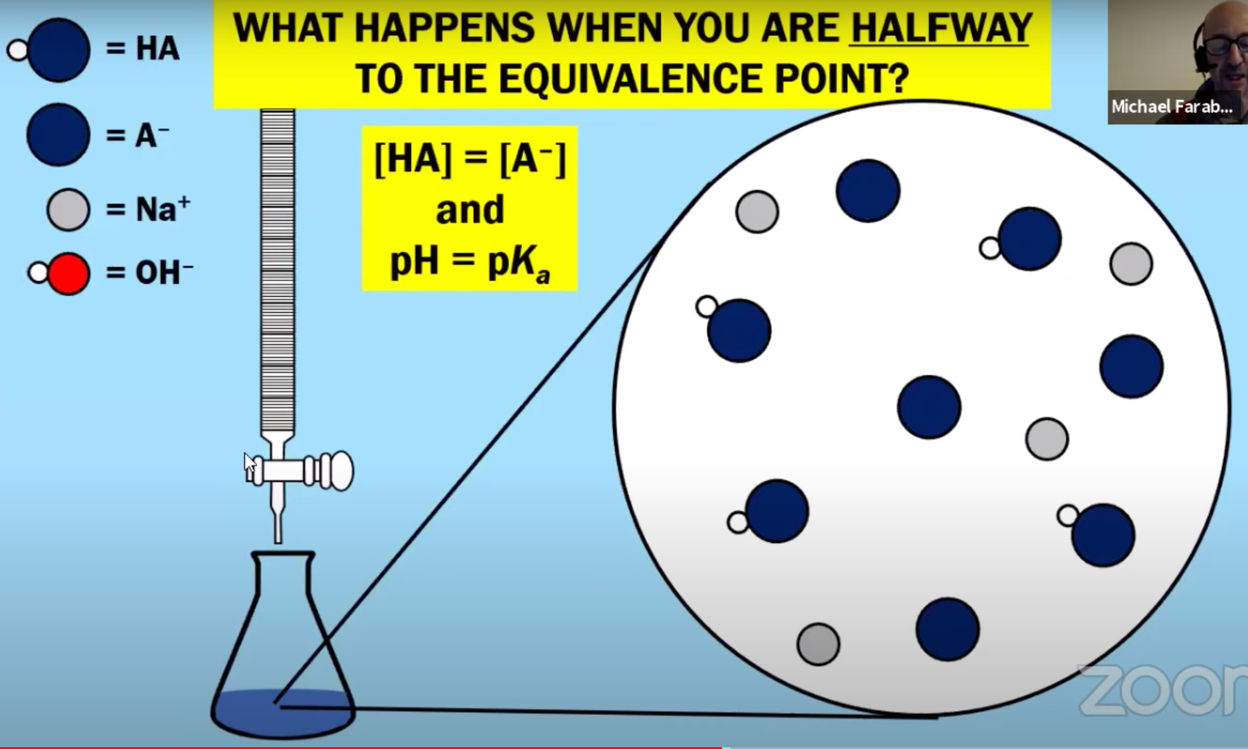

pH Range of a Buffer
- The pH range of a buffer is the pH range over which the buffer acts effectively.
- For most buffers, this pH range tends to be the following: pH = pK_{a} ± 1
- For example, if we had a buffer that had equal concentrations of HNO₂ and NaNO₂:
  - The pH range would be pK_{a} ± 1 …. 3.40 ± 1 ….thus pH = 2.40 to 4.40
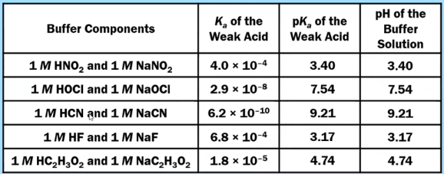

Guided Practice- pH Range of a Buffer
- If you wanted to make a buffer with a pH around 7, which of the buffer components would you use?

- If you wanted to make a buffer with a pH around 10, which of the buffer components would you use?

- What would be the pH range of a buffer solution made from HOCl and OCl－?

- What would be the pH range of a buffer solution made from HCN and CN－?

Addition of a Strong Acid (or Base) to a Buffer Solution
Guided Example - Adding a Strong Acid

1.0 M HNO₂ and 1.0 M NaNO₂ ; HNO₂ = weak acid ; NO₂－ = weak base
Suppose that a small amount of HCl is added to this buffer. Write the net ionization equation for the reaction that would occur between HCl and one of the components of this buffer?
Balanced Chemical Equation: HCl (aq) + NO₂－(aq) ⟶ HNO₂(aq) + Cl－(aq)
Ionic Equation: H⁺(aq) + Cl－(aq) + NO₂－(aq) ⟶ HNO₂(aq) + Cl－(aq)
Net Ionic Equation: H⁺(aq) + NO₂－(aq) ⟶ HNO₂(aq)
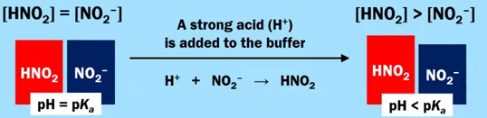

Guided Example - Adding a Strong Base
1.0 M HNO₂ and 1.0 M NaNO₂ ; HNO₂ = weak acid ; NO₂－ = weak base
Suppose that a small amount of NaOH is added to this buffer. Write the net ionization equation for the reaction that would occur between NaOH and one of the components of this buffer?
Balanced Chemical Equation: NaOH (aq) + HNO₂(aq) ⟶ NO₂－(aq) + Na⁺(aq) + H₂O (l)
Ionic Equation: Na⁺(aq) + OH－(aq) + HNO₂(aq) ⟶ NO₂－(aq) + Na⁺(aq) + H₂O (l)
Net Ionic Equation: OH－(aq) + HNO₂(aq) ⟶ NO₂－(aq) + H₂O (l)
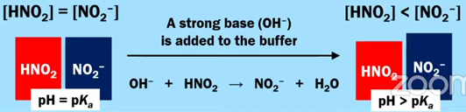
In General for the Addition of a Strong Acid or Strong Base to a Buffer Solution:
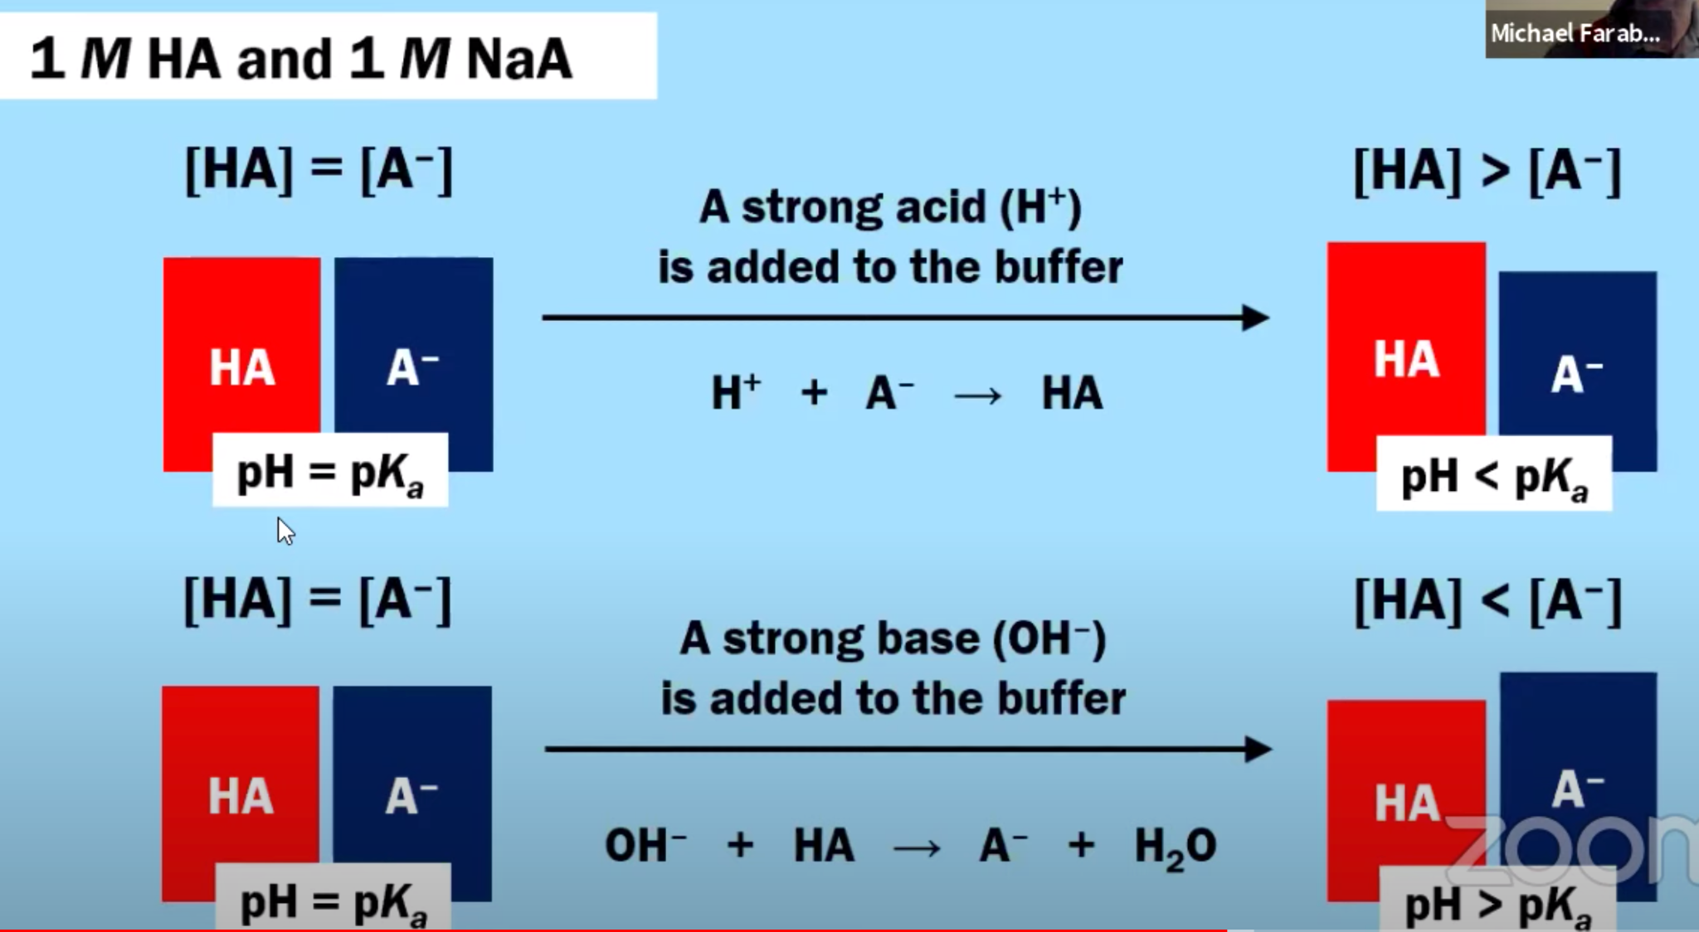
How does a Buffer Solution Resist Changes in pH? (Adding Acid)
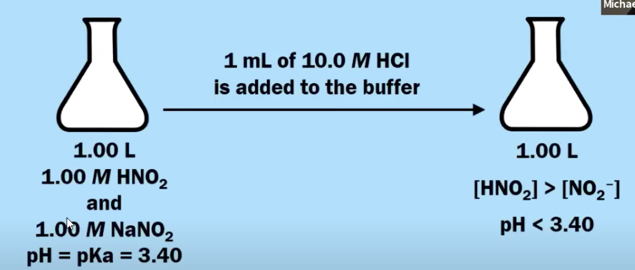
If we add 1 mL of 10.0 M HCl: $0.001 L x \frac{10 mol}{1 L}= 0.01 moles H^{+}$
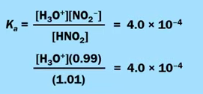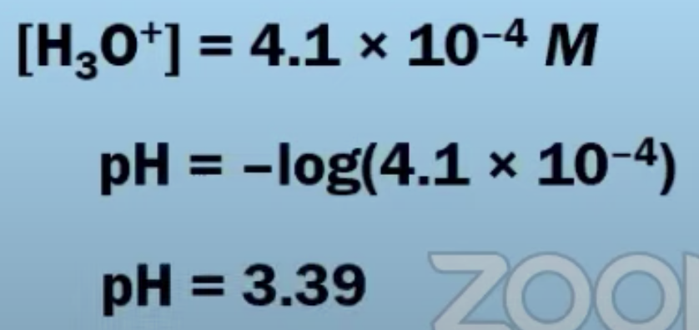
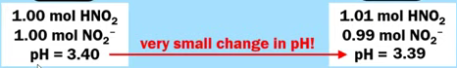
Look at what happens when we add the same amount to pure water (without a buffer!)
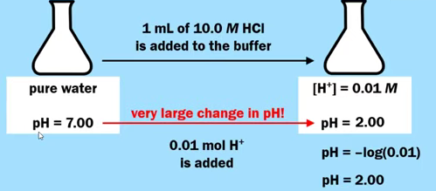
How does a Buffer Solution Resist Changes in pH? (Adding Base)
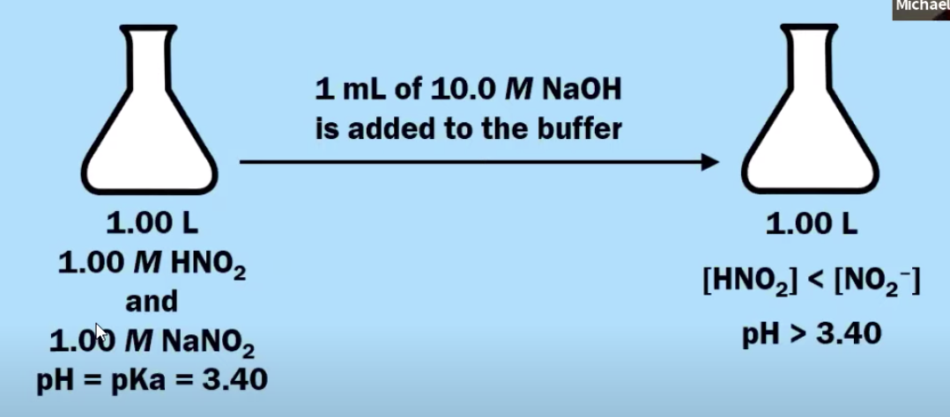
If we add 1 mL of 10.0 M NaOH: $0.001 L x \frac{10 mol}{1 L}= 0.01 moles {OH}^{-}$
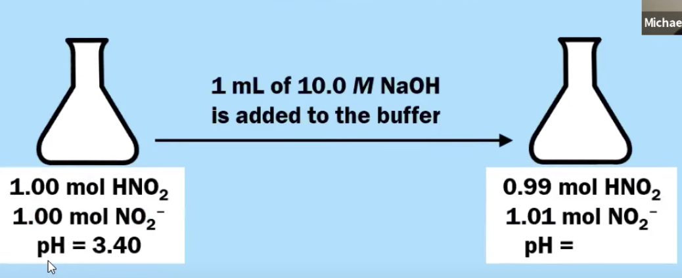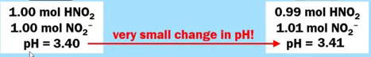
Look at what happens when we add the same amount to pure water (without a buffer!)
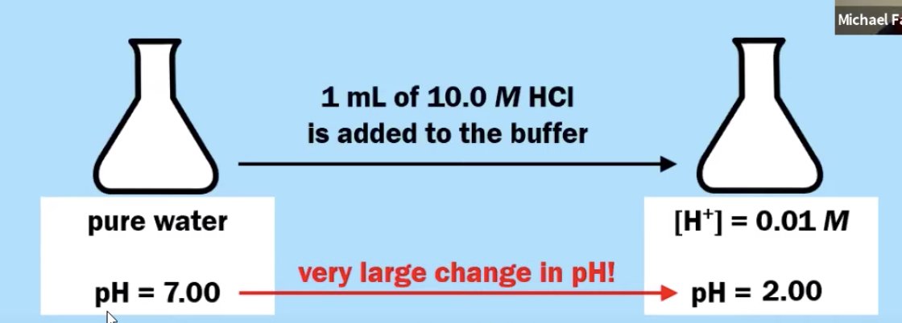
To Summarize:
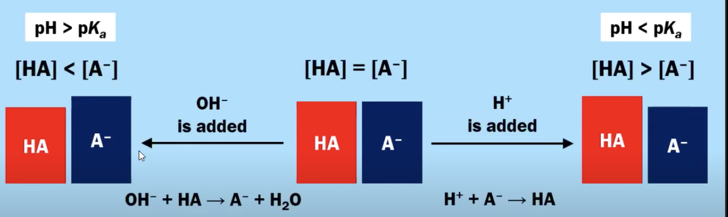
A strong acid and its conjugate base will NOT create a good buffer.
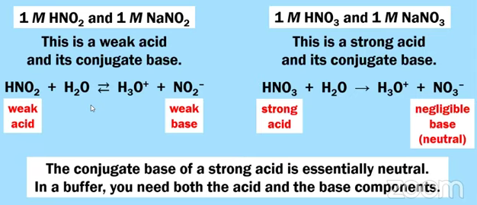
Henderson-Hasselbalch Equation - Derivation and Conclusion
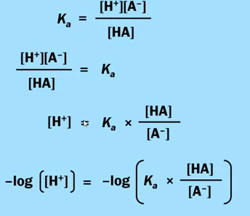 | 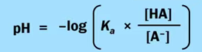  And log AB = log A + log B  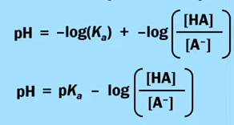  And log(A/B) = -log(B/A)  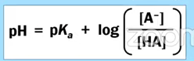
Guided Practice - Using the Henderson-Hasselbalch Equation (or Not)
A buffer solution contains 1.2 M HNO₂ and 0.80 M NaNO₂. What is the pH of this buffer solution? (K_{a} = 4.0 × 10^{－4} )
Solve using the K_{a} expression AND the Henderson-Hasselbalch Equation

Guided Practice - Using the Henderson-Hasselbalch Equation (or Not)
A buffer solution that contains a mixture of HC₂H₃O₂ and NaC₂H₃O₂ has a pH of 5.00. If [HC₂H₃O₂] = 2.0 M, what is the value of the [C₂H₃O₂－]? (K_{a} for HC₂H₃O₂ = 1.8 × 10^{－5}) Solve using the K_{a} expression AND the Henderson-Hasselbalch Equation

pK_{a} and pK_{b}
- We have seen examples of buffer solutions where you start with a weak acid, such as HNO₂ and combine it with the conjugate base, such as NO₂－...
- What about a weak base?
  - Could you start with a weak base, such as NH₃ and combine it with a conjugate acid, such as NH₄⁺?

Guided Practice - pK_{a} & pK_{b}
With the following information, complete the missing parts of the Table below.

K_{a} × K_{b} = K_{w} = 1.0 × 10^{－14} @ 25ºC AND pK_{a} + pK_{b} = 14.00 @ 25ºC

Conjugate Acid | K_{a} | pK_{a} | Conjugate Base | K_{b} | pK_{b}
HNO₂ | 4.0 × 10^{－4} | 3.40 | NO₂－
HOCl | 2.9 × 10^{－8} | 7.54 | ClO－
NH₄⁺ |  |  | NH₃ | 1.8 × 10^{－5} | 4.74
CH₃NH₃ |  |  | CH₃NH₂ | 4.4 × 10^{－4} | 3.36

AP EXAM PRACTICE FRQ 8.4, 8.7-8.9 - HOMEWORK

Answer the following questions that relate to a buffer solution that contains hydrofluoric acid, HF, and sodium fluoride, NaF. (K_{a} for HF = 6.8 × 10^{－4} )

- The pK_{a} for HF is equal to 3.17. A diagram shown below is a particulate representation of a buffer solution containing HF and F－. Based on the information in the diagram, do you predict that the pH of this solution should be less than, equal to, or greater than 3.17? Justify your answer.
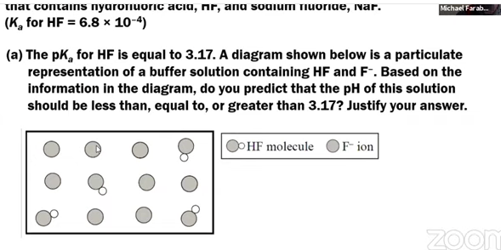

- A buffer solution is made by mixing equimolar amounts of HF(aq) and NaF(aq). When a small amount of 12 M HNO₃(aq) is added to this buffer, the pH of the solution changes from 3.17 to 3.15. Write a balanced net ionic equation that accounts for the fact that the pH does not change significantly when the HNO₃(aq) is added to the buffer solution.

- Determine the volume, in mL, of 10.0 M NaOH(aq) that should be added to 1000 mL of 1.0 M HF(aq) in order to create a buffer solution that has a pH of 3.17. Justify your answer with calculations.

- A buffer has a pH of 3.17 and has the following concentrations.
1.0 M HF and 1.0 M NaF
A solution is prepared combining 500 mL of the buffer described above with 500 mL of distilled water to create a solution with a volume of 1000 mL. Do you predict that the pH of the final solution should be less than, equal to, or greater than 3.17? Justify your answer.

AP CHEMISTRY PRACTICE 9.1-9.3, 9.5, 7.14
AP Chemistry: 9.1-9.3, 9.5, 7.14 Entropy and Gibbs Free Energy
WATCH THIS VIDEO (OR THIS VIDEO) BY MICHAEL FARABAUGH TO ASSIST IN THIS QUESTION

9.1 Introduction to Entropy
- A measure of how dispersed (spread out) the energy of a system is at a specific temperature
- Entropy increases when...
  - ...matter and/or energy becomes more dispersed or spread out
  - ...a substance changes phase from solid to liquid, from liquid to gas, or from solid to gas
  - ...individual particles become freer to move and generally occupy a larger volume
    - Example: letting air out of a tire
  - ...when a gas expands into a larger volume (at constant temperature)
  - ...in a chemical reaction the total number of moles of gaseous products is greater than the total number of moles of gaseous reactants
  - ...the temperature of a gas increases, leading to a broader distribution of the kinetic energies of the gas particles
    - Example: Maxwell-Boltzmann Distribution
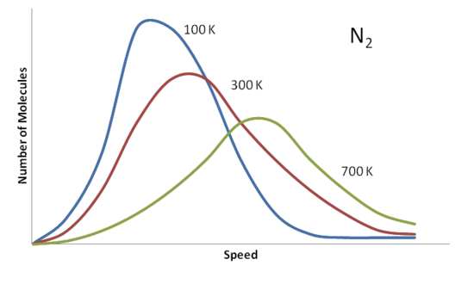
- ...the temperature increases, the entropy of a system increases.
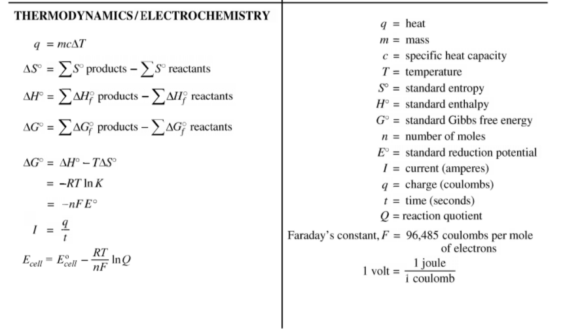

9.2 Absolute Entropy and Entropy Change
- Recall that the ΔH_{f}º for a pure element is zero; this is not the same for entropy
- The only substance that has an entropy value of zero would be a pure crystal that is at Absolute Zero Temperature (-273 ^{O}C or 0 K) ( ΔSº= 0 only at 0 Kelvin)
- To calculate ΔSº, you can use the following equation (like calculating ΔHº_{rxn})
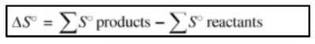
Guided Practice # 1 - Entropy Change Calculations
TABLE OF MOLAR ENTROPIES
Substance | Sº (J/mol-K) |  | Substance | Sº (J/mol-K)
H₂(g) | 130.6 |  | H₂O(l) | 69.9
N₂(g) | 191.5 |  | H₂O(g) | 188.8
O₂(g) | 205.0 |  | Na(s) | 51.3
O₃(g) | 238.8 |  | Cl₂(g) | 223.0
NH₃(g) | 192.5 |  | NaCl(s) | 72.1

For each of the following chemical reactions:
(a) Predict what should happen to the value of entropy change to the above reaction. Should it be positive or negative? Justify your answer with the definition of entropy.
(b) Then, using the table, calculate the entropy change of reaction, ΔSº, for the chemical reaction
Chemical Reaction | Entropy Change Prediction (+ or －) | Entropy Change Calculation
N₂(g) + 3 H₂(g) ⟶ 2 NH₃(g) | Negative, (－); less moles of gas are formed, and less freely moving particles. | ΔSº = [2 ×ΔS(NH₃)] － [1 × ΔS(N₂) + 3 × ΔS(H₂)]  =[2×(192.5)] － [1 × (191.5) + 3 × (130.6)]  =－ 198. 3 J/mol-K
2 O₃(g) ⟶ 3 O₂(g)
H₂O(l) ⟶ H₂O(g)
2 Na(s) + Cl₂(g) ⟶ 2 NaCl(s)
9.3 Gibbs Free Energy and Thermodynamic Favorability

- Gibbs Free energy is the amount of energy that is “free” or “available” to do useful work
  - Meaning that if a reaction is “thermodynamically favorable” that means it happens all by itself and that can be used to do work on the surroundings
    - If a reaction is “not thermodynamically favorable” that means the surroundings would need to supply energy in order for the reaction to work
  - ΔGº = the Gibbs free energy change for a chemical process in which all the reactants and products are present in a standard state (1.0 M, 1.0 atm, and 298 K)
  - If ΔGº < 0, the process is thermodynamically favored to occur at standard conditions. This says nothing about the rate of the reaction. It could be fast or slow.
  - One way to calculate the value of ΔGº is to use the data for standard free energy of formation, ΔG_{f}º
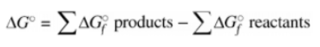
- Another way to calculate the value of ΔGº is to use the following equation:
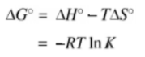

Interpreting ΔGº
ΔGº | Meaning
Negative | The forward process is thermodynamically favored to occur.
Positive | The forward process is NOT thermodynamically favored to occur. Instead, the reverse process is favored. Energy must be supplied from the surroundings in order to get the forward process to occur.
Zero | This can be an equilibrium situation, usually for a phase change. Neither the forward process nor the reverse process is favored.

Guided Practice # 2 - Free Energy and Thermodynamic Favorability.
Substance | ΔG_{f}º (kJ/mol)
H₂(g) | 0
O₂(g) | 0
H₂O(l) | －237.2

- Calculate the change in Gibb’s Free Energy of the following reaction and identify whether it is thermodynamically favorable.
2 H₂(g) + O₂(g) ⟶ 2 H₂O(l)

- Identify whether the reverse of the reaction in (1), shown below, is thermodynamically favorable.
2 H₂O(l) ⟶ 2 H₂(g) + O₂(g)

Guided Practice # 3 - Free Energy and Thermodynamic Favorability.
Substance | ΔG_{f}º (kJ/mol)
H₂O₂(l) | －120.4
H₂O(l) | －237.2
O₂(g) | 0

Calculate the change in Gibb’s Free Energy of the following reaction and identify whether it is thermodynamically favorable.
2 H₂O₂(l) ⟶ 2 H₂O(l) + O₂(g)

AP CHEM TIP: EVEN THOUGH A REACTION MAY BE SLOW, DOES NOT MEAN IT IS THERMODYNAMICALLY UNFAVORABLE. JUST BECAUSE A REACTION IS FAVORED, WE CANNOT SAY WHETHER THE REACTION OCCURS QUICKLY OR SLOWLY. IF THE ACTIVATION ENERGY IS RELATIVELY HIGH, THE REACTION WILL USUALLY OCCUR RATHER SLOWLY.
Guided Practice # 3 - Free Energy and Thermodynamic Favorability. (Time Stamp: 30:14)
Recall: ΔGº = ΔHº － TΔSº
Substance | ΔH_{f}º (kJ/mol) | CaCO₃(s) ⟶ CaO(s) + CO₂(g)  - Using the thermodynamic data at left, calculate the change in Gibbs Free energy, ΔGº for the decomposition of calcium carbonate (above) and determine whether this reaction is thermodynamically favored to occur at 298 K.
CaCO₃(s) | －1206.9
CaO(s) | －634.9
CO₂(g) | －393.5
Substance | Sº (J/mol-K)
CaCO₃(s) | 92.9
CaO(s) | 38.1
CO₂(g) | 213.8

- Is this decomposition of calcium carbonate thermodynamically favored to occur at 1000ºC (1273 K)?

- Determine the minimum temperature that would be required in order for this reaction to be thermodynamically favored.
Keep in mind, when ΔGº =0, then neither the forward or the reverse process is favored. Set ΔGº = 0 to find the “swing” temperature.

The Effect of Temperature on Thermodynamic Favorability
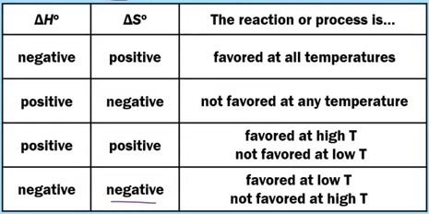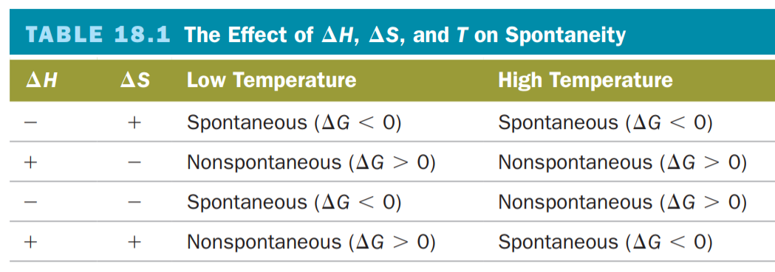

It Depends on Temperature Situations
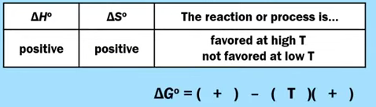
Think about this in terms of Le Chatelier’s Principle

Heat + Reactants ⇄ Products

As T is increased, an endothermic reaction shifts towards the products.

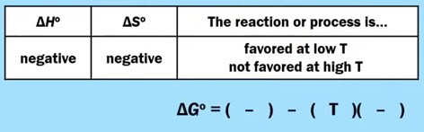
Also, think about this in terms of Le Chatelier’s Principle

Reactants ⇄ Products + Heat

As T is decreased, an exothermic reaction shifts towards the products.
And as T is increased, an exothermic reaction shifts towards the reactants (thus unfavorable)

AP CHEMISTRY EXAM TIP:

You might see a question that asks you the following: “What drives this reaction?”

There will be three possible answers:
- The reaction is driven by enthalpy only
  - This only occurs when you have a negative ΔHº and negative ΔSº
- The reaction is driven by entropy only
  - This only occurs when you have a positive ΔHº and positive ΔSº
- The reaction is driven both by enthalpy and entropy.
  - This only occurs when you have a negative ΔHº and positive ΔSº

9.5 Free Energy and Equilibrium
- If a reaction is thermodynamically favored ΔGº < 0, and K > 1 & if a reaction is NOT thermodynamically favored ΔGº > 0, and K < 1
- Can calculate the relationship between ΔGº and K
  - ΔGº = － RT ln K … And the value of R we are using is 8.314 J mol^{－1} K^{－1}
AND $K = e^{\frac{-ΔG^{o}}{RT}}$
7.14 Free Energy of Dissolution
Substance | ΔH_{f}º (kJ/mol) | NH₄NO₃(s) ⟶ NH₄⁺(aq)) + NO₃－(aq)  - Using the thermodynamic data at left, calculate the change in Gibbs Free energy, ΔGº for the dissolution of ammonium nitrate (above).  - Determine whether this reaction is thermodynamically favored to occur at 298 K.  - Is this process driven by enthalpy only, driven by entropy only, or driven by both enthalpy and entropy? Justify your answer.
NH₄NO₃(s) | －365.6
NH₄⁺(aq) | －132.5
NO₃－(aq) | －205.0
Substance | Sº (J/mol-K)
NH₄NO₃(s) | 151.1
NH₄⁺(aq) | 113.4
NO₃－(aq) | 146.4

The Dissolution of an Ionic Solid - 3 Processes
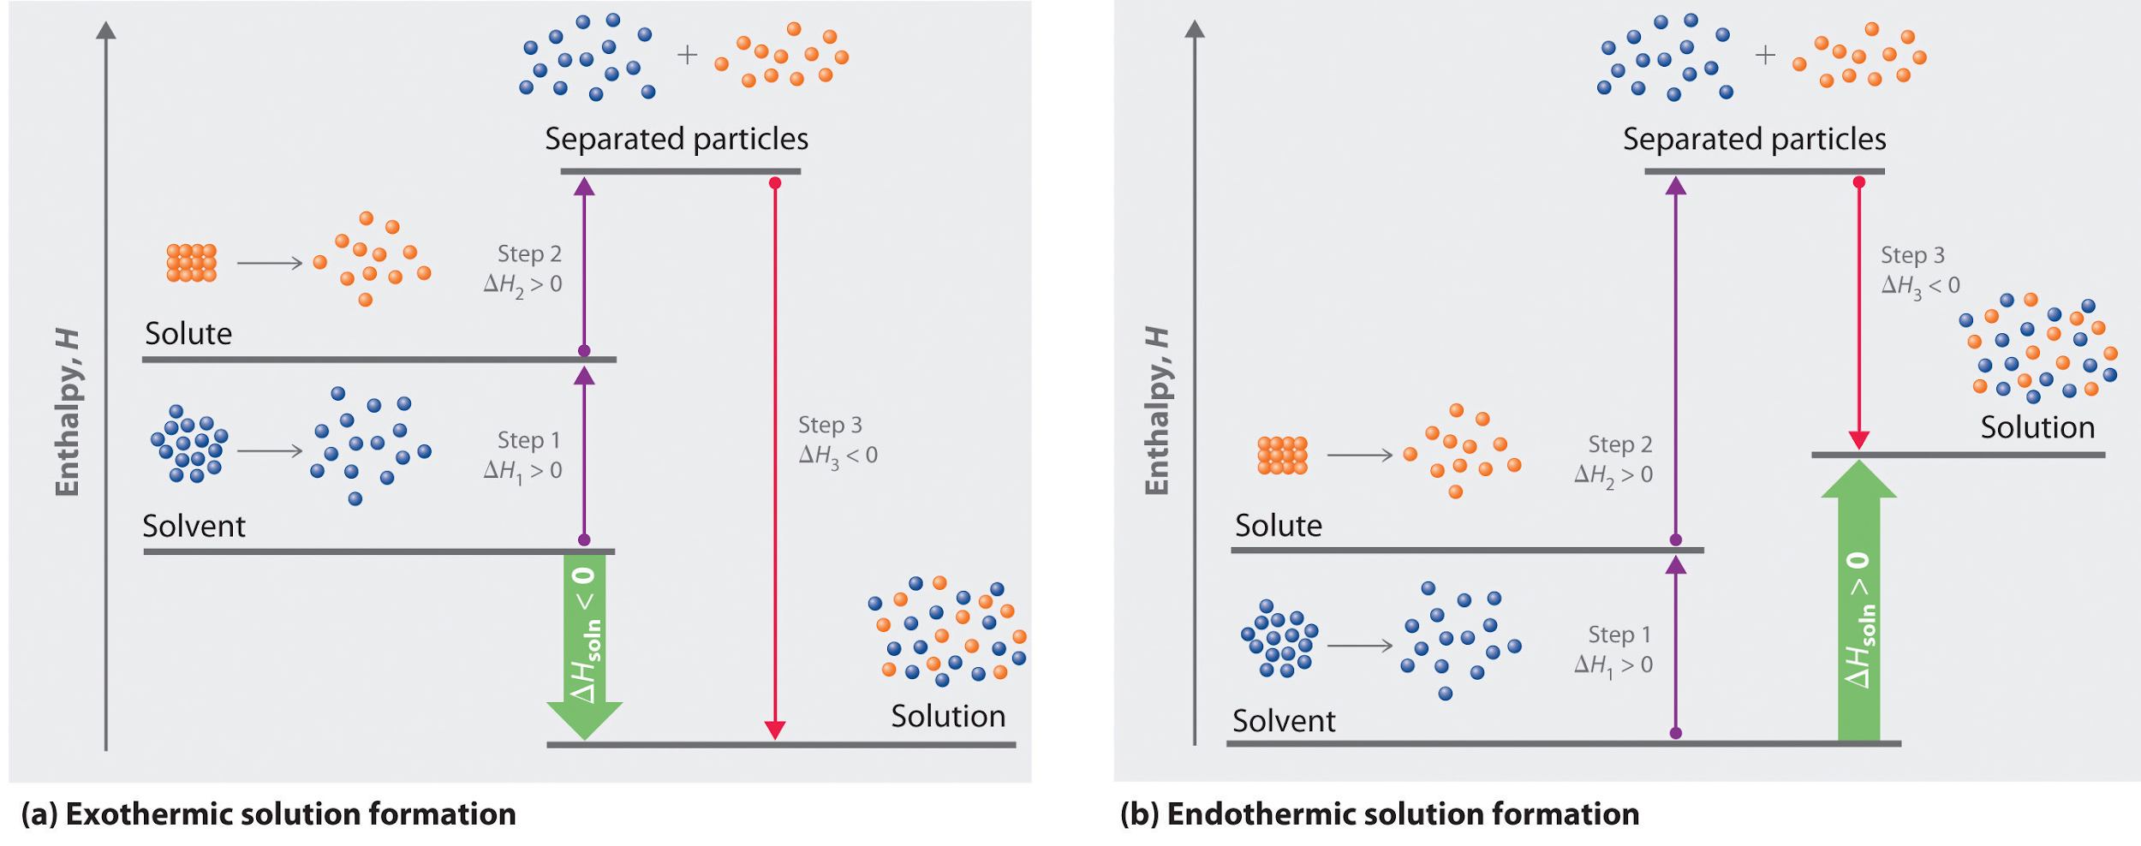

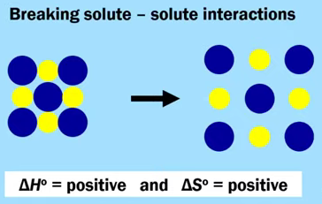
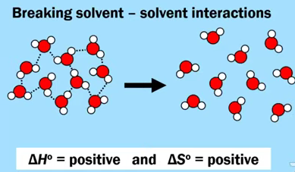
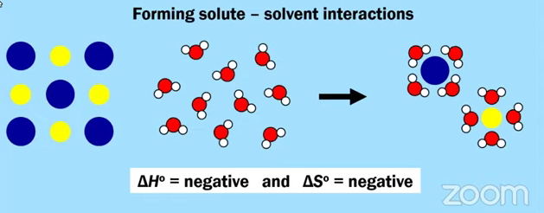
AP EXAM PRACTICE FRQ 9.1 - 9.3, 9.5, 7.14 - HOMEWORK

NaHCO₃(s) + HC₂H₃O₂(aq) ⟶ NaC₂H₃O₂(aq) + H₂O(l) + CO₂(g)

A student designs an experiment to study the reaction between NaHCO₃ and HC₂H₃O₂. The reaction is represented by the equation above. The student places 2.24 g of NaHCO₃ in a flask and adds 60.0 mL of 0.875 M HC₂H₃O₂. The student observes the formation of bubbles and that the flask gets coolers as the reaction proceeds.

- In thermodynamic terms, a reaction can be driven by enthalpy, entropy, or both.
  - Considering that the flask gets cooler as the reaction proceeds, what drives the chemical reaction between NaHCO₃(s) and HC₂H₃O₂(aq)? Answer by drawing a circle around one of the choices below.

Enthalpy only Entropy only Both enthalpy and entropy

  - Justify your selection in part (d)(i) in terms of ΔGº.

Fulminic acid can convert to isocyanic acid according to the equation below.

HCNO(g) ⇄ HNCO(g)
Fulminic acid isocyanic acid
- Using the Lewis electron-dot diagrams of fulminic acid and isocyanic acid shown in the boxes above and the table of average bond enthalpies below, determine the value of ΔHº for the reaction of HCNO(g) to form HNCO(g) .

- A student claims that ΔSº for the reaction is close to zero. Explain why the student’s claim is accurate.

- Which species, fulminic acid (HCNO) or isocyanic acid (HNCO), is present in higher concentration at equilibrium at 298 K. Justify your answer in terms of thermodynamic favorability and the equilibrium constant.

The student reads in a reference text that NO(g) and NO₂(g) will react as represented by the equation below. Thermodynamic data for the reaction are given in the table below the equation

NO(g) + NO₂(g) ⇄ N₂O₃(g)

$ΔH_{298}^{o}$ | $ΔS_{298}^{o}$ | $ΔG_{298}^{o}$
－40.4 kJ/mol_{rxn} | －138.5 J/(Kᐧmol_{rxn}) | －0.87 kJ/mol_{rxn}

- The student begins with an equimolar mixture of NO(g) and NO₂(g) in a rigid reaction vessel and the mixture reaches equilibrium at 298 K.

  - Calculate the value of the equilibrium constant, K, for the reaction at 298 K.

  - If both $P_{NO}$ and $P_{NO_{2}}$in the vessel are initially 1.0 atm, will $P_{N_{2}O_{3}}$at equilibrium be equal to 1.0 atm? Justify your answer.

- The student hypothesizes that increasing the temperature will increase the amount of N₂O₃(g) in the equilibrium mixture. Indicate whether you agree or disagree with the hypothesis. Justify your answer.

H₂NCONH₂(s) ⇄ H₂NCONH₂(aq)

The dissolution of urea is represented by the equation above. A student determines that 5.39 grams of H₂NCONH₂ (molar mass 60.06 g/mol) can dissolve in water to make 5.00 mL of a saturated solution at 20ºC.

- Calculate the concentrations of urea, in mol/L, in the saturated solution at 20ºC.

- The student also determines that the concentration of urea in a saturated solution at 25ºC is 19.8 M. Based on this information, is the dissolution of urea endothermic or exothermic? Justify your answer in terms of Le Chatelier’s principle.

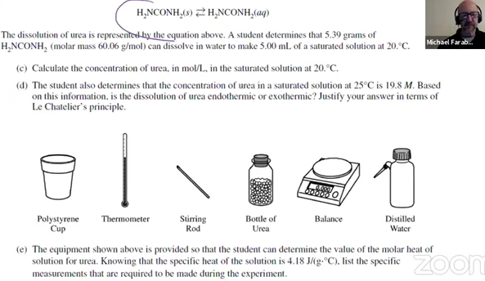
- The equipment shown above is provided so that the students can determine the value of the molar heat of solution for urea. Knowing that the specific heat of the solution is 4.18 J/(gᐧºC), list the specific measurements that are required to be made during the experiment.

 | Sº (J/mol-K)
H₂NCONH₂(s) | 104.6
H₂NCONH₂(aq)

- The entropy change for the dissolution of urea, $ΔS_{soln}^{o}$, is 70.1 J/(mol·K) at 25ºC. Using the information in the table above, calculate the absolute molar entropy, Sº, of aqueous urea.

- Using particle-level reasoning, explain why $ΔS_{soln}^{o}$is positive for the dissolution of urea in water.

- The student claims that $ΔS_{}^{o}$for the process contributes to the thermodynamic favorability of the dissolution of urea at 25ºC. Use the thermodynamic information above to support the student’s claim.

AP CHEMISTRY PRACTICE 9.6-9.10
AP Chemistry: 9.6-9.10 Electrochemistry
WATCH THIS VIDEO BY KRISTEN CACCIATORE TO ASSIST IN THIS QUESTION
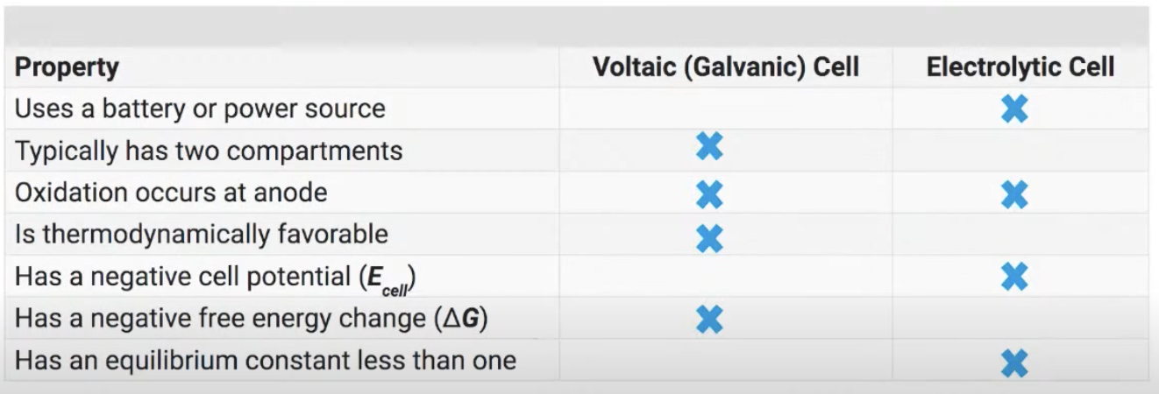
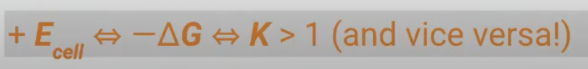
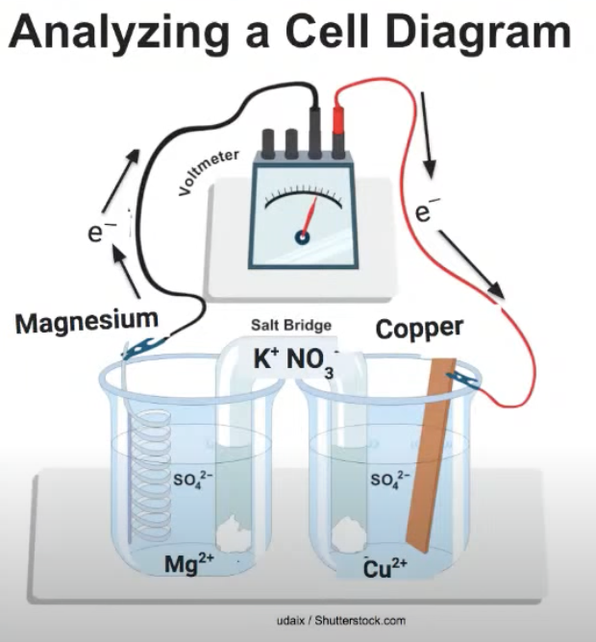
Which type of electrochemical cell is shown in the diagram?

Which side of the cell is the anode, right or left?

What will happen to the concentration of magnesium ions as the cell operates ?

Describe the motion of the ions in the salt bridge as the cell operates.

Remember: No salt bridge, the cell does not operate!! No cell potential and no voltage!

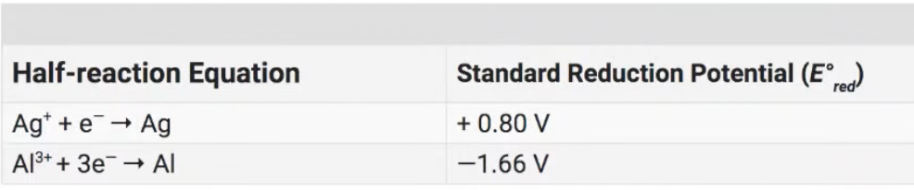
What is the balanced net ionic equation for the reaction that occurs in a galvanic cell involving these two half-reactions?
- Reverse the oxidation half-reaction (less positive/ more negative)
- Multiply half-reactions as needed to equalize electrons
- Add the manipulated half-reactions together. Electrons cancel out!

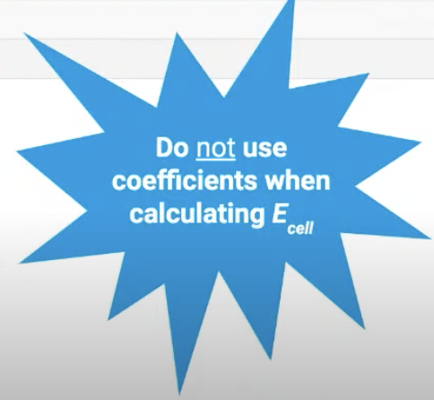
What is the value of the standard cell potential, E°_{cell}?

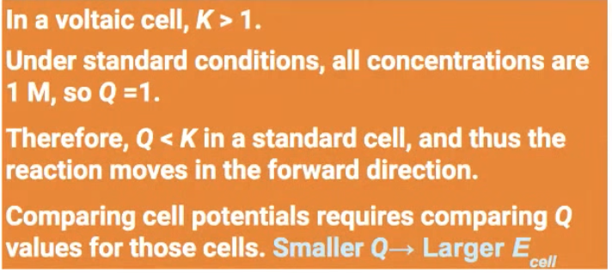
Rank the cell potentials, E_{cell}, of the following nonstandard cells:
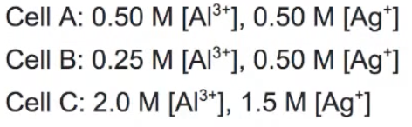

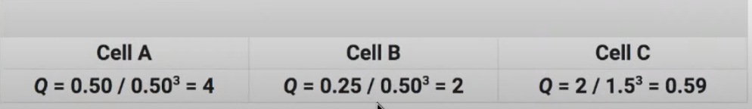

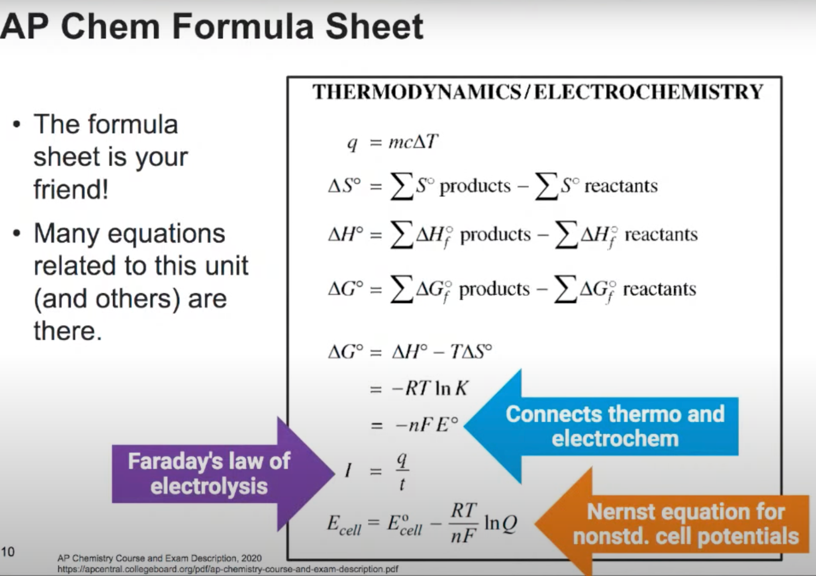
FRQ #1:
The following questions refer to the electrochemical cell diagram and the standard reduction potentials below.
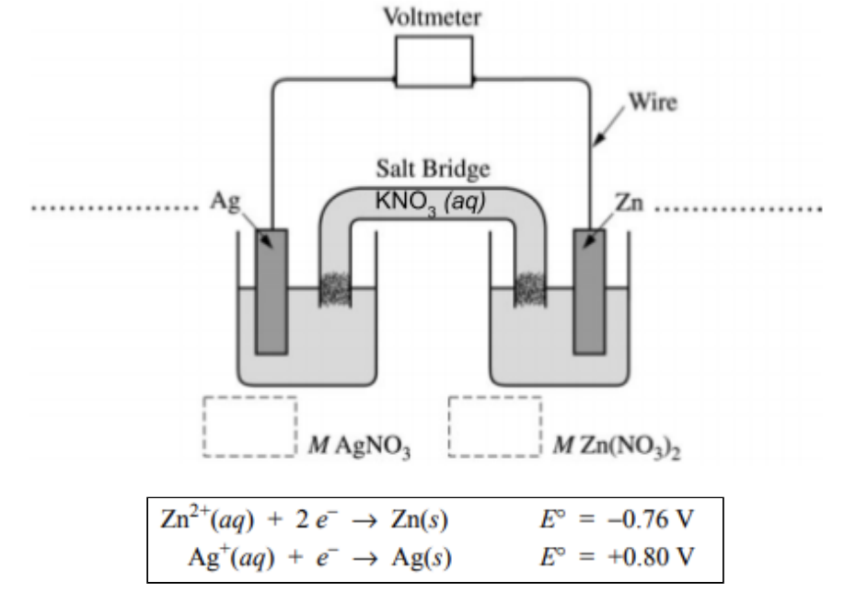
(a) Calculate the standard cell potential, E°, for the thermodynamically favorable reaction that occurs in the cell.

(b) Write a balanced net ionic equation for the reaction in part (a).

(c) In the diagram above,
- label the anode and the cathode on the dotted lines provided, and
(ii) indicate, in the boxes below the half-cells, the concentration of AgNO₃ and the concentration of Zn(NO₃)₂ that are needed to generate E°.

(d) In the expanded view of the center portion of the salt bridge shown in the diagram below, draw and label a particle view of what occurs in the salt bridge as the cell begins to operate. Omit solvent molecules and use arrows to show the movement of particles.
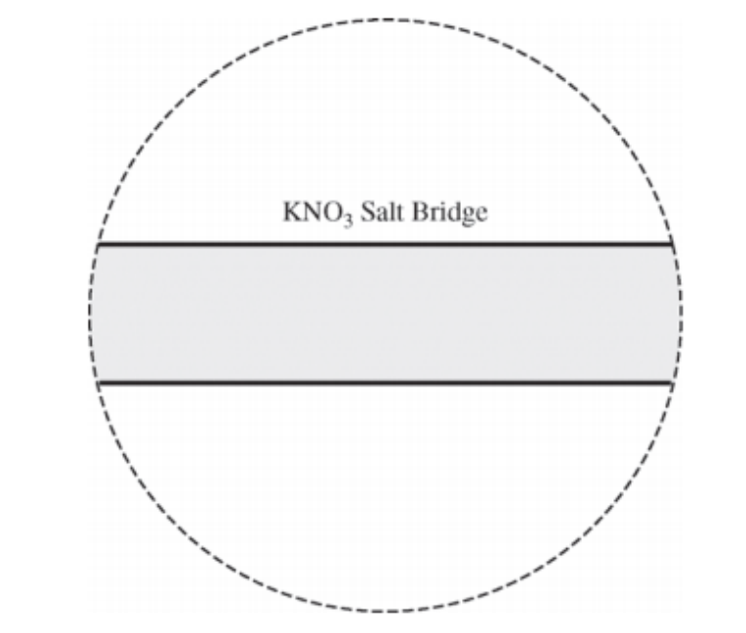
(e) The following questions involve possible alterations to the cell.
(i) Will the cell potential, E_{cell}, increase, decrease, or remain unchanged if [Ag⁺] is doubled? Justify your answer.
Note: Do not use equilibrium/Le Chatelier reasoning with electrochemical cells. Voltaic cells are not at equilibrium during operation, and you will not earn credit for this type of argument

(ii) Will the cell potential, E_{cell}, increase, decrease, or remain unchanged if the initial mass of the Ag electrode is doubled? Justify your answer

(f) Will the cell potential increase, decrease, or remain the same as the cell operates? Justify your answer.

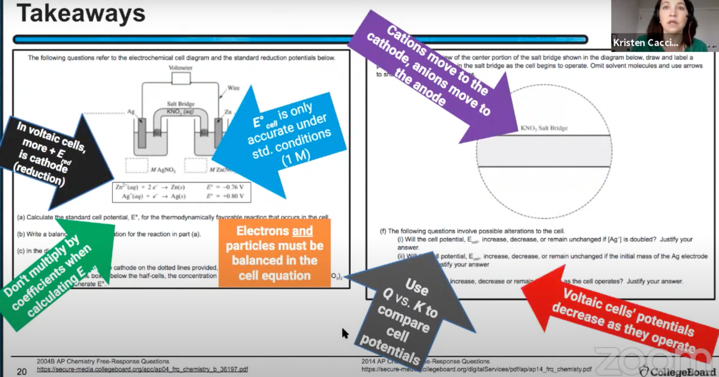
FRQ #2:
A cell produces 110. g of Al(l) via electrolysis as represented in the equation below.

2 Al2O3 (l) + 3 C (s) → 4 Al (l) + 3 CO2 (g)

(a) Determine the number of moles of electrons that must be transferred in the cell to produce the 110. g of Al (l).

(b) The process required 139 minutes using a constant current. Determine the current used.
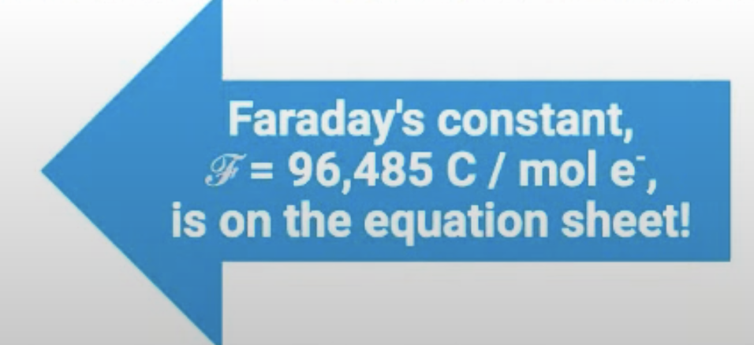

(c) A student hypothesizes that oxygen is oxidized in the reaction. Do you agree or disagree? Justify your answer in terms of oxidation numbers.

(d) Calculate the volume of CO₂(g), measured at standard temperature and pressure (STP), that is produced in the process.
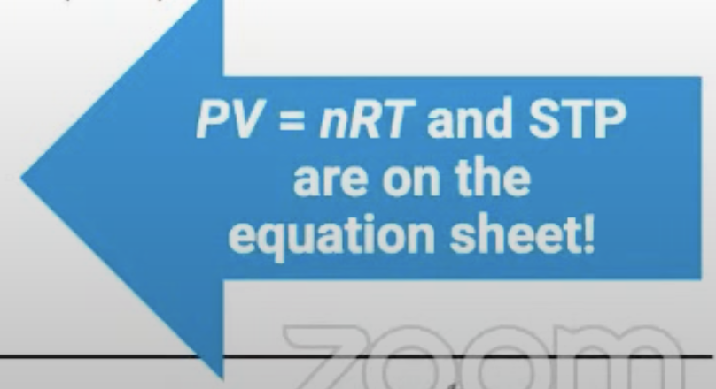

(e) For the electrolytic cell to operate, the Al₂O₃ must be in the liquid state rather than in the solid state. Explain why this is true.

(f) Is the entropy change for this process positive or negative? Justify your answer.

When Al(s) is placed in a concentrated solution of potassium hydroxide, KOH at 25°C, the reaction represented below occurs.
2 Al(s) + 2 OH⁻－ (aq) + 6 H₂O (l) → 2[Al(OH)₄]⁻－ (aq) + 3 H₂ (g)
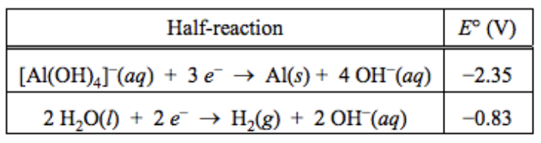
(g) Using the table of standard reduction potentials shown above, calculate the following.

- E°, in volts, for the formation of [Al(OH)₄] (aq) and H₂ (g) at 25°C

－

- ΔG°, in kJ/molrxn, for the formation of [Al(OH)4] (aq) and H₂ (g) at 25°C

－

Aluminum metal can be recycled from scrap metal by melting the metal to evaporate impurities.

(h) Calculate the amount of heat needed to purify 1.00 mol of Al originally at 0℃ by melting it. The melting point of Al is 660℃. The heat capacity of Al is 0.90 J g⁻¹ ℃⁻¹ and the heat of fusion of Al is 0.397 kJ g⁻¹.
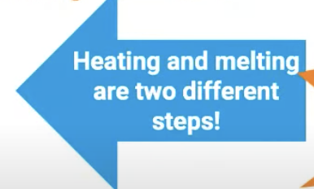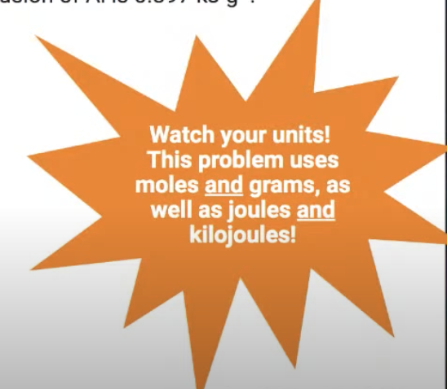
(i) The equation for the overall process of extracting Al from Al₂O₃ is shown below. Which requires less energy, recycling existing Al or extracting Al from Al₂O₃? Justify your answer with a calculation.
Al2O3 (s) → 2Al (s) + 3/2 O2 (g) ΔH° = 1675 kJ/mol rxn

