Amazing resources from AP Chem legends!!! | Practice Questions (G.Watson) | AP Daily Live Review (College Board and the legends of AP Chem)
THE Review ppt  THE Review worksheet  (N.Walsh, J.Tuohy and the amazing AP Chemistry Facebook teachers!) | Unit 1 Practice Questions | MCQ without calculator Video
Pretty Much everything you need to know for the AP Chemistry test | Unit 2 Practice Questions | Conceptual MCQ Video
Chemistry Youtube Live videos  Chemistry Youtube Live worksheet  (S. Byrne and M. Farbaugh) | Unit 3 Practice Questions | Experiment FRQ Video
AP Daily Video notes  (T.Kelleher) | Unit 4 Practice Questions | Coulomb’s/Periodicity/IMF Video
One pagers  (T.Kelleher) | Unit 5 Practice Questions | Acid Base Equilibrium Video
Things to have memorised in AP Chem  (N.Walsh) | Unit 6 Practice Questions | Exp. Method & Analysis Video
Thou Shalt Not Forget  (D.Reid) | Unit 7 Practice Questions | Electrochemistry  Video
Your course at a glance!  (E.Owens & A. Tedaldi) | Unit 8 Practice Questions | FRQ Medley/Exam Strats Video
Implementing CER  (A. Schmidt) | Unit 9 Practice Questions | Graphical Analysis* Video
Click here if you feel mildly panicked | 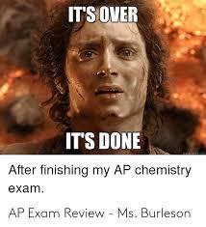 | Kinetics Video
 |  | Ksp/Qsp/Solubility* Video
Exam Success Meditation |  | Equilibrium Video
Click here for exam stress tips! |  | Challenging FRQ* Video
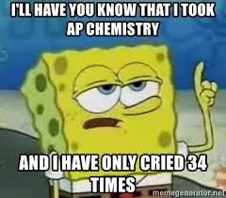 |  | Thermodynamics Video
 |  | Bonding/ Condensed State* Video
 |  | FRQ Medley Video

