**Station 1: (GAS LAW)** The door has just closed! With the building on lockdown, it is imperative that you and your fellow chemists solve the problem quickly before the automatic ventilator sucks out all of the air in the room!

**QUESTION 1:**  We have a 12.2-L sample containing 0.50 mol oxygen gas (O2) at a pressure of 1 atm and a temperature of 25ºC. If all this O2 were converted to ozone (O3) at the same temperature and pressure, what would be the volume of the ozone?

**QUESTION 2:** The density of a gas was measured at 1.50 atm and 27ºC and found to be 1.95 g/L. Calculate the molar mass of the gas.

**Q1.**

3 is to 2 as 0.5 is to x

x = 0.333 mol of O3 formed

Avogadro's Law:

V1 / n1 = V2 / n2

12.2 L / 0.5 mol = y / 0.333 mol

y = 8.13 L

Or

V = nRT/V

= 0.333(.08206)(298)/1

=8.14 (note if use 0.33 moles then get 8.06)

**HINT:** 3O2 → 2O3 **HINT 2:** # of moles should be to 3 sig figs

**(answer 8.13 - 8.15 only no units)**

**Q2.**

GFM= dRT/P

(1.95 g/L)(.08206 L atm/ mol K)(300 K)/(1.50 atm)

= 32.0 g/mol

hin1t: PV= (mass/GFM)RT HINT2: 3 sig figs HINT3: units!

**(answer 32.0 g/mol)**

**Letter given after station is L**

**Station 2: (ELECTROCHEMISTRY)** Welcome to the source of power for this facility. The building has gone into hypermode to produce the necessary electricity for the lockdown to continue. However, the system has malfunctioned and the temperature of the building is no longer regulated. You must solve the problem quickly before the heaters end up melting everything in the building, including you!

**QUESTION 1:** How many grams of Na will be deposited from molten NaCl by a current of 3.0 amps flowing for 4.0 hours?

**Question 2:** 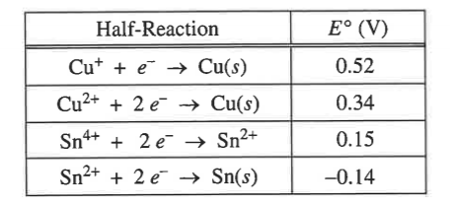

Using information from the table below, write a net-ionic equation for the reaction between the Sn electrode and the Cu(NO3)2 solution that would be thermodynamically favorable. Use that information to calculate the value of ΔG for the reaction. The correct answer with units should be enough to unlock the door

**Q1**.

4 h ( 3600 s/ 1 h) (3 C/s) (1 mol e− /96485 C) (1 mol Na/ 1 mol e−) (23.01 g Na/1 mol Na)

= 10. g

hint: 2 sig figs

**(answer 10. g)**

**Q2.**

HINT 1: answer is THERMODYNAMICALLY FAVORABLE (so neg.) HINT 2: the unit is kJ/mol HINT 3: Coulomb x Volt = Joules so need to convert to kJ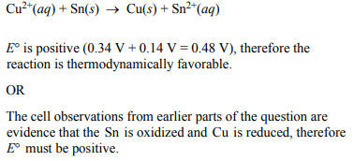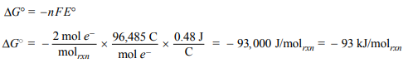

**(answer -93 kJ/mol)**

**Letter given after station is O**

**Station 3: (SOLUTIONS/STOICHIOMETRY)** Welcome to the storage room for the most toxic chemicals known to man. If any containers are compromised, everyone in the vicinity will die. Complete the following problems cautiously, as you will be creating a compound used in explosives, KNO3, and you could blow the facility into smithereens.

**Question 1:**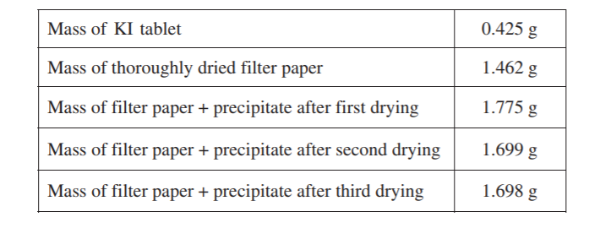

A student is given the task of determining the I− content of tablets that contain KI and an inert, water-soluble sugar as a filler. A tablet is dissolved in 50.0 mL of distilled water, and an excess of 0.20 M Pb(NO3)2(aq) is added to the solution. A yellow precipitate forms, which is then filtered, washed, and dried. The data from the experiment are shown in the table above.

Calculate the number of moles of precipitate that is produced in the experiment.

**Station 3**

**Q1.**

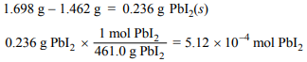

Hint: answer is NOT in scientific notation and contains 3 sig figs

Answer: .000512 (no mol needed, if included answer will work

**Letter given after station is U**

**Station 4: (ACIDS AND BASES)** Welcome to the Hydro-Room where scientists create their own water through acid-base reactions. Due to the lockdown, the building has activated a safety method in which the sprinklers in the room will release a 18.4 M HClO4 instead of water. Work quickly before the acid is dispersed throughout the room, or you will suffer chemical burns!

**Question 1:** Hypochlorous acid, HOCl, is a weak acid commonly used as a bleaching agent. The acid–dissociation constant, Ka, for hypochlorous acid is 3.2×10–8 . Calculate the [H+ ] of a 0.065–molar solution of HOCl.

**Question 2:** Household bleach is made by dissolving chlorine gas in water, as represented below. Cl2 (g) + H2O → H⁺ + Cl⁻ + HOCl(aq)

Calculate the pH of such a solution if the concentration of HOCl in the solution is 0.065 molar.

**Station 4**

**Q1**.  **x2/ 0.065 = 3.2 x 10-8 x = [H+] = 4.6E-5** M **Q2. -log (4.6E-5)**

Hint: format: ##E-# M **pH = 4.34**

hint: use Ka from previous question

Answer: 4.6E-5 Answer: 4.34

**Letter given after station is M**

**Station 5 (THERMOCHEMISTRY)** Not only does the facility produce its own water, but it also creates its own CO2 for the exotic wildlife in the greenhouse. The system is fully automated as the carbon monoxide gas reacts with O2, however, with the lockdown the system has shut down. Unless you can solve the following problem quickly, carbon monoxide will be released into the room.

**Question 1:**

CO(g) + ½O2(g) → CO2(g).

C(s) + ½O2(g) → CO(g) ∆H298 = -110.5 kJ mol⁻¹

C(s) + O2,(g) → CO2(g) ∆H298 = -393.5 kJ mol⁻¹

The combustion of carbon monoxide is represented by the equation above.

(a) Determine the value of the standard enthalpy change, ∆Hrnx, for the combustion of CO(g) at 298 K using the following information.

**hint: unit written as kJ/mol - USE Hess's Law to get your answer**

Q1: Answer: -283.0 kJ/mol

(b) Determine the value of the standard entropy change, rxn ∆S, for the combustion of CO(g) at 298 K using the information in the following table.

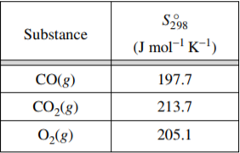

CO(g) + ½O2(g) → CO2(g).

**Hint: products-reactants (unit: J/mol K)**

Q2: Answer: -86.5 J/mol K

(c) Determine the standard free energy change, ∆Grxn, for the reaction at 298 K. Include units with your answer.

HINT 1: reaction IS thermodynamically favorable(unit: kJ/mol) Hint 2: convert J from entropy to kJ

Q3: answer: -257 kJ/mol

**Letter given after station is M**

**Station 5**

**a) (**b)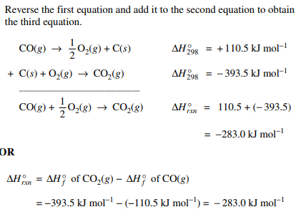

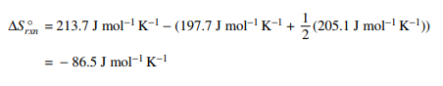

**c)**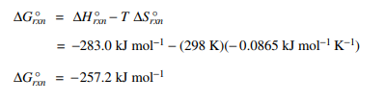

**Station 6 (SOLUBILITY)** Welcome chemists to the lab where various solutions are made. This facility is one of the largest retailers of aqueous Lead (II) Iodide. In this room there is PbI2 (s) which from long exposure can cause kidney and brain damage! If you delay, then you risk becoming a nincompoop!

**Question:**

A saturated solution is prepared by adding excess PbI2(s) to distilled water to form 1.0 L of solution at 25°C. The concentration of Pb⁺²(aq) in the saturated solution is found to be 1.3 × 10⁻³ M . The chemical equation for the dissolution of PbI2(s) in water is shown below.

PbI2(s) ⇄ Pb⁺²(aq) + 2I⁻(aq)

1) Calculate the molar concentration of I⁻(aq) in the solution.

**hint: formation ##E-# M**

Answer: 2.6E-3

2 Calculate the value of the equilibrium constant, Ksp.

**hint: formation ##E-#**

Answer: 8.8E-9

**Station 6**

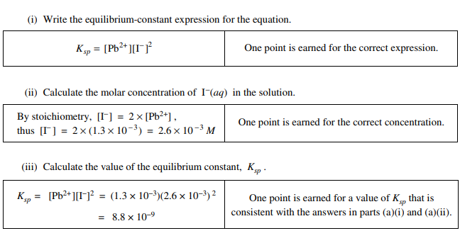

**Letter given after station is B**

**Station 7 (EQUILIBRIUM)** In this part of the facility, scientists work together to create different buffers and test their effectiveness. For emergencies, this section gets filled to the roof with water to prevent any dangerous chemicals from being released into the environment. Work carefully or else you better hope you can hold your breath!

**Question 1:** 50.0 mL of 0.100 M HCl was added to 50.0 mL of a buffer consisting of 20.millimoles of sodium acetate and 35 millimoles of acetic acid. What is the pH of the buffer after the addition of the acid? Ka of acetic acid is 1.7 x 10-5.

**Hint: 1) stoich first 2)Use the henderson hasselbalch equation**

**Station 7**

HA + A- → HA

5mmol 20mmol 35mmol

- 5mmol - 5mmol + 5mmol

------- ----------

100mL 100mL

[A-] = .15M [HA] = .40M

pH = -log (1.7E-5) + log(.15/.40) = 4.34

**Letter given after station is O**

Unscramble letter : COULOMB (must be in all caps)