# **Name:**

# **AP CHEM EXAM REVIEW PACKET**

# **AP CHEMISTRY PRACTICE Unit 1**

1. A student is given 50.0 mL of a solution of Na2CO3 of unknown concentration. To determine the concentration of the solution, the student mixes the solution with excess 1.0 M Ca(NO3)2 (*aq*), causing a precipitate to form. The balanced equation for the reaction is shown below

**Na2CO3(*aq*) + Ca(NO3)2(*aq*) ⟶ 2 NaNO3 (*aq*) + CaCO3(*s*)**

The student filters and dries the precipitate of CaCO3 (molar mass 100.1 g/mol) and records the data in the table below. Determine the number of moles of Na2CO3 in the original 50.0 mL of solution.

|  |  |
| --- | --- |
| Volume of Na2CO3 solution | 50.0 mL |
| Volume of 1.0 M Ca(NO3)2 added | 100.0 mL |
| Mass of CaCO3 precipitate collected | 0.93 g |

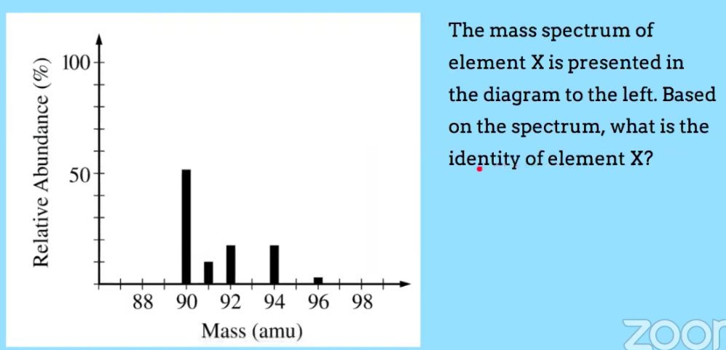

1. The mass spectrum of element X is presented in the diagram below. Based on the spectrum, what is the identity of element X? Explain.
2. The average atomic mass of naturally occurring neon is 20.18 amu. There are two common isotopes of naturally occurring neon as indicated in the table below

|  |  |
| --- | --- |
| **Isotope** | **Mass (amu)** |
| Ne-20 | 19.99 |
| Ne-22 | 21.99 |

Using the information above, calculate the percent abundance of each isotope.

1. A 31 g sample of a compound that contains only the elements C,H and N is completely burned in O2 to produce 44.0 g of CO2, 45.0 g of H2O, and 92.0 g of NO2. Determine the empirical formula of the compound.
2. A student investigates the reactions of nitrogen oxides. One of the reactions in the investigation requires an equimolar mixture of NO(*g*)and NO2(*g*), which the student produces by using the reaction represented above. The particle-level representation of the equimolar mixture of NO(*g*) and NO2(*g*) in the flask at the completion of the reaction between NO(*g*) and O2(*g*) is shown below in the box on the right. In the box below on the left , draw the particle-level representation of the reactant mixture NO(*g*) and O2(*g*) that would yield the product mixture shown in the box on the right. In your drawing, represent oxygen atoms and nitrogen atoms as indicated below.

**2NO(*g*) + O2(*g*) ⟶ 2 NO2(*g*)**

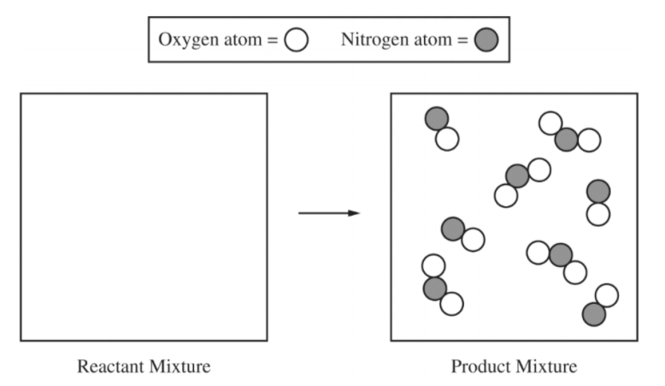

**6.** The complete photoelectron spectrum of an element is given below. What is the electron configuration of the element with this spectrum?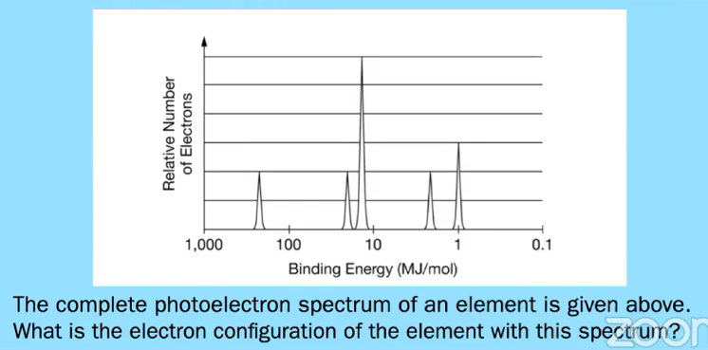

**7**. The elements in which of the following have most nearly the same atomic radius? Explain your choice.

1. Be, B, C, N
2. Ne, Ar, Kr, Xe
3. Mg, Ca, Sr, Ba
4. C, P, Se, I
5. Cr, Mn, Fe, Co

**8.** Using the following elements from the periodic table, select which one that best fits each statement:

1. Se
2. Br
3. Ag
4. Cs
5. Pb
6. Has the highest electronegativity ____
7. Has the largest atomic radius _______
8. Has the lowest first-ionization energy ________

**9.** Atoms of Mg combine with atoms of F to form a compound. Identify another element that you would expect to combine with atoms of F in the same ratio? Explain.

**10.** The only common oxide of zinc has the formula ZnO

(a) Write the electron configuration for a Zn atom in the ground state.

(b) From which sublevel are electrons removed when a Zn atom in the ground state is oxidized?

**11.** Answer the following questions related to Fe and its ions, Fe2+ and Fe3+.

|  |  |
| --- | --- |
| **Ion** | **Ionic Radius (pm)** |
| Fe2+ | 92 |
| Fe3+ | 79 |

1. Write the ground-state electron configuration of the Fe2+ ion.
2. The radii of the ions are given in the table above. Using the principles of atomic structure, explain why the radius of the Fe2+ ion is larger than the radius of the Fe3+ ion.

# **AP CHEMISTRY PRACTICE Unit 2**

**1.** Consider the following information for the Cl**ー**Cl bond:

|  |  |  |
| --- | --- | --- |
| Bond | Cl**ー**Cl | Br**ー**Br |
| Bond Length (pm) | 200 | **?** |
| Bond Energy (kJ/mol) | 243 | **?** |

Make a prediction about the Br**ー**Br bond, in terms of bond length and bond energy. Draw on the graph below the Br-Br bond

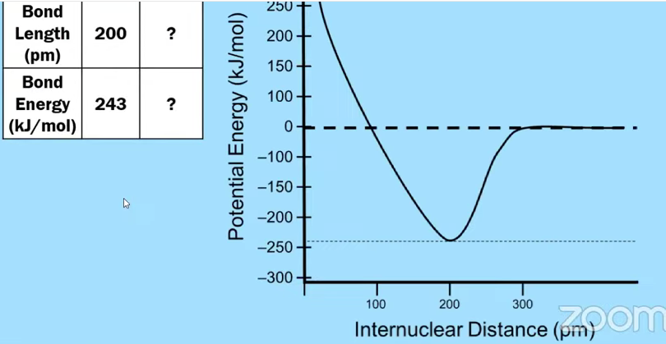

**2.** Data for the lattice energy of NaF is given in the table below. Make predictions about the lattice energy of MgO. Do you predict that the lattice energy of each compound is less than 930 kJ/mol or greater than 930 kJ/mol? Justify your answer in terms of periodic properties and Coulomb’s law.

|  |  |
| --- | --- |
| **Reaction** | **Lattice Energy (kJ/mol)** |
| NaF(*s*) ⟶ Na+(*g*) + F－(*g*) | 930 |
| MgO(*s*) ⟶ Mg2+(*g*) + O2－(*g*) |  |

**3.** Brass is an alloy that contains copper and zinc. The atomic radii of the elements are given in the table below. Should brass be classified as an interstitial alloy or a substitutional alloy? Justify your answer.

|  |  |
| --- | --- |
| **Element** | **Atomic radius (pm)** |
| Cu | 130 |
| Zn | 125 |

1. Answer the following questions about nitrogen and oxygen.
2. Draw the Lewis structure for the diatomic molecules N2 and O2.

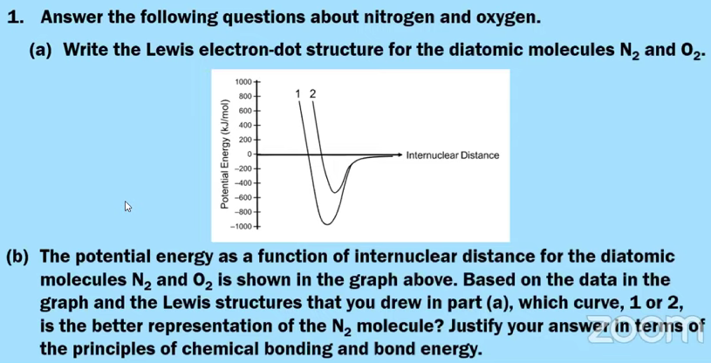

1. The potential energy as a function of internuclear distance for the diatomic molecules N2 and O2 is shown in the graph above. Based on the data in the graph and the Lewis structures that you drew in part (a), which curve, 1 or 2, is the better representation of the N2 molecule? Justify your answer.

**5.** Answer the following questions related to Mg and Sr.

1. Write the complete ground state electron configuration for the ions Mg2+ and Sr2+.
2. The lattice energy of MgCl2(*s*) is equal to 2300 kJ/mol. Do you predict that the lattice energy of SrCl2 should be less than or greater than 2300 kJ/mol? Justify your answer in terms of Coulomb’s law.

**6**. Draw the following Lewis structures in the space provided.

**CH4 NH3 H2O CH2Cl2**

|  |  |  |  |
| --- | --- | --- | --- |
|  |  |  |  |

**C2H6 C2H4 C2H2**

|  |  |  |
| --- | --- | --- |
|  |  |  |

**7.** 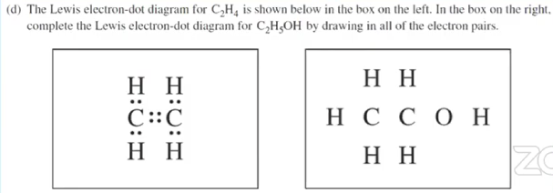

**8.**More than one equivalent Lewis structure can be drawn for the molecule **O3.** Draw all the resonance structures and estimate the bond order for the O-O bonds.

|  |
| --- |
|  |

**9.** Determine the Formal charge on each structure and determine which is the best structure based upon formal charge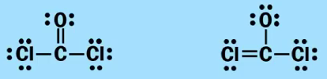

**10.** S2Cl2 is a product of a reaction.

(a) In the box below, complete the Lewis electron-dot diagram for the S2Cl2 molecule by drawing in all of the electron pairs.

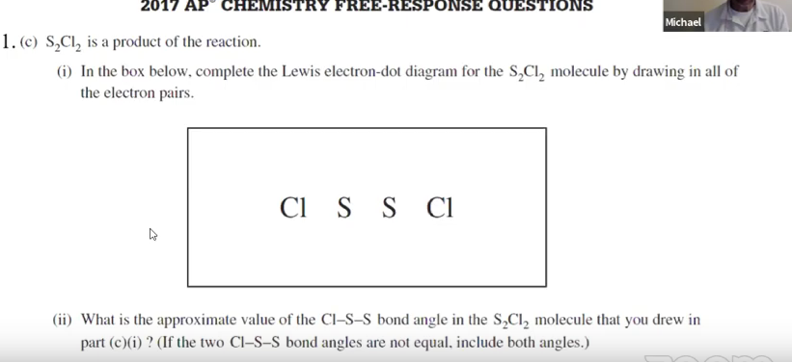

(b) What is the approximate value of the Cl一S一S bond angle in the S2Cl2 molecule that you drew in part (a) ? (If the two Cl一S一S bond angles are not equal, include both angles.)

**11.** The skeletal structure of the HNO2 molecule is shown in the box below.

(a) Complete the Lewis electron-dot diagram of the HNO2 molecule in the box below, including any lone pairs of electrons.

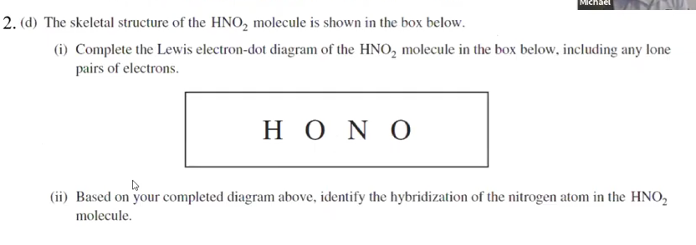

(b) Based on your completed diagram above, identify the hybridization of the nitrogen atom in the HNO2 molecule.

**Unit 3 Review**

1. Substances # 1 and # 2 represent two different elements located in Group 18 (noble gases). Which substance, #1 or # 2, has stronger attractive forces between particles? How can you tell?

|  |  |
| --- | --- |
| **Substance** | **Boiling Point (K)** |
| # 1 | 87 |
| #2 | 165 |

1. 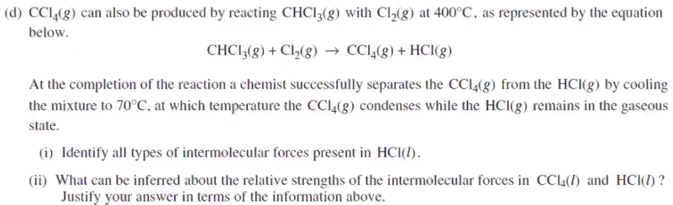

1. Using the boiling point data given below, which liquid, C5H12 or H2O, has a higher vapor pressure at 300 K? Justify your answer.

C5H12 Boiling Point= 309K

H2O Boiling Point = 373K

**4.** Answer the following questions in terms of principles of chemical bonding and intermolecular forces. In each explanation where a comparison is to be made, a complete answer must include a discussion of both substances. The following complete Lewis electron-dot diagrams may be useful in answering parts of this question.

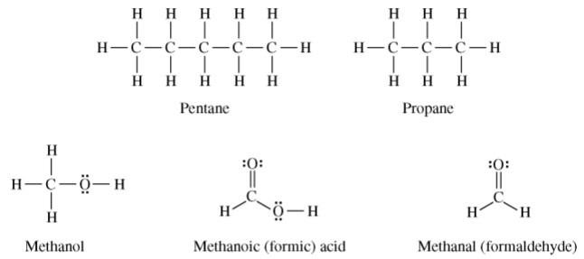

1. At 1 atm and 298 K, pentane is a liquid whereas propane is a gas. Explain.
2. At 1 atm and 298 K, methanol is a liquid whereas propane is a gas. Explain.
3. Indicate the hybridization of the carbon atom in methanol and Methanoic acid

**5**. A gas mixture at OoC and 1.15 atm contains 0.010 mol of H2, 0.015 mol of O2, and 0.025 mol of N2. Assuming ideal behavior, what are the partial pressures of hydrogen gas(H2), oxygen gas (O2) and nitrogen gas (N2) in the mixture?

**6.** Explain the following statements about gases. Be sure to mention specific information about both gases.

a) Ar(*g*) deviates more from ideal behavior at extremely high pressures than Ne(*g*) does.

1. The pressure of a sample of CH4 (*g*) (molar mass = 16 g/mol) is closer to the pressure predicted by the ideal gas law than a sample of NH3(*g*) (molar mass = 17 g/mol)

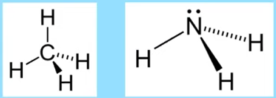 

Mg(*s*) + 2 H+(*aq*) ⟶ Mg2+(*aq*) + H2(*g*)

**7.** A student performs an experiment to determine the volume of hydrogen gas produced when a given mass of magnesium reacts with excess HCl(*aq*), as represented by the net ionic equation above. The student begins with a 0.0360 g sample of pure magnesium and a solution of 2.0 *M* HCl(*aq*).

1. Calculate the number of moles of magnesium in the 0.0360 g sample.
2. Calculate the number of molecules of HCl(*aq*) needed to react completely with the sample of magnesium.

As the magnesium reacts, the hydrogen gas produced is collected by water displacement at 23.0oC. The pressure of the gas in the collection tube is measured to be 749 torr.

1. Given that the equilibrium vapor pressure of water is 21 torr at 23.0oC, calculate the pressure that the H2(*g*) produced in the reaction would have if it were dry.

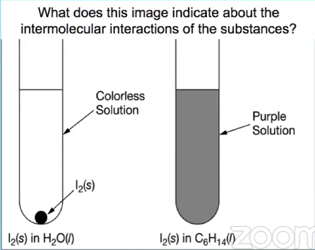

**8.** What does this image indicate about the intermolecular interactions of the substances?

**9.** Which of these pairs of molecules would you expect to mix together? Explain.

1. 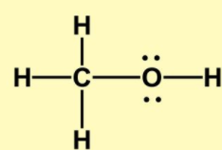 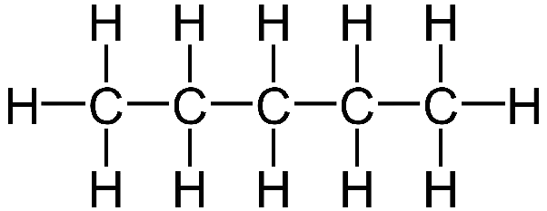
2. 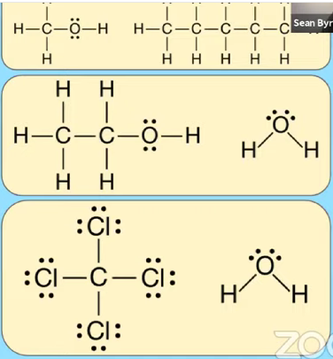
3. 

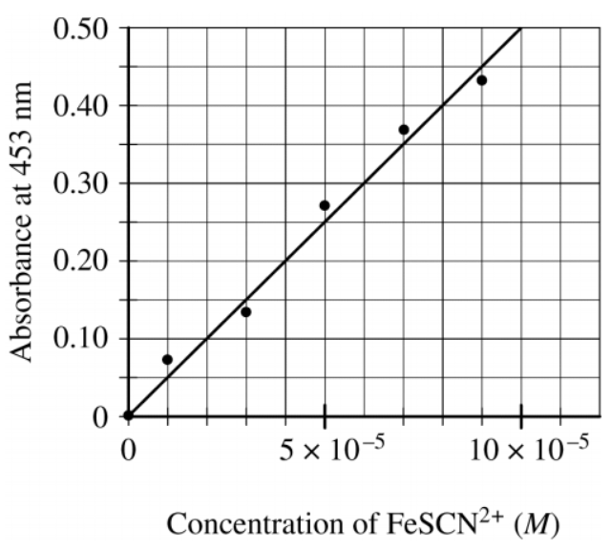

**10.** Fe3+(aq) + KSCN(s) → FeSCN2+(aq) + K+(aq)

To determine the moles of Fe3+*(aq)* in a 100. mL sample of an unknown solution, excess KSCN*(s)* is added to convert all the Fe3+*(aq)* into the dark red species FeSCN2+(aq), as represented by the equation above. The absorbance of FeSCN2+*(aq)* at different concentrations is shown in the graph to the right.The absorbance of the mixture is 0.20 at 453 nm.

a) What is the concentration of FeSCN2+(aq)?

b) How many moles of Fe3+(*aq*) were present in the 125 mL sample?

**11.** A student uses visible spectrophotometry to determine the concentration of CoCl2*(aq)* in a sample solution. First the student prepares a set of CoCl2*(aq)* solutions of known concentration. Then the student uses a spectrophotometer to determine the absorbance of each of the standard solutions at a wavelength of 510 nm and constructs a standard curve. Finally, the student determines the absorbance of the sample of unknown concentration. The student made the standard curve. What is a possible experimental error which could have caused the error in the point the student plotted at 0.050MCo2+*(aq)* ?

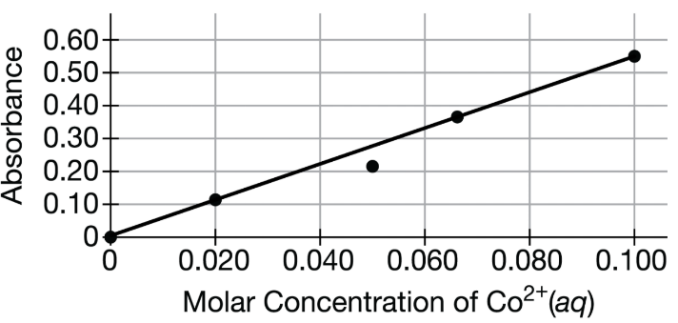

**Unit 4 Review**

1. Solutions of Hg(NO3)2 and NaI are combined. Write the net ionic equation.
2. After examining the particle diagram shown, a student made the claim that the concentration of AgNO3(*aq*) is the same as the concentration of MgCl2(*aq*). Do you agree with the student’s claim? Justify your answer based on the information in the particle diagram.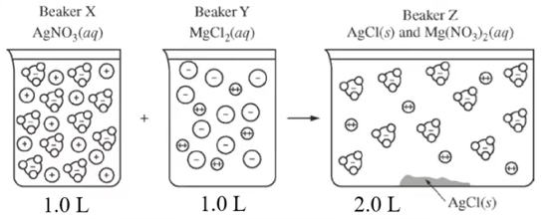

**2 AgNO3(*aq*) + MgCl2(*aq*) ⟶ 2 AgCl(*s*) + Mg(NO3)2(*aq*)**

**3.** A student is given 50.0 mL of a solution of Na2CO3 of unknown concentration. To determine the concentration of the solution, the student mixes the solution with excess 1.0 M Ca(NO3)2 (*aq*), causing a precipitate to form. The balanced equation for the reaction is shown below

**Na2CO3(*aq*) + Ca(NO3)2(*aq*) ⟶ 2 NaNO3 (*aq*) + CaCO3(*s*)**

1. Write the net ionic equation for the reaction that occurs when the solutions of Na2CO3 and Ca(NO3)2 are mixed.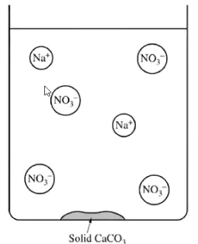
2. The diagram below is incomplete. Draw in the species needed to accurately represent the major ionic species remaining in the solution after the reaction has been completed.

**4.** A student is given the task of determining the I－ content of tablets that contain KI and an inert, water-soluble sugar as a filler. A tablet is dissolved in 50.0 mL of distilled water, and an excess of 0.20 *M* Pb(NO3)2(*aq*) is added to the solution. A yellow precipitate forms, which is then filtered, washed, and dried. The data from the experiment are shown in the table below.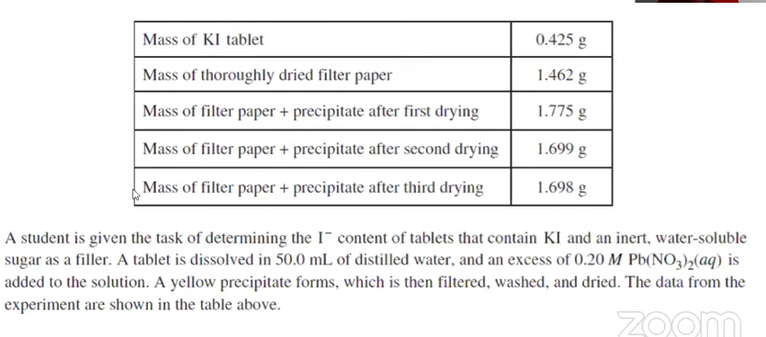

1. For the chemical reaction that occurs when the precipitate forms, write a balanced, net-ionic equation for the reaction.
2. Explain the purpose of drying and weighing the filter paper with the precipitate three times.
3. In the filtrate solution, is [K+] greater than, less than, or equal to [NO3－]? Justify your answer.
4. Calculate the number of moles of precipitate that is produced in the experiment.
5. Calculate the mass percent of I－ in the tablet.

**5. ___Al(*s*) + ___HCl(*aq*) ⟶ ___AlCl3 (*aq*) + ___H2(*g*)**

a)Balance the equation above.

b)Al(*s*) and HCl(*aq*) react together according to the unbalanced chemical equation shown above. If 0.36 mol of AlCl3 is produced in this reaction, how many moles of H2 are also produced?

c)Al(*s*) and HCl(*aq*) react together according to the chemical equation shown above. How many grams of Al are required to produce 75 grams of H2? Assume that HCl is added in excess.

d) Al(*s*) and HCl(*aq*) react together according to the chemical equation shown above. How many mL of 5.0 *M* HCl are required to react completely with 4.25 grams of Al?

*e) Note: Connection to ideal gas law (PV = nRT)*

35 g Al(*s*) reacts with excess HCl(*aq*) according to the chemical equation shown above. What is the volume (in L) of H2 gas produced at a temperature of 345 K and a pressure of 1.12 atm?

f)125 g of Al(*s*) reacts with 2.50 L of 3.20*M of HCl*(*aq*) according to the chemical equation shown above. Which chemical, Al or HCl, is the limiting reactant? What is the theoretical yield of H2 in units of grams?

**6.** A student made the claim that the reaction shown below is a redox reaction. Do you agree with the student’s claim? Justify your answer in terms of the oxidation numbers.

FeS + HNO3 ⟶ Fe(NO3)2 + H2S

**7**. Add the electrons to the half reactions and label as oxidation or reduction

Fe3+ **⟶** Fe2+

Sn2+ **⟶** Sn4+

**8**. For the following reaction, write the oxidation and reduction half reactions.

6H+*(aq)* + 2 MnO4−*(aq)* + 5 H2C2O4*(aq)* → 10 CO2*(g)* + 8 H2O*(l)* + 2 Mn2+*(aq)*

**Unit 5 Review**

1. For the following equation, the rate of disappearance of Br-(*aq*) at a moment during the reaction is 3.5 × 10-4 mol/L*s－1

**5 Br－(*aq*) + BrO3－(*aq*) + 6 H+(*aq*) ⟶ 3 Br2(*aq*) + 3 H2O(*l*)**

1. What is the rate of appearance of Br2(*aq*) at that moment?
2. What is the rate of disappearance of H+(*aq*) at that moment?

**2.** CaCO3(*s*) + 2H+(*aq*) ⟶ Ca2+(*aq*) + H2O(*l*) + CO2(*g*)

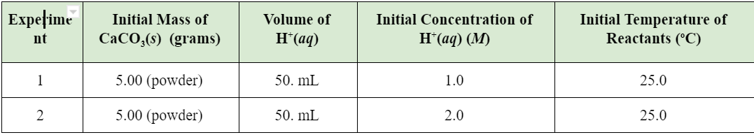

The initial rate of formation of CO2(*g*) from the chemical reaction represented by the equation above was studied in two separate experiments. Which experiment, if any, will have the faster initial rate of formation of CO2(*g*)? Justify

**3.** CaCO3(*s*) + 2H+(*aq*) ⟶ Ca2+(*aq*) + H2O(*l*) + CO2(*g*)

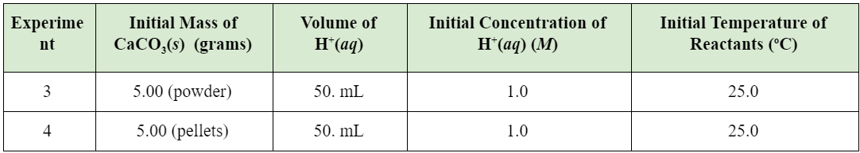

The initial rate of formation of CO2(*g*) from the chemical reaction represented by the equation above was studied in two separate experiments. Which experiment, if any, will have the faster initial rate of formation of CO2(*g*)? Justify

**4.** CaCO3(*s*) + 2H+(*aq*) ⟶ Ca2+(*aq*) + H2O(*l*) + CO2(*g*)

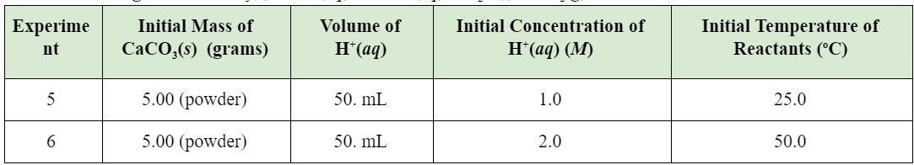

The initial rate of formation of CO2(*g*) from the chemical reaction represented by the equation above was studied in two separate experiments. Which experiment, if any, will have the faster initial rate of formation of CO2(*g*)? Justify

**5.** Ozone in the upper atmosphere is depleted when it reacts with nitrogen oxides. The rates of the reactions of nitrogen oxides with ozone are important factors in deciding how significant these reactions are in the formation of the ozone hole over Antarctica. One such reaction is the combination of nitric oxide, NO, with ozone, O3:

NO(*g*) + O3(*g*) **⟶** NO2(*g*) + O2(*g*)

Use the data to determine the rate law and the rate constant for the reaction at 25oC.

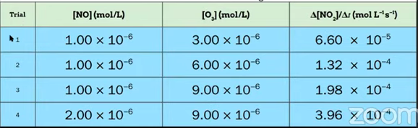

**6.** Hydrogen reacts with nitrogen monoxide to form dinitrogen monoxide (laughing gas) according to the equation: H2(*g*) + 2 NO(*g*) **⟶** N2O(*g*) + H2O(*g*)

Determine the rate law, the rate constant, and the orders with respect to each reactant from the following data:

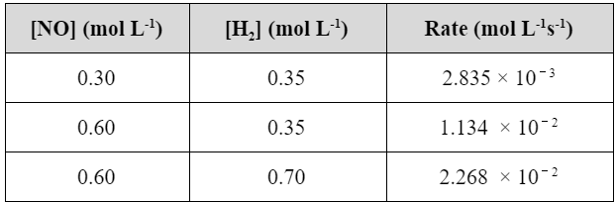

**7**. Na2C37H34N2S3O9 + OCl－ **⟶** products

*blue colorless*

Blue food coloring can be oxidized by household bleach (which contains OCl－) to form colorless products, as represented by the equation above. A student used a spectrophotometer set at a wavelength of 635 nm to study the absorbance of the food coloring over time during the bleaching process. In the study, bleach is present in large excess so that the concentration of OCl－ is essentially constant throughout the reaction. The students use data from the study to generate the graphs below.

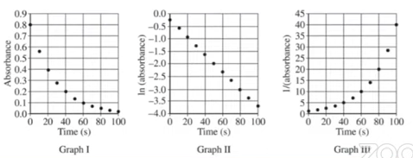

Based on the graphs above, what is the order of the reaction with respect to the blue food coloring? Explain.

**8.** What is the rate law for the overall reaction that is consistent with the proposed mechanism?

**Step 1:** *HBr(g) + O2(g) ⟶ HOBr2(g)*   **(SLOW)**

**Step 2:**  *HOBr2(g) + HBr(g) ⟶ 2 HOBr(g)* **(FAST)**

**Step 3:** *2 HOBr(g) ⟶ H2O2(g) + Br2(g)*  **(FAST)**

2NO2(*g*) + F2(*g*) ⟶ NO2F(*g*)

**9.** NO2 and F2 can react to produce NO2F as represented above. A proposed mechanism for this reaction has two elementary steps, as shown below. Write a rate law for the overall reaction that is consistent with the proposed mechanism.

**Step 1:**  NO2 + F2 *⟶*  NO2F + F (*slow*)

**Step 2:**  NO2 + F *⟶* NO2F (*fast*)

**10.** What is the expected rate law for the overall reaction shown below?

Step 1: NO(*g*) + Br2(*g*) *⇄*  NOBr2(*g*) (*fast*)

Step 2: NOBr2(*g*) + NO ⟶ 2 NO(*g*) + 2 Br(*g*) (*slow*)

**11**. Nitrogen dioxide, NO2(*g*), is produced as a by-product of the combustion of fossil fuels in internal combustion engines. At elevated temperatures NO2(*g*) decomposes according to the equation below.

2 NO2(*g*) ⟶ 2 NO(*g*) + O2(*g*)

The concentration of a sample of NO2(*g*) is monitored as it decomposes and is recorded on the graph directly below. The two graphs that follow it are derived from the original data.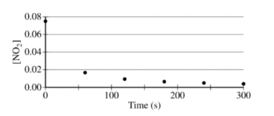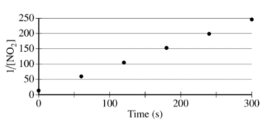

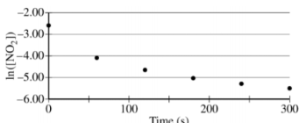

1. What order is the following reaction?
2. Write the rate law for the decomposition of NO2(*g*).

(c) Consider two possible mechanisms for the decomposition reaction.

(i) Is the rate law described by the mechanism I shown below consistent with the rate law you wrote in part (b)? Justify your answer.

Mechanism I

Step 1: NO2(*g*) + NO2(g) ⟶ NO(*g*) + NO3(*g*) *slow*

Step 2: NO3(*g*) ⟶ NO(*g*) + O2(*g*) *fast*

(ii) Is the rate law described by mechanism II shown below consistent with the rate law you wrote in part (b) ? Justify your answer.

Mechanism II

Step 1: NO2(*g*) + NO2(*g*) ⇄ N2O4(*g*) *fast equilibrium*

Step 2: N2O4(*g*) ⟶ 2 NO(*g*) + O2(*g*) *slow*

**12.** Consider the four reaction-energy diagrams below:

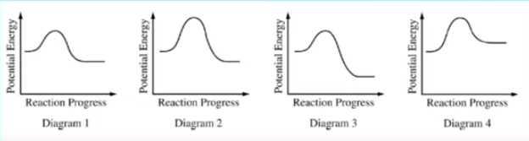

Identify the **two diagrams** that could represent a **catalyzed** and an **uncatalyzed** reaction pathway for the same reaction. Indicate which of the two diagrams represents the catalyzed reaction pathway for the reaction.

**13.** The two reaction diagrams here represent the same reaction: one without a catalyst and one with a catalyst. Estimate the activation energy for each process, and identify which one involves a catalyst.

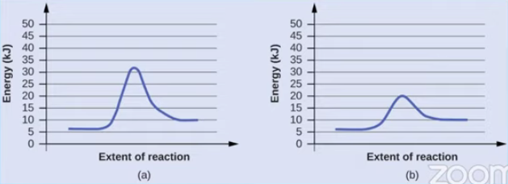

**14.** The formation of C2H5Cl(*g*) is an exothermic reaction (ΔHo = －72.6 kJ/molrxn). The following two step reaction mechanism is proposed:

Step 1: C2H4(*g*) + HCl(*g*) ⟶ C2H5+(*g*) + Cl－(*g*) *Slow step*

Step 2: C2H5+(*g*) + Cl－(*g*) ⟶ C2H5Cl(*g*) *Fast step*

1. Write the rate law for the reaction that is consistent with the reaction mechanism above.



(b) Identify an intermediate in the reaction mechanism above. Using the axes provided, draw a curve that shows energy changes that occur during the progress of the reaction. The curve should illustrate both proposed two-step mechanisms and the enthalpy change of the reaction.

**Unit 6 Review**

1. This is the chemical equation for the process of evaporation

H2O(*l*) ⟶ H2O(*g*)

1. Evaporation is an (exothermic / endothermic) process.
2. Heat flows from the (surroundings to the system / system to the surrounding)

**2.** A student collects the data presented in the table and claims that, since the magnitude of ΔT for the copper is greater than that of water, it means that the magnitude of heat (*q*) lost by the copper is greater than the magnitude of (*q*) gained by the water. Do you agree with this claim?  *Explain.* 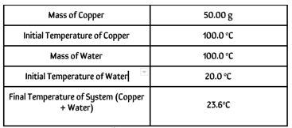

**3.** Suppose that each of these samples absorbs 500 J of heat. Which sample, H2O or Cu, will reach a higher final temperature? Justify your answer. 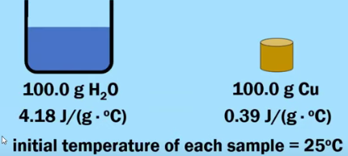

**4**. The following question refers to the graph below, which shows the heating curve for methane, CH4.

|  |  |
| --- | --- |
|  | In terms of intermolecular attractive forces, explain why line segment S is much longer than line segment Q. |

**5.** In terms of intermolecular attractive forces, explain why the value of Δ*Hvap* for H2O is much greater than the value of Δ*Hvap* for CH4.

|  |  |  |
| --- | --- | --- |
| **Substance** | **Δ*Hvap* (kJ/mol)** |  |
| CH4 | 8.2 |
| H2O | 40.7 |

**6.**The lattice enthalpy of LiCl is positive, indicating that it takes energy to break the ions apart in LiCl. However, the dissolution of LiCl in water is an exothermic process. Identify all particle-particle interactions that contribute significantly to the dissolution process being exothermic. For each interaction, include the particles that interact and the specific type of intermolecular force between those particles.

**7**. The combustion of methane gas is represented by the equation shown below.

CH4(*g*) + 2 O2(*g)* ⟶ CO2(*g*) + 2 H2O(*g*) ΔHo = －802 kJ/mol*rxn*

When this reaction occurs, is energy absorbed or released by the system? Explain.

**8**. The combustion of methane gas is represented by the equation shown below.

CH4(*g*) + 2 O2(*g)* ⟶ CO2(*g*) + 2 H2O(*g*) ΔHo = －802 kJ/mol*rxn*

Suppose that 7.50 g of CH4(*g*) reacts completely with excess O2(*g*) according to the equation shown above. How many kJ of thermal energy would be released?

**9**. Fulminic acid can convert to isocyanic acid according to the equation below.

HCNO(*g*) ⇄ HNCO(*g*)

*Fulminic acid isocyanic acid*

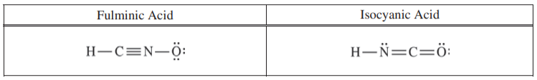

Using the Lewis electron-dot diagrams of fulminic acid and isocyanic acid shown in the boxes above and the table of average bond enthalpies below, determine the value of *ΔHo* for the reaction of HCNO(*g*) to form HNCO(*g*) .

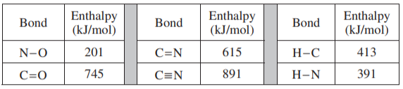

**10.** Calculate the *ΔHrxn* for the following chemical equation. Use the *ΔHfo given.*

CH4(*g*) + 2 O2(*g*) ⟶ CO2(*g*) + 2 H2O

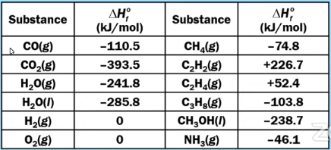

**11**. Na2S2O3(*aq*) + 4 NaOCl(*aq*) + 2 NaOH(*aq*) ⟶ 2 Na2SO4(*aq*) + 4 NaCl(*aq*) + H2O(*l*)

A student performs an experiment to determine the value of the enthalpy change, *ΔHorxn*, for the oxidation-reduction reaction represented by the balanced equation above.

In the experiment, the student uses the solutions shown in the table below.

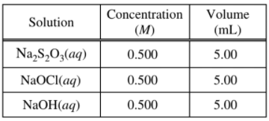

Using the balanced equation for the oxidation-reduction reaction and the information in the table above, determine which reactant is the limiting reactant. Justify your answer.

**12.** Three solutions, all originally at 20.0°C, are combined in an insulated calorimeter. The temperature of the reaction mixture is monitored, as shown in the graph below.

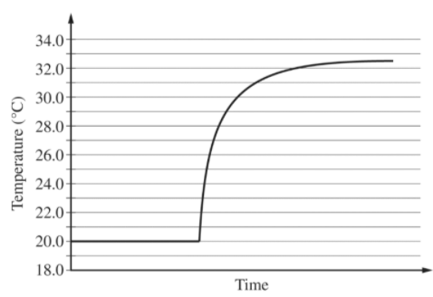

According to the graph, what is the temperature change of the reaction mixture?

**Unit 7 Review**

1. The initial concentrations or pressures of reactants and products are given for each of the following systems. Calculate the reaction quotient and determine the direction in which each system will proceed to reach equilibrium.

|  |  |  |  |  |  |
| --- | --- | --- | --- | --- | --- |
| 1. 2 | 2 NH3(*g*) ⇄ N2(*g*) + 3 H2(*g*) | Kc = 17 | **[NH3]** = 0.20 *M* | **[N2]** = 1.00 *M* | **[H2]** = 1.00 *M* |

|  |  |  |  |  |  |
| --- | --- | --- | --- | --- | --- |
| 1. 2 | 2 NH3(*g*) ⇄ N2(*g*) + 3 H2(*g*) | KP = 6.8 × 104 | **NH3**= 3.0 atm | **N2** = 2.0 atm | **H2** = 1.0 atm |

**2.** 2 A(*g*) + B(*g*) ⇄ 2 C (*g*)

A(*g*) and B(*g*) react to form C(*g*), according to the balanced equation above. In an experiment, a previously evacuated rigid vessel is charged with A(*g*), B(*g*), and C(*g*), each with a concentration of 0.0100 M. The following table shows the concentrations of the gases at equilibrium at a particular temperature.

|  |  |  |
| --- | --- | --- |
| **[A]eq** | **[B]eq** | **[C]eq** |
| 0.018 | 0.014 | 0.0020 |

1. Calculate the value of Kc.
2. If the experiment is repeated at a higher temperature, Kc, is found to have a larger value. Describe the effect of the temperature change on the concentrations of the gases at equilibrium.

**3**. Write equilibrium expressions for the following reactions. (Remember, we do not include solids or liquids)

1. CH4(*g*) + 2 O2(*g*) ⇄ CO2(*g*) + 2 H2O(*l*) K =
2. 2 Pb(NO3)2(*s*) ⇄ 2 PbO(*s*) + 4 NO2(*g*) + O2(*g*) K =

**4.**

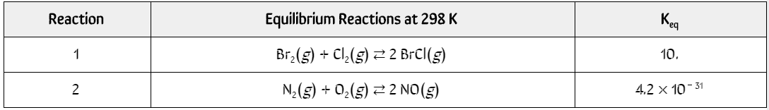

The table above shows data for two reactions carried out in two separate experiments. The students started with 2 evacuated 1.0-Liter rigid containers at a constant temperature of 298 K. To each container 0.50 mol of the appropriate reactants was added, and the reaction was allowed to reach equilibrium. Based on this information, how do the relative concentrations of BrCl and NO present inside their respective containers at equilibrium compare to one another?

**5.** H2(*g*) + I2(*g*) ⇄ 2 HI(*g*)

At Equilibrium, [H2] = 0.100 *M ,* [I2] = 0.100 *M and* [HI] = 0.714 *M.*  **Calculate the value of *Kc*.**

**6**.Given the initial concentrations shown below, find the equilibrium concentrations for A, B, and C.

K = 9.0 x 10 -8[A] = [B] = 0.300M Use a (R )ICE chart to support

A(g) + B(g) ⇆ 2C(g)

**7**. Find final equilibrium concentration for HA, H+ and A-. Initial [HA] = 0.50M. Use a (R )ICE chart to support. HA ⇆ H+ + A- K= 2.0 x 10 -5

**8.**

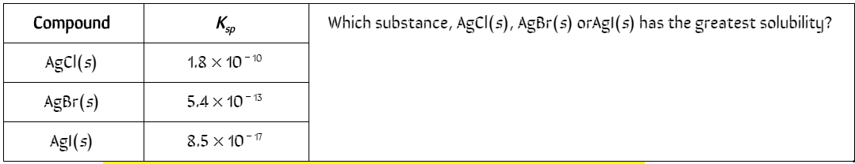

**9.** A 0.0010 mol sample of K2SO4(*s*) is added to the solution in the flask. Will a precipitate occur? Explain.

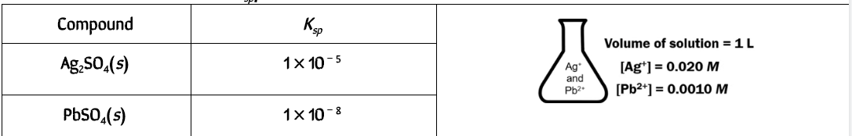

**10.** For the endothermic reaction below, which change would cause the equilibrium to shift to the right? Justify.

CH4(g) + 2H2S(g) ↔ CS2(g) + 4H2(g)

1. Decrease the concentration of dihydrogen sulfide.
2. Increase the pressure on the system.
3. Increase the temperature of the system.
4. Increase the concentration of carbon disulfide.
5. Decrease the concentration of methane.

**11.** Predict the effect of decreasing the temperature on the position of the following equilibria. Justify.

(a) H2(g) + Cl2(g) ↔ 2HCl(g) ∆ H = + 49.7 kJ/mol

(b) 2NH3(g) ↔ N2(g) + 3H2(g) ∆ H = 37.2 kJ/mol

(c) CO(g) + H2O(g) ↔ CO2(g) + H2(g) ∆ H = -27.6 kJ/mol

# **Unit 8 Review**

# **8.1**

**CH3CH2COOH(*aq*) + H2O (*l*) ⇄ CH3CH2COO－(*aq*) + H3O+(*aq*)**

1. 2. Propanoic acid, CH3CH2COOH, is a carboxylic acid that reacts with water according to the equation above. At 25oC the pH of a 50.0 mL sample of 0.20 *M* CH3CH2COOH is 2.79.
2. Identify a Brønsted-Lowry conjugate acid-base pair in the reaction. Clearly label which is the acid and which is the base.

2. Four different examples of acid-base reactions are shown below. In each of these reactions, focus on the H2O. Decide if H2Ois acting as a Brønsted-Lowry acid or as a Brønsted-Lowry base.

* H2O + HCl ⟶ H3O+ + Cl-
* H2O + HCO3-1 ⟶ H2CO3 + OH-1
* H2O + NH3 ⟶ NH4+ + OH-1
* H2O + HCO3-1 ⟶ H3O+ + CO32-

N2O4(*g*) ⇄ 2 NO2 (*g*) ΔHo = +58 kJ/molrxn

3. The chemical equation shown above represents the reversible reaction in which N2O4(*g*) is converted into NO2(*g*). The value of the equilibrium constant,*K*, for this reaction is equal to 0.005 at 25oC..

If the temperature of the reaction vessel is increased from 25oC to 100oC, do you predict that the value of *K* will decrease, increase, or remain the same? Justify your answer.

4. A chemist has three different samples of pure water. Each sample is at a different temperature as shown below.

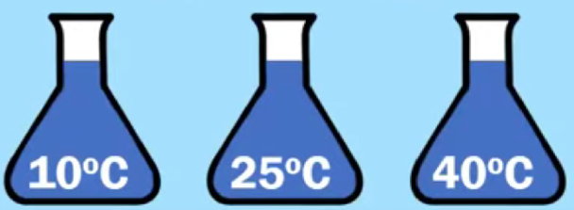

Does each sample have the same pH value? If yes, explain why. If no, explain why not.

If these samples do not have the same pH value, arrange them in order from lowest pH to highest pH.

5. Which of these particle diagrams represents a sample of pure water? How can you tell?

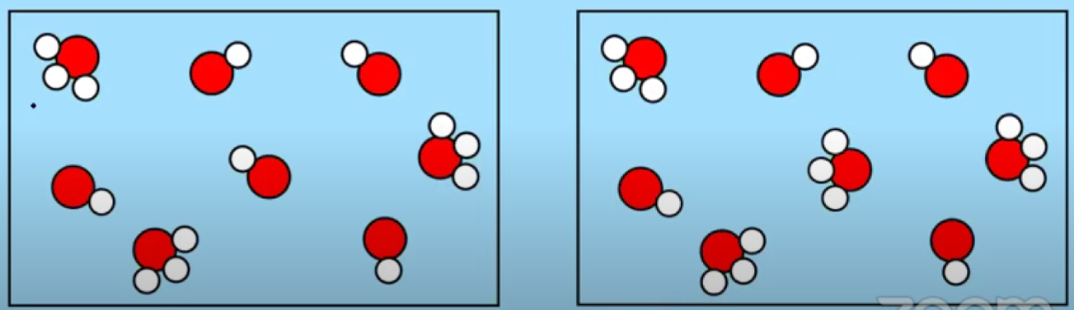

6. Fill in the missing information in the table below. Assume that each solution is at 25oC.

|  |  |  |  |
| --- | --- | --- | --- |
| **[H3O+]** | **pH** | **[OH-1]** | **pOH** |
| 1.0 × 10-9 *M* |  |  |  |
|  | 4.0 |  |  |

|  |  |  |  |  |  |  |  |  |  |
| --- | --- | --- | --- | --- | --- | --- | --- | --- | --- |
| **7.**   |  |  | | --- | --- | | **Temperature (oC)** | **p*KW*** | | **10** | **14.5** | | **25** | **14.0** | | **30** | **13.8** | | Look closely at these p*KW* values.  What happens to the value of p*KW*as the temperature increases?  What happens to the value of *KW* as the temperature increases? |

**AP EXAM PRACTICE FRQ 8.1**

8. A solution of HI(*aq*) is added to a solution of methylamine, CH3NH2(*aq*). An acid-base reaction takes place. All of the water is removed by evaporation, producing crystals of the ionic compound methylammonium iodide.

1. In the reaction described above, methylamine and the methylammonium ion represent a conjugate acid-base pair.
   1. Does the methylamine behave as an acid or as a base in this reaction? Justify your answer.
   2. Write the chemical formula (including the correct charge) for the methylammonium ion.

**H2(*g*) + I2(*g*) ⇄ 2 HI(*g*)**

|  |  |
| --- | --- |
| **Temperature (K)** | **Equilibrium Constant, K** |
| 298 | 790 |
| 700 | 55 |

9. The reaction represented by the balanced equation shown above is an equilibrium system. The value of the equilibrium constant, K, is determined at two different temperatures. The results are shown in the data table above.

1. Based on the information shown above, is the forward reaction classified as an endothermic process or as an exothermic process? Justify your answer.

**8.2 pH and pOH of Strong Acids and Bases**

10. If you are given a 0.0025 *M* HCl solution, what is the pH and pOH?

11. If you are given a 0.0015 *M* NaOH solution, what is the pH and pOH?

12. Calculate the pH, [H3O+], pOH, and [OH－] of a 1.25 × 10－5 *M* solution of HBr.

13. Calculate the pH, [H3O+], pOH, and [OH－] of a 3.85 × 10－4 *M* solution of KOH.

**CH3CH2COOH(*aq*) + H2O (*l*) ⇄ CH3CH2COO－(*aq*) + H3O+(*aq*)**

14. Propanoic acid, CH3CH2COOH, is a carboxylic acid that reacts with water according to the equation above. At 25oC the pH of a 50.0 mL sample of 0.20 *M* CH3CH2COOH is 2.79.

For the following statement ,determine whether the statement is true or false. Explain the reasoning that supports your answer.

“If the pH of a hydrochloric acid solution is the same as the pH of a propanoic acid solution, then the molar concentration of the hydrochloric acid solution must be less than the molar concentration of the propanoic acid solution.”

**8.3 Weak Acid Base Equilibria**

15. Which of the diagrams represents a strong acid, which one represents a weak acid?

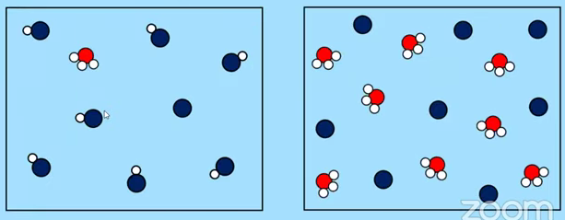

**Relationship between *Ka* (or p*Ka*) and Acid Strength**

**16.** CH3COOH + H2O ⇆ H3O+ + CH3COO－ *Ka* = 1.8 × 10－5

HF + H2O ⇆ H3O+ + F－ *Ka* = 6.8 × 10－4

Two examples of weak monoprotic acids are acetic acid, CH3COOH, and hydrofluoric acid, HF. There equilibrium dissociations and *Ka*’s are given above. Which of these two weak acids is the stronger acid? How can you tell?

**Percent Ionization**

17. Based on this particle diagram, what is the percent ionization of this acid?

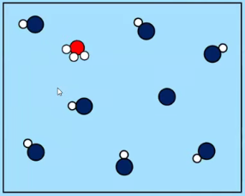

**8.3 Weak Acid Base Equilibria**

18. CH3COOH + H2O ⇆ H3O+ + CH3COO－

Acetic acid, CH3COOH, is a weak monoprotic acid that reacts with water according to the equation shown above.

A solution of 0.10 *M* CH3COOH has a pH of 2.87.

1. Calculate the value of *Ka* for CH3COOH.
2. Calculate the percent ionization for 0.10 *M* CH3COOH.

19. HOCl + H2O ⇆ H3O+ + ClO－

Hypochlorous acid, HClO, is a weak monoprotic acid that reacts with water according to the equation shown above.

The *Ka* for HOCl is 3.0 × 10－8.

1. Calculate the pH of a 0.10 *M* HOCl.
2. Calculate the percent ionization for 0.10 *M* HOCl.

21. (CH3)3N + H2O ⇆ (CH3)3NH+ + OH－

Trimethylamine, (CH3)3N, is a weak base that reacts with water according to the equation shown above.

The *Kb* for (CH3)3N is 6.4 × 10－5.

1. Calculate the pH of 0.10 *M* (CH3)3N.
2. Calculate the percent ionization of 0.10 *M* (CH3)3N.

**AP STYLE FRQ**

22. A student is given a 25.0 mL sample of a solution of an unknown monoprotic acid and asked to determine the concentration of the acid by titration. The student uses a standardized solution of 0.110 *M* NaOH(*aq*), a buret, a flask, an appropriate indicator, and other laboratory equipment necessary for the titration.

1. The images below show the buret before the titration begins (below left) and at the end point (below right). What should the student record as the volume of NaOH(*aq*) delivered to the flask?

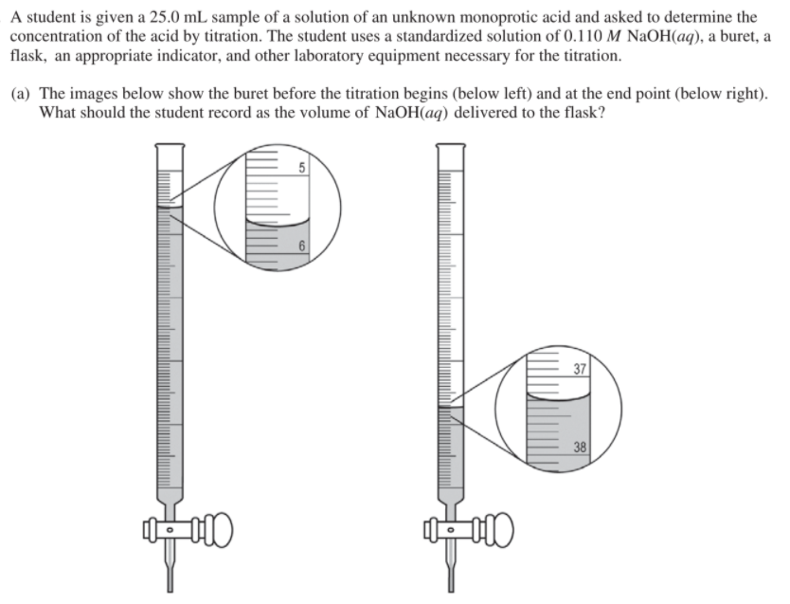

1. Based on the given information and your answer to part (a), determine the value of the concentration of the acid that should be recorded in the student’s lab report.
2. In a second trial, the student accidentally added more NaOH(*aq*) to the flask than was needed to reach the end point, and then recorded the final volume. Would this error increase, decrease, or have no effect on the calculated acid concentration for the second trial? Justify your answer.

HF(*aq*) + H2O(*l*) ⇄ F－(*aq*) + H3O+(*aq*)

23. The ionization of HF(*aq*) in water is represented by the equation above. In a 0.0350 *M* HF(*aq*) solution, the percent ionization of HF is 13.0 percent.

1. Two particulate representations of the ionization of HF molecules in the 0.0350 *M* HF(*aq*) solution are shown below in Figure 1 and Figure 2. Water molecules are not shown. Explain why the representation of the ionization of HF molecules in water in Figure 1 is more accurate than the representation in Figure 2. (The key below identifies the particles in the representations.)

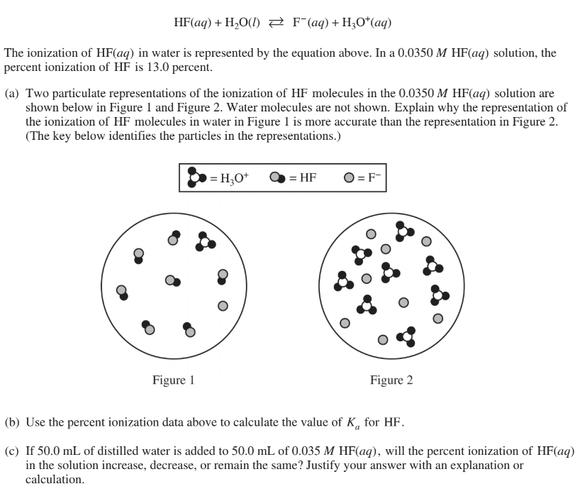

1. Use the percent ionization data above to calculate the value of *Ka* for HF.
2. If 50.0 mL of distilled water is added to 50.0 mL of 0.035 *M* HF(*aq*), will the percent ionization of HF(*aq*) in the solution increase, decrease, or remain the same? Justify your answer with an explanation or calculation.

**8.4 Acid-Base Reactions and Buffers**

**Identifying Strong versus Weak Acids**

24. Which of the following are strong acids? Which of the following are weak acids? Label each as such.

* HCl, hydrochloric acid ______________________________
* HBr, hydrobromic acid ______________________________
* HC2H3O2, acetic acid ______________________________
* HNO2, nitrous acid ______________________________
* HNO3, nitric acid ______________________________

**Definition of a Buffer and Examples of Buffer Solutions**

25. Write in all the conjugate bases of all the conjugate acids in the table below.

|  |  |  |
| --- | --- | --- |
| **Conjugate Acid** | **Conjugate Base** | *For a* ***buffer, you want a WEAK ACID and it’s conjugate base.***  *Cannot use these three. (Strong Acids)*  *Not make a good buffer.*  *Since these five are weak acids, they WOULD make a good buffer solution.* |
| HCl |  |
| HBr |  |
| HNO3 |  |
| HNO2 |  |
| HOCl |  |
| HCN |  |
| HF |  |
| HC2H3O2 |  |

**26. We could find the conjugate bases as sodium salts of the conjugate acids:**

|  |  |
| --- | --- |
| 1.0 *M* HNO2 and 1.0 *M* NaNO2  1.0 *M* HOCl and 1.0 M NaOCl  1.0 *M* HCN and 1.0 *M* NaCN  1.0 *M* HF and 1.0 *M* NaF  1.0 *M* HC2H3O2 and 1.0 *M* NaC2H3O2 | **Guiding Questions**   1. What is the pH of each of these buffer solutions? 2. Why do they behave as a good pH buffer solution? How exactly does a buffer work? |

**27.** Complete the table by calculating the p*Ka* and pH of buffer solutions p*Ka* = － log( *Ka* )

|  |  |  |  |
| --- | --- | --- | --- |
| **Buffer Components** | ***Ka* of the Weak Acid** | **p*Ka* of the Weak Acid** | **pH of the Buffer Solution** |
| 1.0 *M* HNO2 and 1.0 *M* NaNO2 | 4.0 × 10－4 |  |  |
| 1.0 M HOCl and 1.0 M NaOCl | 2.9 × 10－8 |  |  |
| 1.0 M HCN and 1.0 M NaCN | 6.2 × 10－10 |  |  |

**Using the Henderson-Hasselbach Equation (or Not)**

28. A buffer solution contains 1.2 *M* HNO2 and 0.80 *M* NaNO2. What is the pH of this buffer solution? (*Ka* = 4.0 × 10－4 ) **Solve using the *Ka* expression AND the Henderson-Hasselbach Equation**

29. A buffer solution that contains a mixture of HC2H3O2 and NaC2H3O2 has a pH of 5.00. If [HC2H3O2] = 2.0 *M*, what is the value of the [C2H3O2－]? (*Ka*  for HC2H3O2 = 1.8 × 10－5) **Solve using the *Ka* expression AND the Henderson-Hasselbach Equation**

30.

|  |  |  |  |  |  |
| --- | --- | --- | --- | --- | --- |
| **Conjugate Acid** | ***Ka*** | ***pKa*** | **Conjugate Base** | ***Kb*** | ***pKb*** |
| HNO2 | 4.0 × 10－4 | 3.40 | NO2－ |  |  |
| HOCl | 2.9 × 10－8 | 7.54 | ClO－ |  |  |
| NH4+ |  |  | NH3 | 1.8 × 10－5 | 4.74 |
| CH3NH3 |  |  | CH3NH2 | 4.4 × 10－4 | 3.36 |

**AP EXAM PRACTICE FRQ 8.4, 8.7-8.9**

31. Answer the following questions that relates to a buffer solution that contains hydrofluoric acid, HF, and sodium fluoride, NaF. (*Ka* for HF = 6.8 × 10－4 )

1. The *pKa* for HF is equal to 3.17. A diagram shown below is a particulate representation of a buffer solution containing HF and F－. Based on the information in the diagram, do you predict that the pH of this solution should be less than, equal to, or greater than 3.17? Justify your answer.

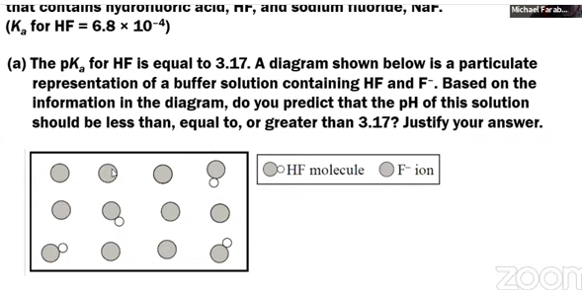

1. A buffer solution is made by mixing equimolar amounts of HF(*aq*) and NaF(*aq*). When a small amount of 12 *M* HNO3(*aq*) is added to this buffer, the pH of the solution changes from 3.17 to 3.15. Write a balanced net ionic equation that accounts for the fact that the pH does not change significantly when the HNO3(*aq*) is added to the buffer solution.

(c.) Determine the volume, in mL, of 10.0 *M* NaOH(*aq*) that should be added to 1000 mL of 1.0 *M* HF(*aq*) in order to create a buffer solution that has a pH of 3.17. Justify your answer with calculations.

(d) A buffer has a pH of 3.17 and has the following concentrations.

1.0 *M* HF and 1.0 *M* NaF

32. A solution is prepared combining 500 mL of the buffer described above with 500 mL of distilled water to create a solution with a volume of 1000 mL. Do you predict that the pH of the final solution should be less than, equal to, or greater than 3.17? Justify your answer.

33. Titration Practice: A 25.00 mL sample of HNO2 (Ka = 4.0x10-4) solution is titrated with 20.50 mL of 0.250M NaOH solution to reach the equivalence point.

1. Write the titration reaction
2. Write the reaction for the hydrolysis
3. Calculate the concentration of the original sample
4. Calculate the Ph of the initial sample before any standard is added
5. Calculate the pH at equivalence point.
6. Calculate the pH after 35.00 mL NaOH is titrated.
7. Construct a titration curve. Include title, labeled axis, correct scaling, plotted ½ equivalence point, equivalence point.

# 

# 

# **Unit 9 Review**

**AP Chemistry: 9.1-9.3, 9.5, 7.14 Entropy and Gibbs Free Energy**

1. Entropy Change Calculations

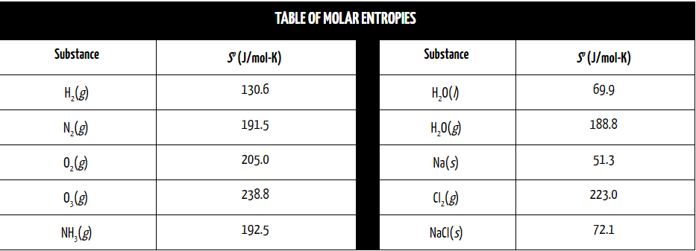

***For each of the following chemical reactions:***

(a) Predict what should happen to the value of entropy change to the reaction. Should it be positive or negative? Justify your answer with the definition of entropy.

(b) Then, using the table, calculate the entropy change of reaction, **ΔSo**, for the chemical reaction

|  |  |  |
| --- | --- | --- |
| ***Chemical Reaction*** | ***Entropy Change Prediction (+ or －)*** | ***Entropy Change Calculation*** |
| N2(*g*) + 3 H2(*g*) ⟶ 2 NH3(*g*) | *Negative,* ***(－);*** *less moles of gas are formed, and less freely moving particles.* | ***ΔSo* = [2 ×ΔS(NH3)] *－* [1 × ΔS(N2) + 3 × ΔS(H2)]**  **=[2×(192.5)] *－* [1 × (191.5) + 3 × (130.6)]**  **=*－* 198. 3 J/mol-K** |
| 2 O3(*g*) ⟶ 3 O2(*g*) |  |  |
| H2O(*l*) ⟶ H2O(*g*) |  |  |
| 2 Na(*s*) + Cl2(*g*) ⟶ 2 NaCl(*s*) |  |  |

Free Energy and Thermodynamic Favorability.

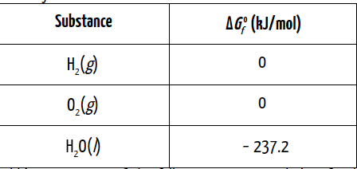

1. Calculate the change in Gibb’s Free Energy of the following reaction and identify whether it is thermodynamically favorable. 2 H2(*g*) + O2(*g*) ⟶ 2 H2O(*l*)
2. Identify whether the reverse of the reaction in (2), shown below, is thermodynamically favorable.

**AP CHEM TIP: EVEN THOUGH A REACTION MAY BE SLOW, DOES NOT MEAN IT IS THERMODYNAMICALLY UNFAVORABLE. JUST BECAUSE A REACTION IS FAVORED, WE CANNOT SAY WHETHER THE REACTION OCCURS QUICKLY OR SLOWLY. IF THE ACTIVATION ENERGY IS RELATIVELY HIGH, THE REACTION WILL USUALLY OCCUR RATHER SLOWLY.**

**Recall: Δ*G*o =**  **Δ*H*o** *－* **TΔ*So***

CaCO3(*s*) ⟶ CaO(*s*) + CO2(*g*)

1. Using the thermodynamic data at left, calculate the change in Gibbs Free energy, ΔG°for the decomposition of calcium carbonate (above) and determine whether this reaction is thermodynamically favored to occur at 298 K.

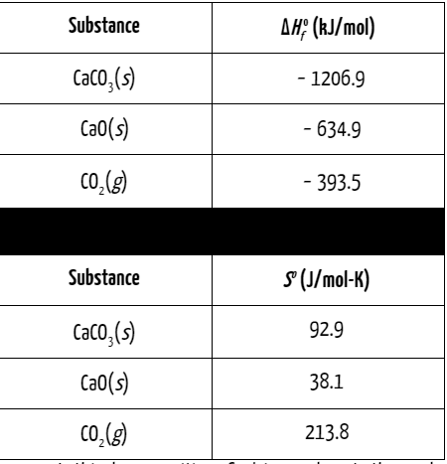

1. Is this decomposition of calcium carbonate thermodynamically favored to occur at 1000oC (1273 K)?
2. Determine the minimum temperature that would be required in order for this reaction to be thermodynamically favored.

**Keep in mind, when Δ*G*o =0, then neither the forward or the reverse process is favored. Set Δ*G*o = 0 to find the “swing” temperature.**

**AP CHEMISTRY EXAM TIP:**

You might see a question that asks you the following: **“What drives this reaction?”**

There will be three possible answers:

1. The reaction is driven by enthalpy only
   1. This only occurs when you have a **negative Δ*H*o and negative Δ*So***
2. The reaction is driven by entropy only
   1. This only occurs when you have a **positive Δ*H*o and positive Δ*So***
3. The reaction is driven both by enthalpy and entropy.
   1. This only occurs when you have a **negative Δ*H*o and positive Δ*So***

**8. AP EXAM PRACTICE FRQ 9.1 - 9.3, 9.5, 7.14**

NaHCO3(*s*) + HC2H3O2(*aq*) ⟶ NaC2H3O2(*aq*) + H2O(*l*) + CO2(*g*)

A student designs an experiment to study the reaction between NaHCO3 and HC2H3O2. The reaction is represented by the equation above. The student places 2.24 g of NaHCO3 in a flask and adds 60.0 mL of 0.875 *M* HC2H3O2. The student observes the formation of bubbles and that the flask gets coolers as the reaction proceeds.

1. In thermodynamic terms, a reaction can be driven by enthalpy, entropy, or both.
   1. Considering that the flask gets cooler as the reaction proceeds, what drives the chemical reaction between NaHCO3(*s*) and HC2H3O2(*aq*)? Answer by drawing a circle around one of the choices below.

Enthalpy only Entropy only Both enthalpy and entropy

* 1. Justify your selection in part (d)(i) in terms of Δ*G*o.

9. Fulminic acid can convert to isocyanic acid according to the equation below.

HCNO(*g*) ⇄ HNCO(*g*)

*Fulminic acid isocyanic acid*

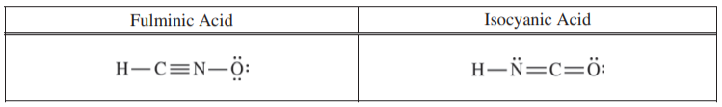

1. Using the Lewis electron-dot diagrams of fulminic acid and isocyanic acid shown in the boxes above and the table of average bond enthalpies below, determine the value of *ΔHo* for the reaction of HCNO(*g*) to form HNCO(*g*) .

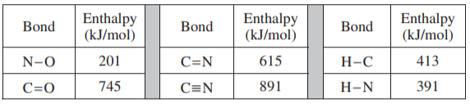

1. A student claims that Δ*S*o for the reaction is close to zero. Explain why the student’s claim is accurate.
2. Which species, fulminic acid (HCNO) or isocyanic acid (HNCO), is present in higher concentration at equilibrium at 298 K. Justify your answer in terms of thermodynamic favorability and the equilibrium constant.

10. The student reads in a reference text that NO(*g*) and NO2(*g*) will react as represented by the equation below. Thermodynamic data for the reaction are given in the table below the equation

NO(*g*) + NO2(*g*) ⇄ N2O3(*g*)

|  |  |  |
| --- | --- | --- |
|  |  |  |
| －40.4 kJ/mol*rxn* | －138.5 J/(Kᐧmol*rxn*) | + 0.87 kJ/mol*rxn* |

1. The student begins with an equimolar mixture of NO(*g*) and NO2(*g*) in a rigid reaction vessel and the mixture reaches equilibrium at 298 K.
   1. Calculate the value of the equilibrium constant, *K*, for the reaction at 298 K.
   2. If both $P_{NO}$ and $P_{NO_{2}}$ in the vessel are initially 1.0 atm, will $P_{N_{2}O_{3}}$ at equilibrium be equal to 1.0 atm? Justify your answer.
2. The student hypothesizes that increasing the temperature will increase the amount of N2O3(*g*) in the equilibrium mixture. Indicate whether you agree or disagree with the hypothesis. Justify your answer.

11. H2NCONH2(*s*) ⇄ H2NCONH2(*aq*)

The dissolution of urea is represented by the equation above. A student determines that 5.39 grams of H2NCONH2 (molar mass 60.06 g/mol) can dissolve in water to make 5.00 mL of a saturated solution at 20oC.

1. Calculate the concentrations of urea, in mol/L, in the saturated solution at 20oC.
2. The student also determines that the concentration of urea in a saturated solution at 25oC is 19.8 *M*. Based on this information, is the dissolution of urea endothermic or exothermic? Justify your answer in terms of Le Chatelier’s principle.

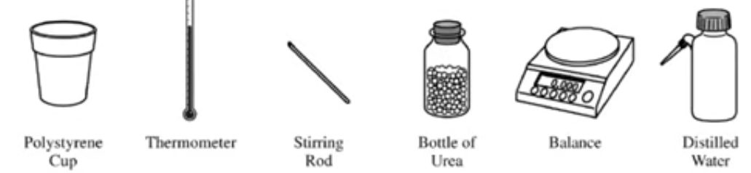

1. The equipment shown above is provided so that the students can determine the value of the molar heat of solution for urea. Knowing that the specific heat of the solution is 4.18 J/(gᐧoC), list the specific measurements that are required to be made during the experiment.

|  |  |
| --- | --- |
|  | ***So* (J/mol-K)** |
| H2NCONH2(*s*) | 104.6 |
| H2NCONH2(*aq*) |  |

1. The entropy change for the dissolution of urea, $ΔS_{soln}^{o}$, is 70.1 J/(mol·K) at 25oC. Using the information in the table above, calculate the absolute molar entropy, *So*, of aqueous urea.
2. Using particle-level reasoning, explain why $ΔS_{soln}^{o}$ is positive for the dissolution of urea in water.
3. The student claims that $ΔS_{}^{o}$ for the process contributes to the thermodynamic favorability of the dissolution of urea at 25oC. Use the thermodynamic information above to support the student’s claim.