**Dougherty Valley HS AP Chemistry**

**2020 Exam Sample Questions**

# Sample Question 1 Time allotted: 25 minutes (plus 5 minutes to submit)

Common additives to drinking water include elemental chlorine, chloride ions, and phosphate ions. Recently, reports of elevated lead levels in drinking water have been reported in cities with pipes that contain lead, Pb(*s*). When Cl2(*aq*) flows through a metal pipe containing Pb(*s*), some of the lead atoms oxidize, losing two electrons each, and aqueous chloride ions form.

a) Write a balanced, net-ionic equation for the reaction between Pb(*s*), and Cl2(*aq*).

|  |  |
| --- | --- |
| **Dissolution Reaction** | ***Ksp*** |
| PbCl2(*s*) ⇆ Pb2+(*aq*) + 2Cl−(*aq*) | 1.6 × 10−5 |
| Pb3(PO4)2(*s*) ⇆ 3Pb2+(*aq*) + 2PO43−(*aq*) | 1.08 × 10−53 |

Dissolution reactions and *Ksp* values for two lead compounds are given in the table.

b) Write the *Ksp* expression for the dissolution of Pb3(PO4)2(*s*) in water.

c) Calculate the molar solubility of Pb3(PO4)2(*s*).

d) Using the table of *Ksp* values above, explain why the addition of PO43−(*aq*) is more effective at reducing [Pb2+] in drinking water than Cl−(*aq*).

e) Cities try to maintain a maximum dissolved lead concentration of [Pb2+] = 1.0 × 10−9 *M*. If a sample of water has [Pb2+] = 1.0 × 10−9*M* and enough phosphate is added such that [PO43−] = 3.0 × 10−5*M* , would the concentration of Pb2+(*aq*) increase, decrease, or remain the same? Justify your answer with a comparison of *Q* and *Ksp* .

f) Higher concentrations of Pb2+(*aq*) are found in pipes carrying hot water than in pipes carrying cold water.

Is this observation consistent with a negative enthalpy of dissolution, Δ*Hsoln* ?

Justify your answer with regards to LeChâtelier’s principle.

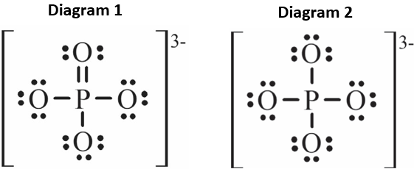A student researches the properties of the phosphate ion and finds the following Lewis electron-dot diagrams and table of bond lengths:

|  |  |
| --- | --- |
| **Bond type** | **Bond length (pm)** |
| P−O | 163 |
| P=O | 150 |

g) Using diagram 1, the student claims that the bond angles are 90°. Do you agree or disagree with the student’s claim? Justify your answer in terms of VSEPR theory.

h) The student also finds that all four P—O bonds in phosphate have a bond length of 162.5 pm.

Which diagram is consistent with this finding? Justify your answer.

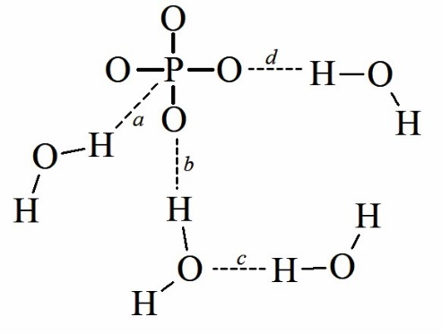 i) The student generates the following particulate diagram of an aqueous solution containing phosphate ions. The student uses dashed lines to show hydrogen bonding and omits lone pairs of electrons for clarity. Identify the letter corresponding to an incorrect hydrogen bonding interaction in the student’s diagram, and indicate how the diagram should be changed to be correct.

The complete photoelectron spectra of phosphorus and of oxygen are given in the following diagrams.

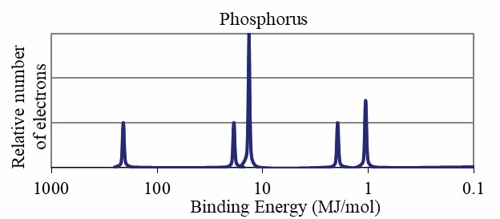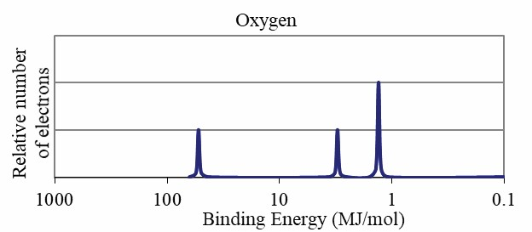

j) The student notices that the rightmost peak of O is taller than the rightmost peak of P. The student claims that this is because O has fewer occupied electron shells, which means that the valence electrons are closer to the nucleus and experience greater attraction. Do you agree or disagree with the student’s claim?

Justify your answer based on the data and principles of atomic structure.

# Sample Question 2 Time allotted: 15 minutes (plus 5 minutes to submit)

Methanoic acid, HCOOH(*aq*) , is a monoprotic acid that can be synthesized by the reaction between CO and NH3 in the presence of hydronium ions. A proposed mechanism for the reaction consists of the three elementary steps shown below.

Step 1: CH3OH + CO → HCO2CH3 *slow*

Step 2: HCO2CH3 + NH3 → HCONH2 + CH3OH *fast*

Step 3: HCONH2 + H3O+ → HCOOH + NH4+ *fast*

Overall reaction: CO + NH3 + H3O+ → HCOOH + NH4+ Δ*Hrxn* = −81 kJ/mol*rxn*

a) Write the chemical formula of a species that behaves as a catalyst in the mechanism.

b) According to the proposed mechanism, if additional NH3 is added to the reaction mixture, will the rate of the overall reaction increase, decrease, or remain the same? Justify your answer.

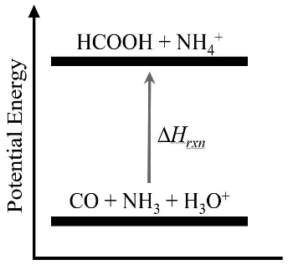A student generates the following potential energy diagram for the overall reaction.

c) Is the student’s diagram consistent with the enthalpy of the overall reaction? Justify your answer.

|  |  |  |
| --- | --- | --- |
| **Substance** | HCOOH | CH3OH |
| **Structure** |  |  |
| **Vapor Pressure at** 50°C | 17.3 kPa | 55.6 kPa |

At the end of the reaction, HCOOH is separated from CH3OH by distillation.

The chemical structures and vapor pressures at 50°C for the two substances are given.

d) Identify the types of intermolecular forces in HCOOH and CH3OH.

e) When an equimolar mixture of the two compounds is heated to 50°C in the distillation, the vapor phase contains a higher mole fraction of CH3OH molecules. Explain this result in terms of the types and relative strengths of intermolecular forces in both substances.

HCOOH(*aq*) + NaOH(*aq*) → NaHCOO(*aq*) + H2O(*l*)

|  |  |  |  |  |
| --- | --- | --- | --- | --- |
| Trial | **Volume of**  **HCOOH** | **Initial Buret Reading** | **Final Buret Reading** | **Volume of NaOH Dispensed** |
| 1 | 20.00 mL | 10.94 mL | 27.61 mL | 16.67 mL |
| 2 | 20.00 mL | 27.61 mL | 48.84 mL | ? |
| 3 | 20.00 mL | 1.12 mL | ? | ? |

The student uses NaOH(*aq*) to titrate a methanoic acid solution of unknown concentration. A balanced chemical equation for the reaction appears above. The student places 20.00 mL of the HCOOH solution into a flask and uses a buret filled with 0.300 *M* NaOH to deliver just enough NaOH(*aq*) to reach the endpoint. The incomplete data from the student’s three trials are summarized in the following table.

f) Calculate the molarity of HCOOH from the student’s data for Trial 1.

g) The final buret reading for Trial 3 is shown in the experimental setup below. What should the student report as the volume of NaOH(*aq*) dispensed for Trial 3 in the data table?

Clearly show the final reading from the buret and the calculation of the volume dispensed.

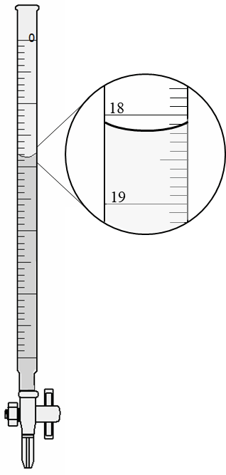

h) The student calculates a value of [HCOOH(*aq*)] for Trial 2 that is significantly higher

than the value for the other two trials. The student claims that the reason for the

higher calculated concentration is that water remained in the flask to which the HCOOH(*aq*) was added, which meant more NaOH(*aq*) was needed to reach the endpoint. Do you agree or disagree with the student’s claim? Justify your answer.