South Pasadena • AP Chemistry Name _______________________________
Period ___ Date ___/___/___
15 • Chemical Kinetics
PRACTICE QUIZ

1. Which of the following does NOT influence the speed of a chemical reaction?
a) concentration of reactants
b) nature of reactants
c) temperature
d) presence of a catalyst
e) none of these

2. What would cause the change in the kinetic energy diagrams as shown?
→
a) increasing the ΔH
b) decreasing the temperature
c) increasing the surface area
d) addition of a catalyst
e) increasing the concentration of reactant

3. A time vs. concentration graph is presented below for the reaction A → B. What is the rate of appearance of ‘B’ 20 seconds after the start of the reaction?
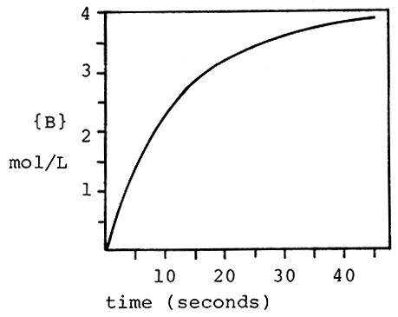
a) 0.050 mol/L⋅s d) 0.010 mol/L⋅s
b) 3.2 mol/L⋅s e) 9.8 mol/L⋅s
c) 2.2 mol/L⋅s
4. The reaction 3O2 → 2O3 is proceeding with a rate of disappearance of O2 equal to 0.60 mol/L⋅s. What is the rate of appearance of O3, in mol/L⋅s?
a) 0.60 d) 0.90
b) 0.40 e) 1.20
c) 0.10

5. What is the rate constant for a first order reaction for which the half-life is 85.0 sec?
a) 0.00814 sec-1 d) 0.0118 sec-1
b) 4.44 sec-1 e) 58.9 sec-1
c) 0.170 sec-1

6. What fraction of a reactant remains after 3 half-lives of a first order reaction?
a) 1/2 d) 1/8
b) 1/3 e) 1/12
c) 1/6

7. According to collision theory, which of the following factors does NOT influence the rate of reaction?
a) collision frequency
b) collision energy
c) collision orientation
d) collision rebound direction
e) none of these

8. What distance corresponds to the activation energy for the reaction of X to Y?
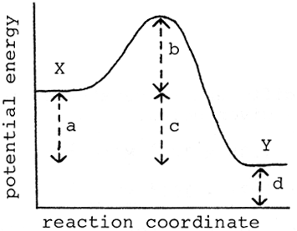
a) a d) d
b) b e) e
c) c

9. At what point on the potential energy diagram given below does the transition state (activated complex) occur?
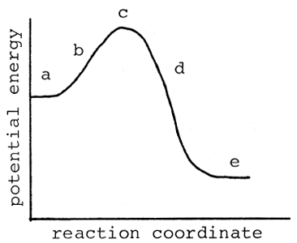
a) a d) d
b) b e) e
c) c

10. Which of the following is NOT true about a catalyst?
a) it speeds up the forward reaction
b) is acts as an inhibitor
c) it speeds up the reverse reaction
d) it may be homogeneous
e) it may be heterogeneous

Answers: (please use CAPITAL letters)
1. _____ 6. _____
2. _____ 7. _____
3. _____ 8. _____
4. _____ 9. _____
5. _____ 10. _____

Useful Formulae:
$$\text{ln}\frac{[A]_{o}}{[A]_{t}}=\text{kt}$$
the special case of half-life
ln(2) = 0.693 = kt_{½}

