South Pasadena • AP Chemistry Name ___________________________________
Period ___ Date ___/___/___
15 • Chemical Kinetics
Station 1 – KINETIC ENERGY DIAGRAMS

Draw how the KE diagram would change if:

the temperature of  the sample is increased. | a catalyst is added  to the reaction mixture. | more chemical is  added at the same temperature.
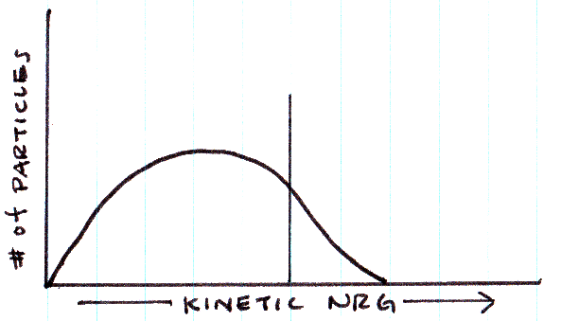

What is the name of the vertical line intersecting the graph? ___________________ __________________

Why do particles need kinetic energy to react?

15 • Chemical Kinetics
Station 2 – POTENTIAL ENERGY DIAGRAMS
The energy of the reactants is 30 kJ/mol.  ΔH = -20 kJ/mol  Ea = +40 kJ/mol  Draw the PE curve.  The energy of the products is _________________  The activation energy for the  reverse reaction is ________________  Draw the same curve with a catalyst included. (- - - - - - -) | 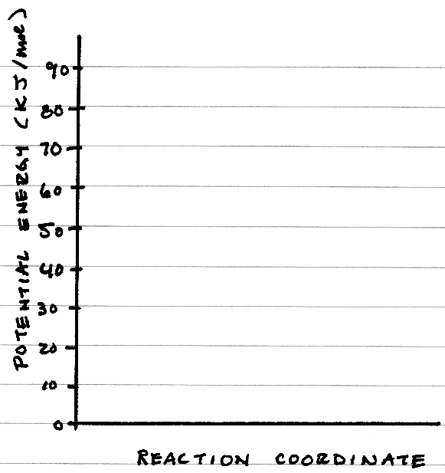

15 • Chemical Kinetics
Station 3 – RATE FROM GRAPHS
The vertical axis is [R] in mol·L⁻¹
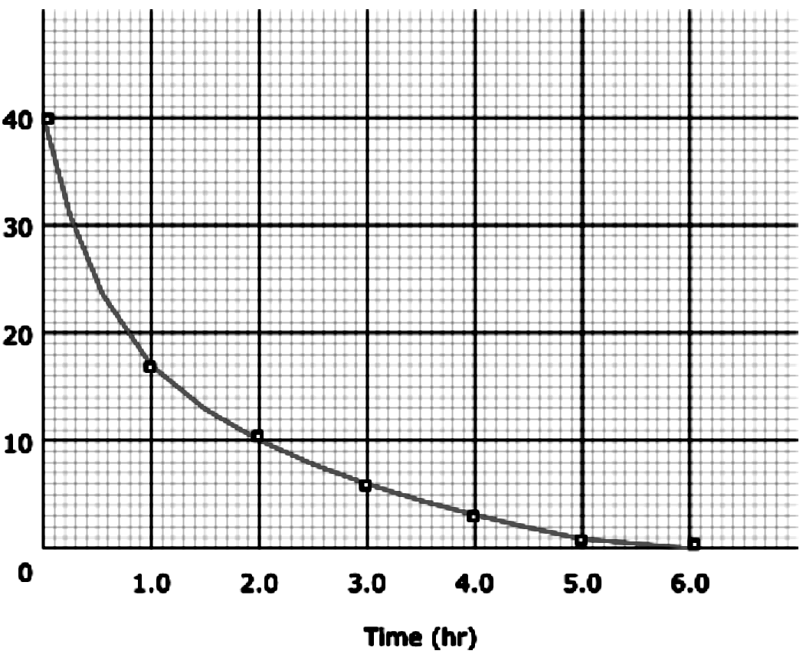 | Show your work for these two problems.  The average rate of the reaction for the first 2.0 hours is _________________.  The instantaneous rate of the reaction at 2.0 hours is ________________.

15 • Chemical Kinetics
Station 4 – CALCULATING RATES OF REACTION

Consider the combustion of propane, C₃H₈(g) + 5 O₂(g) → 3 CO₂(g) + 4 H₂O(g)

The rate of disappearance of O₂(g) is 6.4 mol·L⁻¹·s⁻¹

What is the rate of disappearance of C₃H₈(g)?

What is the rate of appearance of CO₂(g)?

What is the rate of appearance of H₂O(g)?
15 • Chemical Kinetics
Station 5 – RATE LAWS – THE METHOD OF INITIAL RATES

Here is some initial rate data for the reaction, A + B → 2C.

[A] | [B] | Rate (mol·L⁻¹·s¹)
0.40 | 0.10 | 3.5 x 10³
0.20 | 0.10 | 1.8 x 10³
0.20 | 0.50 | 4.5 x 10⁴

a) Determine the orders of reactants A _____ and B _____

b) Write the rate law for this reaction: ______________________________

c) Calculate the value of the rate constant, k, with units. _____________________

15 • Chemical Kinetics
Station 6 – ORDERS OF REACTIONS – GRAPHICAL METHODS

Which graph corresponds to the change in concentration of a reactant that is first order? _____  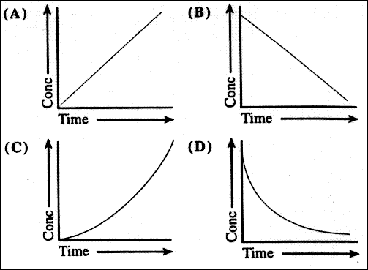 | This graph is a chemical that is second order. The horizontal axis is time. What is the vertical axis? ____  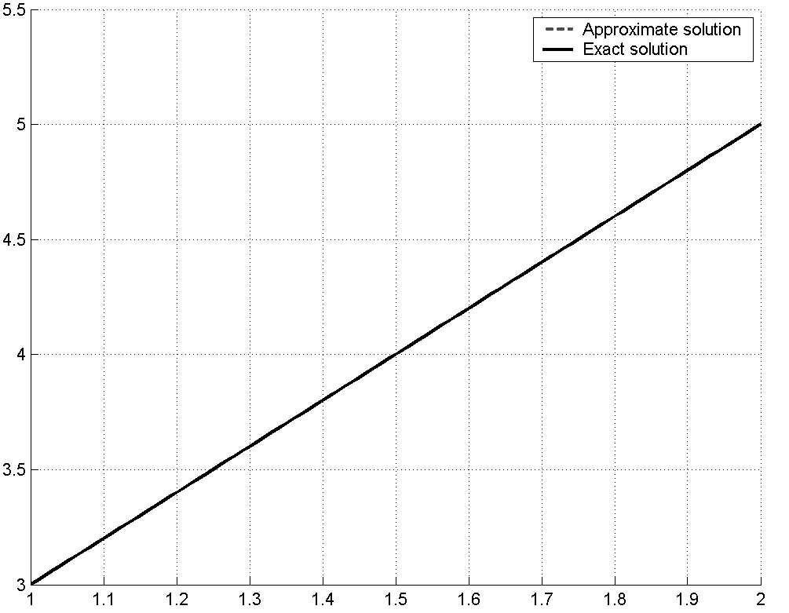

15 • Chemical Kinetics
Station 7 – REACTION MECHANISMS

Consider this reaction mechanism:
HCOOH + H₂SO₄ → HCOOH₂⁺ + HSO₄⁻
HCOOH₂⁺ → COH⁺ + H₂O
COH⁺ + HSO₄⁻ → CO + H₂SO₄

a) What is the overall reaction? ___________________________________________

b) List any “intermediates.” ________________________________________________

c) List any catalysts. __________________________________

d) If the first step is the slow step, what is the rate law? ________________________________

15 • Chemical Kinetics
Station 8 – HALF LIFE PROBLEMS

a) A first-order chemical has a half-life of 8.00 minutes.
How long will it take for 93.75% of this chemical to decay?

b) The reaction X → Y follows first-order kinetics with a half-life of 4.00 minutes. What is the value of k?
If the initial concentration of X is 3.6 M, what is the concentration after 15.0 minutes?

Formula:
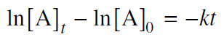
15 • Chemical Kinetics
Station 9 – THE ARRHENIUS EQUATION
Calculate the activation energy, E_{a}, for N₂O₅(g) → 2 NO₂(g) + ½ O₂(g)
given k (at 25°C) = 3.46 x 10⁻⁵ s⁻¹ and k (at 50°C) = 1.10 x 10⁻³ s⁻¹.

Formula:
