Dougherty Valley • AP Chemistry

**S-24**

Chemical Kinetics: Rates of Reaction

**STUDY LIST From Paul Groves**

I can…

Reaction Rates

🞏 give the correct units to describe the rate of a reaction.

Rate = $\frac{∆[chemical]}{∆time}$ Units =

🞏 discuss the rate as the rate of **disappearance** of reactant or the rate of **appearance** of product.

* Watch your signs because -∆[Reactants] = ∆[Products]

🞏 use **coefficients** to change one rate to another (“rate in terms of...”)

Example: 2A + 3B 🡪 4C

🞏 list ways to speed up a reaction

* Increase **concentration** of reactants
* Increase **temperature** of the rxn
* Increase **surface area**
* Add a **catalyst**

🞏 determine the **average rate** of a reaction as well as the **instantaneous rate** of a reaction from a graph of [ ] vs. time

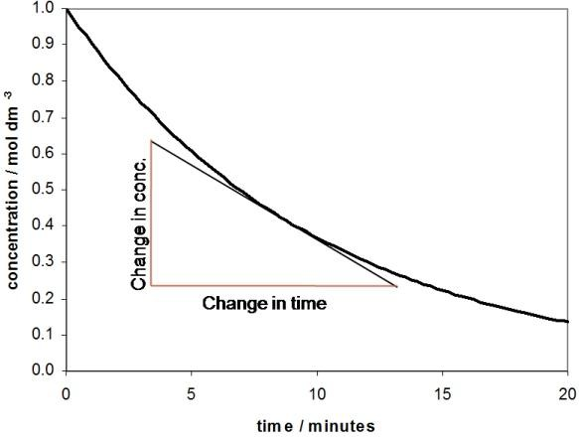

*Example – to find the rate at 8min, find the slope of the tangent line at 8min.*

🞏 describe a catalyst as a substance that speeds up a reaction without getting used up, and describe how a catalyst works.

* Provides an alternate pathway with a lower activation energy.
* Helps orient the molecules for proper collisions.

🞏 determine the order of the reaction by graphical methods. Use the graph to find the value of k.

* Look for the straight line plots to determine order if needed  
  C 🡪 [ ] vs t = 0th order, slope = -k  
  N 🡪 ln[ ] vs t = 1st order, slope = -k  
  R 🡪 1/[ ] vs t = 2nd order, slope = k

KE & PE Diagrams

🞏 draw a kinetic energy distribution

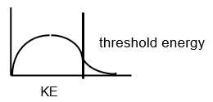

🞏 sketch the change in the KE distribution if the reactants are warmed or cooled.

🞏 state that the only thing that moves the threshold energy is adding a catalyst. Temperature does not shift the threshold energy, just changes shape of the curve. 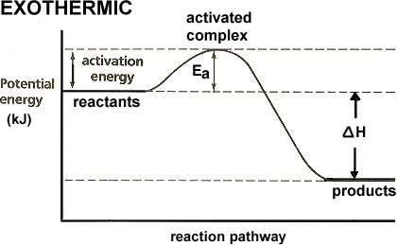

🞏 Explain that a catalyst lowers the Ea by changing the way the reaction occurs.

Half Life

🞏 determine the half-life of a chemical from graphical data, or in a word problem.

🞏 use the integrated rate law to solve half-life problems involving in-between times.

$ln\frac{{[A]}_{0}}{{[A]}_{t}}=kt$

* Special case of half life  
  ln (2) = 0.693 = kt½

Rate Laws:

🞏write the rough rate law to show how the rate of a reaction depends on concentration.  
Ex: N2 + 3H2 ⭢ 2NH3  
 Rate = k [N2]x[H2]y

🞏 determine the order of reaction with respect to a chemical using the method of initial rates by inspection.

🞏 determine orders of reactions using the mathematical method of initial rates.

🞏 solve for the specific rate constant, k, and determine the correct units.

Reaction Mechanisms:

🞏 explain that a reaction often occurs in several “elementary steps” that often involve only two particles at a time.

🞏 combine the elementary steps in a mechanism to identify the overall reaction, the intermediates, and a catalyst.

🞏 state that the slowest step in a mechanism is called the “rate determining step” and is linked to the rate law.

🞏 give an example of a chain reaction mechanism for H2 + Cl2 or for the destruction of ozone (O3) by stratospheric chlorine atoms.

🞏 label steps in a chain reaction mechanism as initiation, propagation, and termination steps.

Reaction Order--Graphical Method:

🞏 identify the integrated rate laws for zero, first, and second order reactions.

🞏 explain that the integrated rate laws can be set into the form “y = mx + b” which means that a graph indicate the order of reaction and the value of the rate constant, k.

🞏 state the straight-line graph that is identified with each reaction order.

🞏 use the slope of the straight-line graph to determine the value of k.

Arrhenius Equation:

🞏 use the Arrhenius equation to calculate the rate constant, k, using R = 8.31 J/mol K.

🞏 graphically or algebraically determine the activation energy, Ea, from rate or k data at different temperatures.

🞏 explain that a rate increase with temperature means that the rate constant, k, has increased proportionately.

🞏 explain that the slope of a graph of ln k vs. 1/T = -Ea/R.

Chain Reaction Mechanisms:

🞏 cite two examples of chain reaction mechanisms and label the elementary steps as initiation, propagation, and termination steps.

From the AP Exam:

