2019-20 Practice Midterm
1-3 Lab themed questions
4-7 Trivia/Misc Questions
*Skip #2-7
8-17 Thermo Questions
18-28 Kinetics Questions
1. | 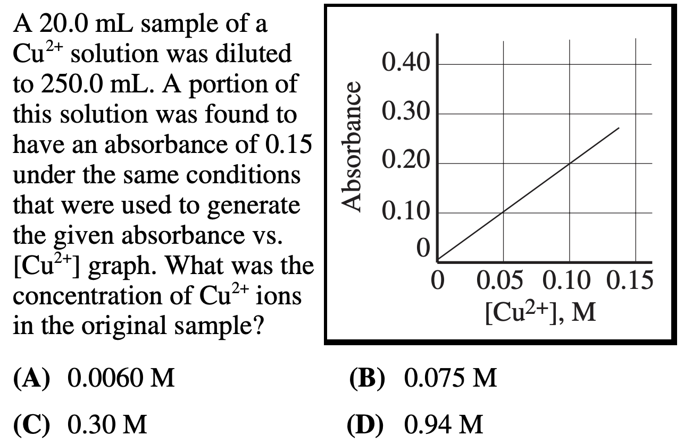
2. | 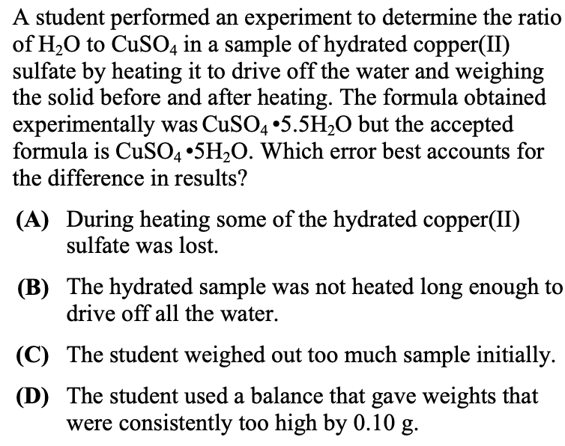
3. | 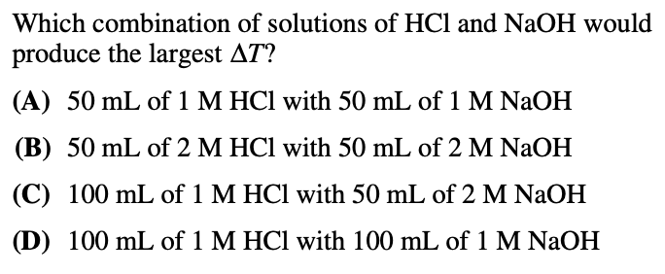
4. | 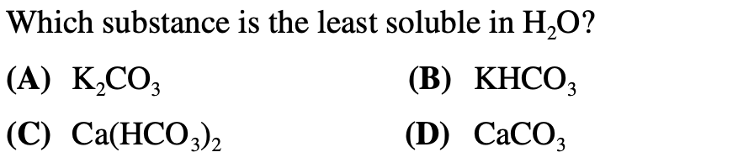
5. | 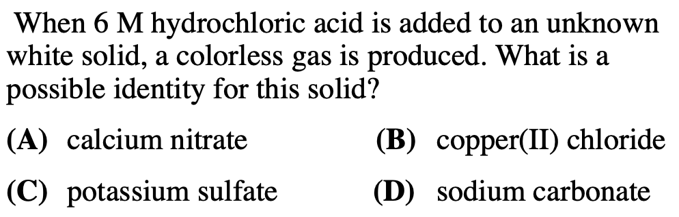
6. | 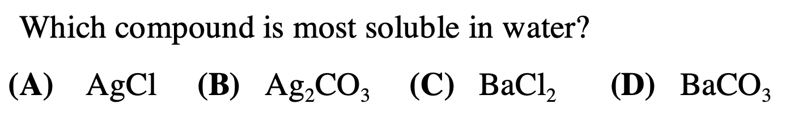
7. | 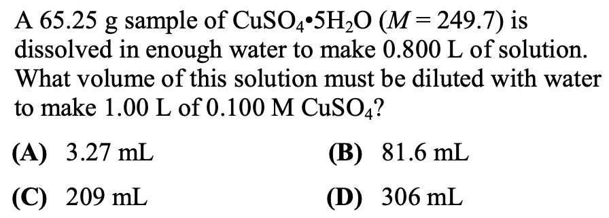
8. | 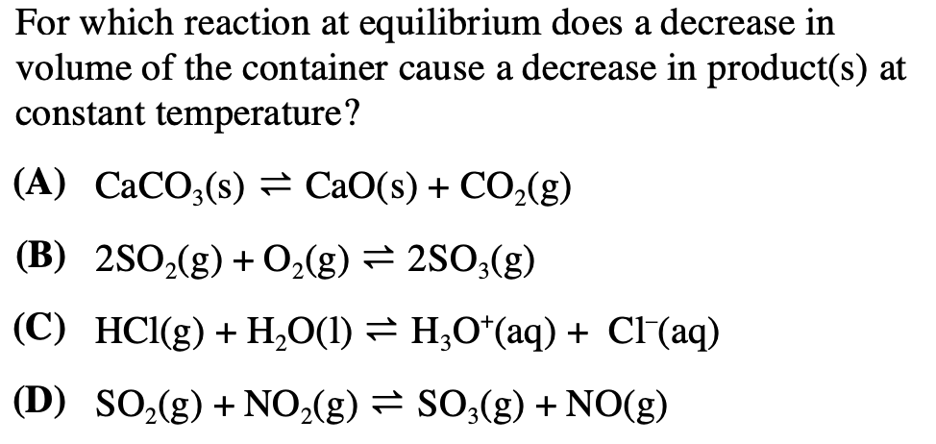
9. | 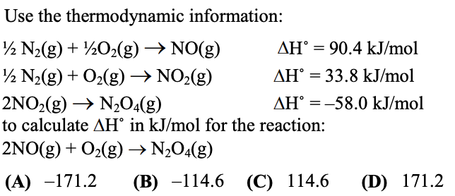
10. | 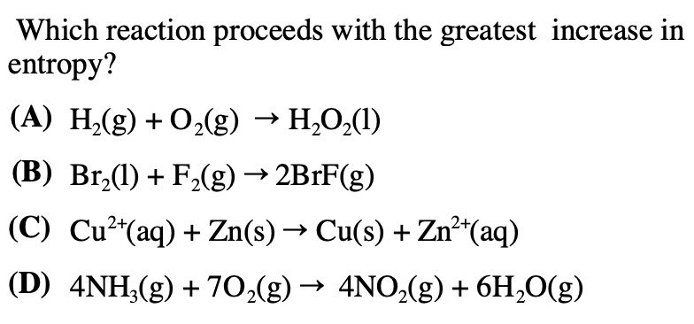
11. | 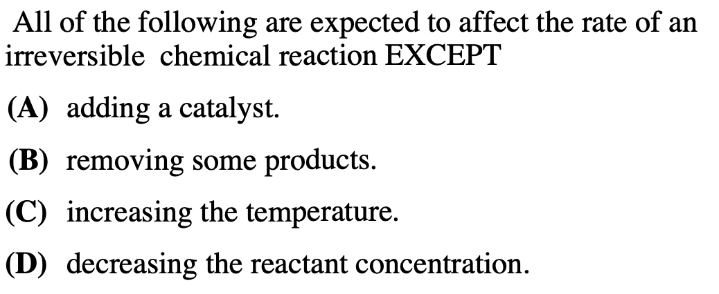
12. | 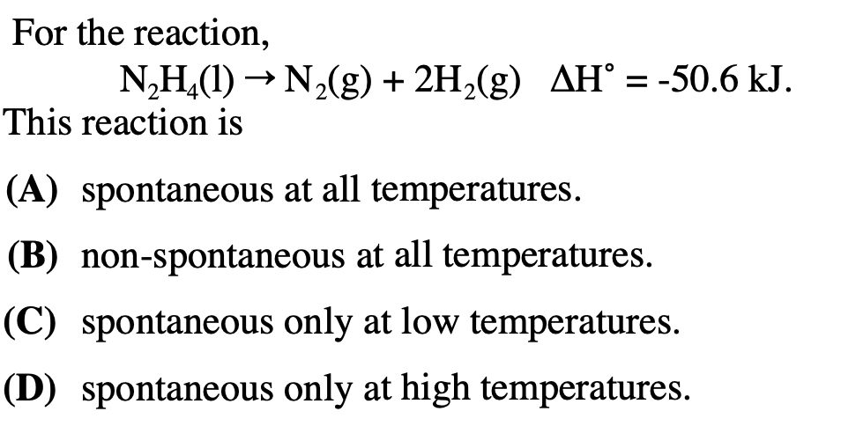
13. | 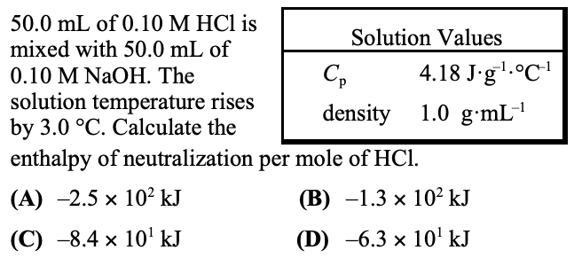
14. | 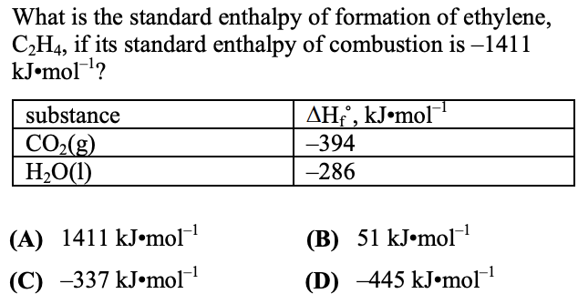
15. | 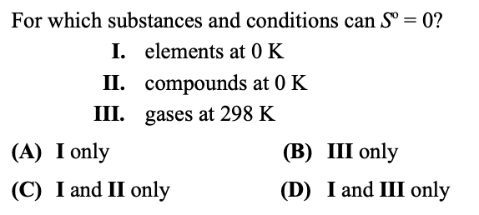
16. | 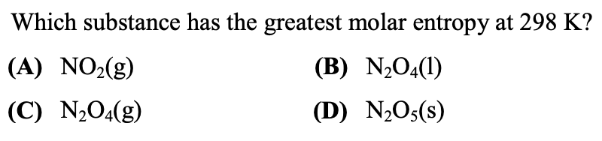
17. | 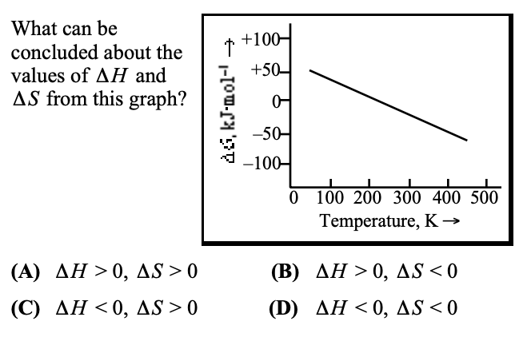
18. | 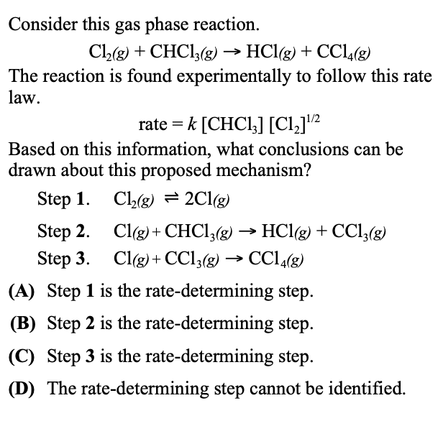
19. | 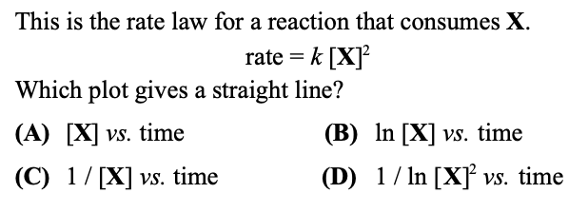
20. | 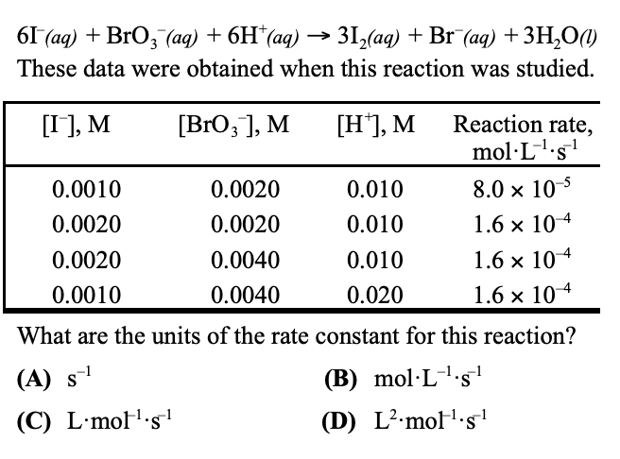
21. | 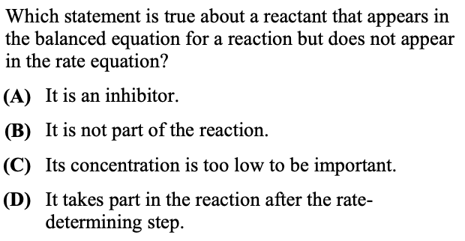
22. | 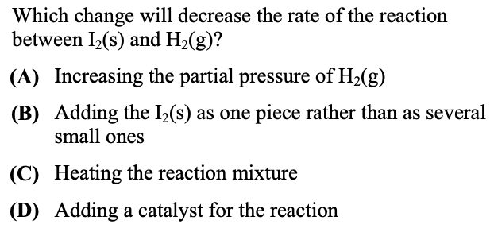
23. | 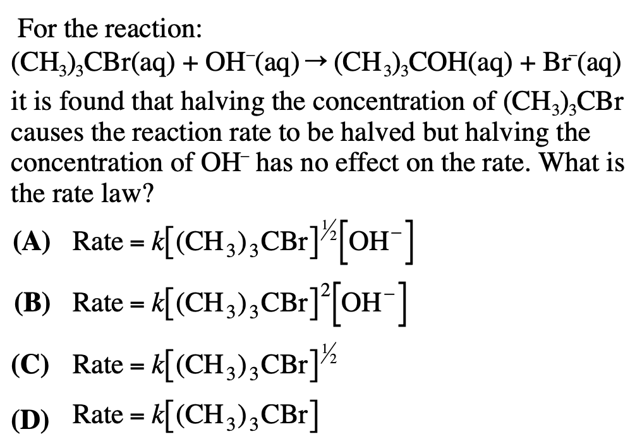
24. | 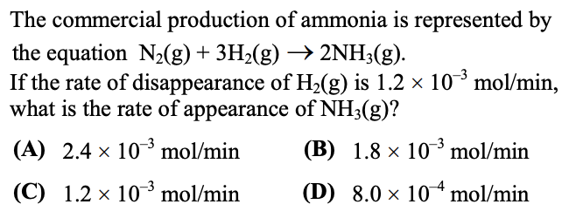
25. | 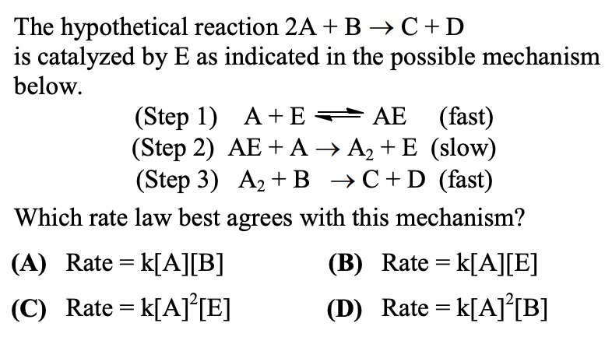
26. | 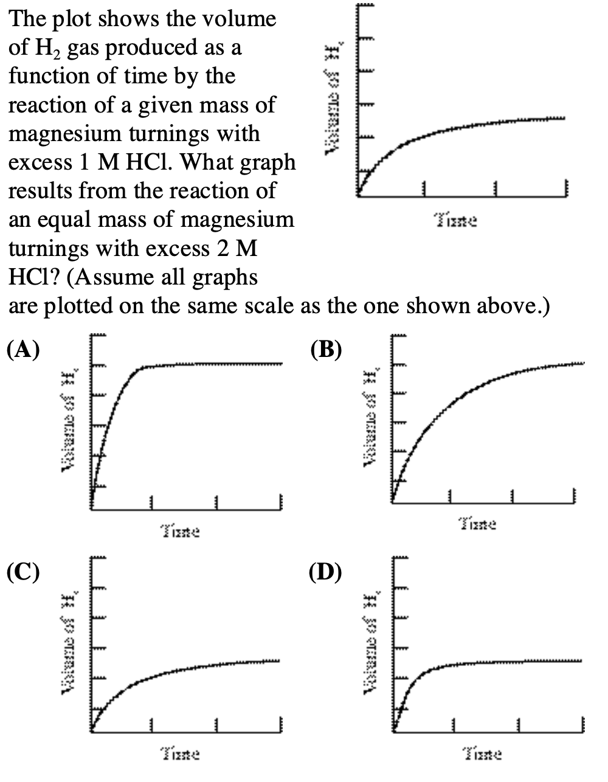
27. | 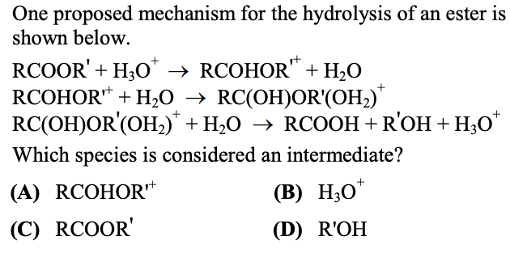
28. | 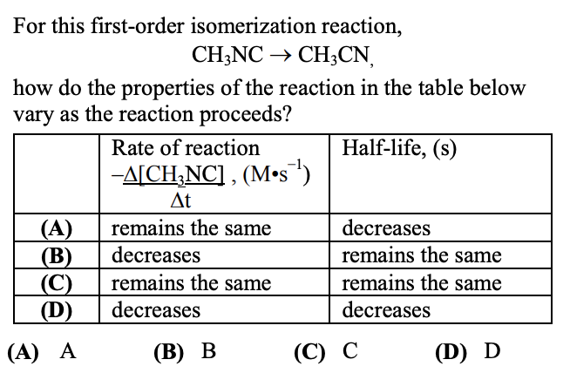

ANSWER KEY:
# | Answer | Source
1 | D | 2000 Local #15
2 | A | 2010 Local #5
3 | B | 2000 Local #26
4 | C | 2000 Local #3
5 | D | 2005 Local #1
6 | C | 2007 Local #1
7 | C | 2011 Local #4
8 | A | 2007 Local #31
9 | A | 2010 Local #20
10 | B | 2005 Local #23
11 | B | 2005 Local #25
12 | A | 2005 Local #24
13 | A | 2002 National #21
14 | B | 2011 Local #21
15 | C | 2002 National #20
16 | C | 2012 National #22
17 | A | 2002 National #22
18 | B | 2002 National #29
19 | C | 2002 National #25
20 | C | 2002 National #28
21 | D | 2011 Local #28
22 | B | 2011 Local #30
23 | D | 2005 Local #28
24 | D | 2010 Local #26
25 | C | 2012 National #29
26 | D | 2007 Local #25
27 | A | 2012 Local #30
28 | B | 2012 Local #28

