**Name: Period: Seat#:**

**S-20, 21, 22, 23**

**Directions:** Try these problems. If you can DO them, check the box (🗹).   
If you CANNOT do them, write some notes TO YOURSELF about what you need to study to succeed at these problems.

|  |  |  |
| --- | --- | --- |
| *From the AP Exam Formula Sheet:* |  |  |

**S20 – Quick Check #1**

🞏 **Integrated Rate Law**

The decomposition of nitrogen dioxide at a high temperature

NO2(g) → NO(g) + ½ O2(g)

is second order with respect to this reactant. The rate constant for this reaction is 3.40 L/mol·min.   
Determine the time needed for the concentration of NO2 to decrease from 2.00 mol/L to 1.50 mol/L.

🞏 **Graphical Methods (from the 2011 AP Exam)**

Ethanol gas, in a container with a copper metal catalyst, will decompose according to the following equation:

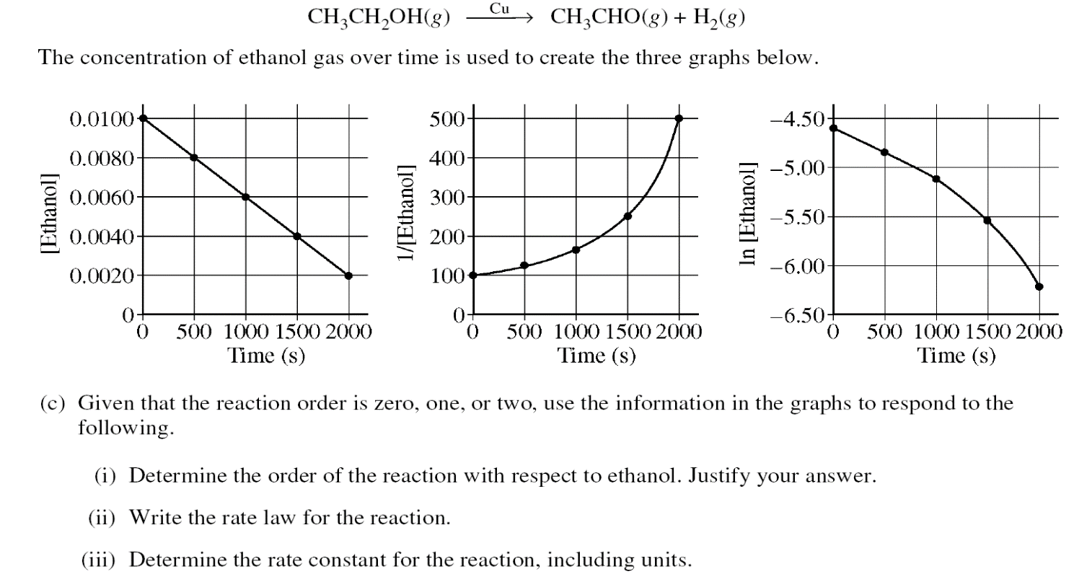

Given that the reaction order is zero, one, or two, use the information in the graphs to respond to the following.

a) Determine the order of the reaction with respect to ethanol. Justify your answer.

b) Write the rate law for the reaction.

c) Determine the rate constant for the reaction, including units.

**S21 – Quick Check #2**

* **Rates:**

Consider the equation: 2AlBr3 + 3K2S → 6KBr + Al2S3  
The rate of formation of KBr is 24 mol·L-1·s-1.  
  
What is the rate of AlBr3? ____________ of K2S? _______________ of Al2S3? _____________

* **Rate from a Graph:**

The concentration of a reactant is followed over time. The data is shown in a table and a graph.

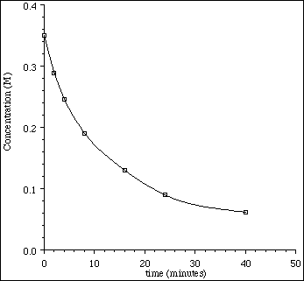 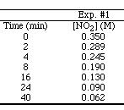

a) Determine the **average rate** between 8 and 24 minutes. (Show work.)

b) Determine the **instantaneous rate** at 8 minutes. (Show work.)

* **Reaction Mechanisms:**

The following mechanism is proposed for a reaction:

NO + NO → NO2 + N slow

N + O2 → NO2 fast

Write the equation for the overall reaction. Identify any reactive intermediates.

* **Orders of Reaction/Rate Laws:**

Nitrogen(II) oxide and hydrogen react to form nitrogen and water according to this equation.

2NO(g) + 2H2 → N2(g) + 2H2O(g)

According to these experimental results, what are the orders for NO and H2O?   
 Then write the rate law for this reaction.

|  |  |  |
| --- | --- | --- |
| [NO] | [H2] | Rate(mol·L-1·min-1) |
| 0.015 | 0.020 | 0.60 |
| 0.015 | 0.040 | 1.20 |
| 0.030 | 0.020 | 2.40 |

**S22 – Quick Check #3**

* **Reaction Mechanisms:**

The following mechanism is proposed for a reaction:

**i. NO2 + F2 ⭢ NO2F + F (slow)  
ii. NO2 + F ⭢ NO2F (fast)**

Write the equation for the overall reaction.

* **Rate Laws:**

Write the rate law for the above mechanism.

* **Graphical Methods:**

The catalyzed decomposition of hydrogen peroxide, H2O2 is studied and found to be   
first order with respect to H2O2.

2 H2O2*(aq)*  2 H2O*(l)* + O2*(g)*

During the analysis of the data, the graph below was produced.



(i) Label the vertical axis of the graph

(ii) On the graph, draw the line that represents the plot of the uncatalyzed first-order   
decomposi­tion of H2O2*(aq)*.

**S23 – Quick Check #4**

|  |  |
| --- | --- |
| **[X] (M)** | **Time (min)** |
| 1.28 x 104 | 0.0 |
| 4.00 x 105 | 35.0 |

🞏 **FRQ Practice** *Useful information: ln[X]t – ln[X]0 = –kt*

The first-order decomposition of X is monitored.   
The data from the experiment are given in the table to the right.

(a) Calculate the rate constant for the first order reac­tion using the values given for concentration and time. Include units with your answers.

(b) Calculate the half-life of the reaction. Include units with your answer.

(c) Experiments were performed to determine the value of the rate constant for this reaction at vari­ous temperatures. Data from these experiments were used to produce the graph below, where T is temperature. This graph can be used to determine *Ea*, the activation energy.

(i) Label the vertical axis of the graph

(ii) Explain how to calculate the activation energy from this graph.



🞏 **Catalysts**

A proposed mecha­nism for the depletion of O3 in the upper atmo­sphere is shown below.

Step I O3 + Cl → O2 + ClO

Step II ClO + O → Cl + O2

1. Write a balanced equation for the overall reaction represented by Step I and Step II above.
2. Clearly identify the catalyst in the mechanism above. Justify your answer.

(c) Clearly identify the intermediate in the mechanism above. Justify your answer.