**Name: Period: Seat#:**

**S-20**

|  |  |  |
| --- | --- | --- |
| *From the AP Exam Formula Sheet:* |  |  |

🞏 **Integrated Rate Law**

The decomposition of nitrogen dioxide at a high temperature

NO2(g) → NO(g) + ½ O2(g)

is second order with respect to this reactant. The rate constant for this reaction is 3.40 L/mol·min. Determine the time needed for the concentration of NO2 to decrease from 2.00 mol/L to 1.50 mol/L.

🞏 **Graphical Methods (from the 2011 AP Exam)**

Ethanol gas, in a container with a copper metal catalyst, will decompose according to the following equation:

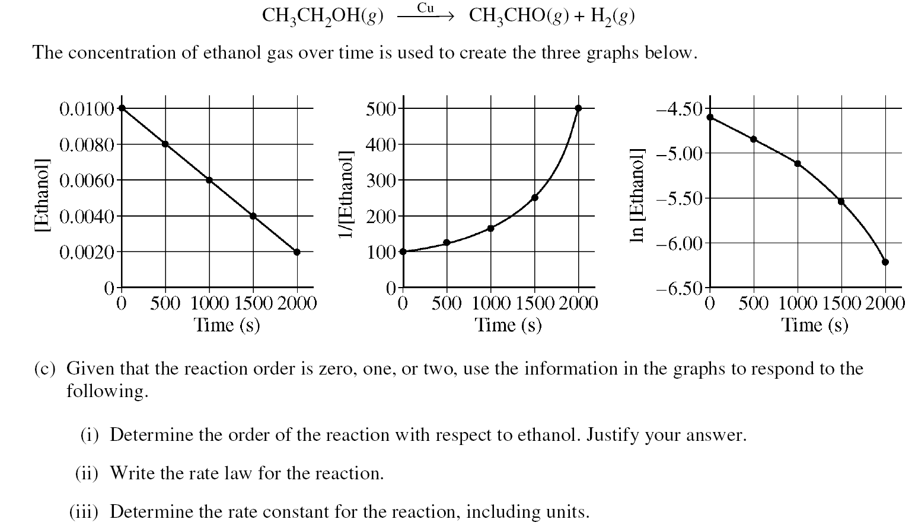

Given that the reaction order is zero, one, or two, use the information in the graphs to respond to the following.

a) Determine the order of the reaction with respect to ethanol. Justify your answer.

b) Write the rate law for the reaction.

c) Determine the rate constant for the reaction, including units.