**Name: Period: Seat#:**

**S-21**

Try these problems. If you can DO them, check the box (🗹). If you CANNOT do them, write some notes TO YOURSELF about what you need to study to succeed at these problems.

* **Rates:**  
  Consider the equation: 2AlBr3 + 3K2S → 6KBr + Al2S3  
  The rate of formation of KBr is 24 mol·L-1·s-1.  
  What is the rate of AlBr3? ____________ of K2S? _______________ of Al2S3? _____________
* **Rate from a Graph:**

The concentration of a reactant is followed over time. The data is shown in a table and a graph.

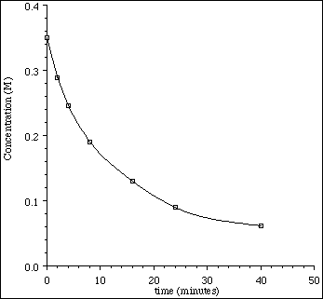 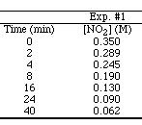

a) Determine the **average rate** between 8 and 24 minutes. (Show work.)

b) Determine the **instantaneous rate** at 8 minutes. (Show work.)

* **Reaction Mechanisms:**

The following mechanism is proposed for a reaction:

NO + NO → NO2 + N slow

N + O2 → NO2 fast

Write the equation for the overall reaction. Identify any reactive intermediates.

* **Orders of Reaction/Rate Laws:**

Nitrogen(II) oxide and hydrogen react to form nitrogen and water according to this equation.

2NO(g) + 2H2 → N2(g) + 2H2O(g)

According to these experimental results, what are the orders for NO and H2O?

|  |  |  |
| --- | --- | --- |
| [NO] | [H2] | Rate(mol·L-1·min-1) |
| 0.015 | 0.020 | 0.60 |
| 0.015 | 0.040 | 1.20 |
| 0.030 | 0.020 | 2.40 |

Write the rate law for this reaction: