Name: Period: Seat#:
Review
STATION 1 • MASS ACTION EXPRESSIONS
Write the mass action expression for the equilibrium: Fe₃O₄(s) + 4 H₂(g) 3 Fe(s) + 4 H₂O(g)

Write the mass action expression for the equilibrium: Ca(OH)₂(s) Ca²⁺(aq) + 2 OH⁻(aq)

The equilibrium constant, K_{c} = 7.9 x 10⁻⁶, is this equilibrium system reactant or product-favored. _________

Chemical Equilibrium
STATION 2 • MANIPULATING K
Given:
H₂O(l) H⁺(aq) + OH⁻(aq) K_{c} = 1 x 10⁻¹⁴
HCN(aq) H⁺(aq) + CN⁻ (aq) K_{c} = 4.0 x 10⁻¹⁰

Calculate K_{c} for this reaction:
HCN(aq) + OH⁻(aq) H₂O(l) + CN⁻(aq) K_{c} = ???

This reaction is _________________-favored.
Chemical Equilibrium
STATION 3 • K_{p} & K_{c}
Consider the equilibrium: 2NO(g) + O₂(g) 2NO₂(g).

At 100°C, the equilibrium concentrations for this system are:
[NO] = 0.52 M; [O₂] = 0.24 M; [NO₂] = 0.18 M

Write the expression for K_{c} and calculate its value at this temperature?

What is Δn for this system? _____

Write the expression for K_{p} and calculate its value at this temperature.

Chemical Equilibrium
STATION 4 • LE CHÂTELIER’S PRINCIPLE
Consider the gaseous equilibrium: 2CCl₄(g) + O₂(g) 2COCl₂(g) + 2Cl₂(g) ΔH = +35 kJ
Predict the effect each change would have on the concentrations of the each substance.

Add CCl₄ ____ ____ ____ ____
Remove Cl₂ ____ ____ ____ ____
Add COCl₂ ____ ____ ____ ____
Increase temperature ____ ____ ____ ____
Reduce container volume ____ ____ ____ ____
Add a catalyst ____ ____ ____ ____
Remove O₂ ____ ____ ____ ____
Add He to increase pressure ____ ____ ____ ____

A different equilibrium shifts toward the reactants when the temperature is increased. From this observation, you know that the reaction is _______________________ (exothermic / endothermic).
Chemical Equilibrium
STATION 5 • ICE BOX PROBLEM

Consider the equilibrium: 2SO₂(g) + O₂(g) 2SO₃(g)

If 0.200 mol SO₃(g) is placed a 0.500 Liter container, it is found that 0.050 mole of O₂(g) is in the container at equilibrium. Fill in the ICE box and determine the K_{c} for this reaction.
 | SO₂ | O₂ | SO₃
Initial
Change
Equilibrium

Chemical Equilibrium
STATION 6 • ANOTHER ICE BOX PROBLEM
At 985°C, the equilibrium constant, K_{c}, for the reaction, H2(g) + CO2(g) H2O(g) + CO(g), is 1.63.
If 2.00 moles each of H₂(g) and CO₂(g) are placed in a 1.00-Liter container and allowed to come to equilibrium, determine the equilibrium concentrations of the four chemicals.

 | H₂ | CO₂ | H₂O | CO
Initial
Change
Equilibrium

Chemical Equilibrium
STATION 7 • TEST QUOTIENT,Q
Consider the equilibrium: 2NO(g) + O₂(g) 2NO₂(g). K_{c} = 0.499

The system is set up with the following concentrations:
[NO] = 0.50 M; [O₂] = 0.25 M; [NO₂] = 0.25 M

This reaction will ____________________ (shift right, shift left, remain unchanged).

Justify your prediction.

Chemical Equilibrium
STATION 8 • NChO PROBLEMS
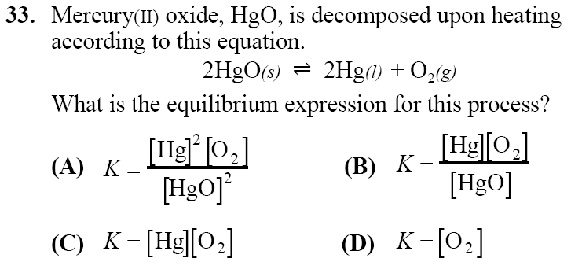 | 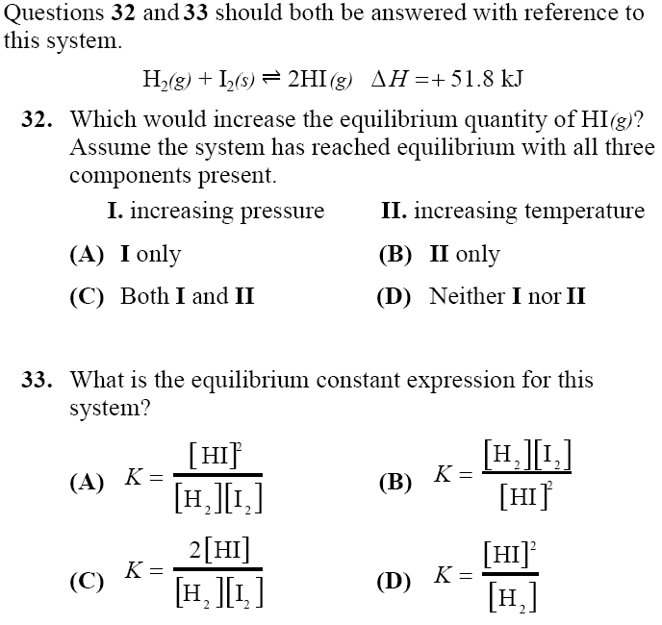
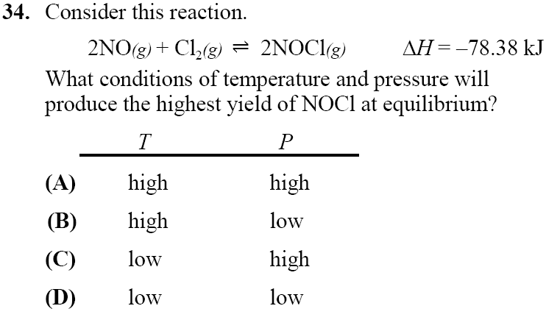

Chemical Equilibrium – Not assessed. Challenge Problem
STATION 9 • PREDICTING REACTIONS

A solution of hydrochloric acid is added to a solution of potassium nitrite.
(i) Balanced equation:

(ii) What are the oxidation states of the N atom before and after the reaction?

_____________________________________________________________________________

_____________________________________________________________________________

