South Pasadena • AP Chemistry Name ___________________________ Per ___

8 • Electron Configurations and Periodicity
STATION 1 – ORBITALS AND ELECTRONS

1. The number of electrons that can occupy a 3d orbital is _____.
2. The highest energy orbital in boron, B, is _____.
3. The orbital farthest from the nucleus in Cr is _____.
4. The number of orbitals when n=3 is _____.
5. The number of electrons that have n=2 is _____.
6. The orbital that fills after the 6s is _____.
7. Circle the orbital representations that could exist: 4s³ 5g¹⁸ 3p⁴ 2p⁸ 6d³ 1s¹ 7f¹⁵
8. When Zn becomes an ion, it loses its electrons from the _____ orbital.

8 • Electron Configurations and Periodicity
STATION 2 – ELECTRON CONFIGURATIONS

Fill in the orbital diagram for S. Fill in the orbital diagram for Cu.
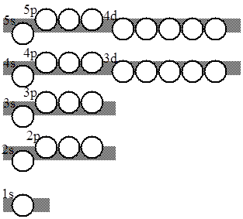

Write the short form and long form electron configurations for S and Cu.

S  long:  short: | Cu  long:  short:

8 • Electron Configurations and Periodicity
STATION 3 – THE PERIODIC TABLE
Write in the last orbital filled in each zone of the periodic table.
1 |  |  |  |  |  |  |  |  |  |  |  |  |  |  |  |  | 18
 | 2 |  |  |  |  |  |  |  |  |  |  | 13 | 14 | 15 | 16 | 17

Circle the following element(s) that would be paramagnetic: Zn Mg Mn²⁺ N O²⁻ Co²⁺

8 • Electron Configurations and Periodicity
STATION 4 – IONIZATION ENERGY

The Period 3 Elements are: | Na | Mg | Al | Si | P | S | Cl | Ar

Which Period 3 element has the following five ionization energies? _____
IE₁ | IE₂ | IE₃ | IE₄ | IE₅
736 kJ | 1445 kJ | 7730 kJ | 10,600 kJ | 13,600 kJ

Which Period 3 element has the following five ionization energies? _____
IE₁ | IE₂ | IE₃ | IE₄ | IE₅
787 kJ | 1575 kJ | 3220 kJ | 4350 kJ | 16,100 kJ

Which period 3 element has the largest 3rd ionization energy? ______

8 • Electron Configurations and Periodicity
STATION 5 – TRENDS IN IONIZATION ENERGY

For each pair of elements, circle the element with the larger ionization energy:
F & Cl | Na & Be | Mg & Al | N & O | C & O

Which element, Mg or Ca has the larger first ionization energy? _____ Explain.

Write the equation for the first ionization of Mg: _________________________________________

Write the equation for the first ionization of Cl: _________________________________________

8 • Electron Configurations and Periodicity
STATION 6 – GRAPHED IONIZATION ENERGIES

This is a graph of the ionization energies for the first 20 elements by atomic number.  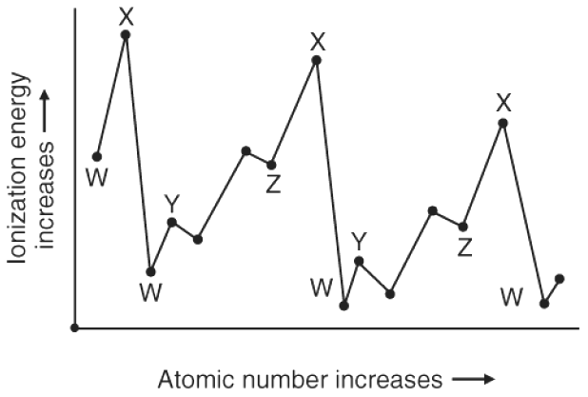 | Determine which families are W, X, and Y:  W is the ____________________ family and the ____________________ family.  X is the ____________________ family.  Y is the ____________________ family.

8 • Electron Configurations and Periodicity
STATION 7 – ELEMENTS & ELECTRON CONFIGURATIONS

Identify the elements with the following electron configurations:

 | 1s² 2s² 2p⁶ 3s² 3p⁶ 4s² |  |  | [Ne] 3s¹
 | [Ar] 4s² 3d⁶ |  |  | 1s² 2s² 2p⁶ 3s² 3p¹
 | 1s² 2s² 2p⁵ |  |  | [Kr] 4d⁷ 5s²
 | [Xe] 6s² 4f⁴ |  |  | 1s² 2s² 2p⁶ 3s² 3p⁶ 3d⁵ 4s¹

Write the long form electron configuration for Fe³⁺:

8 • Electron Configurations and Periodicity
STATION 8 – QUANTUM NUMBERS

Write the quantum numbers for each of the electrons in oxygen, O (Z = 8): | n | l | m_{l} | m_{s}

Write the quantum numbers for the outer electron of rubidium, Rb (Z=37):
8 • Electron Configurations and Periodicity
STATION 9 – TRENDS IN SIZE
For each pair of elements, circle the element with the larger atomic radius:
Mg & Ca | N & O | Sn & As | K & K⁺ | I and I⁻

As you move down a family (column) of elements, the atomic radius _____________ (increases, decreases) because ____________________________________________________________________________.

As you move across a period (horizontal row) of elements, the atomic radius __________ (increases, decreases) because ____________________________________________________________________________.

Put these five elements in order from smallest atomic radius to largest atomic radius. F Br Ca K Cs

Smallest |  |  |  |  |  | Largest

8 • Electron Configurations and Periodicity
STATION 9 – TRENDS IN SIZE
For each pair of elements, circle the element with the larger atomic radius:
Mg & Ca | N & O | Sn & As | K & K⁺ | I and I⁻

As you move down a family (column) of elements, the atomic radius _____________ (increases, decreases) because ____________________________________________________________________________.

As you move across a period (horizontal row) of elements, the atomic radius __________ (increases, decreases) because ____________________________________________________________________________.

Put these five elements in order from smallest atomic radius to largest atomic radius. F Br Ca K Cs

Smallest |  |  |  |  |  | Largest

