Dougherty Valley HS AP Chemistry
REVIEW
Equilibrium – Review

Name: Date: Period: Seat #:
Station 1 – BURNERS AND FLAME TESTS
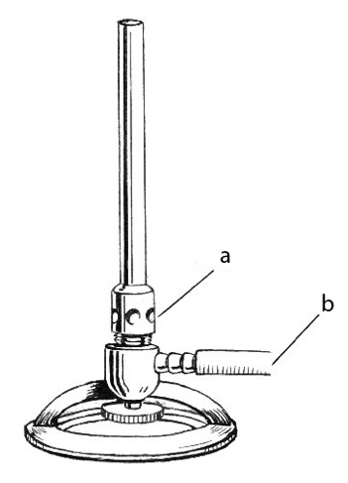 | Metal Ion | Flame Test Color
 | sodium, Na
 | strontium, Sr
 | copper, Cu
 | barium, Ba
During a flame test, light is ________________ (absorbed/emitted) as an electron moves to a _____________ (higher/lower) energy level.

For the Bunsen burner:
a) _________ is added to the flame.
b) _________ is added to the flame.

Draw a well adjusted flame above the burner.
Indicate the hottest part of the flame.

Atomic Structure
Station 2 – VIEWING SPECTRA

Using the triangular spectrometers, look at the provided light source.
The wavelength of light viewed ranges from 400 nm to 700 nm.

What is the wavelength of the GREEN light? _______________

Calculate the frequency of the green light.

Consider the spectrum below. It is an _____________________ (emission/absorption) spectrum.

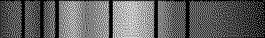
Explain what the electrons are doing to produce the black lines:
Atomic Structure
Station 3 – ENERGY CALCULATIONS
H-O-O-H
The energy required to break the O - O bond in hydrogen peroxide, H₂O_{2(g)}, is 139 kJ mol⁻¹.
How much energy is needed to break one peroxide bond (in Joules)? (Show work)

Blue light has a wavelength of about 475 nm. Does this light have enough energy to break the bond? _____
Justify your answer with calculations.

Atomic Structure
Station 4 – SHELLS, SUBSHELLS & ORBITALS

Circle the subshells that do NOT exist: 4p 1p 2f 5s 3d 7p 2d 3s

_____ The number of orbitals in a 4d subshell.
_____ The number of orbitals in the n=2 shell.
_____ The number of subshells in the n =5 shell.
_____ The number of orbitals in a 4f subshell.
_____ The number of subshells in the n =3 shell.
Atomic Structure
Station 5 – WAVE CALCULATIONS
c = 2.998 x 10⁸ m/s h = 6.626 x 10⁻³⁴ J·s

The color orange (school colors) has a wavelength of 615 nm.
Calculate the frequency of this light.
Calculate the energy of a photon this light.

A radio station broadcasts at a frequency of 590 KHz (590 x 10³ Hz).
What is the wavelength of the radio waves?

Atomic Structure – not assessed
Station 6 – THE BOHR ATOM
c = 2.998 x 10⁸ m/s h = 6.626 x 10⁻³⁴ J·s Rhc = 2.18 x 10⁻¹⁸ J R = 1.0974 x 10⁷ m⁻¹

Sketch the Bohr atom from levels n=1 to n=5. | Show the transition that would give off blue-green light.  Calculate the energy of level n=4.  Calculate the energy change of an electron that drops from level 4 to level 2.  An electron that moves from n=1 to n=5 would _________ (gain / lose) energy and produce an _______________ (absorption / emission) spectrum.

Atomic Structure – not assessed
Station 7 – DE BROGLIE WAVELENGTH
c = 2.998 x 10⁸ m/s h = 6.626 x 10⁻³⁴ J·s Rhc = 2.18 x 10⁻¹⁸ J R = 1.0974 x 10⁷ m⁻¹

Write the equation for the De Broglie wavelength of a particle:

Joule is the same as a unit containing “kg”. What is it?

An electron has a mass of 9.10956 x 10⁻³¹ kg. What is the wavelength of an electron traveling at 75.0% the speed of light?

Atomic Structure – not assessed
Station 8 – QUANTUM NUMBERS
When n = 3, the possible values of l are: 0 1 2 3 4 5 (Circle your answers.)
For a 3d orbital, the value of l is ___.

When n = 5, the possible values of l are: 0 1 2 3 4 5 (Circle your answers.)
For a 5p orbital, the value of l is ___.
There are three different 4p orbitals.  Write the three quantum numbers that describe these orbitals: | n | l | m_{l}
Is this set of quantum numbers possible? ______ | 3 | 2 | -2

Atomic Structure
Station 9 – WAVE FACTS
A = ________________ B = __________________ C = _________________ D = ________________

If this is a wave of YELLOW light, sketch what a wave of RED light would look like.

The red light would have a _________ (higher/lower) frequency, a ___________ (longer/shorter) wavelength, and _________ (more/less) energy.

If this were a picture of a standing wave, how many antinodes are shown? ___

