Dougherty Valley HS AP Chemistry
S-39
Atomic Structure
Quick Check #3
- How many electrons does neutral Vanadium have? _____ Correctly fill in the orbital diagram
below as shown in class.
◻ How many valence electrons does Vanadium have? ______ Put a box around them.
◻ Which electrons above are furthest away from the nucleus? ________
◻ Write the Long Form electron configuration for Vanadium.
______________________________________________________________
◻ Write the Short Form electron configuration for Vanadium.
______________________________________________________________
◻ Which electrons in Vanadium have the greatest amount of energy? ________
◻ Would Vanadium be considered to be an s-block, p-block, d-block or f-block element? _______
- Correctly fill in the orbital diagram below for Manganese ion (Mn²⁺), which has _____ electrons.

- Correctly fill in the orbital diagram below for Molybdenum, Mo, which has _____ electrons.

◻ Looking at the periodic table, shade in a “period”.
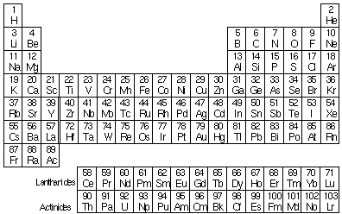
- Looking at the periodic table, shade in a “group”.
◻ What is the difference between a “group” and a “family”? _____________________________

