**Dougherty Valley HS AP Chemistry**

**S-37**

**Atomic Structure**

**Quick Check #1**

**Name: Date: Period: Seat #:**

|  |  |  |  |  |
| --- | --- | --- | --- | --- |
| Formulas and Constants | | | | |
| c = υ | υ = | ● = | E = hυ | E = |
| c = 2.998 x 108 m/s h = 6.626 x 10-34 J·s | | | | |

🞎 List all electromagnetic radiations from low energy to high.

|  |  |  |  |  |  |  |
| --- | --- | --- | --- | --- | --- | --- |
|  |  |  | **R O Y G B V** |  |  |  |

🞎 We can see electromagnetic radiation with wavelengths between 400 nm and 700 nm.

Is 400 nm red light or violet light? ______________ Justify your answer.

🞎 Consider this graphic from the **Online Tutorial: Electromagnetic Radiation**. The scale is in nm.

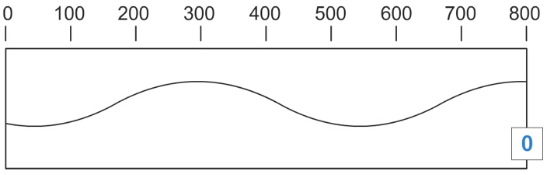

What is the wavelength (λ) of this wave? _______nm

Would you be able to see this wave? ______

What is this wavelength in meters? ___________m

🞎 Yellow light from a sodium vapor light has a wavelength of 589 nm. Calculate the frequency of this color of yellow light in Hz.

🞎 A radio station (KPCC) has a frequency of 89.3 MHz (megahertz).

How many Hz are in a MHz? _________

What is the frequency of this radio wave in s-1? ________

What is the energy of the radio waves being emitted (in Joules)?