Dougherty Valley • AP Chemistry [Keep for Reference]

Bonding, Molecular Structure & Hybridization

STUDY LIST From Paul Groves

**Valence Electrons & Lewis Symbols**

I can…

* State the number of valence electrons for any atom.
* Draw Lewis Dot Symbols for any atom or ion.
* Explain that families II, III, and IV have both a ground state and promoted state form of the Lewis symbol.
* Draw the Lewis symbol for a simple ion such as Na+ or Cl-.

**Bonding**

* State the type of bond (ionic, covalent, metallic) formed between any two atoms.

|  |  |
| --- | --- |
| metal-metal | metallic bond |
| metal-nonmetal | ionic bond |
| nonmetal-nonmetal | covalent bond |

* Explain (using attractions and repulsions) why the formation of a bond lowers the potential energy of a molecule.
* Use the following diagram to determine the bond length and bond energy of a bond.

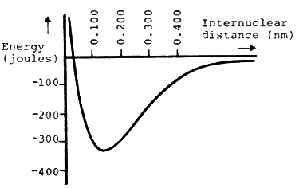

* State that a covalent bond usually forms between two atoms with half-filled orbitals.

**Lewis Dot Symbols**

|  |  |  |
| --- | --- | --- |
|  | Draw Lewis dot symbols to show a covalent bond between atoms in a molecule. |  |

* Identify “lone pair” electrons vs. “shared pair” electrons in a Lewis structure.
* Draw molecules with double and triple bonds.
* Note that only C, N, O, and sometimes S form multiple bonds.
* Use Mr. Groves’ method of “take away a pair, take away a pair, make these guys share” to draw molecules with multiple bonds while maintaining the octet of electrons for each atom.
* State that many atoms gain, lose, or share electrons until they are surrounded by eight electrons. This is called the “octet rule”.
* Memorize the Lewis symbols for the seven diatomic molecules. N2 has a triple bond. O2 has a double bond.
* Draw examples of molecules that do not follow the octet rule because the atoms have **less** than an octet. (e.g., CaH2, H2, Families I, II, III)
* Draw Lewis symbols for polyatomic ions.
* Draw Lewis symbols for molecules and ions that exhibit resonance.
* Memorize some of the more common molecules and ions that exhibit resonance [e.g., NO3-, CO32-, SO2, NO2, O3, C6H6, C2H3O2-].
* Draw Lewis symbols for molecules and ions that violate the octet rule by using their “p” orbitals for extended valence shells. [e.g., SF6, XeF2, XeF4, IBr3, PCl5]
* Explain why P can form PF3 and PF5, but N (same family) can form NF3, but not NF5.

**Bond Energies**

* Define bond energy.
* Write a chemical equation to show bond energy of any bond. For example, the F-F bond in F2 is F2(g) + energy → 2F(g)
* Determine the bonds broken and bonds formed during a chemical reaction by drawing the Lewis structures of the reactants and products.
* Use a chart of bond energies to calculate the Enthalpy of a reaction (ΔH).
* Explain that this method does not give exactly the same answer as Hess’s Law because bond energies are **average** bond energies that differ slightly from molecule to molecule.

**Formal Charge & Oxidation Number**

* Define formal charge as the charge on an atom if all shared electrons are shared equally. 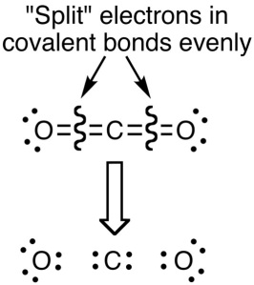
* Determine the formal charge of any atom in a Lewis Structure and use these formal charges to determine the best arrangements of atoms.
* State that the best structures have minimal formal charges and the more electronegative atoms have the negative formal charges.
* Contrast formal charge with oxidation states in which shared electrons are assigned to the more electronegative atom.

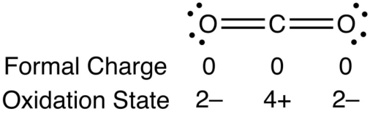

**Shapes of Molecules**

* Define Steric Number (SN) as the # of bonded atoms plus the # of lone pairs on an atom.
* State the Steric Number (SN) of the central atom in any Lewis structure.
* Use VSEPR to state the shape and bond angle associated with each Steric Number.

|  |  |  |
| --- | --- | --- |
| 2 | linear | 180° |
| 3 | trigonal planar | 120° |
| 4 | tetrahedral | 109.5° |
| 5 | trigonal bipyramidal | 90° & 120° |
| 6 | octahedral | 90° |

* State the shape of a molecule (arrangement of the atoms). [AKA “Molecular Geometry”]
* State the type of orbital hybridization used with each steric number.

|  |  |  |  |  |  |
| --- | --- | --- | --- | --- | --- |
| 1 | 2 | 3 | 4 | 5 | 6 |
| s | sp | sp2 | sp3 | sp3d | sp3d2 |

* Explain that non-hybridized orbitals remain as p-orbitals. For example:

**s + p** + *p* + *p* → **sp** + **sp** + *p* + *p*

**s + p + p** + *p* → **sp2** + **sp2** + **sp2** + *p*

**Electronegativity**

* Use the difference in electronegativity values (ΔEN) of any two atoms to classify the bond.

|  |  |
| --- | --- |
| ionic | ΔEN > 1.7 |
| polar covalent | 0.5 < ΔEN < 1.7 |
| nonpolar covalent | ΔEN < 0.5 |

* State the positive and negative end of any polar bond.
* Judge from the molecular shape whether the molecule is polar if the bonds are polar.
* State the electronegativity values for C, N, O, F, P, S, and Cl from their positions on the table.

**Multiple Bonds, Bond Order, & Resonance**

* Define bond order as the number of pairs of electrons holding two atoms together in a covalent bond.

|  |  |  |  |
| --- | --- | --- | --- |
| single bond | B.O. = 1 | longer | weaker |
| double bond | B.O. = 2 |  |  |
| triple bond | B.O. = 3 | shorter | stronger |

* Describe a double bond as an atom using sp2 hybridization (SN=3) and utilizing the p-orbital to form a pi () bond. Example: ethane, C2H4.

|  |  |
| --- | --- |
| c2h4-2 |  |

* Describe a triple bond as an atom using sp hybridization (SN=2) and utilizing the two   
  p-orbitals to form two pi () bonds.

Example: ethyne, C2H2.

|  |  |
| --- | --- |
| C2H2 | image039 |

* Explain that when resonance occurs, each atom involved uses sp2 hybrid orbitals and each of the p-orbitals blends into a pi bond.

Example: the nitrate ion ([ ]- left off for clarity)

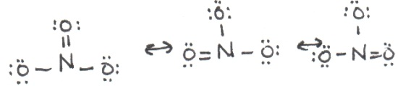

|  |  |
| --- | --- |
| pibonds | Notice that the bond order of the N-O bond is 1.33.  When two resonance structures are involved, the bond order is 1.5. |