**Dougherty Valley HS AP Chemistry**

**S-47**

**Bonding**

**Quick Check #1**

**Name: Date: Period: Seat #:**

🞎 Sketch the potential energy involved as two hydrogen atoms approach each other.

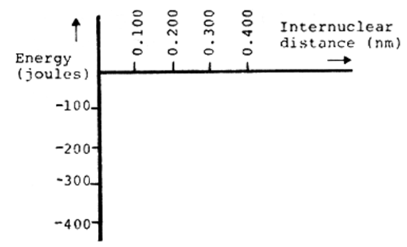

🞎 As the two atoms get closer, the potential energy drops because of the ______________ (attraction/repulsion) between the _____________ and the _______________.

🞎 The distance when the potential energy is a minimum is called  
the ___________________ - __________ - _______________.

🞎 Draw the following ***Lewis Dot Diagrams.***

|  |  |  |  |
| --- | --- | --- | --- |
| Be (ground state) | Be (bonding state) | Si (ground state) | Si (bonding state) |
|  |  |  |  |

🞎 Draw the ***Lewis Dot Diagram*** for Calcium Chloride.

This compound is __________ (covalent/ionic).

🞎 Explain how this bond was formed in terms of the electrons. _______________________________

__________________________________________________________________________________

__________________________________________________________________________________

🞎 Draw the ***Lewis Dot Diagram*** for BeH2.

This compound is __________ (covalent/ionic).

🞎 Explain how this bond was formed in terms of the electrons. _______________________________

__________________________________________________________________________________

__________________________________________________________________________________

🞎 State the octet rule? ____________________________________________________________

_________________________________________________________________________________

🞎 Is the compound BeH2 obeying the octet rule? ______