**Dougherty Valley HS AP Chemistry**

**S-48**

**Bonding**

**Quick Check #2**

**Name: Date: Period: Seat #:**

🞎 Draw the **Lewis structure** for CH3F.

🞎 Draw the **Lewis structure** for SO2.

🞎 Determine the **formal charge** for each atom in COCl2: 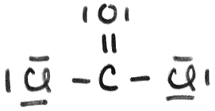

🞎 Draw the **Lewis structure** for CO2.

Determine the **formal charge** ~~and~~ **~~oxidation number~~** of C in CO2.