South Pasadena • AP Chemistry Name ___________________________________
Period ___ Date ___/___/___
13 • IMFs, Liquids and Solids
SAMPLE QUIZ QUESTIONS

1. Give names to the two forces mentioned in the tutorials and indicated in the picture on the right.  Intramolecular force: _______________________  Intermolecular force: _______________________ | 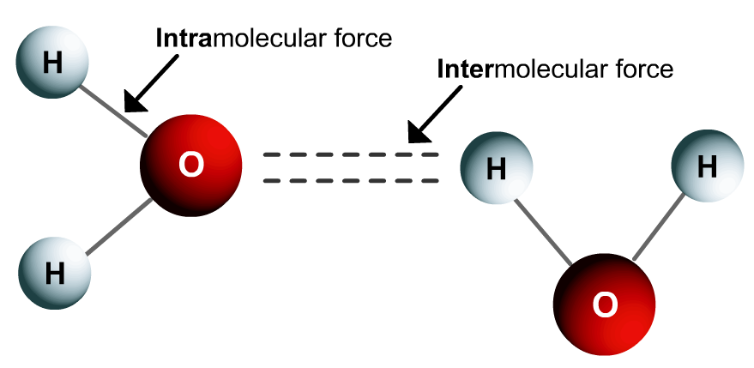

2. Put these three ionic compounds in order of  weakest to strongest IMF.  __________ __________ __________ | 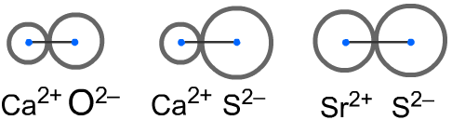

3. Define “miscible”. ________________________________________________________

Are ammonia (NH₃) and water (H₂O) miscible? _____ Justify your answer.

4. Consider the phase diagram shown:  a) Label the x & y axes.  b) Is this water or some other substance?  c) Label the areas as gas, liquid, and solid. | 