Dougherty Valley • AP Chemistry [Keep for Reference]

IMF's, Liquids, & Solids

STUDY LIST From Paul Groves

I can…

Types of Solids

* classify any substance into the four solids:
  + molecular
  + metals
  + ionic
  + covalent network
* list the eight examples of covalent network solids
* determine whether a molecule is polar or nonpolar from its formula & structure
* explain that acids (e.g. HCl) are a **molecular** substance (not an ionic substance) even though they form ions in solution

Bonding and Properties

* describe the bonding in:
  + metals
  + ionic solids, and
  + covalent network solids
* list and explain the properties of the above three types of substances, including
  + melting point/boiling point
  + conductivity as (s), (l), (g), & (aq)
  + brittleness or malleability
* give examples of each of the types of solids
* use lattice energy ideas to compare the strength of bonding in various ion pairs

Intermolecular Forces of Attraction

* make the distinction between inter- and intra-molecular forces of attraction such as in a gaseous sample of HCl.
* list and describe the IMF’s associated with polar molecules, non-polar molecules, and noble gases
  + London dispersion forces (LDF)
  + dipole-dipole attractions
  + hydrogen bonding
* state how the strength of IMF is related to MP, BP, ΔHvap, ΔHfus, & vapor pressure
* predict the strength of London dispersion forces (LDF) in terms of the “polarizable electron clouds” available in the two molecules.
* predict the strength of dipole-dipole interactions based on the polarity of the bonds in two polar molecules
* explain why H-O, H-N, and H-F are placed in a separate category called “hydrogen bonding” (i.e., why N, O, and F).
* explain that during a phase change, the IMF’s are broken, not the *intra*-molecular bonds.
* predict the miscibility of two substances based on the similarity or differences between their IMF’s.
* explain that the stronger a molecule’s IMF, the more it deviates from ideal behavior.

Vapor Pressure & Boiling

* explain that equilibrium vapor pressure is associated with the liquid-vapor dynamic equilibrium measured in a closed container
* state that temperature is the only variable that changes the vapor pressure of any liquid (not the amount of liquid, pressure above the liquid, or volume of the closed container)
* infer the relative strength of IMF’s of two liquids given their vapor pressures
* explain that a liquid will boil when its vapor pressure matches the pressure above the liquid
* explain that a liquid can be made to boil by heating the liquid or by reducing the pressure above the liquid
* define “normal boiling point” as the temperature at which a liquid will boil at sea level (1 atm = 760 mmHg = 101.3 kPa, etc.)
* explain that vapor pressure is a result of the balance between the kinetic energy of the molecules and the strength of their IMF’s.

Phase Changes

* list the names of the phase changes between (s), (l), and (g)
* sketch a “phase diagram” for a substance and label
  + the three phases
  + the triple point
  + the critical point

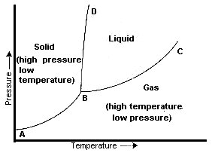

* explain why water’s solid-liquid line has a negative slope in terms of the density of liquid and solid water.  
  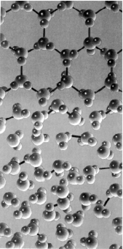
* calculate the energy involved in a phase change given values for ΔHvap and ΔHfus.
* list the type of energy change (kinetic or potential) that occurs during each section of a heating curve. Label the phase(s) present in each section.  
  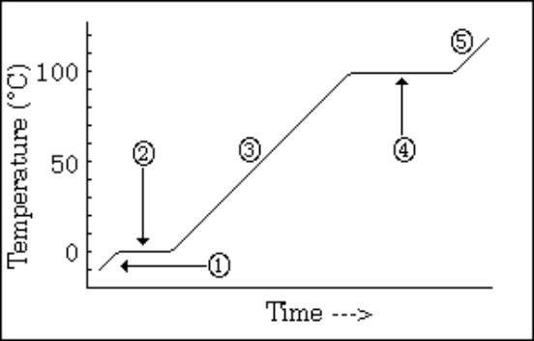

Surface Tension

* explain that a non-surface molecule is more stable (lower potential energy) than a surface molecule because it has the maximum number of neighbors. Liquids tend to minimize the number of high-energy surface molecules. This is called surface tension. The shape with the minimum surface area for its volume is a sphere.

