Name: Period: Seat#:
S-62, 63

Directions: Try these problems. If you can DO them, check the box ().
If you CANNOT do them, write some notes TO YOURSELF about what you need to study to succeed at these problems.

S62 – Quick Check #1

IMF Identification

Indicate the strongest IMF holding together crystals of the following substances:
 |  | London  forces | Dipole-dipole attractions | Hydrogen bonding | Metallic bonding | Ionic  bonding | Covalent bonding
1. | KCl
2. | IF₃
3. | HF
4. | AsH₃
5. | Br₂
6. | Pt
7. | NaOH
8. | H₂S
9. | Ne
10. | SiO₂

Describe the interparticle forces at work in the following:
______________________ a. within a water molecule H₂O
______________________ b. in a crystal of the salt NaCl
______________________ c. in a solution of potassium nitrate KNO₃
______________________ d. in diamond
______________________ e. in a fiber of nylon
______________________ f. in liquid butane
______________________ g. between water molecules in ice
______________________ h. between the two strands in the double helix of DNA
______________________ i. in paraffin wax
______________________ j. between the molecules of carbon dioxide CO₂ in dry ice
______________________ k. between the molecules of HCl in liquid HCl
______________________ l. in tungsten metal
______________________ m. in a solution of perchloric acid

Type of Bonds

Elemental boron is extremely hard (nearly as hard as diamond) and has a melting point of 2300°C.
It is a poor conductor of electricity at room temperature. What kind of solid would you expect for boron based on these properties? _________
A. molecular solid B. metal C. ionic solid D. covalent/network solid
Valence electrons delocalized over huge arrays of atoms.
What kind of solid is described by this property? __________
A. molecular solid B. metal C. ionic solid D. covalent/network solid

Some information that is considered “common knowledge” for AP Chemistry students:

Paraffin wax is made up of long carbon chains. The Alkanes area also called the Paraffins.
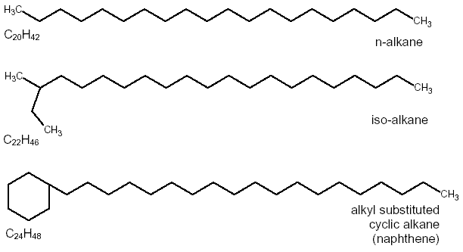

Nylon is a polymer made up of long chains of carbons with amine groups and C=O groups.
The “n” means that this pattern of atoms is repeated thousands of times to make nylon fibers.
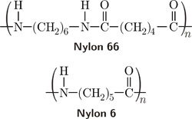

Perchloric acid is based on the perchlorate ion (ClO₄⁻).
This is an “oxoacid” where the H atom bonds to one of the oxygen atoms.
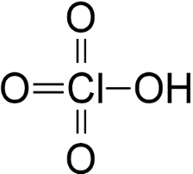

DNA has a familiar structure, but we are interested in how the two sides of DNA are connected to each other. Note that there are some N-H bonds and O-H bonds in the “Nitrogenous bases”.
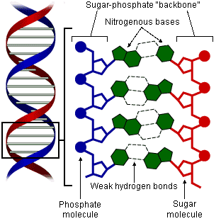

S63 – Quick Check #2

- Explaining Problems (from the 1994 AP Exam)
For each of the following, use appropriate chemical principles to explain the observation.
At room temperature, NH₃ is a gas and H₂O is a liquid, even though NH₃ has a molar mass
of 17 grams and H₂O has a molar mass of 18 grams.

C_{(graphite)} is used as a lubricant, whereas C_{(diamond)} is used as an abrasive.

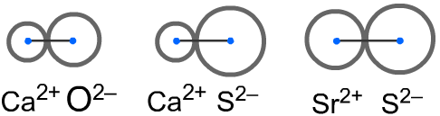
- Strength of Ionic Bonds
Consider these three ionic compounds:

Which one of these has the strongest ionic bond? __________ Explain your answer.
- Boiling

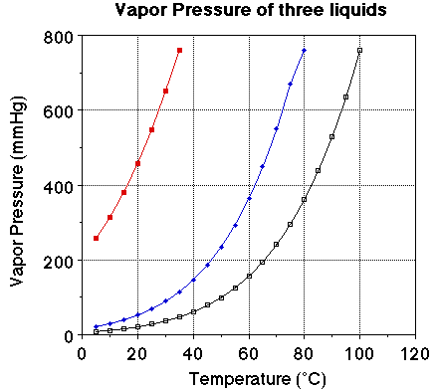 | What are the normal boiling points of the three liquids?  _______ _______ _______  Indicate which liquid has the weakest IMF’s.

