**Dougherty Valley HS AP Chemistry**

**S-62**

**IMF**

**Quick Check #1**

**Name: Date: Period: Seat #:**

Try these problems. If you can DO them, check the box (🗹). If you CANNOT do them, write some notes TO YOURSELF about what you need to study to succeed at these problems.

* Indicate the **strongest** IMF holding together crystals of the following substances:

|  |  |  |  |  |  |  |  |
| --- | --- | --- | --- | --- | --- | --- | --- |
|  |  | London  forces | Dipole-dipole attractions | Hydrogen bonding | Metallic bonding | Ionic  bonding | Covalent bonding |
| 1. | KCl |  |  |  |  |  |  |
| 2. | IF3 |  |  |  |  |  |  |
| 3. | HF |  |  |  |  |  |  |
| 4. | AsH3 |  |  |  |  |  |  |
| 5. | Br2 |  |  |  |  |  |  |
| 6. | Pt |  |  |  |  |  |  |
| 7. | NaOH |  |  |  |  |  |  |
| 8. | H2S |  |  |  |  |  |  |
| 9. | Ne |  |  |  |  |  |  |
| 10. | SiO2 |  |  |  |  |  |  |

* Describe the interparticle forces at work in the following:

______________________ a. **within** a water molecule H2O

______________________ b. in a crystal of the salt NaCl

______________________ c. in a **solution** of potassium nitrate KNO3

______________________ d. in diamond

______________________ e. in a fiber of nylon

______________________ f. in liquid butane

______________________ g. **between** water molecules in ice

______________________ h. between the two strands in the double helix of DNA

______________________ i. in paraffin wax

______________________ j. between the molecules of carbon dioxide CO2 in dry ice

______________________ k. between the molecules of HCl in **liquid** HCl

______________________ l. in tungsten metal

______________________ m. in a solution of perchloric acid

* Elemental boron is extremely hard (nearly as hard as diamond) and has a melting point of 2300°C. It is a poor conductor of electricity at room temperature. What kind of solid would you expect for boron based on these properties? ___  
  A. molecular solid B. metal C. ionic solid D. covalent/network solid
* Valence electrons delocalized over huge arrays of atoms. What kind of solid is described by this property? ___  
  A. molecular solid B. metal C. ionic solid D. covalent/network solid

***Notes about structures that are considered “common knowledge” for AP chemistry students:***

**Paraffin wax** is made up of long carbon chains. The Alkanes area also called the Paraffins.

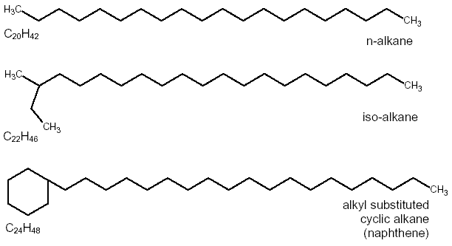

**Nylon** is a polymer made up of long chains of carbons with amine groups and C=O groups. The “*n*” means that this pattern of atoms is repeated thousands of times to make nylon fibers.

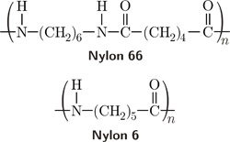

**Perchloric acid** is based on the perchlorate ion (ClO4-). This is an “oxoacid” where the H atom bonds to one of the oxygen atoms.

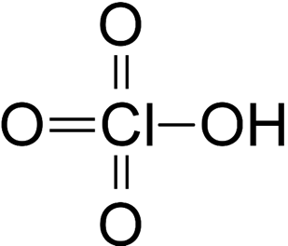

**DNA** has a familiar structure, but we are interested in how the two sides of DNA are connected to each other. Note that there are some N-H bonds and O-H bonds in the “Nitrogenous bases”.

