**Dougherty Valley HS AP Chemistry**

**S-63**

**IMF**

**Quick Check #2**

**Name: Date: Period: Seat #:**

* **Explaining Problems (from the 1994 AP Exam)**  
  *For each of the following, use appropriate chemical principles to explain the observation.*

At room temperature, NH3 is a gas and H2O is a liquid, even though NH3 has a molar mass of 17 grams and H2O has a molar mass of 18 grams.

C(graphite) is used as a lubricant, whereas C(diamond) is used as an abrasive.

* **Stength of Ionic Bonds**  
  Consider these three ionic compounds:

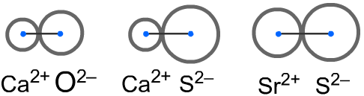  

Which one of these has the strongest ionic bond? __________ Explain your answer.

* **Boiling**

|  |  |
| --- | --- |
|  | What are the normal boiling points of the three liquids?  _______ _______ _______  Indicate which liquid has the **weakest** IMF’s. |