Dougherty Valley HS AP Chemistry
S-68
Solutions
Quick Check #1

Name: Date: Period: Seat #:

Try these problems. If you can DO them, check the box (). If you CANNOT do them, write some notes TO YOURSELF about what you need to study to succeed at these problems.

- Formulas: Quickly write the formulas for the following concentration units:
Molality | Weight Percent | Mole Fraction | Molarity

- Dissecting A Given Concentration:
The concentration of a NaOH solution is 0.25 m. This translates into 0.25 and 1.0.
0.25 = _________________________ and 1.0 = ___________________________
The concentration of a HC₂H₃O₂ solution is 5.00% by weight. This translates into 5.00 and 100.
5.00 = ___________________ and 100 = ____________________ and 95.0 = ___________________
- Change one concentration into another:
Household vinegar is labeled as 5.00% by weight. It has a density of 1.01 g/mL. Fill in the chart.

 | mass (grams) | moles (mol) | volume (L)
solute
solvent
solution

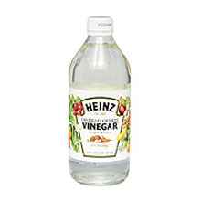 | Molality | Mole Fraction | Molarity

