Dougherty Valley HS AP Chemistry
S-70
Solutions
Quick Check #3

Name: Date: Period: Seat #:

- Concentration:
Concentrated sulfuric acid contains very little water, only 5.0% by mass. It has a density of 1.84 g/mL. What is the molarity of this acid?

- Particles: When 1 mole of each of the following solutes dissolves in water, how many moles of particles are in the solution? Note: this value is called the van’t Hoff factor, i.
___ NaCl ___ glycerol  ___ sugar ___ Ca(NO₃)₂  ___ KNO₃ ___ KCl | 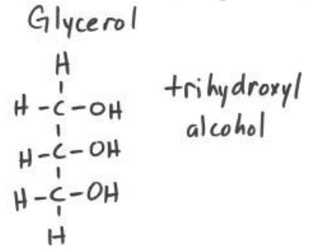

- Henry’s Law: S_{g} = k_{H} P_{g} - SKIP
S_{g} means _______________________ P_{g} means ___________________________
k_{H} is a constant. For oxygen gas in water (at 25°C) it is 1.66 x 10⁻⁶ M/torr.
Calculate the solubility of oxygen in water at 25°C when the total external pressure is 1 atm and the mole fraction of oxygen in the air is 0.20.

Problem broken down into steps…
- Concentration:
Concentrated sulfuric acid contains very little water, only 5.0% by mass. It has a density of 1.84 g/mL. What is the molarity of this acid?

a) What is the formula for sulfuric acid? _______________

b) What is the molar mass for sulfuric acid? ______________

c) 5.0% by mass gives you three useful values: Fill in the units for each.

5.0 100 95

d) Write the formula for molarity?

e) Calculate the moles of solute. Show your set-up.

f) Calculate the volume (in Liters) of the solution. Show your set-up.

g) Calculate the molarity of the solution.

