Name: Period: Seat#:
S-68, 69, 70, 71

Directions: Try these problems. If you can DO them, check the box ().
If you CANNOT do them, write some notes TO YOURSELF about what you need to study to succeed at these problems.

S68 – Quick Check #1

Formulas
Quickly write the formulas for the following concentration units:
Molality | Weight Percent | Mole Fraction | Molarity

Dissecting a Given Concentration

The concentration of a NaOH solution is 0.25 m. This translates into 0.25 and 1.0.
0.25 = _________________________ and 1.0 = ___________________________
The concentration of a HC₂H₃O₂ solution is 5.00% by weight. This translates into 5.00 and 100.
5.00 = ___________________ and 100 = ____________________ and 95.0 = ___________________
Change one concentration into another
Household vinegar is labeled as 5.00% by weight. It has a density of 1.01 g/mL. Fill in the chart.
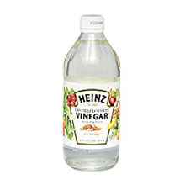
 | mass (grams) | moles (mol) | volume (L)
solute
solvent
solution
Molality | Mole Fraction | Molarity
S69 – Quick Check #2

Terminology:
In the first reaction, __________ is getting oxidized. ________ is the oxidizing agent.
In the first reaction, __________ is getting reduced. ________ is the reducing agent.
In the second reaction, __________ is getting oxidized. ________ is the oxidizing agent.
In the second reaction, __________ is getting reduced. ________ is the reducing agent.
Review of oxidation numbers
Write the balanced chemical equations for the following. Indicate the oxidation numbers.

Zn(s) + HCl(aq) = _______ + _______ Fe(s) + CuSO₄(aq) = _______ + _______

 | Reactants | Products
Zn
H
Cl
 | Reactants | Products
Fe
Cu
S
O

S70 – Quick Check #3

Concentration
Concentrated sulfuric acid contains very little water, only 5.0% by mass. It has a density of 1.84 g/mL. What is the molarity of this acid?

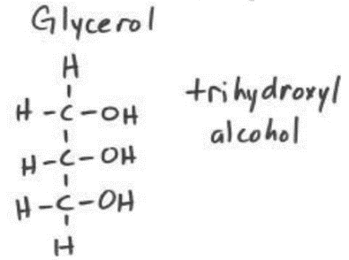

Particles
When 1 mole of each of the following solutes dissolves in water,
how many moles of particles are in the solution?
Note: this value is called the van’t Hoff factor, i.
___ NaCl ___ glycerol ___ sugar ___ Ca(NO₃)₂ ___ KNO₃ ___ KCl

S71 – Quick Check #4

Raoult’s Law Write the formula for Raoult’s Law: P_{solution} =
A solution is made by dissolving 164 g of glycerin (C₃H₈O₃) in 338 mL of H₂O at 40.0 °C.
The vapor pressure of pure H₂O at 40.0 °C is 54.74 torr.
The density of H₂O at 39.8 °C is 0.992 g/mL. The molar mass of glycerin is 92.11 g/mol.

a) How many moles of glycerin are in this solution? How many moles of water?

c) What is the mole fraction, X, of solvent in this solution?

d) Calculate the vapor pressure of the solution.

