**AP Chemistry Fall Semester Practice Exam (from another school, things may not match our 1st semester)**

**Multiple Choice**

Mark the letter that corresponds to the best answer on your scantron. You may write on this test.

1. A 10.0 g sample of which of the following substances contains the most particles?

(a) F2 (b) Ne (c) Na (d) Ar

1. Which of the following molecules has the highest percent by mass of oxygen?
2. CO (b) CO2 (c) H2O (d) H2O2

1. The mass spectrum of an average sample of a pure element is shown in the figure to the right. Which of the following is most likely the identity of the element?
2. Y (b) Zr (c) Nb (d) Th
3. Which of the following elements has a valence electron configuration of 3s23p2?

(a) Cl (b) Ar (c) Si (d) Mg

1. What is the energy of a photon that has a wavelength of 300. nm?

(a) 6.62 x 10-37 J (b) 6.62 x 10-25 J (c) 6.62 x 10-49 J (d) 6.62 x 10-19 J

The next two questions refer to the following elements:

(a) Na (b) K (c) Ca (d) Ar (e) Kr

1. Which of these elements has the largest atomic radius?
2. Which of these elements has the highest first ionization energy?
3. If a pure sample of an oxide of sulfur contains 40% sulfur and 60% oxygen by mass, then the empirical formula of the oxide is…
4. SO3 (b) SO4 (c) S2O6 (d) S2O8
5. An atom has the following ionization energies:

IE1 = 590 kJ/mol IE2 = 1145 kJ/mol IE3 = 4912 kJ/mol IE4 = 6491 kJ/mol

This atom would most likely be

(a) Ne (b) Li (c) Ca (d) Al

1. The complete photoelectron spectra of two unknown elements, X and Y, are shown above. Which of the following can be inferred from the data?
2. Element X has a greater electronegativity than element Y
3. Element X has a greater ionization energy than element Y
4. Element Y has a greater nuclear charge than element X
5. Element Y has a larger atomic radius than element X
6. Which of the following molecules contains polar covalent bonds?
7. Cl2 (b) CO2 (c) MgCl2 (d) CH4
8. Which of following molecules has a trigonal pyramidal molecule geometry?

(a) PH3  (b) N2O (c) CCl4 (d) H2O

1. A certain crystalline substance has a low melting point and does not conduct electricity in an aqueous solution or when melted. This substance is likely to be a/an…

(a) covalent network solid (b) molecular solid (c) ionic solid (d) metallic solid

1. Which of the following molecules does NOT have a dipole moment?

(a) NO2 (b) HCN (c) CCl4  (d) NH3 (e) H2O

1. What is the hybridization of the indicated carbon in the structure of propanoic acid shown on the right?
2. sp3 (b) sp2 (c) sp (d) sp3d
3. BF3 is nonpolar, whereas NF3 is polar. Which of the following statements accounts for this difference?
4. N-F bonds are polar, whereas B-F bonds are nonpolar
5. NF3 is an ionic compound, whereas BF3 is a molecular compound
6. N is more electronegative than B
7. NF3 has a nonplanar geometry due to an unshared pair of electrons on the N atom
8. Which of the following ionic compounds would exhibit the highest melting point?

(a) NaF (b) NaCl (c) MgO (d) CaCl2

1. Which of the following compounds does NOT contain pi bonds?

(a) N2 (b) CO2 (c) C2H6 (d) C2H4

1. What is the formal charge on the nitrogen atom in nitrate ion, NO31-?
2. +1 (b) 0 (c) -1 (d) +5
3. Which of the following is an example of a covalent network solid?

(a) CO2 (s) (b) NaCl (s) (c) C (s) (d) Cu (s)

1. The melting of which solid requires the breaking of London dispersion forces only?
2. Sand, SiO2 (b) Ice, H2O (c) Wax, C25H52  (d) Salt, NaCl
3. Which of the following compounds has the lowest boiling point?

(a) H2O (b) HF (c) HI (d) HCl

1. Which of the following gas samples will exhibit behavior that is closest to “ideal”?

(a) He (g) at 1.0 atm and 100 K (c) NH3 (g) at 1.0 atm and 100 K

(b) He (g) at 0.5 atm and 400 K (d) NH3 (g) at 0.5 atm and 400 K

1. 2.00 g of helium gas, He (g), and 8.00 g of oxygen gas, O2 (g), are mixed together in a container, and the total pressure is measured to be 1.00 atm. What is the partial pressure of the helium gas in the container?
2. 0.250 atm (b) 0.500 atm (c) 0.667 atm (d) 0.750 atm
3. A 9.00 g sample of an unknown gas occupies 5.60 L at STP. What is the most likely identity of this gas?
4. HCl (b) Ar (c) HCN (d) CO2
5. When 25.0 mL of 12.0 M HCl is diluted to a total volume of 200.0 mL, what is the final molarity of the diluted acidic solution?
6. 1.33 M (b) 1.50 M (c) 1.67 M (d) 3.00 M
7. Which of the following compounds would be most soluble in water?
8. CO2 (b) CH3Cl (c) H2S (d) HF
9. 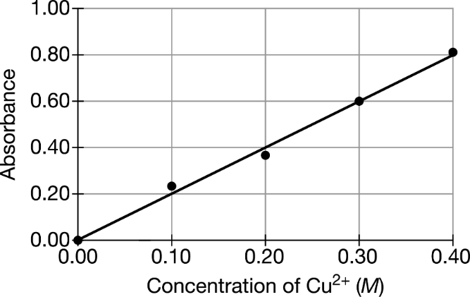 A brass sample is dissolved in 5.00 mL of

concentrated nitric acid and then diluted to

200.0 mL with distilled water. If the resulting

Cu2+ (aq) solution is determined to have an

absorbance of 0.60, then how many moles of Cu

were in the original brass sample?

* 1. 0.030 mol (c) 0.060 mol

(b) 0.30 mol (d) 0.60 mol

1. Diagram

   Description automatically generatedThe following chromatogram was developed using a polar silica gel stationary phase and a nonpolar hexane solvent. Based on the results, what conclusion can be drawn about the polarity of the dyes?
   1. Red is most polar because it has the strongest attraction to the mobile phase.
   2. Blue is most polar because it has the strongest attraction to the mobile phase.
   3. Red is most polar because it has the strongest attraction to the stationary phase.
   4. Blue is most polar because it has the strongest attraction to the stationary phase.
2. Equal numbers of moles of He (g), Ar (g), and Ne (g) are combined in a container at room temperature. If the container has a pinhole-sized leak, which of the following will be true regarding the partial pressures of the gases in the container after a few seconds?

(a) PHe< PAr < PNe (b) PHe< PNe < PAr (c)PNe< PAr < PHe (d) PAr< PHe < PNe

1. Which of the following compounds do you expect to precipitate from an aqueous solution?
   1. AgNO3 (b) KI (c) NH4Cl (d) PbSO4
2. If 1.0 mol of each of the following compounds was added to 1.0 L of distilled water, then the solution with the highest conductivity would contain which compound?

(a) NH3 (b) KOH (c) CH3OH (d) CaCO3

1. What is the correct net ionic equation for the reaction of chlorous acid with sodium hydroxide?

(a) H+ (aq) + OH- (aq)🡪 H2O (l)

(b) HClO2 (aq) + NaOH (aq) 🡪 NaClO2 (aq) + H2O (l)

(c) HClO2 (aq) + OH- (aq) 🡪 ClO2- (aq) + H2O (l)

(d) H+ (aq) + NaOH (aq) 🡪 Na+ (aq) + H2O (l)

HC2H3O2 (aq) + NaOH (aq) 🡪 NaC2H3O2 (aq) + H2O (l)

1. Commercial vinegar was titrated with NaOH solution to determine the content of acetic acid, HC2H3O2. A 10.0 mL sample of vinegar was titrated to the endpoint with 20.0 mL of 0.40 M NaOH. What was the concentration of acetic acid in the vinegar assuming no other acids were present?

(a) 0.40 M (b) 0.80 M (c) 0.20 M (d) 1.60 M

1. What is the oxidation number of Cr in Na2Cr2O7?

(a) + 6 (b) -6 (c) +3 (d) + 12

1. Shape, circle

   Description automatically generatedA mixture of CO (g) and O2 (g) is placed in a container. The initial mixture is shown to the right. A reaction occurs, forming CO2 (g). Which of the following best represents the contents of the container after the reaction has proceeded as completely as possible?

(a) (c)

(b) (d)

1. A solution of which of the following salts dissolved in water will be neutral (pH = 7.00)?

(a) NaC2H3O2 (b) NaNO3 (c) NH4Cl (d) KNO2

3 H2 (g) + N2 (g) 🡪 2 NH3 (g)

1. If 20 g H2 and 56 g N2 are combined and allowed to react to form ammonia, which reactant will act as a limiting reactant, and how much excess reactant will remain?

(a) N2 (g) will be limiting, 8 g of H2 will remain

(b) N2 (g) will be limiting, 12 g of H2 will remain

(c) H2 (g) will be limiting, 14 g of N2 will remain

(d) H2 (g) will be limiting, 28 g of N2 will remain

Mg (s) + 2 HCl(aq) 🡪 H2 (g) + MgCl2 (aq)

1. H2 (g) can be prepared by the reaction of a reactive metal, such as Mg, with acid. If the reaction is performed at STP, what volume of H2 (g) can be produced from 0.0243 g Mg?

(a) 5.6 mL (b) 11.2 mL (c) 22.4 mL (d) 44.8 mL

Zn (s) + CuCl2 (aq) 🡪 ZnCl2 + Cu (s)

1. In the redox reaction above, identify the species being oxidized and reduced.
   1. Zn is oxidized and Cu is reduced
   2. Cu is oxidized and Zn is reduced
   3. Zn is oxidized and Cl is reduced
   4. Cl is oxidized and Cu is reduced
2. For the reaction A + B 🡪 C, it is experimentally observed that doubling the concentration of B causes the reaction rate to be increased fourfold and tripling the concentration of A triples the reaction rate. The rate law is therefore…

(a) Rate = k[A]3[B]2 (b) Rate = k[A]2[B] (c) Rate = k[B]2 (d) Rate = k[A][B]2

1. A reaction follows the rate law: Rate = k. Which of the following plots will give a straight line?

(a) 1/ [A] versus time (c) [A] versus time

(b) ln[A] versus time (d) [A]2 versus time

1. After a certain pesticide compound is applied to crops, its decomposition is a first-order reaction with a half-life of 56 days. What is the rate constant, k, for the decomposition?

(a) 0.012 day-1 (b) 0.018 day-1 (c) 56 day-1 (d) 81 day-1

2 H2 (g) + O2 (g) 🡪 2 H2O (g)

1. Which of the following changes would decrease the rate of production of water vapor?
   1. increasing the temperature of the reaction mixture
   2. increasing the partial pressure of H2 (g)
   3. increasing the volume of the container
   4. adding a catalyst

2 NO2(g) + F2 (g) 🡪 2 NO2F (g)

1. The rate law for the reaction represented by the equation above is Rate = k[NO2][F2]. Which of the following could be the first elementary step of a two-step mechanism if the first step is slow and the second step is fast?

(a) F2 (g) 🡪 2 F (g)

(b) NO2 (g) + F2 (g) 🡪 NO2F (g) + F (g)

(c) NO2 (g) + F (g) 🡪 NO2F (g)

(d) 2 NO2 (g) + F2 (g) 🡪 2 NO2F (g)

1. Given the following data for NH4+ + NO2- 🡪 N2 + 2H2O, determine the rate law.

Trial [NH4+] [NO2-] Rate

1 0.010 M 0.020 M 0.020 M/s

2 0.015 0.020 0.030

3 0.010 0.010 0.005

(a) rate = k [NH4+] [NO2-] (c) rate = k [NH4+]2 [NO2-]

(b) rate = k [NH4+] [NO2-]2 (d) rate = k [NH4+]2 [NO2-]2

1. The reaction A 🡪 B + C is second order in A. When [A]0 = 0.100 M, the reaction is 50% complete in 40 minutes. What is the value of the rate constant, k?

(a) 0.25 M-1 min-1 (b) 0.50 M-1 min-1 (c) 1.00 M-1 min-1 (d) 2.00 M-1 min-1

1. 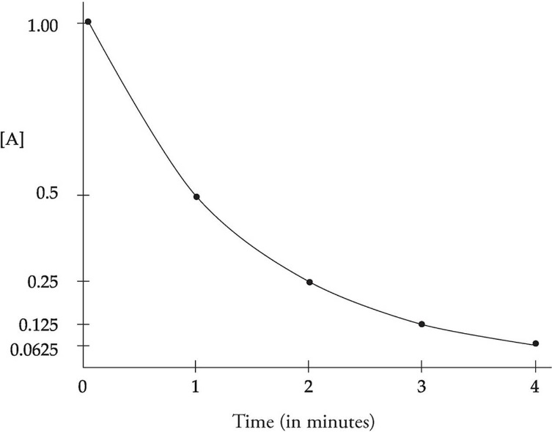For the reaction A 🡪 B, a trial was completed in which the concentration of A started at 1.0 M and was measured every 1.0 second. A graph of [A] vs time is shown to the right. What is the rate law of this reaction?

(a) Rate = k

(b) Rate = k [A]

(c) Rate = k [A]2

(d) Rate = k [A]3

N2O (g) + CO (g) 🡪 N2 (g) + CO2 (g)

1. The rate of the reaction represented above increases significantly in the presence of solid palladium, Pd (s). Which of the following explains this observation?
   1. Pd increases the activation energy of the reaction.
   2. Pd absorbs heat in the reaction.
   3. One of the reactants binds on the surface of the Pd, which introduces an alternative pathway with a lower activation energy.
   4. One of the products binds on the surface of the Pd, which increases the reaction rate by decreasing the concentration of products in the mixture.

1. Data from the study of the decomposition of NO2 (g) to form NO (g) and O2 (g) is presented above. Which of the following gives the correct rate law and value of the rate constant, k?
   1. Rate = k [NO2] k = 0.0020 s-1
   2. Rate = k [NO2] k = 0.20 s-1
   3. Rate = k [NO2]2 k = 0.0075 M-1 s-1
   4. 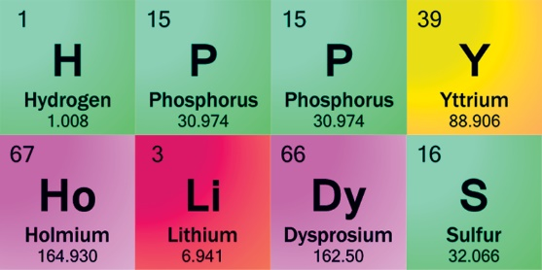Rate = k [NO2]2 k = 0.75 M-1 s-1

Have a fantastic winter break! 😊

**AP Chemistry Fall Semester Exam KEY**

1. B
2. D
3. B
4. C
5. D
6. B
7. D
8. A
9. C
10. C
11. B
12. A
13. B
14. C
15. B
16. D
17. C
18. C
19. A
20. C
21. C
22. D
23. B
24. C
25. A
26. B
27. D
28. C
29. C
30. B
31. D
32. B
33. C
34. B
35. A
36. D
37. B
38. A
39. C
40. A
41. D
42. C
43. A
44. C
45. B
46. B
47. A
48. B
49. C
50. C