AP Chemistry
Topic Worksheets

Contents
Unit 1 7
Topic 1.3 and 1.4 Worksheet 9
Topic 1.1 Worksheet 17
Topic 1.2 Worksheet 19
Topic 1.5 Worksheet 21
Topic 1.6 Worksheet 25
Topic 1.7 and 1.8 Worksheet 29
Unit 2 34
Topic 2.1, 2.2, and 2.3 Worksheet 35
Topic 2.5 Worksheet 41
Topic 2.7 Worksheet 45
Topic 2.6 Worksheet 51
Topic 2.4 Worksheet 53
Unit 3 55
Topic 3.3 Worksheet 57
Topic 3.1 Worksheet 59
Topic 3.10 Worksheet 67
Topic 3.2 Worksheet 69
Topic 3.5 Worksheet 73
Topic 3.4 Worksheet 79
Topic 3.6 Worksheet 87
Topic 3.7 Worksheet 89
Topic 3.8 Worksheet 93
Topic 3.9 Worksheet 99
Topic 3.11 Worksheet 103
Topic 3.12 Worksheet 105
Topic 3.13 Worksheet 107
Unit 4 111
Topic 4.1 Worksheet 113
Review Topic 1.3 and 1.4 115
Review Topic 1.2 116
Topic 4.2 & 4.3 Worksheet 117
Review Topic 2.5 & 2.7 119
Topic 4.4 Worksheet 123
Review Topic 2.4 124
Topic 4.5 Worksheet 125
Review Topic 3.1 128
Topic 4.6 Worksheet 131
Review Topic 1.5 133
Review Topic 1.6 134
Topic 4.7, 4.8, & 4.9 Worksheet 135
Unit 5 145
Topic 5.5 Worksheet 147
Review Topic 3.13 150
Topic 5.4 Worksheet 153
Review Topic 3.2 155
Topic 5.6 Worksheet 157
Topic 5.10 Worksheet 159
Topic 5.1 Worksheet 161
Topic 5.2 Worksheet 165
Topic 5.7, 5.8, 5.9 Worksheet 171
Topic 5.3 Worksheet 175
Unit 6 179
Topic 6.3 Worksheet 181
Topic 6.4 Worksheet 185
Topic 6.5 Worksheet 191
Topic 6.7 Worksheet 193
Topic 6.6 Worksheet 197
Topic 6.1 Worksheet 199
Topic 6.8 Worksheet 201
Topic 6.9 Worksheet 203
Unit 7 207
Topic 7.1 Worksheet 209
Topic 7.2 Worksheet 213
Topic 7.4, 7.5, 7.7 Worksheet 215
Topic 7.8 Worksheet 219
Topic 7.3, 7.10 Worksheet 221
Topic 7.6 Worksheet 223
Topic 7.9 Worksheet 225
Topic 7.11 Worksheet 227
Topic 7.14 Worksheet 231
Topic 7.12 Worksheet 233
Topic 7.13 Worksheet 235
Unit 8 237
Topic 8.1, 8.2 Worksheet 239
Topic 8.3 Worksheet 243
Topic 8.6 Worksheet 247
Topic 8.5 Worksheet 249
Topic 8.8, 8.10 Worksheet 255
Topic 8.4 Worksheet 257
Topic 8.9, 8.7 Worksheet 259
Unit 9 261
Topic 9.1, 9.2 Worksheet 263
Topic 9.3, 9.4 Worksheet 267
Topic 9.6 Worksheet 271
Topic 9.5 Worksheet 273
Topic 9.7 Worksheet 275

Unit 1

Topic 1.3 and 1.4 Worksheet

- Determine if the following substances are made of molecules, atoms, or ions by placing an “X” in the appropriate box.

Substance | Molecules | Atoms | Ions
H₂O
C₆H₁₂O₆
C
NaCl
Al
Al(NO₃)₃

- Explain how to calculate the empirical formula of a compound when given …
  - Grams of each element in the compound.

  - Moles of each element in the compound.

  - Percentage of each element in the compound.

- Determine the percent composition of every element in each compound. First, estimate the percentage without a calculator, then check your work with a calculator.
  - SF₄

  - SF₆

  - CO₂

- Perform the following calculations without a calculator. Then, check your work with a calculator.
  - A 66.0 g sample of a compound contains 36.0 g of C, 6.00 g of H, and 24.0 g of O. Determine the empirical formula.

  - A compound contains 0.75 moles of K, 0.75 moles of Cr, and 5.25 moles of O. What is the simplest formula of the compound?

  - A compound is made of 12.67% Al, 19.73% N, and 67.60% O. Determine the empirical formula of the compound.

- An organic compound, containing only C, H, and O, is analyzed via combustion analysis. A 1.875 g sample of the compound is combusted and 3.834 g of CO₂(g) and 1.177 g of H₂O(l) is collected. Determine the empirical formula of the compound.
- A hydrocarbon undergoes combustion analysis to determine the empirical formula of the compound. After complete combustion it is determined that there are 66 g of CO₂ and 36 g of H₂O.
  - Determine the empirical formula without using a calculator.

  - Determine the empirical formula using a calculator.

- A student is given a mixture of NaCl(s) and NaNO₃(s) and is tasked with determining the percent of NaCl in the mixture. The student dissolves 3.613 g of the mixture in 50 mL of DI water. The student then adds excess AgNO₃(aq) to precipitate the chloride ion as AgCl(s). The student determines that 2.268 g of AgCl is formed.
  - Determine the moles of NaCl in the original mixture.

  - Determine the percent by mass of NaCl in the original mixture.

- In an experiment, a student is assigned the task of determining the number of moles of water in one mole of the hydrate Na₂SO₄ • nH₂O. The student collects the data shown in the following table.

Mass of empty container | 22.347 g
Initial mass of sample and container | 25.959 g
Mass of sample and container after first heating | 24.677 g
Mass of sample and container after second heating | 23.941 g
Mass of sample and container after third heating | 23.940 g

  - Explain why the sample was heated three times.

  - Explain why the student can conclude that all of the water was driven off of the hydrate.

  - Use the data above to …
    - Determine the mass of the sample before heating.

    - Determine the mass of water in the sample.

    - Determine the moles of water in the sample.

    - Determine the mass of anhydrate in the sample.

    - Determine the moles of anhydrate in the sample.

    - Determine the formula of the hydrated compound.
- In an experiment, a student is assigned the task of determining the number of moles of water in one mole of the hydrate CuSO₄ • nH₂O. The student collects the data shown in the following table.

Mass of empty container | 22.347 g
Initial mass of sample and container | 25.959 g
Mass of sample and container after first heating | 25.700 g
Mass of sample and container after second heating | 25.046 g
Mass of sample and container after third heating | 25.045 g

  - Use the data above to …
    - Determine the mass of water in the sample.

    - Determine the moles of water in the sample.

    - Determine the formula of the hydrated compound.

  - Determine if the calculated mass of the water would increase, decrease, or remain the same if …
    - while heating the substance some solid spattered out. Explain your reasoning.

    - after heating the hydrate completely, it was left out on the counter for an entire day before the final weighing. Explain your reasoning.

    - the sample was heated too long and some of the anhydrate vaporized and left the container. Explain your reasoning.

- Answer the following questions about a 1.745 g sample of CaSO₄ • 2H₂O.
  - What percent of the hydrate is water?

  - How many grams of water are present in the compound?

  - The sample is placed in a crucible that weighs 22.35 g. The crucible is heated to constant mass. What would be the mass of the crucible and anhydrate?

- Answer the following questions about different mixtures of chloride compounds.
  - A mixture of NaCl and KCl are in a container. The percent of chloride in NaCl is 60.6%. Would the percent of chloride in the mixture be greater than, less than, or equal to the percent of chloride in NaCl. Explain your reasoning.

  - A mixture of NaCl and LiCl are in a container. The percent of chloride in NaCl is 60.6%. Would the percent of chloride in the mixture be greater than, less than, or equal to the percent of chloride in NaCl. Explain your reasoning.
- Determine if the following impurities would increase, decrease, or not change the percent of carbon in a mixture with C₆H₁₂O₆, which is about 40% carbon by mass.
  - Water, H₂O

  - Ribose, C₅H₁₀O₅

  - Fructose, C₆H₁₂O₆ (an isomer of glucose)

  - Sucrose, C₁₂H₂₂O₁₁

- Perform the following calculations. First, do it without a calculator, then check your answer with a calculator.
  - How many grams of Cu are in 0.010 moles of CuSO₄

  - How many moles are in 1.80 grams of C₆H₁₂O₆ (MM = 180 g/mol)

  - What is the percent composition of Ca in CaF₂?

Topic 1.1 Worksheet
- Calculate the number of atoms in 5.00 g of …
  - Ca

  - N₂

  - Ne

- The minimum energy needed to break an oxygen-oxygen bond in ozone is 387 kJ mol ⁻¹. Determine the amount of energy needed to break 1 oxygen-oxygen bond in ozone.

- Hydrogen peroxide (H₂O₂) decomposes to water and oxygen, as shown below.

2 H₂O₂(aq) → 2 H₂O(l) + O₂(g)

A small sample of MnO₂ is placed into a beaker of H₂O₂ while it is placed on a balance. The mass is measured over a period of 10 seconds and the data shown below.

Time (sec) | Mass (g) |  | Time (sec) | Mass (g)
0 | 134.45 |  | 6 | 132.95
1 | 134.20 |  | 7 | 132.70
2 | 133.95 |  | 8 | 132.45
3 | 133.70 |  | 9 | 132.20
4 | 133.45 |  | 10 | 131.95
5 | 133.20

  - Explain why the beaker lost mass.

  - Determine the moles of oxygen created in the reaction.
- Perform the following calculations. First, without a calculator, then with a calculator.
  - How many molecules are in 1.8 g of H₂O?

  - How many molecules are in 3.8 g of C₆H₆?

  - Determine the number of oxygen atoms in 1.00 g of CaCO₃

- You have a 2.00 g sample of compounds X, Y, and Z. The molar mass (in g mol ⁻¹) of X is 50, Y is 35, and Z is 90. Arrange the compounds from smallest number of moles present to largest number of moles present.

- Four different metal oxides each have one oxygen. The number of metal atoms in each compound may vary.
  - Does the percent of oxygen in the compound increase, decrease, or remain the same as the molar mass of the compound increases?

  - Would a compound with a high percent of oxygen produce more or less oxygen than a compound with a low percent of oxygen?

Topic 1.2 Worksheet
- Briefly explain how a mass spectrometer works.

- An element is composed of three stable isotopes, A₁, A₂, and A₃. Isotope A₁ is found 15% of the time, isotope A₂ is found 65% of the time, and isotope A₃ is found 20% of the time. The atomic mass units of A₁, A₂, and A₃ are 50.0, 52.0, and 53.0 respectively.
  - Draw a mass spectrum of the element.
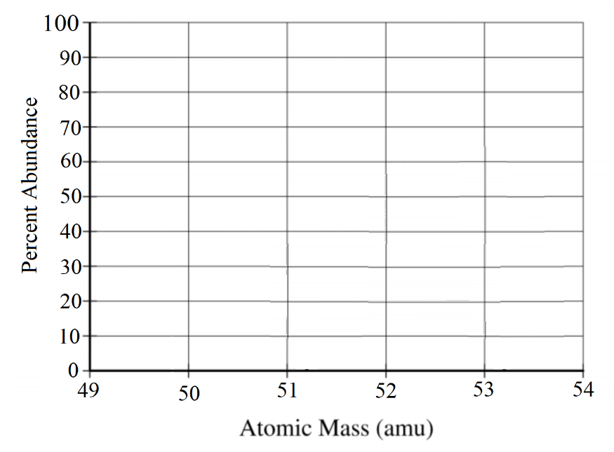

  - Determine the atomic mass of the element.
  - The atomic number of fictitious A is 27.
    - How many protons does A₃ have?

    - How many neutrons does A₃ have?
- Determine the most likely element for the mass spectrums given below then give your reasoning.

Mass Spectrum | Element | Reasoning
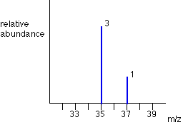 | Bromine
 | Argon
 | Chlorine
 | Hafnium
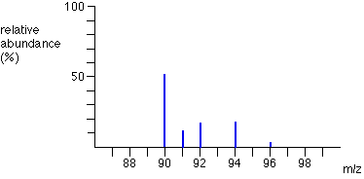 | Tungsten
 | Niobium
 | Zirconium
 | Plutonium
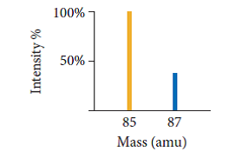 | Rubidium
 | Ytterbium
 | Krypton
 | Strontium

Topic 1.5 Worksheet

- Determine the charge of each of the following subatomic particles.

Particle |  | Charge
Electron |  | Positive |  | Neutral |  | Negative
Nucleus |  | Positive |  | Neutral |  | Negative
Proton |  | Positive |  | Neutral |  | Negative
Neutron |  | Positive |  | Neutral |  | Negative

- According to Coulomb’s Law, what happens when …
  - the distance between the charges increases?

  - the distance between the charges decreases?

  - the magnitude of the charges increases?

  - the magnitude of the charges decreases?

- According to Coulomb’s law, which has a greater effect on the force of attraction, increasing the magnitude of the charge of oppositely charged particles or decreasing the distance between the charges? Explain your reasoning.

- Define the following terms that pertain to electron configuration:
  - Shell (energy level)

  - Subshell (sublevel)

  - Core electrons

  - Valence electrons

  - Electron configuration

  - Aufbau principle
- What is ionization energy?

- Explain how Coulomb’s law can help explain ionization energy.

- Consider the ionization energy to remove an electron from a neutral atom. Would you expect the ionization energy to increase, decrease, or stay the same if …
  - another electron is removed from the neutral atom? Explain your reasoning.

  - an electron is removed from the neutral atom after attaining a +1 charge. Explain your reasoning.

  - an electron is removed from the neutral atom after attaining a – 1 charge. Explain your reasoning.

  - an electron is removed from a different, smaller atom? Explain your reasoning.

  - an electron is removed from a different atom in the same period with more protons. Explain your reasoning.

  - an electron is removed from a different atom in the same group with fewer protons. Explain your reasoning.
- Give the complete electron configuration of the following atoms and ions.
  - Zn

  - Zn²⁺

  - P

  - P³⁻

  - Mg

  - Mg²⁺

  - Fe

  - Fe²⁺

  - Fe³⁺

- Determine which has a greater ionization energy. Then, explain your reasoning.
  - Zn or Zn²⁺

  - Fe²⁺ or Fe³⁺

  - S²⁻ or Ar

  - Be²⁺ or Ar

- Explain why it takes more energy to remove the second electron from Na than it does from Mg.

- How can you tell if an electron configuration indicates that the atom is in the excited state?

Topic 1.6 Worksheet

- What does a photoelectron spectrum show?

- What does the location of a peak along the x-axis indicate about the peak on a PES?

- What does the height of the peak indicate about the peak on a PES?

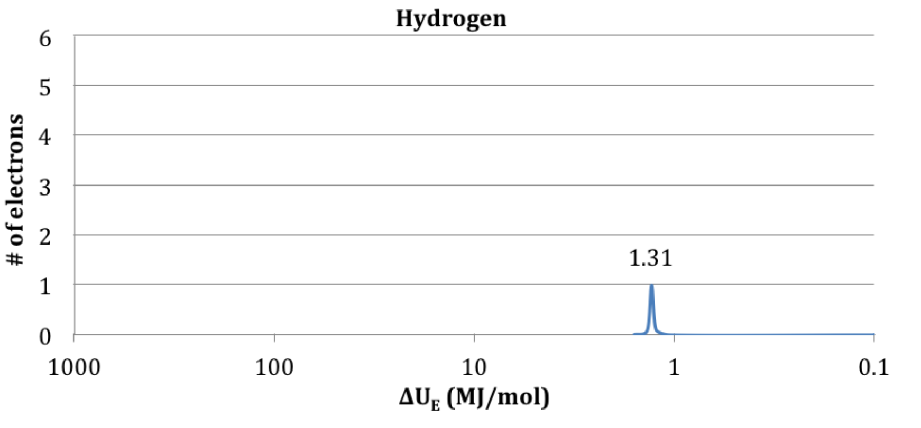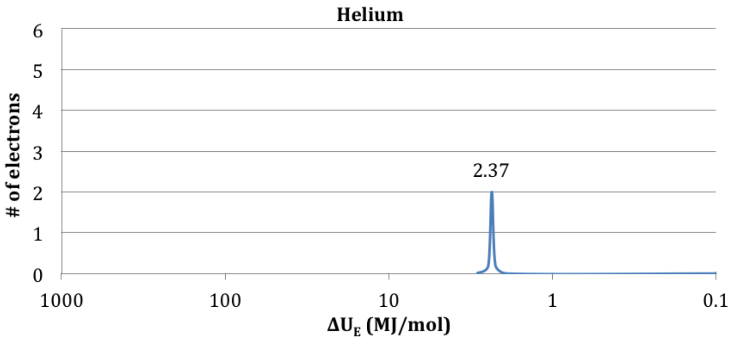

- Answer the following questions about the PES of hydrogen and helium.
  - Why is helium’s peak shifted to the left of hydrogen’s peak?

  - Why is helium’s peak higher than hydrogen’s peak?

  - Would you expect lithium’s first peak to be to the left or to the right of helium’s first peak? Explain your reasoning.
- Use the complete PES shown below to answer the questions that follow.

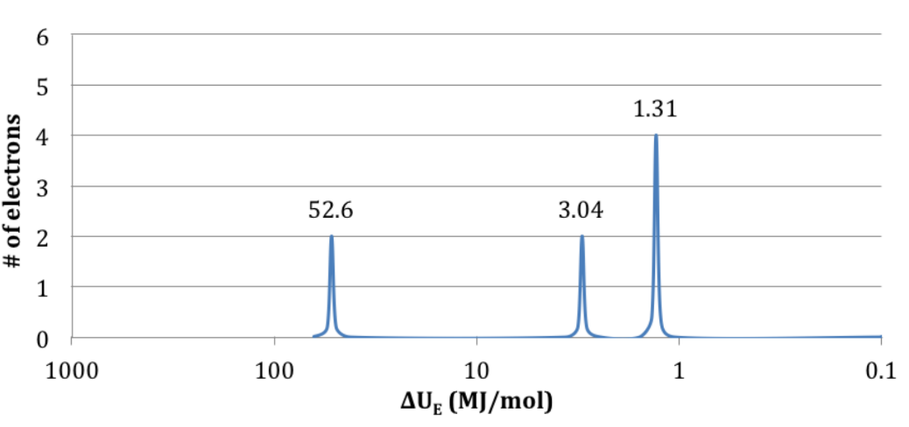
  - Give the complete electron configuration of the element.

  - What is the name of the element shown?

  - Label each peak with the shell and subshell designation.

- Use the complete PES shown below to answer the questions that follow.
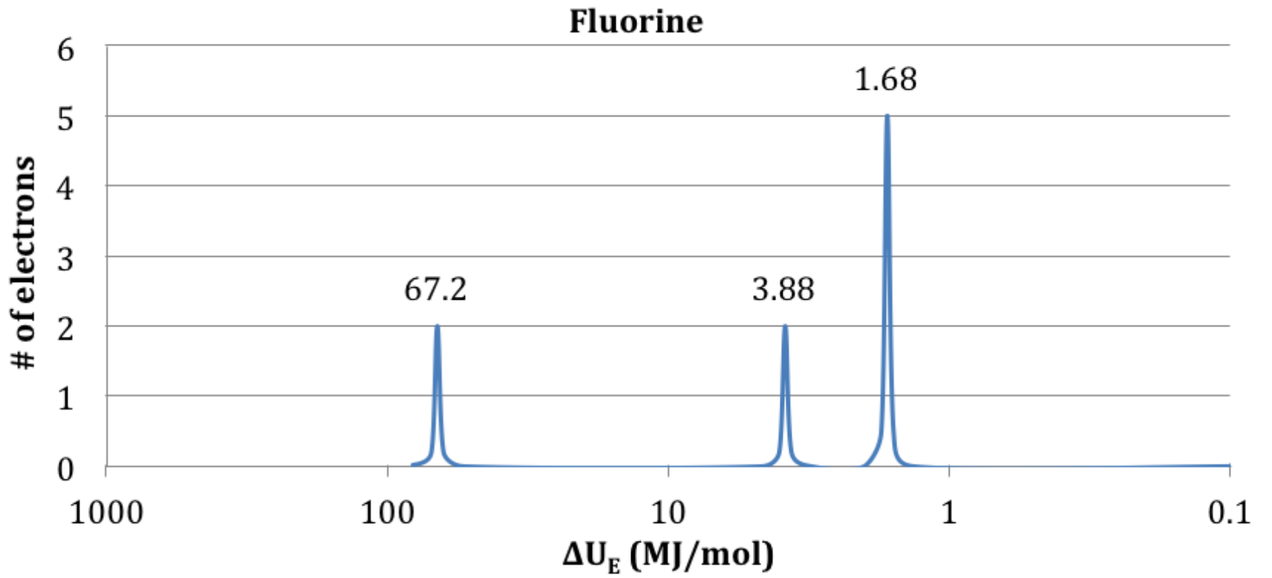

  - Label each peak with its shell and subshell designation.

  - Circle the valence electrons on the PES.

  - Would the next electron added (i.e. the last electron in Ne) be to the left, to the right, or on the peak at 1.68 MJ/mol? Explain your reasoning.
- Give the complete electron configuration for the PES shown below.

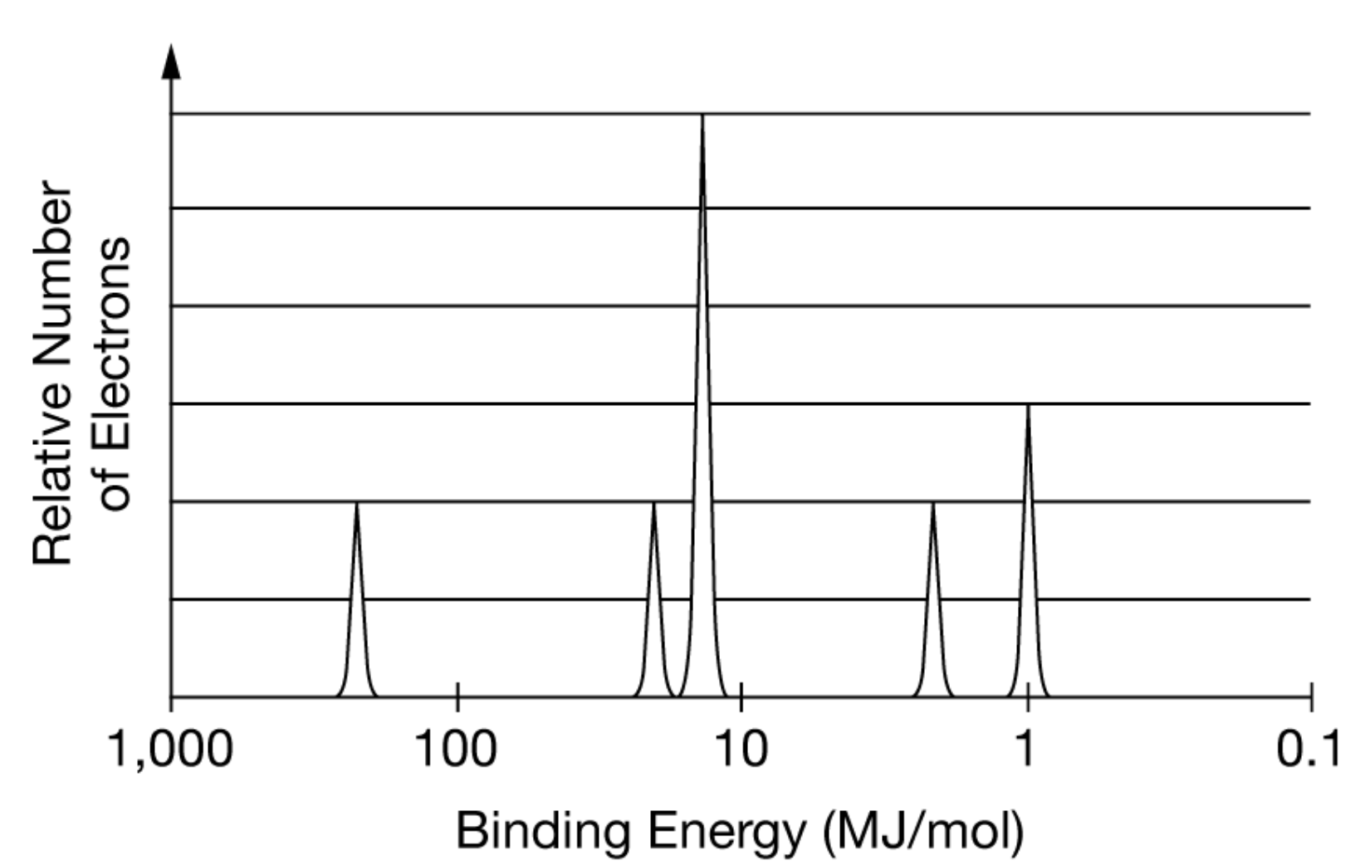

Topic 1.7 and 1.8 Worksheet

- Using the concept of effective nuclear charge, explain why the size of the atom generally decreases when going from left to right across the periodic table.

- Using the concept of electron shells, explain why the size of the atom increases when going from top to bottom of the periodic table.

- Explain why a cation is smaller than the atom it comes from.

- Explain why an anion is larger than the atom it comes from.

- Explain why the first ionization energy of an atom generally increases when going from left to right across the periodic table.

- Explain why the first ionization energy of an atom decreases when going from top to bottom of the periodic table.

- Explain why B and Al deviate from normal ionization energy trends.

- Explain why O and S deviate from normal ionization energy trends.

- Explain why it takes more energy to remove the second electron of an element than the first electron.

- The successive ionization energies of Al are shown below.

1st ionization energy | 2nd ionization energy | 3rd ionization energy | 4th ionization energy
578 kJ/mol | 1820 kJ/mol | 2750 kJ/mol | 11,600 kJ/mol

  - Explain why the ionization energy jumps when removing the 4th electron.

  - Explain how the ionization energies can be used to determine the number of valence electrons.

- Define electron affinity.

- What is the relationship between atom size and electron affinity?
- What is the relationship between electronegativity and nuclear charge/shielding electrons?

- What is the most electronegative element? Lease electronegative?

- Use the ionization energies given below to determine the identity of the second period element. Explain your reasoning.

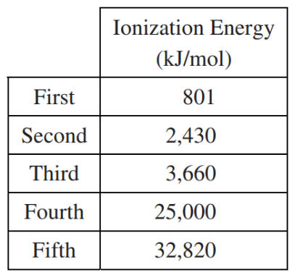

- Write the equation for the ionization of the following elements.
  - Li

  - F

  - Ar

  - Ni

- Explain why Cl⁻ is smaller than S²⁻.

1st electron | 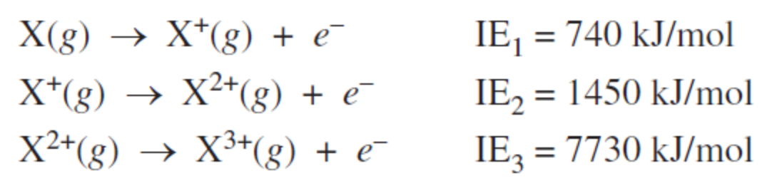
2nd electron
3rd electron

- For the data above, which electron is the closest to the nucleus? Explain your reasoning.
- Consider the electron configurations shown below:

Element | Electron Configuration
X | 1s²2s²2p³
Y | 1s²2s²2p⁵
Z | 1s²2s²2p⁶3s¹

  - What is the typical charge of an ion of …
    - Element X

    - Element Y

    - Element Z

  - What compound would X form if bonded with …
    - Mg?

    - Li

    - Fe³⁺

    - Z

  - Name another element that would bond with X similar to …
    - Mg. Explain your reasoning.

    - Li

    - Z

- What is the relationship between reactivity and ionization energy?

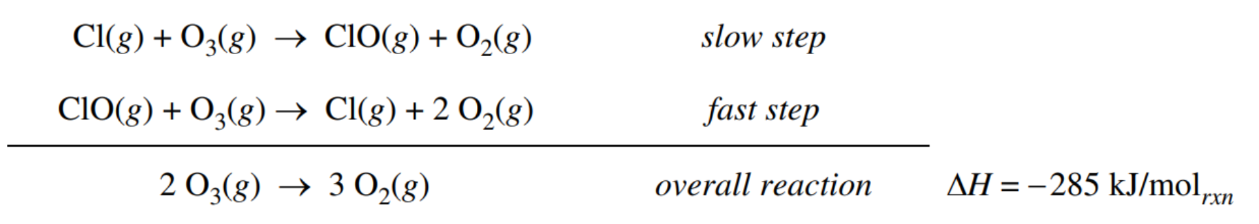
- Shown above is the reaction mechanism of ozone, O₃, converted to oxygen, O₂. In the reaction mechanism Cl is a catalyst. (More on both of these topics in Unit 5.) Give two other elements that could act as a catalyst in the reaction mechanism. Explain your reasoning.

Unit 2

Topic 2.1, 2.2, and 2.3 Worksheet

- Define
  - Electronegativity
  - Dipole
  - Dipole moment

- How can Coulomb’s law be used to predict the electronegativity of an element?

- How can the electron configuration of an element be used to predict the electronegativity of an element?

- A nonpolar covalent bond is made of elements with similar electronegativities.
  - Explain why the bond is nonpolar in this instance.

  - Which of the bonds below would be considered nonpolar and which would be polar? Explain your reasoning.
    - Br−Br

    - C−H

    - I−F

- In a polar bond, which atom is the electron more attracted to, the least electronegative atom or the more electronegative atom? Justify your answer in terms of electronegativity.

- Explain how you could determine which bond would be considered more polar when given two different covalent bonds.

- What types of elements generally make up a …
  - covalent bond?

  - ionic bond?

- What type of bonding occurs in a polyatomic ion?

- What two properties of a bond are illustrated in a graph of potential energy versus bond distance? How are they indicated?

- What does bond order indicate?
- What influences bond length?

- Arrange these bonds from smallest to largest bond length.
  - F−F, Cl−Cl, Cl−Br, Br−Br

  - C−C, C=C, C≡C

- For 12a above which bond would take the most energy to break? Explain your reasoning.

- For 12b above which bond would take the least energy to break? Explain your reasoning.

- How can Coulomb’s law be used to explain increasing bond strength of an ionic compound in terms of …
  - the charge of each ion?

  - the nuclear distance between each ion?

- Does it take more energy, less energy, or the same amount of energy to break apart two ions with …
  - large charge difference compared to small charge difference. Explain your reasoning.

  - large internuclear distance compared to small internuclear distance. Explain your reasoning.

- Determine which ionic bond would have a greater bond strength. Explain your reasoning for each set.
  - RbCl, NaCl, KCl

  - MgF₂, NaF, AlF₃

  - KF, KI, KCl

- Shown below is a graph of potential energy (y-axis) versus internuclear distance (x-axis) for two Br atoms. On each graph, carefully sketch a curve that corresponds to potential energy versus internuclear distance for the atom indicated.

Two Cl atoms | Two F atoms | Two I atom

- Shown below is a graph of potential energy (y-axis) versus internuclear distance (x-axis) for two C atoms. On each graph, carefully sketch a curve that corresponds to potential energy versus internuclear distance for the atom indicated.

Two F atoms | Two O atoms | Two N atoms

- Answer the questions that follow about the potential energy versus internuclear distance graph shown below.

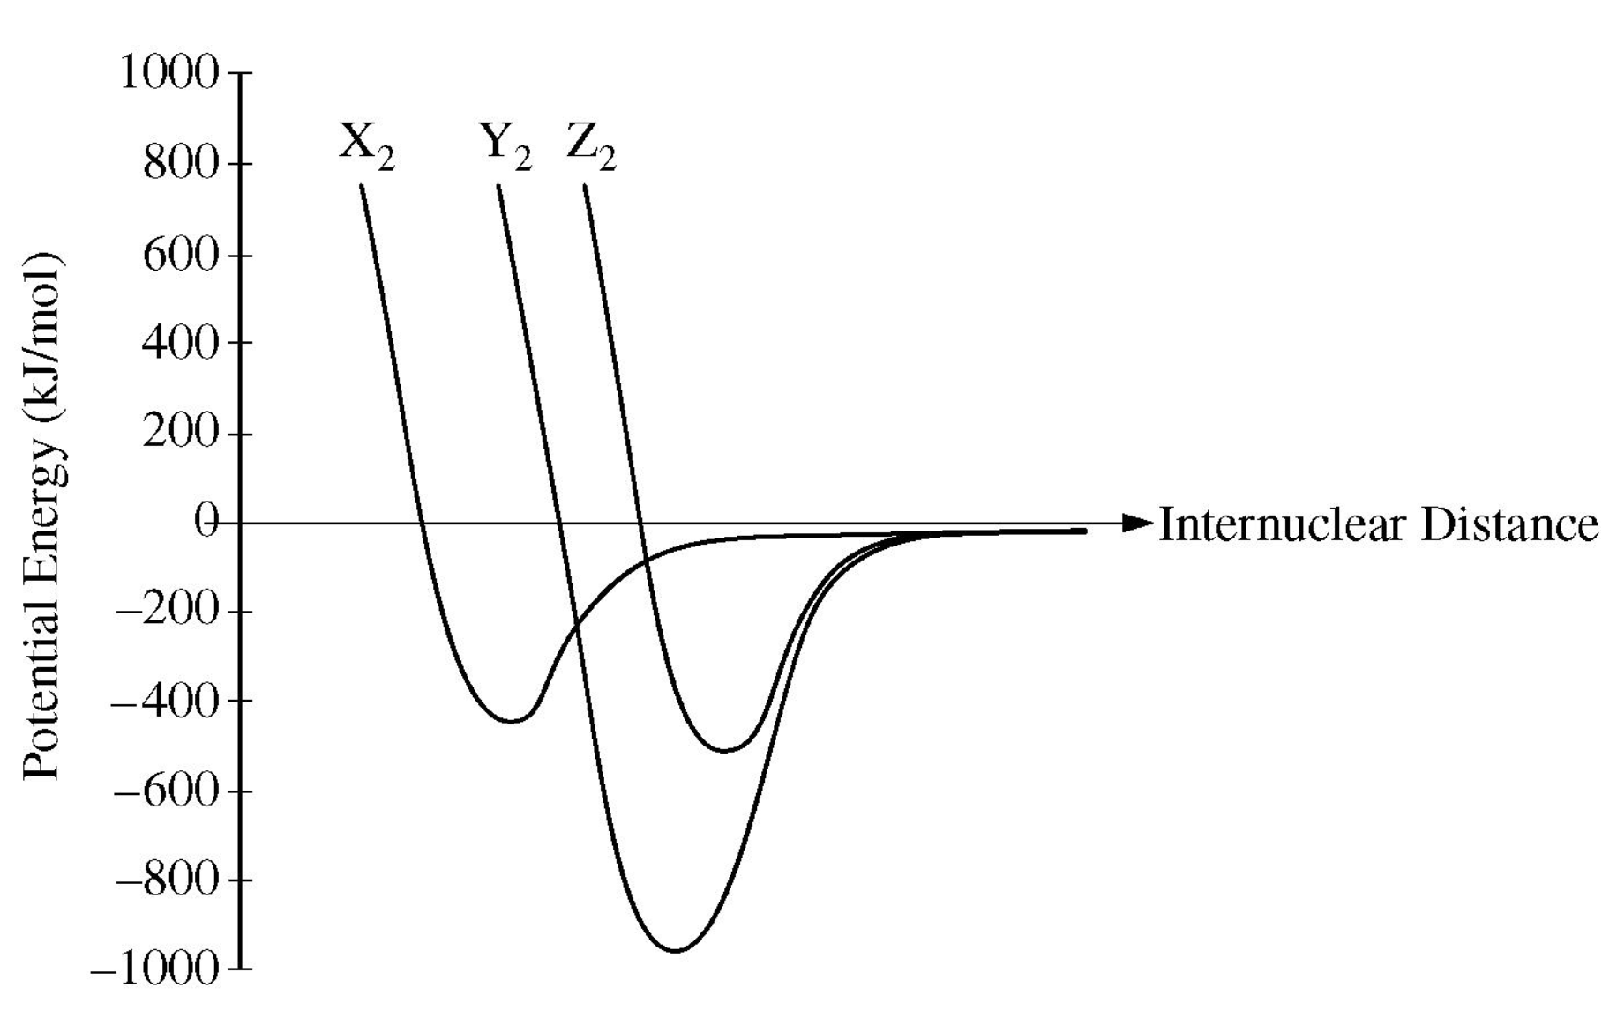

  - Place an X at the internuclear distance where the bond forms of Y₂.

  - How much energy is released when …
    - one mole of X bonds to another mole of X?

    - one atom of X bonds to another atom of X?

  - Which particle, X₂, Y₂, or Z₂, would take the most energy to break the bond?

Compound | Lattice Energy  (kJ/mol) |  | Compound | Lattice Energy  (kJ/mol)
LiF | 1030 |  | NaCl | 788
LiCl | 834 |  | MgCl₂ | 2326
LiI | 730 |  | AlCl₃ | 5376
Lattice Energy 1 |  |  | Lattice Energy 2

- For the lattice energies given above …
  - in Lattice Energy 1, explain why LiF has a greater lattice energy than LiI

  - in Lattice Energy 2, explain why NaCl has a smaller lattice energy than AlCl₃
- Use the potential energy graph of two atoms as they approach each other to answer the questions that follow.

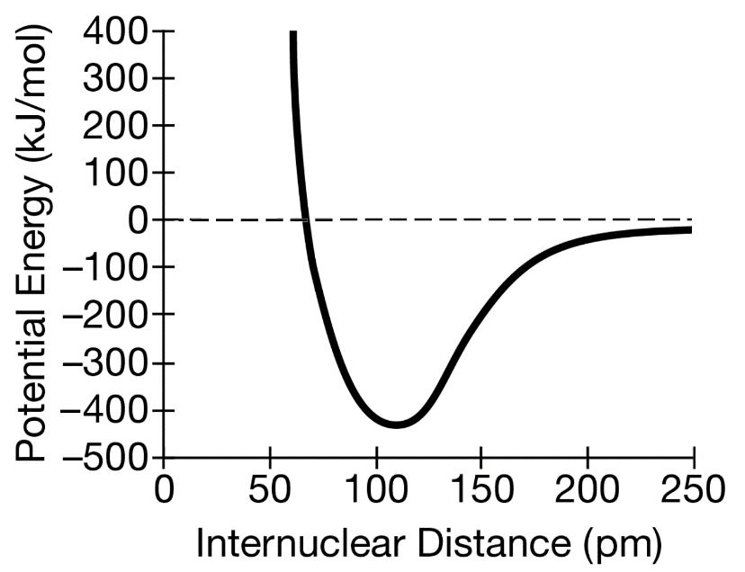

  - At what internuclear distance do the atoms bond?

  - How much energy is released when one mole of the atoms bond?

  - How much energy is required to break the bond between one mole of these atoms?

  - At what internuclear distance are the attractive and repulsive forces between the two atoms balanced?


- The structure above represents the ionic compound KF.
  - Fill in the circles with + and – to indicate the charge of the ions.

  - How would the structure differ if it were KCl instead of KF? Draw a particle picture to explain your answer.

  - Explain why solid ionic compounds are brittle by referring to the particle picture of KF.

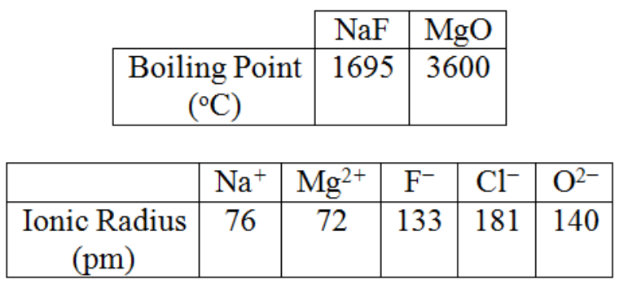
- Using the data above and Coulomb’s Law, predict whether NaCl would have a higher or lower boiling point than NaF. Explain your reasoning.

Topic 2.5 Worksheet

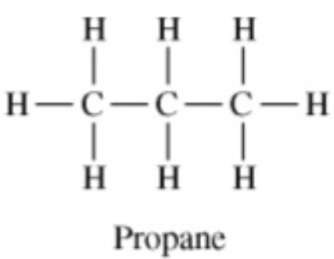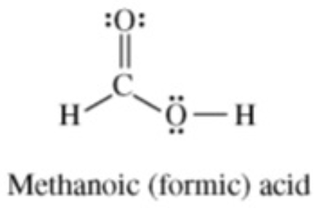

- Shown above are the Lewis structure of propane (C₃H₈) and methanoic acid (HCOOH). Draw the Lewis structure of propanoic acid, HC₃H₅O₂.

- Complete the Lewis electron dot structure for ethanol by drawing in all of the electron pairs.

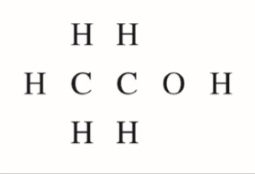

- Complete the Lewis electron dot structure for the weak base methyl amine by showing all bonding and nonbonding electrons.

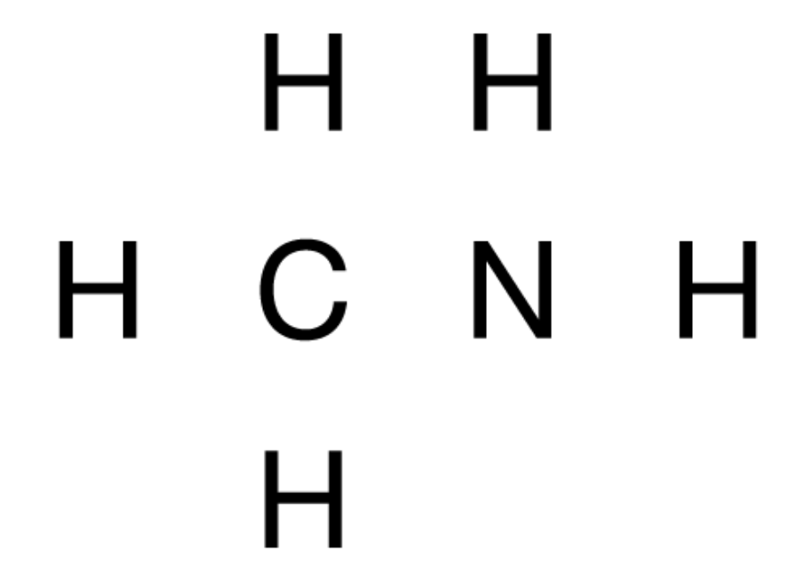

- Draw the Lewis structure of propanone, CH₃COCH₃.
- What is an isomer?

- Explain why CH₃COCH₃ is an isomer of CH₃CH₂CHO.

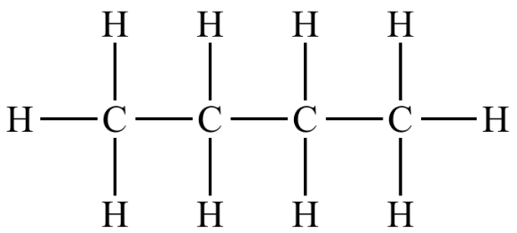
- Butane is shown above. Draw an isomer of butane.

- Explain the following observations about the two carbon-oxygen bonds in the methanoate (formate) anion, HCO₂⁻. Draw a Lewis electron-dot diagram (or diagrams) of the methanoate ion as part of your explanations.
  - The two carbon-oxygen bonds in the methanoate (formate) anion, HCO₂ ⁻, have the same length.

  - The length of the carbon-oxygen bonds in the methanoate (formate) anion, HCO₂ ⁻, is intermediate between the length of the carbon-oxygen bond in methanol and the length of the carbon-oxygen bond in methanol, shown below.
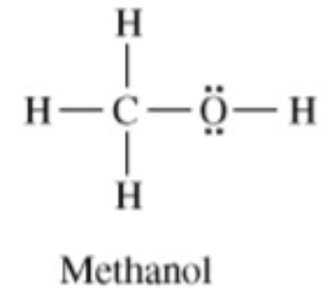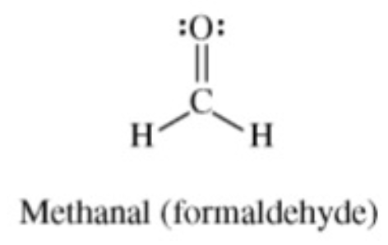

- Draw the following Lewis structures.
CO₂ | CH₄
CO₃²⁻ | SiH₄
CF₄ | PCl₃
SF₄ | SO₃
C₂Cl₄ | H₂S
C₂H₄ | HCN
HF | ClF₃
H₂O | C₂H₂
NH₃ | XeO₃
BH₃ | XeF₄

Topic 2.7 Worksheet

- Determine the molecular geometry and hybridization of each of the central atoms for the Lewis structures you drew in Topic 2.5 Worksheet, #8.

Particle | Molecular Geometry | Hybridization |  | Particle | Molecular Geometry | Hybridization
CO₂ |  |  |  | CH₄
CO₃²⁻ |  |  |  | SiH₄
CF₄ |  |  |  | PCl₃
SF₄ |  |  |  | SO₃
C₂Cl₄ |  |  |  | H₂S
C₂H₄ |  |  |  | HCN
HF |  |  |  | ClF₃
H₂O |  |  |  | C₂H₂
NH₃ |  |  |  | XeO₃
BH₃ |  |  |  | XeF₄

- The bond angle of CH₄, NH₃, and H₂O decreases. Explain why.

- Explain why the carbon-oxygen bond length in CO₃^{2 –} is greater than the carbon-oxygen bond length in CO₂.

- In terms of molecular geometry, account for the fact that the CF₄ molecule is nonpolar, where as the SF₄ molecule is polar.
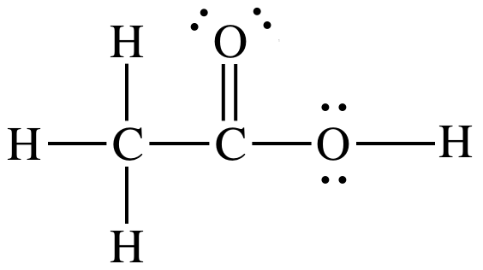

- Shown above is the Lewis structure of ethanoic acid.
  - What is the approximate angle of the H – O − C bond.

  - What is the approximate angle of the O – C = O bond.

  - What is the approximate angle of the H – C – H bond.

- Complete the table below that shows the relationship between hybridization and bond angles.

Hybridization | Bond Angle | Possible VSEPR Molecular Geometries
sp
sp²
sp³

- Determine the number of sigma and pi bonds in the following particles.

Particle | # of sigma and pi bonds on the carbon indicated

- Shown below are two different representations of the same molecule ethene, C₂H₄. Which of the two Lewis structures is a more accurate representation of the molecular shape? Explain your reasoning.

Structure A |  | Structure B
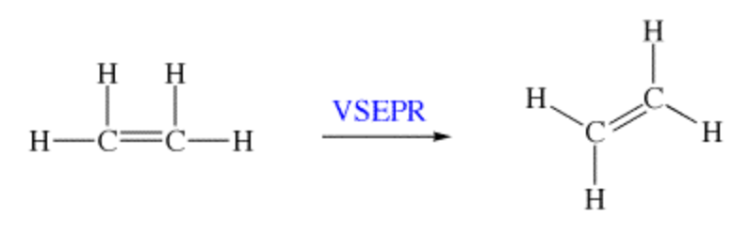

- Give the reasoning for when a molecule is …
  - polar.

  - nonpolar.
- Determine the if the particle is polar or nonpolar for the Lewis structures you drew in Topic 2.5 Worksheet, #8.

Particle | Polar or Nonpolar |  | Particle | Polar or Nonpolar
CO₂ |  |  | CH₄
CO₃²⁻ |  |  | SiH₄
CF₄ |  |  | PCl₃
SF₄ |  |  | SO₃
C₂Cl₄ |  |  | H₂S
C₂H₄ |  |  | HCN
HF |  |  | ClF₃
H₂O |  |  | C₂H₂
NH₃ |  |  | XeO₃
BH₃ |  |  | XeF₄

- BF₃ is nonpolar while NF₃ is polar. Explain why.

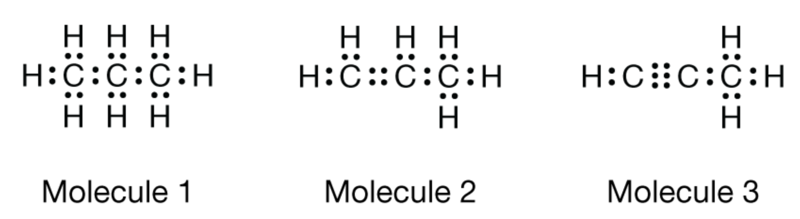

- Use the three molecules above to answer the questions that follow. In each case, refer to all three molecules when asked to explain or justify.
  - Which of these molecules is polar? Explain your reasoning.

  - Which molecule has the strongest carbon – carbon bond? Justify your answer.

  - Which molecule has C – C – H bond angle of approximately 120º? Explain your reasoning.

  - Determine the hybridization of the left most carbon for each molecule.

  - Which molecule would have the highest percent of carbon by mass?

Topic 2.6 Worksheet

- Use the Lewis structures above to answer the questions that follow.
  - Determine the formal charge of every atom in each of the Lewis structures.

  - Based on formal charge, which of the two molecules is the best representation of HCNO? Justify your answer.

- Explain why every bond in CO₃^{2 –} is the same length.

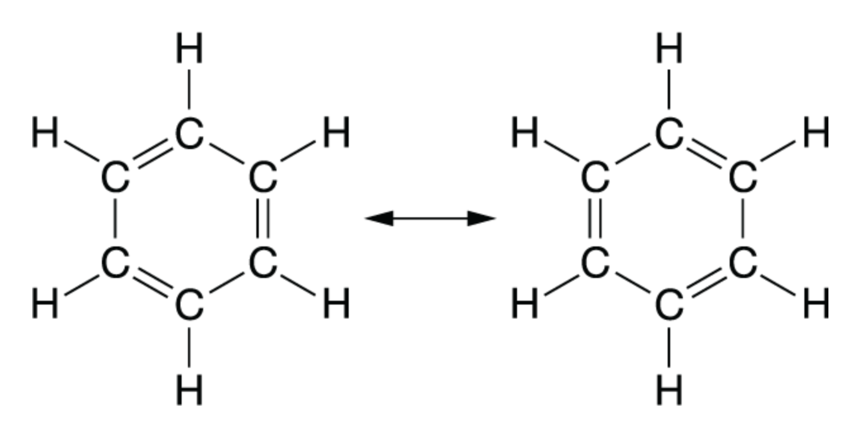
- Shown above is benzene, C₆H₆. Draw all resonance structures that exist.

- Determine which structure below is the best based on formal charge.
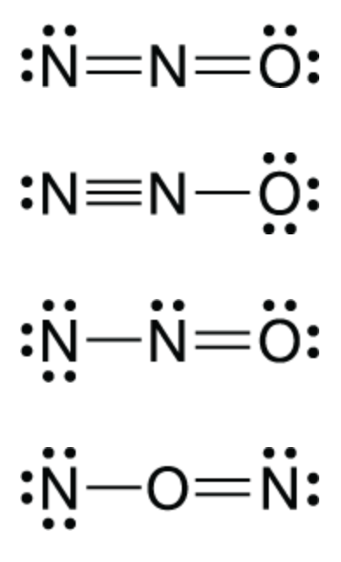

Topic 2.4 Worksheet

- What relative size of metallic atoms would make …
  - an interstitial alloy?

  - a substitutional alloy?

 |  | 
Figure A |  | Figure B

- Use the two figures above to answer the questions that follow.
  - Would Figure A be an interstitial or substitutional alloy? Justify your reasoning.

  - Would Figure B be an interstitial or substitutional alloy? Justify your reasoning.

  - Which figure would represent an alloy made of copper and zinc? Explain your reasoning.

  - Which figure would represent an alloy made of iron and carbon? Explain your reasoning.

  - Which figure would be less malleable? Explain your reasoning.

  - The two alloys are made of the same white element. Which figure would be more dense?

Unit 3

Topic 3.3 Worksheet

- Draw a particulate picture of …

Solid |  | Liquid |  | Gas

- CCl₄(l) is places in a previously evacuated container at 30 ℃, and some of the CCl₄(l) evaporates. In the box below, draw a particulate diagram to show the species in the container after some of the CCl₄(l) has evaporated.

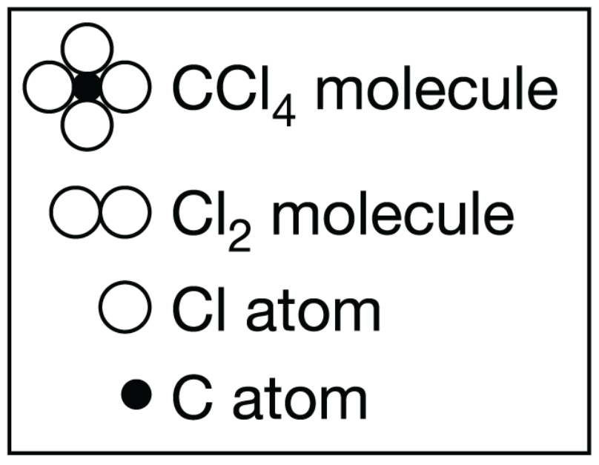

Topic 3.1 Worksheet

- What’s the difference between a single bond (intramolecular force) and intermolecular forces?

- Explain how …
  - London dispersion forces form. Include a picture.

  - Dipole-dipole forces form. Include a picture.

  - Hydrogen bonds form. Include a picture.

  - Dipole-induced dipole forces form. Include a picture.

  - Ion-dipole forces form. Include a picture.

- Explain polarizability.

- Explain how polarizability increases with an increase in the number of electrons.

- Explain how polarizability increases with an increase in surface area of a molecule.

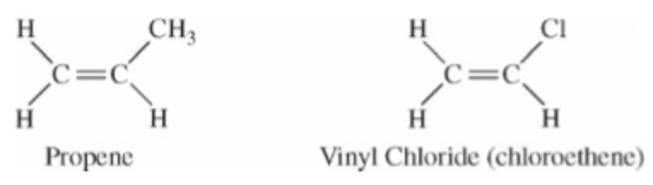
- Answer the questions that follow about propene (CH₂CHCH₃) and vinyl chloride (CH₂CHCl), shown above.
  - Identify the intermolecular forces present in each molecule.

  - The boiling point of liquid propene (226 K) is lower than the boiling point of liquid vinyl chloride (260 K). Account for this difference in terms of the types and strengths of intermolecular forces present in each liquid.
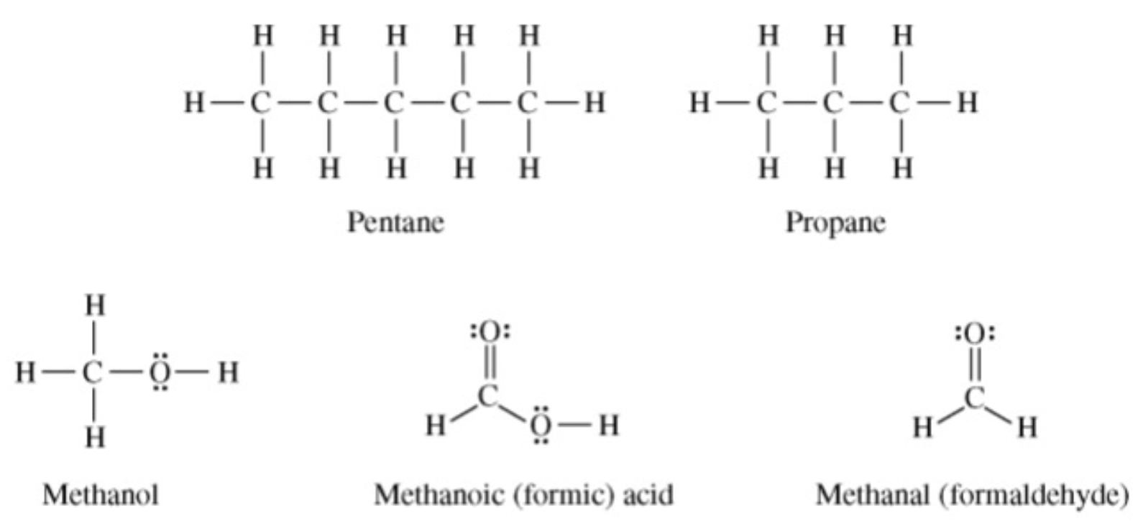

- Answer the following questions in terms of principles of chemical bonding and intermolecular forces. In each explanation where a comparison is to be made, a complete answer must include a discussion of both substances. The following complete Lewis electron-dot diagrams may be useful in answering parts of this question.
  - At 1 atm and 298 K, pentane is a liquid whereas propane is a gas. Explain.

  - At 1 atm and 298 K, methanol is a liquid where as propane is a gas. Explain.

- Two types of intermolecular forces present in liquid H₂S are London (dispersion) forces and dipole-dipole forces.
  - Compare the strength of the London (dispersion) forces in liquid H₂S to the strength of the London (dispersion) forces in liquid H₂O. Explain.

  - Compare the strength of the dipole-dipole forces in liquid H₂S to the strength of the dipole-dipole forces in liquid H₂O. Explain.
- Consider Br₂ and Cl₂.

  - What intermolecular forces do they both exhibit? Justify your answer.

  - Which has stronger intermolecular forces? Justify your answer.

  - Which do you expect to be a liquid at room temperature? Explain why.

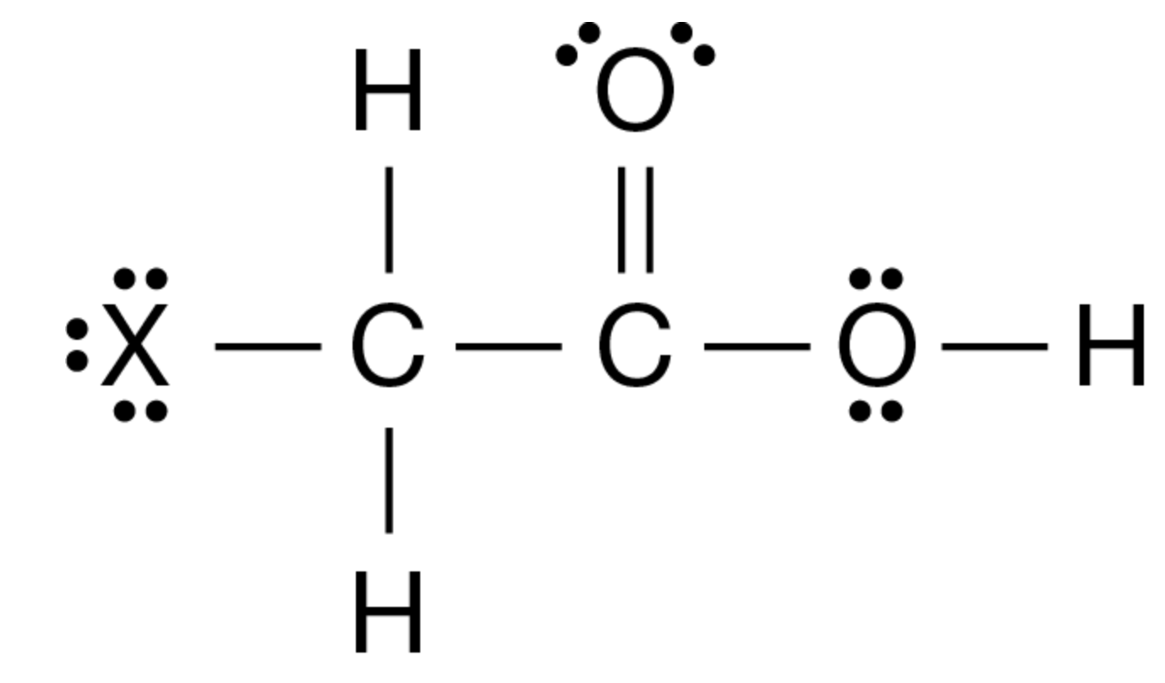
- Consider the haloacetic acids, illustrated above with an “X” in place of the halogen.
  - What intermolecular forces are present in all of the haloacetic acids?

  - Which haloacetic acid would you expect to have the highest boiling point, F, Cl, Br, or I?

  - Explain your reasoning.

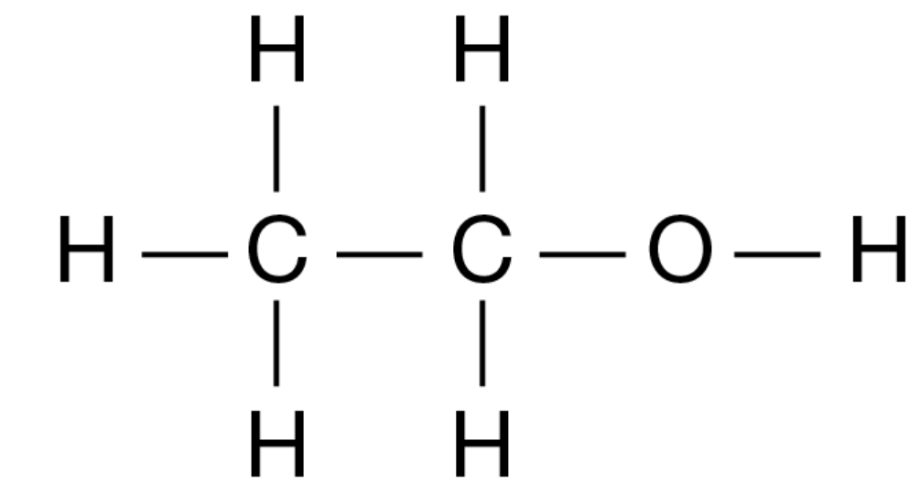 |  | 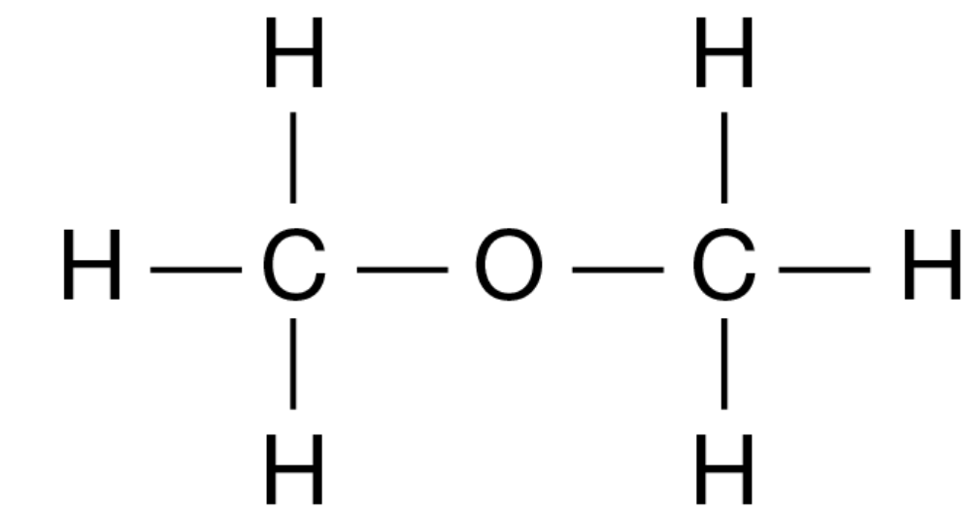
Ethanol |  | Dimethyl ether
- Answer the following questions about the isomers ethanol and dimethyl ether.
  - Explain why methanol and dimethyl ether are isomers of each other.

  - Identify all intermolecular forces in both molecules.

  - Ethanol has a boiling point of 78 ℃ while dimethyl ether has a boiling point of −24 ℃. Identify the intermolecular force that is most responsible for the difference.
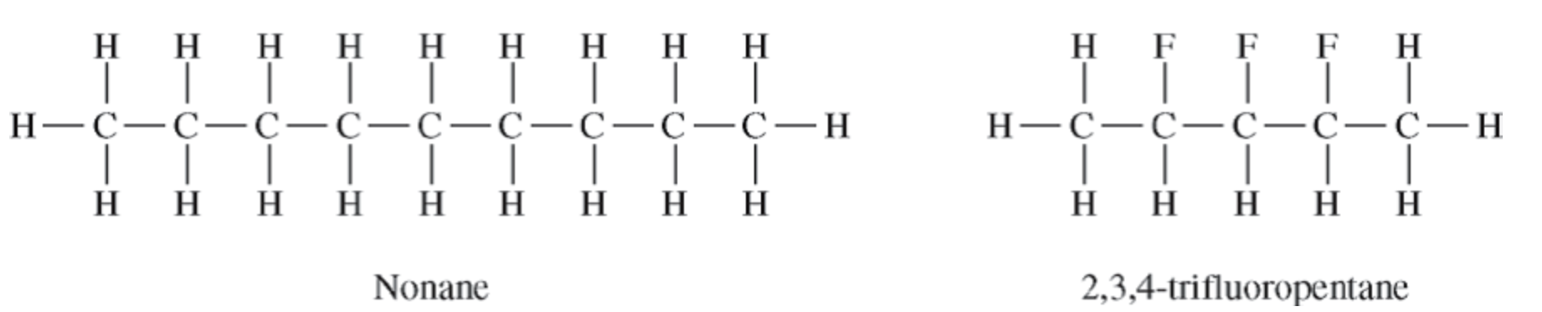

- Shown above are the Lewis structures for nonane and 2,3,4-trifluoropentane.
  - Identify the intermolecular forces present in both molecules.

  - Nonane has a higher boiling point than 2,3,4-trifluoropentane even though they have nearly identical molar masses.
    - Which intermolecular force is most responsible for this difference?

    - Explain how the intermolecular force you identified in bi causes the difference in boiling point.

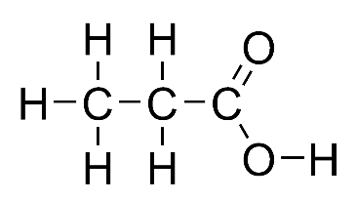 |  | 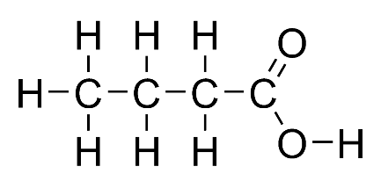
Propanoic acid |  | Butanoic acid

- Shown above are the Lewis structures for propanoic acid and butanoic acid. Propanoic acid has a lower boiling point than butanoic acid.
  - Identify all intermolecular forces present in each molecule.

  - Which intermolecular force is most responsible for the difference in boiling point?

- Br₂ has a higher boiling point than BrCl. Explain why in terms of the intermolecular forces present.

- Energy is required to boil ethanol. Consider the statement “As ethanol boils, energy goes into breaking C – C bonds, C – H bonds, C – O bonds, and O – H bonds.” Is the statement true or false? Justify your answer.

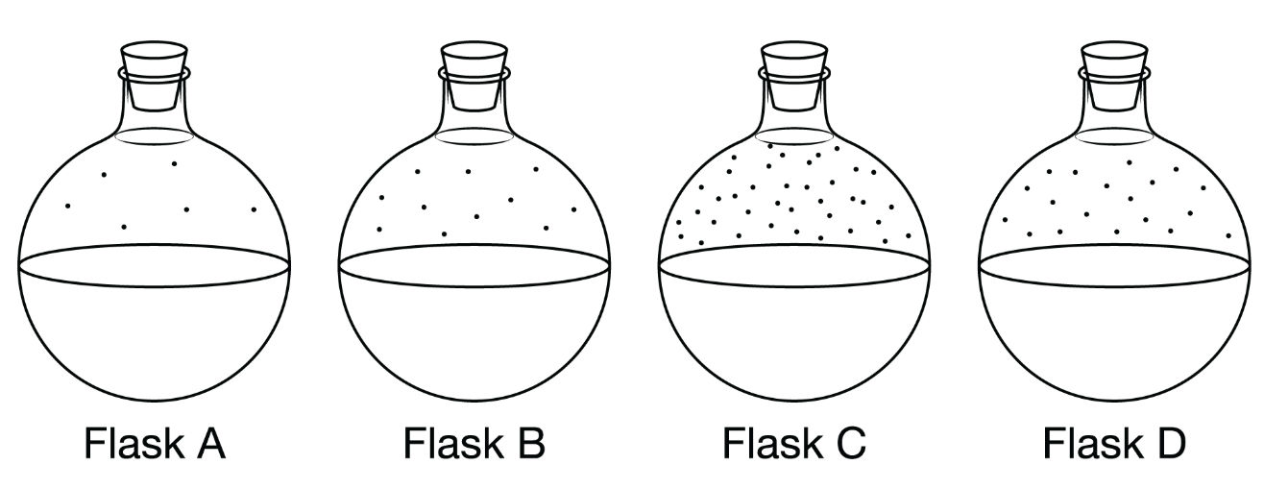
Flask A |  | Flask B |  | Flask C |  | Flask D

- Shown above are four identical flasks that contain four different liquids all at the same temperature. The particles above each liquid are in the vapor phase.
  - Which flask has the weakest forces of attraction between the particles? Explain your reasoning.

  - Which flask has the strongest forces of attraction between the particles? Explain your reasoning.

  - If all of the particles were nonpolar, what could be a possible reason for the difference in the strength of the intermolecular forces?

  - If all of the particles were polar but did not contain hydrogen bonding, …
    - what intermolecular force of attraction would most contribute to the differences in strength?

    - would the liquid in flask A have more, fewer, or the same number of electrons as the liquid in flask D?

Container | A | B | C
Gas | Methane | Ethane | Butane
Formula | CH₄ | C₂H₆ | C₄H₁₀
Molar mass (g/mol) | 16 | 30. | 58
Temperature (℃) | 27 | 27 | 27

- Consider the four gases above in three identical containers. As the pressure of the gases is increased they transition from the gas phase to the liquid phase.
  - Explain, on the molecular level, why increasing the pressure of the gas would change it from gas to liquid.

  - Which gas would condense with the least amount of pressure? Explain your reasoning. You must mention all three gases in your explanation.

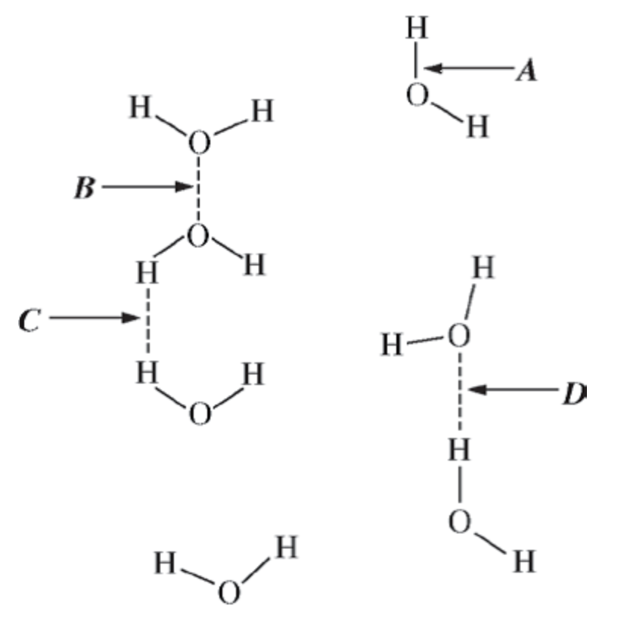
- Use the figure above to answer the questions that follow.
  - What does arrow A indicate?

  - Arrow D indicates a hydrogen bond. Explain why D indicates a hydrogen bond while B and C do not.
- Use the information in the table below to answer the questions that follow about three organic compounds.

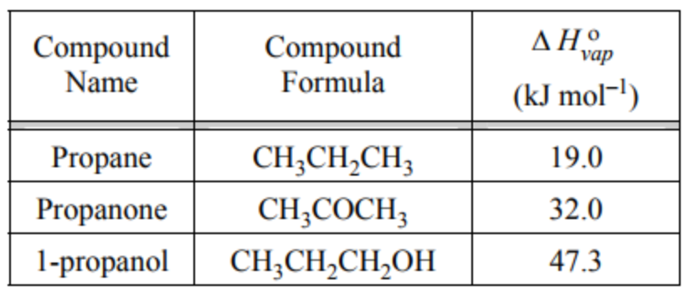

  - Explain why propane has a smaller heat of vaporization than propanone.

  - Explain why propanone has a smaller heat of vaporization than 1-propanol.

- Which of the figures below correctly shows a hydrogen bond? Explain your reasoning.

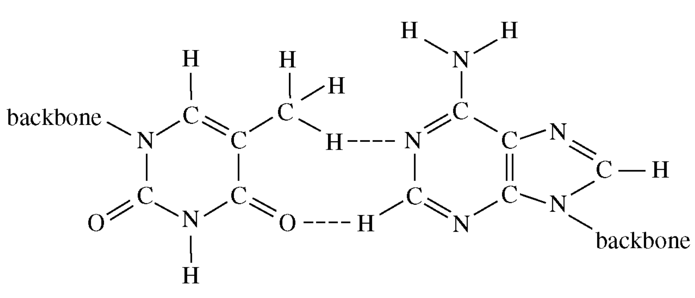 |  | 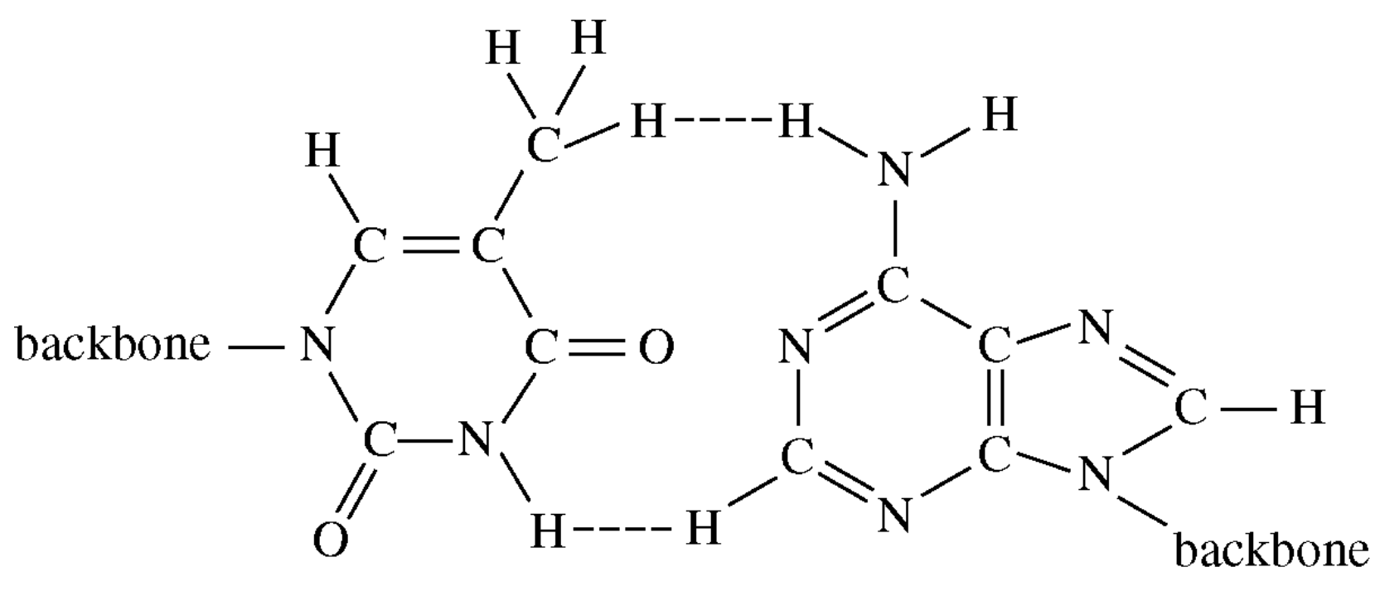
Figure A |  | Figure B
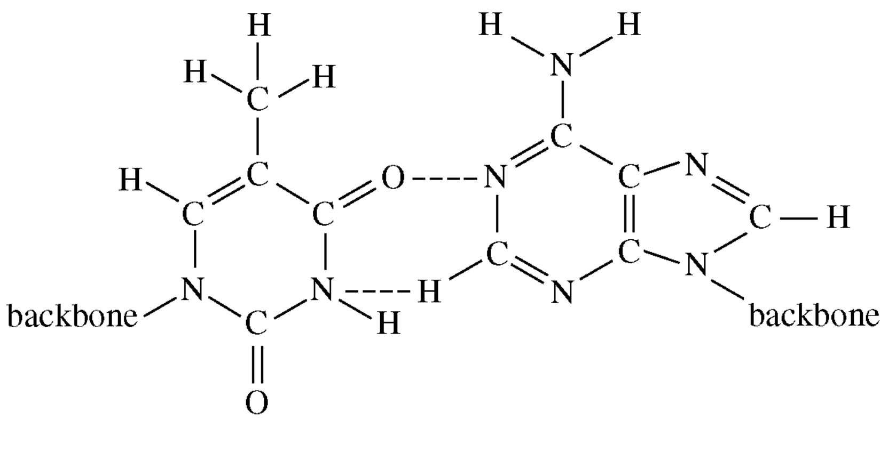 |  | 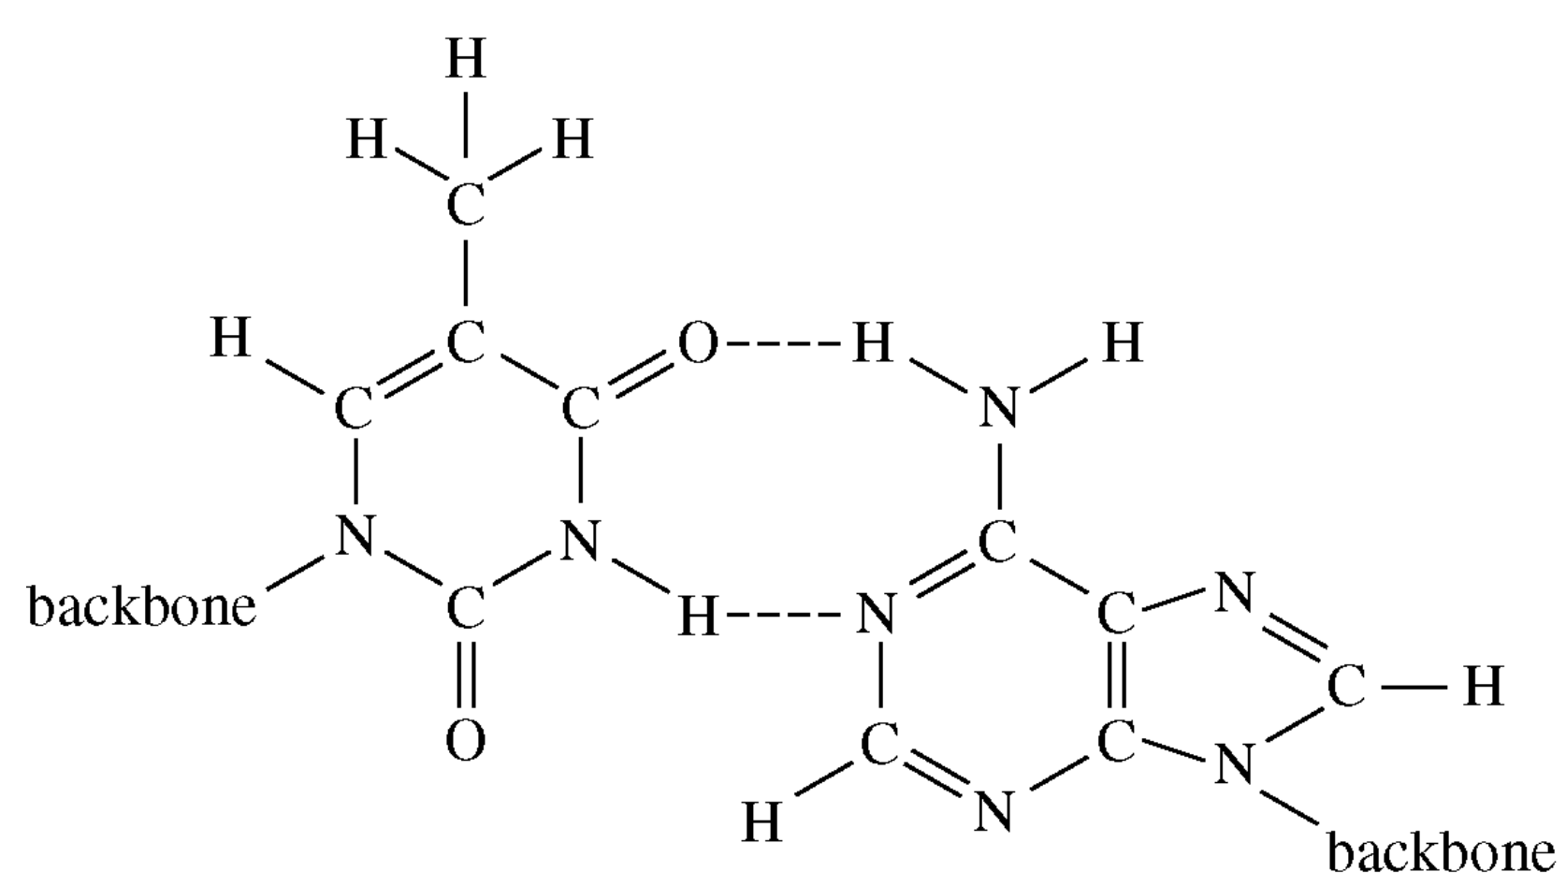
Figure C |  | Figure D

- Shown below is a molecule of urea (H₂NCONH₂) which is highly soluble in water. Draw and label the hydrogen bonds between urea and water.

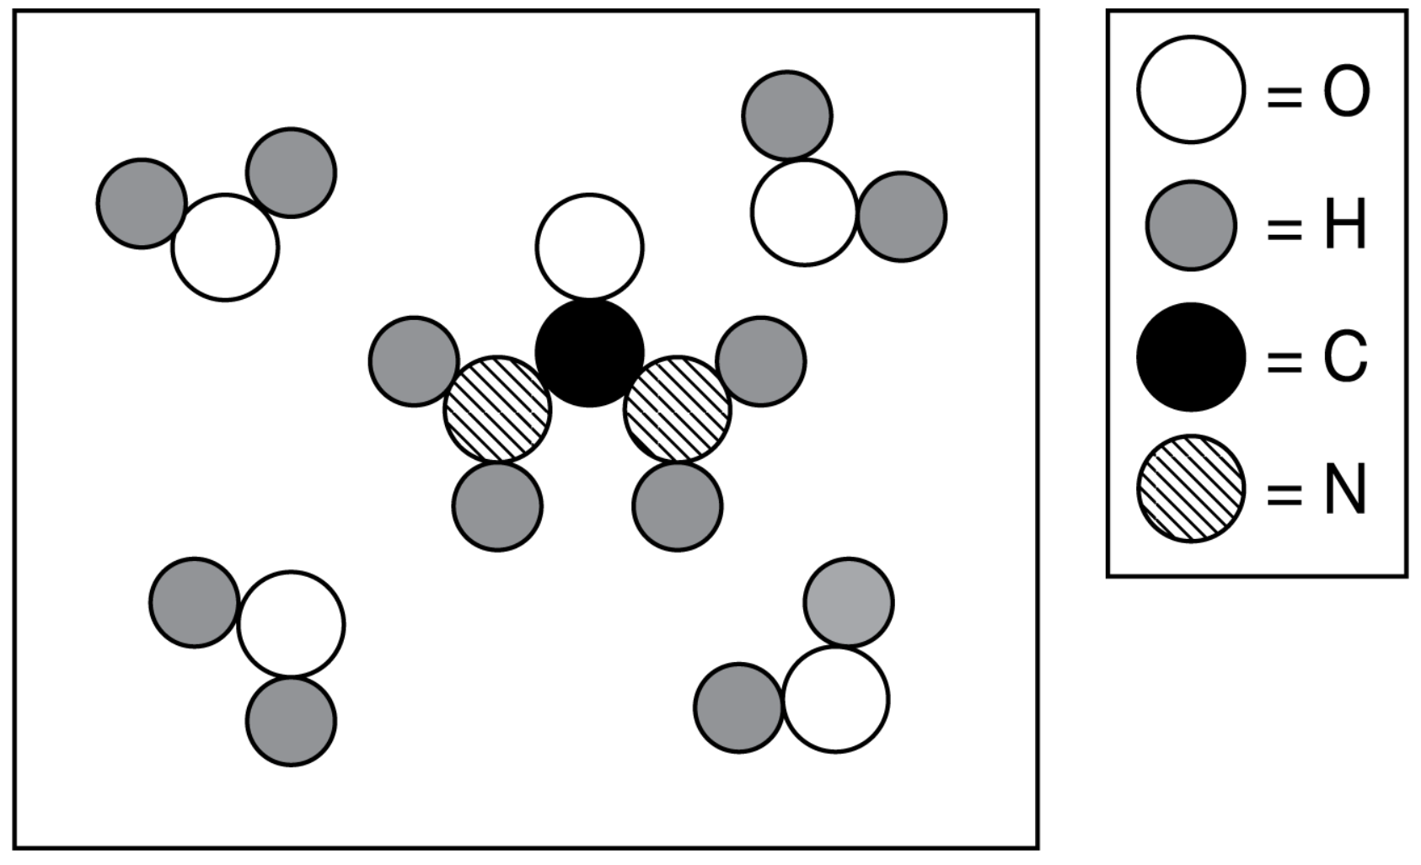

Topic 3.10 Worksheet

- Complete the table below about the general solubility of different compounds in water (H₂O) and hexane (C₆H₁₄).

Strongest Type of IMF in the Particle | Soluble in Water  (Yes or No) | Soluble in Hexane  (Yes or No)
London dispersion forces
Dipole-dipole force
Hydrogen bonding
Ionic bonding

- Define the following terms:
  - Miscible

  - Soluble

  - Solution

- Shown below are the structures of glucose, C₆H₁₂O₆, and cyclohexane, C₆H₁₂.

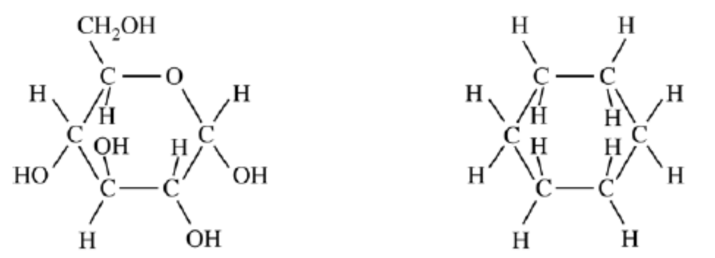
Glucose |  | Cyclohexane

  - Identify all intermolecular attractive forces present in each compound.

  - One of the molecules is soluble while the other is not. Which of the two would be soluble in water? Explain your reasoning.

Compound A |  | Compound B |  | Compound C

- Which of the compounds above is …
  - the most soluble in water? Explain your reasoning.

  - the least soluble in water? Explain your reasoning.

  - the most soluble in hexane, C₆H₆? Explain your reasoning.

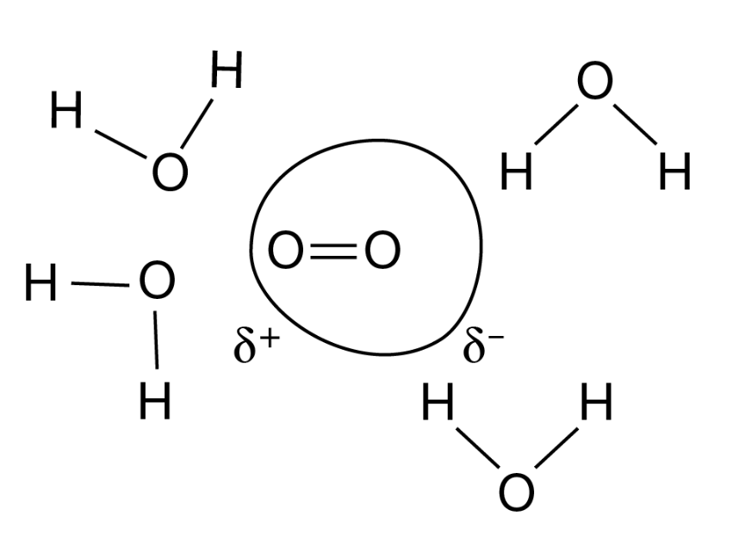
- Shown above is a model that explains how oxygen is dissolved in water. Explain how water creates a temporary dipole in oxygen in order to create a dipole-induced dipole force of attraction.

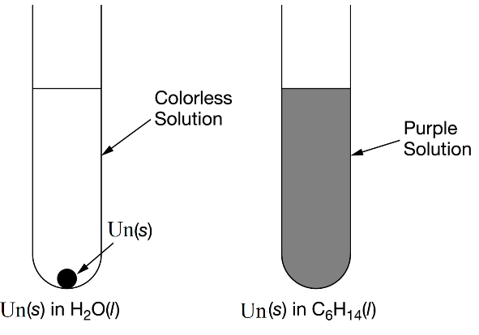
- An unknown solid, Un(s), was placed into two separate test tubes; one containing water and one containing hexane. What do the results indicate about the intermolecular forces in the solid?

Topic 3.2 Worksheet

- Give the properties of the following types of solids. Include example molecules of the solid.
  - Ionic solid

  - Covalent network solid

  - Molecular solid

  - Metallic solid

- Explain why a solid ionic compound will not conduct electricity but an aqueous solution will.

- Answer the following questions about the solids SO₂ and SiO₂.
  - What type of solid is formed by SO₂?

  - What type of solid is formed by SiO₂?

  - Which solid has stronger bonding?

  - Which solid should have a lower melting point?
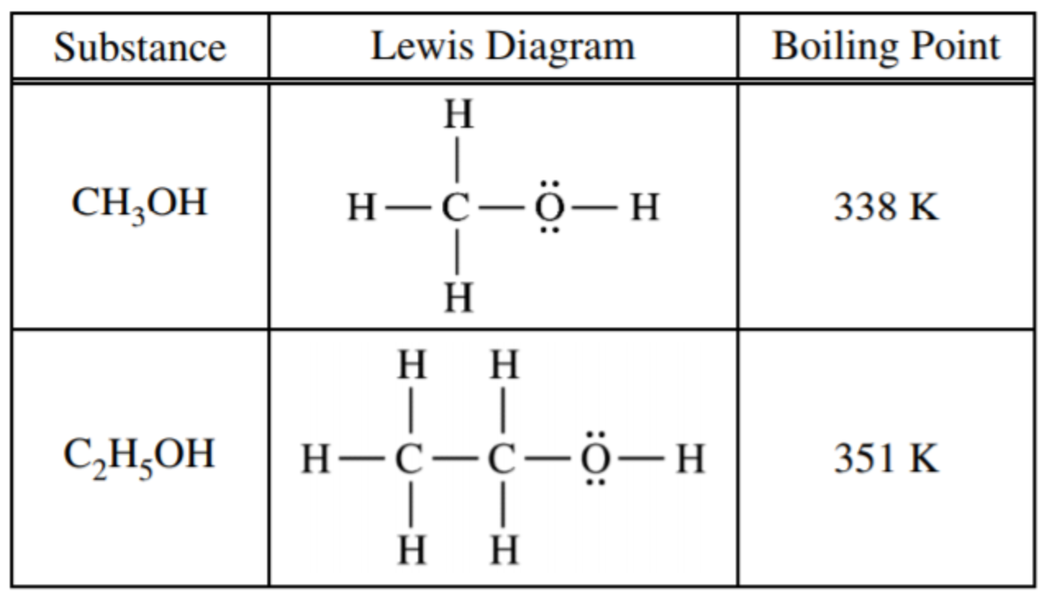
- Consider the information in the table above.
  - Identify the intermolecular forces present in both substances.

  - Which substance would have the lower equilibrium vapor pressure?

  - Identify the intermolecular force most responsible for the lower vapor pressure.

- The electrical conductivity of an ionic compound increases with the number of ions in the formula unit. Explain why a 1.0 M solution of NaCl would have less electrical conductivity than a 1.0 M solution of Na₃PO₄.

- Consider the melting of NaCl or MgS.
  - What types of bonds are being broken when the compounds melt? Explain your reasoning.

  - Which would you expect to have a higher melting point? Use Coulomb’s Law to explain your reasoning.

- Shown below is the solid boron nitride.
  - What type of solid is boron nitride?
  - What evidence in the picture supports your answer?
  - Boron nitride is a very hard solid.
  - What about its structure gives it this property?

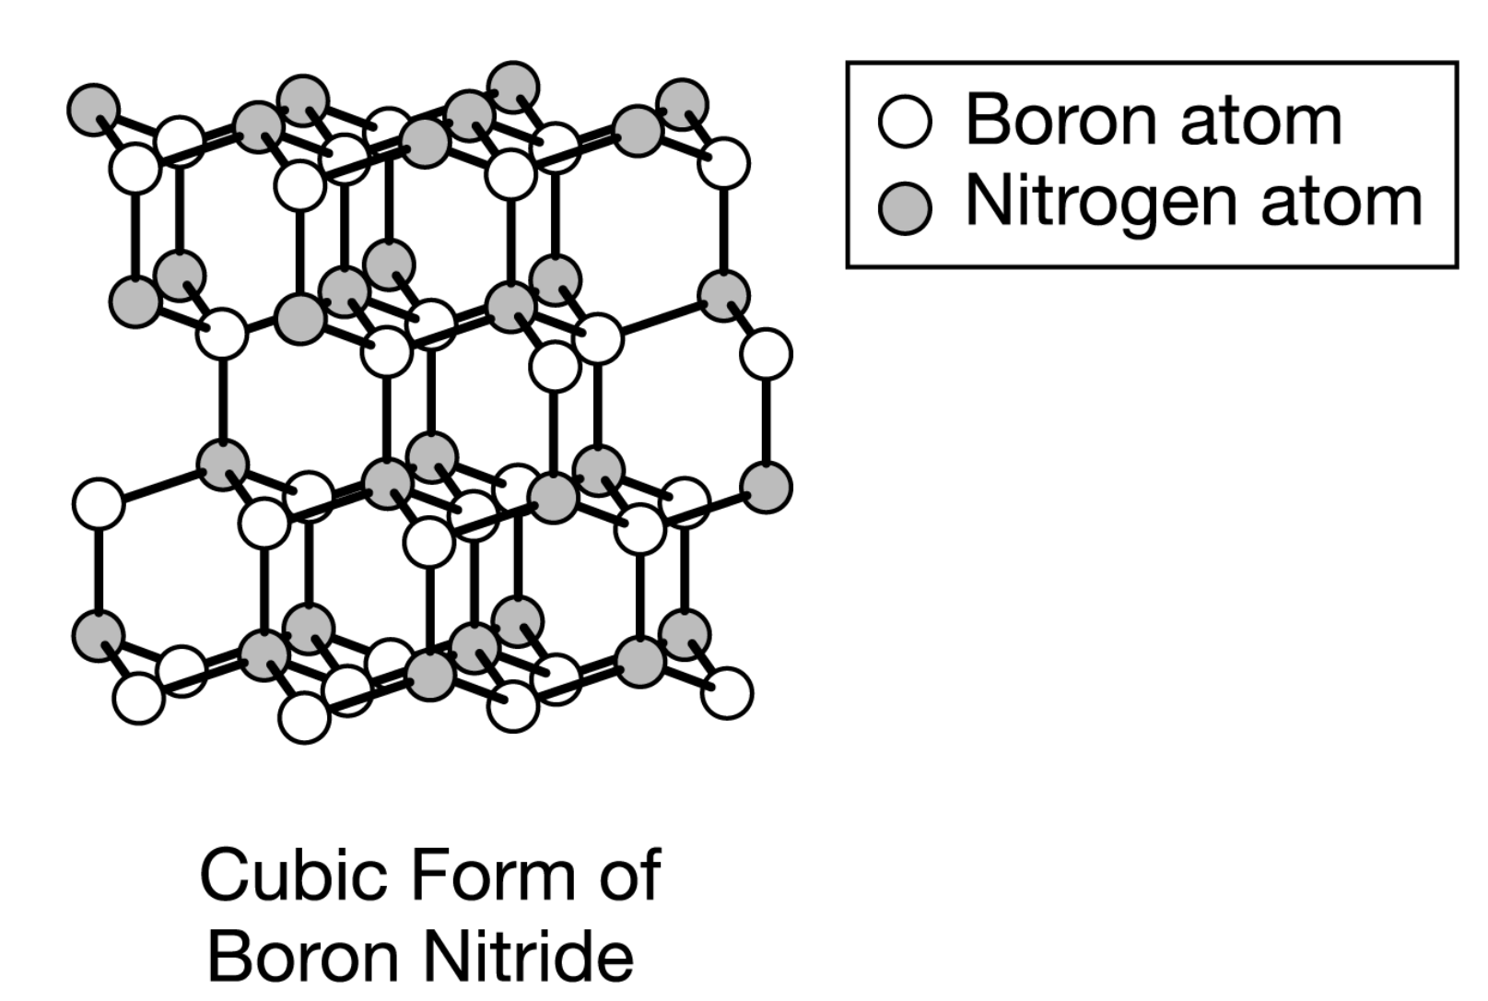

- Shown below are two isomers. Which would have the higher boiling point and why?

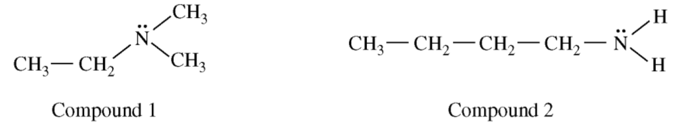

Topic 3.5 Worksheet

- What does a Maxwell-Boltzmann distribution illustrate? Draw an example of one.

- What is the relationship between the velocity of a gas and …
  - temperature.

  - molar mass.

- Gas A (75 ℃, molar mass = 50 g/mol) and gas B (15 ℃, molar mass = 25 g/mol) are placed in the same container and are allowed to come to thermal equilibrium.
  - What happens to the average kinetic energy of gas A as it approaches thermal equilibrium?

  - What happens to the average kinetic energy of gas B as it approaches thermal equilibrium?

  - Compare the temperature of gas A to the temperature of gas B at thermal equilibrium. Explain your reasoning.

  - Compare the average kinetic energy of gas A to the average kinetic energy of gas B at thermal equilibrium. Explain your reasoning.

  - Compare the average speed of gas A to the average speed of gas B at thermal equilibrium. Explain your reasoning.

- Use the Maxwell-Boltzmann distributions shown below to answer the questions that follow.

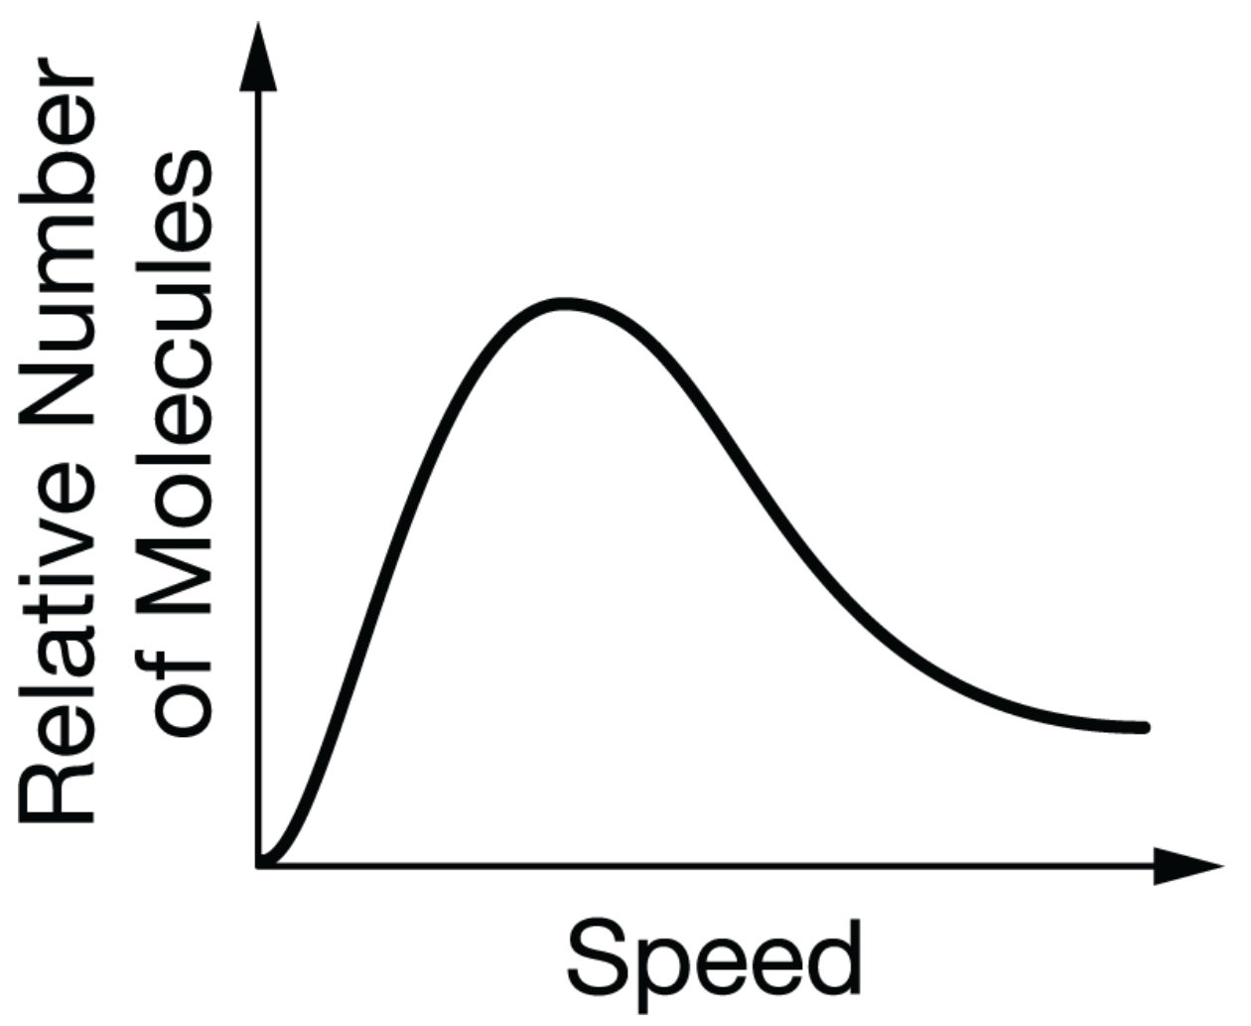
Shown above is the distribution for N₂ at 25 ℃.  Draw and label the distribution for N₂ at 50 ℃. |  | Shown above is the distribution for N₂ at 25 ℃.  Draw and label the distribution for O₂ at 25 ℃

- Describe the effect …
  - of raising the temperature on the motion of gas particles. Explain your reasoning.

  - on the pressure of a gas when the temperature is increased. Explain your reasoning.

- The Maxwell-Boltzmann distrubition below was created using four different gases. What specific property of the gas can you determine from the graph alone?
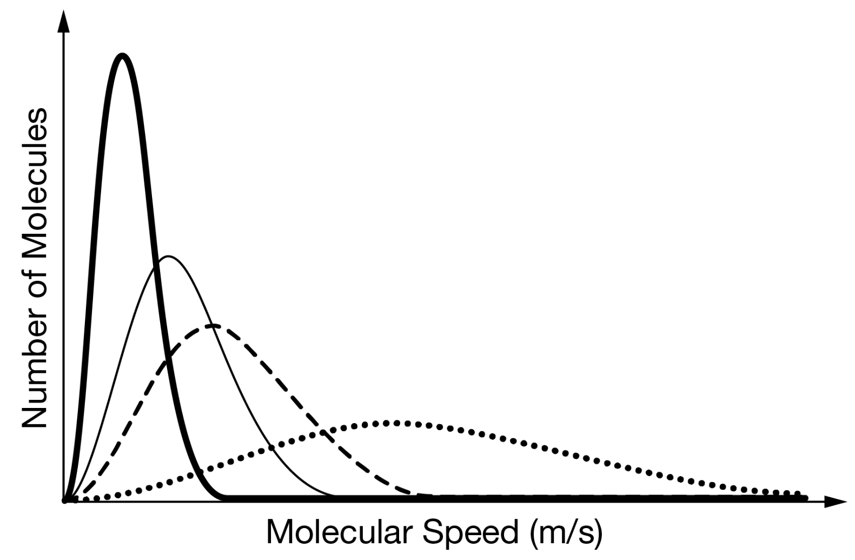
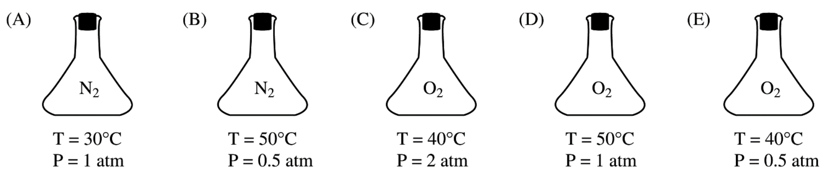

- Use the five flasks above to answer the questions that follow.
  - Which flask do the molecules have the greatest average speed of the particles? Explain your answer.

  - Which nitrogen flask has the most number of particles? Explain your reasoning.

  - Which oxygen flask has the most number of particles? Explain your reasoning.

  - If flask C were placed into flask E, and there was no change in temperature, what would be the total pressure? Explain your reasoning.

  - Which flasks have the same average kinetic energy? Explain your reasoning.
- The apparatus below is a glass tube with two cotton balls stuck in the ends. One cotton ball is soaked with an aqueous solution of HX while the other cotton ball is soaked with a volatile base. When HX and the base meet a white solid is produced and creates a vertical ring in the tube. In the following situations, determine if the white ring will form closer to HX, closer to the base, or near the middle. In each case, explain your reasoning.

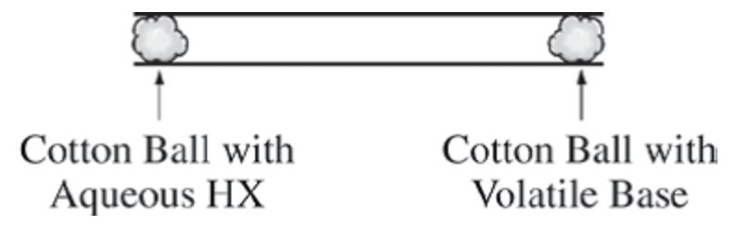

HX |  | Base |  | Location of white ring |  | Reasoning
HCl |  | CH₃NH₂
HBr |  | CH₃NH₂
HCl |  | CH₃(CH₂)₆NH₂

- The Maxwell-Boltzmann distributions below show two different gases at the same temperature. Compare the molar mass of the gas depicted by the solid line (Gas X) to the molar mass of the gas depicted by the dashed line (Gas Y) by stating whether the molar mass of the Gas Y is greater than, less than, or equal to the molar mass of Gas X.

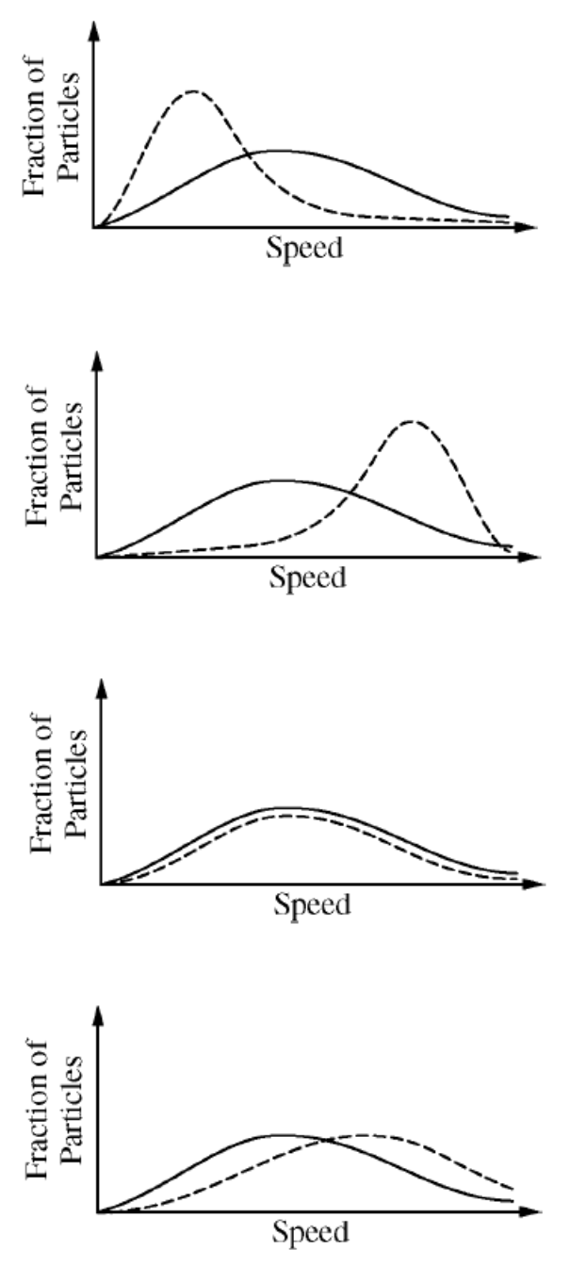

- The particle picture on the left is a gas at a given temperature. Determine if the particle pictures are at a higher temperature or a lower temperature. Explain your reasoning.

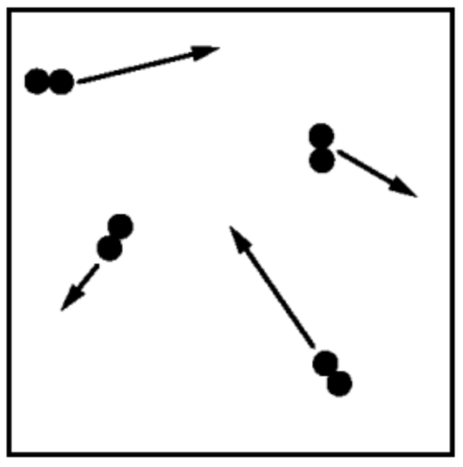 |  | 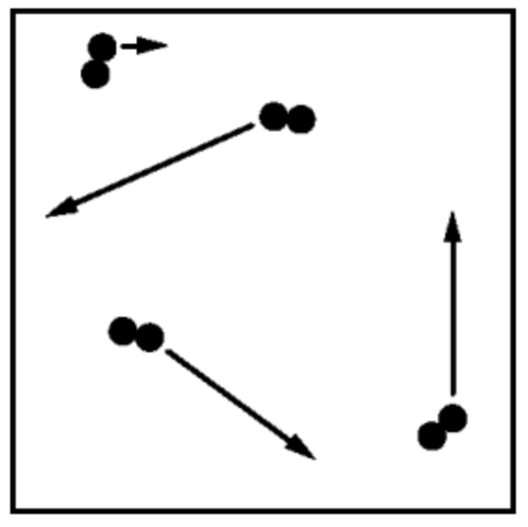 |  | 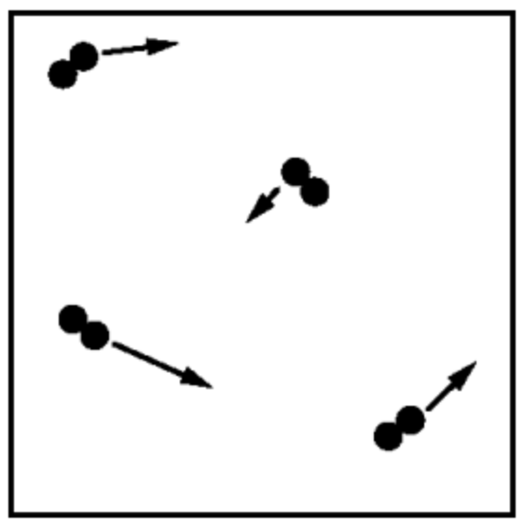
Original temperature |  | Higher Temp or Lower Temp |  | Higher Temp or Lower Temp
Reasoning

Topic 3.4 Worksheet

- Give the following equations or definitions. Identify any variables in an equation.
  - Ideal gas law

  - Ideal gas law (solved for molar mass)

  - Ideal gas law solved for density

  - Mole fraction

  - Partial pressure

  - STP

  - Molar volume of a gas

- Determine the mass, in grams, of each gas under the conditions given. First, do the problem without a calculator. Then, check your work with a calculator.
  - 22.4 L of CH₄(g) at STP

  - 2.2 L of CO₂(g) at 1 atm and 0 ℃

  - .2 L of SO₂(g) at STP

  - 4 L of N₂O(g) at 273 K and 1 atm

- For the following changes to a gas, determine which will have a greater effect for the property specified without using a calculator.
  - Would the pressure increase, decrease, or remain the same if the Celsius temperature is doubled from 10 ℃ to 20 ℃ while the volume the gas occupies is doubled from 2 L to 4 L? Explain your reasoning.

  - Would the volume of a gas increase, decrease, or remain the same if the Kelvin temperature were doubled while the pressure is decreased by a factor of four? Explain your reasoning.

  - Would the temperature of a gas have to increase, decrease, or remain the same if the volume of the container is reduced by half while the pressure was doubled? Explain your reasoning.

- First perform the following calculations without a calculator. Then, check your work with a calculator.
  - Determine the partial pressure of each gas if the canister contains 0.5 moles of O₂, 1.0 moles of N₂, and 0.5 moles of Ar at a total pressure of 600 mm Hg.

  - Determine the partial pressure of N₂ if the canister contains 0.5 moles of O₂, 0.5 moles of N₂, and 0.5 moles of Ar at a total pressure of 900 mm Hg.

- A student collects a gas over water using the apparatus shown below. Answer the questions that follow about the lab experiment.

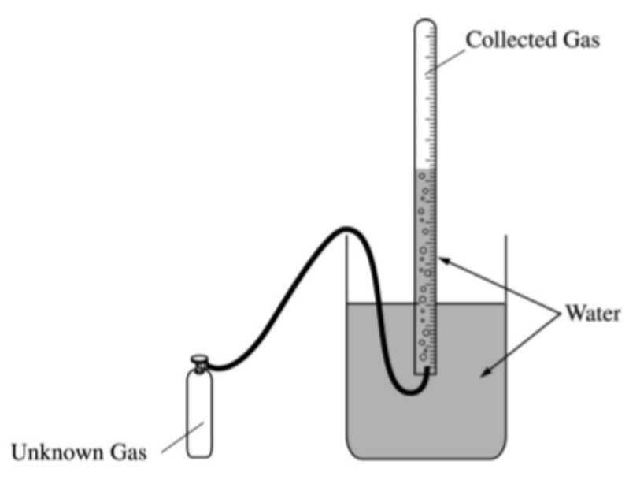

  - Explain why the water level on the inside of the collection tube and the outside of the collection tube needs to be at the same level.

  - Explain why the pressure of the room is the same as the pressure of the gases (assuming a is true).

  - Explain why the pressure of the room is NOT the pressure of the collected gas.

  - How would you determine the mass of gas delivered?

  - Use the data below to determine the molar mass of the unknown gas.

Room Pressure | 750 mm Hg
P_{H2O} at 22 ℃ | 19.8 mm Hg
Mass of Canister Before the lab | 25.100 g
Mass of Canister After the lab | 24.276 g
Temperature of Water (℃) | 22.0 ℃
Volume of Gas Collected (mL) | 358 mL

- A 5.00 milliliter vial contains 0.750 grams of CCl₄ at 0 ℃. Calculate the pressure in the vial at 25 ℃.

- A gas has a vapor density of 7.50 g L⁻¹ at 350 K. If a container of the gas has a pressure of 2.22 atm what would be the molar mass of the gas?

- The pressure in a 1.00 L rigid flask at 1100 K was measured and recorded over time. Use the graph below to answer the questions that follow.

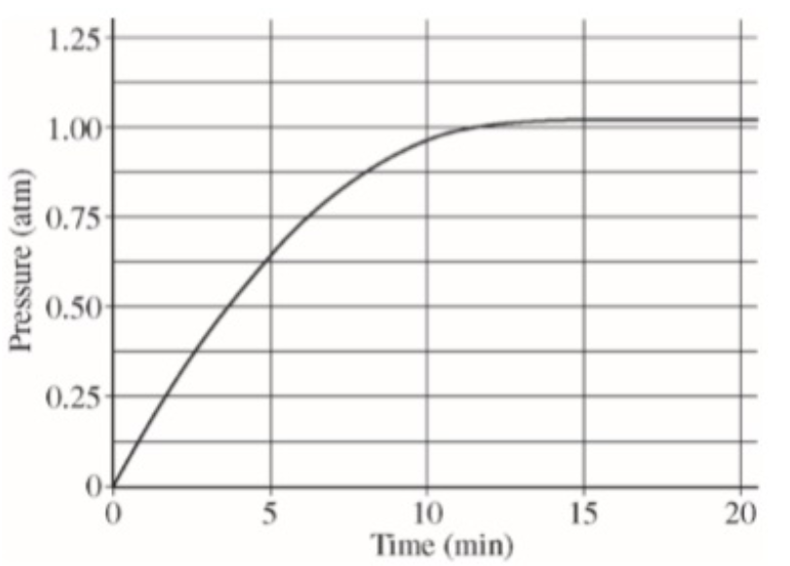

  - Determine the moles of gas present in the flask at 5 minutes.

  - Determine the moles of gas present in the flask at 20 minutes.

  - Which reaction below could be occurring in the flask? Explain your reasoning. In your explanation you must discuss all three reactions.

CaCO₃(s) ⇌ CaO(s) + CO₂(g) | 4 Fe(s) + 3 O₂(g) → 2 Fe₂O₃(s) | CH₄(g) + 2 O₂(g) → CO₂(g) + 2 H₂O(g)
Reaction A | Reaction B | Reaction C

H₂O₂(aq) + OCl⁻(aq) → H₂O(l) + Cl⁻(aq) + O₂(g)

- A student investigates the reaction between H₂O₂(aq) and NaOCl(aq), which is represented by the net-ionic equation shown above. The student decides to produce 40.0 mL of O₂(g) at a pressure of 0.988 atm and a temperature of 298 K using the reaction represented above. The student uses the equipment shown below. The student sets up a 250 mL Erlenmyere flask fitted with a one-hole stopper. The flask is connected to a 50 mL gas-collection tube that initially is copmletely filled with water.

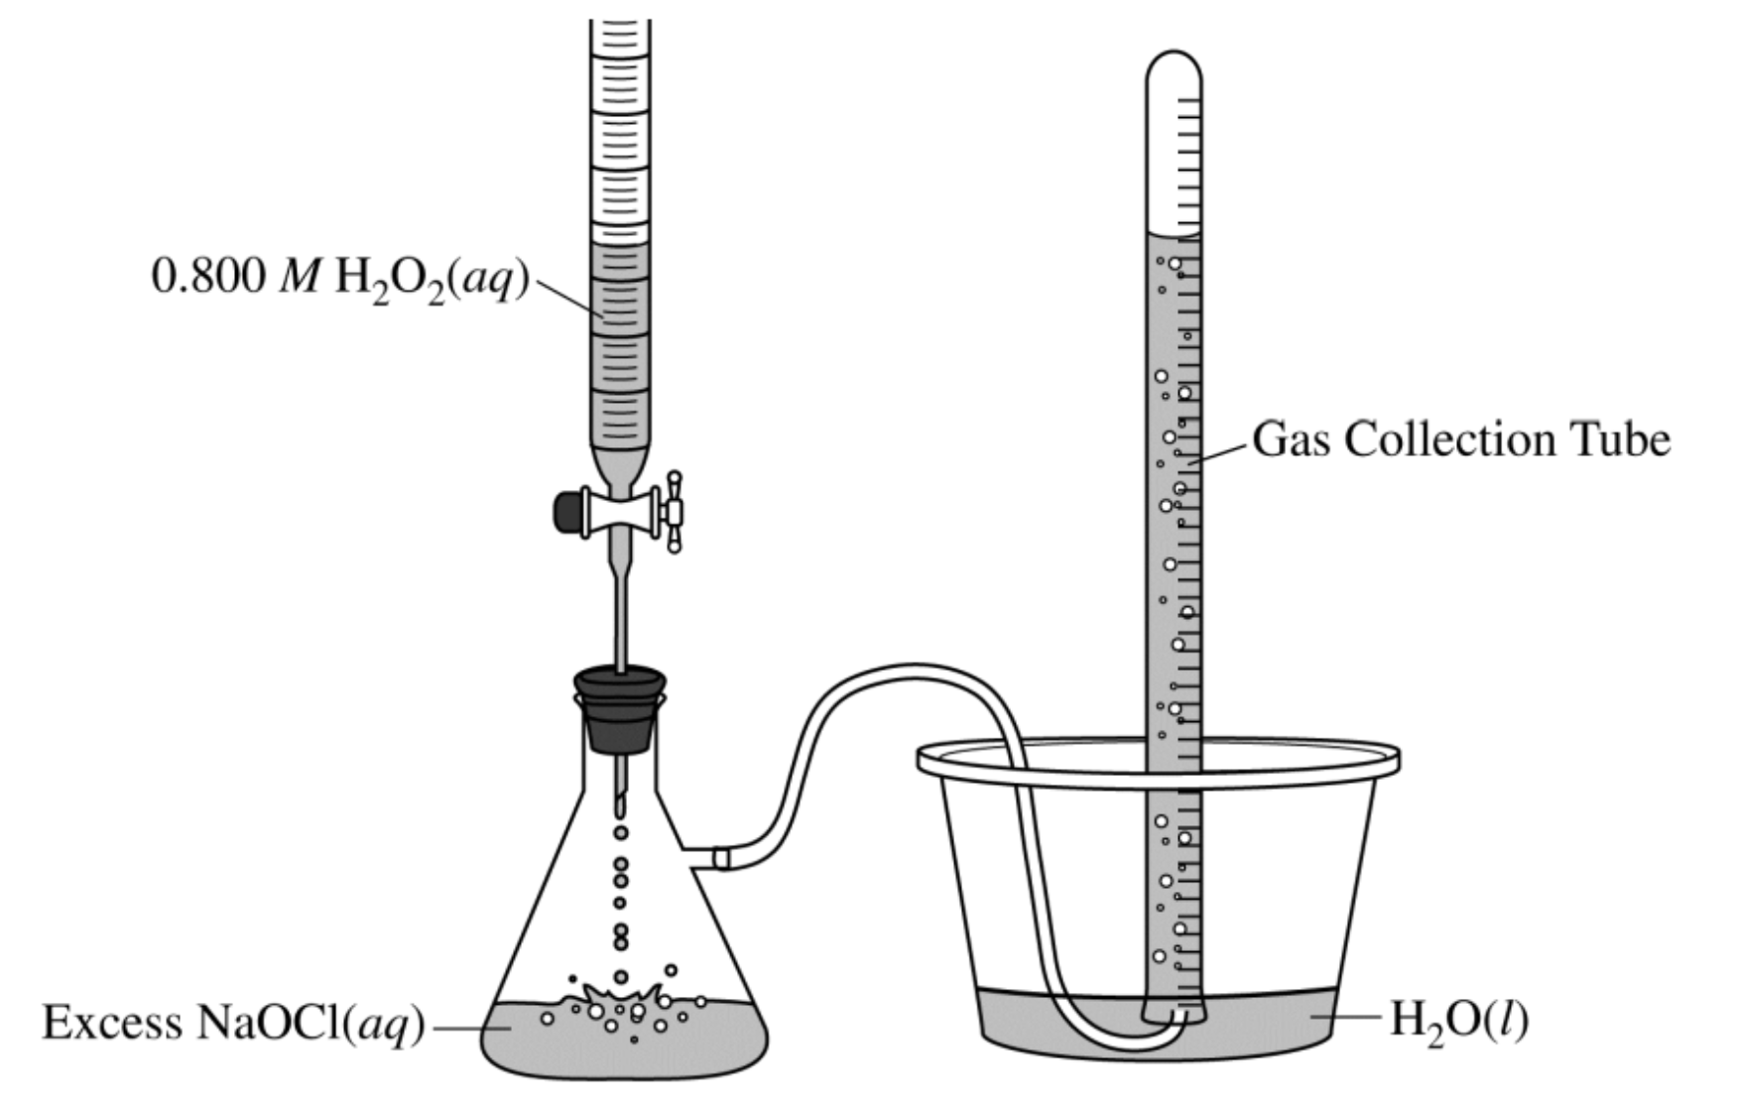

  - Calculate the volume of 0.800 M H₂O₂(aq) that the student should add to excess NaOCl(aq) to produce 40.0 mL of O₂(g) at 0.988 atm and 298 K.
  - The student added the amount of H₂O₂(aq) calculated in part (a) to excess NaOCl(aq). However, instead of producing 40.0 mL of O₂(g), the volume indicated in the diagram below was produced.
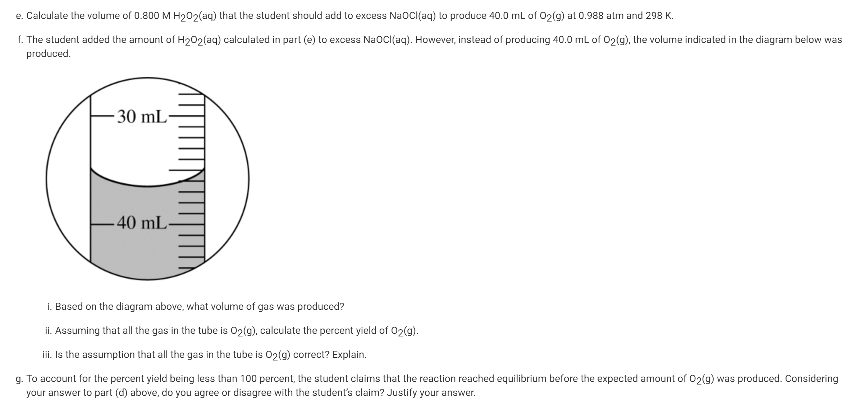
    - Based on the diagram above, what volume of gas was produced?

    - Assuming that all the gas in the tube is O₂(g), calculate the percent yield of O₂(g).

    - Is the assumption that all the gas in the tube is O₂(g) correct? Explain.

- In the apparatus shown below V₁ = V₂. Answer the questions that follow about the apparatus assuming that there is no change in temperature throughout the experiment.

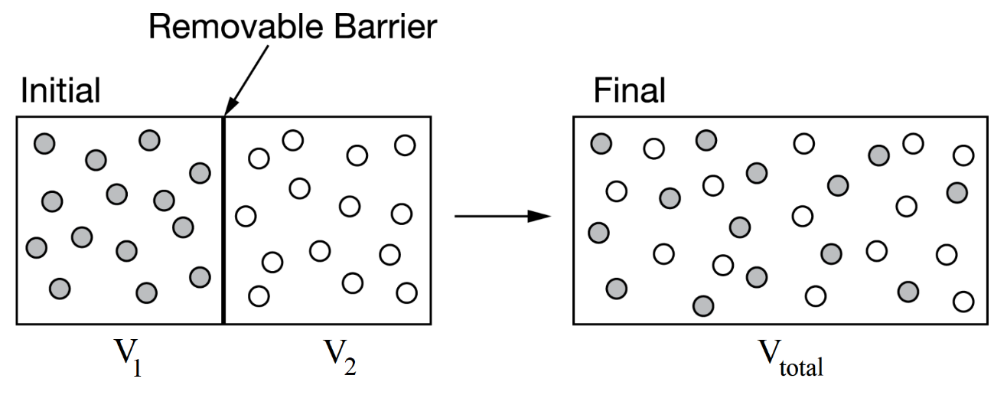

  - How can you tell that in the Initial vessel there are equal number of moles in V₁ and V₂?

  - How would the initial pressure in V₁ compare to the initial pressure in V₂? Explain your reasoning.

  - How does the average KE of the particles in V₁ compare to the average KE of the particles in V₂?

  - What information would you need to know in order to compare the speed of the particles?

  - How does V₁ and V₂ compare to V_{total}?

  - What would happen to the pressure of the gas in V₁ once the barrier is removed, as shown in the Final container? Explain your reasoning.
- Use the data below for the questions that follow. All three gases are in three identical, rigid containers.

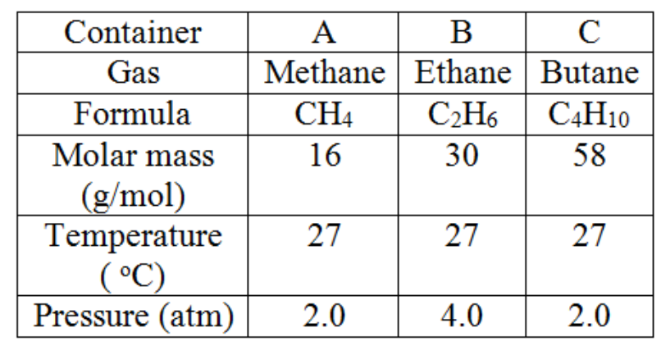

  - Which container has the most number of particles? Explain your reasoning.

  - Which container do the particles have the lowest speed? Explain your reasoning.

  - Which container has the greatest density? Explain your reasoning.

- Consider the boxes below all at the same temperature.

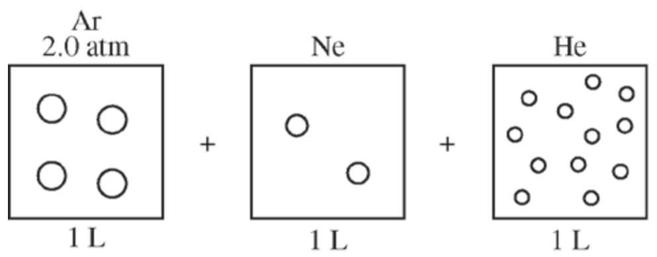

  - Determine the pressure in the Ne box. Explain your reasoning.

  - Determine the pressure in the He box. Explain your reasoning.

  - What would be the total pressure if all three gases were placed in the same 1 L container.

  - What would be the pressure of He if all three gases were placed into a 2 L container. Explain your reasoning.
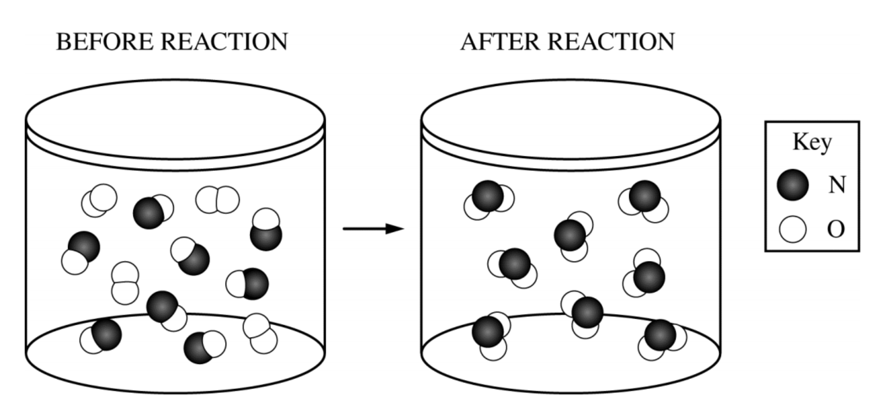
- A chemical reaction is carried out in a rigid container as illustrated above.
  - Write the balanced chemical equation.

  - How would the pressure of the container before the reaction compare to the pressure of the container after the reaction? Explain your reasoning.

- Enough Ar(g) is pumped into a rigid container such that the pressure of Ar(g) is 0.45 atm.
  - What would be the pressure if the number of Ar(g) particles was doubled?

  - The container from (a) has additional CO₂(g) pumped in so that the partial pressure of CO₂(g) is 0.30 atm.
    - What is the partial pressure of Ar(g)?

    - What is the total pressure?

Topic 3.6 Worksheet

- Shown below is the van der Waals equation for real gases. Explain each variable that factors for deviations from the ideal gas law.

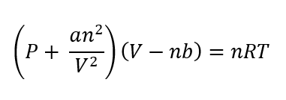

- Explain why a gas at low temperature deviates from the ideal gas law.

- Explain why a gas at high pressure deviates from the ideal gas law.

- Which will deviate more at high pressures, a large gas particle or a small gas particle? Explain your reasoning.

- Which will deviate more at low temperatures, a particle with weak intermolecular forces or a particle with strong intermolecular forces? Explain your reasoning.

- Would you expect the predicted pressure of a sample of CH₄ to be closer to or further from the predicted pressure of a sample of CCl₄? Explain your reasoning.

Topic 3.7 Worksheet

- Describe the procedure a student should use to prepare 250. mL of 0.125 M CuSO₄(aq) using appropriate equipment selected from the list below. Assume that the student uses appropriate safety equipment.

- 250 mL beaker
- 250 mL graduated cylinder
- 250 mL volumetric flask
- Eye dropper
- 500 mL wash bottle filled with distilled water
- 3.000 M CuSO₄ in a 50 mL buret

- Describe the procedure a student should use to prepare 100. mL of 0.250 M NaOH(aq) using appropriate equipment selected from the list below. Assume that the student uses appropriate safety equipment.

- 100 mL beaker
- 100 mL graduated cylinder
- 100 mL volumetric flask
- Eye dropper
- 500 mL wash bottle filled with distilled water
- Electronic balance
- Weigh boat
- NaOH(s)

- A student used a 50.0 mL buret to add KMnO₄(aq) to H₂C₂O₄(aq) until a faint lavender color was observed in the flask, an indication that the end point of the titration had been reached.
  - The initial and final volume readings of the solution in the buret are shown below. Write down the initial reading and the final reading and use them to determine the volume of KMnO₄(aq) that was added during the titration.

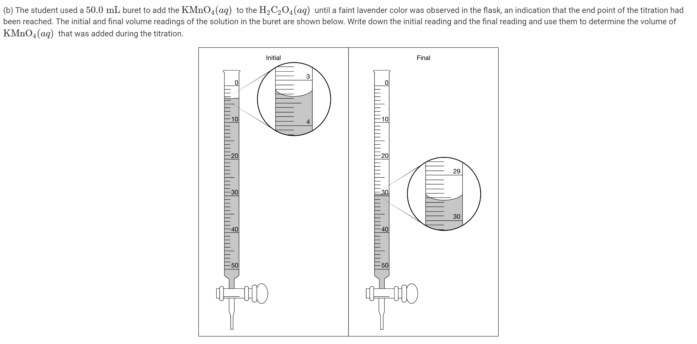
  - Determine the moles of KMnO₄ delivered if the molarity of the KMnO₄(aq) is 0.320 M.
- First, perform the following calculations without a calculator. Then, check your work with a calculator.
  - A 100 mL sample of 0.500 M NaNO₃(aq) solution is mixed with 100 mL of 0.500 M Ca(NO₃)₂(aq) solution. What is the final concentration of the NO₃⁻ ion?

  - How many grams of CaCO₃(s) (molar mass 100. g) are needed to make 10. mL of 0.50 M solution?

  - A 540 mg sample of glucose (molar mass 180 g) is dissolved in enough water to make 300. mL of solution. What would be the molarity of glucose in 100. mL of the solution?

  - A student dilutes 100. mL of 2.00 M CaCl₂(aq) to a final volume of 400. mL with distilled water.
    - How many moles of chloride ion are in the 100. mL solution?

    - How many moles of chloride ion are in the 400. mL solution?

    - What is the molarity of chloride ion in the 100. mL solution?

    - What is the molarity of chloride ion in the 400. mL solution?

Topic 3.8 Worksheet

- Use the key below to draw the solutions indicated.

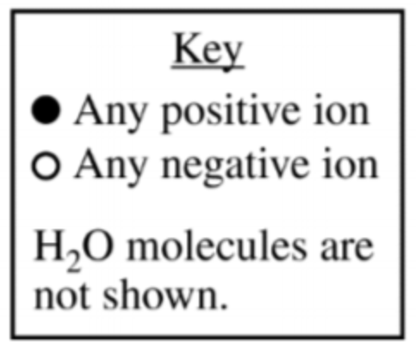

Dilute KCl(aq) |  | Concentrated KCl(aq) |  | Dilute Al(NO₃)₃(aq) |  | Concentrated Al(NO₃)₃(aq)
Dilute Na₃PO₄(aq)

- A student mixes 100. mL of Na₂CO₃(aq) with an excess amount of Ca(NO₃)₂(aq), as shown in the equation below.

Na₂CO₃(aq) + Ca(NO₃)₂(aq) → 2 NaNO₃(aq) + CaCO₃(s)

The diagram below showing the beaker where the reaction takes places is incomplete. Draw in the species needed to accurately represent the major ionic species remaining in the solution after the reaction has been completed.

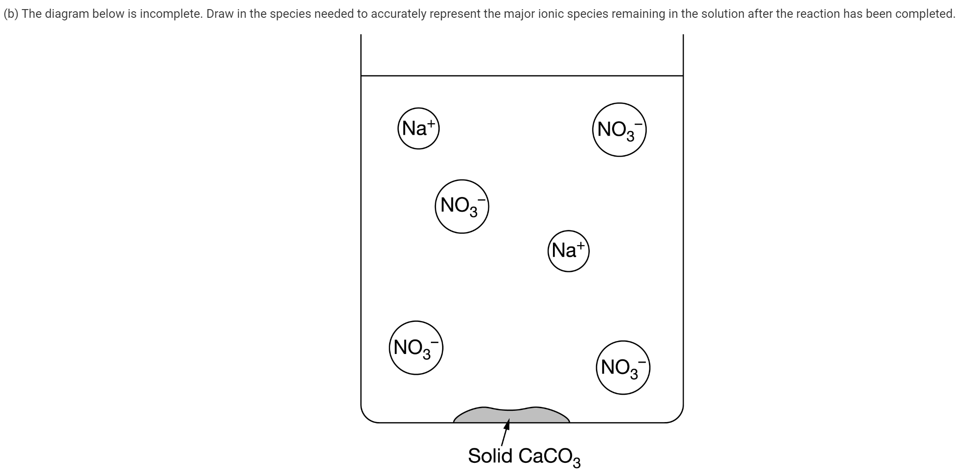
- Beaker X contains a solution of AgNO₃ while Beaker Y contains a solution of MgCl₂. Answer the questions that follow about the reaction that occurs when Beaker X and Beaker Y are poured into Beaker Z.

2 AgNO₃(aq) + MgCl₂(aq) → 2 AgCl(s) + Mg(NO₃)₂(aq)

  - Determine which beaker below is correct for Beaker X. Explain your reasoning. Be certain to discuss all beakers in your explanation.

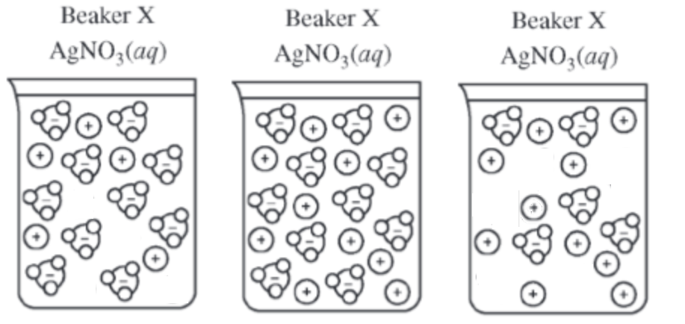
Beaker 1 |  | Beaker 2 |  | Beaker 3

  - Determine which beaker below is correct for Beaker Y. Explain your reasoning. Be certain to discuss all beakers in your explanation.

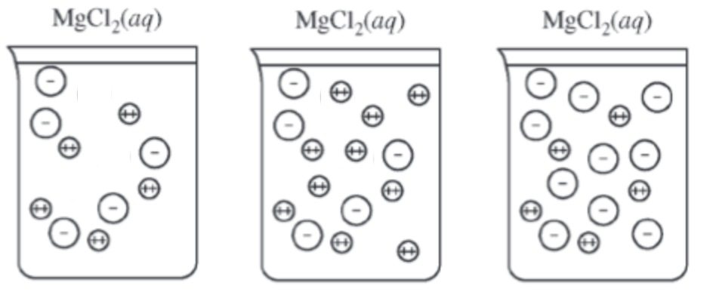
Beaker 4 |  | Beaker 5 |  | Beaker 6

  - In Beaker Z draw in the species needed to accurately represent the major ionic species remaining in the solution after the reaction described has been completed. Draw 10 cations and the correct number of anions each time. Then determine the mass of AgCl(s) formed in each reaction.

    - 50. mL of 1.00 M AgNO₃(aq) reacts with 50. mL of 1.00 M MgCl₂.
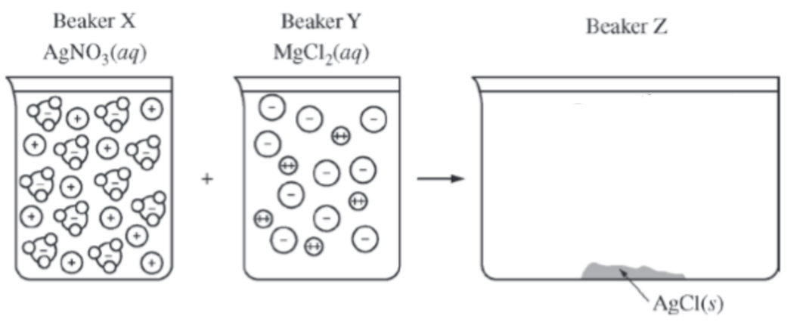

    - 100. mL of 1.00 M AgNO₃(aq) reacts with 50. mL of 1.00 M MgCl₂.

    - 150. mL of 1.00 M AgNO₃(aq) reacts with 50. mL of 1.00 M MgCl₂.
- Use the beakers below to draw an accurate representation of …

CuNO₃(aq) |  | Cu(NO₃)₂(aq)

- In the box below draw the most likely orientation of H₂O(l) molecules around the Cu²⁺ ion.

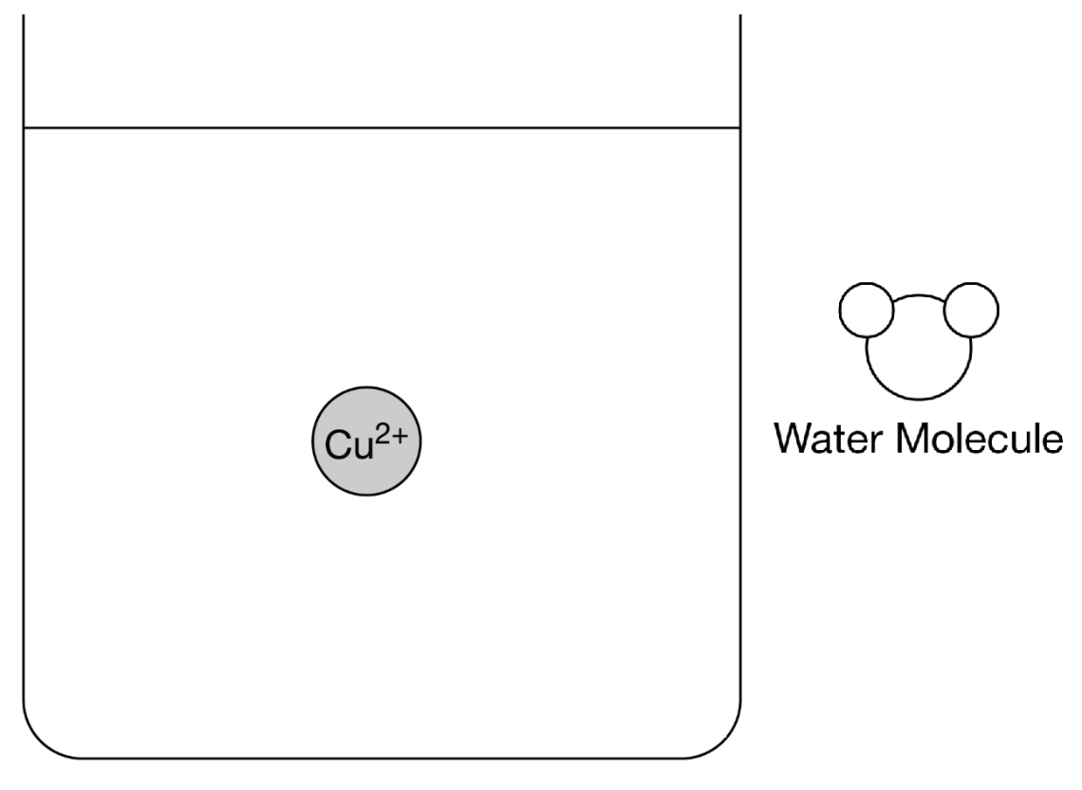

- Shown below is a representation of water and a crystal of LiCl. Answer the questions that follow about a student making a solution of LiCl(aq).

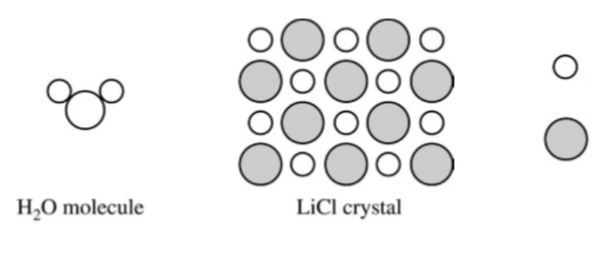
  - Determine the identity of each particle below. Explain your reasoning.

  - In the space provided below, show the interactions of the components of LiCl(aq) by making a drawing that represents the different particles present in the solution. Base the particles in your drawing on the particles shown in the representation above. Include only one formula unit of LiCl and no more than ten molecules of water. Your drawing must include the following details:

- Identify of ions (symbol and charge)
- The arrangement and proper orientation of the particles in the solution

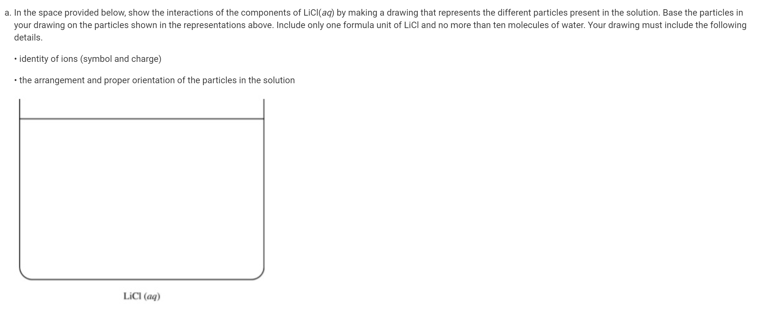

Topic 3.9 Worksheet

- Briefly describe each separation technique and explain when that technique should be used.

  - Filtration
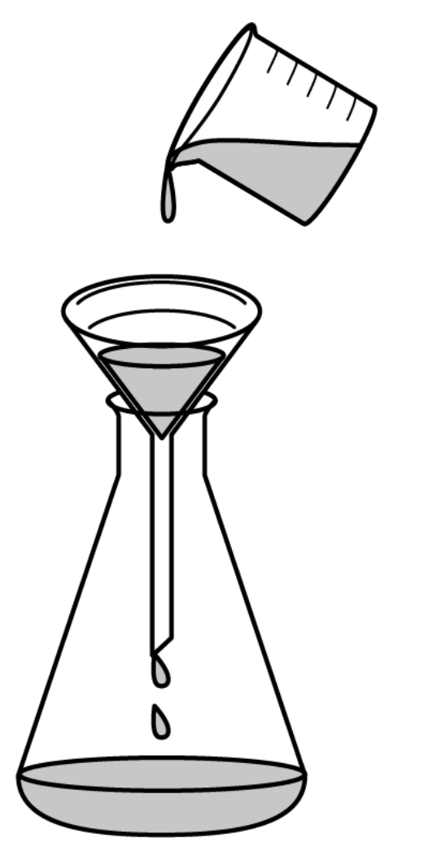
  - Paper Chromatography
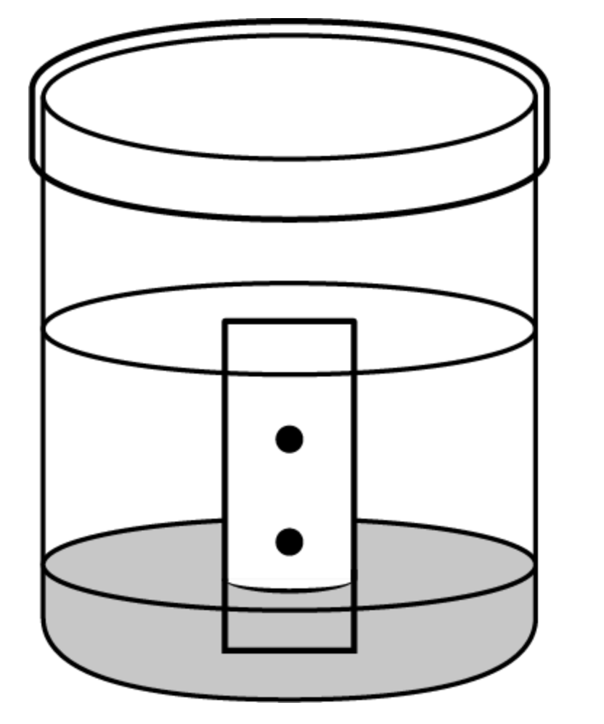
  - Column Chromatography
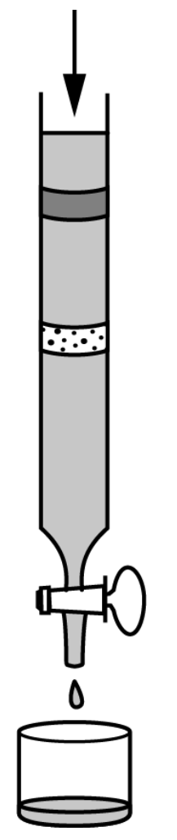
  - Distillation
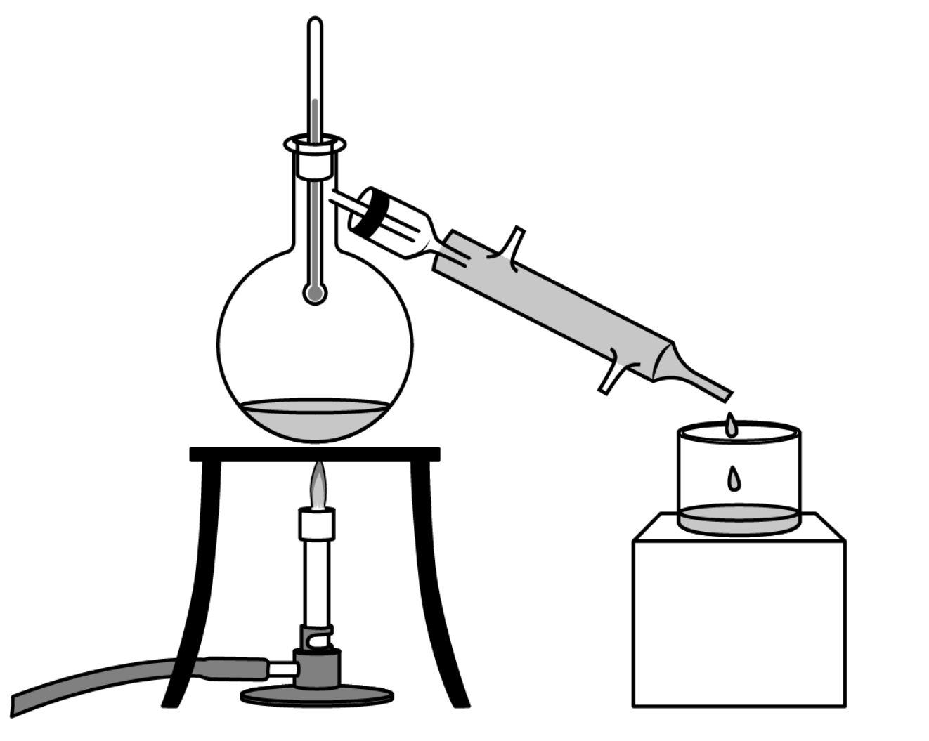

- A student performs a fractional distillation to separate a mixture of two hydrocarbons, C₇H₁₆ and C₈H_{18.} Four ranges are shown for which the student collected the distillate.

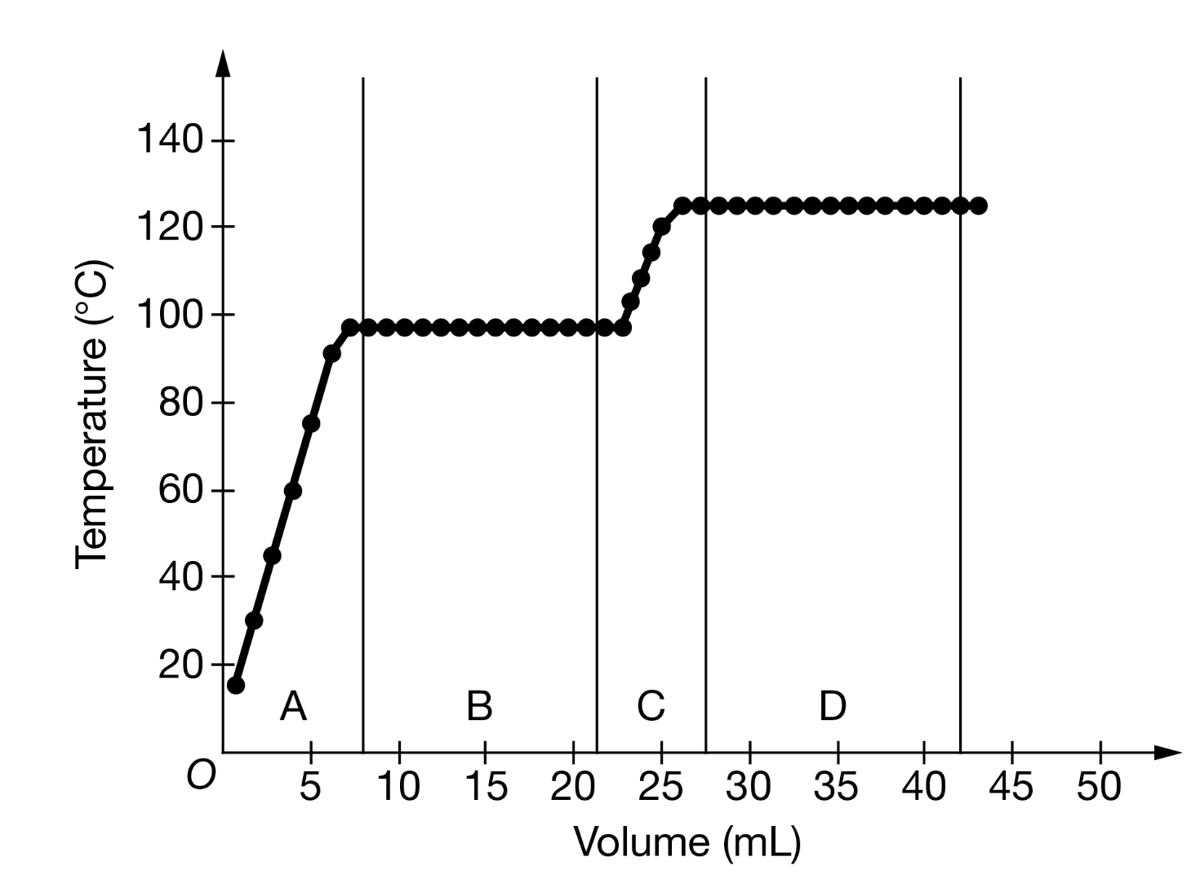

  - Why is there a plateau at both B and D?

  - Which range corresponds to C₇H₁₆? Explain your reasoning. In your explanation, you must discuss both hydrocarbons.

- Consider the paper chromatography experiment shown below. A student is trying to separate a mixture of components X and Y. The paper is slightly polar.

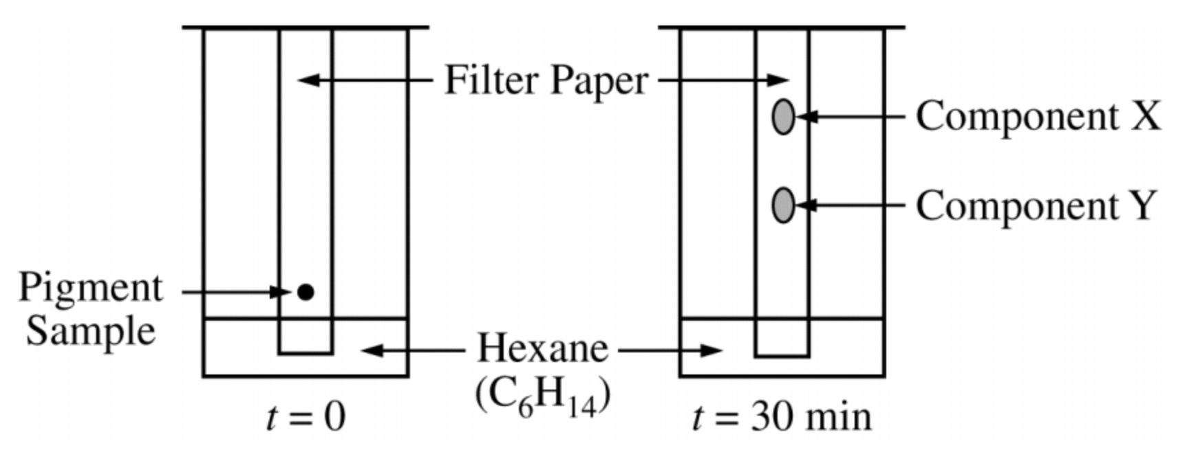
  - What is the mobile phase in this experiment?

  - What is the stationery phase in this experiment?

  - Is Component Y more or less polar than Component X? Explain your reasoning.
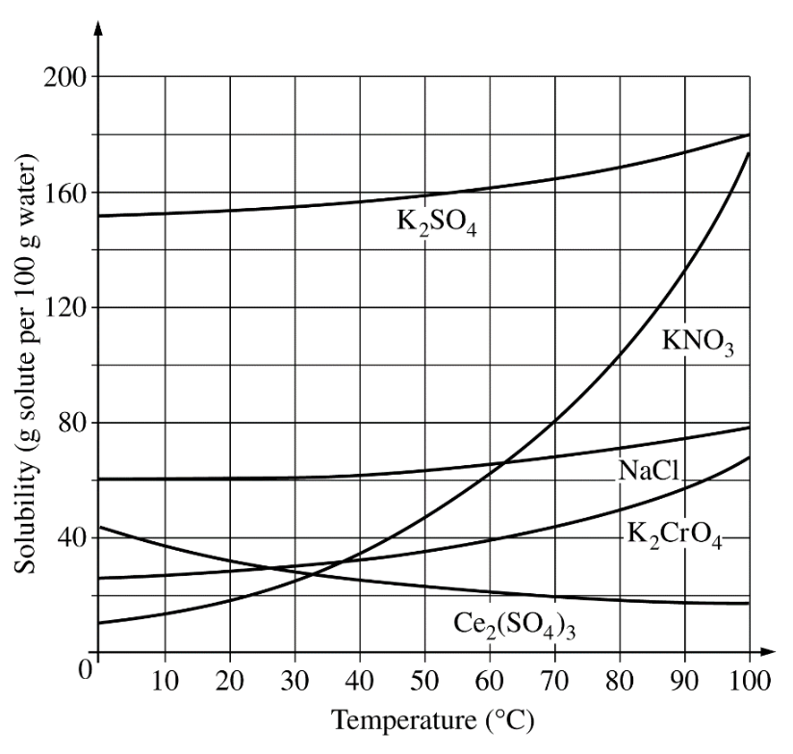
- Use the solubility curve above to answer the question that follows. You have a mixture of saturated KNO₃ and saturated NaCl at 90 ℃. Which solute will precipitate the most when the temperature is dropped to 70 ℃?

Topic 3.11 Worksheet

- Describe the molecular motion or electronic transition for each of the energies listed:
  - Microwave radiation

  - Infrared radiation

  - Ultraviolet/visible radiation

Topic 3.12 Worksheet

- Identify all variables in the equations below and give the magnitude of any constants.
  - $E=hν$

  - $c=λν$

- Perform the following calculations without a calculator. Then check your work with a calculator.
  - Determine the amount of energy of a photon with a frequency of 4 x 10¹⁴ Hz.

  - A photon has 3.3 x 10 ⁻¹⁹ J of energy.
    - What is the frequency of light?

    - What is the wavelength of light?

Topic 3.13 Worksheet

- Identify the variables in the equation below.

$$A=εbc$$

- Answer the following questions about creating a Beer-Lambert Law plot.
  - What is a cuvette?

  - Why do you need to create a “blank”?

  - How do you select a wavelength to measure a colored solution?

  - How would you create a standard curve in a Beer’s Law plot?

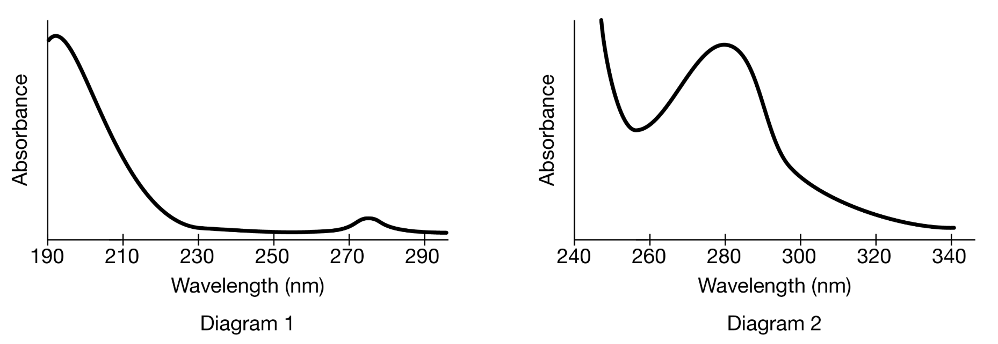

- Diagram 1 shows the absorbance of pure acetone, a common solvent. Diagram 2 is the absorbance of a solution of a solute in acetone.
  - Using diagram 1, explain why it’s more important to make a “blank” of acetone in the experiment.

  - When the student creates Diagram 2 she finds that the absorbance at 280 nm is slightly more than it should be. What is one mistake that could cause the wavelength being greater than it should.
- Determine if the errors below would increase, decrease, or not change the measured absorbance while creating the standard curve of a Beer-Lambert Law plot. Explain your reasoning.
  - There is some distilled water left in the cuvette when the sample is poured into it.

  - The cuvette isn’t properly wiped before being placed in the spectrometer.

  - The molarity of the solution is recorded incorrectly.

- A uses visible spectrophotometry to determine the concentration of CoCl₂(aq) in a sample solution. First the student prepares a set of CoCl₂(aq) solutions of known concentration. Then the student uses a spectrophotometer to determine the absorbance of each of the standard solutions at a wavelength of 510 nm and constructs a standard curve. Finally, the student determines the absorbance of the sample of unknown concentration.

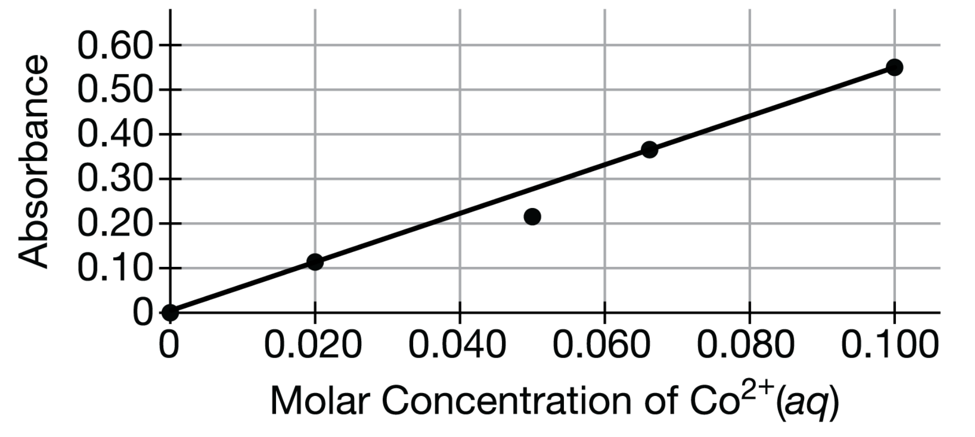

  - The absorbance at 0.050 M is lower than it should be.
    - Is the solution more concentrated or less concentrated than it should be at that point?

    - What could cause this error? Explain your reasoning.

  - The absorbance of the unknown is found to be 0.45.
    - What is the molarity of Co²⁺(aq) in the solution?

    - How many moles of CoCl₂ are in 150. mL of the solution?
- A 1.00 g mixture of sodium sulfate, Na₂SO₄, and copper(II) sulfate, CuSO₄ is to be analyzed to determine the percent by mass of Na₂SO₄. The 1.00 g sample is dissolved into 10.0 mL of total solution and then analyzed via spectrometry. First, the student prepares a calibration graph by measuring the absorbances of CuSO₄(aq) solutions of known concentrations. The graph is shown below. The impure solid has an absorbance of 0.60.

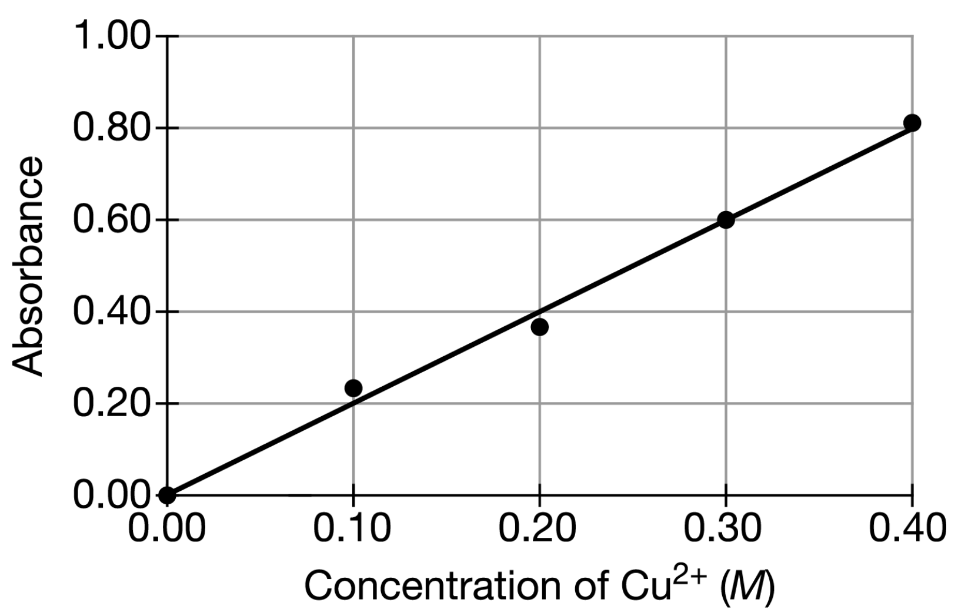

  - Determine the molarity of Cu²⁺ for the solution.

  - Determine the number of moles of Cu²⁺ in the 10.0 mL sample.

  - Determine the percent composition by mass of sodium sulfate in the mixture.

  - If the original solid mixture was dissolved in 100. mL of total solution instead of 10. mL, would you expect the absorbance to increase, decrease, or remain the same? Explain your reasoning.

Unit 4

Topic 4.1 Worksheet

- Determine either the phase change or the term for the phase change. Then determine if the intermolecular forces are weakening, breaking, or forming.

 | Phase Change |  |  |  | Term | Are the IMF weakening,  breaking, or forming?
(A) | Solid | → | _________ |  | Melting | Weakening | Breaking | Forming
(B) |  | → |  |  | Boiling | Weakening | Breaking | Forming
(C) | Gas | → | Liquid |  | Condensing | Weakening | Breaking | Forming
(D) |  | → | Gas |  | Sublimation | Weakening | Breaking | Forming
(E) | Gas | → | Solid |  |  | Weakening | Breaking | Forming
(F) |  | → |  |  | Freezing | Weakening | Breaking | Forming

- Determine if energy is going into the system or if energy is being released from the system for each of the phase changes from #1. Explain how the energy is being used in each case.

 | Energy absorbed or released | Use of energy
(A)
(B)
(C)
(D)
(E)
(F)

- Go back to #1 and circle the phase that has more energy.

- Complete the following reactions.

Metal + Acid
Metal | Acid | → | Salt | + | Gas
Magnesium + | Hydrochloric acid | → |  | +
Zinc + | Hydrochloric acid | → |  | +
Magnesium + | Sulfuric acid | → |  | +

Carbonate + Acid
Carbonate | Acid | → | Products
Magnesium carbonate + | Hydrochloric acid
 |  | →
Zinc carbonate + | Hydrochloric acid
 |  | →
Aluminum carbonate + | Sulfuric acid
 |  | →

Review Topic 1.3 and 1.4

- Draw a picture of a monatomic element. |  | - Draw a picture of a diatomic element.
- Draw a picture of a compound. |  | - Draw a picture of a mixture.

- Consider the compound copper(II) acetate, Cu(C₂H₃O₂)₂ .
  - Determine the percent composition of C.

  - How many grams of carbon would be in 1.85 g of copper(II) acetate.

- Use the information below to determine the molecular formula of a compound.
  - Determine the empirical formula of the compound that is 62.01% carbon, 13.88% hydrogen, and 24.11% nitrogen.

  - Determine the molecular formula of the compound if it has a molar mass of 174.3 g mol ⁻¹.

Review Topic 1.2

- What is the relative atomic mass of this monatomic element? Determine the identity of the element.

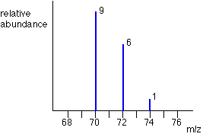

Topic 4.2 & 4.3 Worksheet

- First, balance the equation. Then, give the net-ionic equation for each reaction below. Finally, circle the driving force for each reaction in the net-ionic equation.
  - _____Co(NO₃)_{2(aq)} + _____NaOH_{(aq)} → _____NaNO_{3(aq)} + _____Co(OH)_{2(s)}
  - _____H₂SO₄(aq) + _____CaCO₃(aq) → _____CaSO₄(aq) + _____H₂O(l) + _____CO₂(g)
  - _____HC₂H₃O_{2(aq)} + _____NH_{3(aq)} → _____NH₄C₂H₃O_{2(aq)} [NOTE: HC₂H₃O_{2(aq)} is a weak acid!]

- Define the following:
  - Non electrolyte

  - Weak electrolyte

  - Strong Electrolyte

- What types of compounds are nonelectrolytes? Weak electrolytes? Strong electrolytes?
- Complete the following equations for an ionic compound being placed in water.

  - Sr(NO₃)_{2(s)} →
  - LiCl_{(s)} →
  - (NH₄)₂SO_{4(s)} →

- Draw a picture of a nonelectrolyte in water (CH₃OH), a weak electrolyte in water (HC₂H₃O₂), and a strong electrolyte in water (NaCl).

- In the box below, complete a particle representation diagram that includes four water molecules with proper orientation around the Ca²⁺ ion. Represent water molecules as 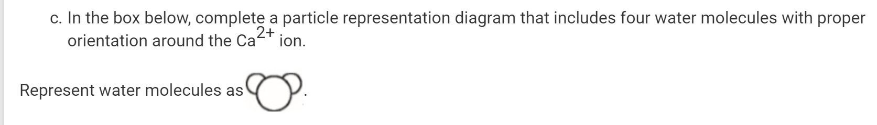.

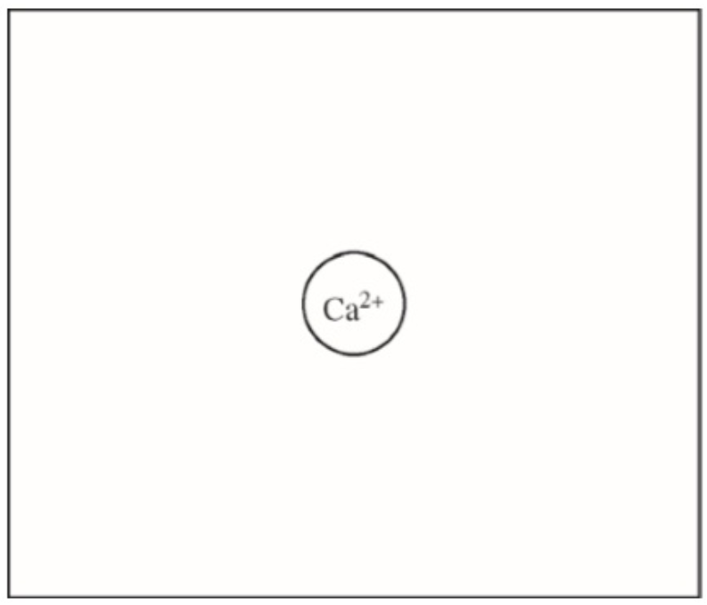

Review Topic 2.5 & 2.7

Bonding Domains around central atom | Nonbonding Domains around central atom | Total # of Electron Domains around central atom | Electron Domain Geometry | Molecular Geometry | Example of a Molecule | Example of a Polyatomic Ion | Hybridization around central atom
2 | 0 | 2 | Linear
3 | 0 | 3 | Trigonal planar
2 | 1 | 3 | Trigonal planar
4 | 0 | 4 | Tetrahedral
3 | 1 | 4 | Tetrahedral
2 | 2 | 4 | Tetrahedral
5 | 0 | 5 | Trigonal bipyramidal
4 | 1 | 5 | Trigonal bipyramidal
3 | 2 | 5 | Trigonal bipyramidal |  |  | N/A
2 | 3 | 5 | Trigonal bipyramidal
6 | 0 | 6 | Octahedral
5 | 1 | 6 | Octahedral |  |  | N/A
4 | 2 | 6 | Octahedral
In the “Molecular Geometry” column, write one of the following molecular shapes in the appropriate spot in the table. Note that some terms may be used more than once.

bent | seesaw | T-shaped | trigonal bipyramidal
linear | square planar | tetrahedral | trigonal pyramidal
octahedral | square pyramidal | trigonal planar

In the “Example of a Molecule” column, write one of the following chemical formulas in the appropriate spot in the table.

CO₂ | ClF₃ | PF₃ | SF₂ | SO₂ | XeF₂
CF₄ | ClF₅ | PF₅ | SF₄ | SO₃ | XeF₄
 |  |  | SF₆

In the “Example of a Polyatomic Ion” column, write one of the following chemical formulas in the appropriate spot in the table.

–  Br₃ | –  ClO₂ | +  NO₂ | –  PF₄ | 2–  SO₄
 | –  ClO₃ | –  NO₂ | –  PF₆ | +  SF₅
 | –  ClF₄ | –  NO₃

In the “Hybridization around central atom” column, write one of the following in the appropriate spot in the table. Note that some terms may be used more than once.

sp | sp² | sp³ | sp³d | sp³d²
 |  |  | (Not tested on exam) | (Not tested on exam)

Complete the following table.
Molecular Geometry | # of Bonding Domains around central atom | # of Nonbonding Domains around central atom | Name of Molecular Shape | All Bond Angles | Hybridization around central atom
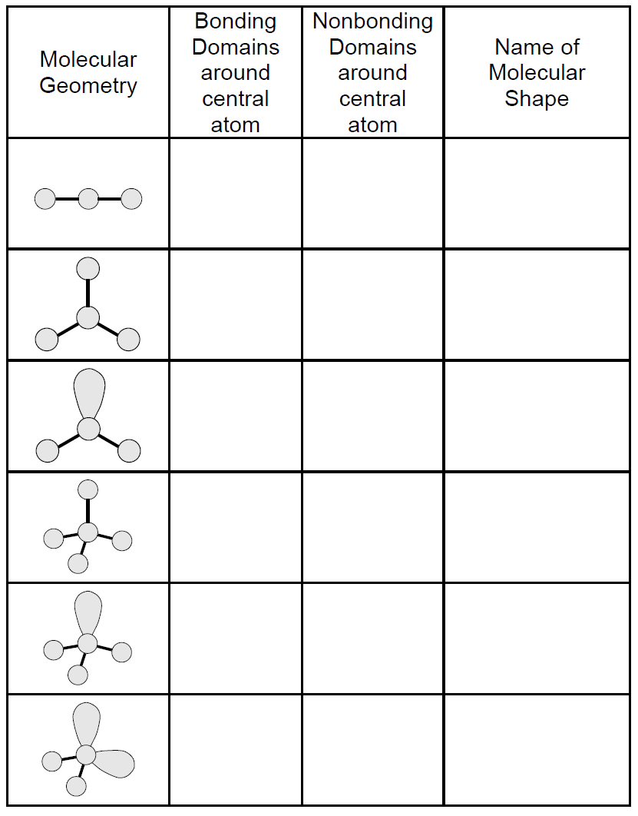
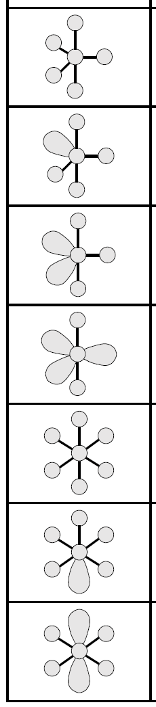

Topic 4.4 Worksheet

- Discuss the changes in forces of attraction that occur during a physical change.

- Discuss the changes in forces of attraction that occur during a chemical change.

Review Topic 2.4

- What are the relative sizes of atoms in an interstitial alloy?

- What are the relative sizes of atoms in a substitutional alloy?

- In the pictures below, circle the interstitial alloy and the substitutional alloy.

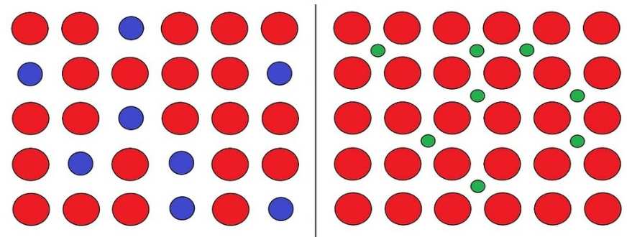
Interstitial Alloy  or  Substitutional Alloy |  | Interstitial Alloy  or  Substitutional Alloy

- Would you expect the density of an interstitial alloy to be greater than, less than, or equal to the density of the original metal? Explain your reasoning.

- Which type of alloy is more malleable and why?

Topic 4.5 Worksheet

Attempt the following questions without a calculator first. Then, check your work with a calculator.

- According to the balanced equation below, how many moles of HI would be necessary to produce 2.5 mol of I₂, starting with 4.0 mol of KMnO₄ and 3.0 mol of H₂SO₄?

10 HI + 2 KMnO₄ + 3 H₂SO₄ → 5 I₂ + 2 MnSO₄ + K₂SO₄ + 8 H₂O

- According to the reaction represented below, about how many grams of aluminum (atomic mass 27 g) are necessary to produce 0.50 mol of hydrogen gas at 25 ℃ and 1.00 atm?

2 Al_{(s)} + 6 HCl_{(aq)} → 2 AlCl_{3(aq)} + 3 H_{2(g)}

- According to the balanced equation below, how many moles of ClO₂–_{(aq)} are needed to react completely with 20. mL of 0.20 M KMnO₄ solution?

2 H₂O(l) + 4 MnO₄ –(aq) + 3 ClO₂ –_{(aq)} → 4 MnO_{2(s)} + 3 ClO₄ –_{(aq)} + 4 OH –_{(aq)}

2 KClO_{3(s)} $\begin{matrix}\underset{→}{∆} \\ MnO_{2}\end{matrix}$ 2 KCl_{(s)} + 3 O_{2(g)}

- According to the equation above, how many moles of potassium chlorate, KClO₃, must be decomposed to generate 1.0 L of O₂ gas at standard temperature and pressure? (This multiple choice gives you an idea of the types of answers that show up from time to time on the AP exam.)
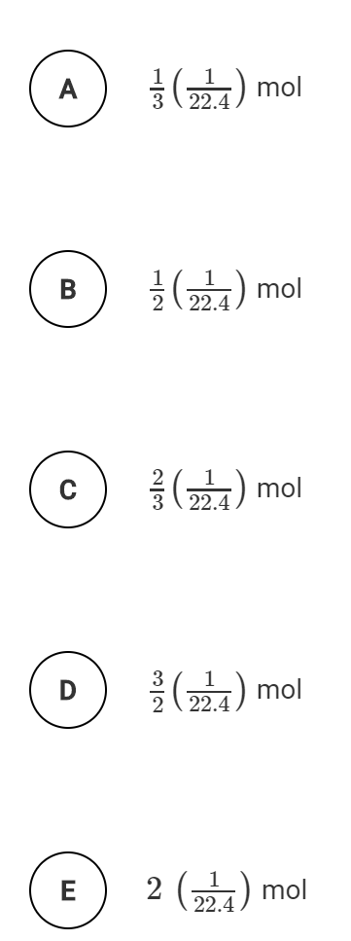

- Acetic acid and sodium bicarbonate are reacted and the gas collected.

HC₂H₃O_{2(aq)} + NaHCO_{3(s)} → NaC₂H₃O_{2(aq)} + H₂O_{(l)} + CO_{2(g)}

  - Determine the volume of CO₂ produced when 2.50 g of NaHCO₃ reacts with 55.0 mL of 0.875 M acetic acid at STP.

  - What mass of sodium bicarbonate is required to produce 19.0 L of carbon dioxide gas at 20 ℃ and 1.2 atm of pressure?

- A 5.000 g sample of an organic hydrocarbon is combusted and the products measured. In the reaction, 15.37 g of carbon dioxide and 7.186 g of water are produced. Assuming the oxygen used for the combustion was in excess, determine the empirical formula of the hydrocarbon.

- A 3.00 g sample of MgSO₄ • xH₂O hydrate is thoroughly heated. The data below is collected.

Mass of test tube | 24.310 g
Mass of test tube + hydrate | 27.330
Mass of test tube + hydrate after 1st heating | 26.320
Mass of test tube + hydrate after 2nd heating | 25.852
Mass of test tube + hydrate after 3rd heating | 25.850

  - Explain why the test tube was heated three times.

  - Determine the mass of water in the hydrate.

  - Determine the ratio of moles of water to moles of anhydrate.

  - Determine the formula of the hydrate.

  - The hydrate is MgSO₄•7H₂O.
    - Determine the percent yield of the hydrate.

    - Determine the percent error of the molar mass of the hydrate.

Review Topic 3.1

- Predict whether the following molecules are polar or nonpolar. Justify your answer using VSEPR models.
Oxygen difluoride, OF₂ |  | Fluoromethane, CH₃F
Methane, CH₄ |  | Hydrogen peroxide, H₂O₂
Carbon disulfide, CS₂ |  | Ammonia, NH₃

- Check the kinds of attractive forces between molecules that are expected.

Molecule | LDF | DD | HB
Oxygen difluoride
Methane
Carbon disulfide
Fluoromethane
Hydrogen peroxide
Ammonia

- What is required for a molecule to be polar?

- When will hydrogen bonding occur? Draw a picture of two different hydrogen bonds between water and
- The boiling point of neopentane is much lower than the boiling point of pentane. Explain why.

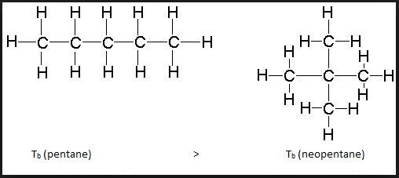
Pentane |  | Neopentane

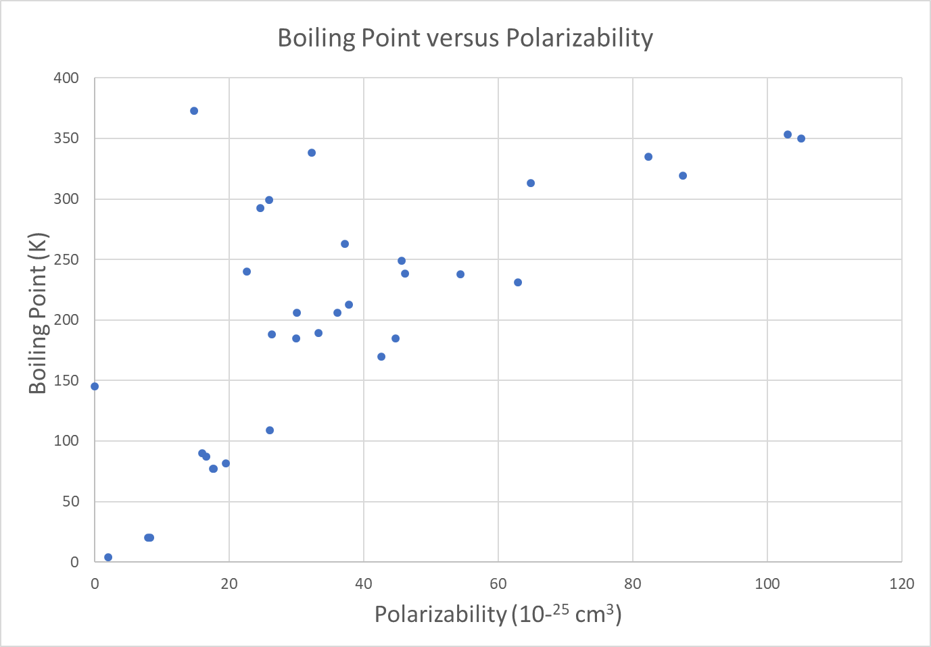

- What is polarizability?

- Which types of compounds exhibit higher polarizability?

- What does the graph above tell you about the general trend for polarizability and boiling point?

- Give two reasons why the highest boiling point of about 375 K has among the lowest polarizability of about 18 x 10 ⁻²⁵ cm³ .

Topic 4.6 Worksheet

- What is a titration?

- What is a titrant?

- What is an analyte?

- What is the equivalence point?

- What is the end point?

- A 0.350 M solution of sodium hydroxide is reacted with 25.00 mL of an unknown molarity of sulfuric acid. It takes 17.3 mL of sodium hydroxide to react completely with the sulfuric acid. Determine the molarity of the sulfuric acid.

_____NaOH_{(aq)} + _____H₂SO_{4(aq)} → _____Na₂SO_{4(aq)} + _____H₂O_{(l)}

- Determine the molarity of an unknown HCl solution if it takes 20. mL of 0.75 M sodium hydroxide to react completely with 10. mL of the HCl solution.

_____HCl_{(aq)} + _____NaOH_{(aq)} → _____NaCl_{(aq)} + _____H₂O_{(aq)}

- A colorless solution of hydrogen peroxide, H₂O₂, is titrated with an acidified, dark purple solution of potassium permanganate, KMnO₄, as shown by the net-ionic reaction below. The student places 5.00 mL of hydrogen peroxide in a 125-mL Erlenmeyer flask and properly fills a buret with the potassium permanganate. Note: At the end point of the titration the solution appears pale pink in color.

5 H₂O_{2(aq)} + 2 MnO₄ ⁻_{(aq)} + 6 H⁺_{(aq)} → 2 Mn²⁺_{(aq)} + 8 H₂O_{(l)} + 5 O_{2(g)}

  - Describe the appearance of the solution as potassium permanganate is added. Explain your reasoning.

  - What in the net-ionic reaction causes the pale pink color at the end point?

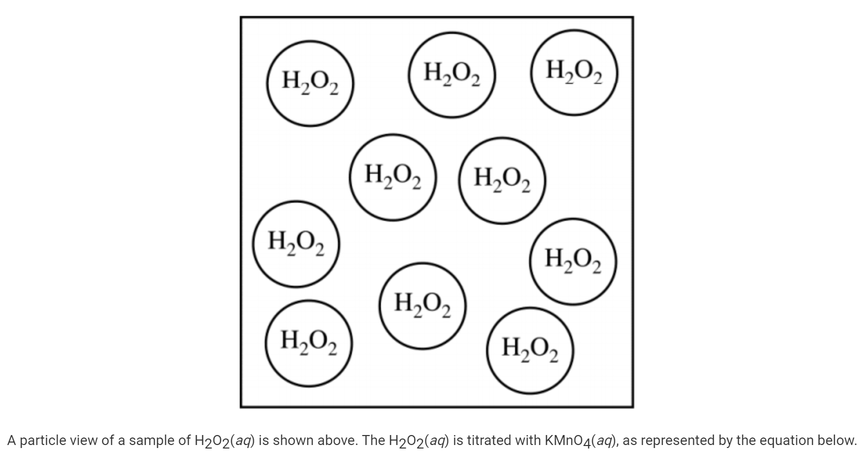
  - A particle view of a sample of H₂O_{2(aq)} is shown above. The H₂O_{2(aq)} is titrated with KMnO₄(aq), as represented in the equation above. Which of the following particle views best represents the mixture when the titration is halfway to the equivalence point? (H₂O molecules and H⁺ ions are not shown.)

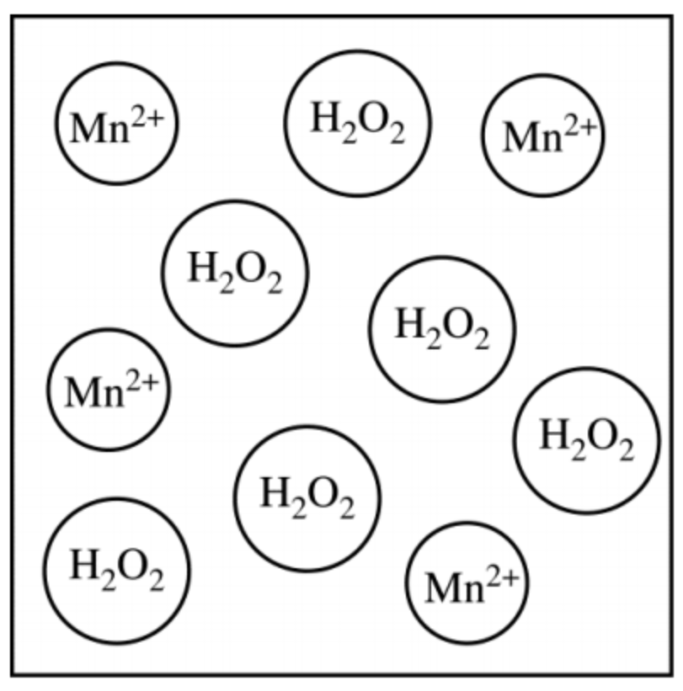 |  | 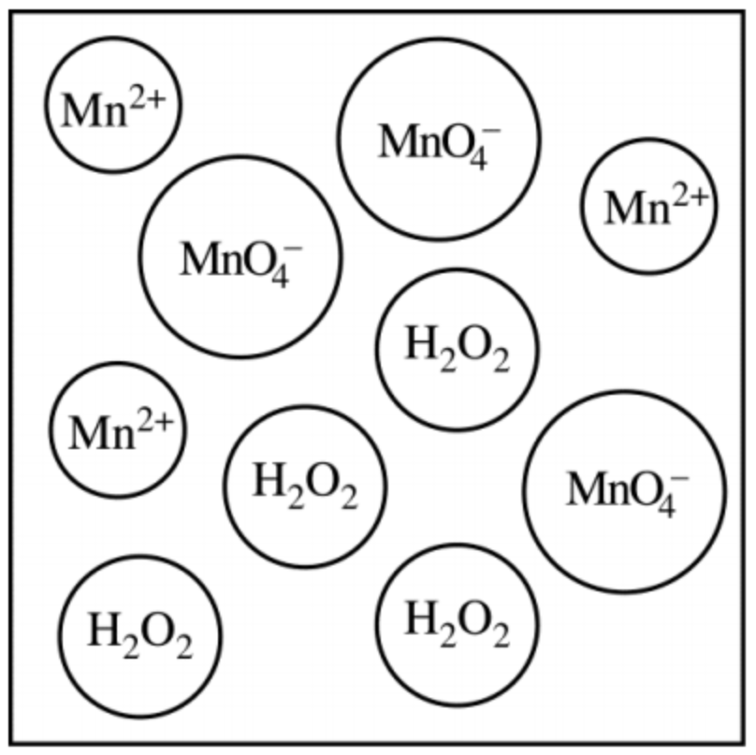 |  | 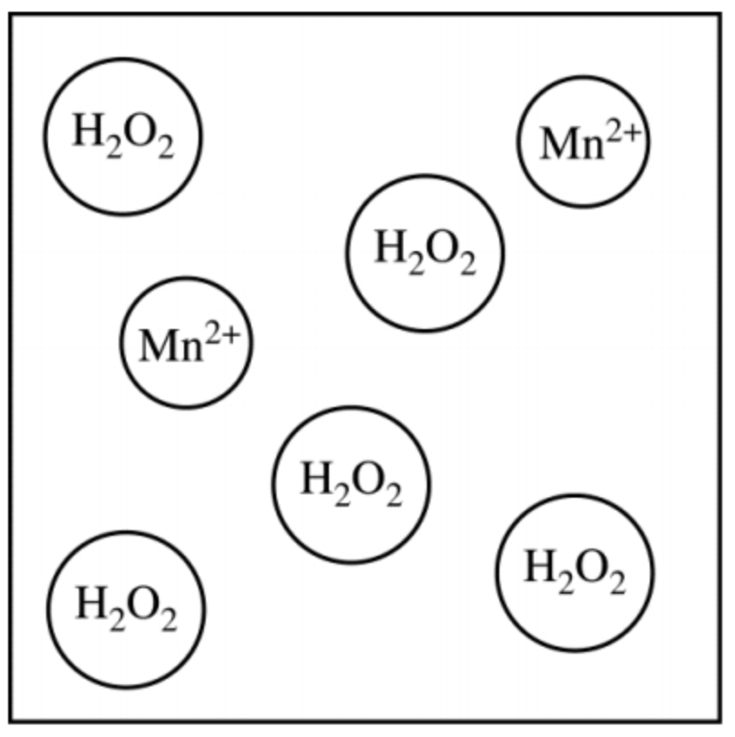 |  | 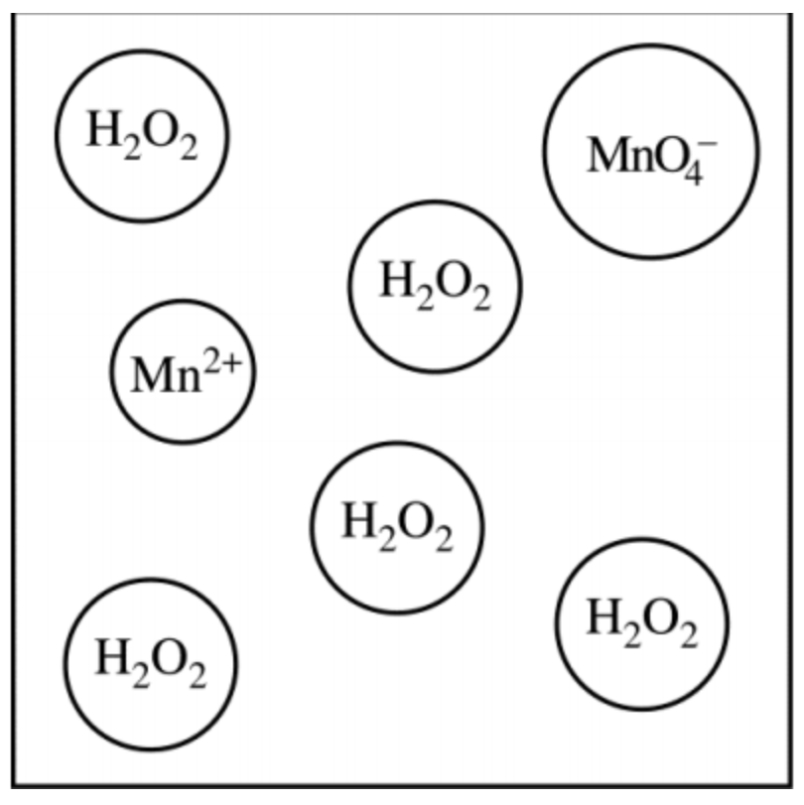
A |  | B |  | C |  | D

  - Determine the molarity of the hydrogen peroxide if a 5.00 mL sample requires 7.98 mL of 0.15 M KMnO₄ to reach equivalence.

  - Determine the percentage by volume of hydrogen peroxide in the aqueous solution. The density of hydrogen peroxide is 1.02 g/mL. Assume the solution of hydrogen peroxide is made up of just water (d = 1.00 g/mL) and hydrogen peroxide and that the volumes are additive.

Review Topic 1.5

- Which has more energy, red light or blue light?

- Give the electron configuration of the following elements:
  - Mg

  - O

  - Br

  - Ni

  - Zr

- Give the orbital notation of each of the elements from #2. You can use the abbreviated electron configuration.
  - Mg

  - O

  - Br

  - Ni

  - Zr

- Give the electron configuration of the most common ion for the following elements:
  - Ca²⁺

  - Fe²⁺

  - Fe³⁺

  - O²⁻

Review Topic 1.6

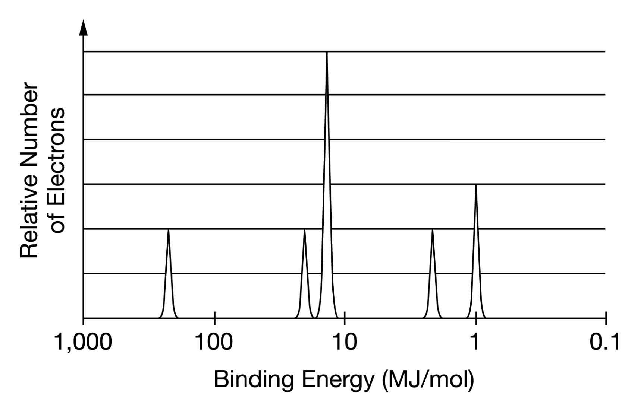

The photoelectron spectrum of an unknown element is shown above.

- Based on the photoelectron spectrum, identify the unknown element and write its electron configuration.

- Label each peak with its shell and subshell designation.

- Circle the valence electrons on the PES graph.

- Consider the element on the periodic table that is directly to the right of the element identified in #1. Would the 1s peak of this element appear to the left of, the right of, or in the same position as the 1s peak of the element in part 1? Explain your reasoning.

Topic 4.7, 4.8, & 4.9 Worksheet
Acid and Base Reactions.

- Define an acid.

- Define a base.

- Define amphoteric.

- What is an acid-base conjugate pair? How do you identify an acid-base conjugate pair?

- Identify the acid, base, conjugate acid, and conjugate base in the following reactions:

HCl (aq) |  | + | H₂O(l) |  | → | H₃O⁺(aq) |  | + | Cl –(aq)
 | Acid |  |  | Acid |  |  | Acid |  |  | Acid
 | Base |  |  | Base |  |  | Base |  |  | Base
 | Conjugate Acid |  |  | Conjugate Acid |  |  | Conjugate Acid |  |  | Conjugate Acid
 | Conjugate Base |  |  | Conjugate Base |  |  | Conjugate Base |  |  | Conjugate Base

NH₃ (aq) |  | + | H₂O(l) |  | ⇌ | NH₄⁺(aq) |  | + | OH ⁻(aq)
 | Acid |  |  | Acid |  |  | Acid |  |  | Acid
 | Base |  |  | Base |  |  | Base |  |  | Base
 | Conjugate Acid |  |  | Conjugate Acid |  |  | Conjugate Acid |  |  | Conjugate Acid
 | Conjugate Base |  |  | Conjugate Base |  |  | Conjugate Base |  |  | Conjugate Base

CH₃NH⁻ (aq) |  | + | HCl(l) |  | → | CH₃NH₂(aq) |  | + | Cl ⁻(aq)
 | Acid |  |  | Acid |  |  | Acid |  |  | Acid
 | Base |  |  | Base |  |  | Base |  |  | Base
 | Conjugate Acid |  |  | Conjugate Acid |  |  | Conjugate Acid |  |  | Conjugate Acid
 | Conjugate Base |  |  | Conjugate Base |  |  | Conjugate Base |  |  | Conjugate Base

- What is a sign in the chemical reaction that the acid/base is stronger than the conjugate acid/conjugate base in a chemical reaction?

- If the acid/base is stronger than the conjugate acid/conjugate base, to which direction does the reaction mostly proceed?

- What is a sign that the acid/base is weaker than the conjugate acid/conjugate base in a chemical reaction?

- If the conjugate acid/conjugate base is stronger than the acid/base, to which direction does the reaction mostly proceed?

- What is a neutralization reaction? What are the products of a neutralization reaction?

- What is the net-ionic reaction for any strong acid/strong base reaction?

- When you look at a chemical reaction, how can you tell that it’s an acid-base reaction?

- Write neutralization reactions for the following reactions. Then give the net-ionic equation. Finally, identify the acid, base, salt, and water. Note: NH₃ is a weak base and HC₂H₃O₂ is a weak acid. Since they are weak they do not break up completely and some molecules are left in solution.

  - HCl + NaOH →

  - H₂SO₄ + NaOH →

  - NH₃ + HCl →

  - HC₂H₃O₂ + NaOH →

Reduction and Oxidation (Redox) Reactions.

- Define oxidation.

- Define reduction.

- Define oxidizing agent. What types of elements tend to be good oxidizing agents?

- Define reducing agent. What types of elements tend to be good reducing agents?

- How can you identify that a substance has been oxidized?

- How can you identify that a substance has been reduced?

- How can you identify a reduction-oxidation reaction?

- Where are the electrons located in an oxidation reaction? A reduction reaction?

- What are the rules for applying oxidation numbers?

- Determine the oxidation number of the atom listed below.
  - C in CO₂
  - S in S²⁻
  - S in S_{(s)}
  - S in SO₄ ²⁻
  - S in SO₃ ²⁻
  - Mn in MnO₄⁻
- For the following reactions,
- Balance the equation.
- Write a net-ionic equation.
- Determine the oxidation states of all species in the net-ionic equation.
- Determine if the reaction is a redox reaction.
  - If the reaction is not a redox reaction then write NONE.
  - If the reaction is a redox reaction determine what is being oxidized and what is being reduced

  - _____Zn_{(s)} + _____HCl_{(aq)} → _____ZnCl_{2(aq)} + _____H_{2(g)}

  - _____Co(NO₃)_{2(aq)} + _____Na₂HPO_{4(aq)} → _____CoHPO_{4(s)} + _____NaNO_{3(aq)}

  - _____CH_{4(g)} + _____O_{2(g)} → _____H₂O_{(l)} + _____CO_{2(g)}

  - _____H₂SO_{4(aq)} + _____Ca(OH)_{2(aq)} → _____CaSO_{4(s)} + _____H₂O_{(l)}

- Write spontaneous redox reactions and determine the overall voltage for the following reactions. DO NOT REPEAT PAIRS OF REACTIONS.

1 | 2 | 3 | 4 | 5 | 6 | 7 | 8 | 9 | 10 | 11 | 12 | 13 | 14 | 15 | 16 | 17 | 18 | 19 | 20 | 21 | 22 | 23 | 24 | 25 | 26
A | B | C | D | E | F | G | H | I | J | K | L | M | N | O | P | Q | R | S | T | U | V | W | X | Y | Z

  - For reaction 1 use the number that corresponds to your first name initial and for reaction 2 use the number that corresponds to your last name initial. If the second reaction is the same letter as your first reaction then add one to the number.

  - For reaction 1 use the second letter of your first name and for reaction 2 use the second letter of your last name. If the second reaction is the same letter as your first reaction then add one to the number.

  - For reaction 1 use the first letter of your friends first name and for reaction 2 use the second letter of your friends first name. If the second reaction is the same letter as your first reaction then add one to the number.

  - For reaction 1 use the fifth letter (or the last letter if there are not five) of your favorite food and for reaction 2 usse the third letter of your middle name. If you don’t have a middle name then use the third letter of your favorite tv show. If the second reaction is the same letter as your first reaction then add one to the number.

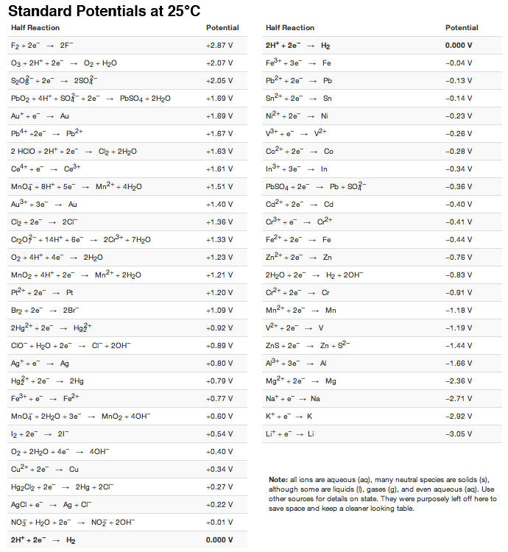

Precipitation Reactions

- For the reactions below:
- Complete the reaction.
- Determine if a precipitate or gas forms. Include phase symbols.
- If a precipitate or gas forms write a net-ionic reaction.

  - NaCl_{(aq)} + NH₄NO_{3(aq)} →

  - Na₃PO_{4(aq)} + Ba(NO₃)_{2(aq)} →

  - K₂S_{(aq)} + (NH₄)₂CO_{3(aq)} →

  - HCl_{(aq)} + NaHCO_{3(aq)} →

Back titration. ( https://cnx.org/contents/r1hm-4a2@3/Back-titration )
A back titration is sometimes used to determine the amount of a substance if the reactant is volatile, if the reactant is contaminated, if the reactant is an insoluble salt, the reaction is too slow, or the reaction involves weak acids and bases. In a back titration, reactant A of unknown concentration is reacted with excess reactant B of known concentration. Then, a normal titration is performed to determine the amount of reactant B in excess. Once you know the excess amount of reactant B you can determine the amount of reactant B used and thus the amount of reactant A.

- A student was asked to determine the mass, in grams, of calcium carbonate present in a 0.125 g sample of chalk. The student placed the chalk sample in a 250 mL Erlenmeyer flask and added 50.00 mL of 0.200 mol L ⁻¹ HCl using a pipette. The excess HCl was then titrated with 0.250 mol L ⁻¹ NaOH. The average amount of NaOH required to reach equivalence was 32.12 mL. Calculate the mass of calcium carbonate, in grams, present in the chalk sample.
Gravimetric analysis.

- A bottle of magnesium chloride, MgCl₂, has been contaminated with an unknown amount of sodium nitrate, NaNO₃. In order to determine the percent by mass of magnesium chloride in the mixture a student conducts a gravimetric filtration. The student takes a known mass of the mixture and dissolves it in 50.0 mL of distilled water to make an aqueous solution. That solution is then reacted with an excess of silver nitrate, AgNO₃, to precipitate the chloride as silver chloride, AgCl_{(s)}. The precipitate is filtered, dried and weighed. The data from the experiment is shown below.

Mass of MgCl₂ & NaNO₃ mixture | 0.7209 g
Mass of filter paper | 4.450 g
Mass of filter paper + precipitate after drying | 5.482 g

  - Determine the mass of precipitate formed in the reaction.

  - Determine the mass of magnesium chloride in the original sample assuming the silver nitrate was in excess and the reaction below went to completion.

_____MgCl_{2(aq)} + _____AgNO_{3(aq)} → _____AgCl_{(s)} + _____Mg(NO₃)_{2(aq)}

  - Determine the percent by mass of magnesium chloride in the original sample.

Unit 5

Topic 5.5 Worksheet

- What are the conditions for the collision theory?

- Define activation energy.

- Explain the various ways a reaction could be unsuccessful according to the collision model.

- Explain how increasing temperature can increase the rate of a reaction in terms of…
  - the collisions.

  - the activation energy.

- Explain how catalysts …
  - lower the required activation energy.

  - correct for orientation.

- Explain why a termolecular elementary step is rare in terms of the collision model.
- Explain why an increase in concentration of a reactant may lead to an increase in reaction rate according to the collision model.

- Explain why, at constant temperature, an increase in pressure of a gas causes an increase in the reaction rate in terms of the collision model.

- Use the figure below to answer the questions that follow.

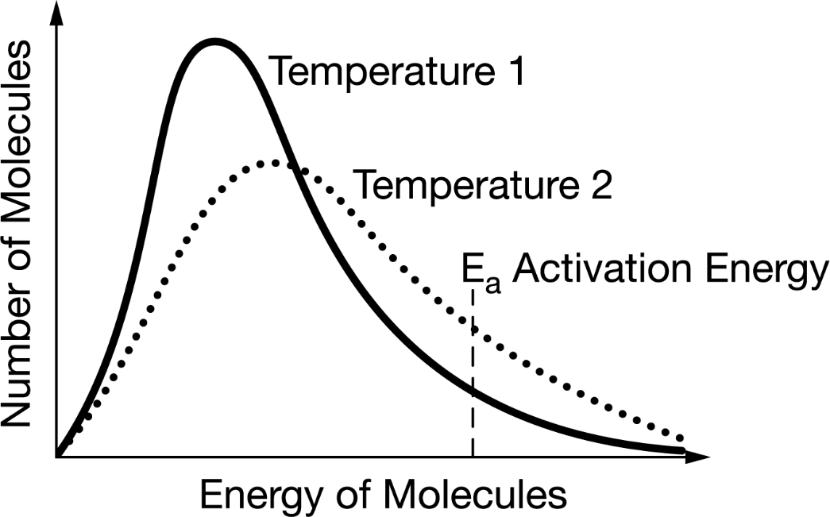

  - Which is at a higher temperature, T₁ or T₂? Justify your answer by referring to the figure.

  - Which would have a greater rate of disappearance of reactants, T₁ or T₂. Explain your answer by referring to the collision model.

- The two elementary steps below are carried out at the same temperature. Reaction 1 takes longer than reaction 2. Assuming no difference in correctly oriented collision, explain why reaction 1 would take longer than reaction 2.

Reaction 1 | H₂(g) + ICl(g) → HI(g) + HCl(g) | Slow
Reaction 2 | HI(g) + ICl(g) → HCl(g) + I₂(g) | Fast

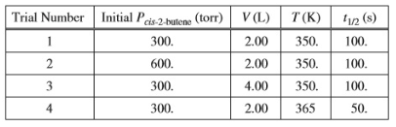

- Refer to the data table above. The half-life of a reaction was measured under various conditions. The half-life of the reaction in trial 4 is less than the half-life in trial 1. Explain why in terms of activation energy.

Review Topic 3.13

- Explain the process of creating a blank and calibrating a spectrophotometer with acetone as the solvent in the experiment.

- Explain why a blank is needed to calibrate the spectrophotometer.

- Explain the effect of a fingerprint on the cuvette for the recorded absorbance.

- Explain why the concentration of sodium chloride can not be measured via Beer’s Law.

- Use the graph below to answer the questions that follow.
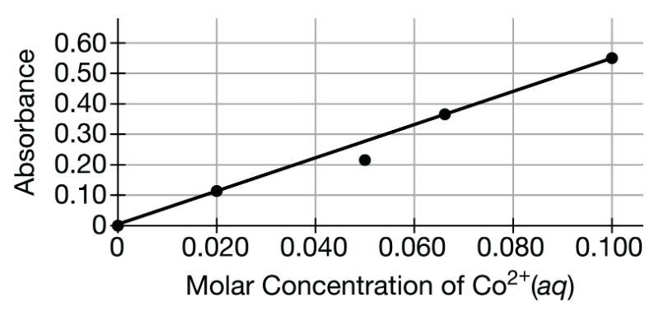
  - Determine the molarity of a solution that has an absorbance of 0.45.

  - What error could have possibly caused the point the student plotted at 0.050 M Co²⁺(aq)?

  - How many moles of Co²⁺(aq) would be present in 100. mL of a solution with an absorbance of 0.15 ?
- A student conducts an experiment to determine the absorbance of red food coloring at various concentrations. The student wants to do the same experiment with blue food coloring. How would the student need to modify the original experimental procedure to determine the absorbance of blue food coloring at various concentrations? Why is the modification required?

- Use the figure below to answer the questions that follow.

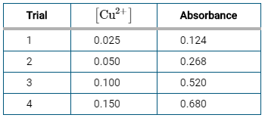

  - Which trial has discrepant data compared to the others? Justify your answer by referring to the data.

  - Would the actual concentration of the trial identified in 7a be greater than, less than, or equal to the concentration expected in the trial.

Topic 5.4 Worksheet

- Write the rate law for each of the elementary steps. Then, determine the molecularity of the reaction.

 | Elementary Step | Rate Law | Molecularity
(A) | A + B → X + Y |  | Unimolecular | Bimolecular | Termolecular
(B) | 2A + B → A₂B |  | Unimolecular | Bimolecular | Termolecular
(C) | NO + O₃ → NO₂ + O₂ |  | Unimolecular | Bimolecular | Termolecular
(D) | Cl + CH₄ → HCl + CH₃ |  | Unimolecular | Bimolecular | Termolecular
(E) | Ar + O₃ → Ar + O₃* |  | Unimolecular | Bimolecular | Termolecular
(F) | A + A → B + C |  | Unimolecular | Bimolecular | Termolecular
(G) | O₃ → O₂ + O |  | Unimolecular | Bimolecular | Termolecular
(H) | O + O₂ + N₂ → O₃ + N₂ |  | Unimolecular | Bimolecular | Termolecular
(I) | A → B + C + D |  | Unimolecular | Bimolecular | Termolecular

- When given the rate law of the elementary step, determine the molecularity and give the reactant side of the elementary step.

 | Rate Law | Molecularity |  |  | Elementary Step (Reactants only)
(A) | Rate = k[A] | Unimolecular | Bimolecular | Termolecular
(B) | Rate = k [NO]² [O₂] | Unimolecular | Bimolecular | Termolecular
(C) | Rate = k [CO]² | Unimolecular | Bimolecular | Termolecular
(D) | Rate = k [A] [B] | Unimolecular | Bimolecular | Termolecular

- Describe the specific collision that must occur for the elementary steps from #1.
  - Reaction C

  - Reaction D

Review Topic 3.2

Topic 5.6 Worksheet

- Consider a series of reactions having these reaction coordinate energy profiles

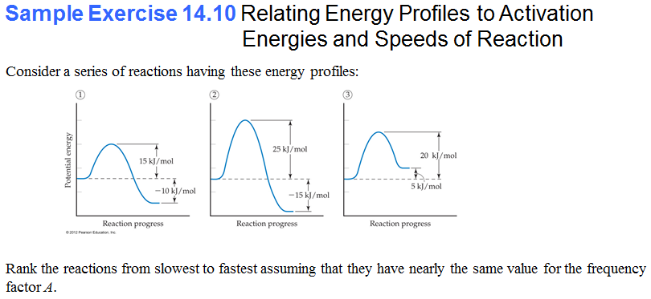

  - Rank the reactions from slowest to fastest. Explain your reasoning.

  - Rank the reactions from slowest to fastest in the reverse direction. Explain your reasoning.

  - Give the activation energy of each reaction in the forward direction.

  - Give the activation energy of each reaction in the reverse direction.

  - Is reaction 1 endothermic or exothermic? Justify your answer. What about the reverse direction?

  - Is reaction 3 endothermic or exothermic? Justify your answer. What about the reverse direction?

  - Give the overall energy change for each reaction in the forward direction.

  - Give the overall energy change for each reaction in the reverse direction.

  - Place an “x” on each diagram where the transition state occurs.

Topic 5.10 Worksheet

- Use the reaction coordinate energy profile given below to answer the questions that follow.
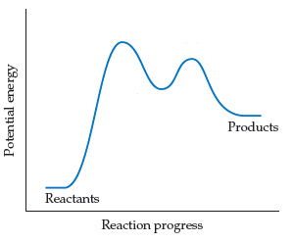

  - How many elementary steps are involved in the reaction?

  - Which step would be faster? Explain your reasoning.

- The following sequence of elementary steps is a proposed mechanism for a given reaction.

Step 1: | NO + NO ⇌ N₂O₂ | Fast
Step 2: | N₂O₂ + H₂ ⇌ H₂O + N₂O | Slow
Step 3: | N₂O + H₂ ⇌ N₂ + H₂O | Fast

  - On the incomplete reaction energy diagram below, draw a curve that shows the following two details:
    - The relative activation energies of the three elementary steps
    - The enthalpy change of the overall reaction if the reaction is endothermic
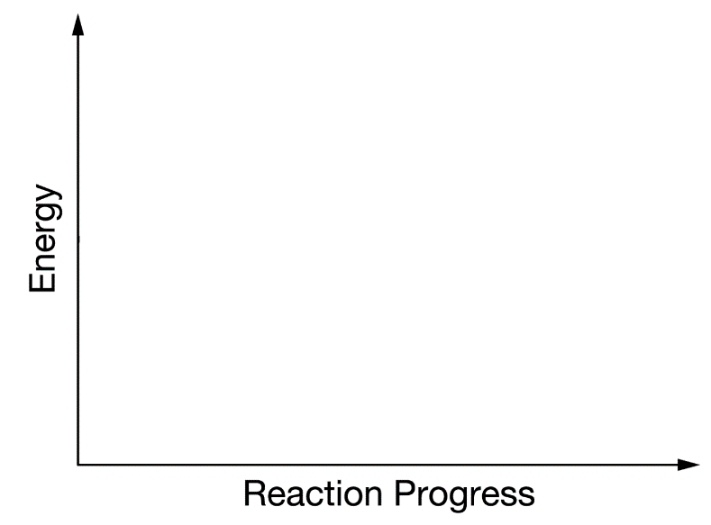

Topic 5.1 Worksheet

- Consider the combustion of ethylene, C₂H₄(g) + 3 O₂(g) → 2 CO₂(g) + 2 H₂O(g) . If the concentration of C₂H₄ is decreasing at the rate of 0.036 M/s, what are the rates of change in the concentrations of CO₂ and H₂O?

- The rate of decrease in N₂H₄ partial pressure in a closed reaction vessel from the reaction N₂H₄(g) + H₂(g) → 2 NH₃(g) is 74 torr per hour. What are the rates of change of NH₃ partial pressure and total pressure in the vessel?

5 H₂O₂(aq) + 2 MnO₄ –(aq) + 6 H⁺(aq) → 2 Mn²⁺(aq) + 8 H₂O(l) + 5 O₂(g)

- At a certain time during the titration, the rate of appearance of O₂(g) was 2.5 x 10 ⁻³ mol/(L•s).
  - What was the rate of disappearance of MnO₄ – at the same time?

  - What was the rate of appearance of Mn²⁺ at the same time?

  - As time progresses, would you expect the rate of disappearance of MnO₄ – to increase, decrease, or remain the same? Explain your answer.

- A kinetics experiment is set up to collect the gas that is generated when a sample of solid CaCO₃ is added to a solution of ethanoic acid, CH₃COOH. The rate of reaction between CaCO₃ and CH₃COOH is determined by measure the volume of gas generated at 25 ℃ and 1 atm as a function of time. Describe how each of the following would effect the rate of the reaction. Explain your answer in terms of the collision theory.
  - Decreasing the volume of ethanoic acid used in the experiment.

  - Decreasing the molarity of the ethanoic acid used in the experiment.

  - Increasing the temperature at which the experiment is performed.

  - Decreasing the temperature at which the experiment is performed.

  - Decreasing the particle size of the CaCO₃ by grinding it into a fine powder.

- In the box below on the left is a picture of a solid sample of Mg and the strong acid HCl(aq) reacting. In the box below on the right draw a picture of Mg(s) with a smaller particle size reacting with HCl(aq). Use your picture to explain why the Mg with smaller particle size reacts at a faster rate.

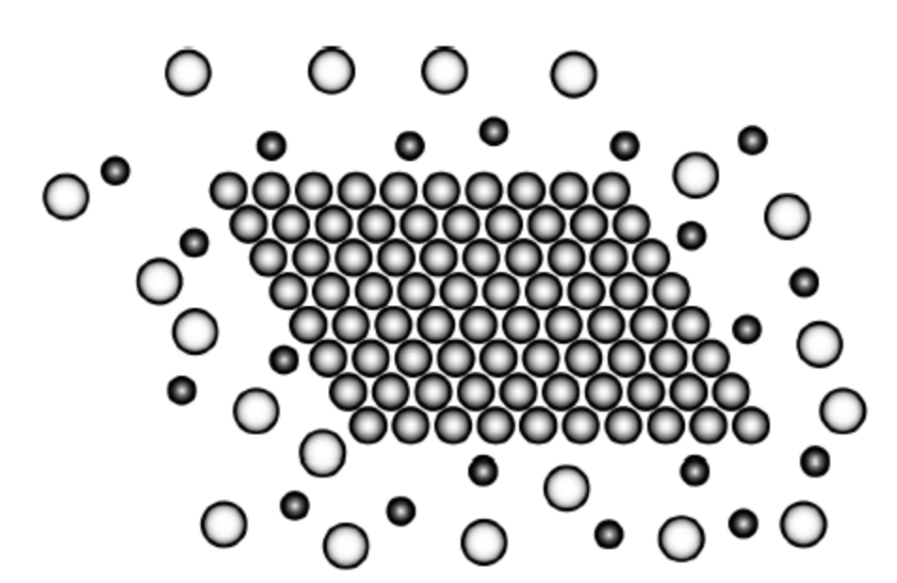 | 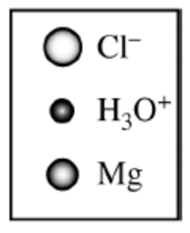

- In the brass lab, we reacted long ribbons of brass with nitric acid. We could have also used small shavings instead of the long ribbons but the shavings don’t work as the nitric acid “bubbles” over. Explain why using the small shavings bubbles over.

2 NO(g) + O₂(g) → 2 NO₂(g) |  | Reactant | Initial Concentration
 |  | NO | 0.0028 M
 |  | O₂ | 0.0014 M

- The oxidation of NO(g) producing NO₂(g) is represented by the chemical equation shown above. The initial concentration of NO and O₂ are given in the table above. The changes in concentration of NO(g) as a function of time are shown in the following graph.

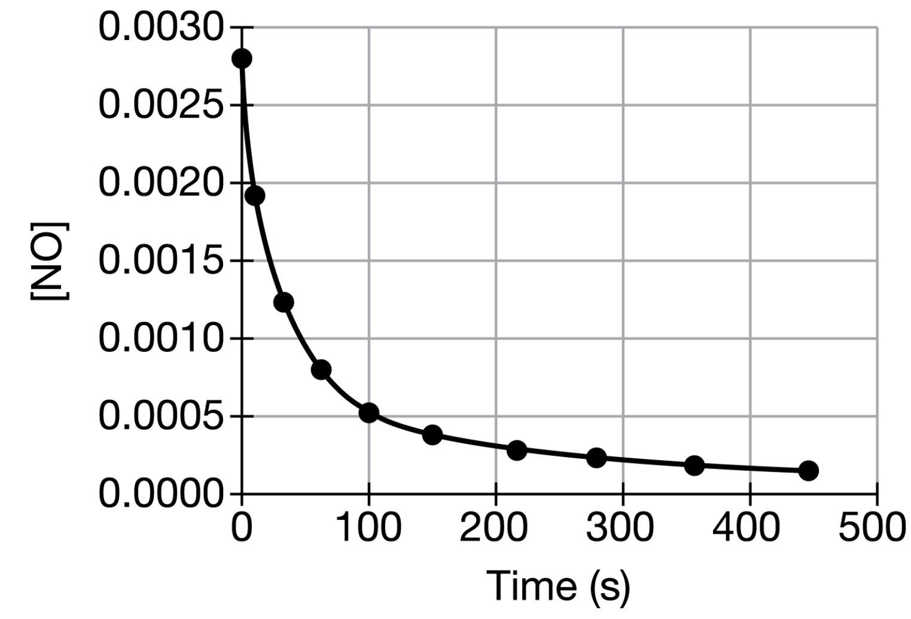
On the graph below, draw the curve for the rate of disappearance of O₂.

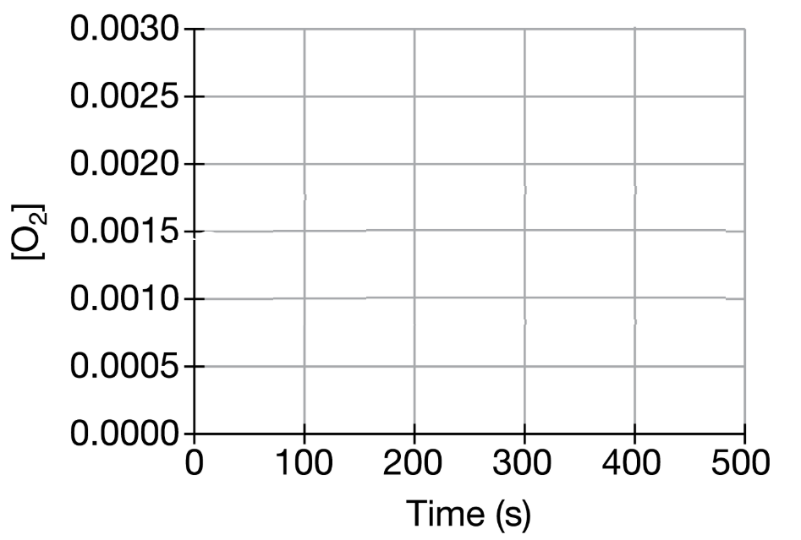

- On the reaction energy diagram below, draw and label the reaction pathway in the presence of a catalyst.

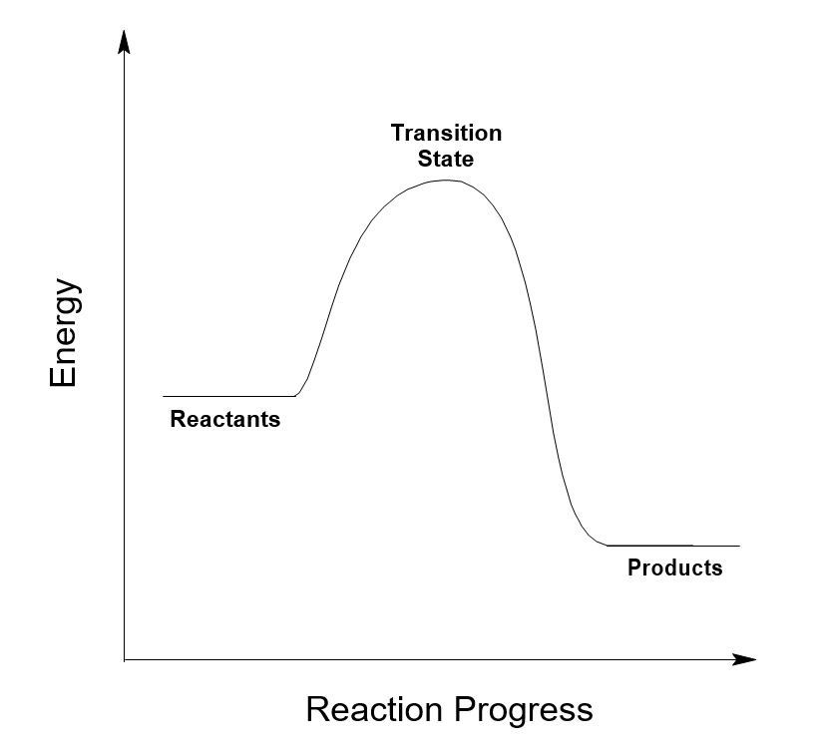

- On the Boltzmann diagram below draw and label the location of the activation energy in the presence of a catalyst.

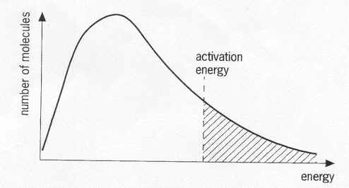

- How does the rate of disappearance of a reactant change with increasing strength of covalent bonds?

Topic 5.2 Worksheet

Rate = k[H₃AsO₄]² [I ⁻ ] [H₃O⁺]⁰

- Use the rate law given above to answer the questions that follow.
  - What is the order with respect to H₃AsO₄ ?

  - What happens to the rate of the reaction if the concentration of H₃AsO₄ is doubled while the others remain the same?

  - What is the order with respect to I ⁻ ?

  - What happens to the rate of the reaction if the concentration of I – is doubled while the others remain the same?

  - What is the order with respect to H₃O⁺ ?

  - What happens to the rate of the reaction if the concentration of H₃O⁺ is doubled while the others remain the same?

  - What is the overall order of the reaction?

  - What would be the units of k, the rate constant, for this reaction?

- Complete the table below about the units for the rate constant, k.

Overall  Order | Units of  Rate Constant
1
2
3

- Use the data to answer the questions that follow.

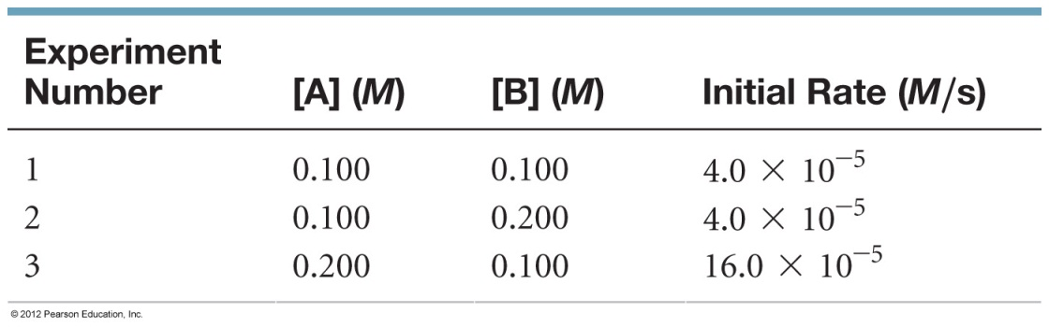

  - Determine the rate law.

  - Determine the overall order of the reaction.

  - Determine the value of k, along with units.

  - Determine the rate of the reaction when [A] is 0.0500 M and the [B] is 0.0750 M.

  - When does the value of k change?
- Use the data to answer the questions that follow.

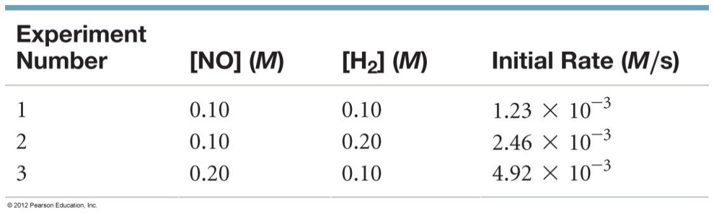

  - Determine the rate law.

  - Determine the overall order of the reaction.

  - Determine the value of k, along with units.

  - Determine the rate of the reaction when [NO] is 0.100 M and the [H₂] is 0.150 M.

  - When does the value of k change?
- Use the data to answer the questions that follow.

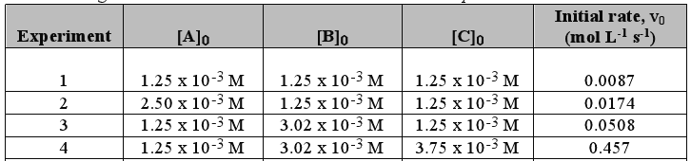

  - Determine the rate law.

  - Determine the overall order of the reaction.

  - Determine the value of k, along with units.

- Use the data to answer the questions that follow.

 | [H₂O₂] | [I⁻] | [H⁺] | Rate (M/s)
I | 0.100 | 5.00 x 10⁻⁴ | 1.00 x 10⁻² | 0.137
II | 0.100 | 1.00 x 10⁻³ | 1.00 x 10⁻² | 0.268
III | 0.200 | 1.00 x 10⁻³ | 1.00 x 10⁻² | 0.542
IV | 0.400 | 1.00 x 10⁻³ | 2.00 x 10⁻² | 1.084

  - Determine the rate law.

  - Determine the overall order of the reaction.

  - Determine the value of k, along with units.

- Use the data to answer the questions that follow.

 | [A] | [B] | [C] | Rate (M/s)
I | 0.1 | 0.05 | 0.02 | 0.2
II | 0.2 | 0.05 | 0.02 | 0.8
III | 0.2 | 0.15 | 0.02 | 2.4
IV | 0.4 | 0.15 | 0.04 | 19.2

  - Determine the rate law.

  - Determine the overall order of the reaction.

  - Determine the value of k, along with units.

Topic 5.7, 5.8, 5.9 Worksheet

- A possible reaction mechanism for the conversion of ozone to O₂ is shown below:

Step 1 |  | O₃(g) → O₂(g) + O(g)
Step 2 |  | O₃(g) + O(g) → 2 O₂(g)

  - What is the molecularity of each step?

  - What is the overall equation?

  - What is the intermediate in the reaction? Explain your answer.

- Nitrous oxide, N₂O, is believed to decompose by a two-step reaction mechanism:

Step 1 |  | N₂O(g) → N₂(g) + O(g) |  | (slow)
Step 2 |  | N₂O(g) + O(g) → N₂(g) + O₂(g) |  | (fast)

  - Write the equation for the overall reaction.

  - Write the rate law for the overall reaction.

  - Which step has the highest activation energy?
- Consider the reaction mechanism shown below:

Step 1 |  | NO(g) + NO(g) $\begin{matrix}\underset{→}{k_{1}} \\ \overset{←}{k_{-1}}\end{matrix}$ N₂O₂(g) |  | (fast, equilibrium)
Step 2 |  | N₂O₂(g) + Br₂(g) $\underset{→}{k_{2}}$ 2 NOBr(g) |  | (slow)

Determine the rate law for the reaction using the steady-state approximation.

- Another mechanism for the conversion of ozone to O₂ shows the possible destruction in the upper atmosphere by NO(g), as shown below.

Step 1 |  | O₃(g) + NO(g) → NO₂(g) + O₂(g) |  | (slow)
Step 2 |  | NO₂(g) + O(g) → NO(g) + O₂(g) |  | (fast)

  - What is the overall equation?

  - What is the intermediate in the equation?

  - What is the role of nitrogen monoxide, NO, in the equation? Explain your reasoning.

  - What is the molecularity of each step in the mechanism?

  - What is the rate law?

- Experiments were conducted to study the rate of the reaction represented by the equation below. Initial concentrations and rates of reaction are given in the table.

2 NO(g) + 2 H₂(g) → N₂(g) + 2 H₂O(g)

Experiment | [NO] | [H₂] | Rate
1 | 0.0060 | 0.0010 | 1.80 x 10 ⁻⁴
2 | 0.0060 | 0.0020 | 3.60 x 10 ⁻⁴
3 | 0.0010 | 0.0060 | 0.30 x 10 ⁻⁴
4 | 0.0020 | 0.0060 | 1.20 x 10 ⁻⁴

  - Determine the order for each of the reactants, NO and H₂, from the data given and show your reasoning.

  - Write the overall rate law of the reaction.

  - Calculate the value of the rate constant, k, for the reaction. Include units.

  - The following sequence of elementary steps is a proposed mechanism for the reaction:

Step 1 |  | NO + NO → N₂O₂
Step 2 |  | N₂O₂ + H₂ → H₂O + N₂O
Step 3 |  | N₂O + H₂ → N₂ + H₂O

    - Based on the data presented, which of the above is the rate-determining step? Explain your reasoning.

    - Show that the mechanism is consistent with the observed rate law and the overall stoichiometry of the reaction.

- For a hypothetical chemical reaction that has the stoichiometry 2X + Y → Z, the following initial rate data were obtained. All the measurements were made at the same temperature.

Rate (M/min) | [X] (M) | [Y] (M)
7.0 x 10 ⁻⁴ | 0.2 | 0.2
1.4 x 10 ⁻³ | 0.4 | 0.2
2.8 x 10 ⁻³ | 0.4 | 0.4
4.2 x 10 ⁻³ | 0.6 | 0.6

  - Give the rate law for this reaction from the data above.

  - Calculate the specific rate constant for this reaction and specify its units.

  - How long must the reaction proceed to produce a concentration of Z equal to 0.20 molar, if the initial reaction concentrations of [X] = 0.80 molar, [Y] = 0.60 molar, and [Z] = 0 molar?

  - Select from the mechanisms below the one most consistent with the observed data. Explain your reasoning for each mechanism.

React ion Mechanism 1 |  |  |  | Reaction Mechanism 2 |  |  |  | Reaction Mechanism 3
X + Y → M |  | Slow |  | X + X ⇌ M |  | Fast |  | Y → M |  | Slow
X + M → Z |  | Fast |  | Y + M → Z |  | Slow |  | M + X → N |  | Fast
 |  |  |  |  |  |  |  | N + X → Z |  | Fast

  - Identify any intermediates and catalysts in the reaction mechanisms.

Topic 5.3 Worksheet

- Complete the table below.

 | 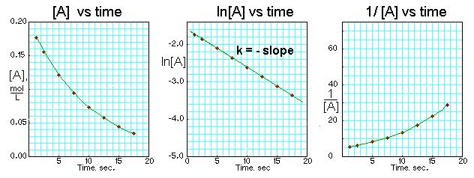 | 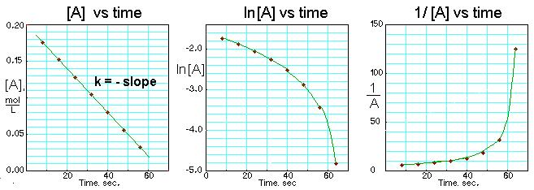 | 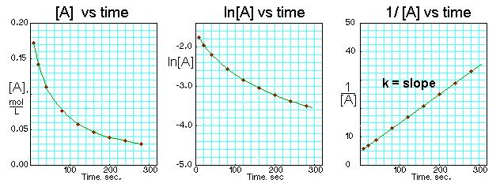
Order?
How do you know?
What must be plotted on the y-axis to give a straight line?

- What is the order of the reaction with respect to NO₂ if the data from the lab is plotted as shown in the graphs below. Explain your reasoning.

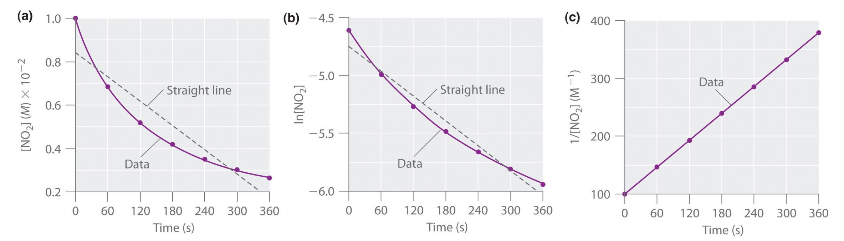

- What is the order of the reaction with respect to N₂O₅ if the data from the lab is plotted as shown in the graphs below. Explain your reasoning.

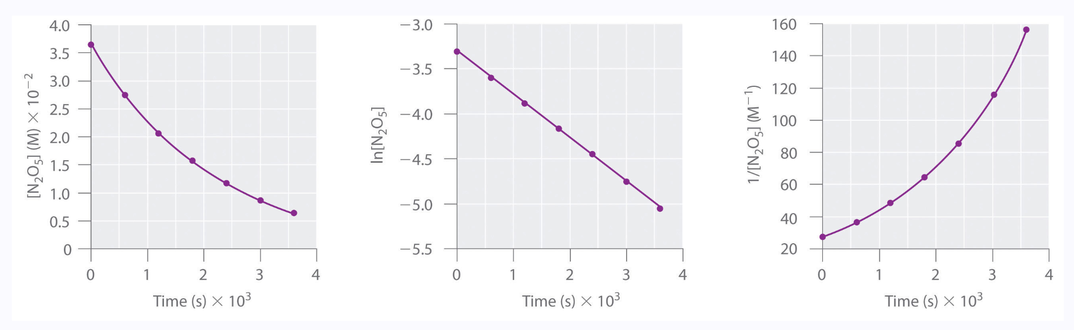

- Data from the lab is plotted below. Determine the order of the reaction with respect to A. Explain your reasoning.

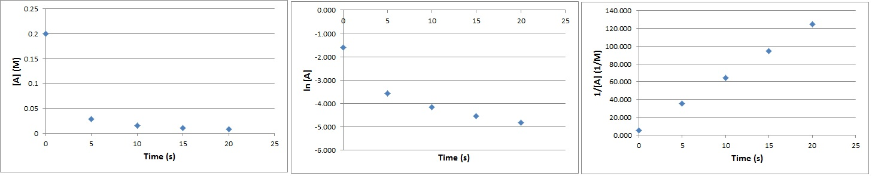

- Complete the table using the AP Chemistry Equations and Constants Sheet

Order of Reaction | 0 | 1 | 2
Integrated Rate Law
Equation for Half-life

- Determine the rate constant or the half-life for the following first order reactions.
  - Half-life of 36 s.

  - Rate constant of 2.00 x 10 ⁻² s ⁻¹

  - k = 25 s ⁻¹

- Use your answers to #6b and #6c to discuss the relationship between half-life and the rate constant. As the rate constant increases in magnitude, does the half-life increase, decrease, or remain the same?

- A certain reaction is first order. Determine the amount of time required for the reactant to go from 0.500 M to 0.250 M if the rate constant is 1200. s ⁻¹.

- Determine the order for each reaction given the data below. Explain your answer.

Time |  | Reaction 1 |  |  |  | Reaction 2 |  |  |  | Reaction 3.
 |  | [A] | ln[A] | 1/[A] |  | [B] | ln[B] | 1/[B] |  | [C] | ln[C] | 1/[C]
0 |  | 150 | 5 | 0.0067 |  | 285.7 | 5.65 | 0.00350 |  | 0 | 0 | 0
15 |  | 75 | 4.3 | 0.013 |  | 200.0 | 5.30 | 0.00500 |  | 12.25 | 2.51 | 0.0816
30 |  | 38 | 3.6 | 0.027 |  | 153.8 | 5.04 | 0.00650 |  | 24.5 | 3.20 | 0.0408
45 |  | 19 | 2.9 | 0.053 |  | 125.0 | 4.83 | 0.00800 |  | 36.75 | 3.60 | 0.0272

- Complete the table below for half-life if the reaction is first order. Assume the half-life is 15 seconds.

Percentage of parent  nuclide remaining | Percentage decayed | Number of half-lives | Elapsed time (s)
50%
25%
12.5%
6.25%

- A certain reaction is second order. Determine the final concentration if the initial concentration is 0.450 M and 15 seconds have passed. The rate constant, k, is 1.24 x 10 ⁻² M ⁻¹s ⁻¹.

- Determine the beginning concentration of a zeroth order reaction if the concentration after 1.25 seconds is 2.45 x 10⁻³ M and the rate constant is 120.

Unit 6

Topic 6.3 Worksheet

- Place an x in the box of the substance that will have the greater average kinetic energy. If the average KE will be the same then place an x in the box for “Same average KE”.

 | 1 L of water at 25 ℃ |  | 1 L of water at 35 ℃ |  | Same average KE
 | 1 L of water at 25 ℃ |  | 5 L of C₆H₆ at 25 ℃ |  | Same average KE
 | 25 g of gold at 55 ℃ |  | 25 g of lead at 35 ℃ |  | Same average KE
 | 1.0 M KNO₃ at 80 ℃ |  | 2.0 M NaOH at 80 ℃ |  | Same average KE
 | 1.00 mole of Al at 30 ℃ |  | 5.00 mole of Cu at 80 ℃ |  | Same average KE

- For the answers in 1 that have the same average KE, circle the substance with the greater velocity.

- Answer the questions that follow about particle pictures of a gas and kinetic energy.
  - What do the arrows indicate? Why are they at different lengths?
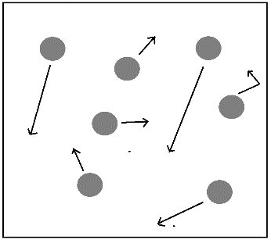

  - What is wrong with the arrows in the picture below?
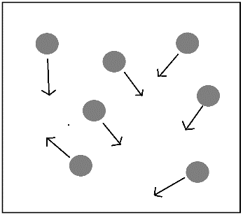

  - Draw arrows for the two gases below that are at the same temperature.
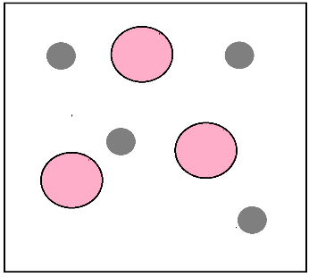

- A 50 g sample of a metal is heated to 75.0 ℃ and placed into 50 g of water at 25.0 ℃. The temperature of the water rose to reach a final temperature of 26.4 ℃.
  - What is the final temperature of the metal? Justify your reasoning.

  - Which substance had the larger change in temperature, the metal or the water?

  - Which substance had the largest change in energy, the metal or the water? Justify your answer.

  - Explain on the particulate level how the temperature of the water increases after addition of the metal. Your answer should explain the role of kinetic energy.

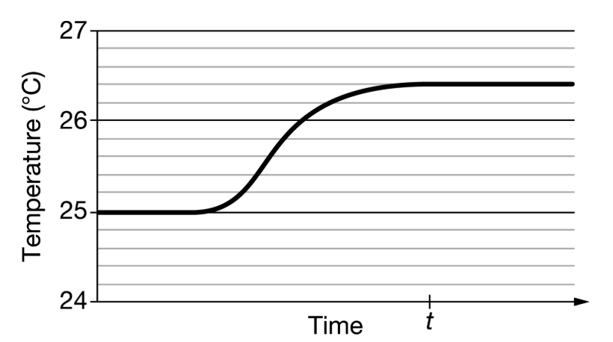
  - The student claims that thermal equilibrium is reached at time t.
    - What is thermal equilibrium?

    - Is the student correct about time t? Justify your answer by referring to the graph.

    - What can be said about the average kinetic energy of the metal and the water at time t?

- A sample of iron at 25 ℃ is placed into a sample of water at 75 ℃.
  - Before the iron is placed into the water, how does the average kinetic energy of the iron compare to the average kinetic energy of the water?

  - What happens to the temperature of the iron once it is placed into the water?

  - Explain on the particulate level how this system will reach thermal equilibrium.

  - After the system has reached thermal equilibrium, how does the average kinetic energy of the iron compare to the average kinetic energy of the water?

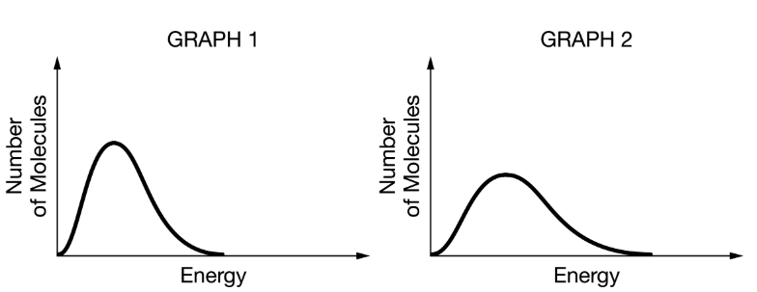
- The graphs above show Maxwell-Boltzmann distributions for one-mole samples of Ar(g).
  - Which graph is at a higher temperature? Explain how you know this.

  - The two samples are mixed. What would happen to the average kinetic energy of …
    - Graph 1

    - Graph 2

Topic 6.4 Worksheet

- Describe each variable in the equation below, including units.

q = m c ∆T

- What is the first law of thermodynamics?

- A reaction is carried out in a Styrofoam calorimeter. The reaction is known to release 15.2 kJ of energy. However, when the reaction is carefully measured and all calculations performed the reaction only gave off 15 kJ of energy.
  - Explain why it is not possible to lose 0.2 kJ of energy.

  - If not to the surroundings, where could that energy have gone?

- Two different metals of equal mass at the same initial temperature are given the same amount of energy.
  - Explain why the two metals would not have the same temperature.

  - Would the metal with he higher specific heat capacity have a higher temperature, lower temperature, or the same temperature as the metal with the lower specific heat capacity? Justify your answer with a calculation for both metals.
- A closed system of a piece of ice and metal is created. The 5.00 g piece of ice at −5.0 ℃ melts to liquid water at 10. ℃ when placed on the metal that has an initial temperature of 75 ℃.
  - Why did the ice melt?

  - Is the energy of the entire system after the ice melts less than, greater than, or equal to the energy of the system before the ice melts? Explain your reasoning.

  - Which has more energy, the ice or the liquid water?

  - What happened to the overall energy of the metal?

  - What happened to the overall energy of the H₂O?

  - Explain your answers to d and e in terms of the first law of thermodynamics.

- Convert the following to either specific heat capacity (J/g ℃) to molar heat capacity (J/mol ℃) .
  - H₂O(l) = 4.184 J/g ℃

  - Al(s) = 24.3 J/mol ℃

  - Au(s) = 0.129 J/g ℃

  - Ethylene glycol = 78 J/mol ℃
- A 200g metallic cube is placed into a coffee cup calorimeter with 100 g of water at 20 ℃. If the metal releases 7.2 kJ of energy to the water, what is the final temperature of the water? (The specific heat capacity of water is 4.2 J/g ℃)

- A neutralization reaction between NaOH and HCl is carried out in a coffee cup calorimeter. A 10.0 mL sample of a 1.0 M NaOH solution is titrated against a 10.0 mL sample of a 1.0 M HCl solution, as shown in the equation below.

HCl(aq) + NaOH(aq) → NaCl(aq) + H₂O(l)

If both solutions started at a temperature of 20 ℃ and ended at 26.0 ℃, what is the ∆H_{rxn} in kJ/mol_{rxn} ? (Assume the specific heat capacity of the total solution is the same as water, 4.18 J/g ℃, and the density is 1.0 g/mL.)

- A student conducts a reaction between hydrochloric acid and calcium hydroxide, as shown in the reaction below:

2 HCl(aq) + Ca(OH)₂(aq) → CaCl₂(s) + H₂O(l)

In the reaction, the student mixes 10.0 mL of 1.00 M HCl and 10.0 mL of 0.500 M Ca(OH)₂. It is determined that 0.870 kJ of energy is absorbed in the reaction.

  - Is the reaction endothermic or exothermic? Should the temperature of the reaction increase or decrease?

  - Determine the ∆H_{rxn} by using the moles of HCl.

  - Determine the ∆H_{rxn} by using the moles of Ca(OH)₂.
- Determine the amount of heat needed to melt 125 g of Au originally at 298 K.

Au melting point (℃) | 1064
C_{Au}  (J/g ℃) | 0.128
∆H_{fusion}  (kJ mol⁻¹) | 12.55

- What is the temperature change for the reaction shown below?

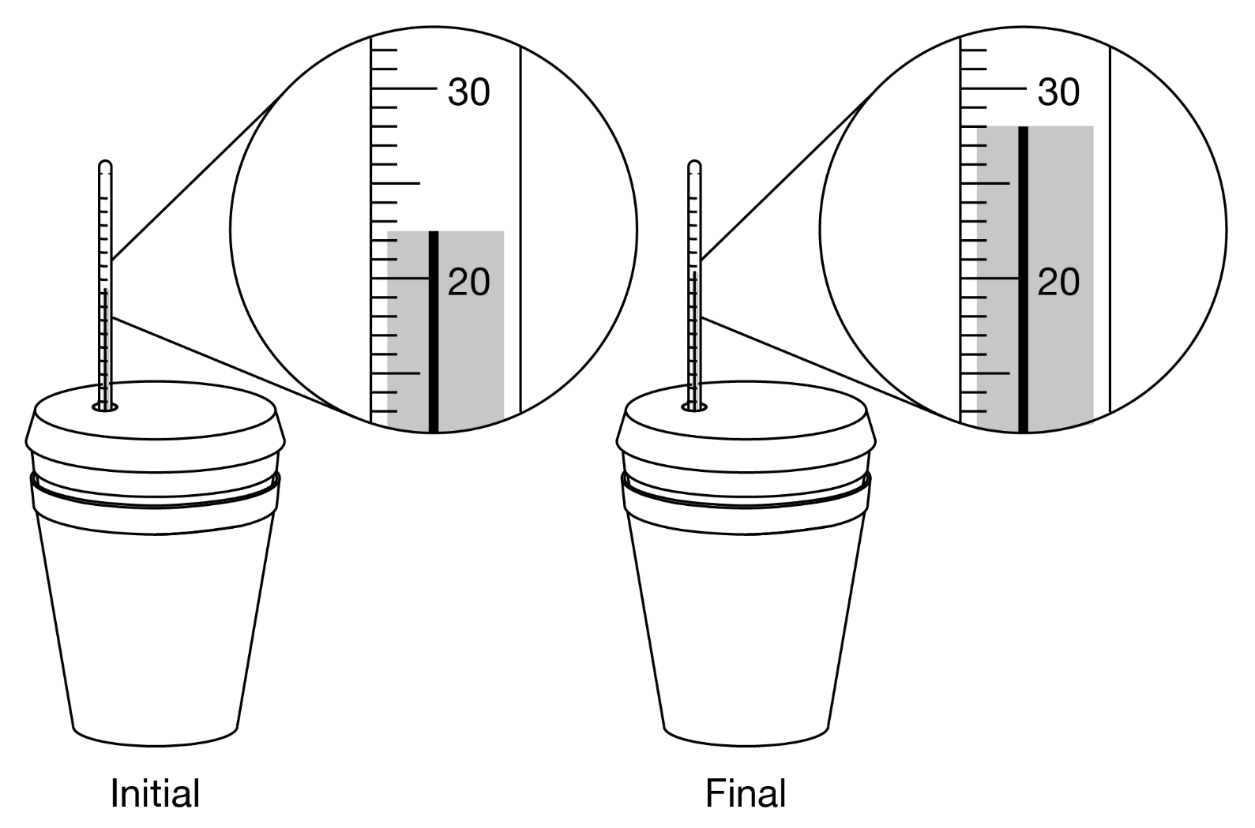

- A student conducts an experiment by mixing 10.0 mL of 1.0 M HCl and 10.0 mL of 1.0 M NaOH. The energy of the reaction is determined. She then mixes 20.0 mL of 1.0 M HCl and 10.0 mL of 1.0 M NaOH. The results of the experiment are shown below.

Experiment | HCl | NaOH | Energy
#1 | 10.0 mL of 1.0 M HCl | 10.0 mL of 1.0 M NaOH | X kJ
#2 | 20.0 mL of 1.0 M HCl | 10.0 mL of 1.0 M NaOH | ??? kJ

Would the energy of experiment #2 be greater than, less than, or equal to the energy for experiment #1?
- The hydrocarbon pentane, C₅H₁₂ (molar mass 72.15g) is combusted to produce carbon dioxide and water, as shown in the unbalanced reaction below.

_____C₅H₁₂(l) + _____O₂(g) → _____H₂O(l) + _____CO₂(g)

The complete combustion of 5.00 g of pentane releases 243 kJ of heat. On the basis of this information, calculate the value of ∆H for the complete combustion of one mole of pentane.

Topic 6.5 Worksheet

Use the heating curve of pure ethanol, CH₃CH₂OH , given below to answer the questions that follow.

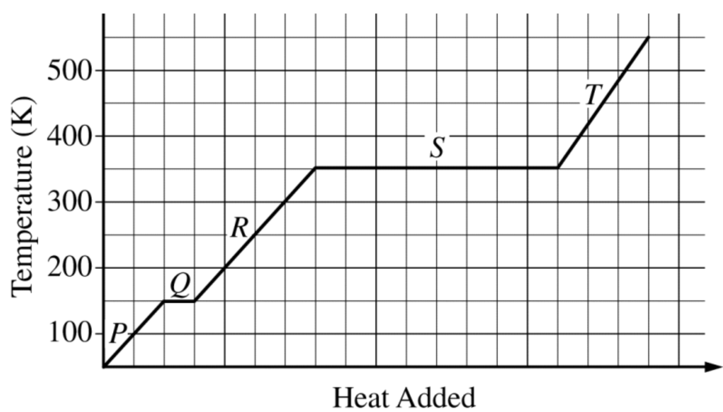

- What is the melting point of ethanol? What is the boiling point of ethanol?

- Explain why line Q is shorter than line S by referring to the specific intermolecular forces of ethanol.

- Which line segment represents …
  - the enthalpy of fusion?

  - the enthalpy of vaporization?

- Explain what is happening on the molecular level at points P, R, and T.

- Is the specific heat capacity of gaseous ethanol greater than, less than, or equal to the specific heat capacity of liquid ethanol? Justify your answer by referring to the slope of line segment R and line segment T.
- Three moles of a gas undergoes a phase transition, as shown below. How much energy is absorbed or released if the enthalpy of vaporization is +25 kJ/mol?

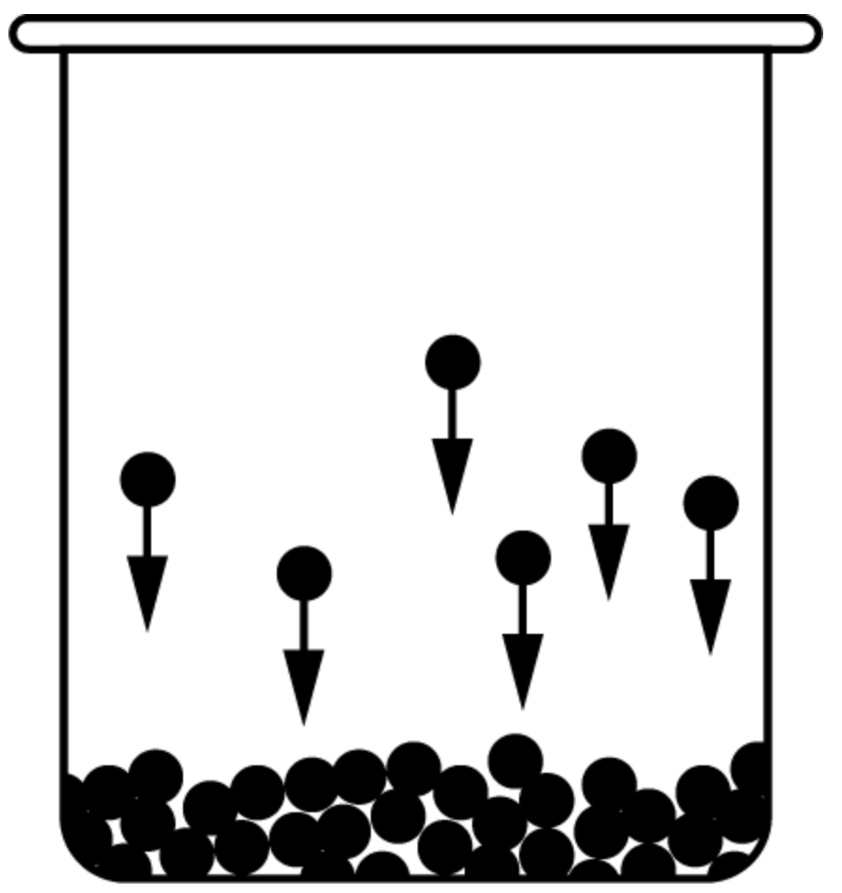

Use the heating curve of methane, CH₄, shown below to answer the questions that follow.
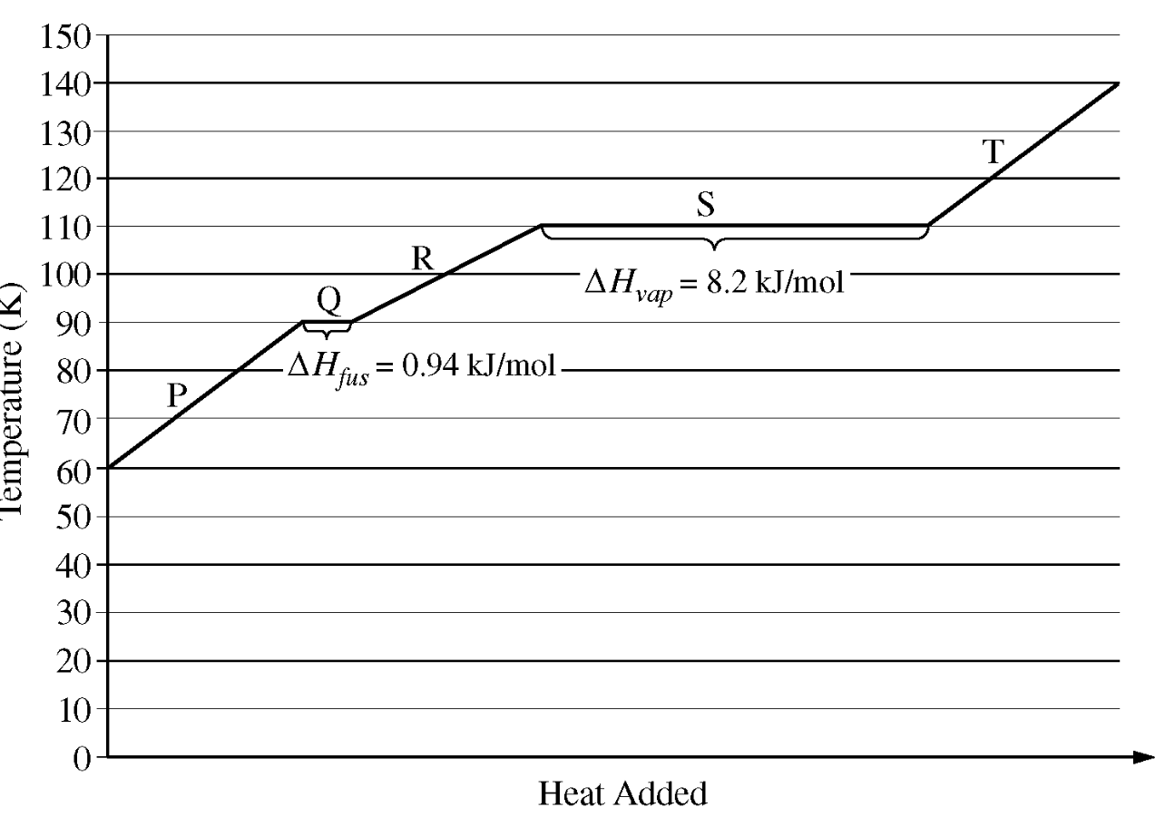
- How much energy does it take to melt 1 mole of methane? Is this process exothermic or endothermic?

- How much energy does it take to vaporize 1 mole of methane? Is this process exothermic or endothermic?

- How much energy does it take to freeze 1 mole of methane? Is this process exothermic or endothermic?

- How much energy does it take to condense 1 mole of methane? Is this process exothermic or endothermic?

- How much energy does it take to freeze 9.0 g of methane?

- How much energy is released when 45 g of methane condenses?

Topic 6.7 Worksheet

- Explain why a carbon-carbon triple bond requires more energy to break than a carbon-carbon single bond.

- Is a carbon-carbon single bond longer than, shorter than, or equal in length to a carbon-carbon double bond?

- Define bond dissociation energy, also known as bond enthalpy.

- Why are bond dissociation energies positive?

- A certain bond has a bond enthalpy of 125 kJ/mol.
  - How much energy is required to break the bond?

  - Is bond breaking endothermic or exothermic?

- A reaction is exothermic. What can be said about the sum of the bond enthalpies of the reactants compared to the sum of the bond enthalpies of the products?

- In the chemical reaction below, it is known that A−B has a bond enthalpy of 85 kJ/mol. Determine the bond enthalpy of A₂.

A₂ + B → ABA ∆H_{rxn} = − 150 kJ/mol_{rxn}

- Predict the sign of ∆H for the following processes:
  - 2 H(g) → H₂(g)

  - Na(g) → Na⁺(g) + e⁻

  - HBr(g) → H(g) + Br(g)

Bond Enthalpy Values
Bond | ∆H (kJ/mol) | Bond | ∆H (kJ/mol) | Bond | ∆H (kJ/mol) | Bond | ∆H (kJ/mol)
C−H | 413 | N−H | 391 | O−H | 463 | F−F | 155
C−C | 348 | N−N | 163 | O−O | 146
C=C | 614 | N−O | 201 | O=O | 495 | Cl−F | 253
C−N | 293 | N−F | 272 | O−F | 190 | Cl−Cl | 242
C−O | 358 | N−Cl | 200 | O−Cl | 203
C=O | 799 | N−Br | 243 | O−I | 234 | Br−F | 237
C−F | 485 |  |  |  |  | Br−Cl | 218
C−Cl | 328 | H−H | 436 |  |  | Br−Br | 193
C−Br | 276 | H−F | 567
C−I | 240 | H−Cl | 431 |  |  | I−Cl | 208
 |  | H−Br | 366 |  |  | I−Br | 175
 |  | H−I | 299 |  |  | I−I | 151

- Explain why the bond enthalpy of C−C is less than the bond enthalpy of C=C.

- Explain why the bond enthalpy of H–Cl is greater than the bond enthalpy of H–Br using principles of atomic structure.

- Determine ∆H_{rxn} for the reactions given below.

- Use the bond enthalpy values to estimate ∆H_{rxn} for the reactions given below:

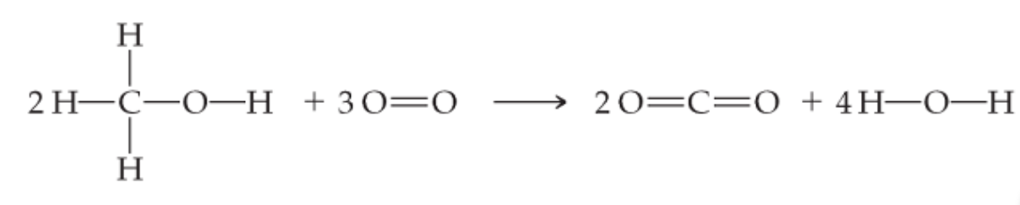
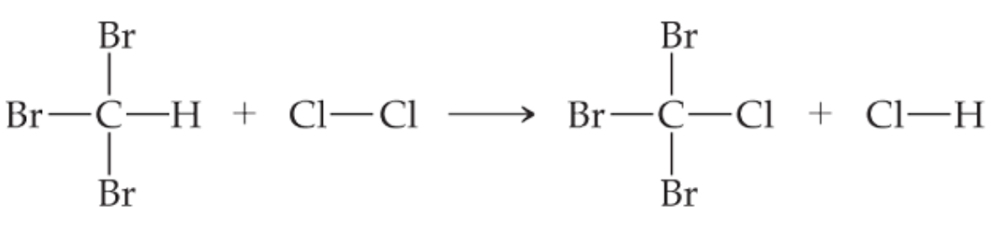

- Determine the bond enthalpy of the O=O for the reaction below if ∆H_{rxn} = −2800 kJ/mol_{rxn}.

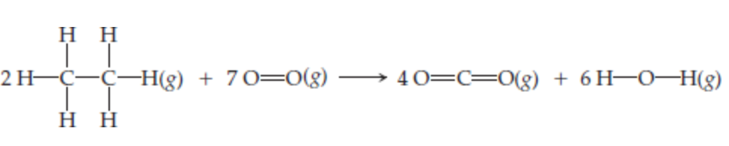

- Two nitrogen atoms combine to form a nitrogen molecule, as represented by the following equation.

2 N(g) → N₂(g)

Using the table of average bond eneriges below, determine the enthalpy change, ∆H, for the reaction.

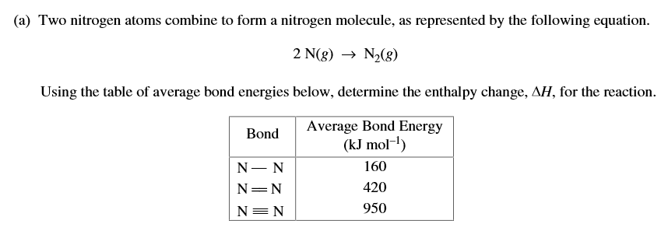

Topic 6.6 Worksheet

- Use the equation below to answer the questions that follow.

  - Determine the amount of energy released when 4.5 moles of O₂(g) is used in the reaction. (Try this without a calculator first.)
  - Determine the amount of energy released when 18 g of H₂O(l) are formed. (MM_{H2O} = 18 g/mol) (Try this without a calculator first.)
  - Determine the amount of energy released when 1.45 grams of SO₂(g) are formed.
  - Determine the mass of H₂S(g) used when 120 kJ of energy are released.
  - For the reaction in c., the energy released is used to heat 250 g of water (C = 4.2 J/g ℃). If the water is initially at a temperature of 25 ℃, determine the final temperature of the water. Assume no energy is lost.
  - Determine the mass of H₂S(g) required to react in order to bring 100. mL of water to a boil. The initial temperature of the water is 20.0 ℃ and the specific heat capacity of the water is 4.18 J/g ℃.
  - Determine the moles of SO₂(g) formed from the reaction above if the energy from the reaction is used to melt 120. g of ice initially at 0 ℃. The heat of fusion of ice is 334 J/g.

- Use the equation below to answer the questions that follow.

  - Determine the amount of energy released when 20.0 mL of 0.75 M HCl is used.
  - When 100. mL of 1.0 M HCl and 100. mL of 1.0 M NaOH are reacted, 5.71 kJ of energy is released. When 100. mL of 2.0 M is reacted with 100. mL of 1.0 M NaOH the energy released is still 5.71 kJ. Explain why.
  - When 25.0 mL of an unknown molarity of HCl is reacted with excess NaOH, 2.55 kJ of energy is released. Determine the molarity of the HCl solution.

Topic 6.1 Worksheet

- Determine if the following observations would be from an endothermic or exothermic reaction. Then determine if energy is flowing into the reaction out of the reaction.
  - A student conducts a chemical reaction in a test tube and feels that the test tube is hot.

 | Endothermic |  |  | Energy flows into the system
 | Exothermic |  |  | Energy flows out of the system

  - A student mixes two chemicals in a beaker. Frost appears on the outside of the beaker.

 | Endothermic |  |  | Energy flows into the system
 | Exothermic |  |  | Energy flows out of the system

  - The temperature on a thermometer drops when placed into a test tube that contains a reaction.

 | Endothermic |  |  | Energy flows into the system
 | Exothermic |  |  | Energy flows out of the system

- Mike Eilerman is a peach farmer. If peaches freeze they are ruined. When temperatures drop below freezing peach farmers will often spray their crop with water that will then freeze.
  - Is water freezing endothermic or exothermic? Explain why by referring to intermolecular forces.

  - Explain how spraying water on peaches keeps the peaches from freezing.

- Shown below are the steps for an ionic solute dissolving into a polar solvent. In Step 1, the ions in the solute separate from each other, in Step 2 the polar solvent is expanded to make space for the solute, and then in Step 3 (unlabeled) the solute combines with the solvent. Determine if each step is exothermic or endothermic.

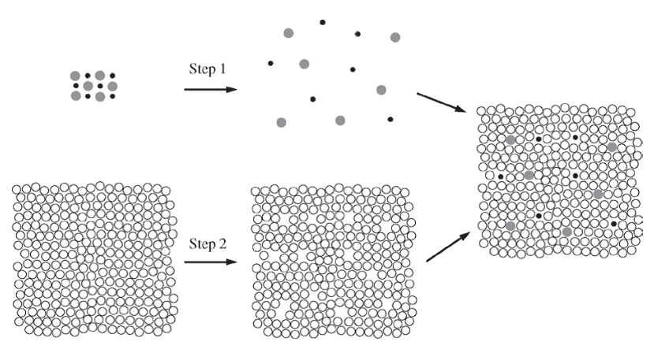

- If the formation of a solution is endothermic …
  - Which would require more energy, separating the ions in the crystal lattice or forming the solution?

  - Explain why your answer to 4a would lead to an endothermic solution.

- Determine if the following processes are endothermic or exothermic by placing a + or – in the box.

Process | + or −
K(s) → K(g)
K(g) → K⁺(g) + e ⁻
Cl₂(g) → 2 Cl(g)
Cl(g) + e ⁻ → Cl –(g)
K⁺(g) + Cl –(g) → KCl(s)

Topic 6.8 Worksheet

- What is the definition of the standard enthalpy of formation?

- Write reactions for the standard enthalpy of formation of the following compounds from their constituent elements in their standard states.

  - MgCO₃(s)
  - C₆H₁₂O₆(s)
  - CO₂(g)
  - NH₃(g)

- Use the standard enthalpies of formation on the next page to calculate the ∆H_{rxn} for each reaction given below.

  - C₂H₄(g) + H₂(g) → C₂H₆(g)
  - 3 NO₂(g) + H₂O(l) → 2 HNO₃(g) + NO(g)
  - N₂O₄(g) + 4 H₂(g) → N₂(g) + 4 H₂O(g)

- Determine the standard enthalpy of formation of nitromethane, CH₃NO₂ , using the equation below and the standard enthalpies of formation on the next page.

2 CH₃NO₂(l) + $3/2$ O₂(g) → 2 CO₂(g) + 3 H₂O(l) + N₂(g) ∆Hº_{rxn} = −1418 kJ/mol_{rxn}

Compound | Standard Enthalpy  of Formation  (kJ mol⁻¹) | Compound | Standard Enthalpy  of Formation  (kJ mol⁻¹) | Compound | Standard Enthalpy  of Formation  (kJ mol⁻¹)
C₂H₄(g) | 52.30 | H₂O(l) | −285.83 | NO₂(g) | 33.84
C₂H₆(g) | −84.68 | H₂O(g) | −136.10 | NO(g) | 90.37
CO₂(g) | −393.5 | HNO₃(g) | −134.3 | N₂O₄(g) | 9.66

- In an experiment, liquid heptane, C₇H₁₆(l), is completely combusted to produce CO₂(g) and H₂O(l), as represented by the following equation.

C₇H₁₆(l) + 11 O₂(g) → 7 CO₂(g) + 8 H₂O(l)

The heat of combustion, ∆Hº_{comb} , for one mole of C₇H₁₆(l) is −4.85 x 10³ kJ. Determine the enthalpy of formation, ∆Hº_{f} , for C₇H₁₆(l)

Topic 6.9 Worksheet

- A certain reaction has a ∆H of −25 kJ/mol_{rxn}. What would be the ∆H for the opposite reaction?

- Is energy transferred to the system or the surroundings …
  - in an endothermic reaction?

  - in an exothermic reaction?

- The reaction below is the sublimation of iodine.

I₂(s) → I₂(g)

  - Would you expect the sublimation of iodine to be endothermic or exothermic? Justify your answer by referring to the bonds/forces of attraction.

  - The energy required to sublime 1 mole of iodine is the same amount of energy that is required to turn 1 mole of solid iodine to liquid iodine and then liquid iodine to gaseous iodine. Explain why by referring to what is occurring with the intermolecular forces.

  - Use the reactions given below to determine the ∆Hº_{rxn} in kJ/mol_{rxn}.

½ H₂(g) + ½ I₂(s) → HI(g) ∆H = 26 kJ/mol_{rxn}

½ H₂(g) + ½ I₂(g) → HI(g) ∆H = −5.0 kJ/mol_{rxn}

- Calculate the standard enthalpy change, ΔHº, for the formation of 1 mol of strontium carbonate (the material that gives the red color in fireworks) from its elements.

Sr (s) + C (graphite) + 3/2 O₂ (g) SrCO₃ (s)

The information available is

Sr (s) + ½ O₂ (g) SrO (s) ΔHº = -592 kJ
SrO (s) + CO₂ (g) SrCO₃ (s) ΔHº = - 234 kJ
C (graphite) + O₂ (g) CO₂ (g) ΔHº = - 394 kJ

- In designing a chemical plant for manufacturing the plastic polyethylene, you need to know the enthalpy change for the removal of H₂ from C₂H₆ (ethane) to give C₂H₄ (ethylene), a key step in the process.

C₂H₆ (g) C₂H₄ (g) + H₂ (g) ΔHº = ?

From experiments you know the following thermochemical equations:

2 C₂H₆ (g) + 7 O₂ (g) 4 CO₂ (g) + 6 H₂O (l) ΔHº = - 3119.4 kJ
C₂H₄ (g) + 3 O₂ (g) 2 CO₂ (g) + 2 H₂O (l) ΔHº = - 1410.9 kJ
2 H₂ (g) + O₂ (g) 2 H₂O (l) ΔHº = - 571.66 kJ

Use this information to find the value of ΔHº for the formation of ethylene from ethane.
- The combustion of carbon monoxide is represented by the equation below.

CO(g) + ½ O₂(g) → CO₂(g)

Determine the value of the standard enthalpy change, ∆Hº_{rxn} , for the combustion of CO(g) at 298 K using the following information.

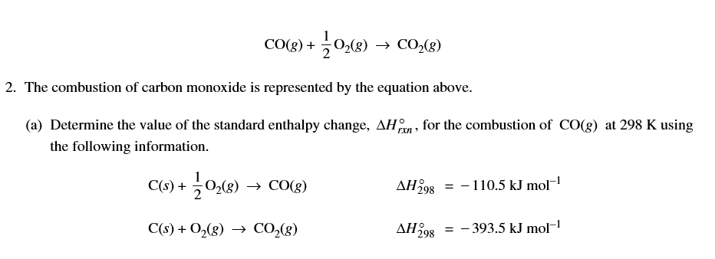

- Consider the two processes represented below.

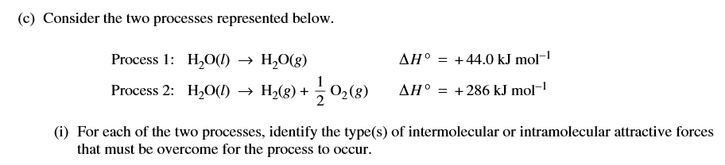

  - For each of the two processes, identify the type(s) of intermolecular or intramolecular attractive forces that must be overcome for the process to occur.

  - Explain why Process 2 requires much more energy than Process 1.

Unit 7

Topic 7.1 Worksheet

- As an equilibrium reaction proceeds …

- the rate of the forward reaction |  | increases | until equilibrium is reached.
 |  | decreases
- the rate of the reverse reaction |  | increases | until equilibrium is reached.
 |  | decreases
- the concentration of the reactants will |  | increase | until equilibrium is reached.
 |  | decrease
- the concentration of the products will |  | increase | until equilibrium is reached.
 |  | decrease

- At equilibrium …

- the rate of the forward reaction is |  | greater than | the rate of the reverse reaction.
 |  | equal to
 |  | less than
- the rate of the reverse reaction is |  | greater than | the rate of the forward reaction.
 |  | equal to
 |  | less than
- the concentration/pressure of the reactants |  | is increasing.
 |  | remains the same.
 |  | is decreasing.
- the concentration/pressure of the products |  | is increasing.
 |  | remains the same.
 |  | is decreasing.

- The reaction shown below is conducted and data collected.
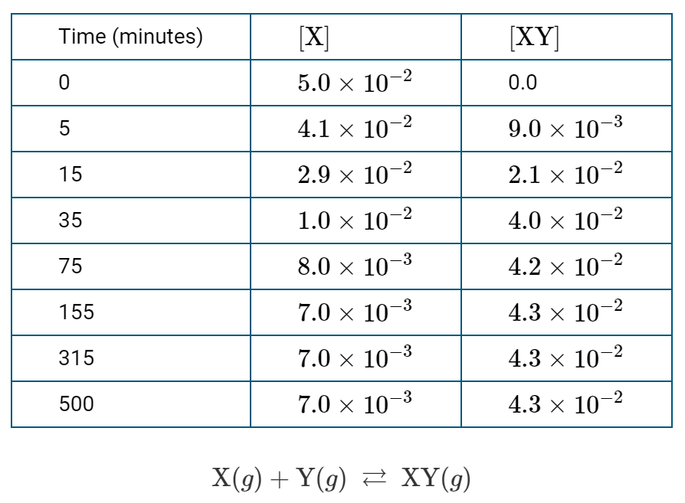

  - At what point does the system reach equilibrium? Justify your answer by referring to the data.

  - At equilibrium, what visible changes can be observed?

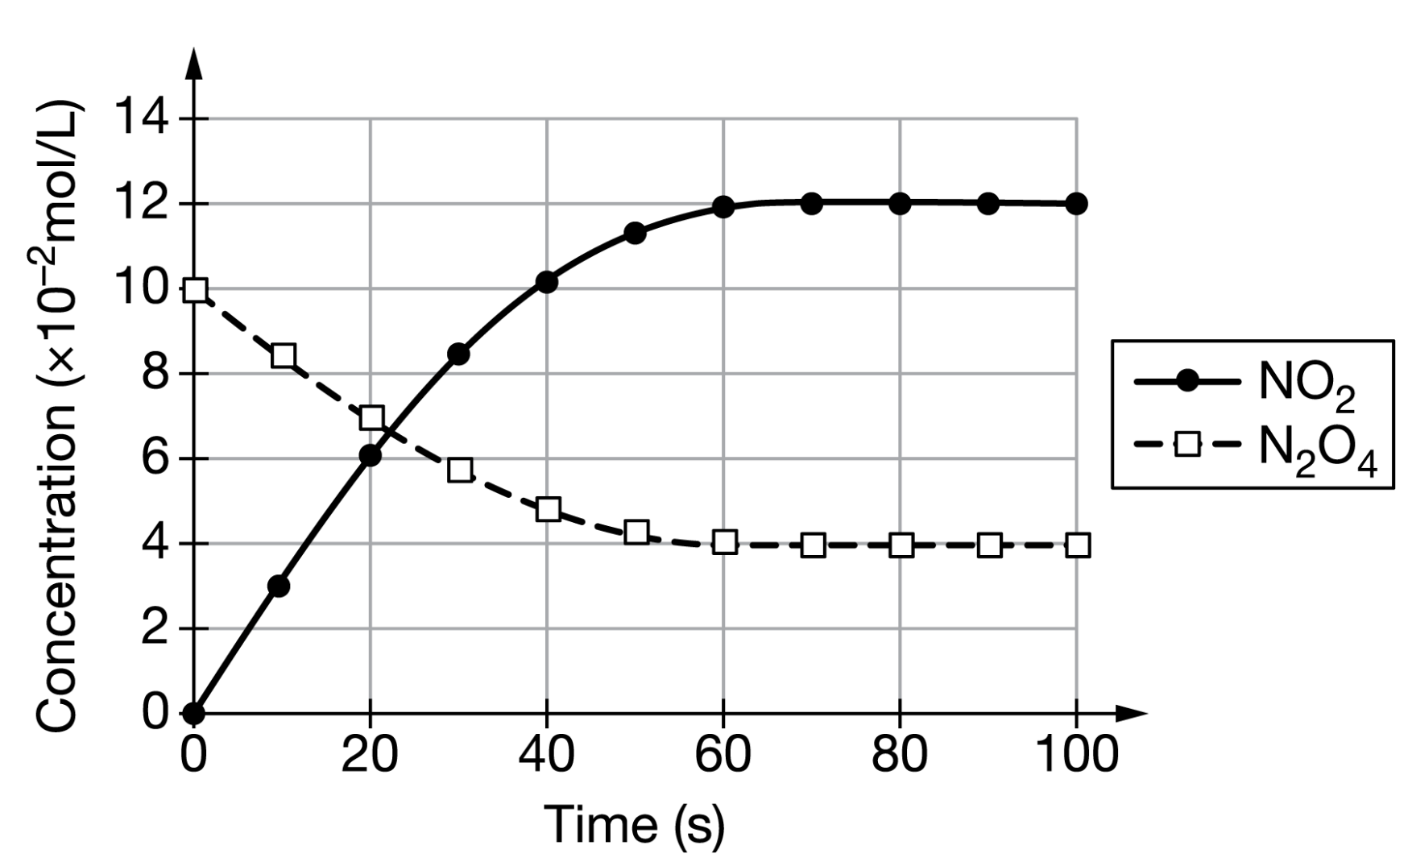

- The reaction N₂O₄ (g) ⇌ 2 NO₂ (g) occurs in an evacuated container at 373 K. The concentration of each species is measured over time and the data are used to make the graph shown above.

  - When does the system reach equilibrium? Justify your answer.

  - At 60 s, is the rate of the forward reaction greater than, less than, or equal to the rate of the reverse reaction? Explain your reasoning.

  - Explain why the slope of the [NO₂] is greater than the slope of the [N₂O₄].
- Two different containers at the same temperature have the same volume of a volatile organic compound. The liquid organic compound is in equilibrium with the vapor phase. Explain why, regardless of size or surface area, the equilibrium vapor pressure of both containers is the same.

- Use the graph below to answer the questions that follow about the reaction 3 H₂ (g) + N₂ (g) ⇌ 2 NH₃ (g)
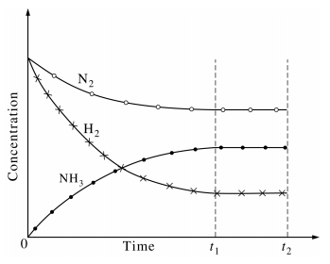
  - What is significant about t₁?

  - Why does the [H₂] decrease faster than the [N₂]?

  - What is the rate of disappearance of H₂ compared to the rate of disappearance of N₂?

  - How does the rate of disappearance of H₂ compare to the rate of appearance of NH₃?

  - At what point does the rate of the forward reaction equal the rate of the reverse reaction?

Topic 7.2 Worksheet

- Use the figures below to answer the questions that follow.

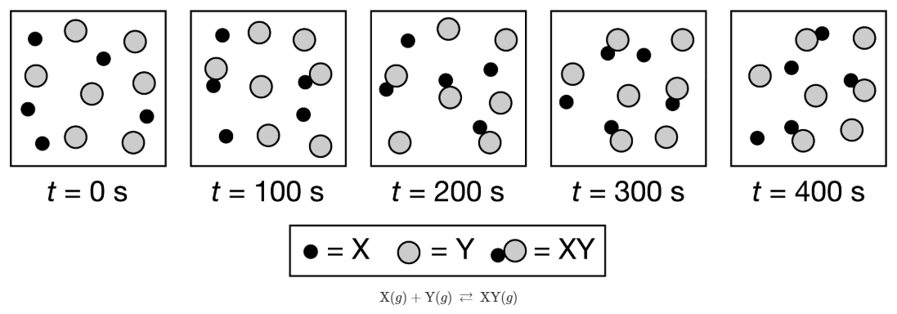

  - At what time is equilibrium established? Justify your answer.

  - Would the value of K be greater than, less than, or equal to 1? Justify your answer.

  - What does the value of K indicate about the amounts of reactants and products?

- Use the figures below to answer the questions that follow.

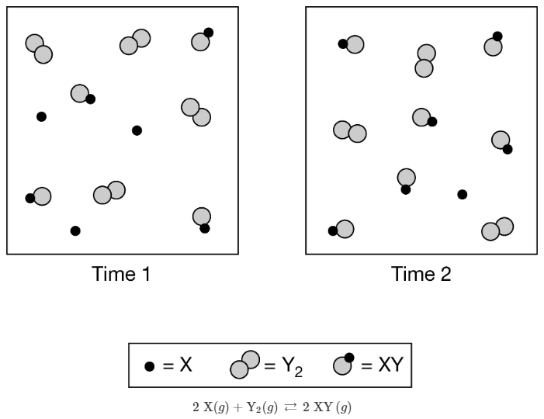
Time 1 | Time 2

  - Has the system reach equilibrium? Justify your answer.

  - What can be inferred about the relative rates of the forward and reverse reactions between time 1 and time 2?
- A student makes the claim shown in the box. Do you agree or disagree with the statement? Explain your reasoning.

At equilibrium, the forward and reverse reaction stop occurring because the concentrations of reactants and products no longer changes.

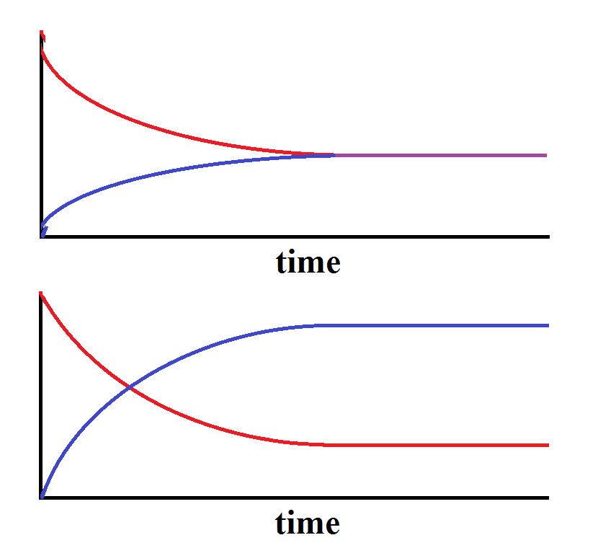
Graph A |  | Graph B

- Of the two graphs above …
  - which shows how the concentration of a reaction changes over time to reach equilibrium? Justify your answer.

  - which shows how the rates of a reaction changes over time to reach equilibrium? Justify your answer.

  - On both graphs, draw a vertical line to show where equilibrium is established.

Topic 7.4, 7.5, 7.7 Worksheet

- Answer the following questions based on the value of K given.

Value  of K | Forward or Reverse  reaction favored |  | Proceeds to Completion or Barely proceeds at all |  | More Reactants  or More Products
1 x 10 ⁻³ | Forward | Reverse | Proceeds to Completion | Barely Proceeds | More Reactants | More Products
10 | Forward | Reverse | Proceeds to Completion | Barely Proceeds | More Reactants | More Products
1 x 10¹⁵ | Forward | Reverse | Proceeds to Completion | Barely Proceeds | More Reactants | More Products
1 | Forward | Reverse | Proceeds to Completion | Barely Proceeds | More Reactants | More Products
1 x 10 ⁻¹⁶ | Forward | Reverse | Proceeds to Completion | Barely Proceeds | More Reactants | More Products

- Use the reaction given below to answer the questions that follow.

2 X (g) + Y (g) ⇌ 3 Z (g)

  - Write the expression for the equilibrium constant, K_{C} , for the reaction.

  - Determine the value of K_{c} if the molar concentrations at equilibrium are [X] = 2.0 M, [Y] = 0.5 M, [Z] = 4.0 M. (Try this calculation without a calculator first and then with a calculator.)

  - Determine the partial pressure of each gas if the total pressure is 17 atm and the gases are in a 5.0 L container.

  - Determine the value of K_{p}.

C (s) + CO₂ (g) ⇌ 2 CO (g)

- Solid carbon and carbon dioxide were placed in a rigid 2.00 L container and the reaction represented above occurred. As the reaction proceeded the total pressure in the container was monitored. When equilibrium was reached there was still some C(s) remaining in the mixture. Results are recorded in the table below.

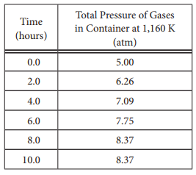

  - Write the expression for the equilibrium constant, K_{p} , for the reaction.

  - Calculate the number of moles of CO₂ (g) initially placed in the container. (Assume that the volume of the solid carbon is negligible.)

  - At what time does the system reach equilibrium? Justify your answer.

  - For the reaction mixture at equilibrium at 1,160 K, the partial pressure of the CO₂ is 1.63 atm. Calculate …
    - the partial pressure of CO (g) and

    - the value of the equilibrium constant, K_{p}

  - According to the K value you calculated in d, does the reaction proceed to near completion, does it barely proceed at all, or is there an equal mixture of reactants and products?
- The same number of moles of HCl and O₂ are used in the reaction below. Answer the questions that following about the reaction after it has reached equilibrium.

4 HCl (g) + O₂ (g) ⇌ 2 Cl₂ (g) + 2 H₂O (g)

  - How would the molarity of H₂O(g) compare to the molarity if Cl₂? Explain why by referring to the reaction stoichiometry.

  - How would the molarity of HCl compare to the molarity of O₂? Explain why by referring to the reaction stoichiometry.

- The reaction below occurs when two aqueous solutions are mixed, forming an aqueous complex ion.

A²⁺ (aq) + B⁴⁻ (aq) ⇌ AB²⁻ (aq) K = 7.7 x 10⁷

  - The value of K is very large. Explain why this reaction can be considered to go to completion even though it is actually in equilibrium.

  - Determine the concentration of AB²⁻ in the equilibrium mixture if 50.0 mL of 0.35 M B⁴⁻ is mixed with 50.0 mL of 0.30 M A²⁺ to produce 100.0 mL of total solution.

CO (g) + H₂O (g) ⇌ CO₂ (g) + H₂(g) K_{c} = 1.5 x 10³

- An equal number of moles of CO and H₂O are placed into a rigid reaction vessel and allowed to reach equilibrium. Answer the following questions about the concentration of each species at equilibrium.
  - Would the equilibrium concentration of CO be greater than, less than, or equal to the equilibrium concentration of H₂O? Explain your reasoning.

  - Would the equilibrium concentration of CO₂ be greater than, less than, or equal to the equilibrium concentration of H₂? Explain your reasoning.

  - Would the equilibrium concentration of CO₂ be greater than, less than, or equal to the equilibrium concentration of H₂O? Explain your reasoning.

Topic 7.8 Worksheet

- The reaction shown below is carried out at various temperatures and the value of K_{C} determined. Draw particulate representations that show the relative amounts of each reactant and product that would roughly correspond to the value of K.

PCl₃ (g) + Cl₂ (g) ⇌ PCl₅ (g)

Legend | Magnitude of K | 1 x 10 ⁻³ | 1 x 10⁵
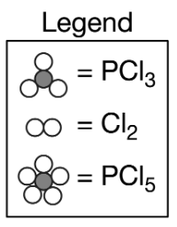 | Particulate diagram of equilibrium mixture | 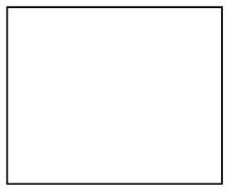

Topic 7.3, 7.10 Worksheet

2 H₂S (g) + CH₄ (g) ⇌ CS₂ (g) + 4 H₂ (g) K_{c} = 3.4 x 10 ⁻⁴

Use the reaction above to answer the questions that follow about Q, K_{c}, and the direction of the reaction.
- A 0.10 mol sample of each of the four species in the reaction represented above is injected into a rigid 1.0 L container.
  - What is the value of Q?

  - In which direction will the reaction proceed to reach equilibrium? Justify your answer by comparing K to Q.

  - Which species will have the highest concentration at equilibrium? Justify your answer.

2 XY (g) ⇌ X₂ (g) + Y₂ (g) K_{p} = 230

- Determine the direction the reaction will proceed to establish equilibrium given the initial conditions of each experiment.

Initial  Conditions (atm) | Value of Q | Direction reaction  will proceed to  establish equilibrium | Will more reactants or products form in order to  reach equilibrium? | The forward reaction is greater than, less than, or equal to the reverse reaction?
XY = 2.0 |  |  |  | greater than
X₂ = 0.0 |  |  |  | less than
Y₂ = 0.0 |  |  |  | equal to
XY = 0.010 |  |  |  | greater than
X₂ = 0.20 |  |  |  | less than
Y₂ = 2.0 |  |  |  | equal to
XY = 0.0 |  |  |  | greater than
X₂ = 5.0 |  |  |  | less than
Y₂ = 5.0 |  |  |  | equal to
XY = 12.0 |  |  |  | greater than
X₂ = 0.05 |  |  |  | less than
Y₂ = 0.05 |  |  |  | equal to
XY = 1.0 |  |  |  | greater than
X₂ = 1.0 |  |  |  | less than
Y₂ = 1.0 |  |  |  | equal to
XY = 0.064 |  |  |  | greater than
X₂ = 0.97 |  |  |  | less than
Y₂ = 0.97 |  |  |  | equal to

- For any situation in 2 …
  - where K > Q, explain your reasoning for the direction the reaction will proceed.

  - where K < Q, explain your reasoning for the direction the reaction will proceed.

  - where K = Q, explain your reasoning for the direction the reaction will proceed.

Topic 7.6 Worksheet

- A series of chemical reactions in equilibrium are used to determine the equilibrium constant of a third reaction, as shown below.

2 A (aq) + B (aq) ⇌ A₂B (aq) |  | K₁ = 25.0
CB (aq) + Y (aq) ⇌ CY (aq) + B (aq) |  | K₂ = 1.0 x 10 ⁻³
2A (aq) + CB (aq) + Y (aq) ⇌ A₂B (aq) + CY (aq) |  | K₃ = ???

Determine the value of K

 | Original Reaction
Reaction | PCl₅ (g) ⇌ PCl₃ (g) + Cl₂ (g) |  |  | 3 PCl₅ (g) ⇌ 3 PCl₃ (g) + 3 Cl₂ (g) |  | PCl₃ (g) + Cl₂ (g) ⇌ PCl₅ (g)
K expression
K value  (in terms of K_{original}) | K_{original}
 |  | Reaction |  | 1/3 PCl₅ (g) ⇌ 1/3 PCl₃ (g) + 1/3 Cl₂ (g) |  | 2 PCl₃ (g) + 2 Cl₂ (g) ⇌ 2 PCl₅ (g)
 |  | K expression
K value
(in terms of K_{original})

Topic 7.9 Worksheet

- For the following situations, determine the direction the reaction will shift to reestablish equilibrium, explain the shift in terms of Q and K, and determine whether the reactants or the products will increase in concentration/pressure.

2 BaO₂(s) ⇌ 2 BaO(s) + O₂(g) ∆H = 162 kJ/mol_{rxn}

System Stress | Direction  reaction shifts | Explanation based on Q and K | Increased concentration/pressure of reactants or products
Decrease pressure of O₂ | Forward |  | Products increase
 | Reverse |  | Reactants increase
 | None |  | No increase
Increase mass of BaO₂ | Forward |  | Products increase
 | Reverse |  | Reactants increase
 | None |  | No increase
Decrease temperature | Forward |  | Products increase
 | Reverse |  | Reactants increase
 | None |  | No increase
Increase size of container | Forward |  | Products increase
 | Reverse |  | Reactants increase
 | None |  | No increase

2 NO (g) + O₂ (g) ⇌ 2 NO₂ (g) ∆H < 0

System Stress | Direction  reaction shifts | Explanation based on Q and K | Increased concentration/pressure of reactants or products
Decrease the size of the container | Forward |  | Products increase
 | Reverse |  | Reactants increase
 | None |  | No increase
Increase concentration of O₂ | Forward |  | Products increase
 | Reverse |  | Reactants increase
 | None |  | No increase
Decrease temperature | Forward |  | Products increase
 | Reverse |  | Reactants increase
 | None |  | No increase
Use a catalyst | Forward |  | Products increase
 | Reverse |  | Reactants increase
 | None |  | No increase

- Explain why an increase in temperature always favors the endothermic reaction.

- What effect does an increase in temperature have on the size of K for …
  - an endothermic reaction?

  - an exothermic reaction?
- Use the redox reaction below to answer the questions that follow.

Cu(s) + 2 Ag⁺ (aq) → Cu²⁺ (aq) + 2 Ag(s) Eº = 0.460 V

  - Would an increase in concentration of Ag⁺ increase, decrease, or have no effect on the voltage of the cell. Justify your answer in terms of Q and K.

  - Would a decrease in concentration of Ag⁺ increase, decrease, or have no effect on the voltage of the cell. Justify your answer in terms of Q and K.

  - Would an increase in concentration of Cu²⁺ increase, decrease, or have no effect on the voltage of the cell. Justify your answer in terms of Q and K.

  - Would a decrease in concentration of Cu²⁺ increase, decrease, or have no effect on the voltage of the cell. Justify your answer in terms of Q and K.

Topic 7.11 Worksheet

- Define the following terms:
  - Solubility product

  - Solubility

- Give the dissociation reaction, then determine the solubility, in mols L⁻¹, of each of the following solids given their K_{sp}

  - AgCl (K_{sp} = 1.8 x 10 ⁻¹⁰)
  - AgBr (K_{sp} = 5.0 x 10 ⁻¹³)
  - Ag₂CrO₄ (K_{sp} = 1.1 x 10 ⁻¹²)
  - PbCrO₄ (K_{sp} = 2.8 x 10 ⁻¹³)
  - Cr(OH)₃ (K_{sp} = 1.6 x 10 ⁻³⁰)

- For each of the solids from #2, give the solubility of the anion.

  - AgCl (K_{sp} = 1.8 x 10 ⁻¹⁰)
  - AgBr (K_{sp} = 5.0 x 10 ⁻¹³)
  - Ag₂CrO₄ (K_{sp} = 1.1 x 10 ⁻¹²)
  - PbCrO₄ (K_{sp} = 2.8 x 10 ⁻¹³)
  - Cr(OH)₃ (K_{sp} = 1.6 x 10 ⁻³⁰)

- How would the solubility of 3c change if it were in 50.0 mL of total solution?

- What condition must be true to be able to directly compare K_{sp} values to determine relative solubility?

- For the salts given below, circle the more soluble salt based solely on K_{sp}.

  - AgCl (K_{sp}= 1.8 x 10 ⁻¹⁰) or AgI (K_{sp} = 8.3 x 10 ⁻¹⁷)

  - Ag₂CrO₄ (K_{sp} = 1.1 x 10⁻¹²) or Co(OH)₂ (K_{sp} = 1.3 x 10⁻¹⁵)

  - CaF₂ (K_{sp} = 3.9 x 10⁻¹¹) or Ag₂S (K_{sp} = 6.0 x 10 ⁻⁵¹)
- A 1.00 L solution saturated at 25 ℃ with calcium oxalate (CaC₂O₄) contains 0.0061 g of CaC₂O₄.
  - Write the dissociation reaction of CaC₂O₄, including phase symbols.

  - Calculate the solubility product constant, K_{sp}, for this salt at 25 ℃.

- The solubility of fluoride in a saturated solution of SrF₂ is 1.76 x 10⁻³ M.
  - Write the dissociation reaction of SrF₂, including phase symbols.

  - Determine the solubility of SrF₂.

  - Determine the K_{sp} of SrF₂.

- If 0.0490 g of AgIO₃ dissolves per liter of solution, calculate the solubility product constant, K_{sp} .

- Determine if a precipitate will form for the following solutions. In each case, justify your answer based on Q.
  - A 500 mL solution of 0.0250 M Pb(NO₃)₂ mixed with a 255 mL solution of 0.0045 M solution of Na₂CrO₄. The K_{sp} of PbCrO₄ is 2.8 x 10⁻¹³.

  - A 255 mL solution of 0.0150 M Co(NO₃)₂ mixed with a 150 mL solution of 0.0122 M solution of NaOH. The K_{sp} of Co(OH)₂ is 1.3 x 10⁻¹⁵.
- In each of the following situations, determine the concentration, in mols/L, of the anion needed to precipitate out the solid.
  - What molarity of Cl – is needed to precipitate out AgCl (K_{sp} = 1.8 x 10⁻¹⁰ ) in a solution that is 0.05 M Ag⁺?

  - How many moles of NaI are needed to form a AgI (K_{sp} = 8.3 x 10 ⁻¹⁷ ) precipitate in 50.0 mL of total solution if the [Ag⁺] is 1.5 x 10⁻⁴ M? (Assume the NaI does not change the volume of the solution.)

Topic 7.14 Worksheet
This section is intentionally left blank. This will be tested in Unit 9.

Topic 7.12 Worksheet

CdF₂ (s) ⇌ Cd²⁺ (aq) + 2 F – (aq)

- A saturated solution of CdF₂ is prepared. The equilibrium in the solution is represented above. In the solution [Cd²⁺]_{eq} = 0.0585 M and [F ⁻]_{eq} = 0.117 M.
  - Determine the solubility of CdF₂.

  - Some 0.90 M NaF is added to the saturated solution. Does the solubility of CdF₂ increase, decrease, or remain the same? Justify your answer based on Q.

- Is the solubility of AgCl(s) greater in distilled water or in tap water where the [Cl⁻] = 0.010 M? Justify your answer based on Q.

- The solubility of CuBr(s) is to be measured in four different solutions: distilled water, an NaBr(aq) solution, an NaNO₃(aq) solution, and a CuNO₃(aq) solution. Determine if the solubility of CuBr will be greater, less, or the same as in distilled water. Justify your answer based on Q or Le Chatelier’s Principle.
  - NaBr(aq) solution

  - NaNO₃(aq) solution

  - CuNO₃(aq) solution

Topic 7.13 Worksheet

- For the solutions below at 25℃, circle whether they have a high concentration of H⁺ or a high concentration of OH⁻.

 | High Concentration of …
- A solution with a low pH. | H⁺ |  | OH⁻
- A solution with a high pH. | H⁺ |  | OH⁻
- A solution with a pH of 8.2 | H⁺ |  | OH⁻
- A solution with a pH of 1.3 | H⁺ |  | OH⁻
- A solution with a pH of 7.00 | H⁺ |  | OH⁻

- Determine if the solubility would increase, decrease, or remain the same for the following solids placed into the solution indicated.

Solid | Solution | Change in solubility
- Cu(OH)₂ | Low pH | Increase | Decrease | Remain the same
 | High pH | Increase | Decrease | Remain the same
 | pH = 7.00 | Increase | Decrease | Remain the same
- FeCO₃ | Low pH | Increase | Decrease | Remain the same
 | High pH | Increase | Decrease | Remain the same
 | pH = 7.00 | Increase | Decrease | Remain the same
- CaF₂ | Low pH | Increase | Decrease | Remain the same
 | High pH | Increase | Decrease | Remain the same
 | pH = 7.00 | Increase | Decrease | Remain the same

Unit 8

Topic 8.1, 8.2 Worksheet

- Write one equation that can be used to calculate …

  - the pH of a solution if [H₃O⁺] is known.

  - the pOH of a solution if [OH⁻] is known.

  - the pH of a solution if [OH⁻] is known.

  - the pOH of a solution if [H₃O⁺] is known.

  - the pH of a solution if pOH is known.

  - the [H₃O⁺] if pH is known.

  - the [OH⁻] if pOH is known.

  - the [H₃O⁺] if [OH⁻] is known.

5 H₂O₂(aq) + 2 MnO₄ –(aq) + 6 H⁺(aq) → 2 Mn²⁺(aq) + 8 H₂O(l) + 5 O₂(g)

- Does the pH of the solution in the reaction above increase, decrease, or remain the same as the reaction proceeds? Justify your answer.

- A neutral solution of water, with pH = 7.00, is heated to 50 ℃ and the pH drops to 6.63.
  - Did the ionization of water increase or decrease with an increase in temperature? Justify your answer.

  - What is the [H₃O⁺]?

  - What is the [OH⁻]?

  - Calculate the value of K_{w} at 50 ℃.

  - Is the solution still neutral? Justify your answer.

  - Does the value of K_{w} increase or decrease with an increase in temperature?

  - Does the value of pK_{w} increase or decrease with an increase in temperature?
- By what factor must a solution of a strong acid be diluted to increase the pH by 1? Give an example to justify your answer.

- What are the formulas and names of the six strong acids?

- What physical property of an acid makes it a strong acid?

- What is the general formula of a strong base?

- What physical property of a base makes it a strong base?

- Give the reaction of HCl(aq) dissolved in water.

- Calculate the pH of the strong acids and bases given below:
  - A 0.002 M solution of HCl

  - A 3.45 x 10⁻⁴ M solution of HNO₃

  - A solution made by dissolving 3.2 g of KOH into 450 mL of total solution.

  - 100 mL of a 1 x 10⁻⁴ M HBr solution.

  - The solution from d that is diluted to a total volume of 1000 mL.

  - 100 mL of a 0.10 M HNO₃ solution added to 100 mL of 0.25 M HCl and diluted to a final volume of 1200 mL.

  - A solution of Ca(OH)₂ made by dissolving 120. g in 3500 mL of total solution.

- Complete the following table without a calculator. Then check your work with a calculator.

[H⁺] or [OH⁻] | pH between …
[H⁺] = 1.25 x 10 ⁻² M | 1 to 2 | 2 to 3
 | 3 to 4 | 4 to 5
 | 5 to 6 | 6 to 7
[H⁺] = 4.56 x 10 ⁻⁴ M | 1 to 2 | 2 to 3
 | 3 to 4 | 4 to 5
 | 5 to 6 | 6 to 7
[OH⁻] = 7.88 x 10 ⁻¹¹ | 1 to 2 | 2 to 3
 | 3 to 4 | 4 to 5
 | 5 to 6 | 6 to 7

- Identify the acid, base, conjugate acid, and conjugate base in the following reactions.

HCl (aq) |  | + | NH₃(aq) |  | → | NH₄⁺(aq) |  | + | Cl –(aq)
 | Acid |  |  | Acid |  |  | Acid |  |  | Acid
 | Base |  |  | Base |  |  | Base |  |  | Base
 | Conjugate Acid |  |  | Conjugate Acid |  |  | Conjugate Acid |  |  | Conjugate Acid
 | Conjugate Base |  |  | Conjugate Base |  |  | Conjugate Base |  |  | Conjugate Base

CH₃CH₂COOH (aq) |  | + | H₂O(l) |  | → | H₃O⁺(aq) |  | + | CH₃CH₂COO –(aq)
 | Acid |  |  | Acid |  |  | Acid |  |  | Acid
 | Base |  |  | Base |  |  | Base |  |  | Base
 | Conjugate Acid |  |  | Conjugate Acid |  |  | Conjugate Acid |  |  | Conjugate Acid
 | Conjugate Base |  |  | Conjugate Base |  |  | Conjugate Base |  |  | Conjugate Base

NaNH₂ (aq) |  | + | HF(aq) |  | → | HNH₂(aq) |  | + | NaFaq)
 | Acid |  |  | Acid |  |  | Acid |  |  | Acid
 | Base |  |  | Base |  |  | Base |  |  | Base
 | Conjugate Acid |  |  | Conjugate Acid |  |  | Conjugate Acid |  |  | Conjugate Acid
 | Conjugate Base |  |  | Conjugate Base |  |  | Conjugate Base |  |  | Conjugate Base

- For the acid, give the conjugate base. For the base, give the conjugate acid.

Acid | Conjugate Base |  | Base | Conjugate Acid
HC₂H₃O₂ |  |  | CH₃NH₂
HF |  |  | C₅H₅N
C₅H₅COOH |  |  | H₂O

Topic 8.3 Worksheet

- In terms of ionization, what is the difference between a strong acid and a weak acid? Use particle pictures in your explanation.

- Write the reaction for the following weak acids reacting with water. Then give the K_{a} expression.
  - CH₃CH₂COOH(aq)

  - HF(aq)

  - HSO₃⁻(aq)

- Different weak acids have different K_{a} values.
  - Does the percent ionization of a weak acid increase, decrease, or remain the same as K_{a} increases? Justify your answer.

  - If the solutions are equimolar, does the pH of a weak acid increase, decrease, or remain the same as K_{a} increases? Justify your answer.

- Give the range of the following K_{a} and K_{b} values when converted to pK_{a} or pK_{b} without using a calculator. Then rank them based on pH assuming they are all 0.100 M and gives or accepts one proton. A high pH should be ranked 5 and a low pH should be ranked 1.

K_{a} | Low pK_{a} value | High pK_{a} value | Relative pH Rank |  | K_{b} | Low pK_{b} value | High pK_{b} value | Relative pH Rank
1.2 x 10 ⁻⁴ |  |  |  |  | 3.8 x 10 ⁻⁷
4.22 x 10 ⁻² |  |  |  |  | 2.2 x 10 ⁻⁵
5.00 x 10 ⁻⁶ |  |  |  |  | 7.9 x 10 ⁻⁸
6.22 x 10 ⁻⁷ |  |  |  |  | 4.11 x 10 ⁻³
7.8 x 10 ⁻⁶ |  |  |  |  | 6.7 x 10 ⁻⁴

- Using a calculator, determine either the K_{a} of the pK_{a} for the following acids.
Acid | K_{a} | pK_{a}
A | 3.2 x 10 ⁻⁴
B |  | 3.80
C | 5.0 x 10 ⁻⁵
D |  | 5.21
E | 9.8 x 10 ⁻⁷

- If each of the acids in #5 were monoprotic and 0.1 M, which would have the lowest pH? Explain your reasoning.

- Without using a calculator, determine the K_{a} for the following weak monoprotic acids. Then check your work with a calculator.
  - A 0.10 M solution that has a pH of 4.0.

  - A 0.0010 M solution that has a pH of 6.0.

  - A 0.050 M solution that has a pH of 5.0.
HCN(aq) + H₂O(l) ⇌ H₃O⁺(aq) + CN –(aq)

- HCN partially ionizes as shown above. For each of the situations, determine if the pH would increase, decrease, or remain the same. In each case, justify your answer by referring to K and Q. (Assume no change in volume.)
  - After the equilibrium has been established, a sample of solid NaCN is added to the solution.

  - After the system has reached equilibrium, a sample containing Pb²⁺ is added to the solution forming Pb(CN)₂(s).

- Without using a calculator, determine the K_{b} for the following weak bases. Then check your work with a calculator.
  - A 0.10 M solution that has a pH of 11.000

  - A 0.0010 M solution that has a pH of 10.00

  - A 0.050 M solution that has a pH of 8.00

- When will the pH of a strong acid be equal to the pH of a weak acid?
- Determine the K_{a} of a 0.15 M weak, monoprotic acid that has a pH of 2.20 .

- The pH of a 1.15 M weak base is 12.65. Determine the K_{b} value.

- The ionization constant (K_{a}) of acid A is 1.8 x 10 ⁻⁵ and acid B is 4.5 x 10 ⁻⁹.
  - Which is a stronger acid?

  - Which has a stronger conjugate base?

- The acids shown in the particle diagrams below all have the same molarity. Arrange the acids from weakest to strongest. Justify your answer.
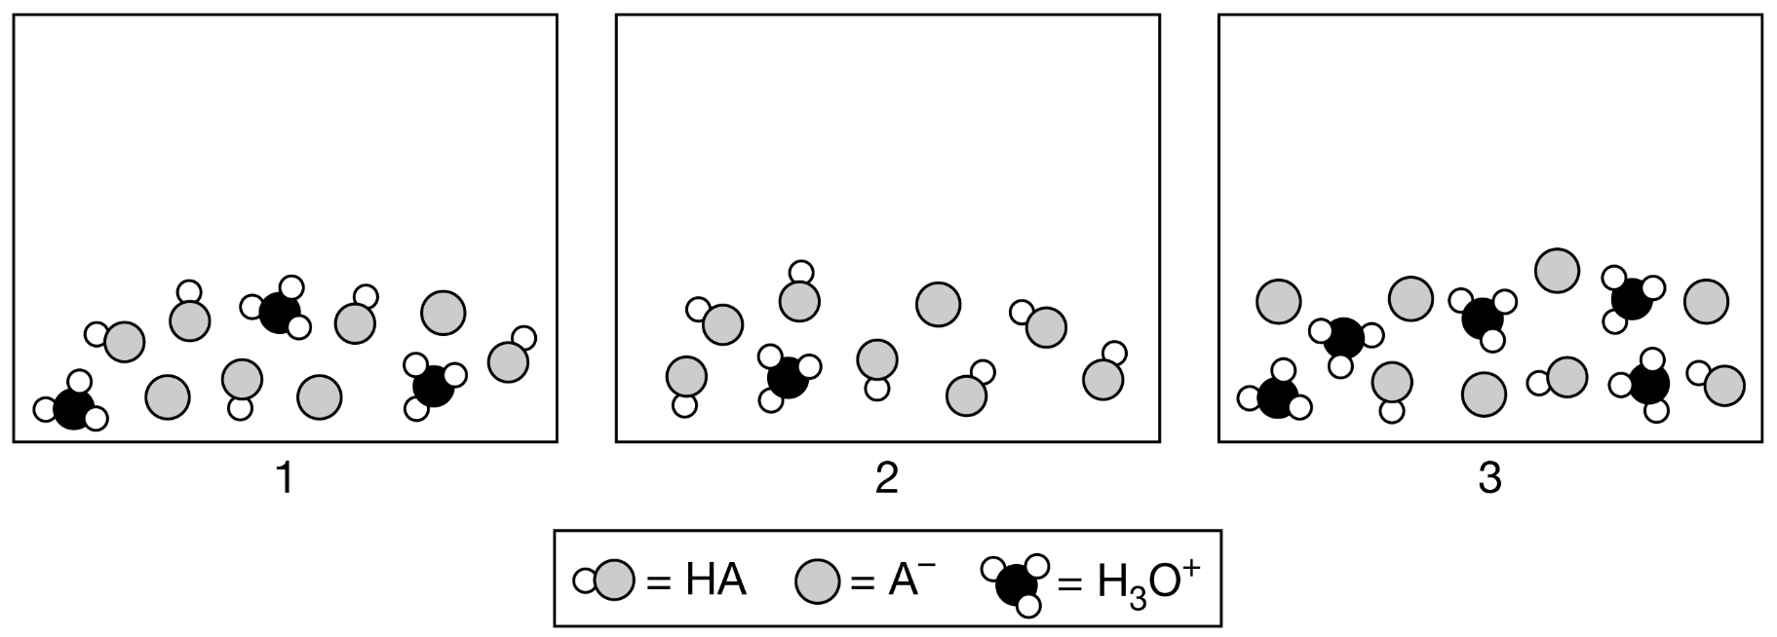

Topic 8.6 Worksheet

- Consider HOI and HOCl. Which is a weaker acid? Justify your answer in terms of the electronegativity of the halogen.

- Consider the four acids shown below. Explain why acidity increases as the number of oxygens added to the halogen increases in terms of electronegativity.

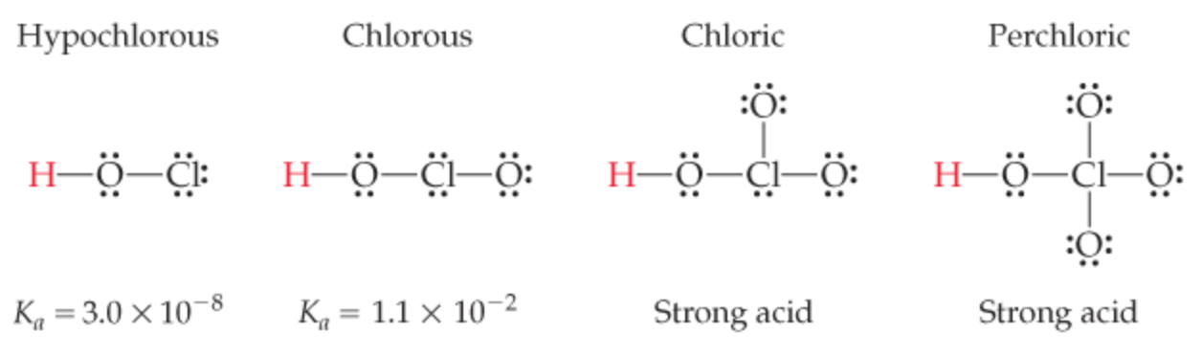

- Consider the two carboxylic acids shown below. The K_{a} of formic acid is 1.8 x 10⁻⁴ and the K_{a} of benzoic acid is 6.3 x 10⁻⁵.

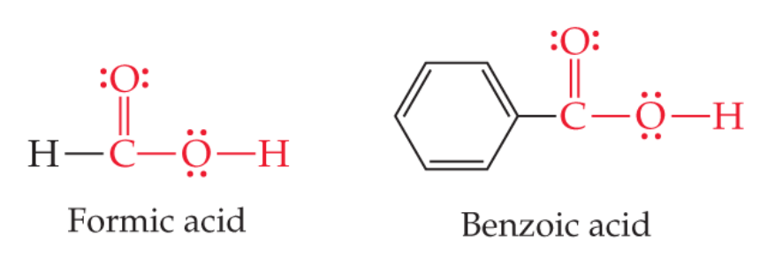
  - Which carboxylic acid is a stronger acid? Explain why in terms of molecular structure.

  - Which conjugate base is more stable? Justify your answer by referring to the K_{b}.

  - Write the equation for the reaction that occurs between benzoic acid and water.

  - Write the equation for the reaction that occurs between formic acid and water.

- Explain why CH₃COOH is an acid while CH₃OH is not.

- Explain why CH₃COOH is a stronger acid than CH₃CH₂COOH.

Topic 8.5 Worksheet

- Explain the process of the titration of an acid with a base.

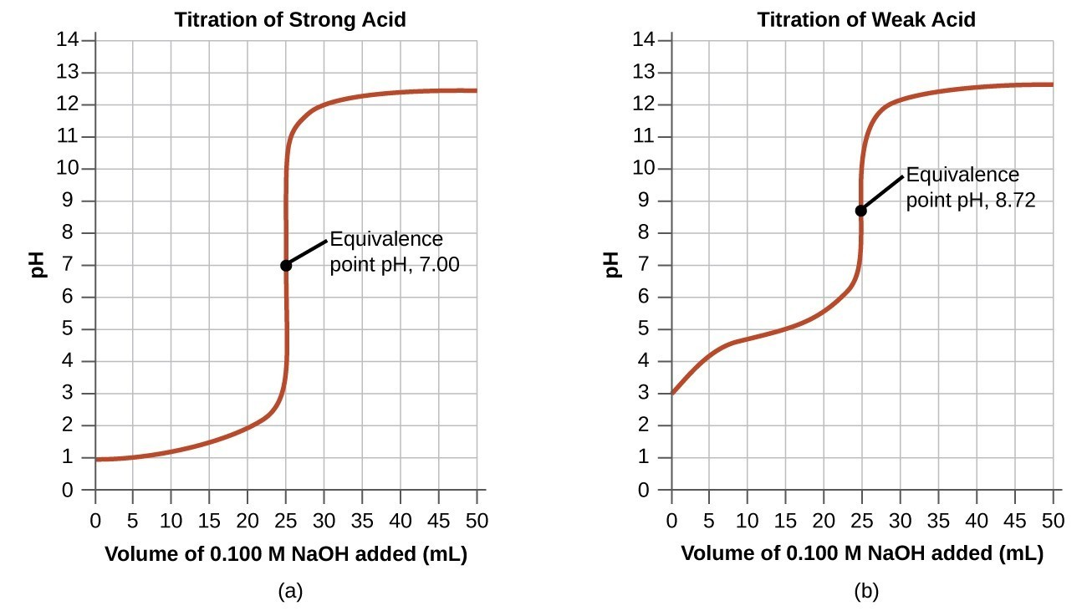
Titration Curve A |  | Titration Curve B

- Consider the two titration curves given above.
  - Which titration curve above is of a strong acid/strong base titration? Explain how you know.

  - Explain why the other titration curve is of a weak acid/strong base titration.

  - What is the pK_{a} and K_{a} of the weak acid?
- For the following titrations, determine the molarity of the monoprotic acid.
  - In a titration, 15.0 mL of acid reaches equivalence with 23.8 mL of 0.100 M base.

  - 13.4 mL of 0.125 M base reaches equivalence with 25.0 mL of a weak acid.

- Determine the pK_{a} and K_{a} of the following acids based on the titration curve.

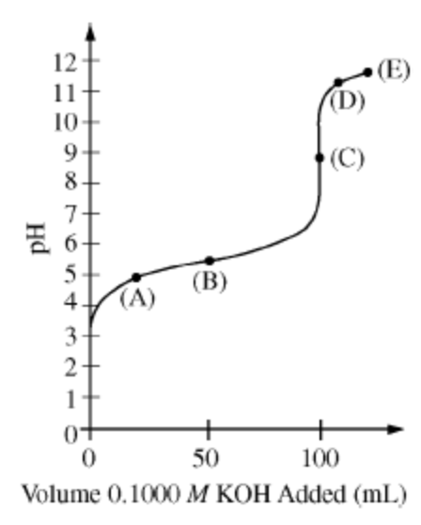 |  | 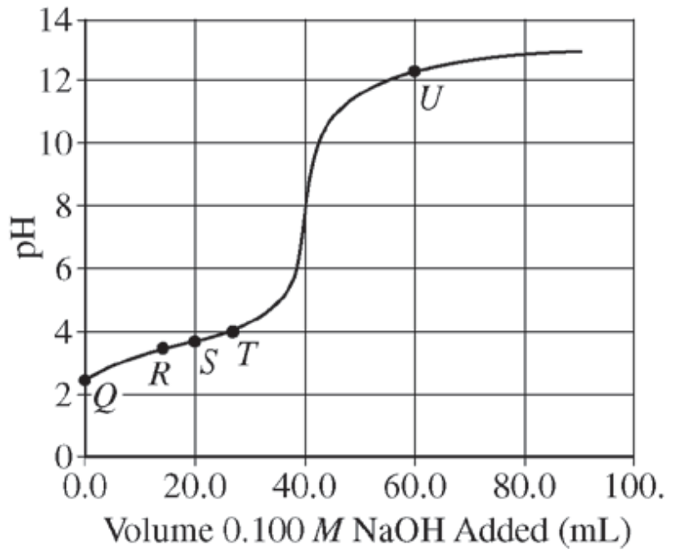
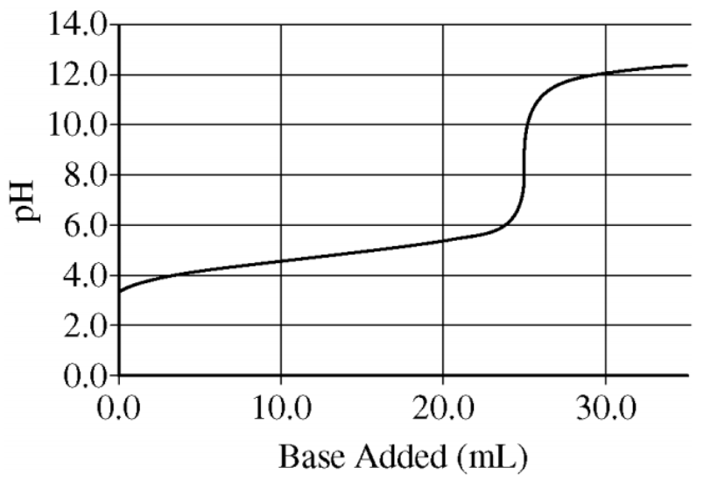

- For a weak acid/strong base titration, explain why the pH = pK_{a} at half-way to the equivalence point.

- Draw a general titration curve for …
  - H₃PO₄

  - H₂SO₄

- Explain the method to …
  - determine equivalence via titration.

  - determine equivalence via pH electrodes.

- Define:
  - Titrant

  - Analyte

  - Equivalence point

  - End point

- At which point in a titration are the concentrations of the weak acid and its conjugate base approximately equal?

- A titration is carried out to determine the molarity of an unknown acid. Determine if the following would increase, decrease, or have no effect on the calculated molarity. Explain your reasoning for each.
  - You use an indicator with an endpoint slightly past the equivalence point.

  - You use an indicator with an endpoint slightly before the equivalence point.

  - You choose the wrong indicator. The indicator you chose should be used for a strong acid/strong base titration but you are carrying out a weak acid/strong base titration.

  - You choose the wrong indicator. The indicator you chose should be used for a weak acid/strong base titration but you are carrying out a strong acid/strong base titration.
- For the titration curve given below, determine which species are present by placing an “X” in the box and which species has the highest concentration by placing also placing an “O” in the box.

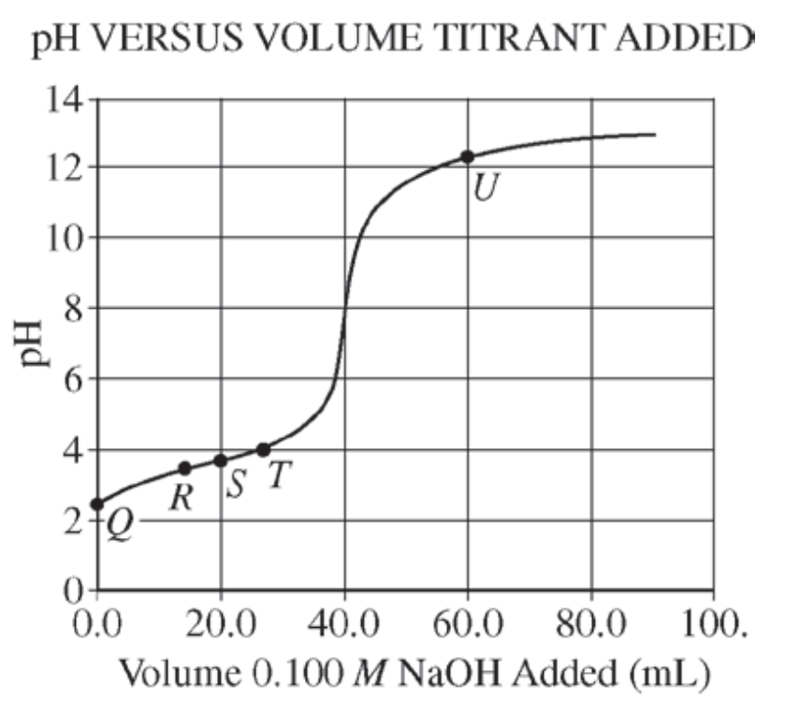 | Point | HA | A⁻ | H₃O⁺ | OH⁻
 | Q
 | R
 | S
 | T
 | U

HCOOH(aq) ⇌ HCOO⁻(aq) + H⁺(aq) K_{a} = 1.8 x 10⁻⁴

- Formic acid, HCOOH, dissociates in water as shown in the equation above. A 25.0 mL sample of an aqueous solution of pure formic acid is titrated using standardized 0.150 M NaOH.
  - After addition of 15.0 mL of the 0.150 M NaOH, the pH of the resulting solution is 4.37. Calculate each of the following.
    - [H⁺] in the solution

    - [OH⁻] in the solution

    - The number of moles of NaOH added

    - The number of moles of HCOO⁻ (aq) in the solution.

    - The number of moles of HCOOH in the solution.

  - At equivalence, will the pH be greater than 7, less than 7, or equal to 7. Explain your reasoning.
- Determine the volume of each solution needed to reach equivalence. Do not use a calculator.
  - What volume of 0.15 M HCl is needed to reach equivalence with 23.0 mL of 0.15 M NaOH?

  - What volume of 0.23 M Benzoic acid (K_{a} = 6.3 x 10 ⁻⁵) is needed to reach equivalence with 32.92 mL of 0.23 M NaOH?

  - What volume of 0.10 M HCl is needed to reach equivalence with 20 mL of 0.20 M NaOH?

- What is the pH at equivalence of a …
  - strong acid/strong base titration. Explain why.

  - weak acid/strong base titration. Explain why.

  - weak base/strong acid titration. Explain why.

- NEED PARTICLE PICTURE PROBLEMS

Topic 8.8, 8.10 Worksheet

- What types of substances make up a buffer?

- What does the conjugate acid react with in a buffer?

- What does the conjugate base react with in a buffer?

- How is a buffer able to resist a change in pH?

- When is a buffer formed in a titration?

- Consider a buffer made from acetic acid and sodium acetate.
  - Explain how to make a buffer using acetic acid, HC₂H₃O₂, and sodium acetate, NaC₂H₃O₂ .

  - Does the acetic acid react with an acid or a base? Give the reaction of acetic acid reacting with the acid/base. In the case of an acid use HCl and in the case of a base use NaOH.

  - Does the sodium acetate react with an acid or a base? Give the reaction of acetic acid reacting with the acid/base. In the case of an acid use HCl and in the case of a base use NaOH.

- Which of the following solutions would be considered a buffer?

Substances | Buffer (Yes or No)
0.10 M HCl + 0.10 M NaCl
0.10 M HF + 0.10 M NaF
0.10 M HBr + 0.10 M NaBr
0.10 M C₆H₅COOH + 0.10 M KC₆H₅COO

- For the buffers in the question above, is the pH greater than, less than, or equal to the pKa? Explain your reasoning by referring to the Henderson-Hasselbach equation.

- Of the buffers created below, which has the greatest buffering capacity?

0.1 M NaH₂PO₄ + 0.1 M Na₂HPO₄
0.01 M NaH₂PO₄ + 0.01 M Na₂HPO₄
1.0 M NaH₂PO₄ + 1.0 M Na₂HPO₄

- For the buffers created in the question above, how does the pH change with the change in molarity?

Topic 8.4 Worksheet

- Give the net-ionic reaction of HCl(aq) reacting with NaOH(aq).

- Give the net-ionic reaction of HC₂H₃O₂(aq) reacting with NaOH(aq).

- Give the net-ionic reaction of NH₃(aq) reacting with HCl(aq).

- For a strong acid/strong base titration, explain how to calculate the pH when …
  - No base has been added.

  - Some base has been added but not enough to reach equivalence.

  - Enough base has been added to reach equivalence.

  - Enough base has been added to go beyond equivalence.

- For a weak acid/strong base titration, explain how to calculate the pH when …
  - No base has been added.

  - Some base has been added but not enough to reach equivalence.

  - Enough base has been added so that it is halfway to equivalence.

  - Enough base has been added to reach equivalence.

  - Enough base has been added to go beyond equivalence.

- For a strong acid/weak base titration, explain how to calculate the pH when …
  - No acid has been added.

  - Some acid has been added but not enough to reach equivalence.

  - Enough acid has been added so that it is halfway to equivalence.

  - Enough acid has been added to reach equivalence.

  - Enough acid has been added to go beyond equivalence.

Topic 8.9, 8.7 Worksheet

- Without a calculator, determine the pH range of the buffers given below:

Buffer | K_{a} of acid or K_{b} of base | pH range
A | K_{a} = 1.3 x 10 ⁻⁴
B | K_{a} = 5.3 x 10 ⁻⁸
C | K_{b} = 7 x 10 ⁻³

- A buffer is created by mixing equal volumes of equimolar weak acid and a salt containing the conjugate base of the weak acid. A little acid or base has been added to change the concentrations of the salt or acid. Does the pH of the buffer increase, decrease, or remain the same when …
  - the concentration of the salt is greater than the concentration of the acid. Explain your reasoning in terms of the Henderson-Hasselbalch equation.

  - the concentration of the acid is greater than the concentration of the salt. Explain your reasoning in terms of the Henderson-Hasselbalch equation.

  - the concentration of the acid and salt remain in the same ratio. Explain your reasoning in terms of the Henderson-Hasselbalch equation.

- Without a calculator, determine the pH of a buffer in the following situations. The pKa of the buffer is 3.08.
  - 20 mL of 0.1 M weak acid is mixed with 20 mL of 0.1 M salt.

  - 20 mL of 0.1 M weak acid is mixed with 20 mL of 1.0 M salt.

  - 20 mL of 0.1 M weak acid is mixed with 200 mL of 1.0 M salt.

  - 200 mL of 0.1 M weak acid is mixed with 20 mL of 0.1 M salt.
- Determine the molarity of the salt created and the resulting pH for the following situations. In each case, the acid being used is 20 mL of 0.10 M HC₃H₅O₃ with a K_{a} of 8.3 x 10 ⁻⁴.
  - The acid is mixed with 10 mL of 0.10 M NaOH.

  - The acid is mixed with 5 mL of 0.10 M NaOH.

  - The acid is mixed with 15 mL of 0.10 M NaOH.

- Which species is dominant, the acid or the conjugate base of the acid, if …
  - the pH < pKa.

  - the pH > pKa.

  - the pH = pKa.

Unit 9

Topic 9.1, 9.2 Worksheet

- Place an “X” in the box for the system with higher entropy.

NaCl(s)  Or  NaCl(aq) |  | H₂O(l)  Or  H₂O(g) |  | H₂O(l) at 50 ℃  Or  H₂O(l) at 25 ℃
CO₂(s)  Or  CO₂(g) |  | 1 mol of gas in a 1.0 L container  Or  1 mol of gas in a 5.0 L container |  | 1.0 L of CH₄(g)  Or  5.0 L of CH₄(g)
1.0 M C₁₂H₂₂O₁₁
Or
10.0 M C₁₂H₂₂O₁₁

- Determine if ∆S would be positive, negative, or near zero for the following reactions. Place an “X” in the appropriate box.

Reaction | ∆S
 | + | 0 | −
2 H₂S(g) + SO₂(g) ⇌ 3 S(s) + H₂O(g)
3 Ag(s) + 4 HNO₃(aq) → 3 AgNO₃(aq) + NO(g) + 2 H₂O(l)
H₂O(l) → H₂O(s)
I₂(s) + ½ Cl₂(g) ⇌ ICl(g)
CO₂(g) + 2 NH₃(g) → CO(NH₂)₂(s) + H₂O(l)
Cl₂(g) → Cl₂(l)
Mg²⁺(aq) + 2 OH –(aq) → Mg(OH)₂(s)
C₃H₈(g) + 5 O₂(g) → 3 CO₂(g) + 4 H₂O(g)
Pb(NO₃)₂(s) + 2 KI(s) → PbI₂(s) + 2 KNO₃(s)

- Draw particle diagrams for the following situations.

Draw a situation where ∆S is +.
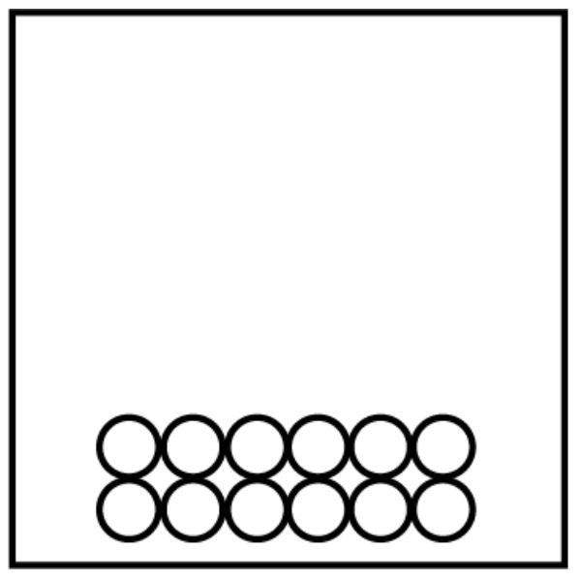
Before |  | After
Draw a situation where ∆S is −
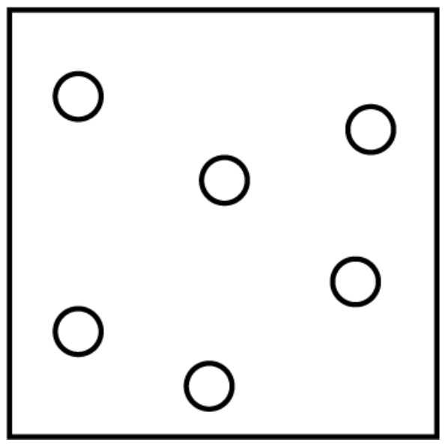
Before |  | After
Draw a chemical reaction where ∆S is +
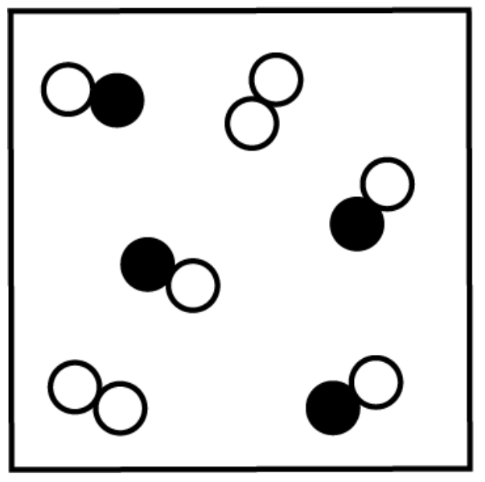
Before |  | After
Draw a chemical reaction where ∆S is −
Before |  | After

- What equation is used to calculate ∆Sº? What are the units for ∆Sº?

- Use the entropy values given to calculate ∆Sº values for the following reactions.
  - C₂H₄(g) + H₂(g) → C₂H₆(g)
Compound | Sº(J/mol•K)
C₂H₄(g) | 219.4
H₂(g) | 130.58
C₂H₆(g) | 229.5

  - Be(OH)₂(s) → BeO(s) + H₂O(g)
Compound | Sº(J/mol•K)
Be(OH)₂(s) | 50.21
BeO(s) | 13.77
H₂O(g) | 188.83

  - 2 CH₃OH(g) + 3 O₂(g) → 2 CO₂(g) + 4 H₂O(g)
Compound | Sº(J/mol•K)
CH₃OH(g) | 237.6
O₂(g) | 205
CO₂(g) | 213.6
H₂O(g) | 188.83

- Would you expect the entropy of CH₃OH(l) to be greater than, less than, or equal to the entropy of CH₃OH(g)? Explain your reasoning.

Topic 9.3, 9.4 Worksheet

- What are the conditions for standard state?

- What is the sign for ∆Gº when …
  - the reaction is thermodynamically favorable?

  - the reaction is not thermodynamically favorable?

- What does it mean when a reaction is not thermodynamically favorable? Explain your answer in terms of the reaction progress.

- What is the formula to calculate ∆Gº_{reaction} when given the ∆Gº of the reactants and products?

- What is the formula to calculate ∆Gº when ∆Hº and ∆Sº are known?

- Complete the table below by indicating the relative temperature for which the reaction would be considered thermodynamically favorable.

∆Hº | ∆Sº | Symbols | ∆Gº < 0 at which temperature?
< 0 | > 0 | < >
> 0 | < 0 | > <
> 0 | > 0 | > >
< 0 | < 0 | < <

- What is the sign of ∆H …
  - when bonds are broken?

  - when bonds are formed?
- Calculate ∆Gº for the following reactions given the Gº of the reactants and products.
  - 2 Ag(s) + Cl₂(g) → 2 AgCl(s)
Compound | ∆G_{f}º (kJ/mol)
AgCl(s) | −109.70

  - P₄O₁₀(s) + 16 H₂(g) → 4 PH₃(g) + 10 H₂O(g)
Compound | ∆G_{f}º (kJ/mol)
P₄O₁₀(s) | −2675.2
PH₃(g) | 13.4
H₂O(g) | −228.57

- Calculate ∆Hº, ∆Sº, and ∆Gº for the reactions given below. Then state if they are thermodynamically favorable. Assume ∆H_{f}º and ∆Sº do not change with a change in temperature.

  - NO₂(g) + N₂O(g) → 3 NO(g) (carried out at a temperature of 800 K)

Compound | ∆H_{f}º (kJ/mol) | ∆Sº (J/mol•K)
NO₂(g) | 33.84 | 240.45
N₂O(g) | 81.6 | 220.0
NO(g) | 90.37 | 210.62

  - 2 KClO₃(s) → 2 KCl(s) + 3 O₂(g) (carried out at a temperature of 25 ℃)

Compound | ∆H_{f}º (kJ/mol) | ∆Sº (J/mol•K)
KClO₃ | −391.2 | 143.0
KCl | −435.9 | 82.7

- Explain why a reaction may be thermodynamically favorable but not proceed at a measurable rate.

- What is the relationship between the magnitude of activation energy and the degree to which a thermodynamically favorable reaction proceeds?

CaSO₄ • 2 H₂O(s) ⇌ CaSO₄(s) + 2 H₂O(g)

- The hydrate CaSO₄ • 2 H₂O(s) can be heated to form the anhydrous salt, CaSO₄(s), as shown by the reaction represented above.
  - Using the data in the table below, calculate the value of ∆Gº, in kJ/mol_{rxn} , for the reaction at 298 K.

Substance | ∆G_{f}º at 298 K (kJ/mol)
CaSO₄ • 2 H₂O(s) | −1795.70
CaSO₄(s) | −1320.30
H₂O(g) | −228.59

  - Given that the value of ∆Hº for the reaction at 298 K is +105 kJ/mol_{rxn} , calculate the value of ∆Sº for the reaction at 298 K. Include units with your answer.

- When is thermodynamic favorability determined by …
  - Enthalpy

  - Entropy

- For a particular reaction, ∆H = −32 kJ and ∆S = −98 J/K. Assume that ∆H and ∆S do not vary with temperature.
  - At what temperature will the reaction have ∆G = 0?

  - If the temperature is increased will the reaction be thermodynamically favored? Explain your reasoning.
- Calculate ∆Gº for the reaction given below and the indicated temperature.

2 PbS(s) + 3 O₂(g) → 2 PbO(s) + 2 SO₂(g) ∆Hº = −844 kJ/mol_{rxn} ∆Sº = −165 J/K

  - at a temperature of 0 ℃

  - at a temperature of 250 ℃

  - at a temperature of 500 ℃

  - Does the thermodynamic favorability increase, decrease, or remain the same with an increase in temperature? Justify your answer.

- Determine at which temperature, high, low, all, or none, the reaction is thermodynamically favorable.

Reaction | Sign of ∆H |  | Sign of ∆S | Temp
A sample of an ionic compound dissolves endothermically into a beaker of water. |  |  |  | None | High
 |  |  |  | Low | All
2 H₂(g) + O₂(g) → 2 H₂O(g) |  |  |  | None | High
 |  |  |  | Low | All
The exothermic reaction of 4 Fe(s) + 3 O₂(g) ⇌ 2 Fe₂O₃(s) |  |  |  | None | High
 |  |  |  | Low | All
A(g) + B(g) → AB(g) |  |  |  | None | High
 |  |  |  | Low | All
2 A(g) ⇌ A₂(g) |  |  |  | None | High
 |  |  |  | Low | All
∆H < 0, ∆S < 0 |  |  |  | None | High
 |  |  |  | Low | All
∆H > 0, ∆S < 0 |  |  |  | None | High
 |  |  |  | Low | All

Topic 9.6 Worksheet

This page is intentionally left blank.

Topic 9.5 Worksheet

- Is the value of K greater than 1, less than 1, or equal to 1 …
  - for a thermodynamically favored reaction at equilibrium?

  - for a thermodynamically unfavorable reaction at equilibrium?

- As the sign of ∆G becomes more and more negative, does the equilibrium constant become larger, smaller, or remain the same?

- What happens to the size of ∆G as K_{eq} …
  - gets smaller and smaller?

  - gets bigger and bigger?

Topic 9.7 Worksheet

- Describe the role of each part of a Galvanic cell:
  - Anode (electrode)

  - Cathode (electrode)

  - Anode solution

  - Cathode solution

  - Salt bridge

- For an anode with an electrode that participates in the reaction …
  - does oxidation or reduction occur?

  - does the electrode gain or lose mass?

  - does the salt bridge contribute cations or anions?

  - do the electrons flow to or away from the electrode?

- For a cathode with an electrode that participates in the reaction …
  - does oxidation or reduction occur?

  - does the electrode gain or lose mass?

  - does the salt bridge contribute cations or anions?

  - do the electrons flow to or away from the electrode?

- A galvanic cell uses a platinum electrode as the anode. Does the mass of the electrode increase, decrease, or remain the same as the reaction proceeds?
- The voltaic cell shown below is thermodynamically favorable.

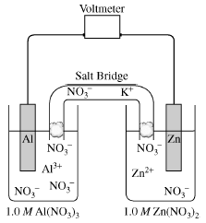

Reduction Reaction | Voltage
Al³⁺(aq) + 3 e ⁻ → Al(s) | −1.66 V
Zn²⁺ + 2 e⁻ → Zn(s) | −0.763

  - Determine the voltage of the voltaic cell.

  - Determine the net-ionic reaction.

  - How many moles of electrons are transferred during the chemical reaction?

  - Which metal, Al(s) or Zn(s), is used in the anode?

  - Is the value for the standard free energy change, ∆Gº, positive, negative, or zero. Justify your answer.

  - If the concentration of Zn²⁺ was changed from 1.0 M to 0.01 M, would the cell voltage increase, decrease, or remain the same? Explain your answer.

  - What would happen to the voltage if the salt bridge was removed? Explain why.
- The galvanic cell shown below is constructed and analyzed. The standard free-energy change of the cell is negative. Answer the questions that follow.

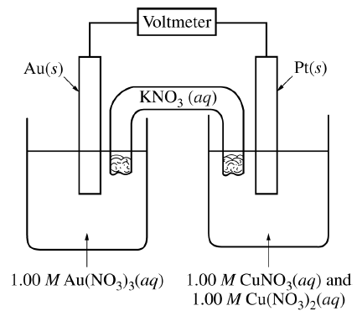
The standard reduction potentials associated with the cell are given in the following table.

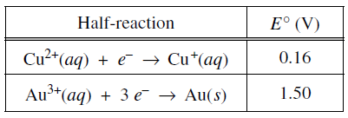

  - Determine the value of the standard cell potential, Eº.

  - Give the net-ionic reaction for the cell.

  - Label which half-cell is the cathode and which is the anode.

  - How many moles of electrons are transferred as the reaction proceeds?

  - Does the mass of the Pt(s) electrode increase, decrease, or remain the same as the cell operates? Justify your answer.

  - Would the voltage of the cell increase, decrease, or remain the same if the mass of the Au(s) electrode was increased?

  - Calculate ∆Gº, in kJ/mol_{rxn}, for the cell.
- In an electrolytic cell …
  - will the more positive or more negative reduction reaction occur at the cathode?

  - will the more positive or more negative oxidation reaction occur at the anode?

- In each electrolyte cell below, determine which reaction will occur at the anode and which reaction will occur at the cathode by placing an “X” in the appropriate box.
  - Electrolysis of NaCl(aq)
Reaction | Voltage |  | Occurs at the cathode |  | Occurs at the anode
Na⁺(aq) + e⁻ → Na(l) | Eº = −2.71 volts
2H₂O(l) + 2 e⁻ → H₂(g) + 2 OH⁻(aq) | Eº = −0.83 volts
Cl⁻(aq) → ½ Cl₂(g) + e⁻ | Eº = −1.359 volts
H₂O(l) → ½ O₂(g) + 2 H⁺(aq) + 2 e⁻ | Eº = −1.23 volts

  - Electrolysis of LiCl(aq)
Reaction | Voltage |  | Occurs at the cathode |  | Occurs at the anode
Li⁺(aq) + e⁻ → Li(s) | Eº = −3.05 volts
2H₂O(l) + 2 e⁻ → H₂(g) + 2 OH⁻(aq) | Eº = −0.83 volts
Cl⁻(aq) → ½ Cl₂(g) + e⁻ | Eº = −1.359 volts
H₂O(l) → ½ O₂(g) + 2 H⁺(aq) + 2 e⁻ | Eº = −1.23 volts

  - Electrolysis of CuBr₂(aq)
Reaction | Voltage |  | Occurs at the cathode |  | Occurs at the anode
Cu²⁺(aq) + 2e⁻ → Cu(s) | Eº = 0.34 volts
2H₂O(l) + 2 e⁻ → H₂(g) + 2 OH⁻(aq) | Eº = −0.83 volts
2 Br⁻(aq) → Br₂(g) + 2 e⁻ | Eº = −1.07 volts
H₂O(l) → ½ O₂(g) + 2 H⁺(aq) + 2 e⁻ | Eº = −1.23 volts

- Will a higher molarity voltaic cell operate for a longer time, a shorter time, or the same amount of time as a lower molarity voltaic cell? Explain your reasoning.

- Give the line notation of …
  - #5

  - #6

