**2015 USNCO National Part 2**

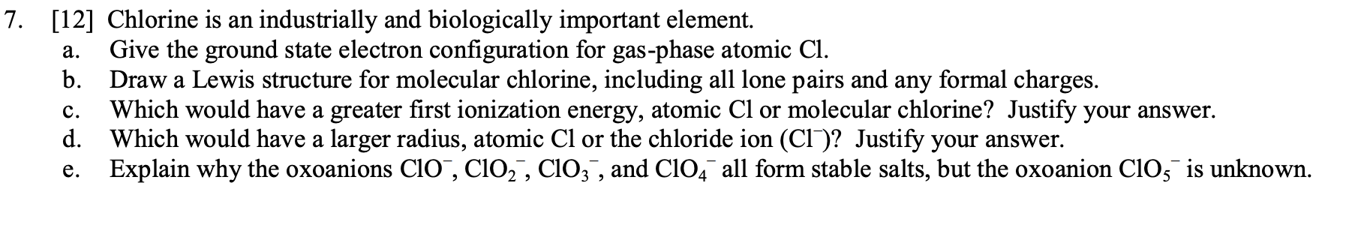

**2013 USNCO National Part 2**

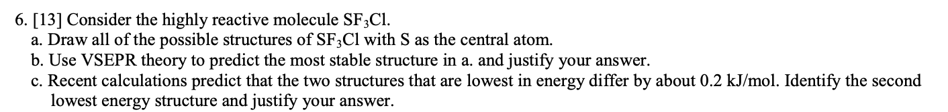



*(Part d. Omitted)*

***Answer Key***

|  |
| --- |
| **2015 USNCO National Part 2** |
|  |
| **2013 USNCO National Part 2** |
|  |