***Bonding***

Here are some practice problems!

-Venky & Anugrah

**2019 USNCO Local**

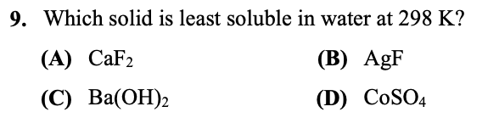

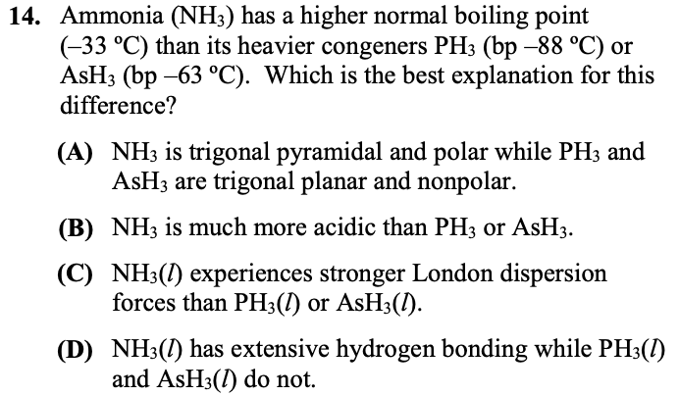

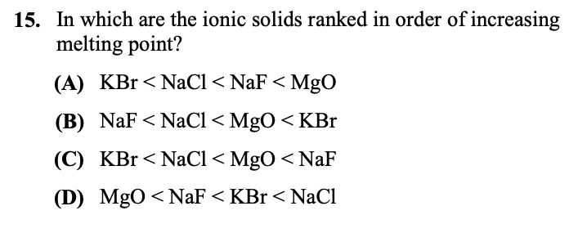

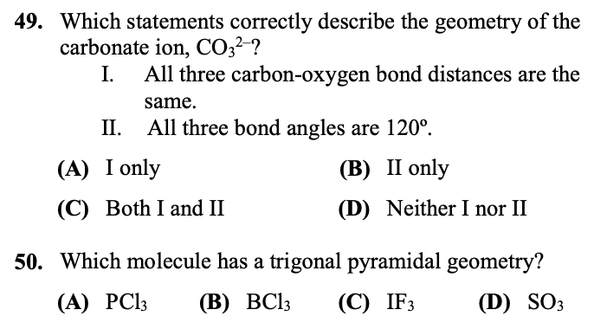

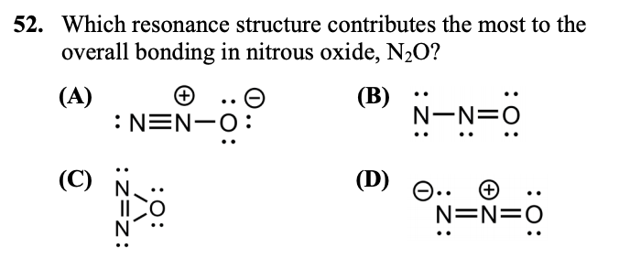

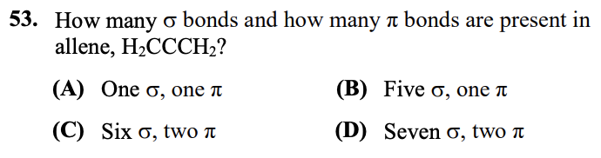

**2018 USNCO Local**

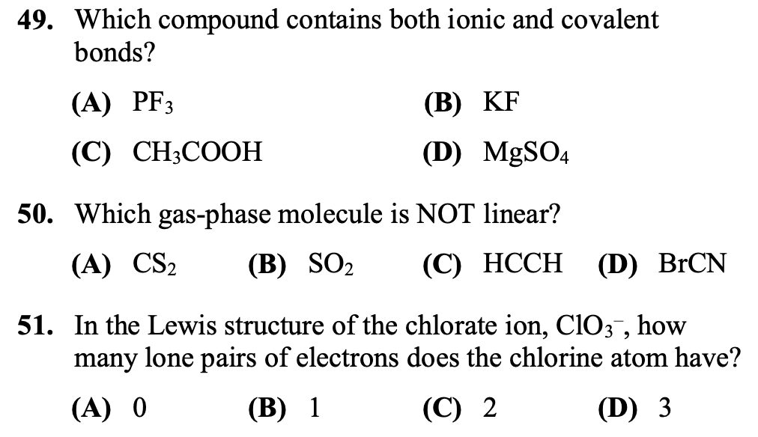

**2015 USNCO Local**

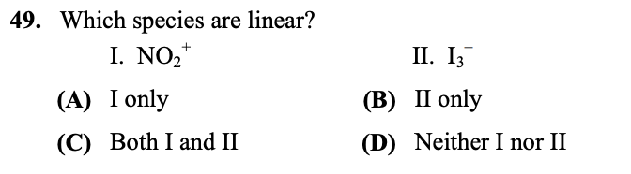

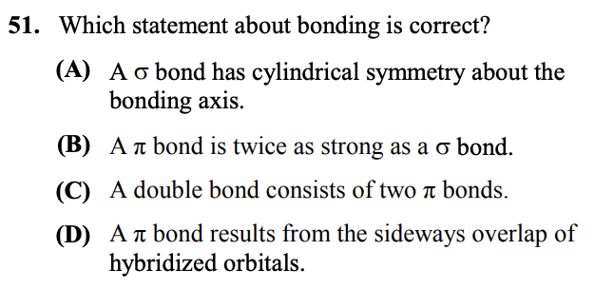

**2014 USNCO Local**

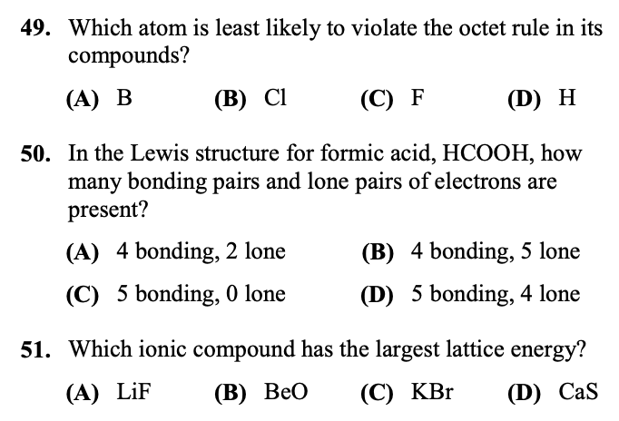

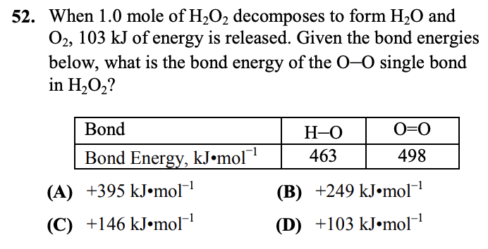

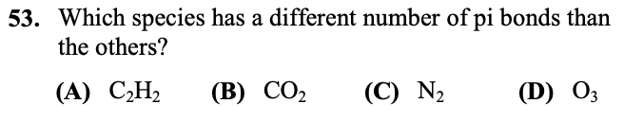

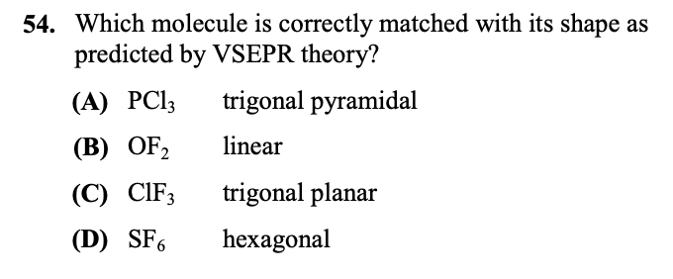

**2012 USNCO Local**

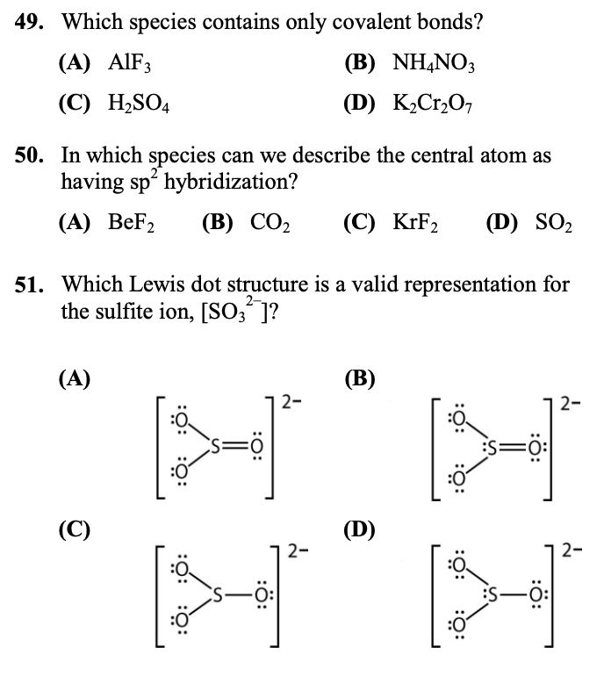

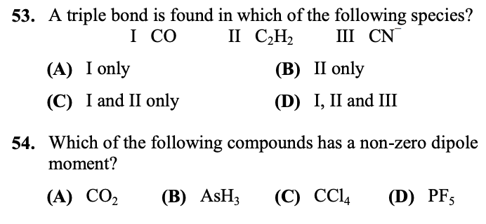

|  |  |
| --- | --- |
| ***ANSWER KEYS:*** | |
| **2019 Local:**  9: A  14: D  15: A  49: C  50: A  52: A  53: C  **2018 Local:**  49: D  50: B  51: B  **2015 Local:**  49: C  51: A | **2014 Local:**  49: C  50: D  51: B  52: C  53: D  54: A  **2012 Local:**  49: C  50: D  51: D  53: D  54: B |