***Equilibrium***

*Basic Overview*

With reaction aA + bB ➝ cC + dD:

$K_{c}=\frac{{[C]}^{c}{[D]}^{d}}{{[A]}^{a}{[B]}^{b}}$

$K_{p}=\frac{p_{C}^{c}*p_{D}^{d}}{p_{A}^{a}*p_{B}^{b}}$

$K_{p}=K_{c}(RT)^{Δn}$ (*Δn* = prod. - reac. moles)

$ΔG=ΔG°+RTlnQ$

Le Chatelier's Principle: Changing temperature, volume, or moles in equilibrium will cause a shift in the opposite direction.

* Q > K => reaction goes reverse
* Q = K => equilibrium
* Q < K => reaction goes forward
* exothermic + T increase -> reverse
* endothermic + T increase -> forward

*Practice Problems*

**2014 USNCO Local**

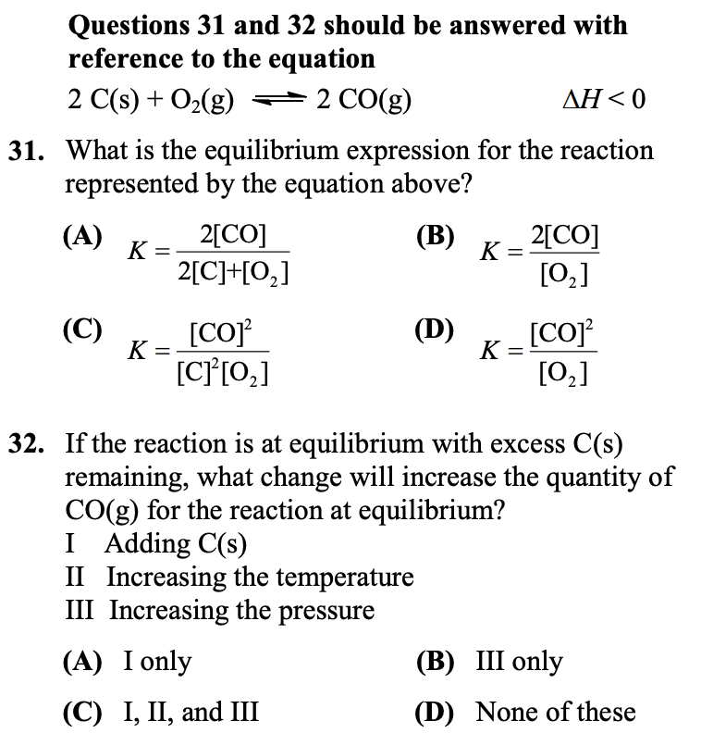

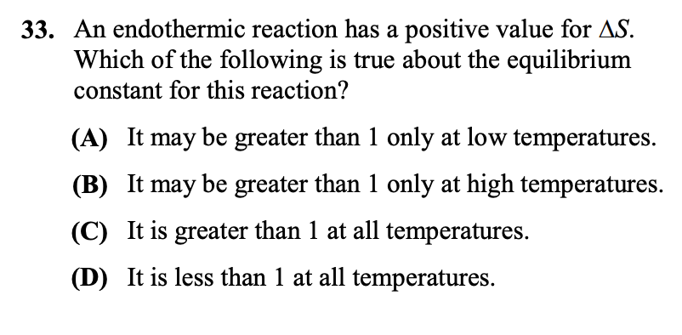

**2009 USNCO Local**

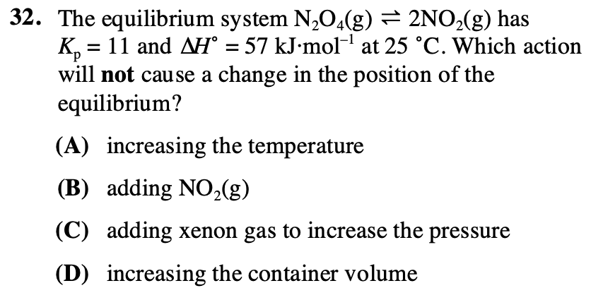

**2008 USNCO Local**

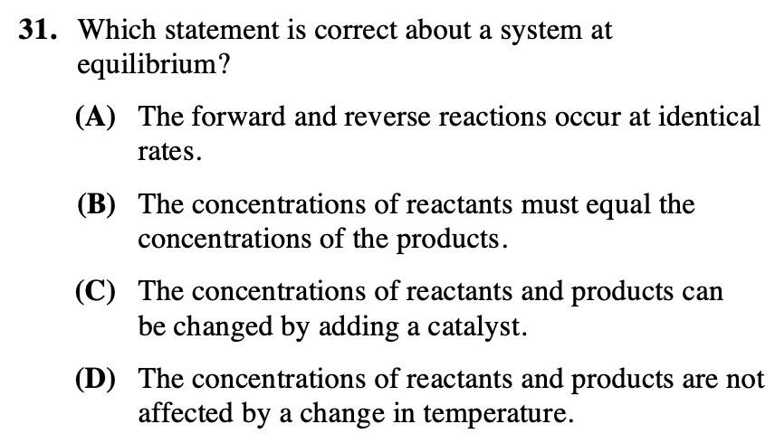

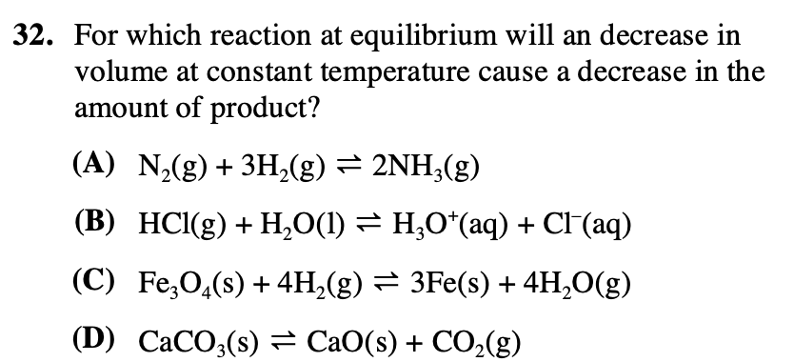

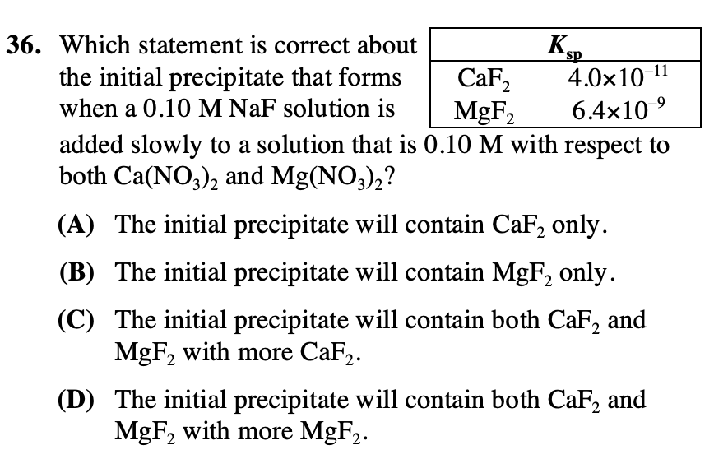

**2006 USNCO Local**

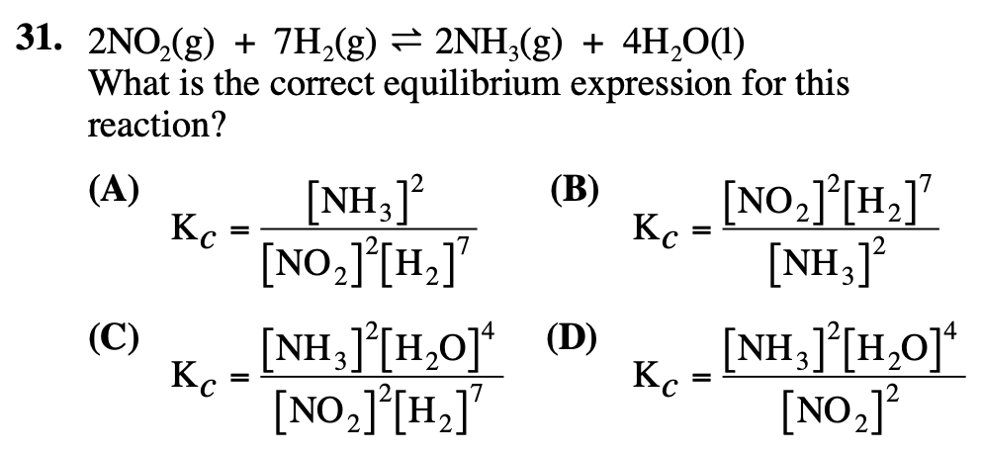

**2006 USNCO National**

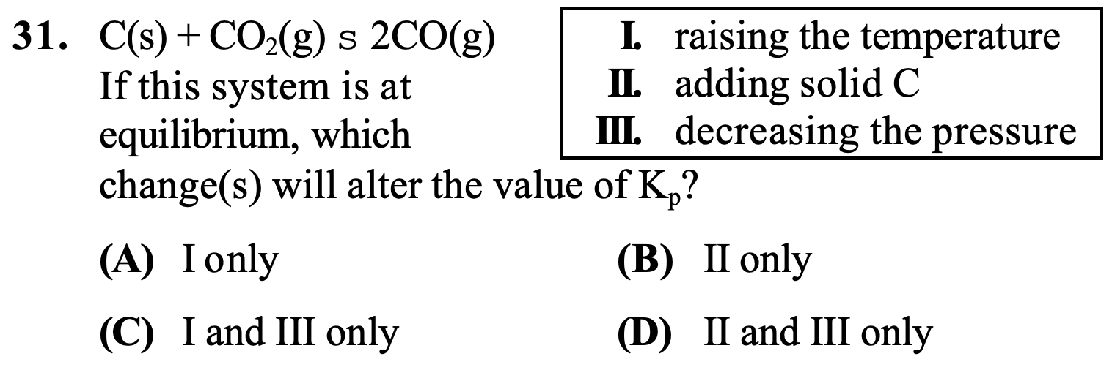

**2001 USNCO National**

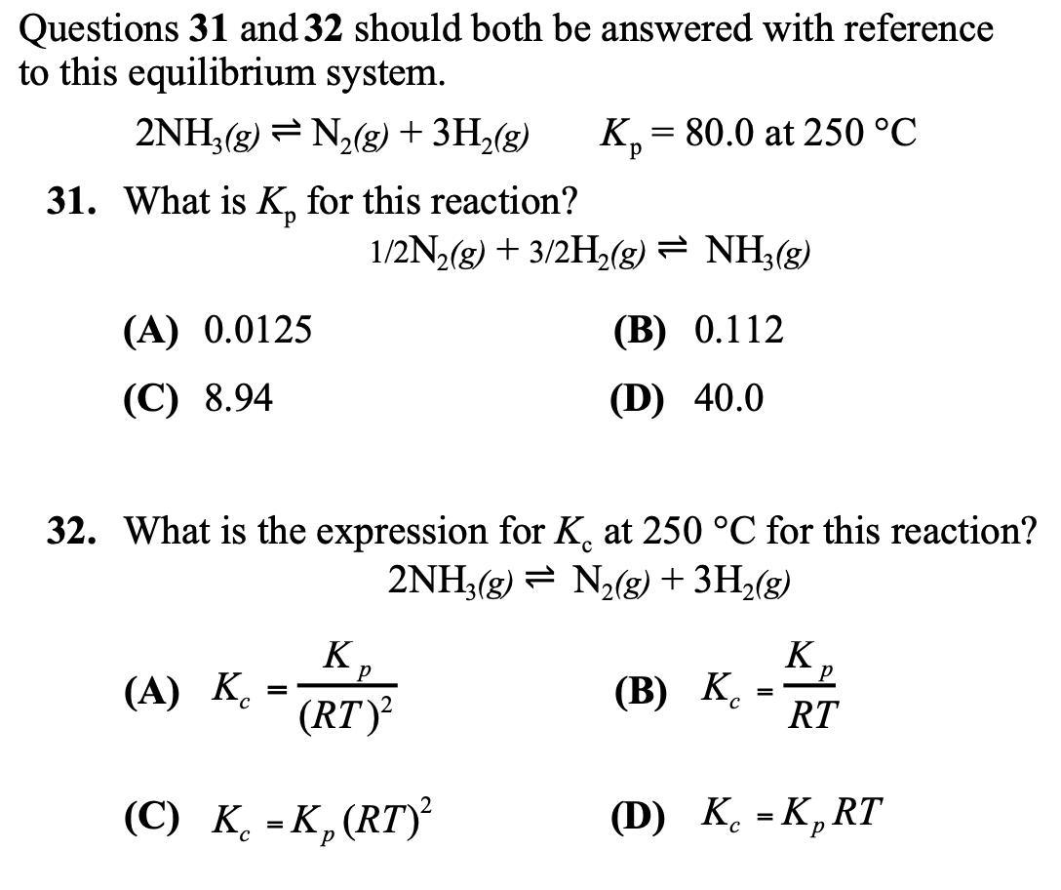

***ANSWER KEYS***

*2014 USNCO Local*

31. D

32. D

33. B

36. C

*2009 USNCO Local*

32. C

*2008 USNCO Local*

31. A

32. C

36. D

*2006 USNCO Local*

31. A

*2001 USNCO National*

31. A

*2001 USNCO National*

31. B

32. A