(Some) Solutions at the bottom of this document

2018 AP exam #2

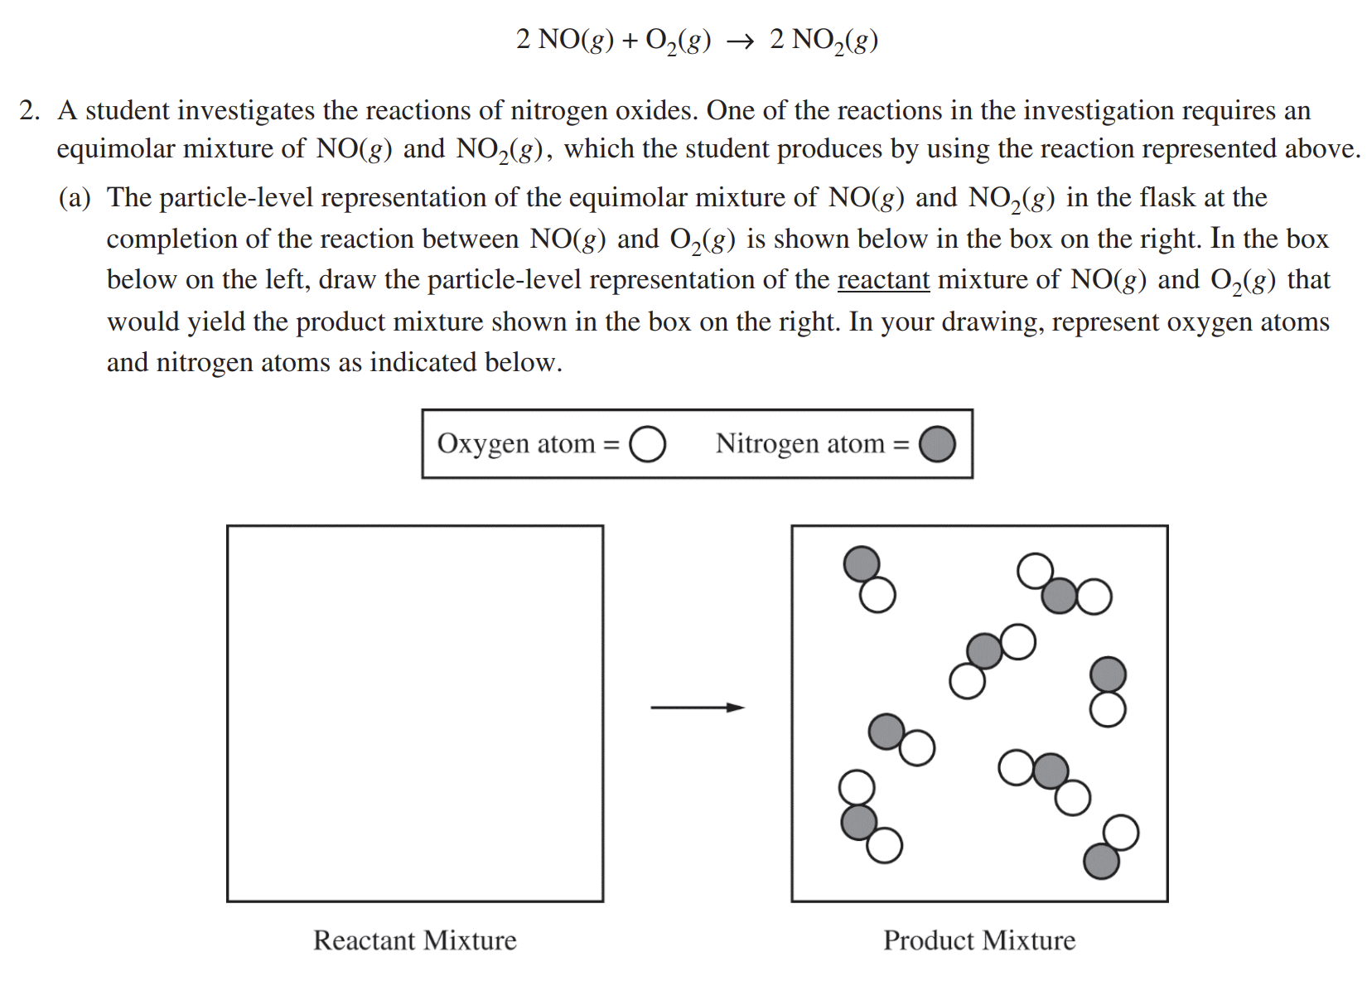

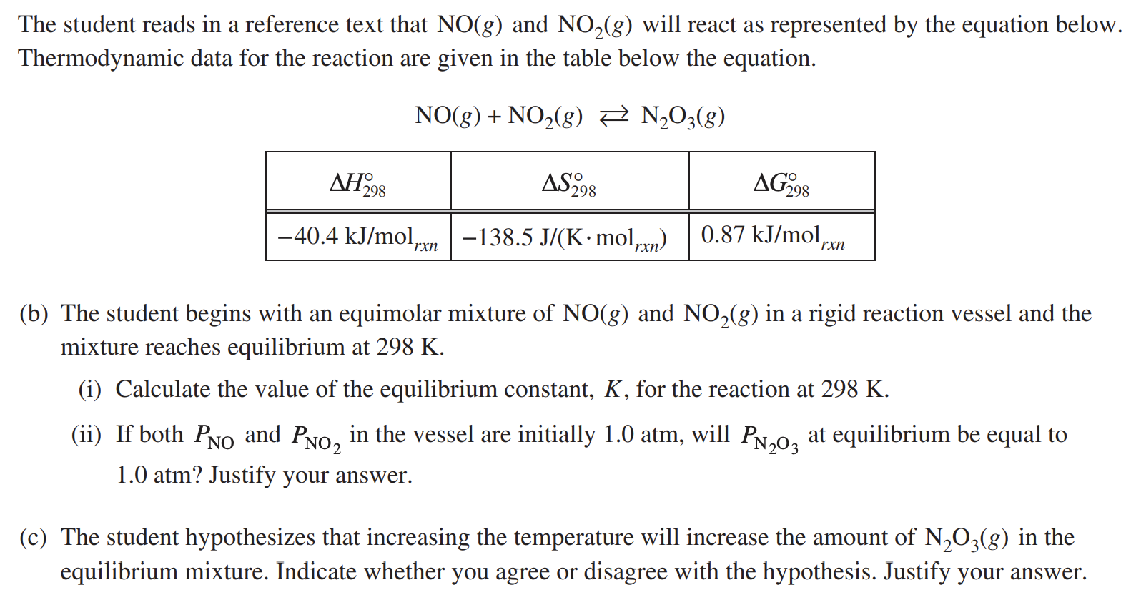

2013 USNCO National Part II #4

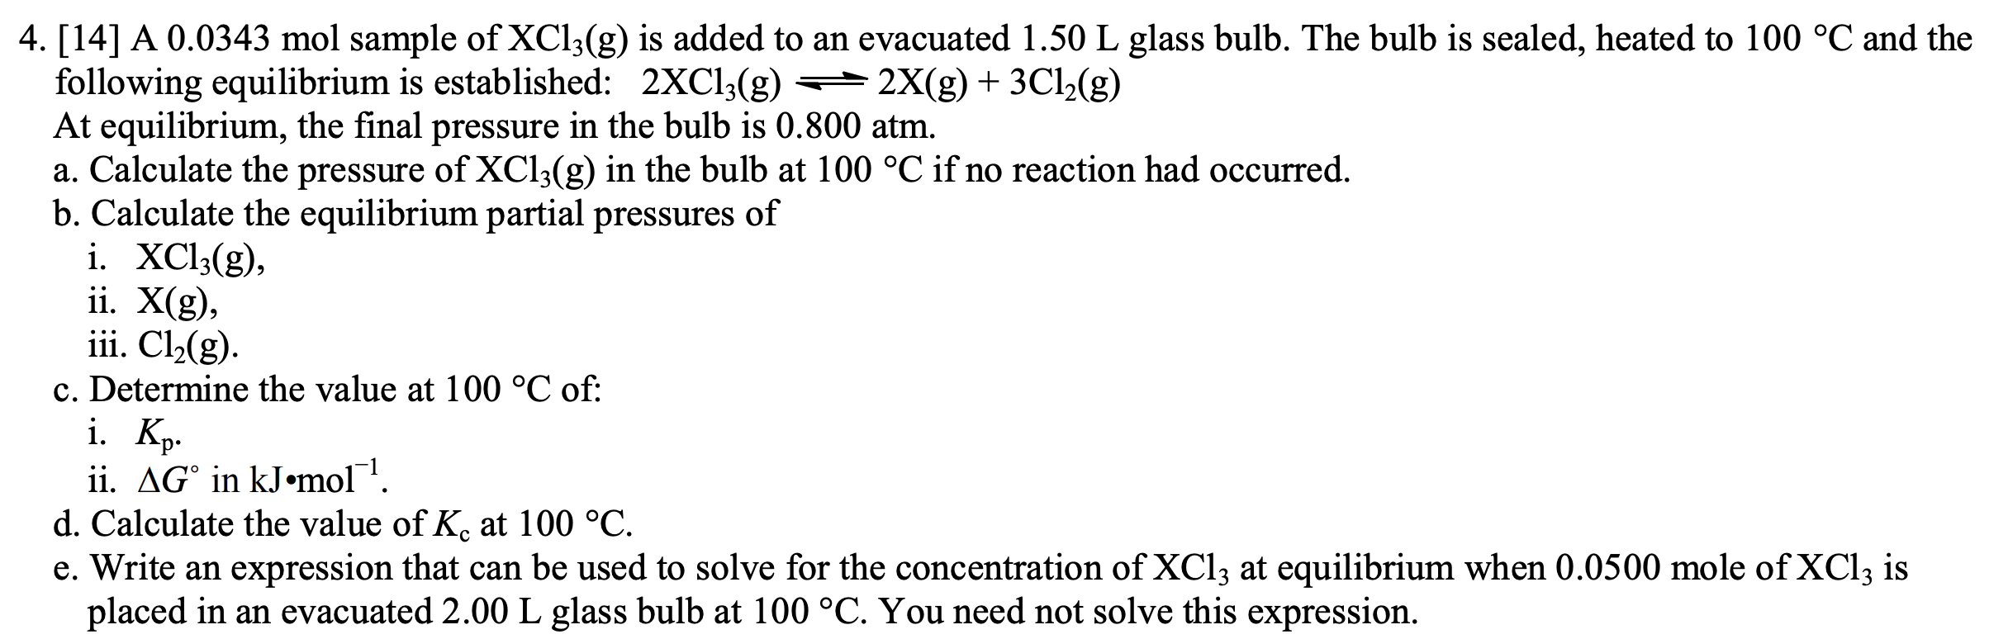

2010 UNSCO National Part II #1

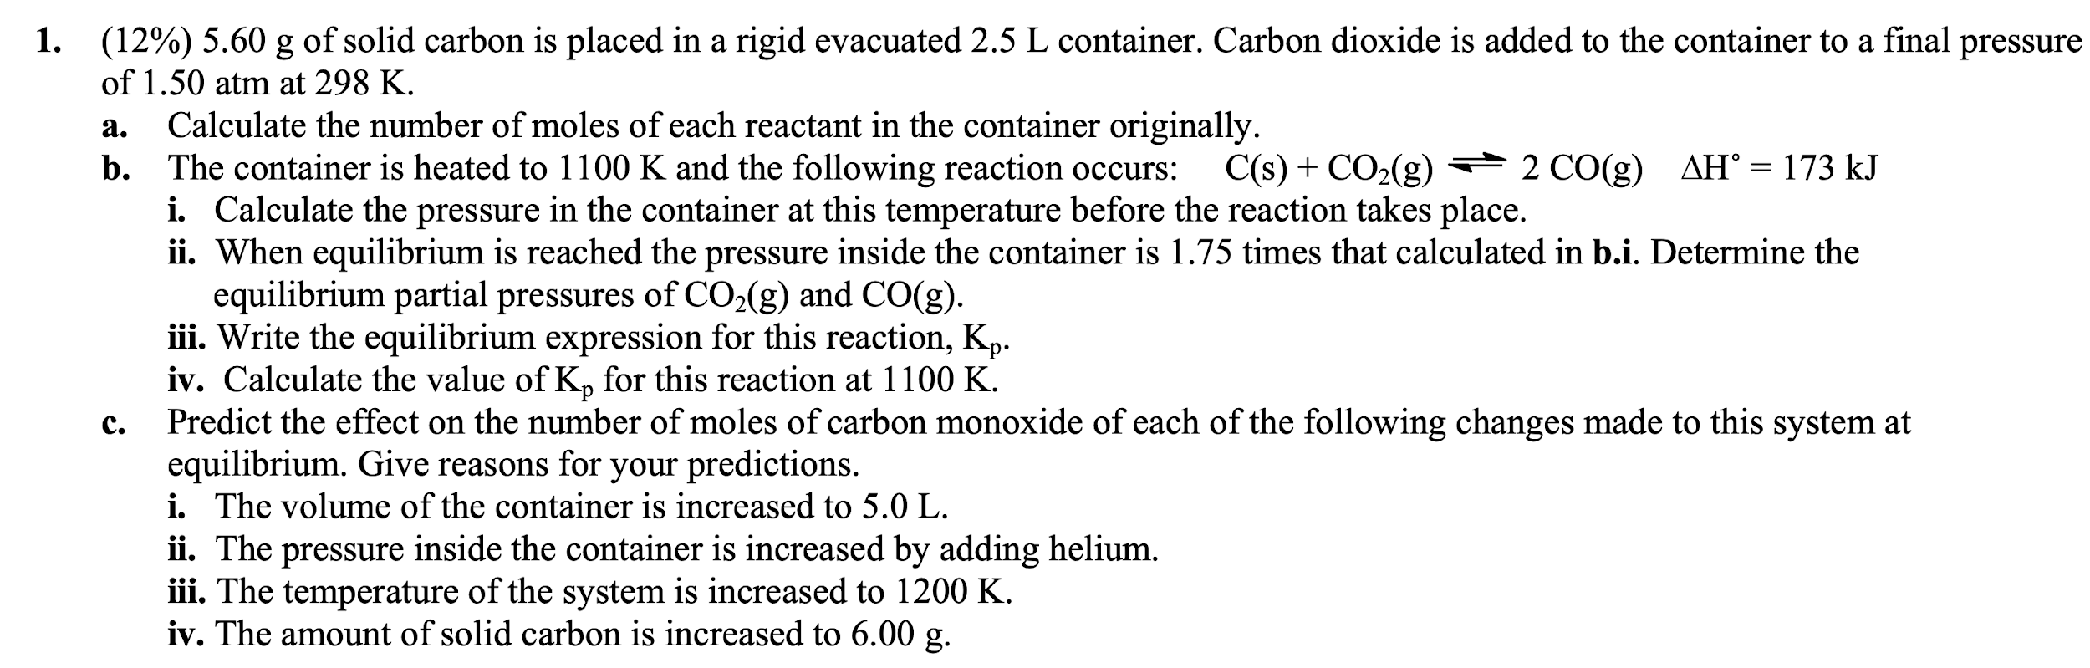

2018 AP exam #7

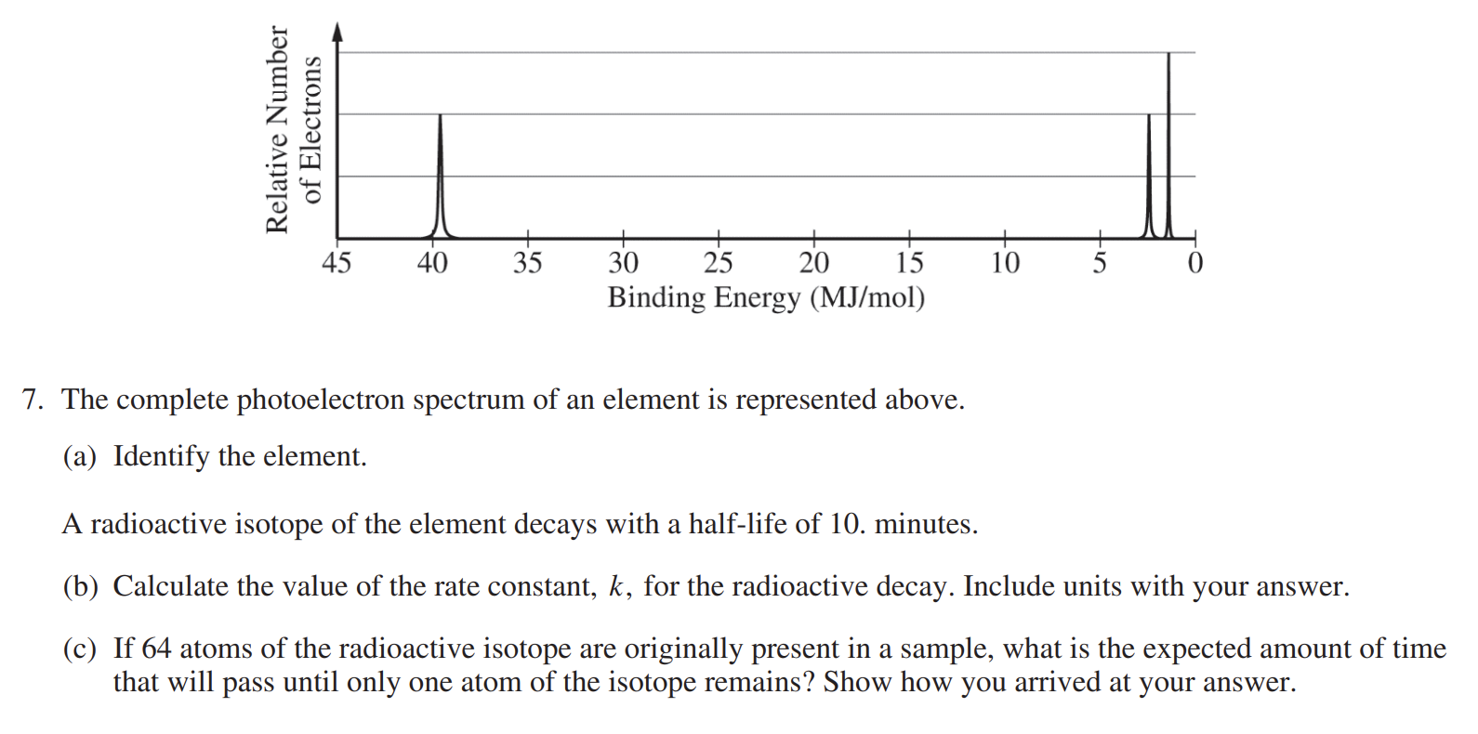

2019 AP Exam #5

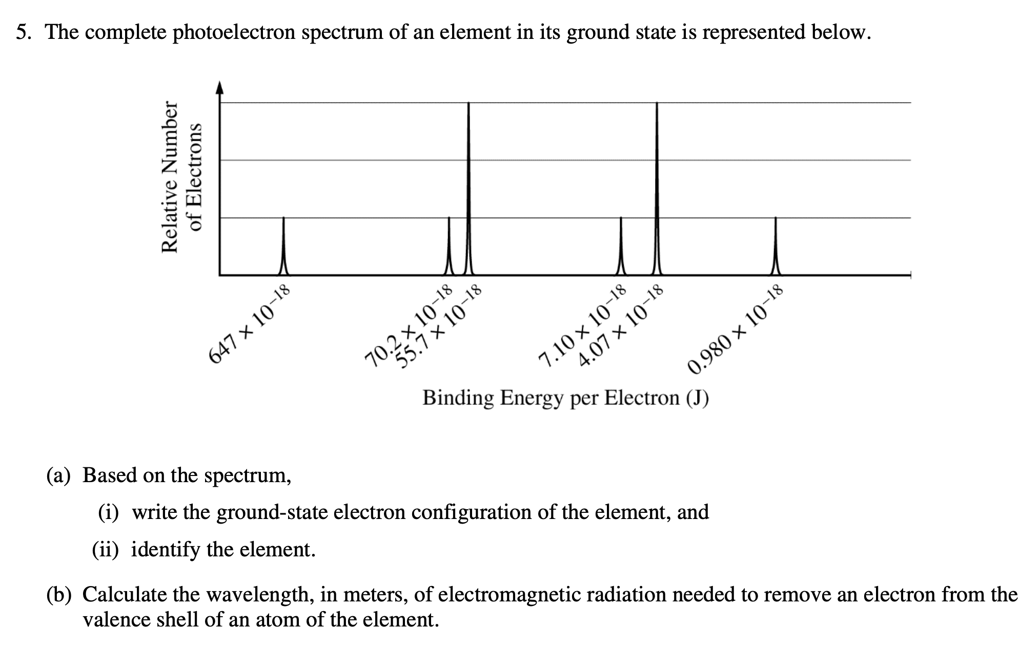

There is a noticeable lack of Atomic Theory FRQs in this handout. Sad!

Some past Atomic Theory FRQs can be found at this link:

<http://bhs.bellvilleisd.org/UserFiles/Servers/Server_1204/File/Schumann/Atomic%20Theory%20&%20Periodicity%20FR%20worksheet.pdf>

The corresponding solutions are available here:

<https://pobchemteam.weebly.com/uploads/2/5/7/7/25772138/atomic_theory_and_periodicity_fr_worksheet_key.pdf>

**(Some) Solutions**

Solutions to old AP exam questions can be found at AP Central

|  |  |
| --- | --- |
| 2019 (Scroll Down) | <https://apcentral.collegeboard.org/courses/ap-chemistry/exam> |
| Pre 2018 | <https://apcentral.collegeboard.org/courses/ap-chemistry/exam/past-exam-questions?course=ap-chemistry> |

The solutions to the selected FRQs from Old USNCOs are below.

**2013 USNCO Part II #4**

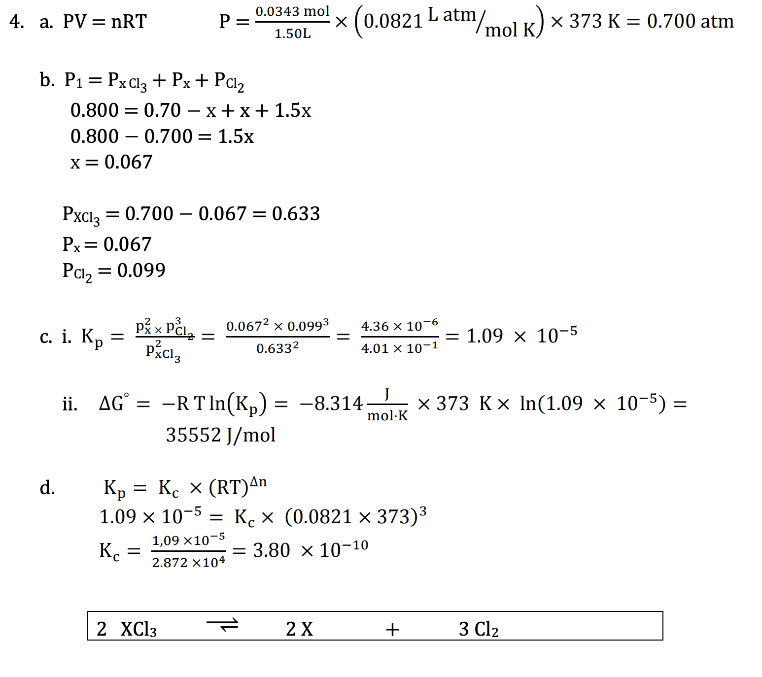

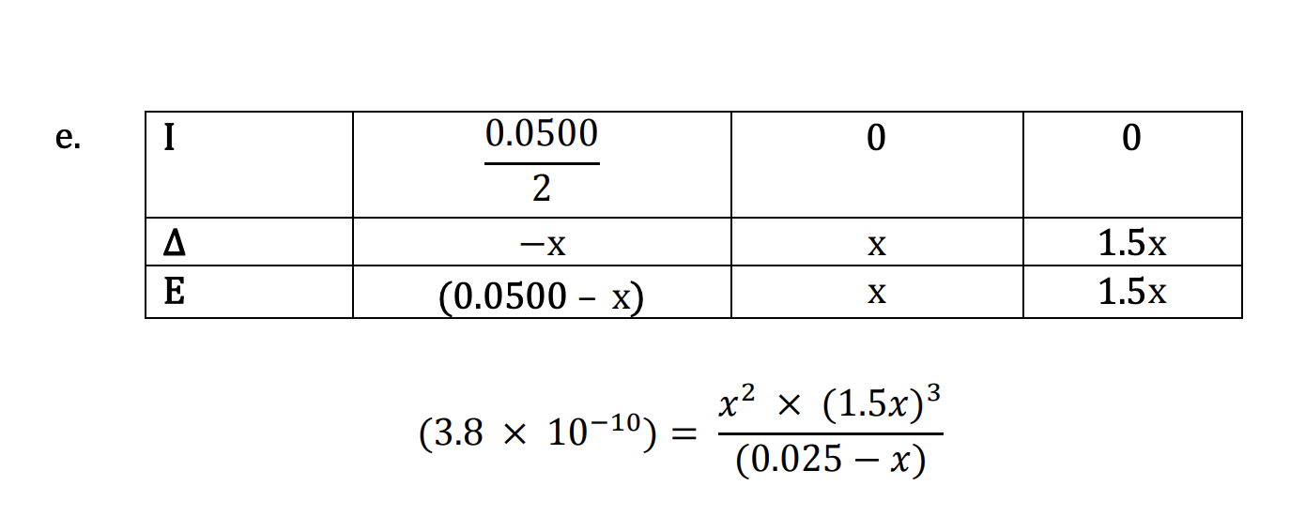

**2010 USNCO Part II #4**

