***2019 USNCO Local***

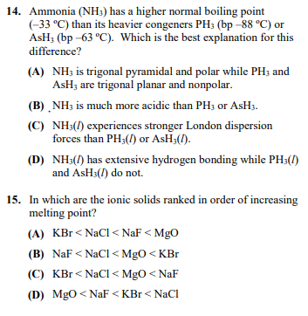

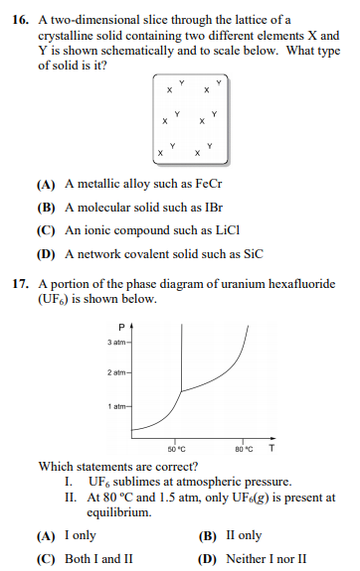

***2018 USNCO Local***

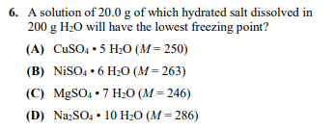

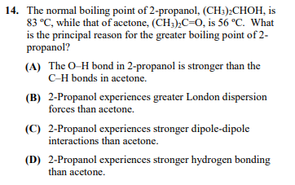

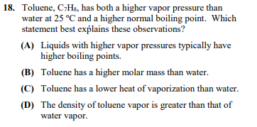

***2017 USNCO Local***

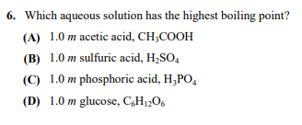

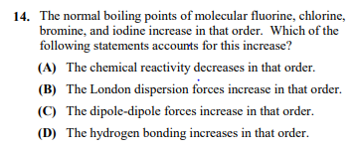

***2017 Local(contd.)***

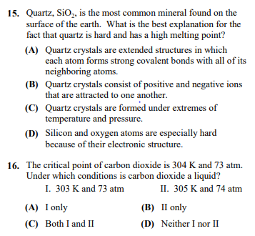

***2016 USNCO Local:***

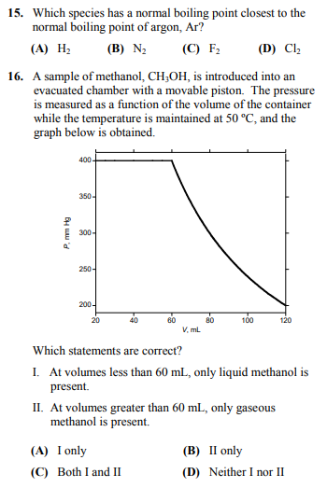

***ANSWER KEY***

***2019 Local:***

***14: D***

***15: A***

***16: B***

***17: C***

***2018 Local:***

***6: D***

***14: D***

***18: C***

***2017 Local:***

***6: B***

***14: B***

***15: A***

***16: A***

***2016 Local:***

***15: C***

***16: B***