2019-20 Practice Midterm
1-3 Lab themed questions
4-7 Trivia/Misc Questions
8-17 Thermo Questions
18-28 Kinetics Questions
1. | 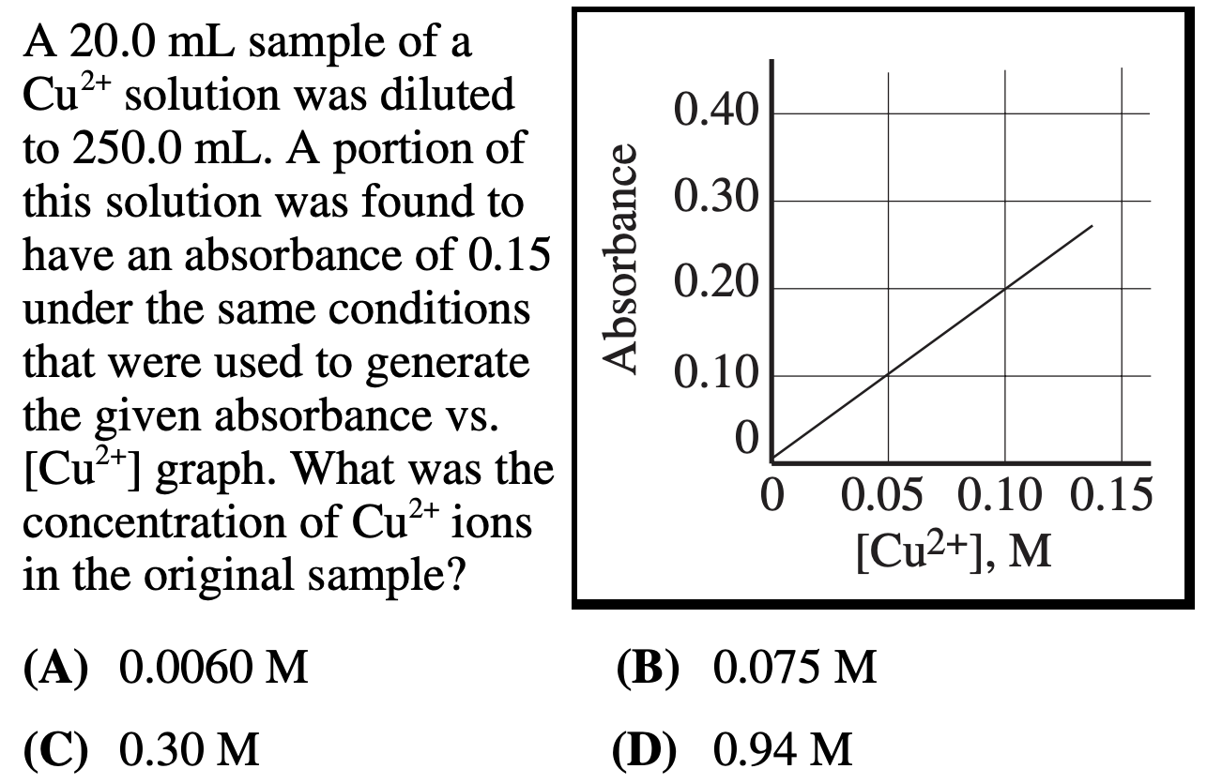
2. | 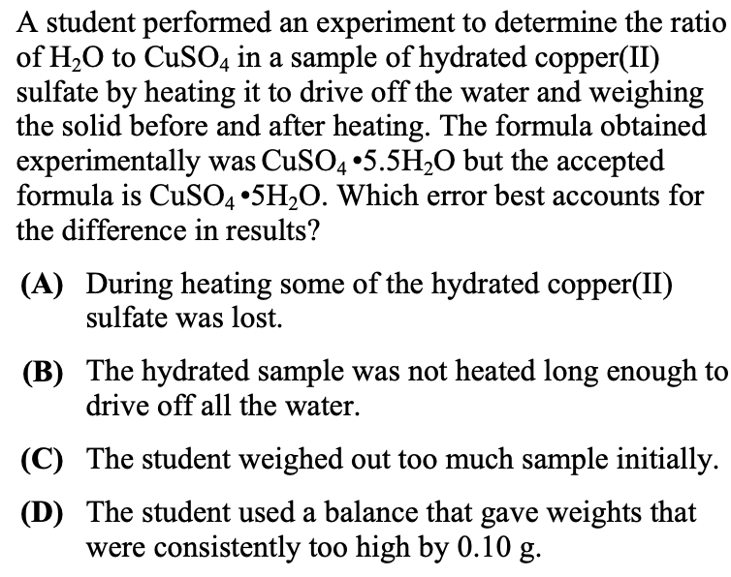
3. | 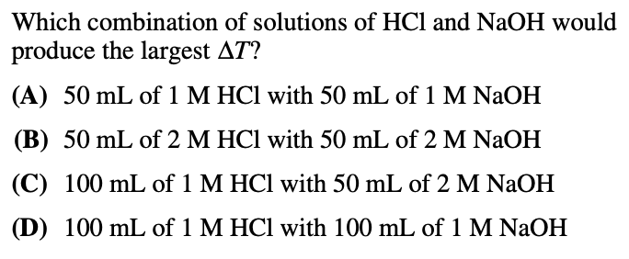
4. | 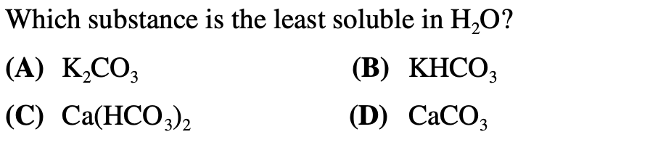
5. | 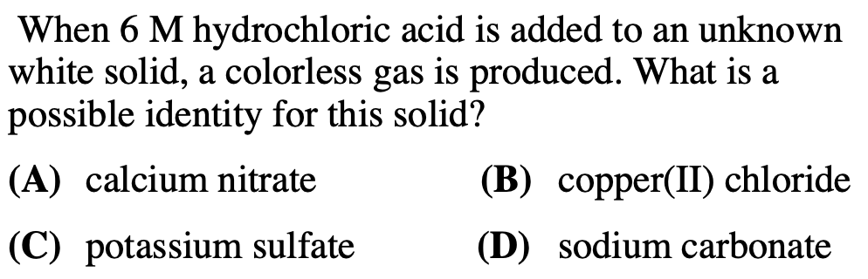
6. | 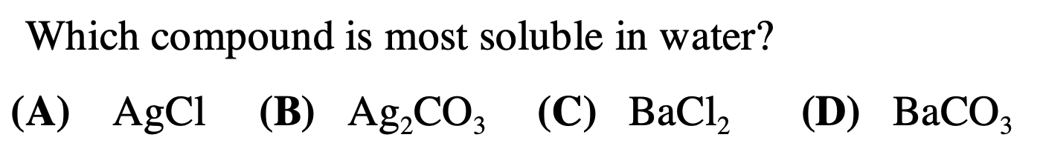
7. | 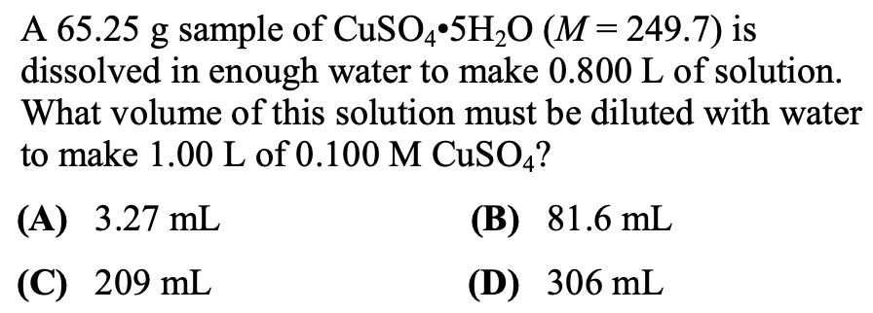
8. | 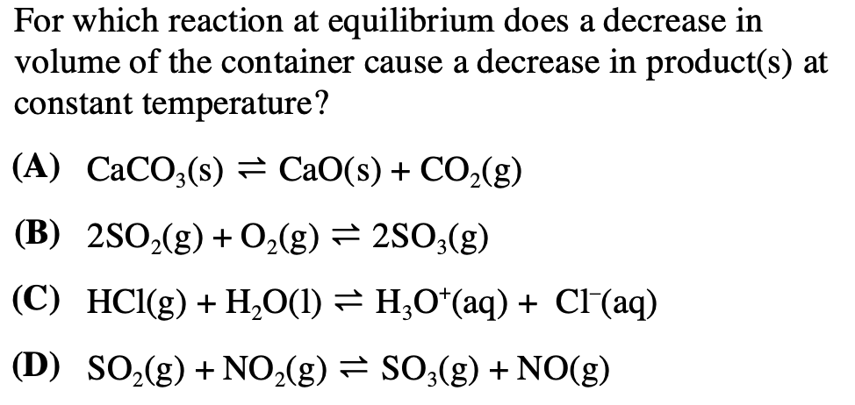
9. | 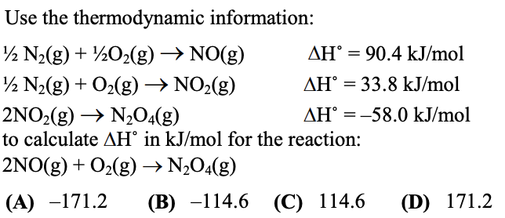
10. | 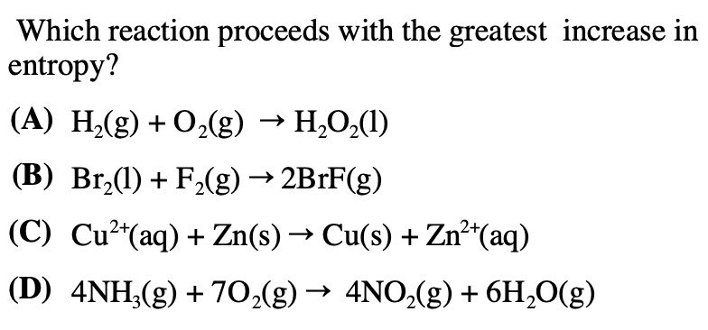
11. | 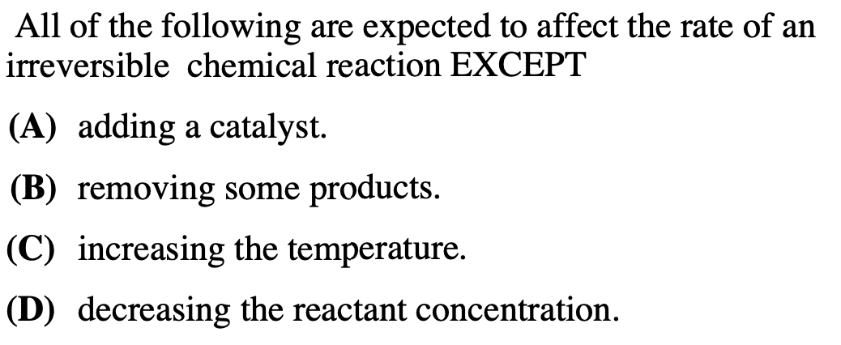
12. | 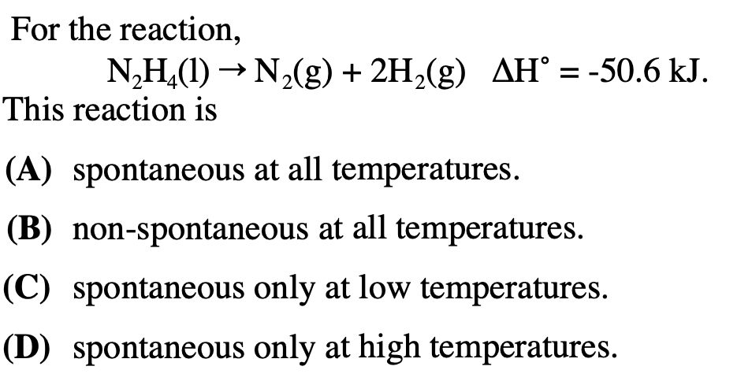
13. | 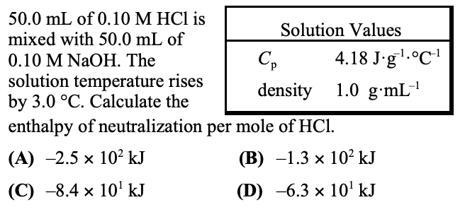
14. | 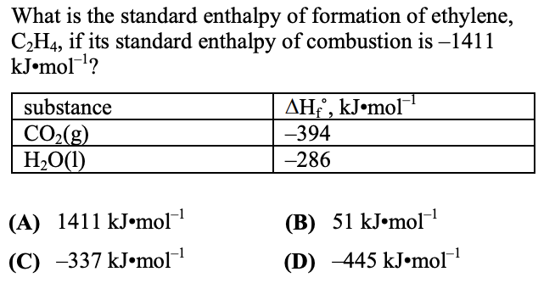
15. | 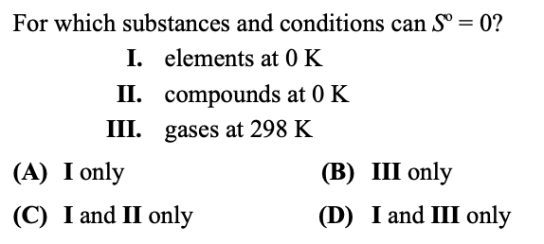
16. | 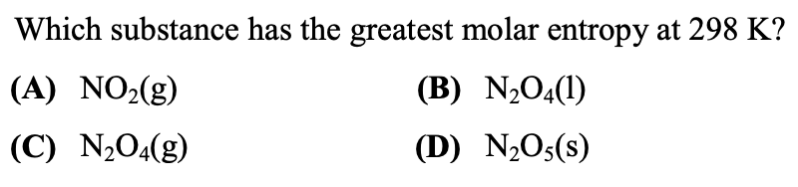
17. | 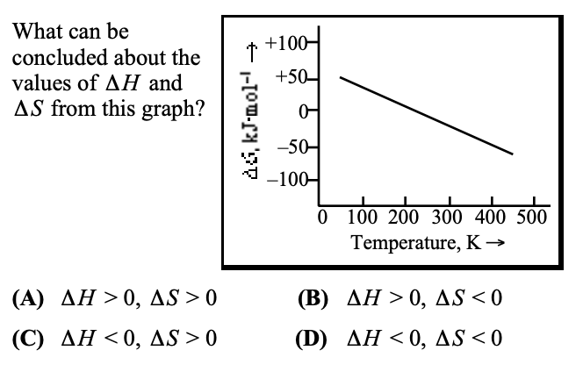
18. | 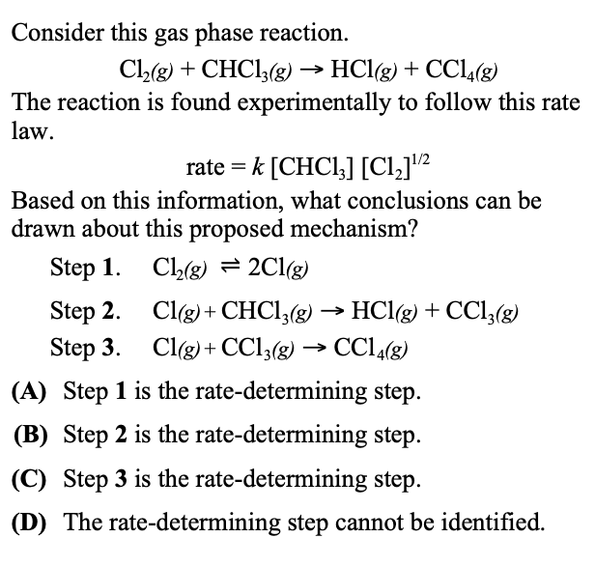
19. | 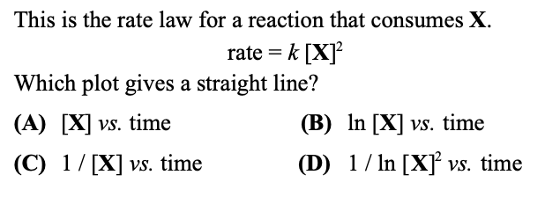
20. | 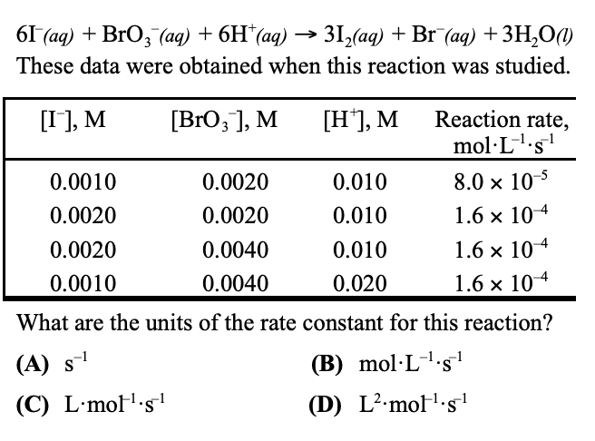
21. | 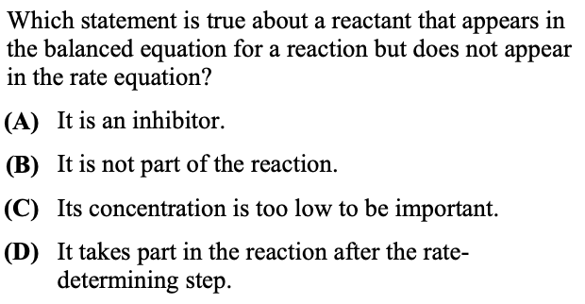
22. | 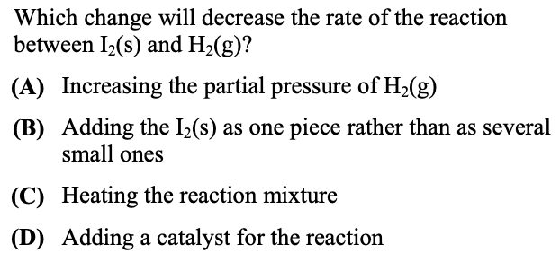
23. | 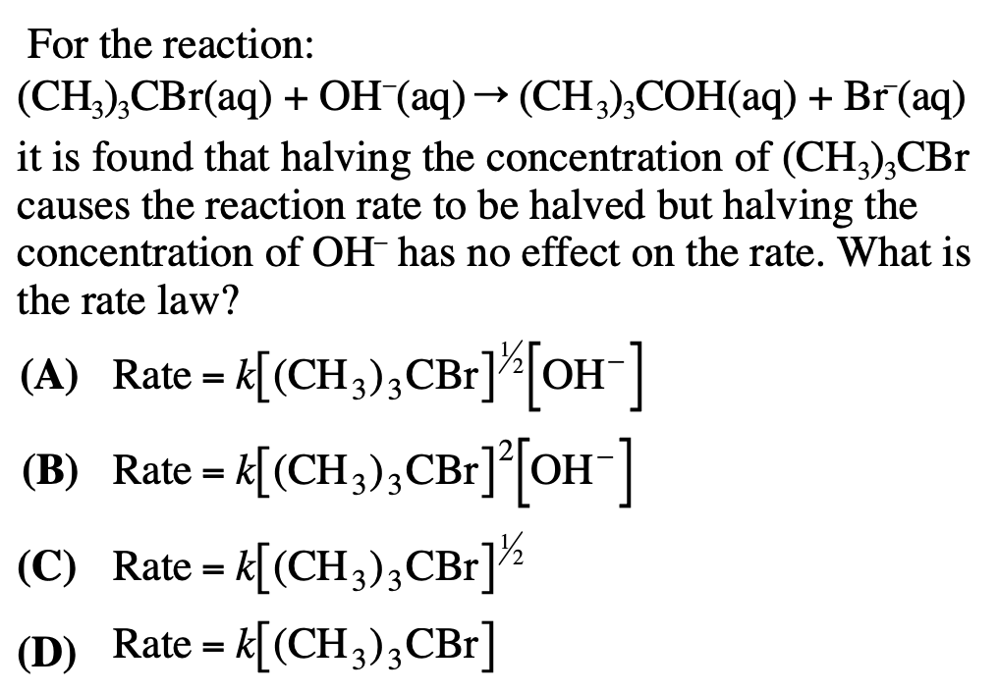
24. | 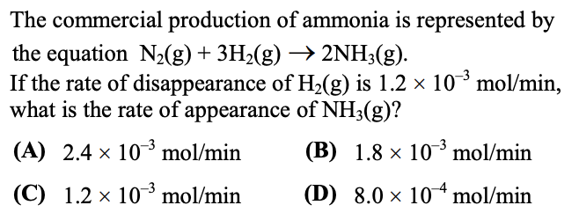
25. | 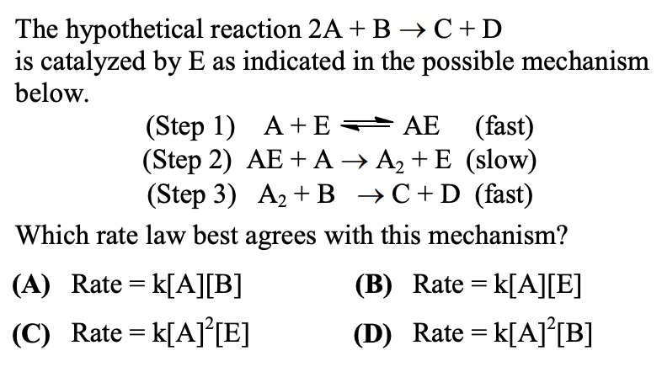
26. | 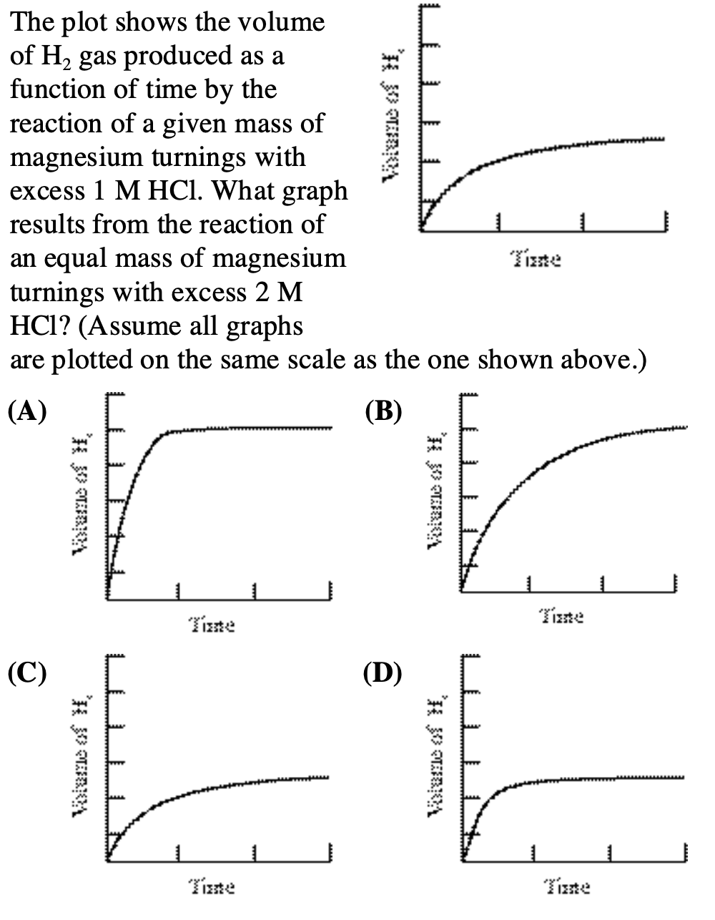
27. | 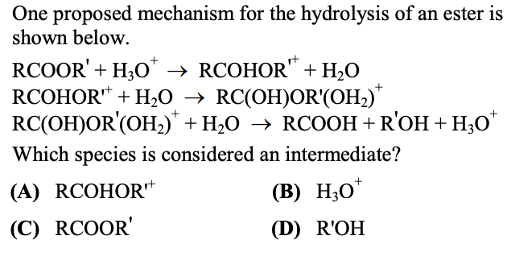
28. | 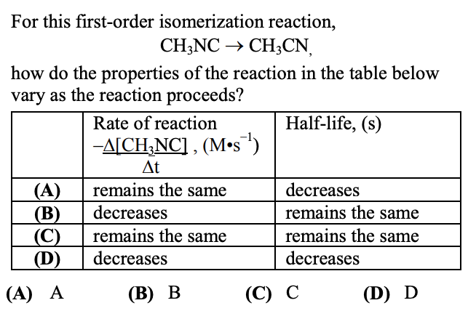

ANSWER KEY:
# | Answer | Source
1 | D | 2000 Local #15
2 | A | 2010 Local #5
3 | B | 2000 Local #26
4 | C | 2000 Local #3
5 | D | 2005 Local #1
6 | C | 2007 Local #1
7 | C | 2011 Local #4
8 | A | 2007 Local #31
9 | A | 2010 Local #20
10 | B | 2005 Local #23
11 | B | 2005 Local #25
12 | A | 2005 Local #24
13 | A | 2002 National #21
14 | B | 2011 Local #21
15 | C | 2002 National #20
16 | C | 2012 National #22
17 | A | 2002 National #22
18 | B | 2002 National #29
19 | C | 2002 National #25
20 | C | 2002 National #28
21 | D | 2011 Local #28
22 | B | 2011 Local #30
23 | D | 2005 Local #28
24 | D | 2010 Local #26
25 | C | 2012 National #29
26 | D | 2007 Local #25
27 | A | 2012 Local #30
28 | B | 2012 Local #28

Note:
It is possible that some of these answers might be copied down wrong. If some of them seem fishy, you can check the original tests they were selected from at the following link:
https://www.acs.org/content/acs/en/education/students/highschool/olympiad/pastexams.html

If you are suspicious of the answer, you should verify that the question is indeed the one listed in the source (i.e. if you are confused about question 1, look up 2000 USNCO Local #15 to verify that it is indeed the question 1 in this document, and then check the answer key at the bottom of the pdf). There might have been some typos in the source, or the answer key.

