***Thermodynamics and Thermochemistry***

*Formulas* (in order of decreasing importance)

1. ΔG°= ΔH° - TΔS°
2. ΔG° = -RT ln(K)
3. ΔH°rxn = Σ[ΔHf°(prod.)]- Σ[ΔHf° (react.)]... 1.
4. ΔS°rxn = Σ[S°(prod.)]- Σ[S° (react.)]... 2.
5. ΔG°rxn = = Σ[Gf°(prod.)]- Σ[Sf° (react.)]
6. ΔG = ΔG° + RT ln(Q)
7. Q= m C ΔT

1.prod. = products, react. = reactants

2.Anugrah will comment on this during the meeting

*Basic Overview*

* Entropy is the overall “disorder of a system”. If you have more possible arrangements of “stuff” in your system, there is more entropy.
* If reaction increases the Entropy of the whole(!) universe, then it will occur spontaneously:
  + ΔSuniv= ΔSsystem+ΔSsurroundings
* Gibbs Free Energy is a way of computing the Entropy change of the universe in terms of quantities we can measure
  + “Heat” given out of the system(ΔH)
  + Changes in System disorder (ΔS)
* Spontaneous if: ΔS°univ>0, or ΔG°sys<0

Also, you should remember the Standard States of some common elements!

*Quiz: What are the standard states of these elements? Write out the equation for their standard state and the phase. (Ex F -> F2(g) )*

|  |  |  |  |
| --- | --- | --- | --- |
| *1* | *Br* | *7* | *O* |
| *2* | *N* | *8* | *B* |
| *3* | *Na* | *9* | *I* |
| *4* | *H* | *10* | *Mg* |
| *5* | *He* | *11* | *Hg* |
| *6* | *Ne* | *12* | *S* |

*Practice Problems*

**2001 USNCO National**

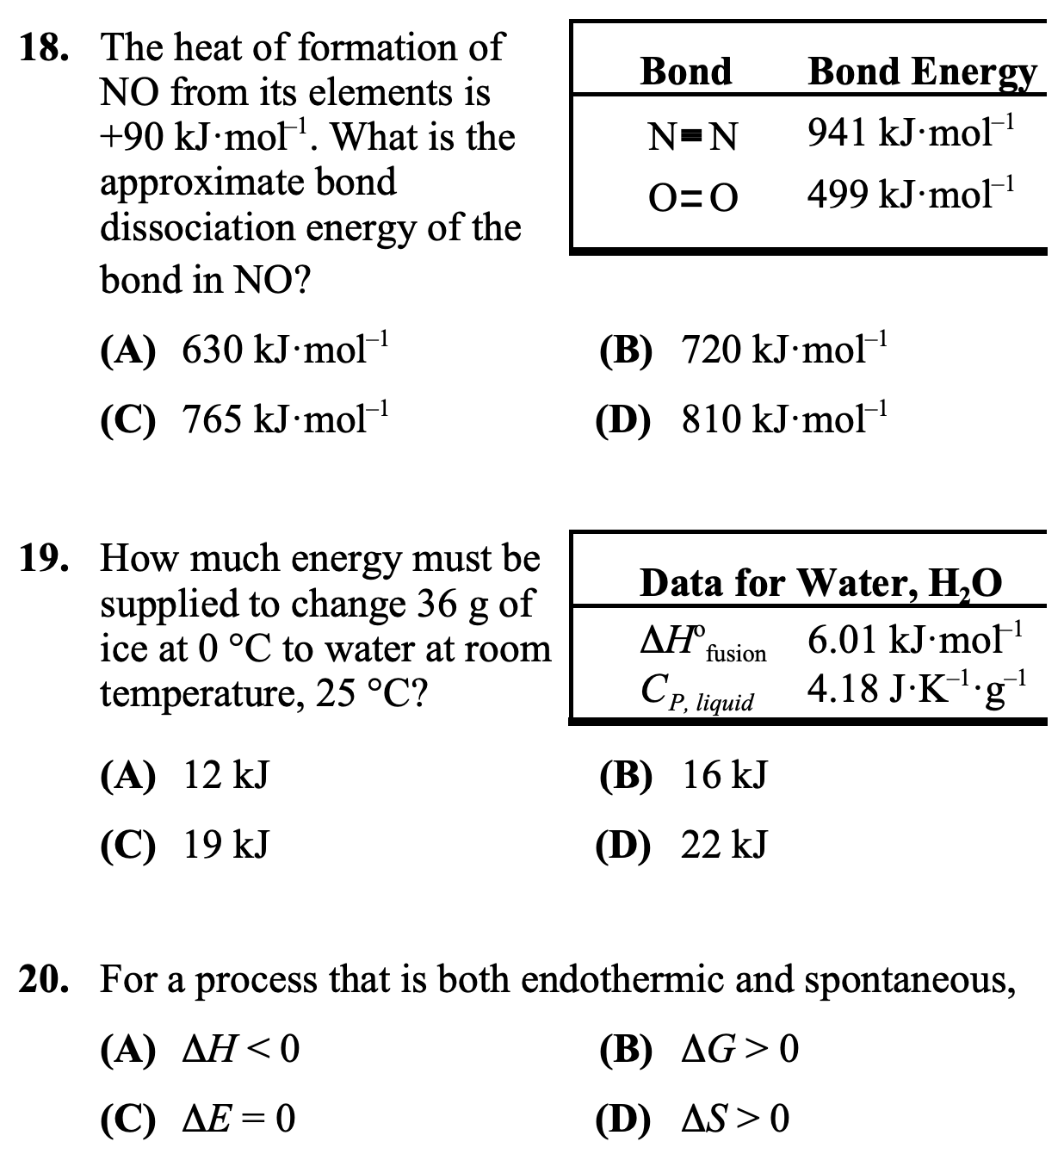

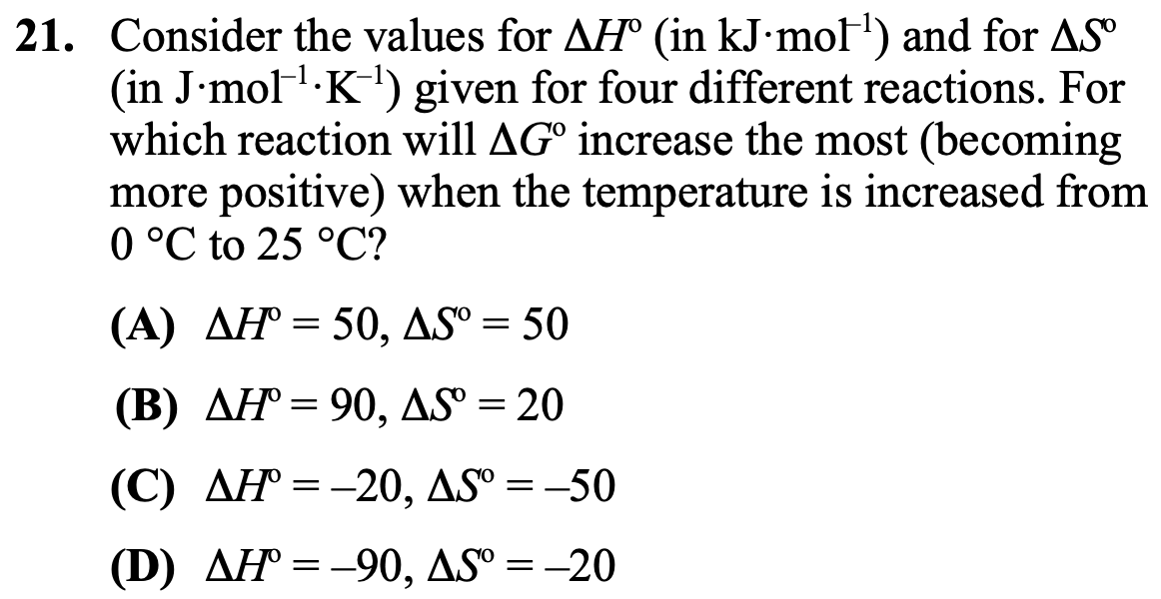

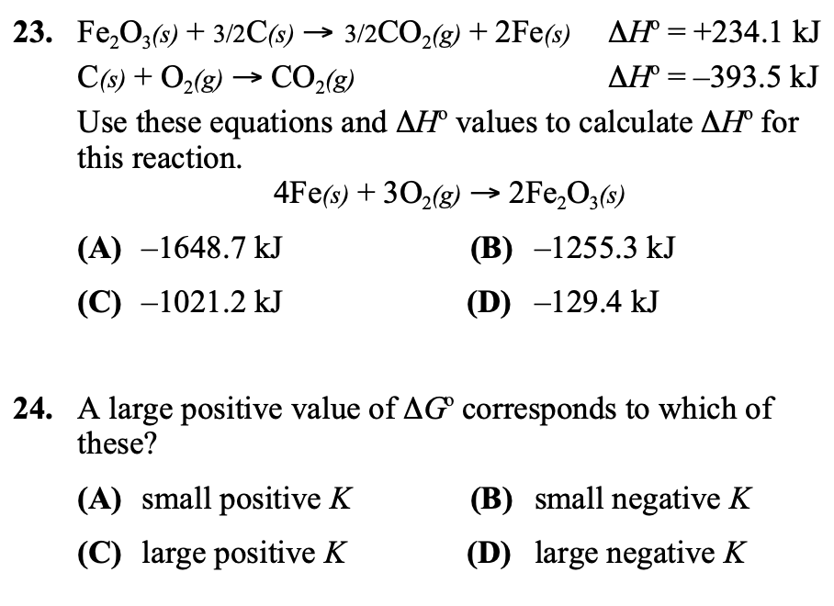

***ANSWER KEYS***

|  |  |  |  |
| --- | --- | --- | --- |
| *1* | *Br2 (l)* | *7* | *O2(g)* |
| *2* | *N2(g)* | *8* | *B(s)* |
| *3* | *Na (s)* | *9* | *I2(s)* |
| *4* | *H2(g)* | *10* | *Mg(s)* |
| *5* | *He(g)* | *11* | *Hg(l)* |
| *6* | *Ne(g)* | *12* | *S(s)* |

*2001 USNCO National*

18. A

19. B

20. D

21. C

22. D

23. A

24. A