Here are four FRQ questions in *roughly increasing* order of difficulty

Try to give yourself 15-20 minutes to try each of these FRQ questions

*1999 USNCO #3*

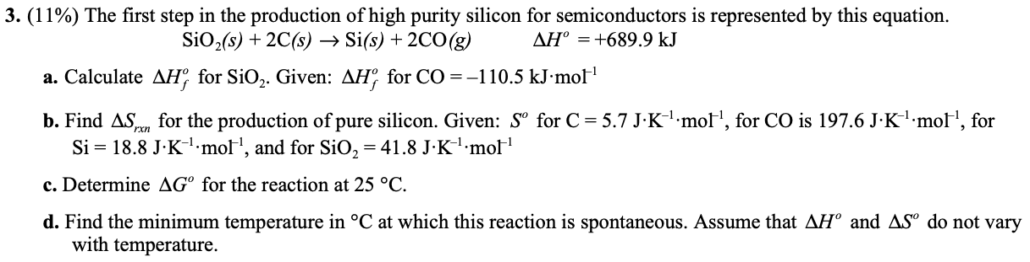

*2000 USNCO #2*

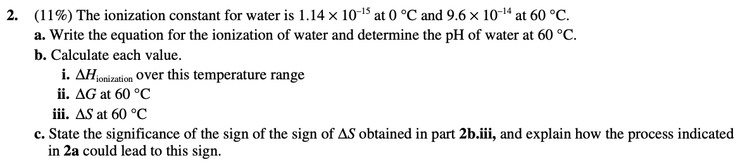

*2002 USNCO #2*

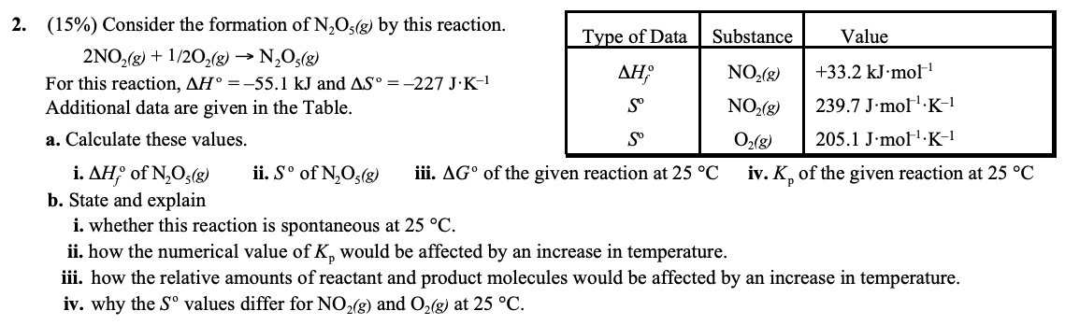

*2005 USNCO #2*

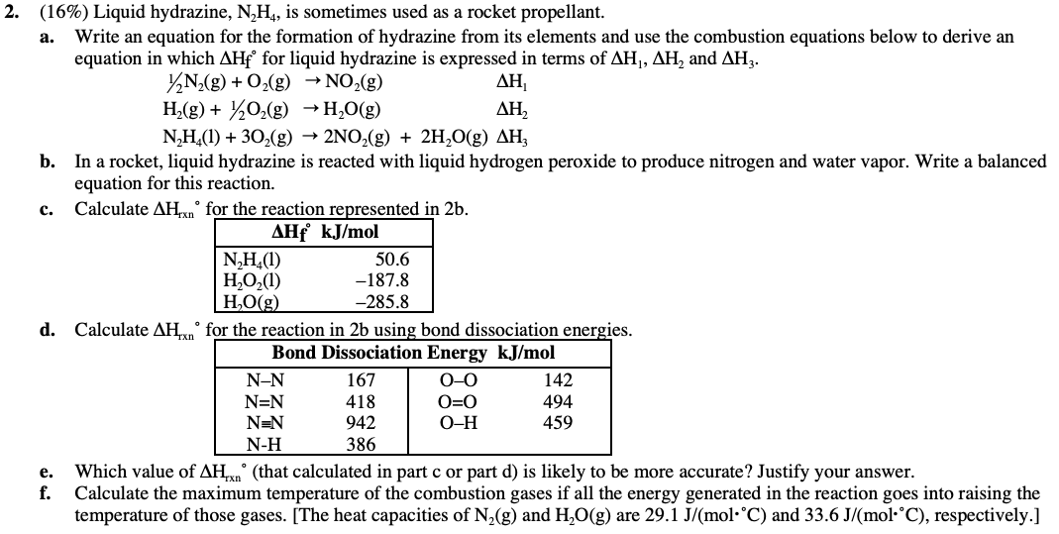

***ANSWER KEYS***

*1999 USNCO #3*

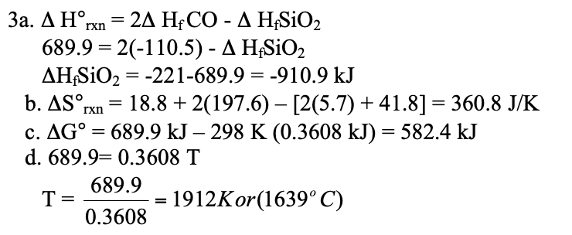

*2000 USNCO #2*

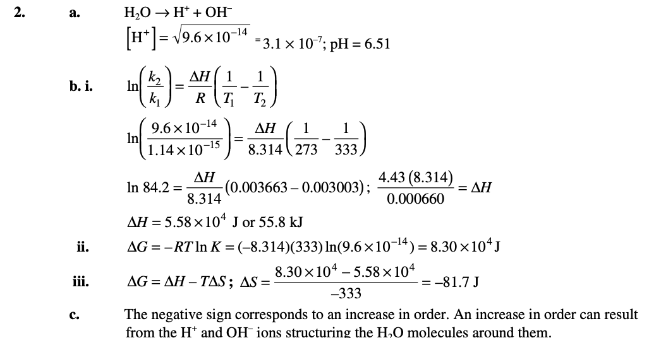

*2002 USNCO #2*

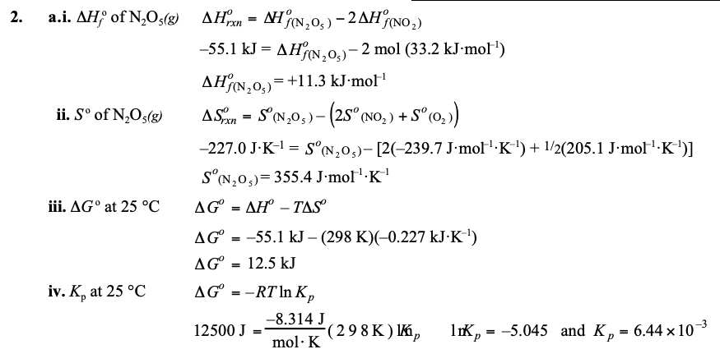

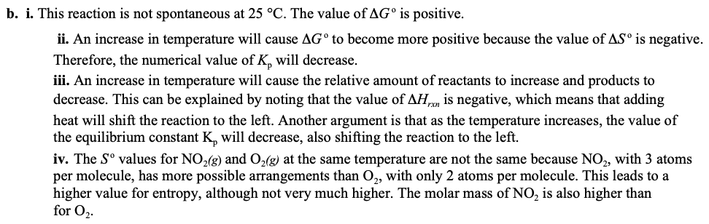

*2005 USNCO #2*

