**S-13**

**Unit 2 – Thermodynamics**

1. Thermodynamically favorable (spontaneous) reactions have a (−)ΔG.
2. Reactions with (−)ΔH and (+)ΔS are ALWAYS thermodynamically favorable…  
   “enthalpy driven & entropy driven”
3. Reactions that increase the # of moles of gas have a (+)ΔS.
4. If ΔG is (−), then Keq >1.
5. If ΔG is (−), then the reaction is product favored.   
   If ΔG is (+), then the reaction is reactant favored.
6. ΔH and ΔS are usually NOT given in the same units!! Be careful!  
   When using ΔGo =ΔHo−TΔSo, make sure they match units.
7. ΔG = 0 at equilibrium.
8. When using ΔGo = −RT lnK, the value for R is 8.314 J/mol K so the answer for ΔG will be in the units of Joules.
9. Sometimes a reaction with a (−)ΔG does not proceed at a measurable rate. They are said to be under “kinetic control.” High activation energy is a common reason for a process to be under kinetic control.
10. When using ΔGo =ΔHo−TΔSo and ΔSo is a negative value, as T increases, we need to be careful of how we describe the mathematical impact on ΔGo. Subtracting negative numbers is hard to explain.   
    Use safe phrases like:

As T increases, we are *subtracting a negative number that is larger in magnitude*, therefore...

ΔGo will *be a less negative number*, therefore the reaction is less spontaneous.

ΔGo will *shift in a more positive direction*, therefore the reaction is less spontaneous.

ΔGo will *shift in a less negative direction*, and therefore the reaction is less spontaneous.

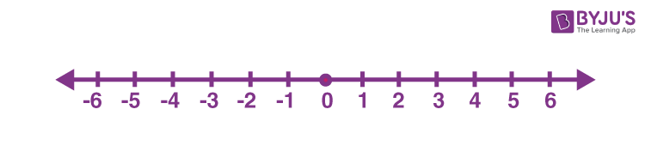  
Remember... -3 vs 3 🡪 -3 is more negative, 3 is less negative   
 1 vs 3 🡪 1 is more negative, 3 is less negative

**Unit 2 – Thermodynamics**

1. Thermodynamically favorable (spontaneous) reactions have what algebraic sign for ΔG?
2. a) Reactions with what signs for ΔH and ΔS are ALWAYS thermodynamically favorable?   
   b) Reactions with what signs for ΔH and ΔS are NEVER thermodynamically favorable?  
   c) If a reaction is “enthalpy driven & entropy driven”, what are signs of ΔH and ΔS?
3. If a reaction increases the # of moles of gas, then the sign for ΔS is what?  
   If a reaction decreases the # of moles of gas, then the sign for ΔS is what?
4. If ΔG is (−), then Keq is greater than or less than 1?  
   If ΔG is (+), then Keq is greater than or less than 1?
5. If ΔG is (−), then the reaction is _______ favored.   
   If ΔG is (+), then the reaction is _______ favored.
6. What are the most common units for ΔH and ΔS?
7. At equilibrium, what is the value of ΔG?
8. a) When using ΔGo = −RT lnK, the value w/ units for R is ________________.  
   b) If you use the value of 8.314 for R in the equation ΔGo = −RT lnK, then what are the units for ΔG?
9. Why might a reaction with a (−)ΔG not proceed at a measurable rate?
10. If ΔSo is negative, as T increases, you are subtracting a ________________________ number,   
    therefore ΔGo will ____________________________,   
    therefore the reaction will be _____________ spontaneous,  
    therefore the reaction will be more _________________ favored,  
    therefore Keq will be _____________________.