**Name: Period: Seat#:**

**Worksheet #2**

**Required Sections:** (Refer to R-15 for guidelines and requirements. Make note of any specific changes given by your teacher in class.)

**Prelab:** Prelab Questions, Purpose, Materials, Reagent Table, Procedures, and set up Data Tables before you get to class.

**During Lab:** Data section – Fill out your data table that is already set up from the prelab.

**Post-lab:** Calculation section, Discussion Questions Section, Post-Lab Two Pager done on separate Worksheet.

**Introduction**

Alloys are solid solutions of two or more metals. Alloys are made to modify the properties of pure metals. For example, sterling silver, an alloy of Ag and Cu, retains the bright luster of Ag but is much stronger and more rigid than pure silver.

**Concepts**

Oxidation-reduction reaction Gravimetric analysis Precipitation reaction

**Background**

Silver and copper are very nonreactive metals. Neither will dissolve in hydrochloric acid or sulfuric acid. The "oxidizing" acid nitric acid, HNO3, is required. In acidic solutions the nitrate ion is an excellent oxidizer, and it will oxidize Ag(s) to Ag+(aq) and Cu(s) to Cu2+(aq). The reduction product is the gas NO. As the colorless nitrogen monoxide gas forms, it immediately reacts with the oxygen in the air to produce the orange-brown gas N02. The half-reactions for the oxidation of silver and copper by nitric acid are as follows:

Ag(s)  Ag+(aq) + e

Cu(s)  Cu2+(aq) + 2e

4H+(aq) + NO  (aq) + 3e  NO(g) + 2H O(*l*)

3 2

Once the silver and copper ions are in solution, they can be separated from each other by precipitating the silver ions as silver chloride. Silver chloride (AgCl) is very insoluble in water, while copper (II) chloride (CuCl2) is soluble. The addition of chloride ions to the solution will precipitate essentially all of the silver and none of the copper. The silver chloride precipitate is then filtered from the solution.

**Experimental Overview**

In this experiment an alloy of silver will be analyzed to determine its silver content. The silver-copper alloy will be dissolved in nitric acid, the silver will be precipitated as AgCl, and the AgCl will be filtered, washed, dried and its mass determined. From the mass of the AgCl formed and the mass of the original sample, the percent of silver in the alloy is calculated. Because the results are based on the mass of a product, this procedure is classified as a gravimetric analysis.

**Prelab Questions** (Part of your Prelab Assignment)

Before beginning work on this experiment, read the directions and answer the following questions:

1. What is the difference between qualitative and quantitative analytical methods?
2. Why is it possible to analyze the silver content of a silver-copper alloy by precipitating with chloride ion?
3. Is there any other ion, besides chloride, that could be used in this procedure? If so, why would this ion work?
4. A silver-copper alloy had a mass of 0.1264 g. When the alloy was dissolved in nitric acid and the silver precipitated as silver chloride, the precipitate had a mass of 0.1375 g. Calculate the percent of silver in the alloy. Show your calculations.
5. If the silver chloride is not dry when its mass is determined, will the calculated percent of silver in the alloy be too high or too low? Explain.

**Materials** – [Flinn’s MSDS Website](https://www.flinnsci.com/sds/)

Chemicals

* Silver-copper alloy,   
  0.2 to 0.5 g piece [MSDS Here](MSDS%20Sterling%20Silver.pdf)
* Nitric acid solution,   
  6M HNO3, 12mL
* Class rinse wash bottle w/ 2 mL of 6M HNO3 per 150 mL
* Isopropyl Alcohol, 10mL
* Sodium chloride, NaCl, 0.8 g

Equipment

* Beakers, 100 mL x 2
* Graduated cylinder, 25 mL
* Graduated cylinder, 50 mL
* Filter paper, qualitative,   
  small and large (or weigh boat)
* Weigh boats x 2
* Parafilm
* Balance, 0.001g precision
* Hot plate
* Drying oven
* Fume hood
* Aspirator
* Crucible tongs
* Heat resistant pad
* Rubber policeman
* Stir rod
* Watch glass
* Filter flask
* Buchner funnel
* Wash bottle with DI H2O

**SAFETY PRECAUTIONS**

*Nitric acid solution is severely corrosive, a strong oxidant, and toxic by ingestion and inhalation. Solutions containing silver cause dark stains on skin and clothing that do not appear for several hours. As the silver-copper alloy dissolves, the toxic gases nitrogen monoxide, NO, and nitrogen dioxide, N02 are evolved. Carry out the reaction* ***in a fume hood or under a funnel attached to an aspirator****. Wear chemical splash goggles, chemical-resistant gloves, and a chemical-resistant apron. Wash hands thoroughly with soap and water before leaving the laboratory.*

**Procedure**

1. To filter the solution, a qualitative filter paper and a Buchner funnel will be used with a filter flask. Refer to Figure 1 to see how the vacuum filtration set up will be assembled.
2. Obtain a sample of silver alloy that is between 0.1 and 0.5 g. Determine its mass precisely on a sensitive balance. Record this value in the Data Table.
3.  DO THIS STEP IN THE FUME HOOD! Put the alloy in a clean labeled 100-mL beaker,   
    and carefully pour 10 mL of 6 M nitric acid over it.
4. Cover the beaker with a watch glass so none of the solution spatters out. It may be necessary to gently heat the solution so that the alloy dissolves.
5. Allow the alloy to totally dissolve.
6. Calculate the amount of sodium chloride that would be necessary to precipitate the silver in your sample, assuming that the sample is 100% silver. Show calculation in Calculations section. Record this value on your data table.
7. Weigh out two times this amount of sodium chloride and dissolve in 25 mL of DI water in a 100-mL beaker.
8. Remove the watch glass from the first beaker with the dissolved silver, and rinse any moisture on the bottom of the watch glass back into the beaker with your DI wash bottle.
9. To precipitate the silver as silver chloride, slowly add the sodium chloride solution to the dissolved silver. Stir with a stirring rod, and use DI water to rinse any solution clinging to the rod back into the beaker.
10. Gently heat (without boiling) the solution for about 15 minutes. This will cause the precipitate particles to grow larger so they are easier to filter. Alternatively, cover the beaker with Parafilm and allow it to stand overnight. This will also allow the particles to grow larger.
11. Weigh the clean, dry filter paper while it is in a labeled weigh boat. Record the mass on your data table.
12. Put the filter paper into the Buchner funnel and pull DI water through the assembly to be sure the filter paper is seated tightly on the bottom of the Buchner funnel.
13. Carefully pour the solution and the silver chloride down a stirring rod onto the filter paper in the Buchner funnel.
14. Your teacher has prepared an acidic wash for everyone to share. Your teacher added 2 mL of 6 M HNO3 for every 150 mL of DI water. Use this as a rinse. The addition of the acid to the rinse water helps to keep the precipitate from "peptizing," or forming extremely small particles that will run through the filter.
15. Wash the precipitate that is on the Buchner funnel with the diluted nitric acid solution in the wash bottle. Be sure to get every particle! A rubber policeman can be used as a squeegee to clean the sides of the beaker.
16. Double check all particles have been transferred onto the Buchner funnel filter paper. Rinse w/ 10-ml of Alcohol.
17. Very carefully put the filter paper with all the precipitate into your pre-weighed labeled weigh boat to dry overnight.
18. Weigh and record mass of your filter paper and precipitate inside your data table.

**Figure 1**

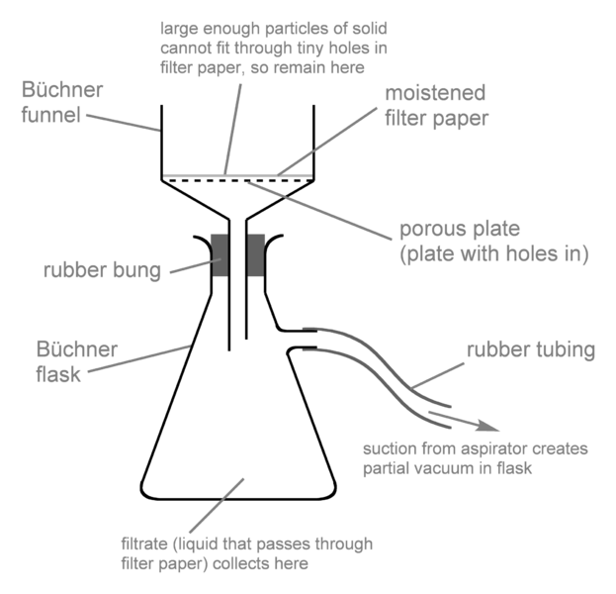

**Disposal and Cleanup**

Your teacher will provide disposal and cleanup instructions.

**Data Table**

|  |  |
| --- | --- |
| Mass of silver alloy (g) |  |
| Mass of NaCl needed to precipitate the silver (g) |  |
| Mass of NaCl used (g) |  |
| Mass of dry filter paper, in labeled weigh boat (g) |  |
| Mass of AgCl precipitate on filter paper, in labeled weigh boat (g) |  |
| Mass of AgCl (g) |  |
| Calculated percent of Ag in AgCl by weight |  |
| Calculated mass of Ag in alloy (g) | Sample |
| % Ag in silver bead |  |

**Calculations**

Show all calculations and be sure to record all values into your Data Table.

1. (From Step #10 during the lab) Calculate the amount of NaCl needed to precipitate all the silver in the sample. Assume the sample is 100% silver.
2. Calculate the percent silver in silver chloride. Record this value in the Data Table.
3. From the mass of filtered silver chloride and the mass of the silver alloy sample, calculate the mass of silver in the alloy. Record this value in the Data Table.
4. Calculate the % silver in your silver bead. Record this value in the Data Table.

**Post Lab Discussion Questions**

Answer as part of your post lab. Do not recopy the questions, just paraphrase them into your answer so the reader can infer what the question was.

1. Why is a twofold excess of chloride added to precipitate the silver? In other words, why are we using so much?
2. Why doesn't the NaCl need to be weighed on a sensitive balance like the Ag bead and filter paper needed to be?
3. Why is it necessary to wash the precipitate with water?
4. Why is it necessary to rinse the precipitate with a nitric acid wash?
5. Will the nitric acid in the wash water interfere with the weight of the silver chloride? Why or why not?
6. If your weigh boat and filter paper with the silver chloride is not cooled down from being in the drying oven when its mass is determined, will the calculated percent silver be too high or too low? Why?
7. Why isn't hydrochloric acid used to both dissolve and precipitate the silver?
8. Why would it be better to use a Gooch crucible rather than plain filter paper and a Buchner funnel like we did?
9. Why do you think we used plain filter paper and a Buchner funnel instead of a Gooch crucible?
10. “Numismatics” is the scientific study of money and its history. Since 1965 American dimes have been made of 75% copper and 25% nickel. Before 1965 dimes were made of copper and silver. Using the data table below, calculate what percent of the pre-1965 dimes were silver.

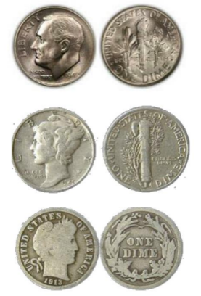

|  |  |
| --- | --- |
| Mass of dime | 2.8357 g |
| Mass of dry filter paper | 0.7942 g |
| Mass of AgCl precipitate and filter paper | 4.1860 g |
| Mass of AgCl |  |
| % Composition of Ag in AgCl |  |
| Mass of Ag in AgCl sample |  |
| % Ag in dime |  |