## AP CHEMISTRY IONIC COMPOUNDS FROM PREVIOUS TESTS NAME:

In each blank: a) write the balanced chemical equation for the dissolution in water of this ionic compound (include the formula of the compound as a reactant), b) circle the side that is predominant in a 1 M solution (use solubility rules!). If the compound is a metal oxide or hydride, write the appropriate reaction with water, not a dissociation.

1.

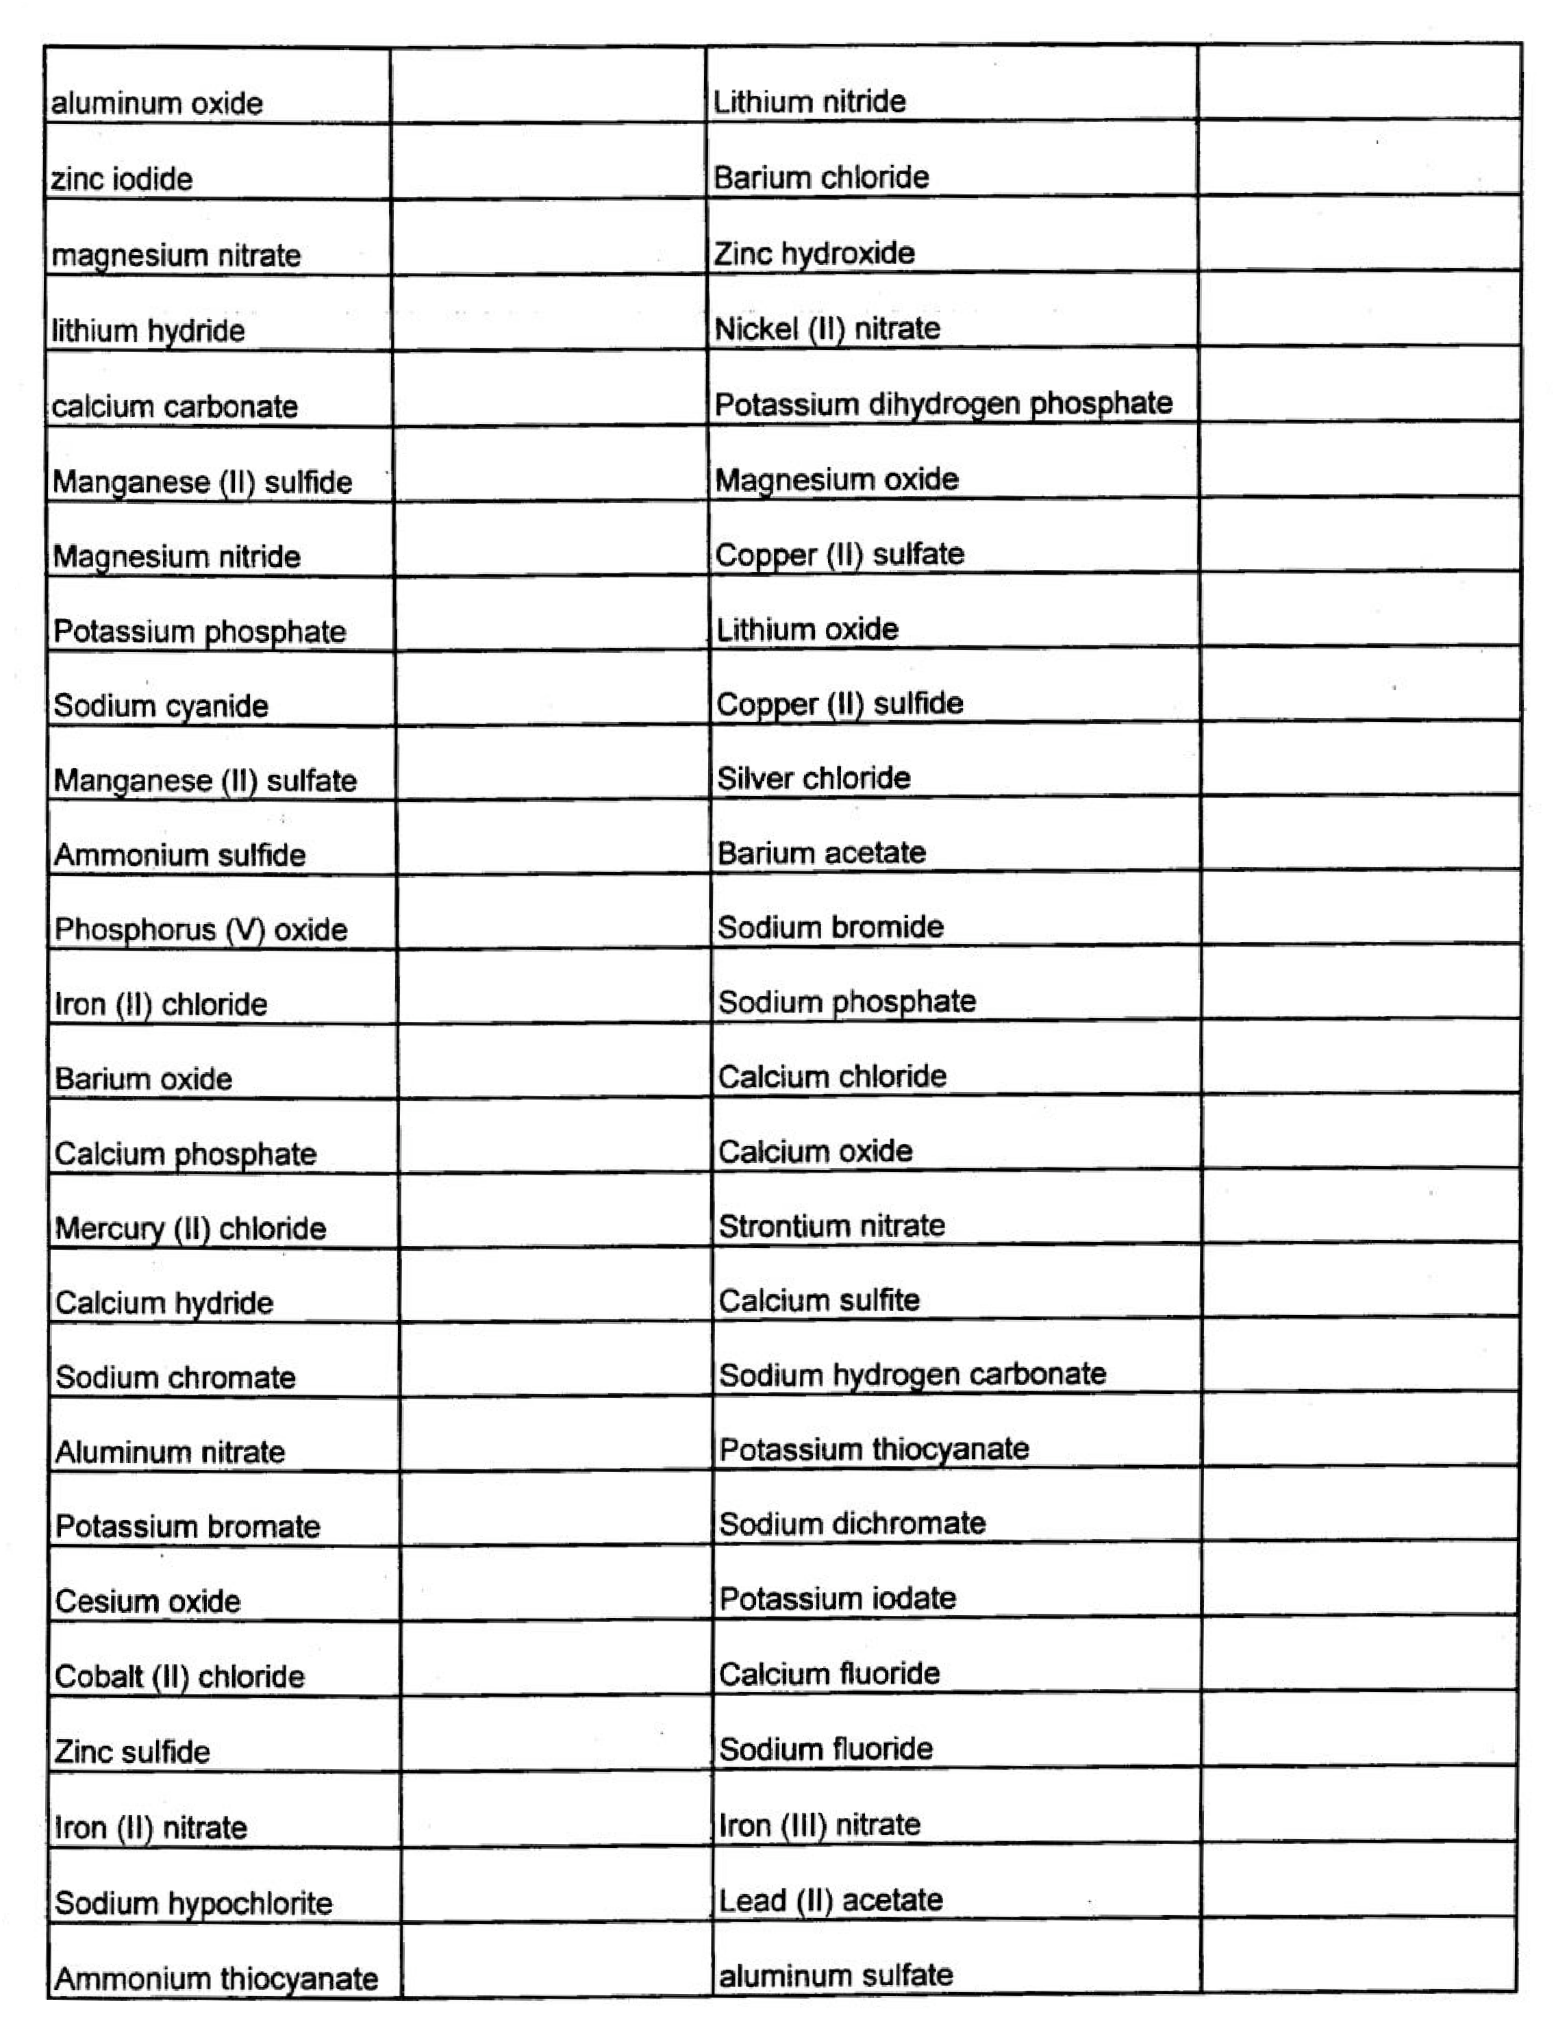

2.

3.

4.

5.

6.

7.

8.

9.

10.

11.

12.

13.

14.

15.

16.

17.

18.

19.

20.

21.

22.

23.

24.

25.

26.

Mg(NO3)2 (s) →

Mg2+ (aq) + 2 NO - (aq)

3

ZnS (s) →

Zn2+ (aq) + S2- (aq)

27.

28.

29.

30.

31.

32.

33.

34.

35.

36.

37.

38.

39.

40.

41.

42.

43.

44.

45.

46.

47.

48.

49.

50.

51.

52.

|  |  |  |  |  |
| --- | --- | --- | --- | --- |
| Potassium dichromate |  | iron (II) sulfite | 79. |  |
| Sodium sulfate |  | copper (II) oxide | 80. |  |
| Lithium hydrogen carbonate | | sodium hydride | 81. |  |
| Sodium hydroxide | .... --- ·- --- | potassium **sulfate** -· | 82. |  |
| Sodium permangante |  | hydroQen chloride | 83. |  |
| Sodium sulfite |  | nickel (II) bromide | 84. |  |
| Iron (Ill) oxide |  | strontium chloride | 85. |  |
| Zinc carbonate |  | magnesium iodide | 86. |  |
| Calcium acetate |  | sodium acetate | 87. |  |
| Calcium hydroxide |  | hydrogen iodide | 88. |  |
| Iron (II) oxide |  | Potassium carbonate | 89. |  |
| **Nickel** (II) chloride |  | Iron (Ill) chloride | 90. |  |
| Cobalt (II) nitrate |  | Sodium iodide | 91. |  |
| Ammonium nitrate |  | Lead (II) nitrate | 92. |  |
| Lead (II) carbonate |  | Hydroaen sulfide | 93. |  |
| Barium nitrate |  | Potassium hydroxide | 94. |  |
| Potassium chromate |  | Silver nitrate | 95. |  |
| Nickel (II) sulfate |  | Lithium bromide | 96. |  |
| Copper {II) chloride |  | Potassium sulfite | 97. |  |
| Tin (II) nitrate |  | Potassium permanganate | 98. |  |
| Potassium hydrogen carbonate | | Ammonium thiocyanate | 99. |  |
| Strontium oxide |  | Sodium oxalate | 100. |  |
| zinc hydroxide |  | Sodium sutfide | 101. |  |
| Nickel (II) nitrate |  | Lithium carbonate | 102. |  |
| Potassium dihydrogen phosphate | | Sodium chloride | 103. |  |
| Magnesium **oxide** |  | Sodium hydroxide | 104. |  |

53.

54.

55.

56.

57.

58.

59.

60.

61.

62.

63.

64.

65.

66.

67.

68.

69.

70.

71.

72.

73.

74.

75.

76.

77.

78.

105.

106.

107.

108.

109.

110.

111.

112.

113.

114.

115.

116.

117.

118.

119.

120.

121.

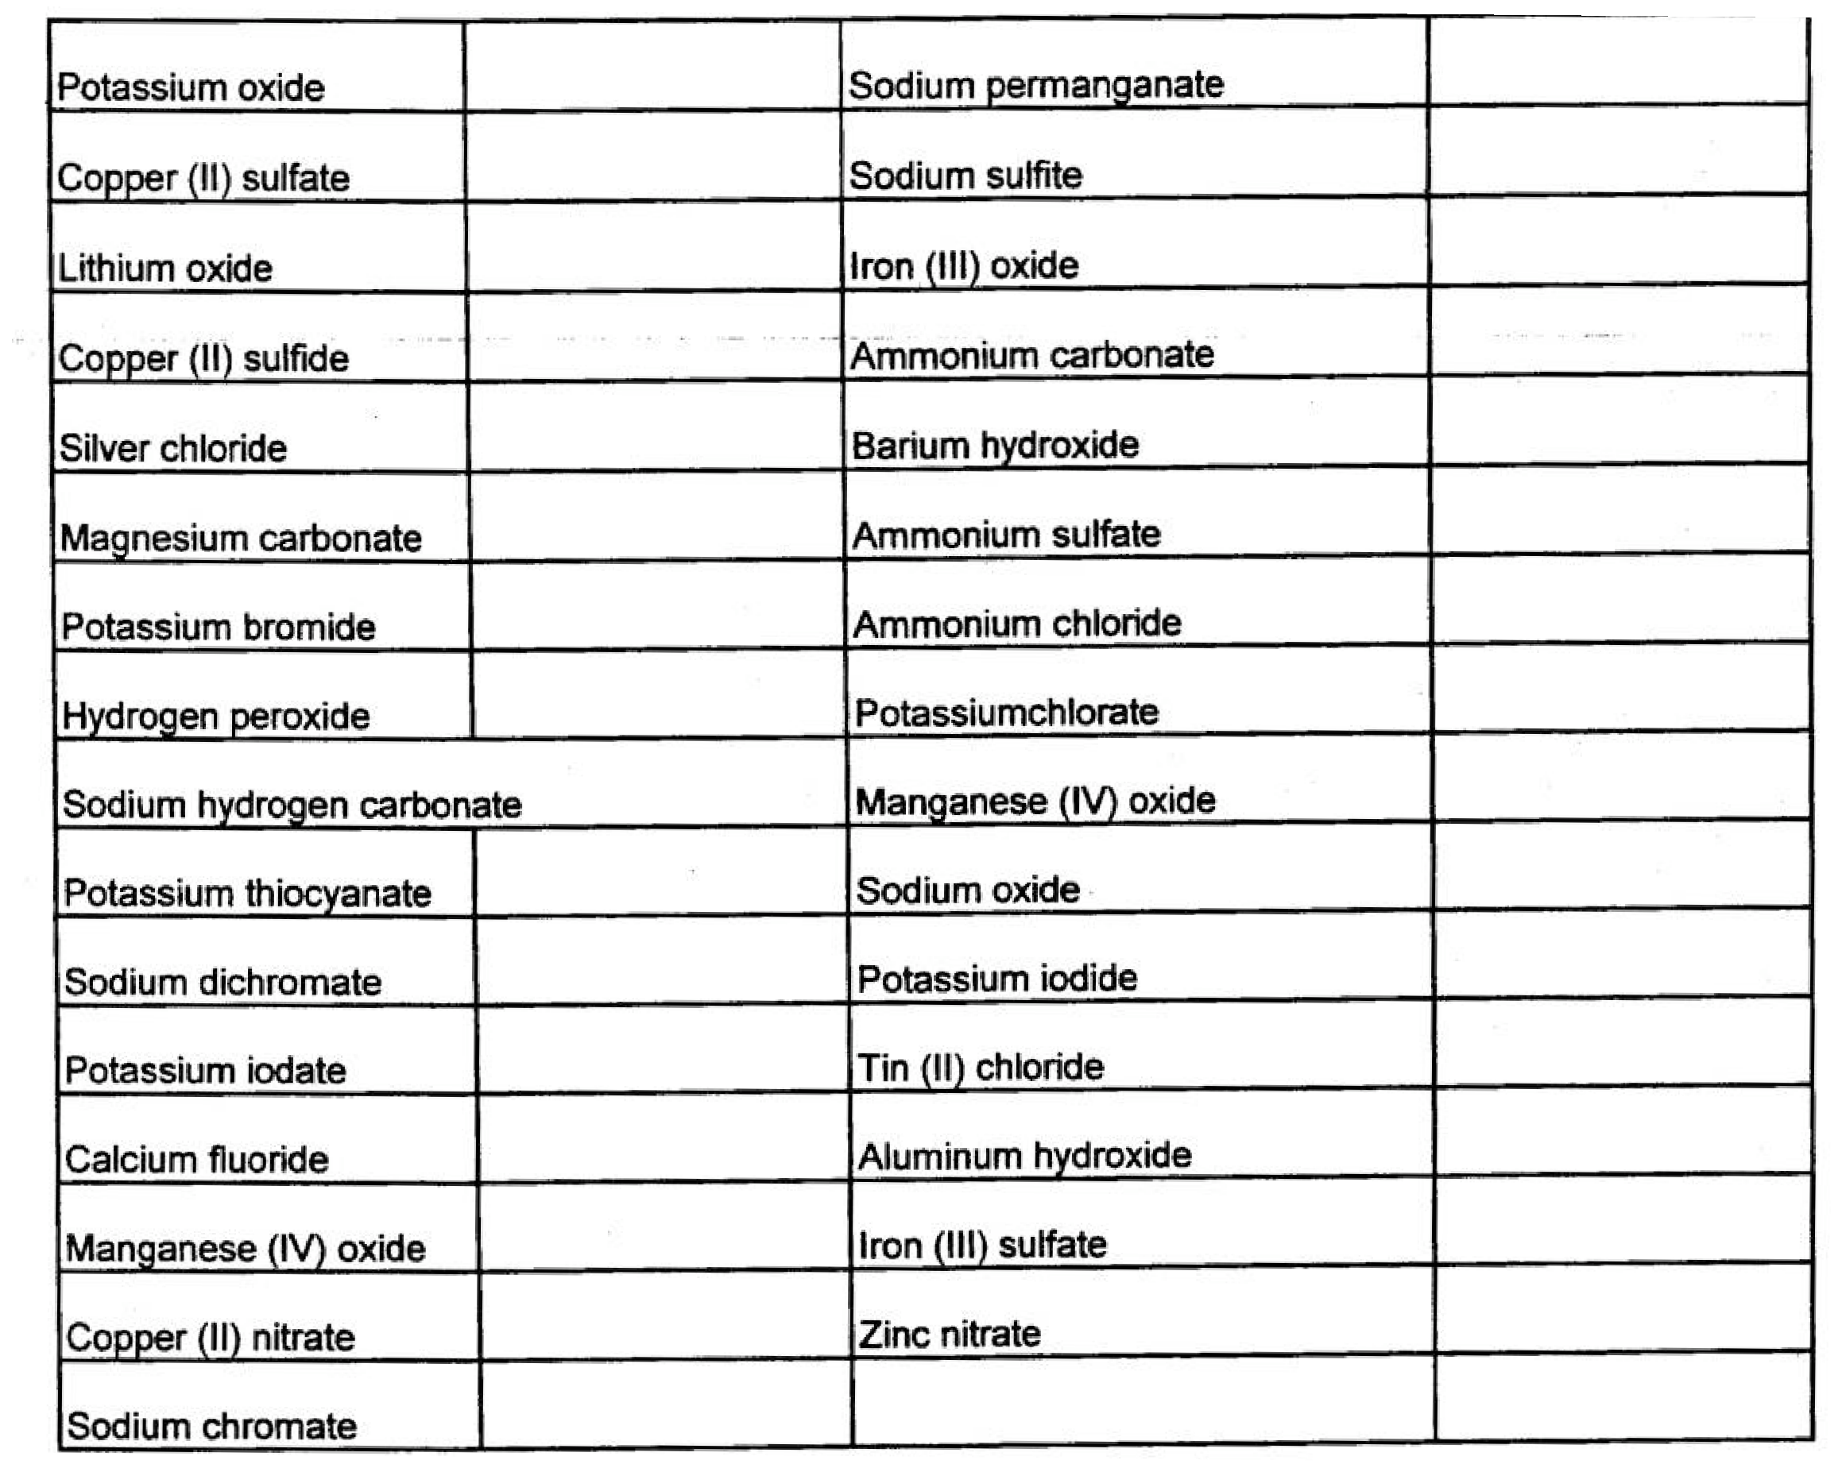122.

123.

124.

125.

126.

127.

128.

129.

130.

131.

132.

133.

134.

135.

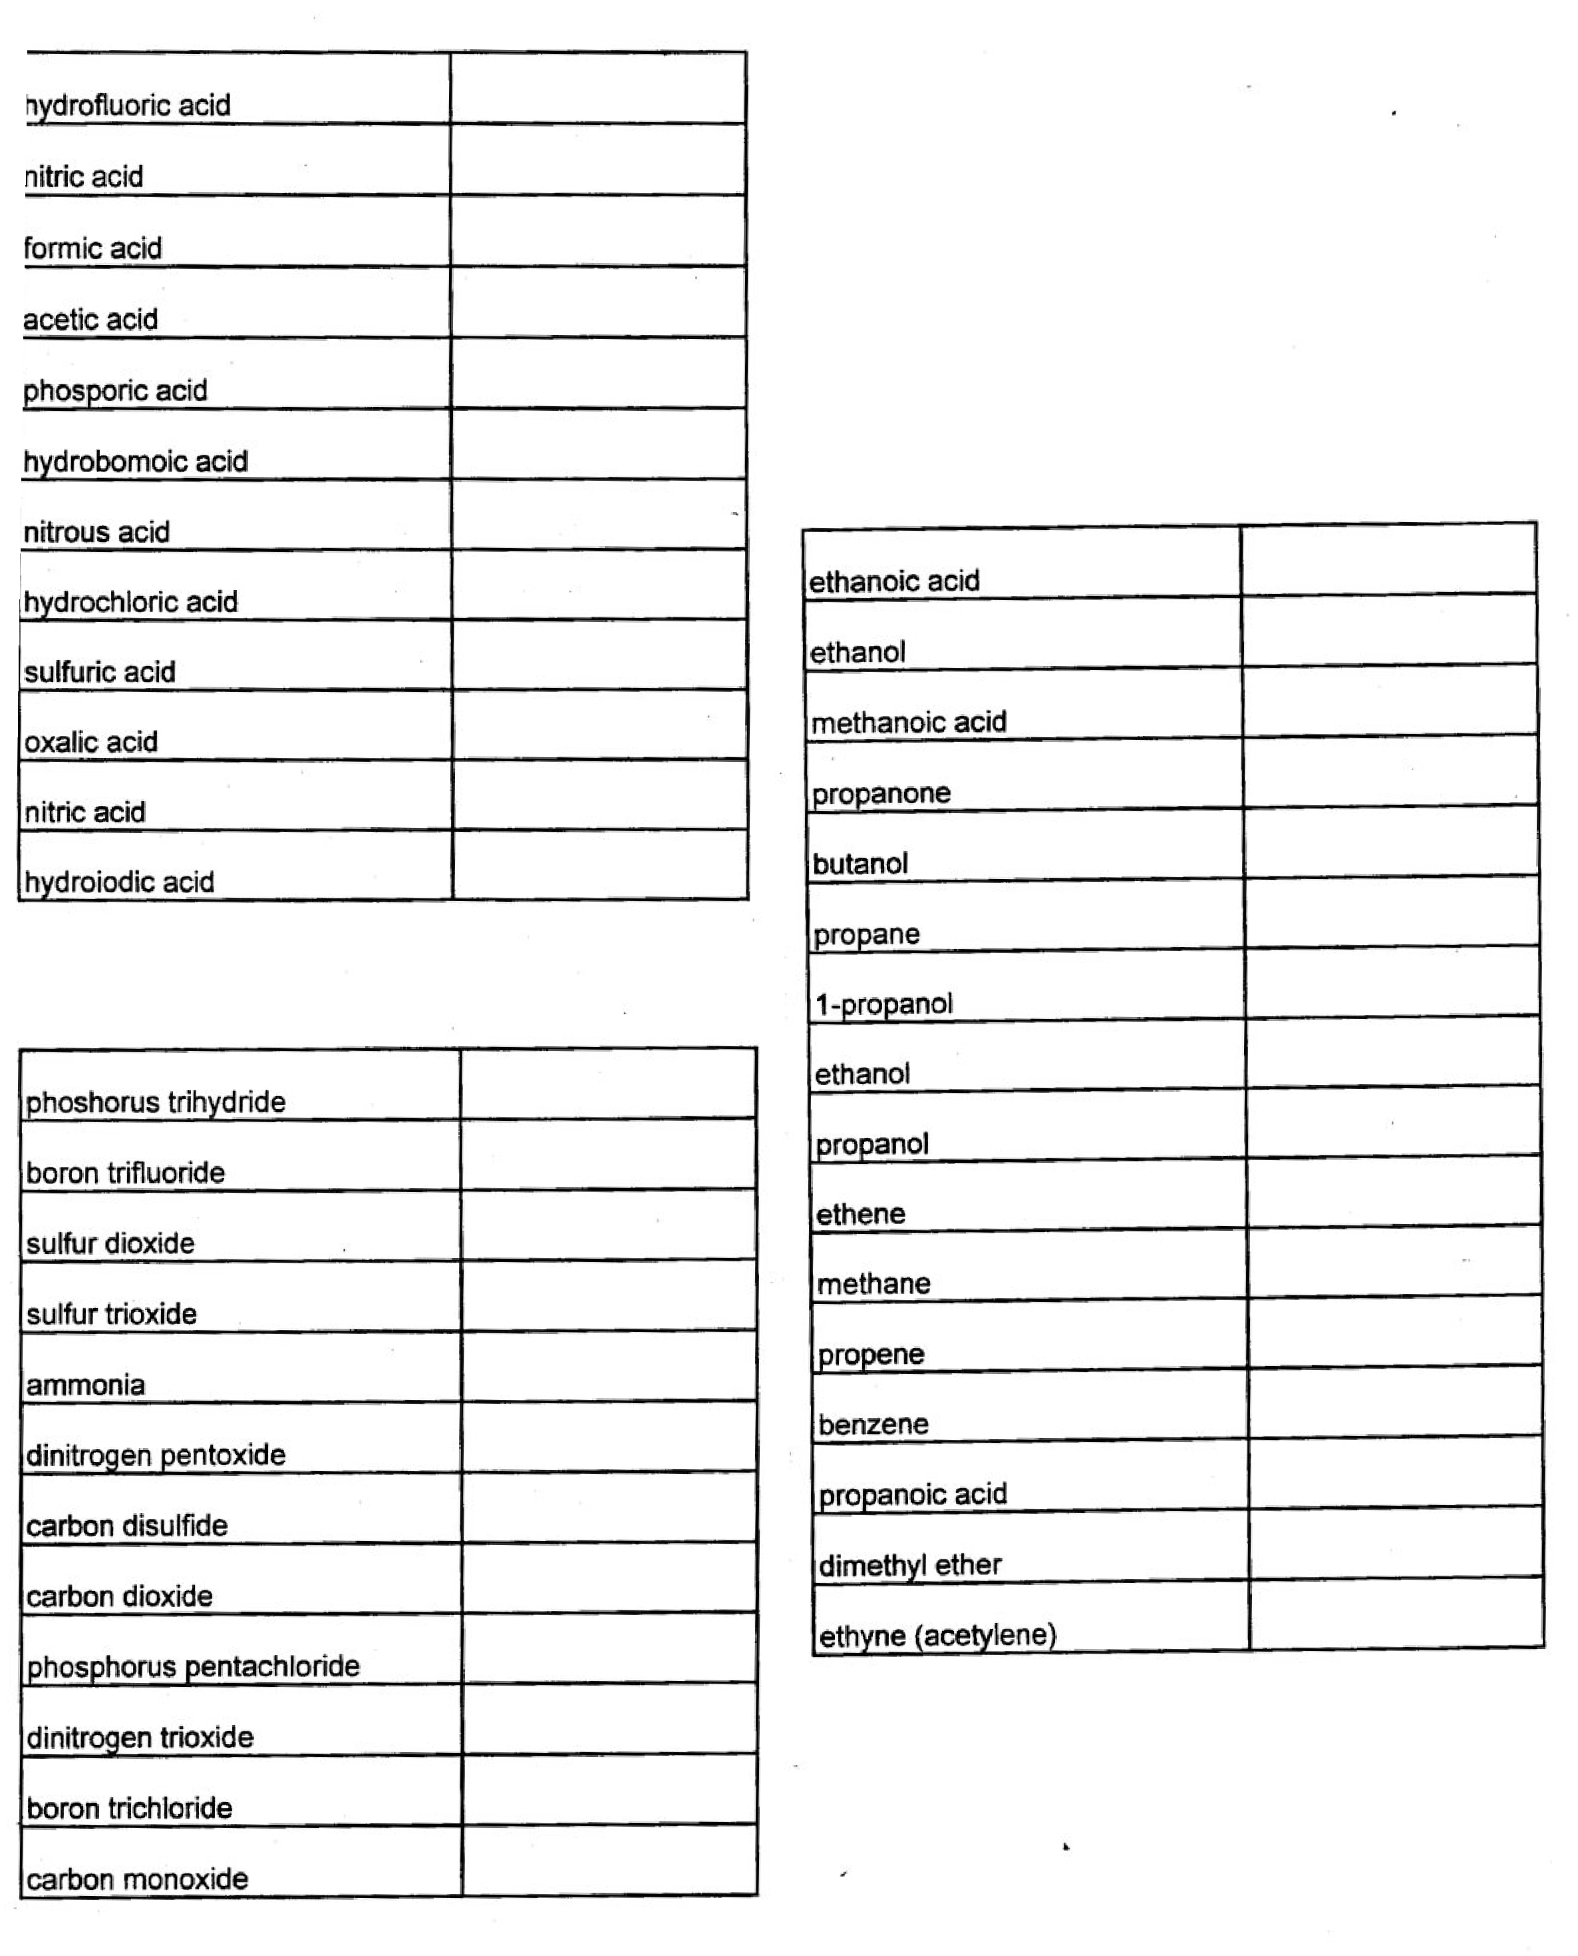

1.

2.

3.

4.

5.

6.

7.

8.

9.

10.

1

1.

12.

1.

2.

3.

4.

5.

6.

7.

8.

9.

10.

11.

12.

## ACIDS

**MOLECULAR COMPOUNDS**

hydrochloric acid

1.

2.

3.

4.

5.

6.

7.

8.

9.

10.

11.

12.

13.

14.

15.

16.

## AP CHEMISTRY NAMING OF ACIDS, MOLECULAR COMPOUNDS, AND ORGANIC COMPOUNDS FROM PREVIOUS TESTS

Directions: In the blank provided, write the formula. For compounds labeled “Molecular Compounds”, also record their complete Lewis structure.

## ORGANIC COMPOUNDS

**AP CHEMISTRY NAMING AND STRONG/WEAK FOR ACIDS FROM PREVIOUS TESTS**

Directions: In the blanks provided, write the name of the acid, “S” or “W” for strong or weak, and how itʼs written in solution.

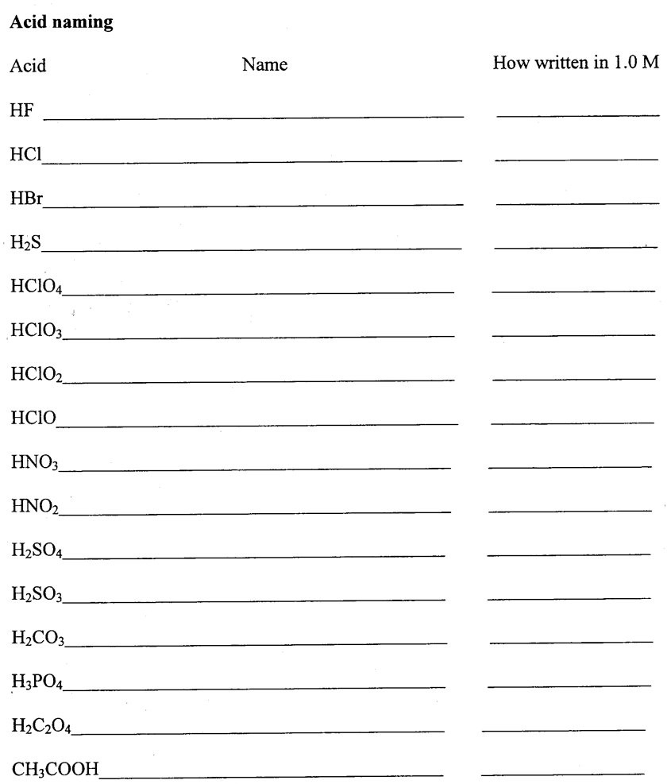

strong/ weak?

# hydrofluoric acid HF (aq) W

1. hydrochloric acid H+(aq) + Cl-(aq) S

3.

4.

5.

6.

7.

8.

9.

10.

11.

12.

13.

14.

15.

16.

## AP CHEMISTRY PRECIPITATION REACTIONS FROM PREVIOUS TESTS

Directions: Balance and indicate phases (s,aq). Do so in 2 ways:

* 1. molecular equation for each
  2. 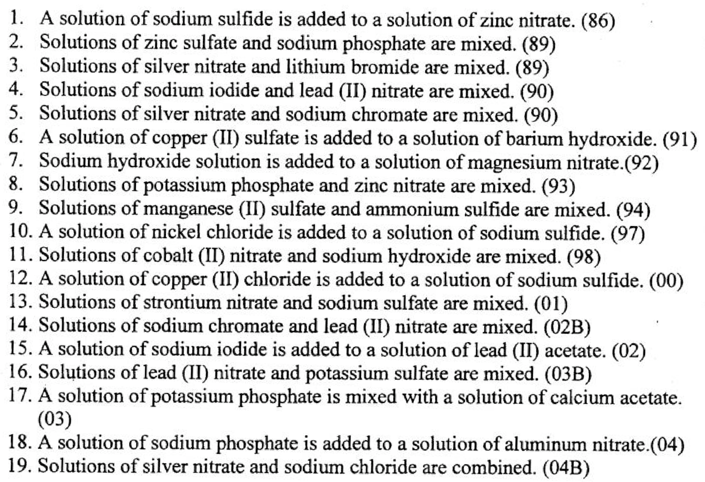net ionic equation for each

Example:

2 a) 3 ZnSO4 (aq) + 2 Na3PO4 (aq) → Zn3(PO4)2 (s) + 3 Na2SO4 (aq) b) 3 Zn2+ (aq) + 2 PO43- (aq) → Zn3(PO4)2 (s)