N4 – Thermochemistry –  
 Heat of Formation

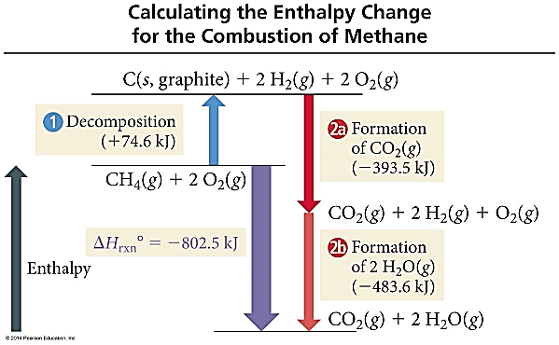**Practice #1 -** Calculate ΔH for the combustion of methane, CH4 **CH4(g) + 2O2(g) 🡪 CO2(g) + 2H2O(l)**

|  |  |
| --- | --- |
| **Formula** | **ΔHf  (kJ)** |
| CH4 | -74.80 |
| O2 | 0 |
| CO2 | -393.50 |
| H2O | -285.83 |

**Practice #2 -** Ethanol is used as an additive in many fuels today. What is Δ*H*ºrxn (kJ) for the combustion of ethanol?  
**2 C2H5OH (*l* ) + 6 O2 (*g*) → 4 CO2 (*g*) + 6 H2O (*l* )**

|  |  |
| --- | --- |
| **Formula** | **Δ*H*º*f*** |
| C2H5OH (*l*) | –277.6 |
| CO2 (*g*) | –393.5 |
| H2O (*g*) | –241.8 |
| H2O (*l*) | –285.8 |

**Practice #3 – What is the enthalpy of formation for the equation below, using the table of bond energies provided.**

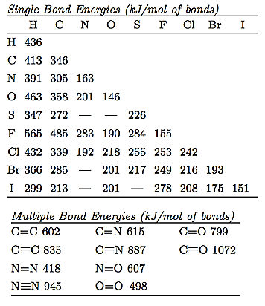

N4 – Thermochemistry –   
 Heat of Formation

**Practice #1 -** Calculate ΔH for the combustion of methane, CH4 **CH4(g) + 2O2(g) 🡪 CO2(g) + 2H2O(l)**

|  |  |
| --- | --- |
| **Formula** | **ΔHf  (kJ)** |
| CH4 | -74.80 |
| O2 | 0 |
| CO2 | -393.50 |
| H2O | -285.83 |

|  |  |
| --- | --- |
| **Formula** | **ΔHf  (kJ)** |
| CH4 | -74.80 |
| O2 | 0 |
| CO2 | -393.50 |
| H2O | -285.83 |

**Practice #2 -** Ethanol is used as an additive in many fuels today. What is Δ*H*ºrxn (kJ) for the combustion of ethanol?  
**2 C2H5OH (*l* ) + 6 O2 (*g*) → 4 CO2 (*g*) + 6 H2O (*l* )**

|  |  |
| --- | --- |
| **Formula** | **Δ*H*º*f*** |
| C2H5OH (*l*) | –277.6 |
| CO2 (*g*) | –393.5 |
| H2O (*g*) | –241.8 |
| H2O (*l*) | –285.8 |

**Practice #3 – What is the enthalpy of formation for the equation below, using the table of bond energies provided.**

