N4 – Thermochemistry –  
 Heat of Formation

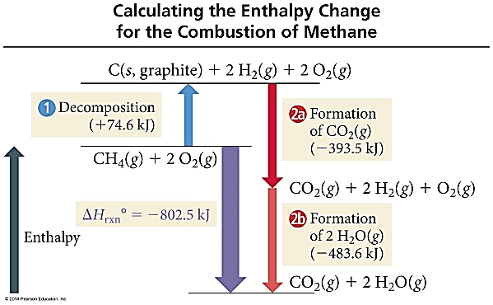**Practice #1 -** Calculate ΔH for the combustion of methane, CH4 **CH4(g) + 2O2(g) 🡪 CO2(g) + 2H2O(l)**

|  |  |
| --- | --- |
| **Formula** | **ΔHf  (kJ)** |
| CH4 | -74.80 |
| O2 | 0 |
| CO2 | -393.50 |
| H2O | -285.83 |

**Practice #2 -** Ethanol is used as an additive in many fuels today. What is Δ*H*ºrxn (kJ) for the combustion of ethanol?  
**2 C2H5OH (*l* ) + 6 O2 (*g*) → 4 CO2 (*g*) + 6 H2O (*l* )**

|  |  |
| --- | --- |
| **Formula** | **Δ*H*º*f*** |
| C2H5OH (*l*) | –277.6 |
| CO2 (*g*) | –393.5 |
| H2O (*g*) | –241.8 |
| H2O (*l*) | –285.8 |

**Practice #3 – What is the enthalpy of formation for the equation below, using the table of bond energies provided.**

N3 – Thermochemistry – Hess’s Law

|  |
| --- |
| **Definitions** |
| **Hess’s Law**  “In going from a particular set of reactants to a particular set of products, the change in enthalpy is the same whether the reaction takes place in one step or a series of steps.”  **Add Reactions** *+ ∆H’s*  **Multiplying a Rxn by a factor** *x ∆H by the factor*  **Reversing a Rxn -** *∆H  (opposite sign, not necessarily a negative value)* |
| **Standard State**   * Pure gas at 1 atm pressure * Pure solid or liquid in its most stable form at  1 atm, and temp of interest (usually 25°C) * Substances in a solution with a [ ] of 1M |

|  |  |  |
| --- | --- | --- |
| **#** | **Reaction** | **ΔHo** |
| 1 | C + 2H2 🡪 CH4 | -74.80 kJ |
| 2 | C + O2 🡪 CO2 | -393.50 kJ |
| 3 | H2 + ½ O2 🡪 H2O | -285.83 kJ |

**Hess’s Law #1**

**Hess’s Law #2**

**Rxn #1) ½ N2 (*g*) + ½ O2 (*g*) → NO (*g*)   
 Δ*H* = 90.3 kJ  
  
Rxn #2) NO (*g*) + ½ Cl2 (*g*) → NOCl (*g*)   
 Δ*H* = –38.6 kJ**

**Hess’s Law #3**

**Rxn #1) 3Fe2O3 + CO (g) 🡪 2Fe3O4 + CO2 (g)**

**ΔH°= -47 kJ  
  
Rxn #2) Fe2O3 + 3CO (g) 🡪 2Fe (s) + 3CO2 (g)**

**ΔH°= -25 kJ  
  
Rxn #3) Fe3O4 + CO (g) 🡪 3FeO (s) + CO2 (g)**

**ΔH°= 19 kJ**

You should notice that I put these in backwards order. That makes it easier to cut them out without the whole thing falling out of your binder!

N2 – Thermochemistry – A Review

|  |
| --- |
| Some Background Knowledge Definitions |
| *Not all the definitions from the notes – you still have to take notes!* |
| **Energy** – capacity to do work or produce heat |
| **Potential Energy** – due to position or composition |
| **Kinetic Energy** - due to motion |
| **Electrical Energy** – flow of electrical charge |
| **Thermal Energy** – molecular motion |
| **Light/Radiant Energy** – energy transitions in an atom |
| **Nuclear Energy** – potential energy in atomic nuclei |
| **Chemical Energy** – due to structure of atoms/bonds |
| **Law of Conservation of Energy** –  cannot create or destroy energy |
| **1st Law of Thermodynamics** –  total energy content of universe is constant |
| **State Function** –  depends only on present state, not pathway to get there |

|  |  |
| --- | --- |
| **Endothermic** | |
| System absorbs energy | Surroundings release energy |
| System energy increases | Surrounding energy decreases |
| + qsystem | – qsurroundings |
| If you touch the container YOU feel cold – the system is taking heat away from YOU! Your thermometer is in the SURROUNDINGS so the temperature it reads decreases! | |

|  |  |
| --- | --- |
| **Exothermic** | |
| System releases energy | Surroundings gain energy |
| System energy decreases | Surrounding energy increases |
| – qsystem | + qsurroundings |
| If you touch the container YOU feel hot – the system is releasing heat towards YOU! Your thermometer is in the SURROUNDINGS so the temperature it reads increases! | |

**Q#1** Identical amounts of heat are applied   
to 50 g blocks of lead, silver, and copper,   
all at an initial temp of 25°C. Which block   
will have the largest increase in temp?

**Q#2** Determine the energy required to convert 21.1 grams of ice at -6°C to steam at 100°C

**Q#3** A sample of barium chloride is increased in temperature by 3.8C when the sample absorbed 2.4 x 102J of heat energy. Calculate the number of mole sof barium chloride in the sample if its molar heat capacity is 75.1 J/mol•K

**Q#4** The temperature of a 700.0-g bar of iron decreases by 10.0°C when the iron is plunged into 500.0 g of water. What is the temperature increase of the water, assuming that no heat is lost in the transfer? (CFe = 0.45 J/g°C)

**Q#5** 50.0 g of water at 22 °C is mixed with 125 g of water initially at 36 ° C. What is the final temperature of the water after mixing, assuming no heat is lost to the surroundings?