Lab – The Titration Anthology

Overview: At this point in the year, you’ve already completed two kinds of titrations. Let’s review them.

Titration #1 was when we used a solid organic acid—potassium hydrogen phthalate, or KHP—to react with NaOH so that we could standardize our NaOH solution. “Standardize” means to calculate its precise concentration, which Mr. Pratt tried to get as close to 0.100 M as possible. This reaction is shown below.

HC₈H₄O₄⁻ + OH⁻ → H₂O + C₈H₄O₄²⁻

By reacting to equivalence, we could calculate the precise moles of NaOH (since it was 1:1 ratio with moles to acid) and thus calculate concentration using $M= \frac{mol}{L}$ . You didn’t know it at the time during Unit 4, but this was a weak acid / strong base titration that created a weak base in solution at the equivalence point of the reaction.

Titration #2 was an application of the principles of solubility. Mr. Pratt created a saturation solution of Mg(OH)₂ (aq) by putting a large amount of solid into a 1000 mL beaker of water. After sitting for a couple of days, the system reached equilibrium and a precipitate could be seen at the bottom of the beaker. The following equilibrium was established:

Mg(OH)₂ (s) ↔ Mg²⁺ (aq) + 2 OH⁻ (aq)

Because the analyte had OH⁻ ions in solution, we could titrate the analyte using 0.100 M HCl to reach equivalence. This was a strong acid / strong base reaction with the following net ionic equation:

H⁺ (aq) + OH⁻ (aq) → H₂O (l)

As equal moles of HCl were added to the OH⁻ solution, a neutral pH was produced, producing a color change from blue to yellow-green. Once the moles of OH⁻ were calculated, the concentration for [OH⁻] and [Mg²⁺] could be established (via 2 : 1 molar ratio) and a K_{sp} value could be determined. In this instance, titration was the most precise way to establish K_{sp}.

Now, we will begin a series of 3 different titrations. In all three titrations, you will:
- follow the same basic procedure of setting up your burette with the analyte (rinsing and filling)
- selecting the proper indicator based on the pH at the equivalence point
- record initial & final volumes to the correct number of digits
- calculate the molarity of the analyte using the volume of titrant needed to reach the equivalence point

Read over the general titration procedure so that you are familiar with the correct steps. You’ll be using it for each trial.

Each titration will have a series of pre-lab questions to answer before you can begin. These questions will guide you towards selecting the proper indicator as well as understanding the net ionic equation.

By the end of the lab period, you’ll need to perform all 3 titrations. If you focus & work together as a team, you can get it done. As always, Mr. Pratt is here to help you.

Good luck!

Procedure for a Titration

- Obtain a burette. Make sure the stopcock is in the closed position. Using a funnel to avoid spills, fill your burette with your analyte so that it is mostly full. Rinse the analyte through the burette into a clean beaker.

- After rinsing, fill the analyte into the burette. Fill the burette so that it is close to the top, somewhere between 0 and 5 mL. Record the initial volume on your data table to the correct number of decimal places (in this case, to the hundredths place).

- Using a graduated cylinder (less precise) or a graduated pipette (more precise), add 10.0 mL of your analyte into an Erlenmeyer flask. This step is critical for precision, as you are adding the exact number moles of analyte that will react with your titrant. (If using a solid at this step, use a spatula to measure out the recommended number of grams onto a weigh paper on a balance).

- Use a wash bottle of distilled water to add another 15 – 20 mL of water into the flask. This added volume will help reduce splashing—it will not affect the amount of titrant needed to react, since it does not affect the moles of analyte.

- Add 2 – 3 drops of your selected indicator into your flask. (Note: your indicator should have a pKA close to the equivalence point pH).

- Place the flask directly under the burette. Place a white piece of paper under the flask to help visualize the color change of the solution. Carefully open the stopcock so that a slow, steady stream of analyte flows into the flask. Gently swirl the flask to mix the solution. You should observe some color change as the analyte is added.

- The color change will persist for a longer period of time as approach the equivalence point. As you approach the equivalence point, reduce the volume of titrant being added to the flask.

- Once the end point has been reached, record the final volume reading on the burette to the correct decimal place.

- Pour the contents of the flask into the classroom waste beaker. Rinse out your flask with water three times. It does not have to be dry, but all of the solutions should be removed. You can use the same flask for Trials 2 and 3.

- Repeat this procedure for each trial of your titration. Each trial should be faster since you have an approximate volume change to reach the end point, so you can add the titrant faster until you approach the equivalence point.

Titration #1: Strong Acid / Strong Base Titration ( HCl + NaOH )

Pre-Lab Questions

- In this reaction, your titrant will be 0.100 M NaOH and your analyte will be 10.0 mL of unknown concentration of HCl.

Write out the net ionic equation for a strong acid + strong base reaction.

- What is the molar ratio of strong base to strong acid? _____________

- Before you reach the equivalence point, the pH will be ( acidic basic neutral ). This is

because the ions or species in highest concentration is ( H⁺ H₂O OH⁻ ).

- When you reach the equivalence point, the pH will be ( acidic basic neutral ). This is

because the ions or species in highest concentration is ( H⁺ H₂O OH⁻ ).

- After you reach the equivalence point, the pH will be ( acidic basic neutral ). This is

because the ions or species in highest concentration is ( H⁺ H₂O OH⁻ ).

- Draw the approximate shape of the titration curve on the pH vs mL titrant below. Label the equivalence point.
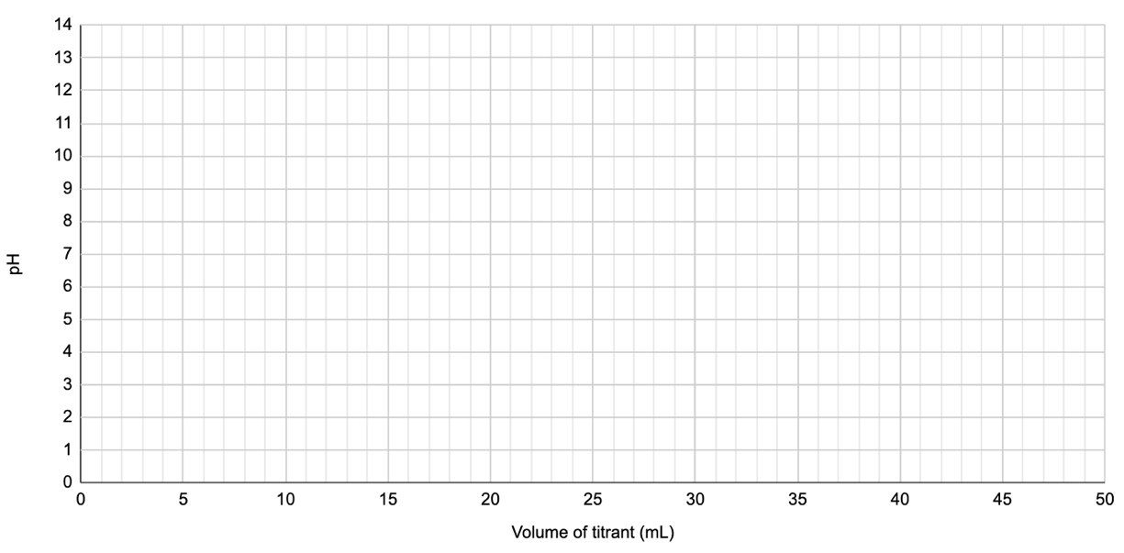

- The analyte in the flask will be ( NaOH HCl ) and the titrant will be ( NaOH HCl ).

- Based on the chart below, the best indicator we should use is _______________________.

Indicator | pH Range | Color Change
Methyl red | 4.4 – 6.2 | Red to Yellow
Phenolphthalein | 8.00 - 10 | Clear to Pink
Alzarin yellow | 10.0 – 12.10 | Yellow to Red

Data Table for Titration #1

Make sure you record your UNITS in each box (mL, g, mol, etc.)

 | Trial 1 | Trial 2 | Trial 3
Exact volume of the HCl added to the flask
Initial volume reading on the burette
Final volume reading on the burette
Describe the shade of pink of your flask @ end point
Volume of NaOH solution used in the titration
Moles of NaOH used in the titration
Moles of HCl in the flask
Molarity of the HCl in the flask

Average Molarity of HCl solution:

Actual Molarity of HCl solution: _______________

Percent Error: _______________

$$Percent Error= \frac{\left| Lab Value-Actual Value \right|}{Actual Value} × 100$$

Titration #2: Weak Acid / Strong Base Titration ( CH₃COOH + NaOH )

Pre-Lab Questions
- In this reaction, your titrant will be 0.100 M NaOH and your analyte will be 10.0 mL of unknown concentration of ethanoic acid (CH₃COOH). Write out the net ionic equation for this weak acid + strong base reaction.

- What is the molar ratio of weak acid to strong base? _____________

- Before you reach the equivalence point, the pH will be ( acidic basic neutral ). This is

because the ions or species in highest concentration is ( CH₃COOH OH⁻ H⁺ CH₃COO⁻ ).

- As you approach the equivalence point, you are creating a buffer solution. This is because the following ions are in solution: ( CH₃COOH OH⁻ H⁺ CH₃COO⁻ ).

- At the halfway point, your pH of your solution is equal to the _____ of the acid.

- When you reach the equivalence point, the pH will be ( acidic basic neutral ). This is

because the ions or species in highest concentration is ( CH₃COOH OH⁻ H⁺ CH₃COO⁻ ).

- After you reach the equivalence point, the pH will be ( acidic basic neutral ). This is

because the ions or species in highest concentration is ( CH₃COOH OH⁻ H⁺ CH₃COO⁻ ).

- Draw the approximate shape of the titration curve on the pH vs mL titrant below. Label the equivalence point & halfway point.
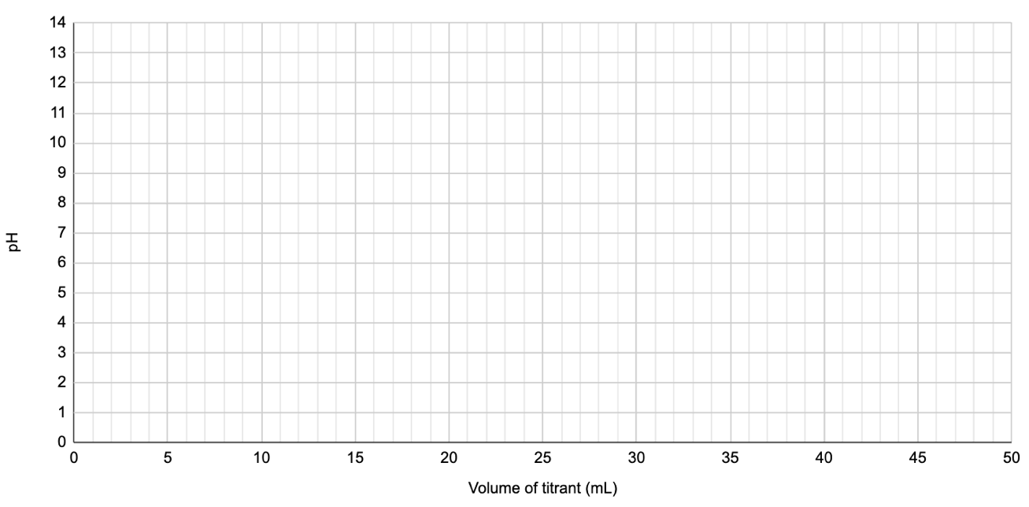
- The analyte in the flask will be ( NaOH CH₃COOH ) and the titrant will be ( NaOH CH₃COOH).

- Based on the chart below, the best indicator we should use is _______________________.

Indicator | pH Range | Color Change
Methyl red | 4.4 – 6.2 | Red to Yellow
Phenolphthalein | 8.00 - 10 | Clear to Pink
Alzarin yellow | 10.0 – 12.10 | Yellow to Red

Data Table for Titration #2

Make sure you record your UNITS in each box (mL, g, mol, etc.)

 | Trial 1 | Trial 2 | Trial 3
Exact volume of the weak acid added to the flask
Initial volume reading on the burette
Final volume reading on the burette
Describe the color shade of your flask @ equivalence point
Volume of NaOH solution used in the titration
Moles of NaOH used in the titration
Moles of ethanoic acid in the flask
Molarity of the ethanoic acid in the flask

Avg. Molarity of Ethanoic Acid solution:

Actual Molarity of Ethanoic Acid: ______________________

Percent Error: ______________________

$$Error= \frac{\left| Lab Value-Actual Value \right|}{Actual Value} × 100$$

Titration #3: Weak Base / Strong Acid Titration ( NH₃ + HCl )

Pre-Lab Questions
- In this reaction, your titrant will be 0.100 M HCl and your analyte will be 10.0 mL of unknown concentration of ammonia (NH₃). Write out the net ionic equation for this weak base + strong acid reaction.

- What is the molar ratio of weak base to strong acid? _____________

- Before you reach the equivalence point, the pH will be ( acidic basic neutral ). This is

because the ions or species in highest concentration is ( NH₃ H⁺ H₂O NH₄⁺ ).

- As you approach the equivalence point, you are creating a buffer solution. This is because the following ions are in solution: ( NH₃ H⁺ H₂O NH₄⁺ ).

- At the halfway point, your pH of your solution is equal to the _____ of the conjugate acid, _____.

- When you reach the equivalence point, the pH will be ( acidic basic neutral ). This is

because the ions or species in highest concentration is ( NH₃ H⁺ H₂O NH₄⁺ ).

- After you reach the equivalence point, the pH will be ( acidic basic neutral ). This is

because the ions or species in highest concentration is ( NH₃ H⁺ H₂O NH₄⁺ ).

- Draw the approximate shape of the titration curve on the pH vs mL titrant below. Label the equivalence point & halfway point.
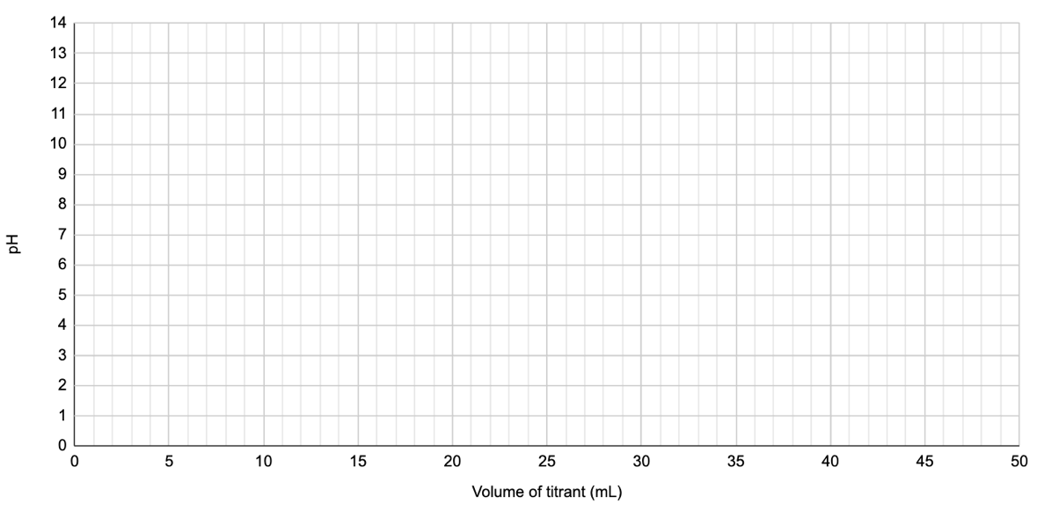
- The analyte in the flask will be ( NaOH CH₃COOH ) and the titrant will be ( NaOH CH₃COOH).

- Based on the chart below, the best indicator we should use is _______________________.

Indicator | pH Range | Color Change
Methyl red | 4.4 – 6.2 | Red to Yellow
Phenolphthalein | 8.00 - 10 | Clear to Pink
Alzarin yellow | 10.0 – 12.10 | Yellow to Red

Data Table for Titration #3

Make sure you record your UNITS in each box (mL, g, mol, etc.)

 | Trial 1 | Trial 2 | Trial 3
Exact volume of the weak base added to the flask
Initial volume reading on the burette
Final volume reading on the burette
Describe the color shade of your flask @ equivalence point
Volume of HCl solution used in the titration
Moles of HCl used in the titration
Moles of ammonia in the flask
Molarity of the ammonia in the flask

Avg. Molarity of Ammonia solution:

Actual Molarity of Ammonia solution: ______________________

Percent Error: ______________________

$$Error= \frac{\left| Lab Value-Actual Value \right|}{Actual Value} × 100$$

BONUS Titration: Determining the Molar Mass of an Unknown Triprotic Acid

Pre-Lab Questions
- You will be performing a neutralization reaction between a solid triprotic acid and NaOH. Since you don’t know the formula of the acid, we will call it “H₃A”. The conjugate base of the triprotic acid will have a charge of -3 to balance out the 3 acidic hydrogens. Assume that all three hydrogens are removed by the hydroxide, thus forming 3 moles of water. Finish balancing the equation below.

___ H₃A + ___ NaOH → ___ H₂O + ____ Na₃A

- Based on the balanced equation you wrote (#2), what is the molar ratio of OH⁻ to H₃A? _____

- Before you reach the equivalence point, the pH will be ( acidic basic neutral ). This is

because the ions or species in highest concentration is ( H₃A H₃O⁺ H₂O OH⁻ ).

- When you reach the equivalence point, the pH will be ( acidic basic neutral ). This is

because the ions or species in highest concentration is is ( H₃A H₃O⁺ H₂O OH⁻ ).

- After you reach the equivalence point, the pH will be ( acidic basic neutral ). This is

because the ions or species in highest concentration is is ( H₃A H₃O⁺ H₂O OH⁻ ).

- Because the unknown triprotic acid will be a solid, you will need a ( pipette burette balance ) to measure the precise grams of solid into the flask.

- The analyte in the flask will be ( NaOH H₃A ) and the titrant will be ( NaOH H₃A ).

- Based on the chart below, the best indicator we should use is _______________________.

Indicator | pH Range | Color Change
Methyl red | 4.4 – 6.2 | Red to Yellow
Phenolphthalein | 8.00 - 10 | Clear to Pink
Alzarin yellow | 10.0 – 12.10 | Yellow to Red

Data Table for BONUS Titration

Make sure you record your UNITS in each box (mL, g, mol, etc.)

 | Trial 1 | Trial 2 | Trial 3
Mass of triprotic acid added to the flask
Initial volume reading on the burette
Final volume reading on the burette
Describe the shade of pink of your flask.
Volume of NaOH solution used in the titration
Molar ratio of OH⁻ to H₃A | ____ : _____ | ____ : _____ | ____ : _____
Moles of NaOH used to reach equivalence
Moles of H₃A at equivalence
Molar Mass of the Acid

$$M.M.= \frac{grams}{mol}$$

Average Molar Mass: ______

Formula of triprotic acid: _____________________
(given to you by your teacher)

Actual Molar Mass: _____________________

Percent Error: _____________________

$$Error= \frac{\left| Lab Value-Actual Value \right|}{Actual Value} × 100$$

Conclusion & Reflection

Here are the skills you need to be able to do at the conclusion of these labs. Rate yourself on your ability to do them.

1 = lost / confused 2 = basic knowledge 3 = pretty good 4 = can explain to others

Rank | Skill / Knowledge
 | Describe the procedure for setting up a titration (including rinsing, filling, adding analyte to the flask, initial vs final volume)
 | Writing out the net ionic equation for each of the titrations
 | Predicting the pH of the equivalence point (acidic, basic, or neutral) based on the reagents that are being combined
 | Selecting the correct indicator based on predicted pH of the equivalence point & indicator pKA
 | Calculating the unknown chemical’s concentration using the equivalence point
 | Being able to draw from memory & describe the pH vs mL titrant graph for each of the titrations
 | For WA / SB and WB / SA titrations, knowing what a “halfway point” is and how this value is equal to pKA

