**Name_______________________________ Lab Partner______________________________ Period_____**

**LAB 16: Determining the Ka and Molar Mass of an Unknown Solid Acid**

A titration is a process used to determine the volume of a solution needed to react with a given amount of another substance. In this experiment, you will titrate an unknown solid acid to determine its Ka and molar mass. The concentration of the NaOH solution is given.

OH- + HA 🡨 🡪 A- + H2O

When an acidic solution is titrated with an NaOH solution, the pH of the acidic solution is initially low. As base is added, the change in pH is quite gradual until close to the equivalence point, when equimolar amounts of acid and base have been mixed. Near the equivalence point, the pH increases very rapidly, as shown in Figure 1. The change in pH then becomes more gradual again, before leveling off with the addition of excess base.

In this experiment, you will use a pH Sensor to monitor pH as you titrate. The region of most rapid pH change will then be used to determine the equivalence point. The volume of NaOH titrant used at the equivalence point will be used to determine the molar mass of your unknown solid acid.

Then, you will use the volume at the equivalence point to determine the location of the midpoint. The pH at the midpoint can be used to determine the Ka of the unknown acid.

**Figure 1.** Titration of an Unknown Acid with 0.50 M NaOH

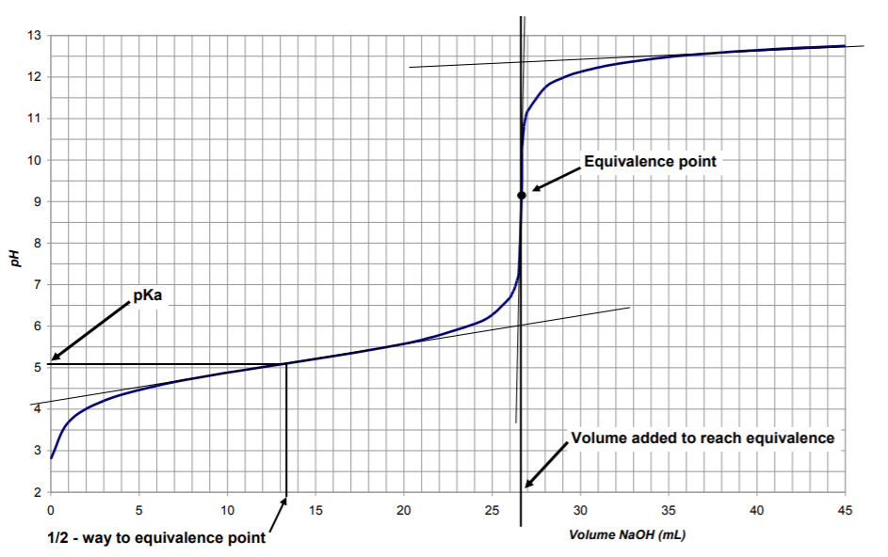

**MATERIALS**

| Chromebook, computer, **or** mobile device  Graphical Analysis 4 app  Go Direct pH probe  Stir Station  magnetic stirring bar  (optional) Phenolphthalein  buret clamp or utility clamp | ~0.50 M NaOH solution  250 mL beaker  Solid acid  wash bottle  distilled water  Electrode Support  50 mL buret |
| --- | --- |

**PROCEDURE: Obtain and wear goggles.**

1. Weigh out approximately 0.75 – 1.00 g of solid acid into a weigh boat. Record the exact mass of solid acid you obtained. Record which solid acid you used (A, B, C, or D).
2. Dissolve the solid acid in approximately 50.0 mL of deionized water in a 250 mL beaker. (The amount of water does not matter) Make sure it is all dissolved.
3. Add a couple drops of phenolphthalein to the solid acid solution you just made.
4. Obtain a 50 mL buret and rinse the buret with a few mL of the 0.50 M NaOH solution. Dispose of the rinse solution down the drain. **All classes:** Fill the buret with 0.50 M NaOH solution to the 0.00 mL line exactly. **WARNING**: *Sodium hydroxide solution,* NaOH: *Causes skin and eye irritation.*
5. First, we will do a “dirty” titration to see how approximately how much base is required to reach the equivalence point. Add the NaOH in approximately 0.50 mL increments. Record the approximate volume needed to reach the equivalence point, where the acid turned pink. _____ (This is merely to help you for the 2nd titration which is the true titration. Go **FAST** on this titration! You do not need to collect pH data. Just go!)
6. Dump out the contents of the beaker down the sink, and refill the buret to 0.00 mL with 0.50 M NaOH.
7. Weigh out *about* the same amount as before of the solid acid. Record the exact mass in the data table below. Dissolve in *about* 50 mL water in the beaker and add a couple drops of phenolphthalein.
8. Set up the pH meter where it can touch the liquid but not be hit by the spinning magnet. You can add more water if you choose.
9. Launch Graphical Analysis. Select “Sensor Data Collection” and connect the pH sensor to your phone by making sure the sensor is turned on and selecting the sensor on your phone with the same number as is written on the back of the pH meter. ***(Tip: If it can’t connect with the sensor, exit out of the app and come back in. Also make sure the sensor is turned on.)***
10. Set up the data-collection mode.
    1. Click or tap Mode (at the bottom of the screen) to open Data Collection Settings. Change Mode to Event Based.
    2. Enter **Volume** as the Event Name and **mL** as the Units. Click or tap Done.
11. Position the pH Sensor in the acid solution with an electrode clamp. Check to make sure that the pH value is below 7.

***Tip: Be careful with sensors! The bulbs at the end break easily and that is the end of that $100 pH meter. The tips must be rinsed with deionized water before and after use. Don’t break the glass bulb at the end of the sensor by stirring with the probe.***

1. You are now ready to perform the titration. This process is faster if one person manipulates and reads the buret while another person enters volumes. We are trying to see the typical “S” shaped curve of a titration.
   1. Click or tap **Collect** to start data collection.
   2. Before you have added any drops of NaOH solution, click or tap **Keep** and enter **0** as the buret volume in mL. Click or tap **Keep** Point to store the first data pair for this experiment.

***Tip: Do not press stop until the end of the titration! If you do, you will have to exit the program and start again!***

* 1. Add about 0.50 mL of sodium hydroxide. Stir the solution until the pH (mostly) stabilizes. Press **Keep** and type in the volume of NaOH delivered (Remember you just read the buret, you do NOT subtract!).

***Tip: If you have a data point entered incorrectly, you can click on it and change the volume after the titration is completed and you have “STOPPED”. You cannot delete a point, but you can choose to leave the volume field empty and that will take away the point. You can also just choose to ignore a bad a point as it will not affect your ability to locate the equivalence point and the midpoint and we are not making an equation for our curve.***

* 1. Continue adding NaOH solution in approximately half milliliter increments and enter the buret reading after each increment UNTIL the you near the equivalence point.
  2. **Once you notice the pH starts to change by more than 0.1 pH units or you recognize that you are near the volume required to reach the equivalence titration from the “dirty” titration, you MUST SLOW DOWN. Add the base in much smaller increments – 0.10 mL increments (if possible) and then one-drop increments (if possible). Enter a new buret reading after each increment.**
  3. Once the pH stops changing rapidly, you can increase the increments to 0.50 mL, then 1 mL.
  4. Continue adding NaOH solution until the pH value remains relatively constant – well past the equivalence point!

1. Click or tap **Stop** to stop data collection. Screenshot the graph as a backup plan!
2. In the top right-hand corner, click on the box-like icon and choose “1 graph”.
3. Examine the data on the graph of pH *vs*. volume to find the *equivalence point*—that is the largest increase in pH upon the addition of 1 drop of NaOH solution. Move to the region of the graph with the largest increase in pH (you can tap on the screen and a line will appear that reads the graph points). The equivalence point should be about halfway up this region. Record this on your data table.
4. When you back arrow on your phone, it will ask you if you want to save your graph. Save it!!! Or **SAVE** your graph by clicking on top left-hand corner.
5. Dispose of the beaker contents down the drain. Rinse the beaker well. Rinse the pH Sensor with water and return it to the pH storage solution. Leave the NaOH in the buret for next period.

**DATA:**

Mass of solid acid used _____________ (virtual students: 2.85 g) Letter of Unknown Acid ________

***Tip: Be sure to record the exact mass of the solid acid used.***

The equivalence point has a volume of __________________ and a pH of ________________.

The midpoint (or half equivalence point) has a volume of __________________ and a pH of ______________.

(**Virtual students, use the graph depicted at the beginning of the lab**)

**Calculations/ANalysis of DATA (Don’t CLOSE THE GRAPH!):**

1. Write the balanced equation for the reaction that occurs when the titrant, sodium hydroxide, is reacted with a weak acid, HA.
2. According to the graph, the equivalence point was reached when ___________ mL of 0.50 M NaOH had been delivered. Using this volume, calculate the molar mass of the unknown acid. ***(Tip: Put all known data underneath the substances in the reaction above as often do when we solve stoichiometry problems)***
3. Since the equivalence point occurred at ________ mL, then the midpoint occurred at _______ mL.
4. Using the pH at the midpoint, determine the Ka of the unknown acid. ***(Tip: Decimal exponents aren’t allowed! Calculate it out)***
5. Which acid below do you think you have? Why?

|  | **Formula** | **Molar Mass** | **Ka** |
| --- | --- | --- | --- |
| **Potassium bisulfate** | KHSO4 | 136.09 g/mol | 1.2 x 10-2 |
| **Potassium hydrogen phthalate** | KHC8H4O4 | 204.42 g/mol | 3.98 x 10-6 |
| **Sodium bisulfite** | NaHSO3 | 104.07 g/mol | 1.02 x 10-7 |
| **Sodium dihydrogen phosphate** | NaH2PO4 **.** H2O | 138.00 g/mol | 6.23 x 10-8 |
| **Potassium dihydrogen phosphate** | KH2PO4 | 136.09 g/mol | 6.23 x 10-8 |
| **Sodium bicarbonate** | NaHCO3 | 84.01 g/mol | 5.61 x 10-11 |
| **Sodium hydrogen phosphate** | Na2HPO4 | 141.96 g/mol | 4.7 x 10-13 |

1. What acid does your instructor say you have?
2. Write the **net ionic** equation for the reaction that occurred while the titration was occurring, using your unknown substance. (Tip: Leave out the sodium or potassium)
3. What species (ion) remains in solution at the equivalence point?
4. The equivalence point did not have a pH of 7! What was the pH at the equivalence point? Why?
5. Write the net ionic equation, using YOUR unknown, for the reaction that occurs in solution at the equivalence point causing the pH to not be neutral.

**FOLLOW UP PRACTICE**

1. What volume should be recorded as the volume of titrant delivered according to the images below of before and after a titration? (Pay attention to significant figures, of course!)

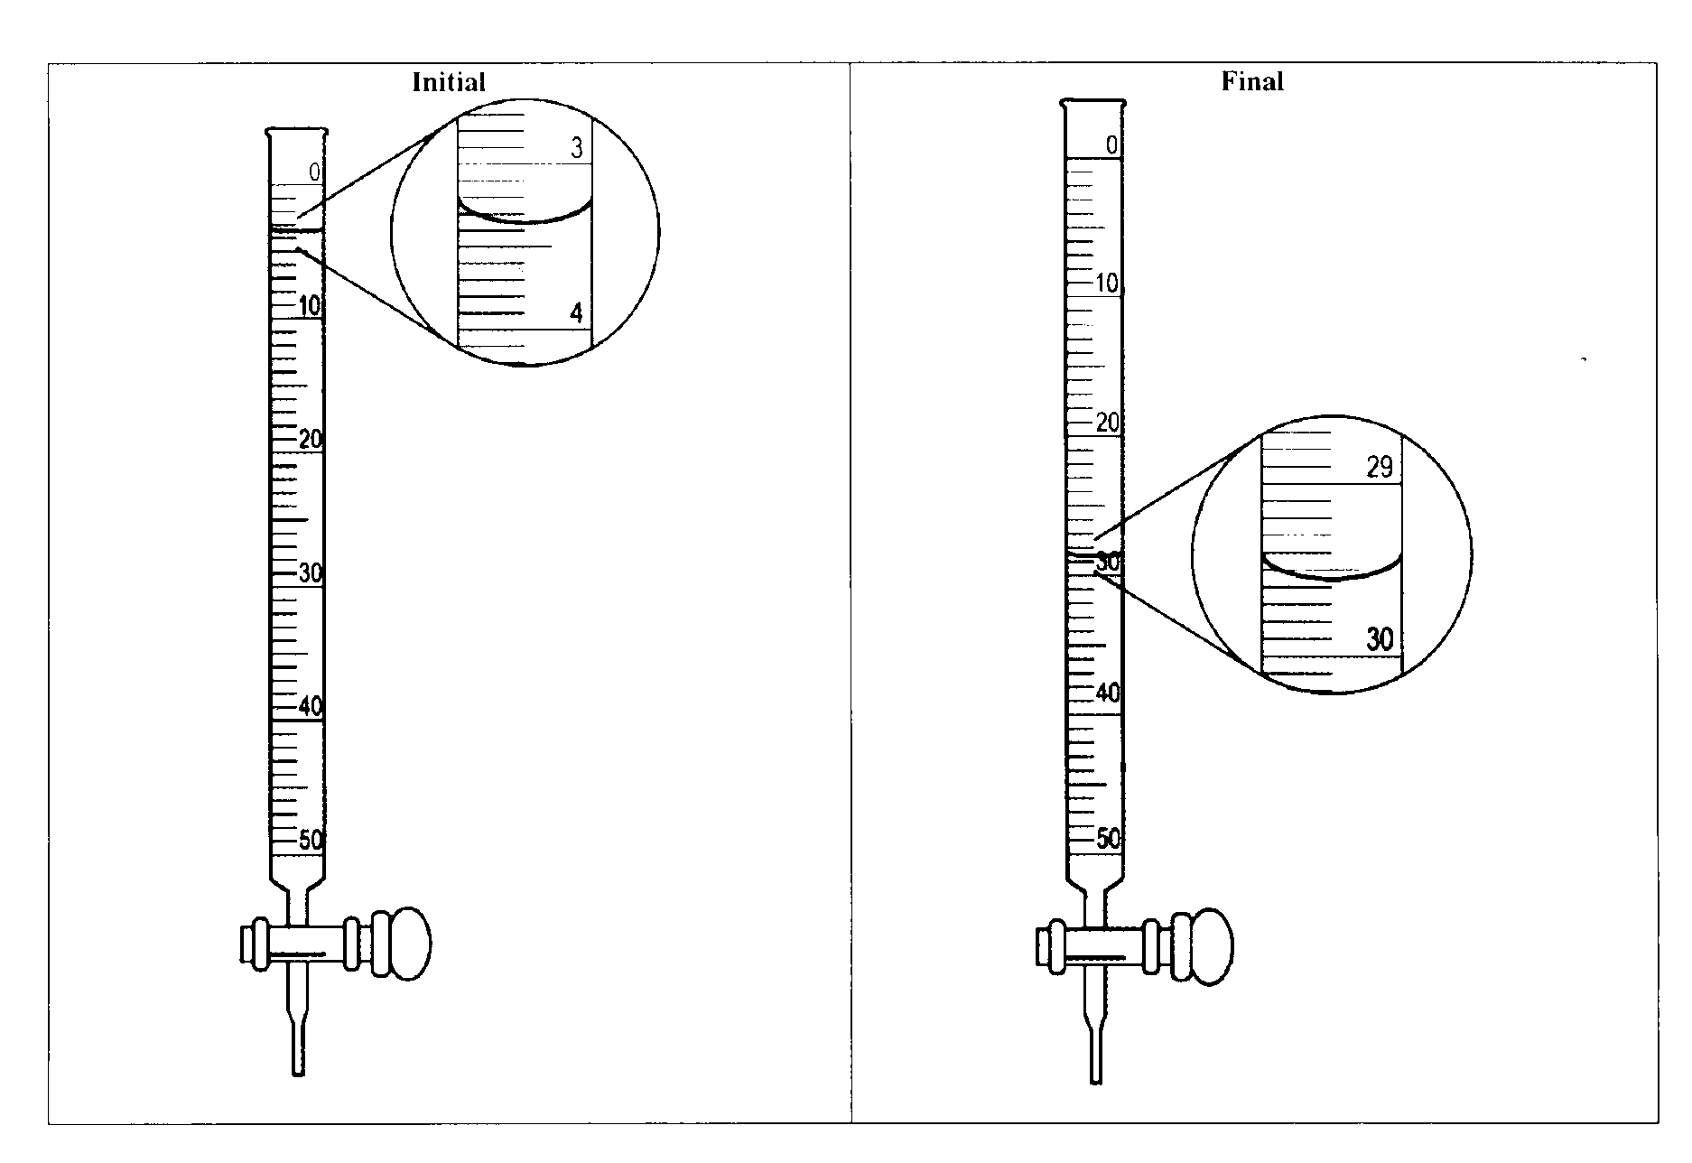

1. 0.35g of an unknown weak acid is titrated with 0.100 M NaOH and the pH is measured. The following titration curve is produced. 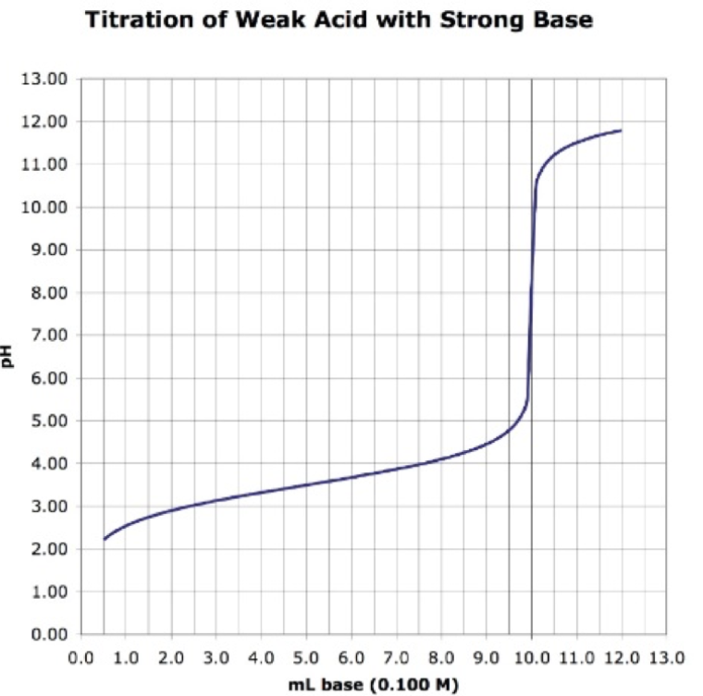
2. On the titration curve above, identify the equivalence point, the midpoint, and the buffer region.
3. What is the molar mass of unknown monoprotic acid titrated in the above graph? Show your work below.
4. What is the Ka of the unknown monoprotic acid titrated in the above graph?
5. Based on Ka, what indicator from the indicators listed below would be the **best** choice for the above titration?

thymol blue Ka = 3.1 x 10-2

methyl red Ka = 1.6 x 10-5

bromothymol blue Ka = 6.3 x 10-8

cresol purple Ka = 5.0 x 10-9

Teacher tip: Use an acid that has a pKa around 5, 6, 7. (sodium bisulfite works well!) If it is too high, it confuses students on the graph.

KHP is good, too. Sodium dihydrogen phosphate is nice BUT it gives a 2nd equivalence point if students keep going….can be a good discussion point.