N38 - Salts

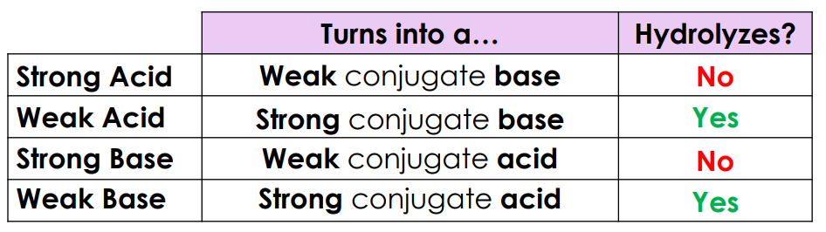

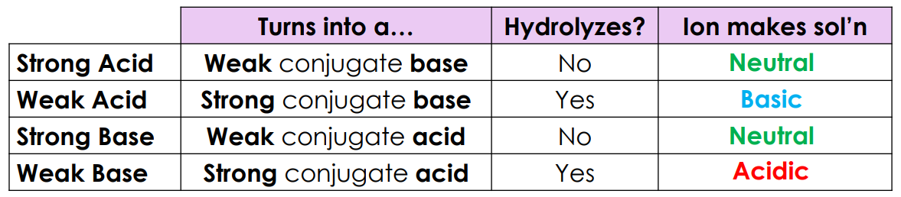

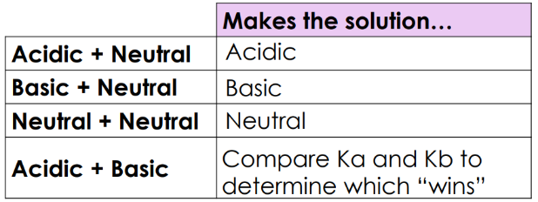

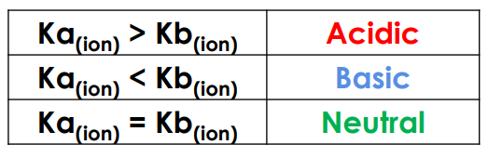

N38



N38 - Salts









